EVOLUTION OF GLACIAL LAKE COCHRANE DURING THE LAST GLACIAL TERMINATION, CENTRAL CHILEAN PATAGONIA (~47°S)
Alicia Vásquez, Valentina Flores-Aqueveque, Esteban Sagredo, Rodrigo Hevia, Rodrigo Villa-Martínez, Patricio I. Moreno, José L. Antinao
Supplementary material
Table S.1: Recalculated ¹⁰Be cosmogenic ages.
 |  |  |  |  | Recalculated age CRONUS v3
Site | Sample name | Latitude | Longitude | Elevation | Age (yr) | Interr (yr) | Exterr (yr) | Arithmetic mean (yr) | ± | Source
Menucos | LBA-03-10 | -46.236 | -71.516 | 628 | 15677 | 262 | 585 | 16770 | 1292 | Douglass et al. (2006)
 | LBA-03-11 | -46.236 | -71.530 | 651 | 18343 | 258 | 665 |  |  | Douglass et al. (2006)
 | LBA-03-13 | -46.236 | -71.531 | 656 | 16406 | 351 | 651 |  |  | Douglass et al. (2006)
 | LBA-03-17 | -46.234 | -71.540 | 673 | 15255 | 239 | 563 |  |  | Douglass et al. (2006)
 | LBA-04-12 | -46.227 | -71.575 | 722 | 17540 | 607 | 844 |  |  | Douglass et al. (2006)
 | LBA-04-14 | -46.226 | -71.577 | 737 | 17398 | 482 | 755 |  |  | Douglass et al. (2006)
Fénix I | LBA-01-04 | -46.595 | -71.038 | 438 | 19234 | 305 | 712 | 18260 | 1543 | Douglass et al. (2006)
 | LBA-01-05 | -46.595 | -71.038 | 438 | 17619 | 567 | 818 |  |  | Douglass et al. (2006)
 | LBA-01-06 | -46.596 | -71.036 | 438 | 20465 | 1620 | 1759 |  |  | Douglass et al. (2006)
 | LBA-02-10 | -46.608 | -71.050 | 428 | 18308 | 431 | 748 |  |  | Douglass et al. (2006)
 | LBA-02-11 | -46.609 | -71.053 | 420 | 19369 | 615 | 893 |  |  | Douglass et al. (2006)
 | LBA-02-12 | -46.603 | -71.036 | 432 | 16713 | 792 | 969 |  |  | Douglass et al. (2006)
 | LBA-02-13 | -46.587 | -71.038 | 444 | 17173 | 557 | 800 |  |  | Douglass et al. (2006)
 | LBA-03-19 | -46.235 | -71.473 | 699 | 16139 | 264 | 600 |  |  | Douglass et al. (2006)
 | LBA-03-23 | -46.235 | -71.472 | 700 | 19323 | 267 | 699 |  |  | Douglass et al. (2006)
Fénix II | LBA-98-78 | -46.626 | -71.043 | 454 | 19890 | 706 | 970 | 19571 | 1539 | Douglass et al. (2006)
 | LBA-98-97 | -46.556 | -71.026 | 430 | 20417 | 754 | 1017 |  |  | Douglass et al. (2006)
 | LBA-98-98 | -46.556 | -71.026 | 430 | 22142 | 711 | 1027 |  |  | Douglass et al. (2006)
 | LBA-01-10 | -46.599 | -71.029 | 445 | 18425 | 304 | 687 |  |  | Douglass et al. (2006)
 | LBA-01-11 | -46.601 | -71.026 | 448 | 18395 | 243 | 661 |  |  | Douglass et al. (2006)
 | LBA-01-12 | -46.601 | -71.026 | 439 | 19102 | 287 | 700 |  |  | Douglass et al. (2006)
 | LBA-02-15 | -46.598 | -71.029 | 435 | 19684 | 370 | 755 |  |  | Douglass et al. (2006)
 | LBA-02-16 | -46.599 | -71.029 | 436 | 19985 | 464 | 814 |  |  | Douglass et al. (2006)
 | LBA-03-18 | -46.124 | -71.461 | 694 | 17018 | 298 | 642 |  |  | Douglass et al. (2006)
 | LBA-03-20 | -46.234 | -71.459 | 709 | 20650 | 189 | 716 |  |  | Douglass et al. (2006)
Río Blanco First limit | BC07-7 | -47.519 | -71.236 | 564 | 29193 | 1029 | 1420 | 29755 | 3555 | Hein et al. (2010)
 | BC07-8 | -47.556 | -71.263 | 587 | 34779 | 1146 | 1636 |  |  | Hein et al. (2010)
 | BC07-12 | -47.584 | -71.355 | 665 | 27481 | 936 | 1313 |  |  | Hein et al. (2010)
 | BC07-43 | -47.508 | -71.245 | 581 | 27565 | 863 | 1264 |  |  | Hein et al. (2010)
Río Blanco Second limit | BC07-9 | -47.580 | -71.358 | 95 | 24780 | 783 | 1141 | 24622 | 874 | Hein et al. (2010)
 | BC07-22 | -47.573 | -71.417 | 250 | 24096 | 892 | 1203 |  |  | Hein et al. (2010)
 | BC07-23 | -47.576 | -71.413 | 130 | 24989 | 1515 | 1731 |  |  | Hein et al. (2010)
Río Blanco Third limit | BC07-16 | -47.304 | -71.403 | 620 | 21271 | 699 | 997 | 20740 | 1348 | Hein et al. (2010)
 | BC07-17 | -47.309 | -71.405 | 614 | 19371 | 852 | 1071 |  |  | Hein et al. (2010)
 | BC07-20 | -47.326 | -71.294 | 565 | 21578 | 590 | 933 |  |  | Hein et al. (2010)
Río Blanco Final limit | BC07-21 | -47.336 | -71.283 | 509 | 19036 | 778 | 1005 |  |  | Hein et al. (2010)
Erratic, lake draining | BC07-13 | -47.453 | -71.712 | 352 | 17242 | 91 | 581 |  |  | Hein et al. (2010)
María Elena moraine | LL4602 | -47.071 | -72.367 | 463 | 16055 | 597 | 803 | 16154 | 496 | Boex et al. (2013)
 | LL4601 | -47.111 | -72.460 | 493 | 16142 | 3079 | 3125 |  |  | Boex et al. (2013)
 | LL5861 | -47.081 | -72.365 | 586 | 16265 | 373 | 659 |  |  | Boex et al. (2013)
Columna moraine | COL2 | -47.224 | -71.787 | 630 | 19205 | 2301 | 2389 |  |  | Boex et al. (2013)
Cerro Oportus, erratics | OW2 | -47.109 | -72.209 | 1895 | 19106 | 2581 | 2659 |  |  | Boex et al. (2013)
 | OW3 | -47.109 | -72.209 | 1894 | 18115 | 615 | 863 |  |  | Boex et al. (2013)
 | CO5 | -47.101 | -72.116 | 1302 | 18031 | 632 | 874 |  |  | Boex et al. (2013)
 | COC4 | -47.101 | -72.114 | 1305 | 17350 | 495 | 762 |  |  | Boex et al. (2013)
Cerro Tamango, erratics | CTCB3 | -47.162 | -72.558 | 1521 | 16503 | 428 | 698 |  |  | Boex et al. (2013)
 | CTC5 | -47.158 | -72.553 | 1259 | 16981 | 499 | 756 |  |  | Boex et al. (2013)
 | CTC11 | -47.126 | -72.568 | 520 | 16302 | 477 | 724 |  |  | Boex et al. (2013)
Valle Chacabuco | LL145-1 | -47.125 | -72.604 | 231 | 15012 | 2188 | 2244 |  |  | Boex et al. (2013)
Lago Bertrand moraine LBM2 | LB15.6 | -46.834 | -72.829 | 601 | 14655 | 501 | 700 | 15215 | 913 | Davies et al. (2018)
 | LB15.7 | -46.835 | -72.828 | 630 | 15774 | 572 | 777 |  |  | Davies et al. (2018)
Lago Bertrand moraine LBM3 | LB15.3 | -46.836 | -72.843 | 577 | 14162 | 483 | 676 | 14045 | 467 | Davies et al. (2018)
 | LB15.4 | -46.836 | -72.843 | 575 | 14195 | 476 | 672 |  |  | Davies et al. (2018)
 | LB15.2 | -46.834 | -72.840 | 554 | 14068 | 512 | 695 |  |  | Davies et al. (2018)
 | LB15.5 | -46.834 | -72.841 | 566 | 13754 | 546 | 714 |  |  | Davies et al. (2018)
Nef lateral moraine | NEF1 | -47.136 | -73.168 | 1114 | 11196 | 458 | 591 | 11084 | 572 | Glasser et al. (2012)
 | NEF2 | -47.136 | -73.168 | 1115 | 11484 | 436 | 581 |  |  | Glasser et al. (2012)
 | NEF3 | -47.136 | -73.168 | 1117 | 10573 | 438 | 562 |  |  | Glasser et al. (2012)
Lago Esmeralda, moraine mounds | LE1 | -47.337 | -72.588 | 365 | 12818 | 811 | 917 | 12400 | 698 | Glasser et al. (2012)
 | LE2 | -47.337 | -72.588 | 365 | 11982 | 498 | 639 |  |  | Glasser et al. (2012)
Lago Plomo moraine | LPB1 | -46.985 | -72.861 | 288 | 10928 | 461 | 588 | 10823 | 357 | Glasser et al. (2012)
 | LPB2 | -46.986 | -72.861 | 292 | 10717 | 419 | 551 |  |  | Glasser et al. (2012)
Lago Negro moraine | LNM1 | -46.892 | -72.789 | 254 | 11150 | 475 | 604 | 10989 | 717 | Glasser et al. (2012)
 | LNM2 | -46.892 | -72.789 | 257 | 10288 | 516 | 619 |  |  | Glasser et al. (2012)
 | LNM3 | -46.892 | -72.789 | 247 | 11530 | 685 | 786 |  |  | Glasser et al. (2012)
Rio Chacabuco moraine mounds | RC1 | -47.126 | -72.599 | 309 | 11304 | 489 | 617 | 12516 | 1884 | Glasser et al. (2012)
 | RC2 | -47.126 | -72.599 | 314 | 11603 | 583 | 700 |  |  | Glasser et al. (2012)
 | RC3 | -47.109 | -72.561 | 350 | 14641 | 597 | 771 |  |  | Glasser et al. (2012)
Leones moraine | MLV1 | -46.747 | -72.867 | 296 | 11053 | 539 | 653 | 11240 | 428 | Glasser et al. (2012)
 | MLV2 | -46.747 | -72.867 | 296 | 11426 | 598 | 709 |  |  | Glasser et al. (2012)
Lago Tranquilo, Río Bayo | LTE1 | -46.610 | -72.756 | 336 | 14424 | 882 | 1005 | 14324 | 1146 | Glasser et al. (2006)
 | LTE2 | -46.609 | -72.759 | 317 | 13215 | 734 | 857 |  |  | Glasser et al. (2006)
 | LTW1 | -46.652 | -72.810 | 773 | 15333 | 577 | 772 |  |  | Glasser et al. (2006)
Salto Moraine above 350 m | C.15.7 | -47.296 | -72.658 | 359 | 12518 | 445 | 611 |  |  | Davies et al. (2018)
Salto Moraine below 350 m | C.15.6 | -47.295 | -72.668 | 338 | 12067 | 444 | 600 | 12137 | 377 | Davies et al. (2018)
 | C.15.5 | -47.295 | -72.671 | 349 | 12206 | 423 | 587 |  |  | Davies et al. (2018)
Esmeralda Moraines | C.15.8 | -47.292 | -72.565 | 365 | 12814 | 600 | 737 | 13044 | 433 | Davies et al. (2018)
 | C.15.9 | -47.292 | -72.565 | 365 | 13322 | 466 | 644 |  |  | Davies et al. (2018)
 | C.15.10 | -47.292 | -72.565 | 368 | 12975 | 435 | 614 |  |  | Davies et al. (2018)
 | C.15.2 | -47.320 | -72.562 | 512 | 13075 | 450 | 627 |  |  | Davies et al. (2018)
 | C.15.3 | -47.320 | -72.562 | 508 | 13034 | 455 | 630 |  |  | Davies et al. (2018)

Table S.2: Recalculated radiocarbon dates.
 |  |  |  |  |  |  |  | SHCal20 (Hogg et al., 2020), Calib 8.2
Site | Lab Code | Lat | Lon | Elev | Length (cm) | 14C | ± | lower cal age BP | upper cal age BP | median probability | Source
Canal Estancia Caracoles | AA42405 | ? | ? | ? | - | 11850 | 75 | 13491 | 13804 | 13673 | Turner et al. (2005)
Kettle Hole Cordon Esmeralda | AA42406 | ? | ? | ? | - | 11205 | 85 | 12900 | 13291 | 13098 | Turner et al. (2005)
Kettle Hole Rio Cochrane | AA35093 | ? | ? | ? | - | 10840 | 95 | 12515 | 12971 | 12765 | Turner et al. (2005)
Kettle Hole El maiten | AA42410 | ? | ? | ? | - | 10472 | 72 | 12003 | 12615 | 12319 | Turner et al. (2005)
Kettle Hole L. Esmeralda | AA42411 | ? | ? | ? | - | 10752 | 87 | 12487 | 12834 | 12697 | Turner et al. (2005)
Kettle Hole L. Esmeralda | AA35090 | ? | ? | ? | - | 10975 | 80 | 12745 | 13070 | 12871 | Turner et al. (2005)
Kettle Hole L. Esmeralda | AA35089 | ? | ? | ? | - | 9805 | 70 | 10802 | 11313 | 11184 | Turner et al. (2005)
Kettle Hole Cerro Ataud II | AA42409 | -47.298 | -72.655 | 345 | - | 11578 | 71 | 13251 | 13582 | 13409 | Turner et al. (2005)
Kettle Hole Cerro Ataud II | AA35092 | -47.298 | -72.655 | 345 | - | 12105 | 80 | 13770 | 14121 | 13934 | Turner et al. (2005)
Kettle Hole Cerro Ataud I | AA42408 | -47.295 | -72.653 | 354 | - | 13107 | 81 | 15357 | 15922 | 15665 | Turner et al. (2005)
Kettle Hole Cerro Ataud I | AA35091 | -47.295 | -72.653 | 354 | - | 13550 | 95 | 15993 | 16605 | 16297 | Turner et al. (2005)
Mirador Chile Chico | AA42407 | ? | ? | ? | - | 11636 | 73 | 13316 | 13595 | 13461 | Turner et al. (2005)
kame delta rio neff | CAMS75510 | -47.143 | -72.986 | 345 | - | 10780 | 50 | 12633 | 12762 | 12724 | Turner et al. (2005)
Canal Caleta Cachorra | AA42412 | ? | ? | ? | - | 4280 | 45 | 4580 | 4957 | 4769 | Turner et al. (2005)
Lago Edita | UCIAMS-133501 | -47.147 | -72.43 | 570 | 660-661 | 8935 | 25 | 9901 | 10180 | 10033 | Henríquez et al. (2017)
Lago Edita | UCIAMS-133416 | -47.147 | -72.43 | 570 | 705-706 | 11350 | 60 | 13108 | 13313 | 13219 | Henríquez et al. (2017)
Lago Edita | UCIAMS-133417 | -47.147 | -72.43 | 570 | 757-758 | 13740 | 70 | 16335 | 16883 | 16583 | Henríquez et al. (2017)
Lago Edita | UCIAMS-133418 | -47.147 | -72.43 | 570 | 795-796 | 16250 | 90 | 19335 | 19866 | 19566 | Henríquez et al. (2017)
Lago Edita | CAMS-144454 | -47.147 | -72.43 | 570 | 795-796 | 16020 | 50 | 19135 | 19465 | 19298 | Henríquez et al. (2017)
Lago Augusta | CAMS-146710 | -47.083 | -72.394 | 440 | 220 | 6770 | 40 | 7510 | 7675 | 7599 | Villa-Martinez et al. (2012)
Lago Augusta | CAMS-146712 | -47.083 | -72.394 | 440 | 256 | 7465 | 35 | 8174 | 8362 | 8262 | Villa-Martinez et al. (2012)
Lago Augusta | CAMS-146700 | -47.083 | -72.394 | 440 | 267 | 8625 | 35 | 9486 | 9664 | 9544 | Villa-Martinez et al. (2012)
Lago Augusta | CAMS-144596 | -47.083 | -72.394 | 440 | 275 | 8890 | 35 | 9747 | 10168 | 9972 | Villa-Martinez et al. (2012)
Lago Augusta | CAMS-144597 | -47.083 | -72.394 | 440 | 291 | 10225 | 35 | 11722 | 11950 | 11852 | Villa-Martinez et al. (2012)
Lago Augusta | CAMS-144598 | -47.083 | -72.394 | 440 | 323 | 12725 | 35 | 14988 | 15267 | 15132 | Villa-Martinez et al. (2012)
Lago Augusta | CAMS-146711 | -47.083 | -72.394 | 440 | 348 | 12850 | 45 | 15130 | 15513 | 15294 | Villa-Martinez et al. (2012)
Lago Augusta | CAMS-144599 | -47.083 | -72.394 | 440 | 373 | 12785 | 35 | 15061 | 15344 | 15205 | Villa-Martinez et al. (2012)
Lago Augusta | CAMS-144600 | -47.083 | -72.394 | 440 | 381 | 16445 | 45 | 19587 | 19933 | 19765 | Villa-Martinez et al. (2012)

Table S.3: OSL ages from previous authors.
Code | Lat | Lon | Elev | Place/morphology | Age ka | ± | Author
LTH01 | -46.758 | -72.477 | 452 | Los Tres Hermanos, paleobeach | 11.8 | 1.2 | Glasser et al. (2016)
MCS02 | -46.804 | -72.602 | 444 | Las Mercedes, aeolian sand on beach | 12 | 1.3 | Glasser et al. (2016)
MCS01 | -46.775 | -72.605 | 330 | Las Mercedes, paleobeach | 8.5 | 1.1 | Glasser et al. (2016)
BC02 | -46.999 | -72.800 | 396 | Lago Bertrand, delta | 12.9 | 2.1 | Glasser et al. (2016)
RII01 | -46.254 | -72.014 | 400 | Río Ibañez, flat surface | 10.3 | 0.9 | Glasser et al. (2016)
RII02 | -46.262 | -72.010 | 315 | Río Ibañez, delta | 9.5 | 0.8 | Glasser et al. (2016)
PII02 | -46.268 | -71.951 | 396 | Río Ibañez, delta | 11.1 | 4.2 | Glasser et al. (2016)
PL01 | -46.355 | -71.906 | 301 | Península Levican, delta | 10.2 | 0.7 | Glasser et al. (2016)
BMG02 | -46.446 | -72.671 | 315 | Bahía Murta, delta | 10.6 | 0.9 | Glasser et al. (2016)
FD02 | -46.566 | -72.244 | 303 | Fachinal, delta | 11 | 0.7 | Glasser et al. (2016)
JV02 | -46.572 | -71.690 | 303 | Jenemeni Valley, delta | 9.8 | 0.7 | Glasser et al. (2016)
PSM01 | -46.636 | -72.826 | 333 | Puente Santa Marta, aeolian sand on beach | 8 | 0.5 | Glasser et al. (2016)
CL1256 | -47.130 | -72.689 | 190 | Loess on slackwater deposit | 7.8 | 0.5 | Thorndycraft et al. (2019)

OSL dating
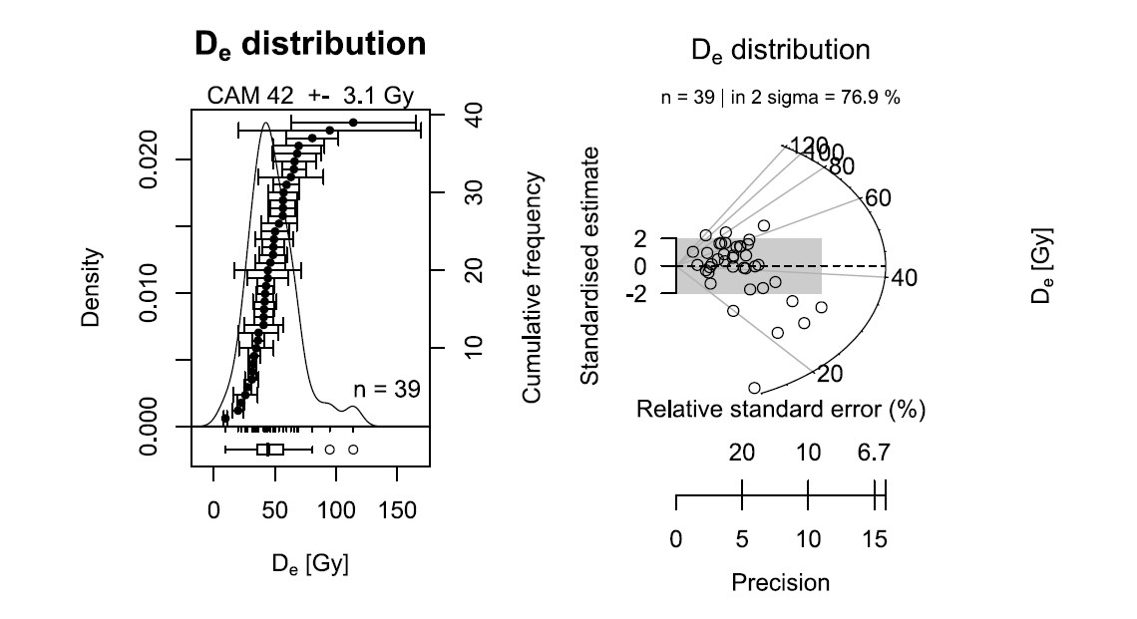
Figure S.1. Equivalent dose distribution for sample D3.2, Quartz OSL signal. A MAM model age with all points (n=40) yields a value of 24 ± 3 Gy (overdispersion used=19%). A CAM model (preferred) by not considering the highest DE point (i.e, with n=39, shown in plot) yields a value of 42 ± 3 Gy (overdispersion 40%).
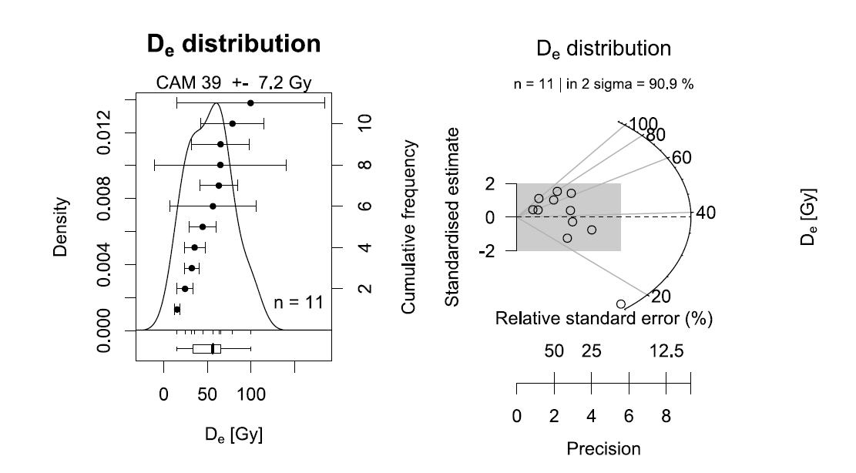
Figure S.2. Equivalent dose distribution for sample D3.1, Quarts OSL signal. A CAM model age with all points (n=11) yields a value of 39 ± 3 Gy. Overdispersion obtained=43%.

Statistical comparison between ALOS PALSAR & ASTER G-DEM DEMs and GNSS data
Table S.4: GNSS data and the respective ALOS PALSAR and ASTER G-DEM extracted elevation. The orthogonally transformation is also shown (EGM96 geoid).
date | time | north | east | Elevation m - ASE | EGM96 geoid (m) | vertical accuracy (m) | horizontal accuracy (m) | AP DEM elev (m) | ASTER G-DEM (m)
01/28/21 | 04:20:16pm | 4760447.7 | 689265.88 | 242.769 | 223.331 | 0.564 | 0.61 | 239 | 215
01/28/21 | 04:21:22pm | 4760460.9 | 689253.75 | 243.024 | 223.586 | 0.986 | 1.03 | 240 | 221
01/28/21 | 04:22:46pm | 4760468.8 | 689243.84 | 238.38 | 218.942 | 0.634 | 0.625 | 239 | 221
01/28/21 | 04:42:30pm | 4758686.6 | 689188.91 | 387.378 | 367.942 | 0.689 | 0.642 | 383 | 358
01/28/21 | 04:43:10pm | 4758693.8 | 689182.15 | 387.504 | 368.068 | 0.596 | 0.53 | 383 | 357
01/28/21 | 04:43:54pm | 4758703.4 | 689180.82 | 386.61 | 367.174 | 0.621 | 0.564 | 381 | 357
01/28/21 | 04:45:04pm | 4758704.8 | 689173.96 | 385.103 | 365.667 | 0.644 | 0.598 | 381 | 354
01/28/21 | 04:46:28pm | 4758730.1 | 689155.14 | 384.939 | 365.503 | 0.542 | 0.475 | 378 | 351
01/28/21 | 04:49:11pm | 4758760.2 | 689121.23 | 381.761 | 362.325 | 0.532 | 0.537 | 370 | 346
01/28/21 | 04:50:02pm | 4758756.4 | 689116.57 | 382.93 | 363.494 | 0.583 | 0.552 | 369 | 349
01/28/21 | 04:50:42pm | 4758755.9 | 689124.33 | 382.509 | 363.073 | 0.611 | 0.659 | 370 | 346
01/25/21 | 05:18:19pm | 4761880.8 | 694474.7 | 470.609 | 451.197 | 0.629 | 0.513 | 463 | 453
01/25/21 | 04:50:58pm | 4761983.4 | 694642 | 475.086 | 455.674 | 0.577 | 0.575 | 464 | 452
01/25/21 | 04:51:48pm | 4761997.8 | 694648.77 | 473.892 | 454.48 | 0.549 | 0.552 | 467 | 457
01/25/21 | 04:52:53pm | 4762016.1 | 694659.05 | 472.96 | 453.548 | 0.669 | 0.662 | 467 | 455
01/25/21 | 10:47:48am | 4762387.7 | 699018.05 | 620.008 | 600.612 | 0.794 | 0.623 | 611 | 590
01/25/21 | 10:48:30am | 4762392.6 | 699005.08 | 618.28 | 598.884 | 0.612 | 0.488 | 610 | 599
01/25/21 | 10:51:24am | 4762417.4 | 698962.37 | 617.973 | 598.577 | 0.632 | 0.464 | 607 | 603
01/25/21 | 10:59:32am | 4762419.9 | 698869.47 | 624.653 | 605.256 | 0.608 | 0.403 | 624 | 601
01/25/21 | 12:08:55pm | 4762431.3 | 699041.34 | 603.362 | 583.966 | 0.656 | 0.449 | 595 | 574
01/25/21 | 01:26:23pm | 4763308.7 | 699669.22 | 476.836 | 457.437 | 0.562 | 0.628 | 471 | 439
01/25/21 | 01:29:38pm | 4763333.7 | 699611.62 | 477.529 | 458.13 | 0.596 | 0.534 | 469 | 437
01/25/21 | 01:30:26pm | 4763334.6 | 699597.77 | 477.362 | 457.963 | 0.532 | 0.496 | 469 | 437
01/25/21 | 01:31:27pm | 4763336.3 | 699580.23 | 477.686 | 458.286 | 0.596 | 0.584 | 469 | 437
01/25/21 | 01:35:41pm | 4763261.2 | 699475.81 | 481.163 | 461.764 | 0.61 | 0.517 | 482 | 451
01/25/21 | 01:56:13pm | 4764395.6 | 700574.41 | 364.297 | 344.893 | 0.623 | 0.49 | 357 | 340
01/25/21 | 01:58:16pm | 4764344.8 | 700602.44 | 364.603 | 345.2 | 0.631 | 0.482 | 361 | 341
01/25/21 | 01:59:27pm | 4764337.8 | 700641.9 | 364.836 | 345.433 | 0.676 | 0.493 | 359 | 338
01/25/21 | 02:02:02pm | 4764286.2 | 700697.15 | 365.81 | 346.408 | 0.66 | 0.499 | 359 | 337
01/25/21 | 02:05:52pm | 4764245.6 | 700732.47 | 363.917 | 344.515 | 0.859 | 0.805 | 361 | 337
01/25/21 | 02:07:28pm | 4764232.2 | 700791.18 | 365.635 | 346.233 | 1.034 | 0.701 | 359 | 342
01/25/21 | 02:09:55pm | 4764278.6 | 700834.81 | 362.792 | 343.39 | 0.601 | 0.495 | 346 | 337
01/25/21 | 02:19:55pm | 4764338 | 700881.31 | 342.129 | 322.727 | 0.714 | 0.48 | 333 | 302
01/24/21 | 03:48:44pm | 4765069.9 | 709646.05 | 352.119 | 332.735 | 0.592 | 0.49 | 349 | 341
01/24/21 | 03:50:53pm | 4765077.4 | 709661.13 | 351.125 | 331.741 | 1.034 | 0.863 | 350 | 326
01/24/21 | 03:51:43pm | 4765094.3 | 709677.03 | 352.522 | 333.138 | 0.994 | 0.758 | 345 | 324
01/24/21 | 03:52:33pm | 4765100.6 | 709679.87 | 352.172 | 332.788 | 0.685 | 0.539 | 345 | 324
01/24/21 | 03:53:45pm | 4765133.5 | 709687.22 | 350.554 | 331.169 | 0.89 | 0.85 | 342 | 316
01/24/21 | 03:54:50pm | 4765170.7 | 709692.38 | 348.859 | 329.474 | 0.674 | 0.563 | 339 | 313
01/24/21 | 03:56:07pm | 4765206.1 | 709710.61 | 348.935 | 329.55 | 0.578 | 0.516 | 344 | 321
01/24/21 | 03:57:58pm | 4765258.6 | 709734.29 | 349.125 | 329.739 | 0.584 | 0.545 | 343 | 313
01/24/21 | 04:01:13pm | 4765302.6 | 709752 | 348.657 | 329.271 | 0.59 | 0.562 | 342 | 307
01/24/21 | 02:12:38pm | 4763405.6 | 710974.68 | 594.436 | 575.075 | 0.671 | 0.499 | 587 | 576
01/24/21 | 02:13:33pm | 4763397.5 | 710968.14 | 594.967 | 575.606 | 0.595 | 0.633 | 590 | 576
01/24/21 | 02:14:38pm | 4763378.2 | 710945.75 | 595.333 | 575.973 | 0.613 | 0.586 | 593 | 576
01/24/21 | 02:16:10pm | 4763371.5 | 710927.42 | 595.356 | 575.995 | 0.635 | 0.503 | 590 | 571
01/24/21 | 01:52:44pm | 4763518.7 | 710972.91 | 561.432 | 542.07 | 0.597 | 0.519 | 548 | 531
01/24/21 | 02:59:26pm | 4763730.5 | 710744.68 | 461.835 | 442.47 | 0.918 | 0.905 | 445 | 435
01/24/21 | 02:59:57pm | 4763732.8 | 710746.87 | 461.282 | 441.917 | 0.643 | 0.59 | 448 | 435
01/24/21 | 03:00:27pm | 4763734 | 710751.13 | 463.366 | 444.001 | 0.947 | 0.791 | 448 | 435
01/24/21 | 03:01:08pm | 4763727 | 710741.42 | 461.733 | 442.368 | 0.633 | 0.655 | 444 | 435
01/24/21 | 03:01:45pm | 4763723 | 710742.97 | 462.205 | 442.84 | 1.104 | 0.949 | 444 | 435
01/24/21 | 02:55:40pm | 4763758.1 | 710719.97 | 450.776 | 431.41 | 0.864 | 0.741 | 439 | 427
01/24/21 | 02:56:39pm | 4763760.2 | 710723.72 | 452.16 | 432.794 | 0.644 | 0.579 | 442 | 431
01/24/21 | 02:57:28pm | 4763756.9 | 710715.88 | 449.138 | 429.772 | 0.606 | 0.509 | 439 | 427
01/26/21 | 01:15:10pm | 4771923.9 | 720003.76 | 337.633 | 318.181 | 0.589 | 0.58 | 327 | 317
01/26/21 | 01:16:18pm | 4771946.8 | 719975.54 | 337.678 | 318.225 | 0.61 | 0.553 | 328 | 321
01/26/21 | 01:20:14pm | 4771983 | 719952.57 | 336.711 | 317.258 | 0.796 | 0.736 | 330 | 319
01/26/21 | 01:21:26pm | 4772003.2 | 719928.01 | 338.179 | 318.725 | 0.774 | 0.921 | 326 | 322
01/26/21 | 01:22:46pm | 4772034.2 | 719896.94 | 337.676 | 318.221 | 0.673 | 0.594 | 326 | 318
01/26/21 | 01:23:32pm | 4772044.1 | 719884.86 | 337.81 | 318.355 | 0.589 | 0.544 | 324 | 317
01/26/21 | 12:23:44pm | 4772080 | 720685.02 | 457.801 | 438.349 | 0.588 | 0.465 | 453 | 440
01/26/21 | 12:24:33pm | 4772096.8 | 720686.41 | 459.085 | 439.633 | 0.616 | 0.485 | 455 | 452
01/26/21 | 12:25:33pm | 4772112 | 720686.52 | 459.053 | 439.601 | 0.722 | 0.566 | 457 | 452
01/26/21 | 12:28:39pm | 4772149.1 | 720684.49 | 459.173 | 439.72 | 0.577 | 0.443 | 459 | 459
01/26/21 | 12:36:18pm | 4772171 | 720615.28 | 436.048 | 416.594 | 0.624 | 0.59 | 434 | 436
01/26/21 | 12:37:18pm | 4772155.8 | 720611.49 | 434.913 | 415.459 | 0.639 | 0.66 | 433 | 432
01/26/21 | 12:38:05pm | 4772135.9 | 720607.53 | 434.895 | 415.442 | 0.594 | 0.469 | 428 | 426
01/26/21 | 12:39:35pm | 4772111.1 | 720607.64 | 434.185 | 414.732 | 0.591 | 0.482 | 426 | 424
01/26/21 | 11:35:30am | 4772122.2 | 721063.83 | 570.527 | 551.077 | 0.702 | 0.524 | 568 | 546
01/26/21 | 11:37:50am | 4772184.7 | 721070.42 | 571.355 | 551.903 | 0.69 | 0.615 | 567 | 557
01/26/21 | 11:44:56am | 4772155.8 | 721143.97 | 583.357 | 563.906 | 0.651 | 0.404 | 580 | 575
01/26/21 | 11:46:57am | 4772135.9 | 721145.91 | 582.965 | 563.515 | 0.656 | 0.424 | 579 | 572
01/26/21 | 11:49:51am | 4772136.5 | 721189.52 | 591.089 | 571.639 | 0.617 | 0.407 | 591 | 582
01/26/21 | 11:50:59am | 4772121.8 | 721186.19 | 591.743 | 572.293 | 0.701 | 0.507 | 592 | 586
01/26/21 | 11:51:59am | 4772103.5 | 721182.95 | 591.406 | 571.957 | 0.661 | 0.424 | 589 | 581
01/26/21 | 11:14:28am | 4772285.8 | 720993.94 | 555.726 | 536.272 | 0.652 | 0.388 | 553 | 546
01/26/21 | 11:25:50am | 4772251.2 | 720994.82 | 553.929 | 534.475 | 0.711 | 0.405 | 551 | 552
01/26/21 | 11:27:05am | 4772226.6 | 720998.33 | 554.674 | 535.221 | 1.291 | 0.75 | 552 | 547
01/26/21 | 11:28:29am | 4772184.3 | 721004.85 | 554.121 | 534.669 | 0.663 | 0.45 | 548 | 543
01/26/21 | 11:30:41am | 4772134.3 | 721009.16 | 557.654 | 538.203 | 1.315 | 0.91 | 552 | 538
01/27/21 | 11:58:12am | 4761131.6 | 718921.39 | 308.422 | 289.143 | 0.612 | 0.444 | 303 | 283
01/27/21 | 11:59:08am | 4761135 | 718919.56 | 307.895 | 288.616 | 0.62 | 0.572 | 304 | 283
01/27/21 | 12:02:59pm | 4761150 | 718963.66 | 297.075 | 277.796 | 0.616 | 0.49 | 296 | 277
01/27/21 | 12:04:02pm | 4761147.8 | 718970.58 | 296.935 | 277.657 | 0.631 | 0.624 | 296 | 277
01/27/21 | 10:46:49am | 4761275.1 | 718659.49 | 343.214 | 323.931 | 0.626 | 0.505 | 335 | 322
01/27/21 | 10:49:14am | 4761304 | 718653.44 | 343.079 | 323.795 | 0.62 | 0.453 | 331 | 316
01/27/21 | 10:50:36am | 4761308.1 | 718646.44 | 342.297 | 323.013 | 0.609 | 0.425 | 331 | 321
01/27/21 | 11:48:12am | 4761063 | 718731.87 | 343.111 | 323.831 | 0.648 | 0.469 | 339 | 313
01/27/21 | 12:20:02pm | 4761185.9 | 719419.52 | 236.826 | 217.551 | 0.597 | 0.454 | 234 | 211
01/27/21 | 12:20:44pm | 4761197.1 | 719415.78 | 236.707 | 217.432 | 0.547 | 0.438 | 233 | 211
01/24/21 | 12:19:43pm | 4765099.6 | 708467.14 | 173.262 | 153.874 | 0.603 | 0.433 | 175 | 162
01/24/21 | 12:20:31pm | 4765099.7 | 708467.19 | 173.27 | 153.882 | 0.593 | 0.437 | 175 | 162
01/24/21 | 12:21:04pm | 4765099.7 | 708467.15 | 173.157 | 153.769 | 0.598 | 0.437 | 175 | 162
 |  |  |  |  |  | 0.678 | 0.568

Table S.5: Statistical parameters between GNSS and DEM elevation data.
 | GNSS / ALOS PALSAR | GNSS / ASTER G-DEM
Correlation coef. r | 0.999 | 0.997
r² | 0.998 | 0.993
Bias | -6.490 | -6.376
RMSE | 7.940 | 10.179

Figure S.3. Correlation diagram between GNSS and ALOS PALSAR DEM elevation data.

Figure S.4. Correlation diagram between GNSS and ASTER G-DEM elevation data.
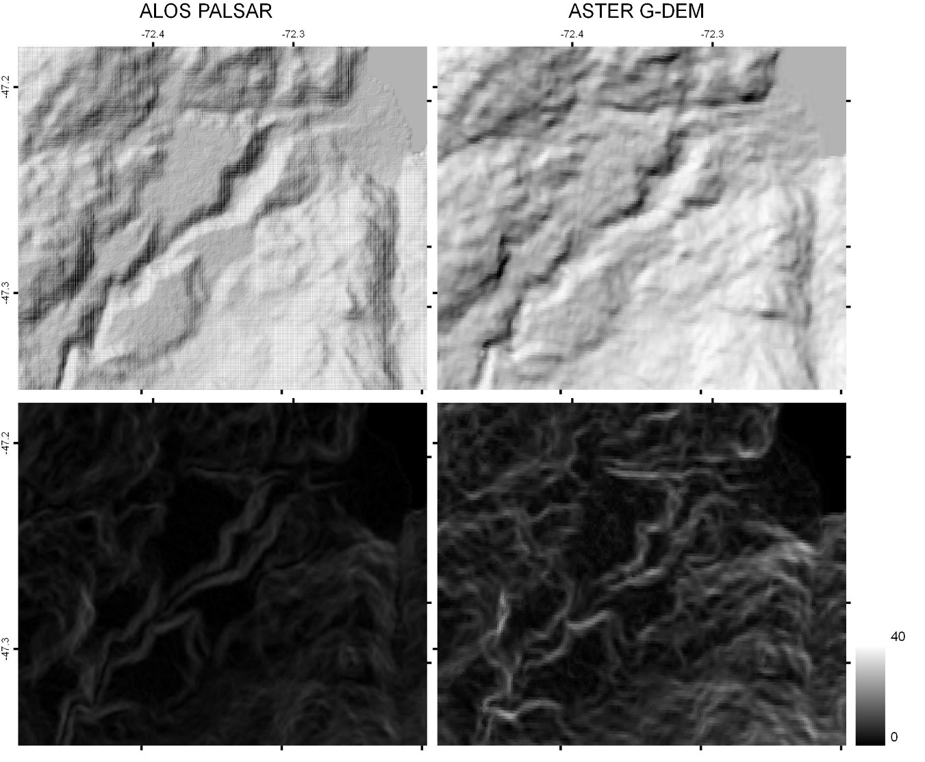
Figure S.5. Hillshade maps (top panels) and Terrain Ruggedness Index (TRI) (bottom panels) of ALOS PALSAR (left) and ASTER G-DEM (right) Dems in Dos Arroyos sector.
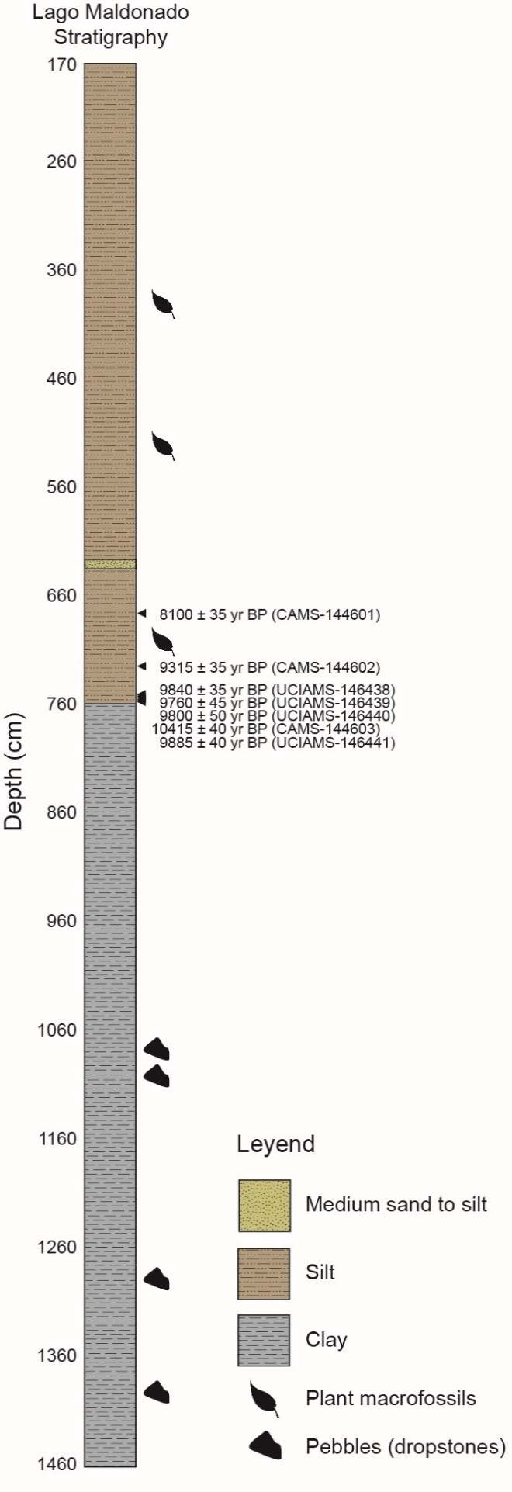
Figure S.6. Stratigraphic column of Lago Maldonado, Series PC0904A.

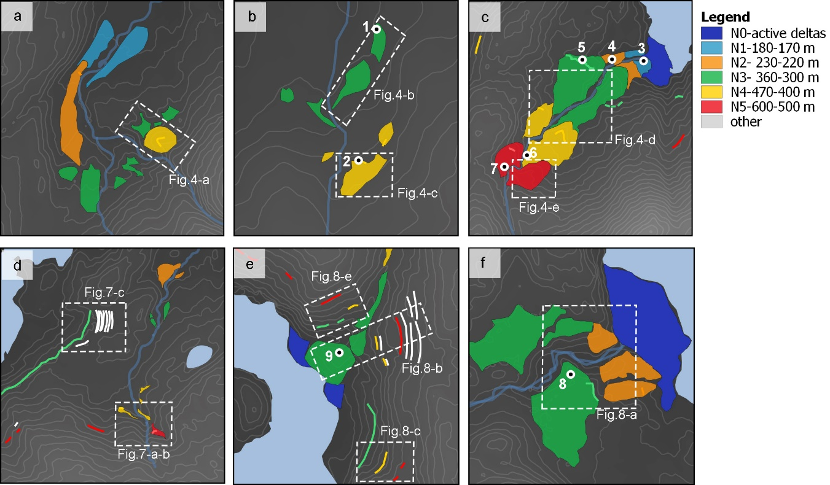
Figure S.7. Sectors with field-based GNSS measurements, descriptions, and sampling. Lines represent paleo-shorelines (beaches, wave-cut scarps and benches, delta brink-points) and polygons deltas. (a) La Ponderosa; (b) Frutillar; (c) Dos Arroyos; (d) Buena Vista; (e) Paso La Leona; (f) Río Brown. The location of these panels can be seen in Figure 3 in the main article.

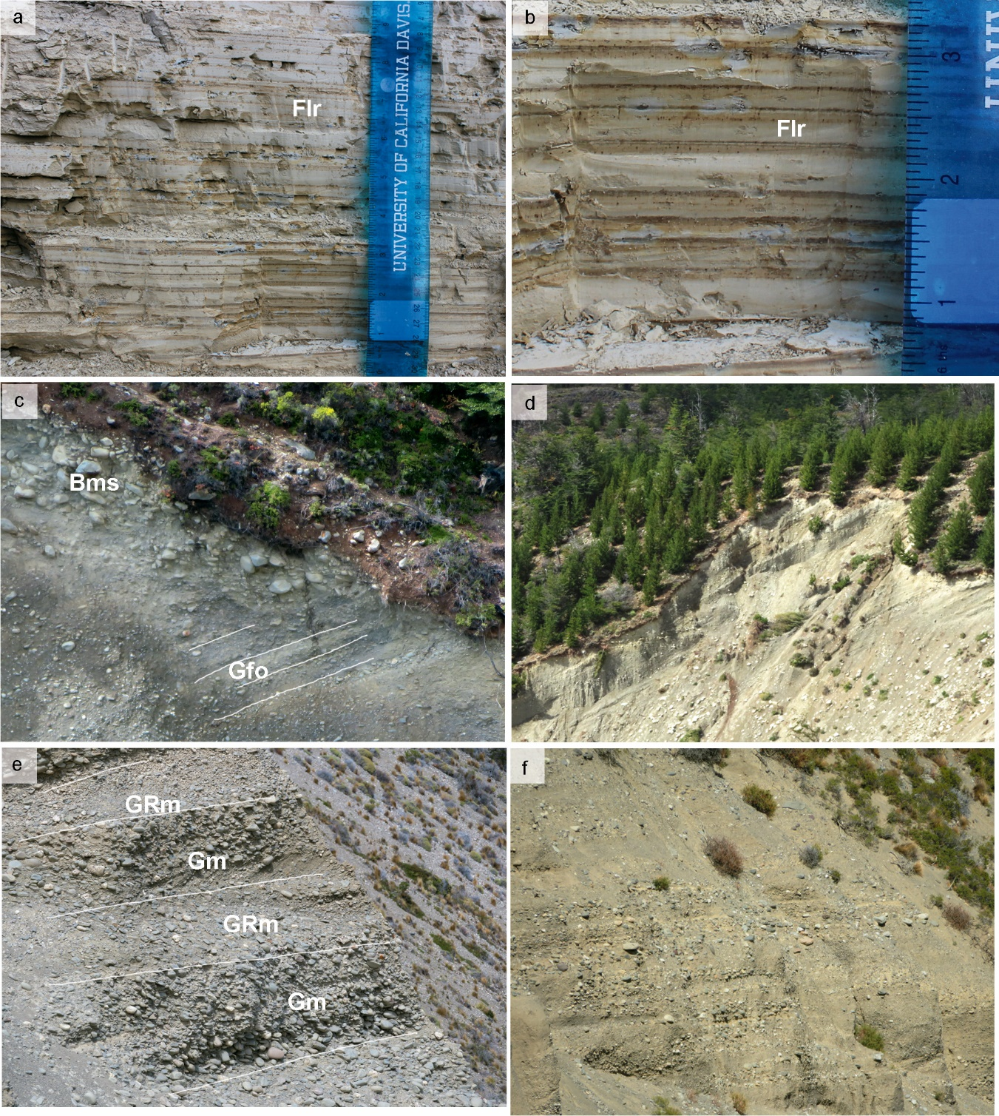
Figure S.8. (a) Delta topset and foreset on site 7. (b) Delta topset on site 10. (c) Delta topset on site 9. (d) Delta topset and foreset on site 8. (e and f) Rythmites near Río Cochrane (site 1). Bms, matrix-supported massive boulders; Flr: Finely laminated rhythmites.

