Supplementary figures to
Mercury in Sediment Core Samples from Deep Siberian Ice-Rich Permafrost
- Clara Rutkowski^{1,2}, Josefine Lenz^{1,3}, Andreas Lang², Juliane Wolter^{1,4}, Sibylle Mothes⁵, Thorsten Reemtsma⁵, Guido Grosse^{1,6}, Mathias Ulrich⁷, Matthias Fuchs¹, Lutz Schirrmeister¹, Alexander Fedorov⁸, Mikhail Grigoriev⁹, Hugues Lantuit^{1,6} and Jens Strauss¹*
¹Permafrost Research Section, Alfred Wegener Institute Helmholtz-Centre for Polar and Marine Research, Potsdam, Germany
²Department of Geography and Geology, Paris Lodron University Salzburg, Salzburg, Austria
³Water and Environmental Research Center, Institute of Northern Engineering, University of Alaska Fairbanks, Fairbanks, AK, United States
⁴Institute of Biochemistry and Biology, University of Potsdam, Potsdam, Germany
⁵Department of Analytical Chemistry, Helmholtz-Centre for Environmental Research – UFZ, Leipzig, Germany
⁶Institute of Geosciences, University of Potsdam, Potsdam, Germany
⁷Institute for Geography, Leipzig University, Leipzig, Germany
⁸Laboratory of Permafrost Landscapes, Melnikov Permafrost Institute Siberian Branch of the Russian Academy of Sciences, 677010 Yakutsk, Russia
⁹Laboratory of General Geocryology, Melnikov Permafrost Institute Siberian Branch of the Russian Academy of Sciences, 677010 Yakutsk, Russia
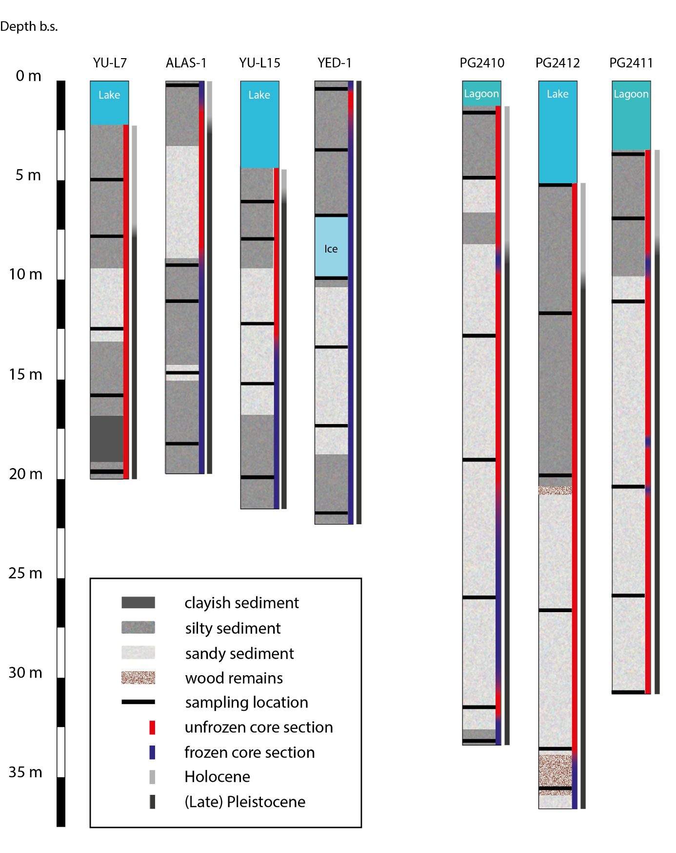
Figure A. Stratigraphic successions of the sediment cores investigated from Yukechi Alas and Bykovsky Peninsula.

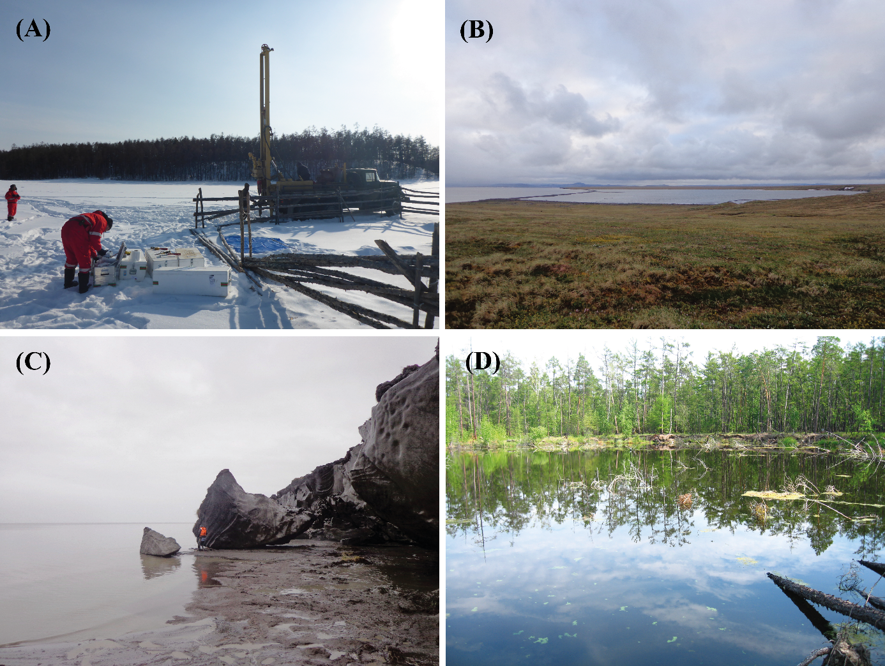
Figure B. (A) Drilling of the core Alas-1; (B) Uomullakh-Kyuel Lagoon; (C) degrading cliff on Bykovsky Peninsula; (D) Lake YU-L15 with degrading shoreline. Photos: M. Angelopoulos, Alfred Wegener Institute ((B) and (C)); M. Ulrich, Leipzig University ((A) and (D)).

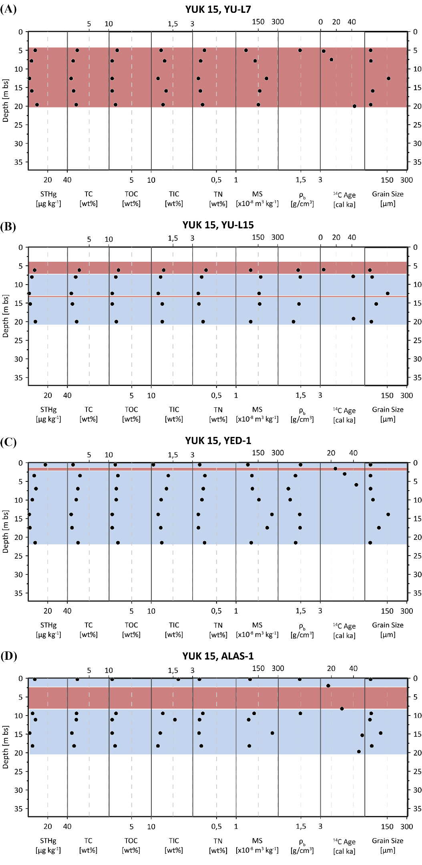
Figure C. Multiplots per core. (A) to (D) show all measured parameters in the cores of Central Yakutia (Yukechi Alas) and (E) to (G) from Northern Yakutia (Bykovsky Peninsula). Frozen core sections are shown in blue, unfrozen ones in red. STHg = soil total mercury; TC = total carbon; TOC = total organic carbon; TIC = total inorganic carbon; TN = total nitrogen; MS = magnetic susceptibility; ρ_{b} = bulk density of water saturated samples. Grain size is shown as mean after the Folk and Ward Method (Blott & Pye, 2001).

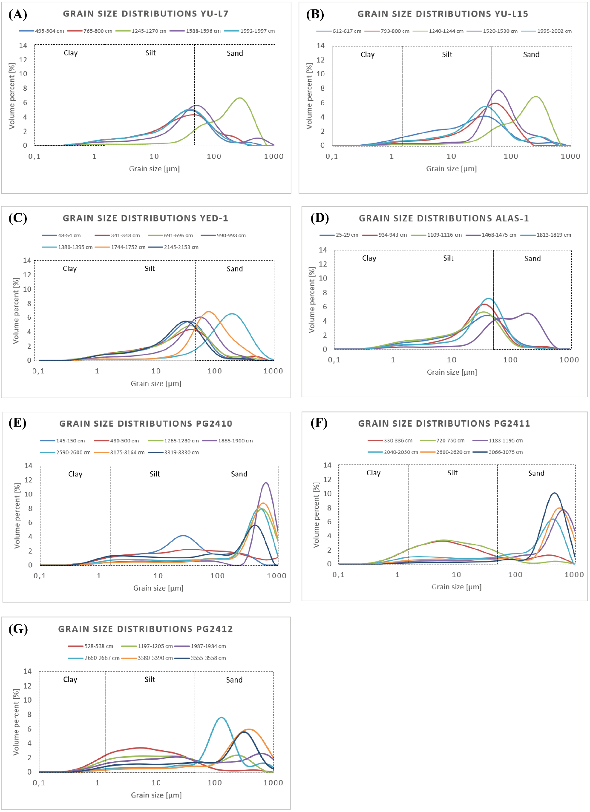
Figure D. Grain-size distributions < 1 mm in a logarithmic scale for all cores. (A) to (D) show the distributions of all samples from the Yukechi Alas and (E) to (G) from the Bykovsky Peninsular.

