Supplementary materials 1

Region | Crop | Median price survey data  (USD PPP/kg) | Price literature  (USD PPP/kg)
Nyando | maize | 0.71
 | beans | 1.25
 | sorghum | 0.57
 | sugarcane | 0.06
Rakai | maize | 1.54 | 0.80 | Own data, living income survey 2017, van de Ven et al., (2020)
 | maize | 1.54 | 0.80 | Own data, living income survey 2017, van de Ven et al., (2020)
 | beans | 3.17 | 2.01 | Own data, living income survey 2017, van de Ven et al., (2020)
 | beans | 3.17 | 2.01 | Own data, living income survey 2017, van de Ven et al., (2020)
 | irish potato | 1.43 | 0.80 | Own data, living income survey 2017, van de Ven et al., (2020)
 | irish potato | 1.43 | 0.80 | Own data, living income survey 2017, van de Ven et al., (2020)
 | banana | 0.27 | 0.16 | Own data (unpublished) and Wairegi and van Asten (2010)
 | cassava | 0.39
 | coffee | 0.80 | 1.61 | Calculated from https://ugandacoffee.go.ug/monthly-reports  ?field_month_year_value%5Bvalue%5D%5Byear%5D=2016
Lushoto | maize | 0.74
 | beans | 1.40
 | irish potato | 0.74
Crop prices derived from the survey and from literature. Prices in bold were used for the analysis

Supplementary materials 2
Yield figures for the most common crops in Nyando, Rakai and Lushoto. ¹Current survey yields were reported per year and could not be attributed to a season.
Site | crop | season | Yield figures (kg FW/ha) |  |  |  |  | Source and reasoning for current yields | Source and reasoning water-limited yield
 |  |  | Yw | 50% Yw | Current survey | Baseline literature | Soil supply
Nyando | maize | A | 11300 | 5650 | 661¹ | 2000 | 1000 | Yieldgap.org, Climate zone Kenya Kisii zone | Yieldgap.org, Climate zone Kenya Kisii zone
 | maize | B | 7458 | 3729 |  | 1320 | 660 | Season A times 0.66 based on relative yield in yield gap atlas for maize | Season A times 0.66 based on relative yield in yield gap atlas for maize
 | sugarcane | year | 79200 | 39600 | 17847¹ | 19000 | 9000 | Francis et al., 2020 | Francis et al., 2020
 | sorghum | A | 5000 | 2500 | 297¹ | 700 | 400 | Yieldgap.org, Climate zone Kenya (Code=7-4-01), Embu climate zone | SC Sila: https://www.seedcogroup.com/ke/products/sorghum/sc-sila-0
 | sorghum | B | 3300 | 1650 |  | 462 | 264 | Season A times 0.66 based on relative yield in yield gap atlas for maize | Season A times 0.66 based on relative yield in yield gap atlas for maize
 | beans | A | 2000 | 1000 | 149¹ | 400 | 300 | Ojiem et al., 2014, intercropping in maize, therefore also no fertiliser application | Estimate, in intercropping with maize
 | beans | B | 2000 | 1000 |  | 400 | 300 | Ojiem et al., 2014, intercropping in maize, therefore also no fertiliser application | Estimate, in intercropping with maize
 | kale | A | 19800 | 9900 |  | 4900 | 1000 | (KEPHIS, 2018; JICA report; Mogenia, 2020) | (KEPHIS, 2018; JICA report; Mogenia, 2020)
 | kale | B | 13100 | 6600 |  | 3200 | 700 | Estimate based on long rain yields and season yield differnces of maize | Estimate based on long rain yields and season yield differnces of maize
Rakai | maize | B | 6900 | 3450 | 404 | 1500 | 500 | Yield gap, expert judgement based on Yw and the fact that most farmers grow local or improved OPV's | Yield gap atlas Climate zone Uganda (Code=7-4-01) rainfed maize water-limited yield potential (Yw) : 6.9 tonnes / harvested ha.
 | maize | A | 4140 | 2070 | 395 | 1000 | 300 | Assumed based on yield gap atlas and a seasonal yield difference of 40% | Assumed based on yield gap atlas and a seasonal yield difference of 40%
 | banana | year | 11000 | 55000 | 5560 | 20000 | 10000 | Own data, unpublished; Wairegi et al 2016: Banana coffee cropping guide | Taulya, 2015, times two to account for two bunches per mat per year. In line with highest yields in field monitoring Marinus
 | coffee | year | 6000 | 3000 | 847 | 600 | 300 | Wairegi et al., 2016: Banana coffee cropping guide | Wairegi et al., 2016: Banana-coffee system cropping guide 2015 Revised Edition
 | beans | A | 3000 | 1500 | 411 | 700 | 300 | Estimate based on Nyando, pure stand | Estimate, pure stand
 | beans | B | 2000 | 1000 | 444 | 400 | 300 | Estimate based on Nyando, in intercropping with maize | Estimate, in intercropping with maize
 | cassava | year | 50000 | 25000 | 831 | 10000 | 6300 | Fermont et al., 2009 | Fermont et al., 2009, 50 ton in Uganda; Adiele, 2020, >90 ton but in Nigeria
 | irish potato | B | 40000 | 20000 | 1168 | 2700 | 1500 | Gov. statistics in Harahagazwe et al. 2016 | Highest yields in Harahagazwe et al. 2016
 | irish potato | A | 40000 | 20000 | 1261 | 2700 | 1500 | Gov. statistics in Harahagazwe et al. 2016 | Highest yields in Harahagazwe et al. 2016
 | tomato | A | 38400 | 19200 | 3864 | 7200 | 3000 | Everaards et al 2011; Msogoya et al 2016; Guijt and Reuver 2019 and corrected for seasonal yield differences | Yield estimate Rijk Zwaan Holland Greentech; Msogoya et al 2016 and corrected for seasonal yield differences
 | tomato | B | 64000 | 32000 | 3864 | 12000 | 5000 | Everaards et al., 2011; Msogoya et al 2016; Guijt and Reuver 2019 | Yield estimate Rijk Zwaan Holland Greentech; Msogoya et al 2016
Lushoto | maize | A | 7200 | 3600 | 785¹ | 1300 | 650 | MoALF, 2016, 2014/15 Annual Agricultural Sample Survey report | yield gap atlas, average of zone 7-5-01, 7-3-01, 7-2-01, 6-5-01, 7-4-01, 6-4-01
 | maize | B | 6300 | 3150 |  | 1130 | 650 | MoALF, 2016, 2014/15 Annual Agricultural Sample Survey report | yield gap atlas season A, using yield difference in current yields
 | beans | A | 3600 | 1800 | 354¹ | 500 | 300 | MoALF, 2016, 2014/15 Annual Agricultural Sample Survey report | Estimate, in intercropping with maize
 | beans | B | 3600 | 1800 |  | 500 | 300 | MoALF, 2016, 2014/15 Annual Agricultural Sample Survey report | Estimate, in intercropping with maize
 | irish potato | A | 40000 | 20000 | 2780¹ | 2700 | 1500 | MoALF, 2016, 2014/15 Annual Agricultural Sample Survey report | Highest yields in Harahagazwe et al.., 2016
 | cabbage | B | 42000 | 21000 | 9822¹ | 3000 | 1500 | MoALF, 2016, 2014/15 Annual Agricultural Sample Survey report | Seminis product catalogue 2008
 | cabbage | A | 70000 | 35000 |  | 5000 | 2500 | MoALF, 2016, 2014/15 Annual Agricultural Sample Survey report | Seminis product catalogue 2008

Supplementary materials 3
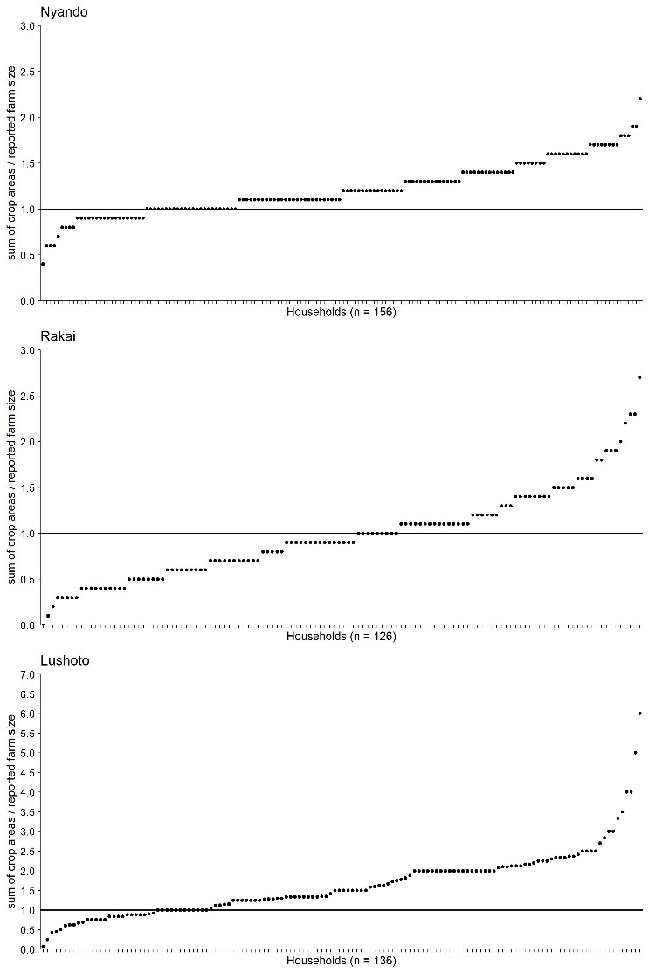
The sum of crop areas divided by the reported cultivated area for all households in the survey This fraction indicates whether the sum of crop areas is higher than, lower than, or equal to the total cultivated area.

Supplementary materials 4
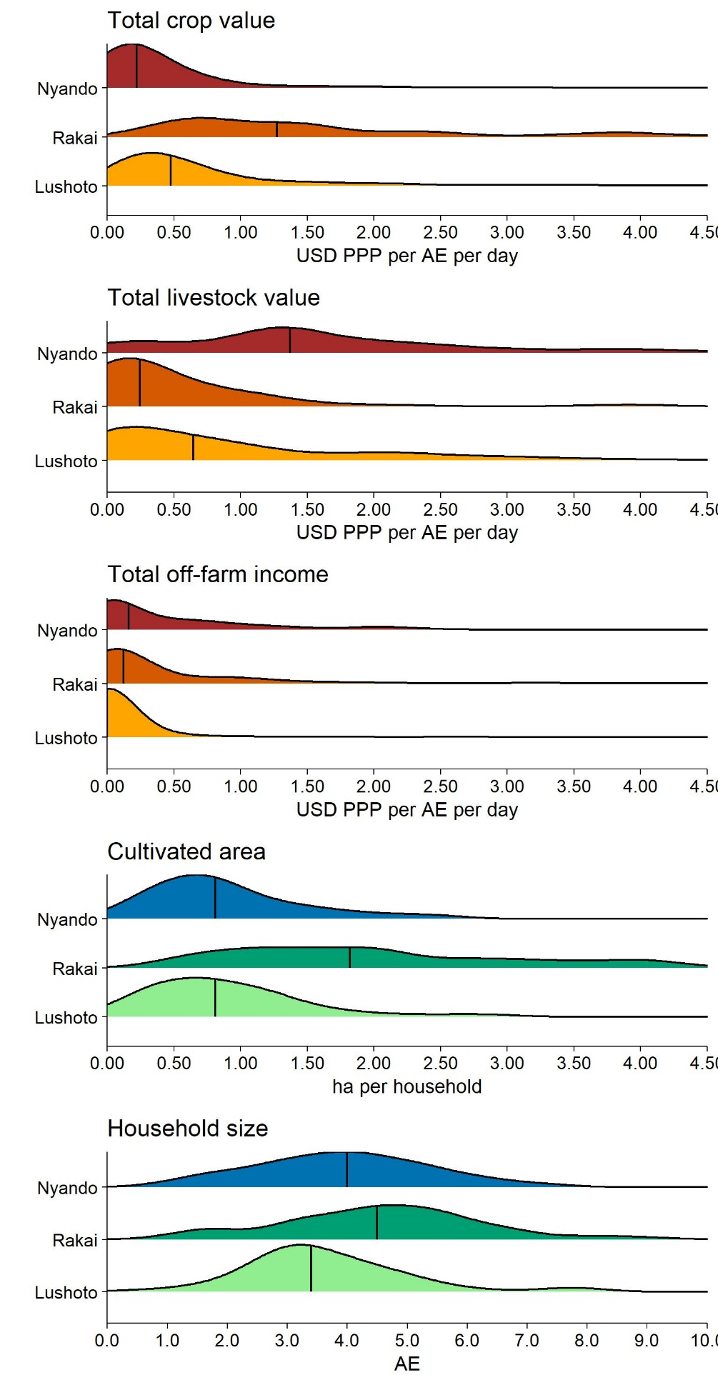
Probability density plots for total crop value produce, total livestock value produce, off-farm income, cultivated area and household size.

Supplementary materials 5
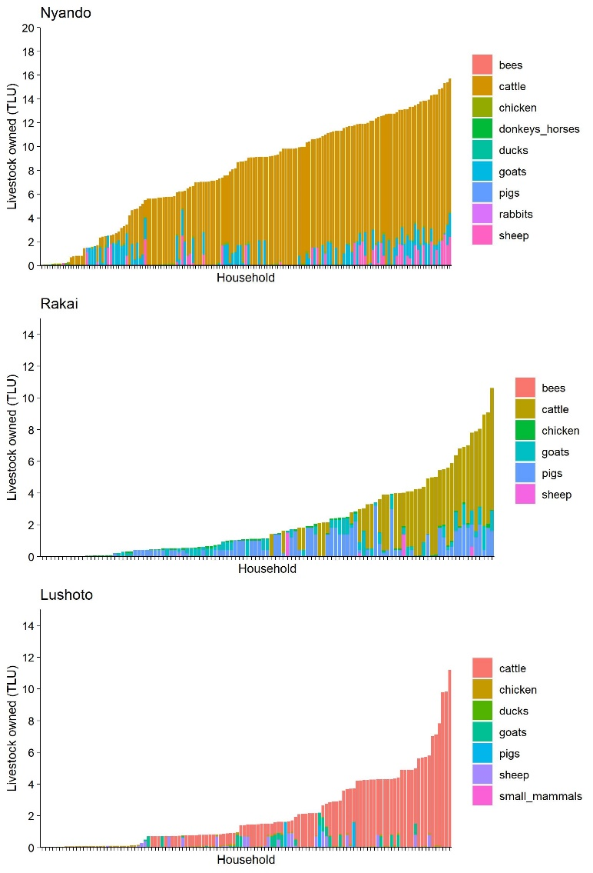
The distribution of livestock owned in Tropical Livestock Units (TLUs) per livestock type in each region.

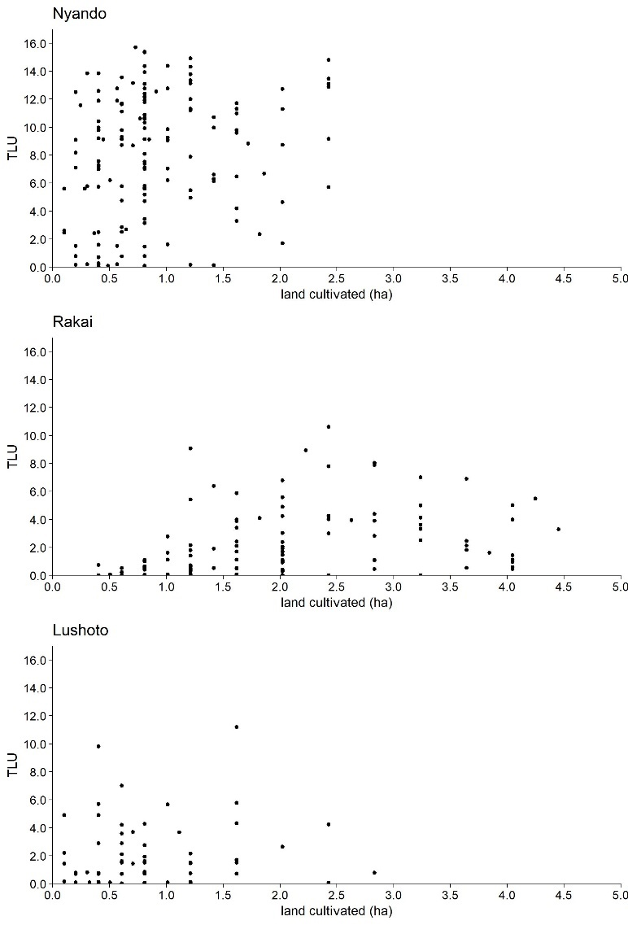
Supplementary materials 6
Current livestock holding in relation to cultivated area per household.

Supplementary materials 7
The input variables used to calculate how the different crops in a farm contribute to a living income in B1: baseline yields-scenario.
Region | Living Income (US$ PPP/AE/day) | Sustainable farm size (ha) | Household size (AE) | Crop | Price (US$ PPP/kg) | Proportion of cultivated area (-) | Season | Yield (kg/ha) | Value produce (US$ PPP/ha) | Crop area (ha) | Production (kg) | Crop value (US$PPP/ AE/day) | Crop value (% total income crop)
Nyando | 4.54 | 2.52 | 4.0 | maize | 0.71 | 0.70¹ | A | 2000 | 1412 | 1.77 | 3549 | 1.74 | 38
 |  |  |  | maize | 0.71 | 0.70¹ | B | 1320 | 932 | 1.77 | 2342 | 1.15 | 25
 |  |  |  | beans | 1.25 | 0.70¹ | A | 400 | 500 | 1.77 | 710 | 0.62 | 14
 |  |  |  | beans | 1.25 | 0.70¹ | B | 400 | 500 | 1.77 | 710 | 0.62 | 14
 |  |  |  | sorghum | 0.57 | 0.21 | A | 700 | 396 | 0.53 | 374 | 0.15 | 3
 |  |  |  | sorghum | 0.57 | 0.21 | B | 462 | 261 | 0.53 | 247 | 0.10 | 2
 |  |  |  | sugarcane | 0.06 | 0.08 | year | 19000 | 1229 | 0.21 | 4010 | 0.18 | 4
Rakai | 3.82 | 2.07 | 4.4 | maize | 0.80 | 0.23¹ | B | 1500 | 1207 | 0.47 | 700 | 0.35 | 9
 |  |  |  | beans | 2.01 | 0.22 | A | 700 | 1408 | 0.46 | 320 | 0.40 | 10
 |  |  |  | beans | 2.01 | 0.23¹ | B | 400 | 805 | 0.47 | 187 | 0.23 | 6
 |  |  |  | irish potato | 0.80 | 0.10 | A | 2700 | 2172 | 0.21 | 577 | 0.29 | 8
 |  |  |  | irish potato | 0.80 | 0.10 | B | 2700 | 2172 | 0.20 | 549 | 0.28 | 7
 |  |  |  | banana | 0.16 | 0.30 | year | 20000 | 3218 | 0.62 | 12469 | 1.25 | 33
 |  |  |  | cassava | 0.39 | 0.15 | year | 10000 | 3862 | 0.31 | 3067 | 0.74 | 19
 |  |  |  | coffee | 1.61 | 0.23 | year | 600 | 965 | 0.47 | 284 | 0.28 | 7
Lushoto | 4.04 | 1.58 | 3.3 | maize | 0.74 | 0.90¹ | A | 1300 | 960 | 1.43 | 1858 | 1.14 | 28
 |  |  |  | maize | 0.74 | 0.90¹ | B | 1130 | 835 | 1.43 | 1615 | 0.99 | 25
 |  |  |  | beans | 1.40 | 0.90¹ | A | 500 | 700 | 1.43 | 715 | 0.83 | 21
 |  |  |  | beans | 1.40 | 0.90¹ | B | 500 | 700 | 1.43 | 715 | 0.83 | 21
 |  |  |  | irish potato | 0.74 | 0.10 | A | 2700 | 1994 | 0.15 | 408 | 0.25 | 6
¹Maize and beans were assumed to be cultivated in intercropping in all three sites.

