Additional file 3
Elbow Plot of Fit Statistics Based on Latent Class Growth Analysis of Sedentary Behavior Change Trajectories
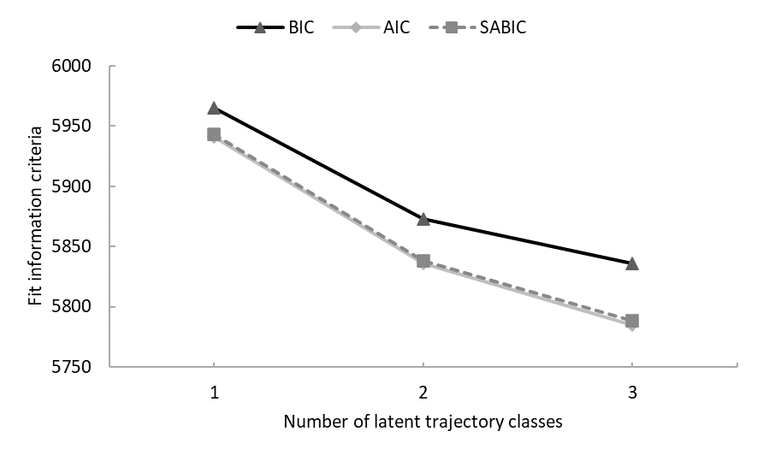
Note. The point at which the information criterion value becomes stable, even if more classes are added, is used as indication of the solution best fitting the data. AIC = Akaike’s information criterion; BIC = Bayesian information criterion; SABIC = sample size adjusted BIC.

