Electronic Supplementary Material for
Flexible group cohesion and coordination, but robust leader-follower roles, in a wild social primate using urban space
CONTENTS
Supplementary Methods 2
GPS accuracy and cleaning 2
Urban and natural spaces 2
Dominance ranks 3
GPS data used to investigate patterns of collective behaviour 3
Supplementary Tables 5
Table S1. 5
Table S2. 6
Table S3. 6
Supplementary Figures 7
Figure S1. 7
Figure S2. 8
Figure S3. 9
Figure S4. 10
Figure S5. 11
Figure S6. 12
Figure S7. 13
Figure S8. 14
Supplementary Video 15
Supplementary Data 16
Data frame S1. 16
Data frame S2. 16
Data frame S3. 16
Data frame S4. 16
Data frame S5. 16
Data frame S6. 16
Data frame S7. 16
Data frame S8. 16
Data frame S9. 17
Supplementary References 18

Supplementary Methods

GPS accuracy and cleaning
Ad hoc checks of the GPS data using known landmarks both at the field site in Cape Town and in Swansea, UK, indicated positional accuracy as within 5 m. However, some GPS error was observed, and data were processed to remove erroneous fixes (median 0.01% of the dataset, range 0.00% - 0.03%) and to linearly interpolate missing fixes under 10 s long (median 0.02% of the dataset, range 0.00 % - 0.07%), as described in Bracken et al. [1].

Urban and natural spaces
The group’s home range includes both urban and natural space (Fig. S1a). Urban space encompasses two residential suburbs: Da Gama, which is mostly lower/middle-income suburb with state housing for staff of the South African Navy, and Welcome Glen, a middle-income suburb with privately owned houses. The peri-urban and urban habitat provides an abundance of natural and exotic vegetation in addition to energy-rich food sources (such as bread, vegetables and bird seed, compost) from gardens, houses, bins and food waste [2-4]. The natural habitat is mostly within Table Mountain National Park and is dominated by indigenous fynbos vegetation with smaller patches of exotic vegetation [3, 5].
Using all GPS data (n = 13 individuals, representing 61% of adults in the group, over a mean ± S.D. of 42.77 ± 9.92 days, range = 21 - 54 days; see: Table S1 [1]), we defined the baboon groups 95% home range using fixed kernel densities and an ad hoc method for selecting the smoothing parameter, using the function “getvolumeUD” in the “adehabitat” package, R [6] (Fig S1a). Within the home range, we designated urban space as the area dominated by residential buildings and surfaced roads, and drew a polygon around this using QGIS [7]. All areas outside of this urban space were defined as natural space (Fig S1b). Natural space therefore represented 9.67 km² and 87 % of the home range, whilst urban space represented 0.77 km² and 13 % of the home range.
We calculated the times baboons spent in the natural and urban space using the function “getRecursionsInPolygon” using the Recurse package, R [8], labelling each recorded position for each baboon as either “urban” or “natural” (i.e. whether they were inside or outside the urban polygon).

Dominance ranks
Dominance ranks were calculated from direct observations of aggressive interactions (displacements, chases and aggressive displays), following the clear submission of one individual, collected ad libitum over 78 days of group follows. Female dominance rank was calculated from 634 interactions (median = 96, range 11 – 129) using the packages ‘AniDom’ and ‘Compete’ in R [9]. Male dominance rank was calculated from 75 interactions: M1 won 28 interactions (37%) and M2 won 16 interactions (21%), with 31 interactions undecided (41%), and therefore M1 was ranked first. Adult males outrank adult females in baboon troops [10, 11]. Ranks were standardised between 0 and 1 (with 0 being the lowest and 1 being the highest ranking individuals), using the function ‘rescale’ from the ‘scales’ package, R [12].

GPS data used to investigate patterns of collective behaviour
We used times when 10 or more collars were recording since we wanted to directly compare ‘whole group’ behaviour patterns, and because key features of the baboons’ spatial association networks remain stable where ten or more collars are analysed in natural space [1]. We used “daytime” hours, as this excluded the period after sunset when the baboons were returning/had returned to their sleep-site which tended to be located in urban space (36/39 days [1]; Fig. S1d). These criteria meant that we had an abundance of data for natural space – where the baboons are often seen as a whole group – but much less data for urban space, where baboons are more frequently alone or in small groups (Fig. S1b, [1]). For natural space, a mean ± SD of 384 ± 209 mins per day met the above criteria (Fig. S1c) and these occasions were approximately uniformly distributed throughout daytime hours (Fig. S1d). For urban space, a mean ± SD of 25 ± 27 mins per day met these criteria, occurring on 11 days (Fig. S1c) and at times that tended to be focussed in the early morning and afternoon (Fig. S1d). Given large differences in sample sizes between natural and urban space (48x more minutes for natural space), we used bootstrapping with repetition in all model comparisons of baboon behaviour in each habitat (see statistical analyses section).

Supplementary Tables
Table S1. Details of the GPS recording period for each collared adult baboon (F= female, M = male in column “Individual”). One collar (F1) collar was not retrieved after drop-off. Two GPS (F4 and F19) failed to record GPS data.
Collar | Individual | GPS Start | GPS End | Total duration (days)
1 | M1 | 30-07-2018 | 11-09-2018 | 44
2 | M2 | 30-07-2018 | 10-09-2018 | 43
3 | F1 | no data
4 | F2 | 25-07-2018 | 13-09-2018 | 50
5 | F4 | no data
6 | F5 | 26-07-2018 | 09-09-2018 | 46
7 | F6 | 26-07-2018 | 07-09-2018 | 44
8 | F7 | 26-07-2018 | 09-09-2018 | 46
9 | F9 | 26-07-2018 | 15-08-2018 | 21
10 | F10 | 30-07-2018 | 12-09-2018 | 45
11 | F13 | 02-08-2018 | 24-09-2018 | 54
12 | F14 | 02-08-2018 | 25-08-2018 | 24
13 | F15 | 26-07-2018 | 07-09-2018 | 44
14 | F17 | 02-08-2018 | 19-09-2018 | 49
15 | F18 | 26-07-2018 | 09-09-2018 | 46
16 | F19 | no data

Table S2. Results of a linear mixed effects model for the effect of area (urban, natural) on baboon eigenvector centrality in a leadership network, using different spatial thresholds. Significant values are in bold.
Spatial threshold | Estimate | SE | t | p
5 m | -0.167 | 0.031 | -5.322 | <0.001
10 m | -0.173 | 0.335 | -5.169 | <0.001
15 m | -0.115 | 0.037 | -3.129 | 0.009
20 m | -0.081 | 0.035 | -2.278 | 0.042
25 m | -0.077 | 0.036 | -2.16 | 0.052
30 m | -0.082 | 0.040 | -2.029 | 0.065
150 m | -0.229 | 0.091 | -2.510 | 0.027

Table S3. Spearman’s correlation coefficient and associated p-value for the relationship between baboon eigenvector centrality in a leadership network and baboon dominance rank, using different spatial thresholds, in both urban and natural areas. Significant values are in bold.
Spatial threshold | Urban | Natural
5 m | rho: 0.792  p = 0.001 | rho: 0.666  p = 0.013
10 m | rho: 0.801  p = 0.001 | rho: 0.429  p = 0.143
15 m | rho: 0.759  p = 0.003 | rho: 0.151  p = 0.623
20 m | rho: 0.597  p = 0.031 | rho: -0.008  p = 0.979
25 m | rho: 0.512  p = 0.074 | rho: -0.008  p = 0.979
30 m | rho: 0.391  p = 0.187 | rho: -0.085  p = 0.782
150 m | rho: 0.025  p = 0.936 | rho: 0.069  p = 0.823

Supplementary Figures
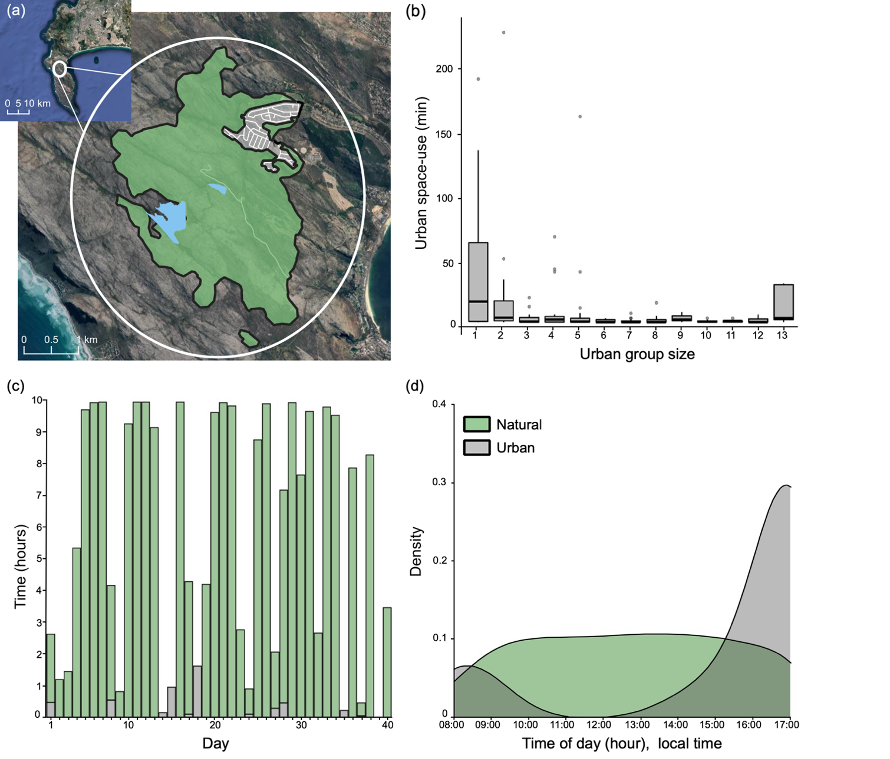
Figure S1. Study site and baboon space-use. (a, inset) Position of the baboon home range on the Cape Peninsula; (a, main) Da Gama group home range; (b) time spent (minutes) in urban space according to the number of baboons inside the urban space, i.e., ‘Urban group size’; (c) total time (hours) where 10+ baboon collars were recorded in urban and natural spaces grouped by observation day (1-40). These represent occasions where all 10 individuals were together in either natural or urban spaces, and therefore days with little or no data are a result of the group being split across areas for most or all of the day; (d) density of time spent by baboons in urban and natural spaces as a whole group (10+ active collars) across hours of the day. In (a, main), (c) and (d) natural spaces are in green and urban spaces in grey. In (a, main) dams are represented by blue areas and roads by white lines. In (b) boxplots indicate median, upper and lower quartiles, whiskers indicate inter-quartile ranges, and filled grey circles indicate outliers.
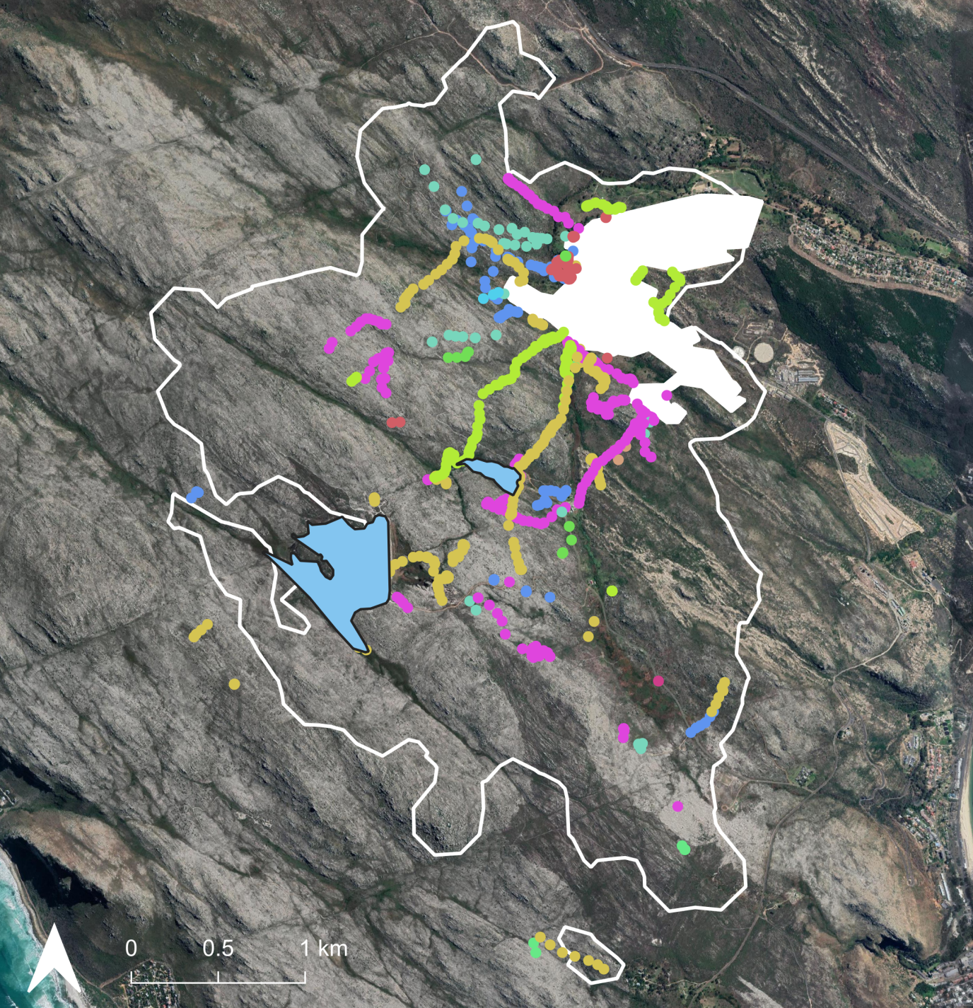
Figure S2. Instances of single baboons identified alone in 150m in natural space is largely due to individuals travelling to/returning from urban space. Individuals are represented by coloured dots. Baboon group home range is represented as a white outline, and the urban space as a solid white polygon. Dams are represented as light blue areas with a solid black outline.
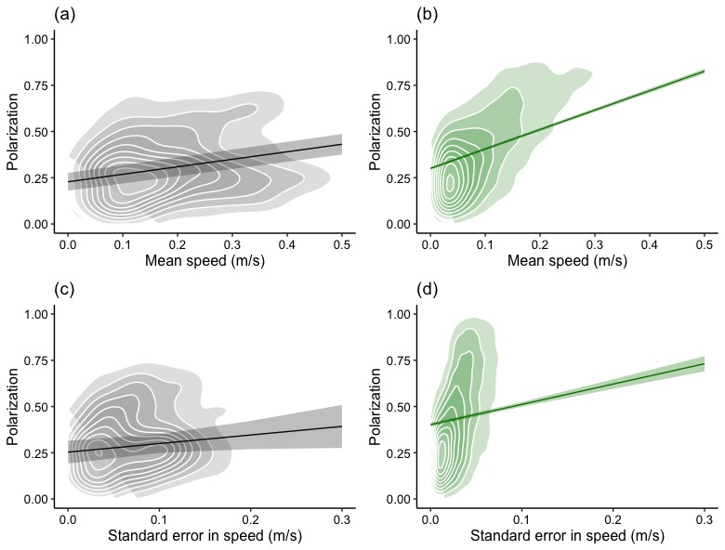
Figure S3. Reduced group coordination and synchrony in collective motion in urban space. Two-dimensional density plots of group polarization and mean group speed in (a) urban and (b) natural space; and group polarization and standard error in group speed in (c) urban and (d) natural space.

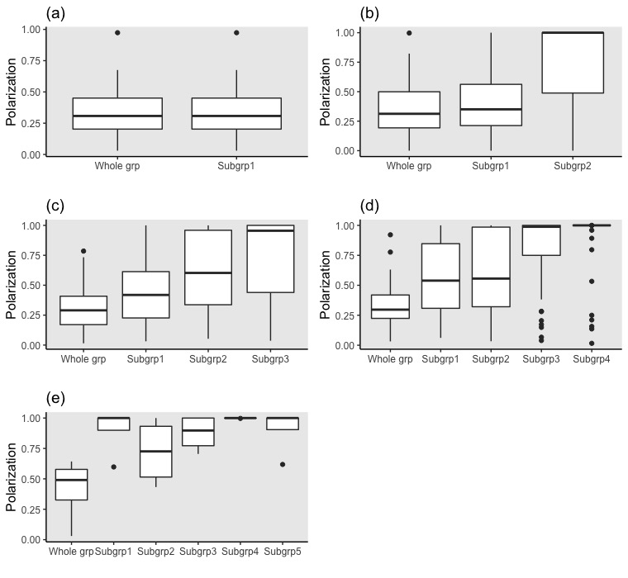
Figure S4. As the number of subgroups in the urban space increases, whole group polarization remains low, but polarization within subgroups increases. (a) Comparison of polarization between whole group and when one subgroup is present (i.e. when all individuals are in 150m of one another); n = 60 mins, group size mean ± SD: 11 ± 1; (b) Polarization between all individuals (“whole group”) when split into two subgroups, and the polarization within those subgroups; n = 59 mins, group size mean ± SD: 5 ± 4; (c) Polarization between all individuals (“whole group”) when split into three subgroups, and the polarization within those subgroups; n = 101 mins, group size mean ± SD: 4 ± 2; (d) Polarization between all individuals (“whole group”) when split into four subgroups, and the polarization within those subgroups; n = 57 mins, group size mean ± SD: 3 ± 2; (e) Polarization between all individuals (“whole group”) when split into five subgroups, and the polarization within those subgroups; n = 4 mins, group size mean ± SD: 2 ± 1. Where one individual is present in a subgroup, polarization = 1. Boxplots indicate median, upper and lower quartiles, whiskers indicate inter-quartile ranges, and filled grey circles indicate outliers.
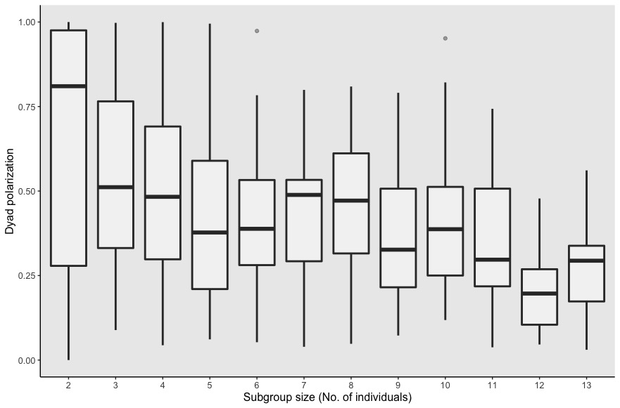
Figure S5. Polarization between baboon dyads, sampled from different subgroup sizes in urban space, using all data.

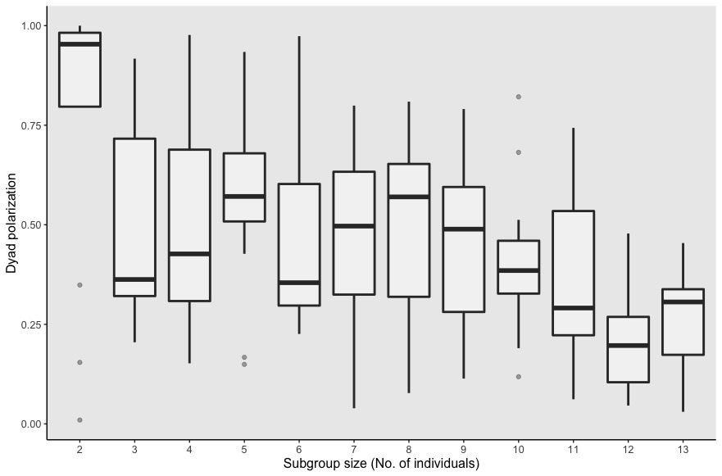
Figure S6. Polarization between baboon dyads, sampled from different subgroup sizes in urban space. Number of observations is equal across subgroups (each subgroup represents 13 observation minutes, which is the lowest number of minutes for any subgroup).

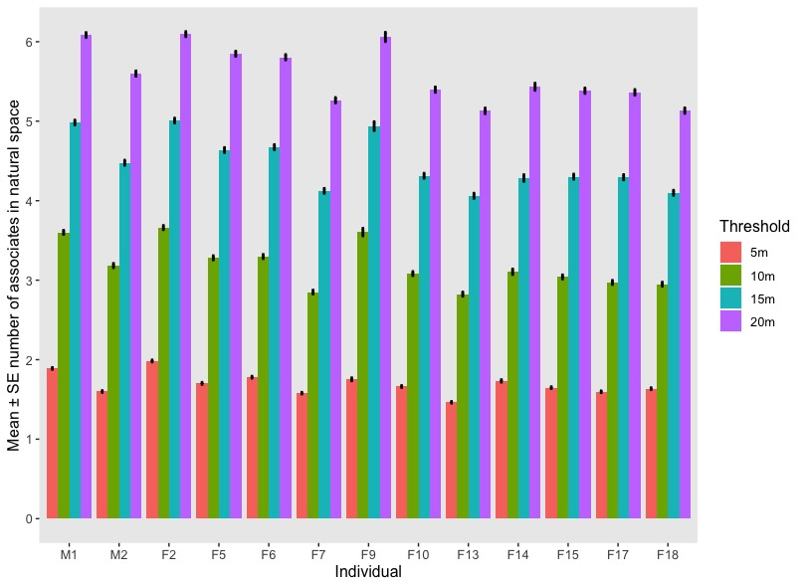
Figure S7. Average (mean) number of associates of each baboon (on x-axis: ordered high – low dominance rank from left – right) in natural space, within 4 distance thresholds (5, 10, 15 and 20 m). Standard error is represented by error bars.
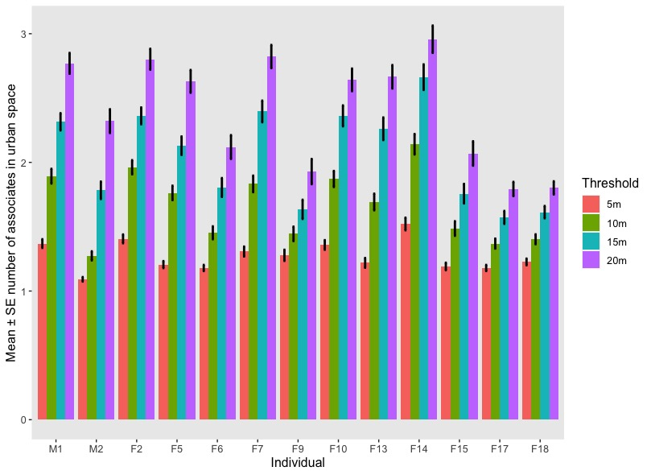
Figure S8. Average (mean) number of associates of each baboon (on x-axis: ordered high – low dominance rank from left – right) in urban space, within 4 distance thresholds (5, 10, 15 and 20 m). Standard error is represented by error bars.

Supplementary Video
Video S1. Baboon group movement in natural and urban spaces over 10 minutes, for n = 12 individuals. Points indicate individual baboons.

Supplementary Data
Data frame S1. Data frame used in generalised least squares model for the effect of space (urban, natural) on each of eleven collective parameters
Data frame S2. Data frame used in linear mixed model for effect of space (urban, natural) on network strength and eigenvector centrality in association networks and for Spearman’s correlation between association centrality and dominance rank in urban and natural areas
Data frame S3. Data frame used in linear mixed model for the effect of space (urban, natural) on eigenvector centrality in leadership networks and for Spearman’s correlation between leadership centrality and dominance rank in urban and natural areas, at spatial threshold of 5 m (used in main analyses)
Data frame S4. Data frame used in linear mixed model for the effect of space (urban, natural) on eigenvector centrality in leadership networks and for Spearman’s correlation between leadership centrality and dominance rank in urban and natural areas, at spatial threshold of 10 m (used in supplementary analyses)
Data frame S5. Data frame used in linear mixed model for the effect of space (urban, natural) on eigenvector centrality in leadership networks and for Spearman’s correlation between leadership centrality and dominance rank in urban and natural areas, at spatial threshold of 15 m (used in supplementary analyses)
Data frame S6. Data frame used in linear mixed model for the effect of space (urban, natural) on eigenvector centrality in leadership networks and for Spearman’s correlation between leadership centrality and dominance rank in urban and natural areas, at spatial threshold of 20 m (used in supplementary analyses)
Data frame S7. Data frame used in linear mixed model for the effect of space (urban, natural) on eigenvector centrality in leadership networks and for Spearman’s correlation between leadership centrality and dominance rank in urban and natural areas, at spatial threshold of 25 m (used in supplementary analyses)
Data frame S8. Data frame used in linear mixed model for the effect of space (urban, natural) on eigenvector centrality in leadership networks and for Spearman’s correlation between leadership centrality and dominance rank in urban and natural areas, at spatial threshold of 30 m (used in supplementary analyses)
Data frame S9. Data frame used in linear mixed model for the effect of space (urban, natural) on eigenvector centrality in leadership networks and for Spearman’s correlation between leadership centrality and dominance rank in urban and natural areas, at spatial threshold of 150 m (used in supplementary analyses)

Supplementary References
1. Bracken A.M., Christensen C., O’Riain M.J., Fehlmann G., Holton M.D., Hopkins P.W., Fürtbauer I., King A.J. 2021 Socioecology Explains Individual Variation in Urban Space Use in Response to Management in Cape Chacma Baboons (Papio ursinus). International Journal of Primatology, 1-18. (doi:https://doi.org/10.1007/s10764-021-00247-x).
2. Fehlmann G., O'Riain M.J., Kerr-Smith C., Hailes S., Luckman A., Shepard E.L.C., King A.J. 2017 Extreme behavioural shifts by baboons exploiting risky, resource-rich, human-modified environments. Scientific Reports 7(1), 15057. (doi:https://doi.org/10.1038/s41598-017-14871-2).
3. Hoffman T.S. 2011 The spatial ecology of chacma baboons (Papio ursinus) in the Cape Peninusula, South Africa: towards improved management and conservation strategies [Doctoral thesis], University of Cape Town.
4. Johnson C.A., Raubenheimer D., Rothman J.M., Clarke D., Swedell L. 2013 30 days in the life: daily nutrient balancing in a wild chacma baboon. Plos One 8(7), e70383. (doi:https://doi.org/10.1371/journal.pone.0070383).
5. van Doorn A.C., O'Riain M.J. 2020 Nonlethal management of baboons on the urban edge of a large metropole. American Journal of Primatology, e23164. (doi:https://doi.org/10.1002/ajp.23164).
6. Calenge C. 2006 The package “adehabitat” for the R software: a tool for the analysis of space and habitat use by animals. Ecological Modelling 197(3-4), 516-519. (doi:https://doi.org/10.1016/j.ecolmodel.2006.03.017).
7. QGIS.org. 2020 QGIS Geographic Information System. Open Source Geospatial Foundation Project. (http://qgis.osgeo.org.
8. Bracis C., Bildstein K.L., Mueller T. 2018 Revisitation analysis uncovers spatio‐temporal patterns in animal movement data. Ecography 41(11), 1801-1811. (doi:https://doi.org/10.1111/ecog.03618).
9. Sánchez‐Tójar A., Schroeder J., Farine D.R. 2018 A practical guide for inferring reliable dominance hierarchies and estimating their uncertainty. Journal of Animal Ecology 87(3), 594-608. (doi:https://doi.org/10.1111/1365-2656.12776).
10. Engh A.L., Hoffmeier R.R., Seyfarth R.M., Cheney D.L. 2009 O brother, where art thou? The varying influence of older siblings in rank acquisition by female baboons. Behavioral Ecology and Sociobiology 64(1), 97-104. (doi:https://doi.org/10.1007/s00265-009-0824-4).
11. Kitchen D.M., Beehner J.C., Bergman T.J., Cheney D.L., Crockford C., Engh A.L., Fischer J., Seyfarth R.M., Wittig R. 2009 The causes and consequences of male aggression directed at female chacma baboons. In Sexual coercion in primates and humans: An evolutionary perspective on male aggression against females (eds. Muller M.N., Wrangham R.W.), pp. 128-156. Cambridge, MA: Harvard University Press.
12. Wickham H. 2014 Package 'scales'. Scale functions for visualization. (https://cran.r-project.org/web/packages/scales/scales.pdf.

