Year-Round Dive Characteristics of Male Beluga Whales from the Eastern Beaufort Sea Population Indicate Seasonal Shifts in Foraging Strategies

Supplementary Material 2: Dive Characterization and Classification Methods

Luke Storrie^{1,2}*, Nigel E. Hussey³, Shannon A. MacPhee², Greg O’Corry-Crowe⁴, John Iacozza¹, David G. Barber¹, Alex Nunes⁵ and Lisa L. Loseto^{1,2}

¹ Centre for Earth Observation Science, Department of Environment and Geography, The University of Manitoba, Winnipeg, MB, Canada
² Freshwater Institute, Fisheries and Oceans Canada, Winnipeg, MB, Canada
³ Department of Integrative Biology, University of Windsor, Windsor, ON, Canada
⁴ Harbor Branch Oceanographic Institute, Florida Atlantic University, Fort Pierce, FL, United States
⁵ Ocean Tracking Network, Dalhousie University, Halifax, NS, Canada

*Correspondence:
Luke Storrie
storriel@myumanitoba.ca

List of figures and tables
Figures
Figure S2a: Example of DRange and ‘surface’ depths . 3
Figure S2b: Representation of dive phase identification in divebomb. 5
Figure S2c: Limitations of using a 75 s sample frequency in divebomb 6
Figure S2d: Upsampling to 15 s for divebomb 6
Figure S2e: Determining appropriate ‘at depth threshold’, example for shallow dives 7
Figure S2f: Determining appropriate ‘at depth threshold’, example for deeper dives. 7
Figure S2g: Example of upsampling to 1 s for divebomb. 8
Figure S2h: Examples of Deep Benthic type dive profiles characterized in divebomb. 18
Figure S2i: Examples of Deep Pelagic V type dive profiles characterized in divebomb 19
Figure S2j: Examples of Deep Pelagic W type dive profiles characterized in divebomb. 19
Figure S2k: Examples of Deep Pelagic Skew type dive profiles characterized in divebomb. 20
Figure S2l: Examples of Intermediate Benthic type dive profiles characterized in divebomb. 20
Figure S2m: Examples of Intermediate Pelagic type dive profiles characterized in divebomb 21
Figure S2n: Examples of Shallow V type dive profiles characterized in divebomb. 21
Figure S2o: Examples of Shallow W type dive profiles characterized in divebomb 22
Figure S2p: Examples of dive profiles which may not be well represented by the typical phases of descent, bottom, and ascent, characterized in divebomb. 23

Tables
Table S2a: Eigenvalues and cumulative proportion of the variance explained by the ten principal components for the dive classes prior to hierarchical clustering analyses. 11
Table S2b: Principal component loadings for the dive parameters of the Deep Pelagic class. 12
Table S2c: Principal component loadings for the dive parameters of the Deep Benthic class. 12
Table S2d: Principal component loadings for the dive parameters of the Intermediate Pelagic class. 13
Table S2e: Principal component loadings for the dive parameters of the Intermediate Benthic class. 13
Table S2f: Principal component loadings for the dive parameters of the Shallow class. 14
Table S2g: Varimax rotated principal component loadings for the dive parameters of the Deep Pelagic class. 14
Table S2h: Varimax rotated principal component loadings for the dive parameters of the Deep Benthic class. 15
Table S2i: Varimax rotated principal component loadings for the dive parameters of the Intermediate Pelagic class. 15
Table S2j: Varimax rotated principal component loadings for the dive parameters of the Intermediate Benthic class. 16
Table S2k: Varimax rotated principal component loadings for the dive parameters of the Shallow class. 16
Table S2l: Jaccard’s similarity scores for cluster solutions of the dive categories. Bold scores denote a stable cluster solution (Jaccard’s similarity score ≥ 0.7). 17

1. Overview
This document contains all supplementary information pertaining to depth error and surface correction (Figure S2a); divebomb functioning and appropriate selection of parameters (Figure S2b - Figure S2g); dive classification procedures; principal component scores and loadings on varimax-rotated factors used in hierarchical clustering analyses (Table S2a - Table S2k); and Jaccard’s similarity scores for different cluster solutions within each dive category (Table S2l).
A sample dataset (depth_data.csv) and an example script for isolating and characterizing dives from time series data in Python is provided in Section 3.5.
Examples of dive profiles isolated and characterized in divebomb are provided for each of the subsequently classified dive types (Figure S2h - Figure S2o), and some examples are given for dives which could arguably be characterized and classified differently (Figure S2p).

2. Depth error and surface correction
The depth sensor had a resolution of ± 0.5 m, however depths recorded in time-series data may be incorrect due to drift in the pressure transducer over time, compression of data, or instrument resolution. A typical first step in identifying dives from time-series data is to zero-offset correct the depths (e.g. Luque & Fried 2011). This is important in isolating dives based on the surface interval between them. A surface threshold of 5 m was used here (see section 3.3 of this document), meaning that any depths greater than 5 m could constitute a dive. The Wildlife Computers (WC) tags used in this study use the wet/dry sensor to correct the drift in the pressure transducer (https://static.wildlifecomputers.com/manuals/MK10-User-Guide.pdf, accessed 25.05.21), however, the tags scale the depth resolution in each hourly message of time-series data by the range of depths encoded in that message for transmission (personal communication Matthew Rutishauser, WC), and this is represented by the resolution given as ‘DRange’. This means that successive hours of time-series data may have large differences in the depths representative of surfacing events (Figure S2a). The method of smoothing and filtering the data used in a number of studies (e.g. Luque & Fried 2011), was deemed insufficient to resolve the surface depths in our study, especially in cases where successive hours had large differences in the range of depths recorded, or when a deep dive crossed two hourly messages (Figure S2a). Examination of the data revealed that the incorrect surface depths all had maximum depths ≤ 12 m, and these depths all had a DRange greater than half the value of the depth (thus error overlapped with the 5 m surface threshold used here). Hence, these depths were reassigned a depth of 0.5 m, which was representative of the typical measurement of the ‘surface’ depth under optimal conditions.

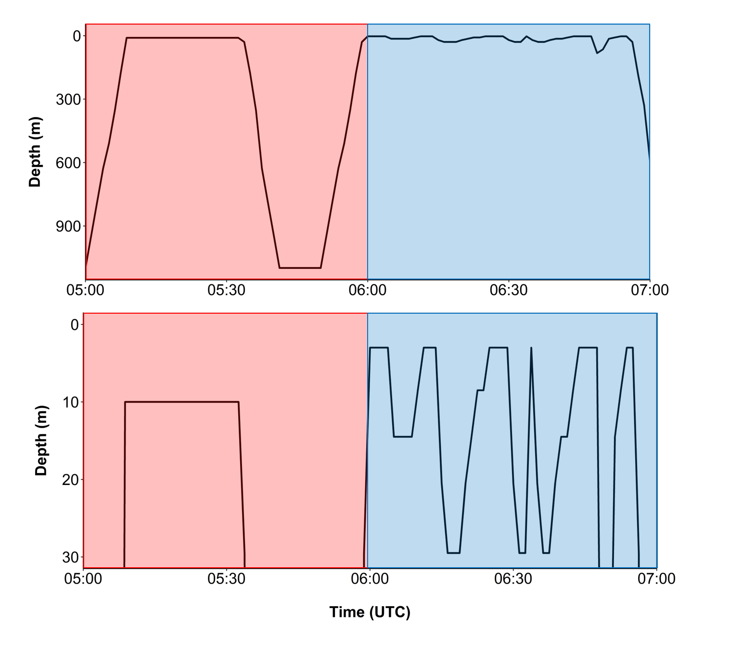
Figure S2a: Time-depth profile over a two hour period (i.e. two data messages) for beluga LC2018#2. The red box denotes an hour of time-series data where the maximum depth recorded was 1099 m, and the surface depth was recorded as 10 m, with a DRange of 10 m. The blue box denotes the following hour of time-series data where the maximum depth recorded was 329.5 m, and the surface depth was recorded as 3 m (DRange = 3 m). Both upper and lower panels show the same time-series depth data, but with different scales on the y-axis.

3. Divebomb functioning
Divebomb (v1.1.2, Nunes 2019) requires four parameters to be set by the user, however, they depend on the nature of the dataset including maximum depths reached, variation in depth during a single dive, sampling frequency of the data, and the surface threshold of interest / possible from the data. The final parameters used in this study were selected after multiple runs of divebomb, checking a large number of dives visually after each run, and working with its creator. We recommend trialing various parameters on a small number of dives of different structures (i.e. maximum depth, and whether there are inflection points during the bottom, descent and ascent phases), to optimize parameterization of dives. We also recommend undertaking interpolation to upsample moderate frequency (here 75 s interpolated to 15 s) data. We have outlined below some of the key points to consider and justification for the decisions that were made in divebomb. It is important to note that these decisions were based on the dive behaviour of an animal which surfaces between dive events (‘Dive’ class in divebomb); divebomb also has settings for analyzing dives in infrequently surfacing animals (‘DeepDive’ class).
Divebomb identifies dives and the phases of each dive based on a ‘surface threshold’, an ‘at depth threshold’, ‘dive detection sensitivity’, ‘minimal time between dives’, and the rate of change in depth. We undertook various trials with these settings, and found that ‘dive detection sensitivity’ and ‘minimal time between dives’ had no effect on the identification and characterization of dives. In the final run, ‘dive detection sensitivity’ was set to 0.98, which is the recommended default for regularly surfacing animals; and ‘minimal time between dives’ was set to 0 s. ‘Dive detection sensitivity’ and ‘minimal time between dives’ are not discussed here as they are more important when analyzing dive behavior of infrequently surfacing animals such as sharks (‘DeepDive’ class), where there is no set ‘surface threshold’ between dives.
The functioning of divebomb for frequently surfacing animals (‘Dive’ class) based on the ‘surface threshold’, ‘at depth threshold’, and the rate of change in depth are shown in Figure S2b.

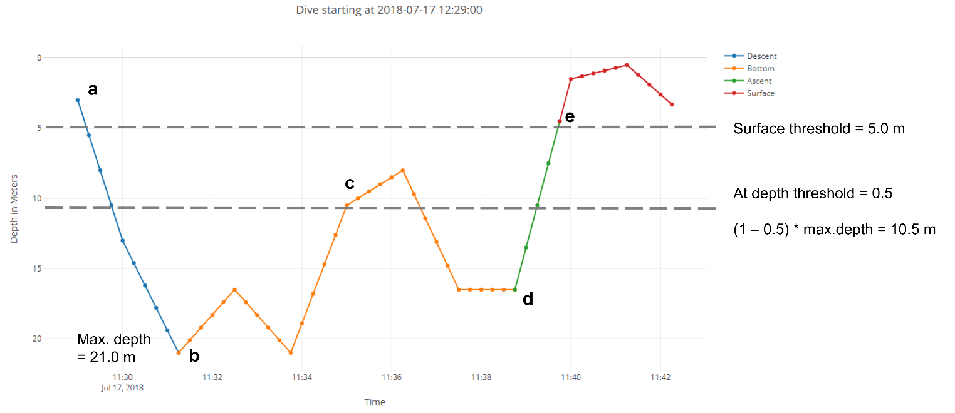
Figure S2b: Example of a dive identified in divebomb and plotted using Plotly in Jupyter notebook. Depths shown interpolated to 15 s from 75 s data (see section 3.1 below). In this dive the ‘surface threshold’ was set at 5.0 m and the ‘at depth threshold’ set at 0.5. The ‘at depth threshold’ of 0.5 gives a an ‘at depth threshold’ depth of 10.5 for the dive shown which has a maximum depth of 21.0 m ((1-0.5) * 21.0 = 10.5).
- The descent phase starts when the surface threshold is passed, and then back tracks one data point (i.e. 15 s) (although see section 3.3 in this document for consideration of sampling frequency in relation to the surface threshold).
- The bottom phase starts when rate of change in depth becomes zero or negative, and the depth calculated from the ‘at depth threshold’ is passed.
- The bottom phase continues here as although there is a negative rate of change in depth and the depth is less than the ‘at depth threshold’, successive depths are below the ‘at depth threshold’ before the animal crosses the ‘surface threshold’ again.
- The ascent phase starts once there is a negative rate of change in depth and there are no subsequent periods with a positive rate of change in depth that reach below the ‘at depth threshold’ depth.
- The surface phase begins once the ‘surface threshold’ has been passed.

3.1 Interpolating time-series data
Currently, divebomb requires each dive to have unique time-depth points representative of descent, ascent, and surface phases; each of which can only be represented in a single dive. On occasions where short dives were recorded in the 75 s frequency time-series data, for example two successive dives with only a single depth point representing surface (Figure S2c), the ascent or bottom phase would be missed from the first dive at the 75 s sampling rate. To solve this, data was upsampled by linear interpolation to 25 s, 15 s, 5 s, and 1 s, and outputs were explored to address this point. Upsampling to 15 s produced dives with the most appropriate characterization given the surface threshold, so this value was used in the presented analyses (Figure S2d). See section 3.3 of this document for information regarding why upsampling to 1 s was inappropriate for the present study.
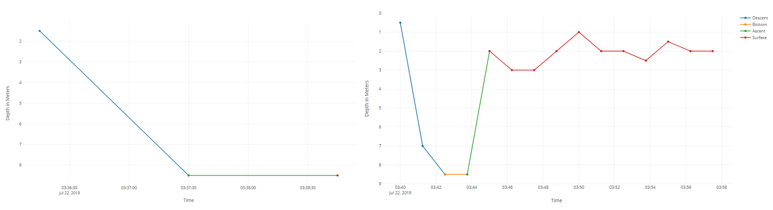
Figure S2c: A sequence of two dives using time-depth data at 75 s intervals where the bottom phase is modeled as ascent, and there is no visible true ascent phase. This is due to the single point at the surface being used in the second dive, so there is no surface data point to register the end (surface) of the first dive.
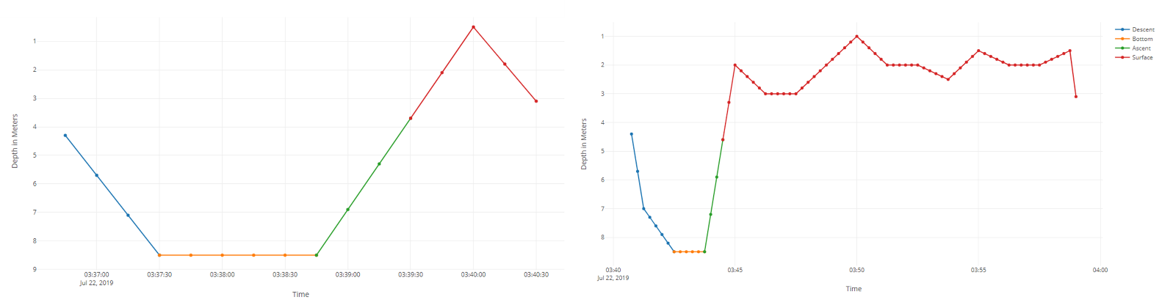
Figure S2d: The same two sequential dives from Figure S2c, but using time-depth data interpolated to 15 s frequency. Both have all phases correctly modeled in relation to the ‘surface threshold’.
Furthermore, in its current state, divebomb (v1.1.2) misses out the interval represented by the final time-depth point in a dive (for example see Figure S2d; the surface period of the first dive ends at 03:40:30, and the descent phase of the second dive starts at 03:40:45). This has less of an effect in high frequency (e.g. 1 s) data, but can skew the results in the case of lower frequency sampled data, i.e. satellite-transmitted time-series depth data. Hence in the present study 15 s was added to the post-dive surface interval for each dive.

3.2 At depth threshold
The at depth threshold determines what relative depths can be considered as the bottom phase of the dive. Setting this value too high can result in overestimation of the bottom phase, and underestimation of the descent or ascent phases (Figure S2e). This was principally an issue in shallower dives. Conversely, setting this value too low can result in underestimation of the bottom phase, principally during dives with a high variance in depth during the bottom phase (Figure S2f). After visual examination of dives across all depths, we used an ‘at depth threshold’ of 0.1 for dives < 15.0 m deep, and 0.5 for dives ≥ 15 m. This involved two separate runs of divebomb, and retention of dives only in their correct ‘at depth threshold’ category.

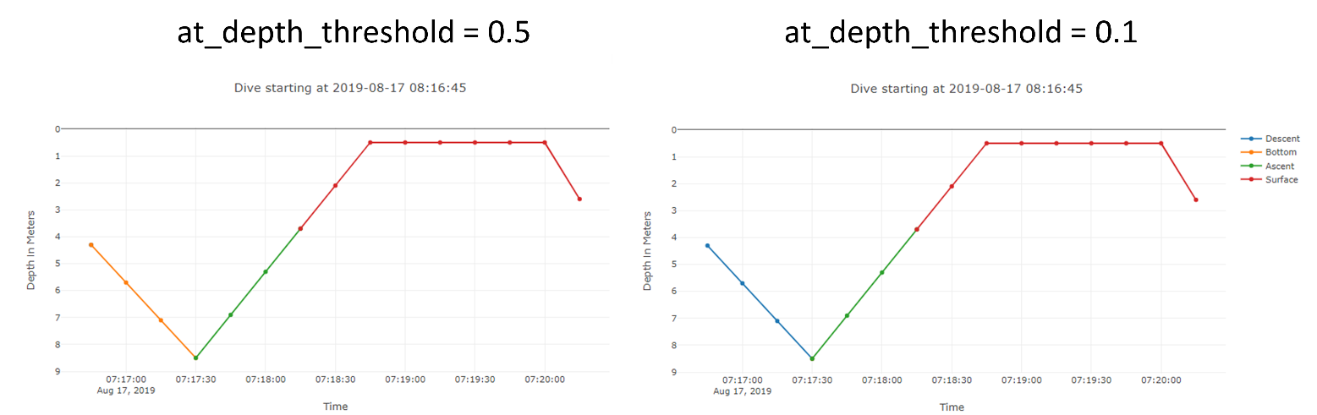

Figure S2e: When the ‘at depth threshold’ is set too high (left) the descent phase of shallow dives may be modeled as bottom. In this case the maximum depth is 8.5 m, and as depths during descent are all ≥ 4.25 (which is the ‘at depth threshold’ depth = (1-0.5)*8.5), the descent phase is modeled incorrectly as bottom phase. Lowering the ‘at depth threshold’ for shallow dives ensures that descent phases are not modeled as bottom phases. In this case (right) depths of the ‘descent phase’ are mostly < 7.65 (which is the ‘at depth threshold’ depth = (1-0.1)*8.5). The exception to this is the deepest point at 8.5 m, however, as depth decreases and never increases beyond the ‘at depth threshold’ again, the dive is correctly modeled as going straight from the ‘descent phase’ to the ‘ascent phase’ with no bottom phase.
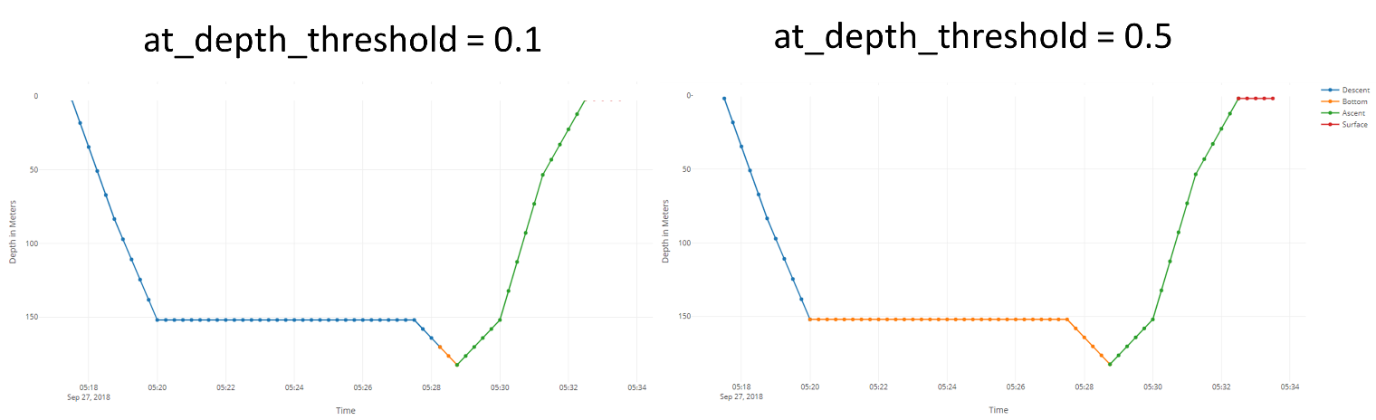

Figure S2f: When the ‘at depth threshold’ is set too low for deeper dives with variation in depth during the bottom phase, the bottom phase may be underestimated. In this case (left), rate of change in depth becomes zero at 152.0 m, however, as the maximum depth is 182.5 m, and as 152.0 < 164.25 (which is the ‘at depth threshold’ depth = (1-0.1)*182.5), this is still considered as descent. The bottom phase only starts once the threshold has been passed. Instead when the ‘at depth threshold’ is increased to 0.5 (right), as 152 > 91.25 (which is the ‘at depth threshold’ depth = (1-0.5)*182.5), and the rate of change in depth is equal to zero, the bottom phase is modeled more appropriately.

3.3 Surface threshold
Surface threshold is set to zero in default settings in divebomb, which was initially designed for data sampled at a 1 s frequency; and a low surface threshold value is recommended to improve dive modeling. A surface threshold of 5 m was used here as this was greater than the length of the largest beluga (4.70 m) in our study and erroneous measurements most frequently occurred within 5 m of the surface, although it should be noted that other studies have used shallower dive thresholds (Lefebvre et al. 2018, Vacquié-Garcia et al. 2019). Whilst visual exploration of the dives revealed that this produced a good approximation of most dives, shorter dives were naturally characterized less effectively due to the 75 s sampling frequency of the raw data.
It is important to note that in its current state, divebomb (v1.1.2) models the start of the descent phase relative to the surface threshold differently depending on the sampling frequency. For sampling frequencies ≥ 10 s, the start of the descent phase is determined when the surface threshold is passed, and back tracks one point (as shown in Figure S2b); however, for sampling frequencies < 10 s the descent phase starts when 1 m depth is passed, and back tracks one point, irrespective of the surface threshold. The end of the ascent phase is determined when the surface threshold is passed for all sampling frequencies (see Figure S2g for example of depth data at 1 s frequency).

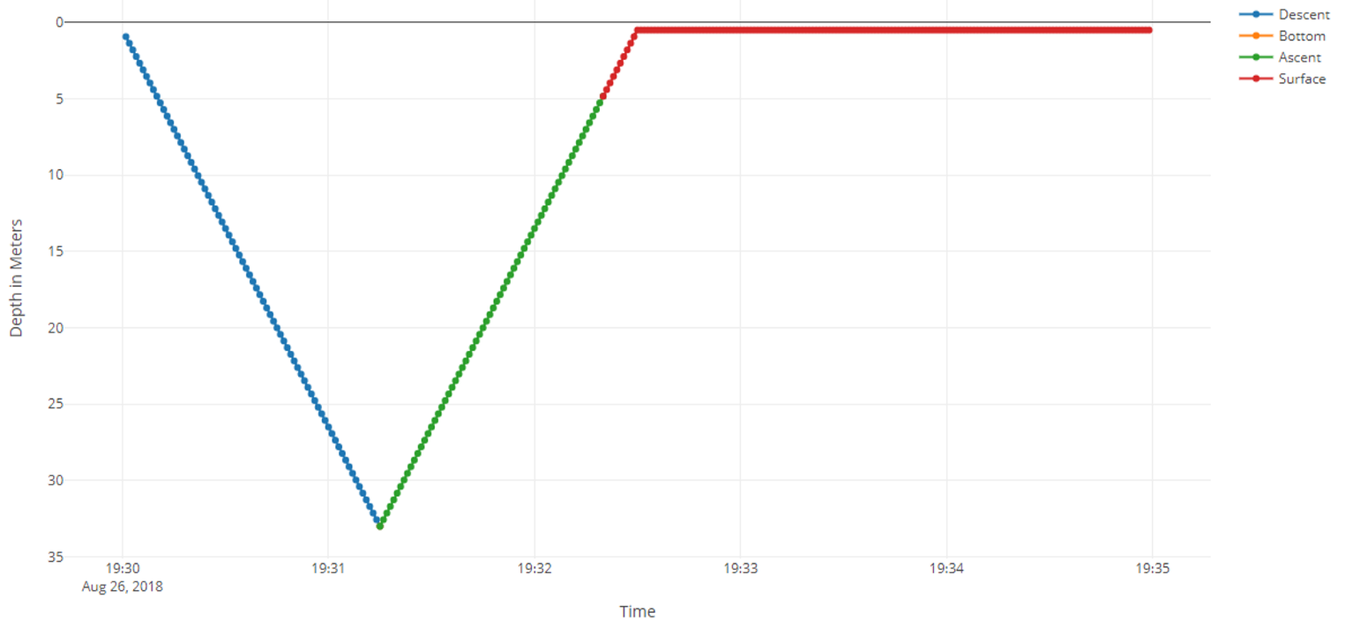
Figure S2g: Dive identified in divebomb using time-depth data upsampled to 1 s from 75 s. ‘Surface threshold’ was set at 5 m. The descent phase begins when depth exceeds 1 m, and back tracks one data point, however, the ascent phase ends when the 5 m threshold is passed, resulting in this symmetric dive being characterized as having a shorter ascent phase than descent phase.

3.4 Missing data
Divebomb is sensitive to gaps in the data, which is a common occurrence for Argos-transmitted data. The time-series data were therefore linearly interpolated across these missing phases (which were always ≥ 1 hour in duration), and incorrectly modeled dives were identified and removed in post-processing. To identify incorrectly modeled dives the missing phases were identified in the raw time-series data, and any dive which was modeled over a time period of a missing phase was removed. To maximize the number of dives used in the classification procedure, dives with incorrectly-modeled post-dive surface intervals (i.e. post-dive surface intervals interpolated across missing data) were not excluded, instead their post-dive surface intervals were converted to NA (n = 1305, 1.5 % of dives) and this metric was not used in the classification procedure, but was compared between dive types after classification (see Supplementary material 3, Table S3a).

3.5 Script for characterizing dives with divebomb v1.1.2
The code below can be used with the example depth time series data from a tagged beluga (Supplementary Table 2 csv file) to isolate and characterise dives using divebomb in Python. The script here firstly upsamples the data from 75 s to 15 s intervals using linear interpolation, and then profiles the dives. To view dive profiles in Jupyter Notebook, ‘ipython_display_mode’ should be set to ‘True’. If saving the profiles dives this should be set to ‘False’.
from datetime import datetime
from pandas import read_csv
from pandas import datetime
from pandas import to_datetime
import pandas as pd

## Load time series data
series = read_csv('file path/depth_data.csv', header=0, names=['time', 'depth']).set_index('time')
series.head()

series.index = pd.to_datetime(series.index)

## Interpolate time series data to 15 s intervals
upsampled = series.resample('15s').mean()

upsampled

interpolated =upsampled.interpolate(method='linear')

df = pd.DataFrame(interpolated)
df

# Use divebomb to isolate and characterize dives
depth_data = df.reset_index()
from divebomb import profile_dives

surface_threshold=5
at_depth_threshold = 0.1

## Change ipython_display_mode = False, for saving dives to csv, or True for
# viewing in Jupyter notebook
dives,insufficient_dives, data = profile_dives(depth_data, surface_threshold=surface_threshold, at_depth_threshold = at_depth_threshold,ipython_display_mode=False)

dives

from divebomb import export_to_csv
from divebomb import cluster_dives

# Save dives to csv file
dives.to_csv("output folder/profile_dives.csv", index=False)

4. Classification procedure
Divebomb has a built-in classification function, however, this was not appropriate for the beluga data due to requirements of (i) filtering out incorrectly modeled dives, and (ii) assigning a seafloor depth to each dive and using this metric in the classification process. Instead, a three-step classification procedure was adopted in the current study (Figure 2).
Step one involved fitting Gaussian mixture models to the maximum depth metric using the ‘mixtools’ v1.2.0 package (Young et al. 2020) in R, specifying three Gaussian distributions. Dives were then split into depth categories (Shallow, Intermediate, and Deep) where the probability of a maximum depth belonging to two distributions was equal, with significance of distributions confirmed through the K-S test (p ≤ 0.05). Step two involved further subdivision of the Intermediate and Deep dive categories into Benthic (maximum depth / seafloor depth ≥ 0.8) and Pelagic (maximum depth / seafloor depth < 0.8) (Figure 2). For the Shallow dive category, no division was made given uncertainty in the CTCRW locations and error in the IBCAO and GEBCO data at such shallow depths that could lead to spurious results. Step three involved exploring dives within each of the above defined categories for further groupings using a clustering approach. The ten metrics (excluding maximum depth / seafloor depth) were scaled and centered, and a PCA was run using the ‘psych’ v1.9.12.31 package (Revelle 2020) in R (Table S2a - Table S2f). The first four principal components explained ≥ 87% of the variance for each dive category (Table S2a), and a PCA with a varimax rotation (see Lesage et al. 1999) was rerun on the data to reduce the number of metrics to sets of four uncorrelated factors (Table S2g-Table S2k). A hierarchical clustering analysis (HCA) was then undertaken using the ‘fastcluster’ v1.1.25 package (Müllner 2018) in R, for each of the dive categories (Shallow, Intermediate Pelagic, Intermediate Benthic, Deep Pelagic, and Deep Benthic) using the varimax-rotated factor scores as inputs and based on the Euclidean distance and Ward’s method (Borcard et al. 2018). Dendrograms were viewed for the maximum potential number of clusters, and cluster stability was assessed using 1000 iterations of bootstrapping and calculation of Jaccard’s similarity index with the ‘clusterboot’ function in the ‘fpc’ v2.2-7 package (Henning 2020) in R. Due to memory limitations, n dives from each cluster within the Shallow dive category was randomly subsampled, where n was the number of dives in the smallest cluster, and recombined prior to assessment of cluster stability within this dive category. Only clusters with a Jaccard similarity score ≥ 0.7 were considered valid (see Henning 2020). If the Jaccard’s similarity score was < 0.7 a cluster was deemed unstable (Table S2l), and stability was iteratively reassessed through fewer cluster solutions until stability was achieved across all clusters. If no stable clusters were identified by HCA, the dive type was classified as the dive category determined following the Gaussian mixed model and benthic/pelagic differentiation (Figure 2).
Table S2a: Eigenvalues and cumulative proportion of the variance explained by the ten principal components for the dive classes prior to hierarchical clustering analyses.
Dive class |  | PC1 | PC2 | PC3 | PC4 | PC5 | PC6 | PC7 | PC8 | PC9 | PC10
Deep Pelagic | Eigenvalue | 4.10 | 2.32 | 1.93 | 0.87 | 0.51 | 0.17 | 0.04 | 0.03 | 0.02 | 0.01
 | Cumulative proportion explained | 0.41 | 0.64 | 0.83 | 0.92 | 0.97 | 0.99 | 0.99 | 1.00 | 1.00 | 1.00
Deep Benthic | Eigenvalue | 3.57 | 2.42 | 2.15 | 0.99 | 0.69 | 0.09 | 0.04 | 0.02 | 0.01 | 0.01
 | Cumulative proportion explained | 0.36 | 0.60 | 0.81 | 0.91 | 0.98 | 0.99 | 1.00 | 1.00 | 1.00 | 1.00
Intermediate Pelagic | Eigenvalue | 3.61 | 2.57 | 2.12 | 0.60 | 0.52 | 0.25 | 0.18 | 0.08 | 0.05 | 0.02
 | Cumulative proportion explained | 0.36 | 0.62 | 0.83 | 0.89 | 0.94 | 0.97 | 0.98 | 0.99 | 1.00 | 1.00
Intermediate Benthic | Eigenvalue | 3.26 | 2.43 | 2.12 | 0.99 | 0.70 | 0.21 | 0.15 | 0.07 | 0.05 | 0.01
 | Cumulative proportion explained | 0.33 | 0.57 | 0.78 | 0.88 | 0.95 | 0.97 | 0.99 | 0.99 | 1.00 | 1.00
Shallow | Eigenvalue | 3.74 | 2.23 | 2.01 | 0.71 | 0.61 | 0.28 | 0.23 | 0.08 | 0.07 | 0.02
 | Cumulative proportion explained | 0.37 | 0.60 | 0.80 | 0.87 | 0.93 | 0.96 | 0.98 | 0.99 | 1.00 | 1.00

Table S2b: Principal component loadings for the dive parameters of the Deep Pelagic dive category.
Dive parameter | PC1 | PC2 | PC3 | PC4 | PC5 | PC6 | PC7 | PC8 | PC9 | PC10
Max. depth | -0.48 | 0.11 | -0.01 | 0.01 | -0.22 | 0.00 | -0.35 | 0.43 | 0.03 | -0.64
Bottom duration / dive duration | 0.32 | 0.37 | -0.31 | -0.13 | 0.32 | 0.09 | -0.38 | 0.55 | 0.01 | 0.30
Bottom variance | -0.05 | 0.25 | -0.20 | 0.94 | 0.08 | -0.01 | 0.04 | -0.05 | -0.08 | 0.01
Dive duration | -0.28 | 0.34 | -0.28 | -0.14 | -0.68 | -0.11 | 0.07 | -0.04 | -0.21 | 0.43
Ascent / descent | 0.14 | 0.37 | 0.52 | 0.03 | -0.01 | -0.67 | -0.31 | -0.15 | 0.08 | 0.02
Descent / ascent | -0.05 | -0.42 | -0.50 | 0.00 | 0.09 | -0.71 | 0.11 | 0.17 | 0.12 | 0.00
Ascent rate | -0.35 | 0.37 | 0.16 | -0.16 | 0.41 | -0.13 | 0.64 | 0.24 | -0.19 | -0.02
Descent rate | -0.43 | 0.03 | -0.25 | -0.16 | 0.44 | 0.00 | -0.42 | -0.51 | -0.32 | 0.04
Max. depth / bottom duration | -0.48 | -0.05 | 0.13 | 0.07 | 0.11 | 0.11 | -0.07 | 0.03 | 0.74 | 0.41
Bottom duration | 0.19 | 0.46 | -0.40 | -0.18 | 0.00 | 0.02 | 0.18 | -0.37 | 0.49 | -0.38

Table S2c: Principal component loadings for the dive parameters of the Deep Benthic dive category.
Dive parameter | PC1 | PC2 | PC3 | PC4 | PC5 | PC6 | PC7 | PC8 | PC9 | PC10
Max. depth | 0.49 | 0.12 | -0.09 | 0.06 | -0.29 | 0.08 | -0.66 | 0.03 | 0.06 | 0.45
Bottom duration / dive duration | -0.25 | 0.46 | -0.18 | -0.10 | 0.49 | 0.08 | -0.54 | 0.09 | -0.14 | -0.35
Bottom variance | 0.07 | 0.06 | -0.10 | 0.96 | 0.21 | 0.00 | 0.06 | -0.01 | 0.06 | -0.02
Dive duration | 0.21 | 0.43 | -0.26 | 0.02 | -0.57 | -0.05 | 0.15 | -0.02 | 0.17 | -0.56
Ascent / descent | -0.02 | 0.29 | 0.59 | 0.07 | -0.05 | -0.62 | -0.12 | -0.38 | -0.14 | -0.01
Descent / ascent | -0.04 | -0.29 | -0.58 | -0.03 | 0.01 | -0.73 | -0.09 | 0.11 | -0.10 | 0.02
Ascent rate | 0.44 | 0.21 | 0.21 | -0.13 | 0.36 | -0.25 | 0.22 | 0.59 | 0.35 | 0.02
Descent rate | 0.44 | -0.02 | -0.25 | -0.17 | 0.42 | 0.04 | 0.12 | -0.69 | 0.22 | -0.04
Max. depth / bottom duration | 0.50 | -0.18 | 0.09 | 0.01 | 0.06 | 0.08 | 0.05 | 0.11 | -0.78 | -0.29
Bottom duration | -0.07 | 0.58 | -0.28 | -0.06 | 0.02 | 0.01 | 0.41 | -0.02 | -0.37 | 0.53

Table S2d: Principal component loadings for the dive parameters of the Intermediate Pelagic dive category.
Dive parameter | PC1 | PC2 | PC3 | PC4 | PC5 | PC6 | PC7 | PC8 | PC9 | PC10
Max. depth | 0.09 | 0.51 | 0.02 | -0.63 | 0.22 | -0.05 | 0.39 | -0.03 | -0.25 | -0.26
Bottom duration / dive duration | -0.43 | 0.24 | -0.03 | 0.48 | 0.06 | -0.02 | 0.39 | -0.04 | -0.52 | 0.31
Bottom variance | -0.29 | 0.33 | -0.02 | -0.17 | -0.87 | -0.01 | -0.08 | 0.01 | 0.11 | 0.03
Dive duration | -0.46 | 0.14 | 0.02 | -0.37 | 0.35 | -0.01 | -0.34 | 0.03 | 0.23 | 0.58
Ascent / descent | 0.01 | 0.01 | -0.64 | -0.07 | 0.01 | 0.66 | -0.13 | -0.33 | -0.13 | -0.02
Descent / ascent | -0.02 | 0.01 | 0.64 | -0.03 | -0.02 | 0.68 | -0.13 | 0.26 | -0.21 | -0.04
Ascent rate | 0.23 | 0.46 | -0.30 | 0.26 | 0.10 | 0.13 | 0.03 | 0.68 | 0.29 | 0.06
Descent rate | 0.22 | 0.46 | 0.30 | 0.29 | 0.08 | 0.12 | 0.06 | -0.59 | 0.43 | 0.09
Max. depth / bottom duration | 0.45 | 0.27 | 0.01 | 0.05 | -0.05 | -0.24 | -0.60 | -0.06 | -0.52 | 0.21
Bottom duration | -0.46 | 0.23 | -0.01 | 0.22 | 0.22 | -0.11 | -0.43 | -0.03 | 0.00 | -0.67

Table S2e: Principal component loadings for the dive parameters of the Intermediate Benthic dive category.
Dive parameter | PC1 | PC2 | PC3 | PC4 | PC5 | PC6 | PC7 | PC8 | PC9 | PC10
Max. depth | 0.12 | 0.25 | 0.43 | -0.39 | 0.56 | 0.08 | -0.43 | 0.00 | 0.17 | 0.22
Bottom duration / dive duration | 0.48 | 0.15 | 0.06 | 0.25 | -0.37 | 0.16 | -0.25 | 0.03 | 0.63 | -0.23
Bottom variance | 0.18 | -0.07 | -0.09 | -0.84 | -0.50 | 0.01 | -0.02 | 0.00 | -0.08 | -0.01
Dive duration | 0.51 | -0.03 | -0.05 | -0.12 | 0.41 | -0.08 | 0.30 | 0.03 | -0.18 | -0.65
Ascent / descent | -0.06 | 0.50 | -0.35 | -0.07 | 0.04 | -0.64 | -0.02 | -0.41 | 0.18 | 0.00
Descent / ascent | 0.05 | -0.53 | 0.31 | 0.01 | -0.02 | -0.70 | 0.00 | 0.27 | 0.23 | 0.06
Ascent rate | 0.03 | 0.58 | 0.21 | 0.10 | -0.22 | -0.19 | 0.01 | 0.65 | -0.33 | -0.02
Descent rate | 0.09 | 0.04 | 0.64 | 0.15 | -0.28 | -0.09 | -0.02 | -0.58 | -0.36 | -0.11
Max. depth / bottom duration | -0.41 | 0.19 | 0.35 | -0.19 | -0.01 | 0.12 | 0.62 | 0.01 | 0.46 | -0.18
Bottom duration | 0.54 | 0.07 | 0.00 | 0.07 | 0.04 | 0.03 | 0.52 | -0.06 | 0.01 | 0.65

Table S2f: Principal component loadings for the dive parameters of the Shallow dive category.
Dive parameter | PC1 | PC2 | PC3 | PC4 | PC5 | PC6 | PC7 | PC8 | PC9 | PC10
Max. depth | 0.33 | -0.41 | 0.02 | -0.10 | 0.54 | -0.13 | 0.16 | -0.48 | -0.03 | -0.38
Bottom duration / dive duration | 0.43 | 0.11 | -0.04 | -0.14 | -0.59 | 0.17 | 0.14 | -0.59 | -0.01 | 0.18
Bottom variance | 0.34 | 0.04 | -0.02 | 0.87 | 0.12 | 0.27 | 0.18 | 0.07 | 0.00 | 0.07
Dive duration | 0.47 | 0.14 | -0.01 | -0.12 | 0.33 | -0.39 | -0.25 | 0.09 | 0.02 | 0.65
Ascent / descent | -0.02 | 0.03 | -0.65 | -0.04 | 0.17 | 0.41 | -0.53 | -0.13 | -0.27 | -0.02
Descent / ascent | 0.03 | 0.09 | 0.65 | -0.03 | 0.14 | 0.43 | -0.51 | -0.15 | 0.28 | -0.04
Ascent rate | 0.15 | -0.57 | -0.26 | -0.11 | -0.13 | 0.19 | -0.01 | 0.26 | 0.67 | 0.11
Descent rate | 0.17 | -0.54 | 0.29 | -0.11 | -0.16 | 0.21 | -0.03 | 0.30 | -0.64 | 0.15
Max. depth / bottom duration | -0.32 | -0.40 | 0.04 | 0.41 | -0.23 | -0.44 | -0.41 | -0.36 | 0.00 | 0.14
Bottom duration | 0.47 | 0.11 | -0.03 | 0.05 | -0.30 | -0.32 | -0.38 | 0.30 | 0.00 | -0.58

Table S2g: Varimax rotated principal component loadings for the dive parameters of the Deep Pelagic dive category.
Dive parameter | RC1 | RC2 | RC3 | RC4
Max. depth | 0.92 | -0.33 | -0.04 | 0.12
Bottom duration / dive duration | -0.24 | 0.93 | 0.09 | 0.07
Bottom variance | 0.12 | 0.12 | 0.01 | 0.98
Dive duration | 0.79 | 0.33 | -0.06 | 0.12
Ascent / descent | -0.14 | 0.07 | 0.95 | 0.00
Descent / ascent | -0.06 | -0.05 | -0.95 | -0.01
Ascent rate | 0.84 | -0.06 | 0.42 | 0.01
Descent rate | 0.86 | -0.13 | -0.36 | 0.00
Max. depth / bottom duration | 0.77 | -0.61 | -0.03 | 0.07
Bottom duration | 0.06 | 0.98 | 0.05 | 0.11

Table S2h: Varimax rotated principal component loadings for the dive parameters of the Deep Benthic dive category.
Dive parameter | RC1 | RC2 | RC3 | RC4
Max. depth | 0.94 | 0.08 | 0.01 | 0.17
Bottom duration / dive duration | -0.35 | 0.83 | 0.06 | -0.06
Bottom variance | 0.05 | 0.04 | -0.02 | 0.98
Dive duration | 0.50 | 0.71 | -0.03 | 0.15
Ascent / descent | -0.06 | 0.02 | 0.98 | 0.00
Descent / ascent | -0.05 | -0.02 | -0.97 | 0.02
Ascent rate | 0.83 | 0.05 | 0.44 | -0.07
Descent rate | 0.87 | 0.02 | -0.32 | -0.06
Max. depth / bottom duration | 0.89 | -0.43 | 0.03 | 0.06
Bottom duration | 0.00 | 0.99 | 0.03 | 0.04

Table S2i: Varimax rotated principal component loadings for the dive parameters of the Intermediate Pelagic dive category.
Dive parameter | RC1 | RC2 | RC3 | RC4
Max. depth | 0.13 | 0.50 | -0.01 | 0.82
Bottom duration / dive duration | 0.96 | 0.03 | 0.01 | -0.16
Bottom variance | 0.69 | 0.07 | 0.03 | 0.35
Dive duration | 0.79 | -0.41 | -0.05 | 0.33
Ascent / descent | 0.01 | -0.02 | 0.94 | 0.03
Descent / ascent | 0.02 | -0.02 | -0.93 | 0.04
Ascent rate | 0.03 | 0.85 | 0.45 | 0.17
Descent rate | 0.02 | 0.87 | -0.42 | 0.17
Max. depth / bottom duration | -0.52 | 0.77 | 0.01 | 0.20
Bottom duration | 0.96 | -0.10 | -0.01 | 0.00

Table S2j: Varimax rotated principal component loadings for the dive parameters of the Intermediate Benthic dive category.
Dive parameter | RC1 | RC2 | RC3 | RC4
Max. depth | 0.09 | 0.05 | 0.81 | 0.28
Bottom duration / dive duration | 0.89 | 0.09 | 0.23 | -0.12
Bottom variance | 0.15 | -0.03 | 0.01 | 0.89
Dive duration | 0.87 | -0.07 | 0.03 | 0.30
Ascent / descent | -0.03 | 0.94 | -0.09 | 0.04
Descent / ascent | 0.01 | -0.94 | 0.03 | 0.03
Ascent rate | 0.08 | 0.65 | 0.67 | -0.23
Descent rate | 0.09 | -0.39 | 0.83 | -0.26
Max. depth / bottom duration | -0.80 | 0.09 | 0.53 | -0.06
Bottom duration | 0.96 | 0.01 | 0.15 | 0.10

Table S2k: Varimax rotated principal component loadings for the dive parameters of the Shallow dive category.
Dive parameter | RC1 | RC2 | RC3 | RC4
Max. depth | 0.32 | 0.82 | 0.02 | 0.14
Bottom duration / dive duration | 0.82 | 0.18 | -0.01 | 0.19
Bottom variance | 0.34 | 0.08 | 0.00 | 0.92
Dive duration | 0.89 | 0.17 | 0.04 | 0.23
Ascent / descent | 0.04 | -0.09 | -0.92 | -0.03
Descent / ascent | 0.06 | -0.07 | 0.93 | -0.02
Ascent rate | -0.04 | 0.88 | -0.40 | 0.02
Descent rate | -0.04 | 0.89 | 0.38 | 0.02
Max. depth / bottom duration | -0.88 | 0.27 | -0.01 | 0.10
Bottom duration | 0.83 | 0.19 | 0.01 | 0.37

4.1 Cluster stability
It should be noted that Henning (2020) suggests that clusters with Jaccard’s similarity scores < 0.6 represent an unstable cluster. Herein we found that clustering within the Deep Benthic group produced a two cluster solution, one cluster of which had a Jaccard’s similarity score of 0.61 (Table S2l), however, exploration of this group revealed that it was small and too similar to the other cluster to justify its own group. Hence a value of 0.7 was selected.

Table S2l: Jaccard’s similarity scores for cluster solutions of the dive categories. Bold scores denote a stable cluster solution (Jaccard’s similarity score ≥ 0.7 for all clusters identified). See Figure 2 within manuscript for final dive types identified after clustering.
Dive category | Number of clusters in solution
 | 2 | 3 | 4 | 5
Deep Pelagic |  | 0.89, 0.85, 0.89 | 0.89, 0.89, 0.48, 0.72 | 0.87, 0.89, 0.50, 0.50, 0.50
Deep Benthic | 0.91, 0.61 | 0.45, 0.59, 0.82 | 0.52, 0.49, 0.60, 0.80 | 0.55, 0.53, 0.59, 0.63, 0.79
Intermediate Pelagic | 0.53, 0.55 | 0.48, 0.48, 0.27 | 0.44, 0.40, 0.48, 0.40 | 0.38, 0.39, 0.55, 0.35, 0.43
Intermediate Benthic | 0.51, 0.50 | 0.46, 0.40, 0.33 | 0.43, 0.39, 0.44, 0.37 | 0.43, 0.47, 0.52, 0.41, 0.46
Shallow | 0.96, 0.72 | 0.46, 0.59, 0.73 | 0.46, 0.61, 0.51, 0.73 | 0.69, 0.58, 0.68, 0.55, 0.71

5. Examples of dives characterized in divebomb
The figures below (Figure S2h - Figure S2o) show examples of dives which were characterized using the parameters specified above in divebomb. Dives are labeled with the dive type classification resolved using the Gaussian mixed modeling and hierarchical clustering procedures. The final figure (Figure S2p) shows examples of dives which could arguably be characterized and classified differently, or would require methods for identifying changes in depth during the descent and ascent phases to better infer functionality. Dive shapes such as these were infrequent (n = 4 / visual examination of 2000 dives). Note that plots show depths sampled at 75 s intervals and interpolated to 15 s for the reasons detailed in section 3.1 of this document.

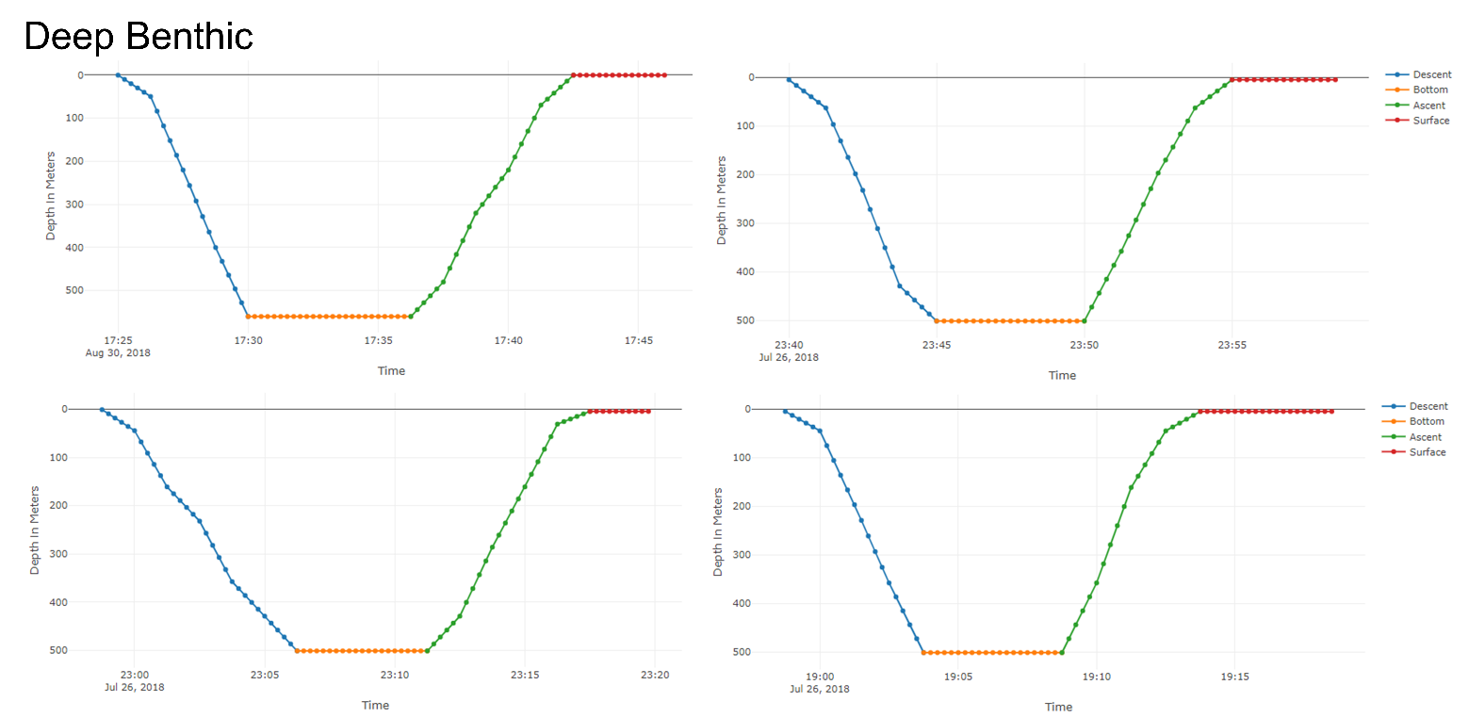
Figure S2h: Examples of Deep Benthic type dive profiles. Colours denote phases identified in divebomb. Dives plotted using Plotly in Jupyter notebook.

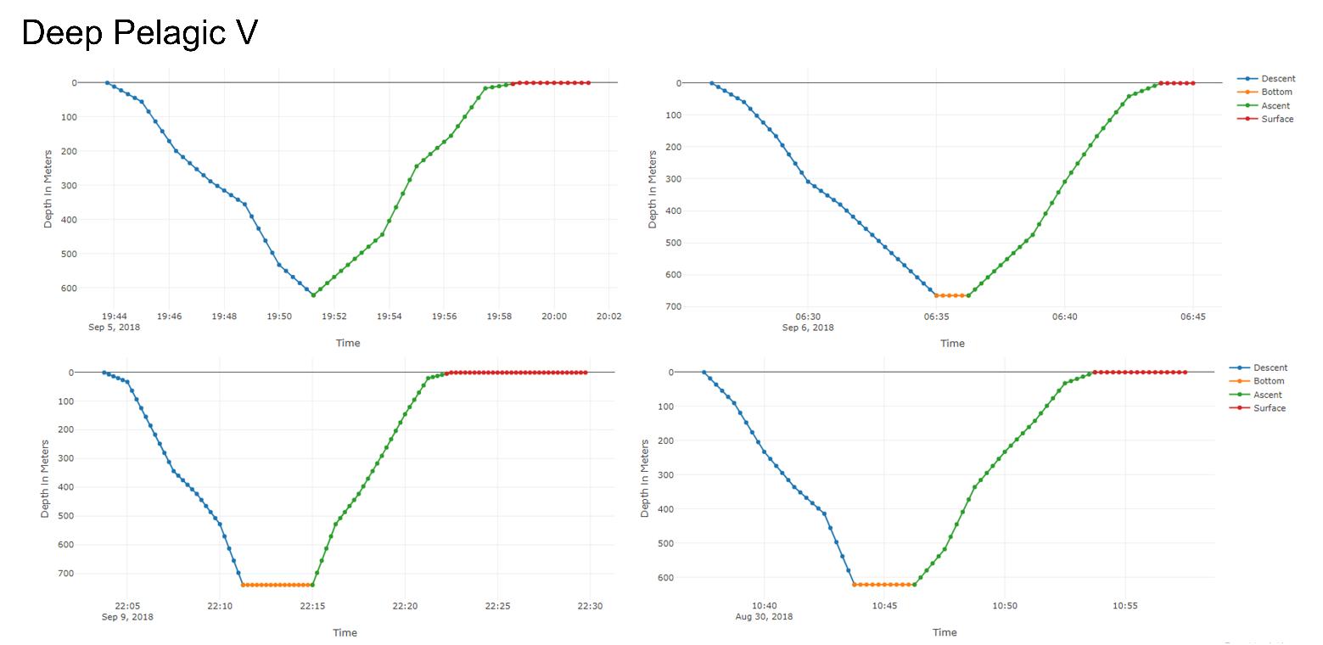
Figure S2i: Examples of Deep Pelagic V type dive profiles. Colours denote phases identified in divebomb. Dives plotted using Plotly in Jupyter notebook.

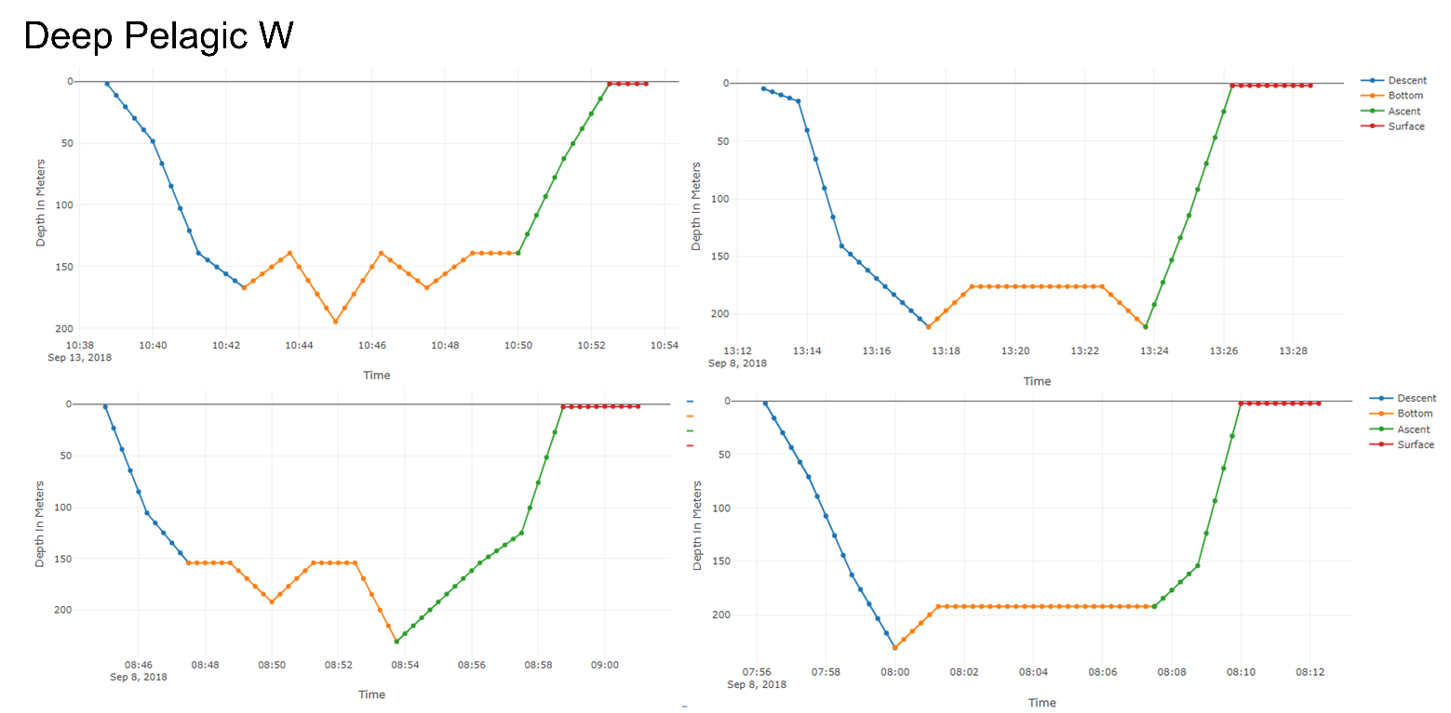
Figure S2j: Examples of Deep Pelagic W type dive profiles. Colours denote phases identified in divebomb. Dives plotted using Plotly in Jupyter notebook.

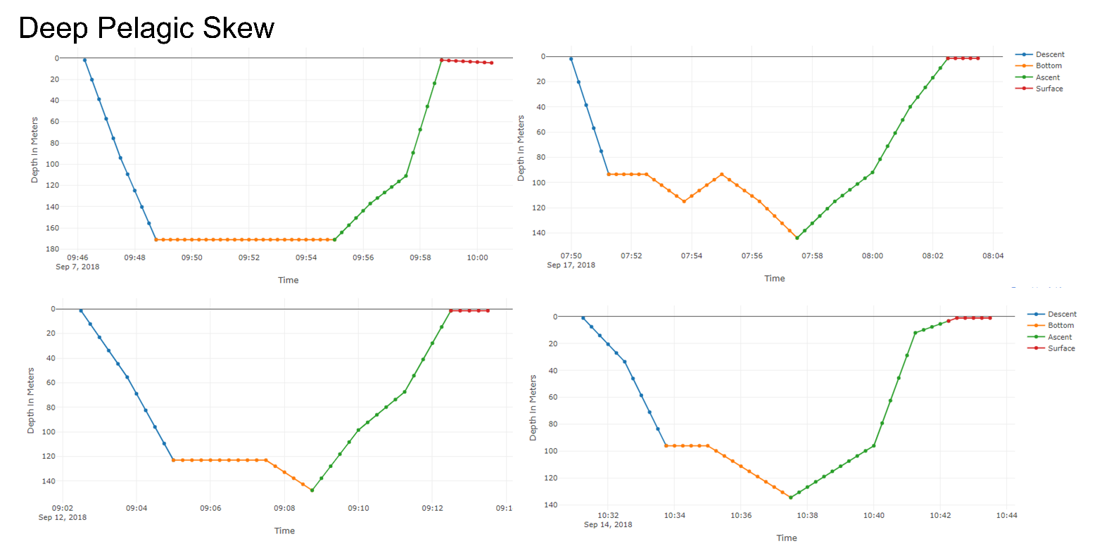
Figure S2k: Examples of Deep Pelagic Skew type dive profiles. Colours denote phases identified in divebomb. Dives plotted using Plotly in Jupyter notebook.

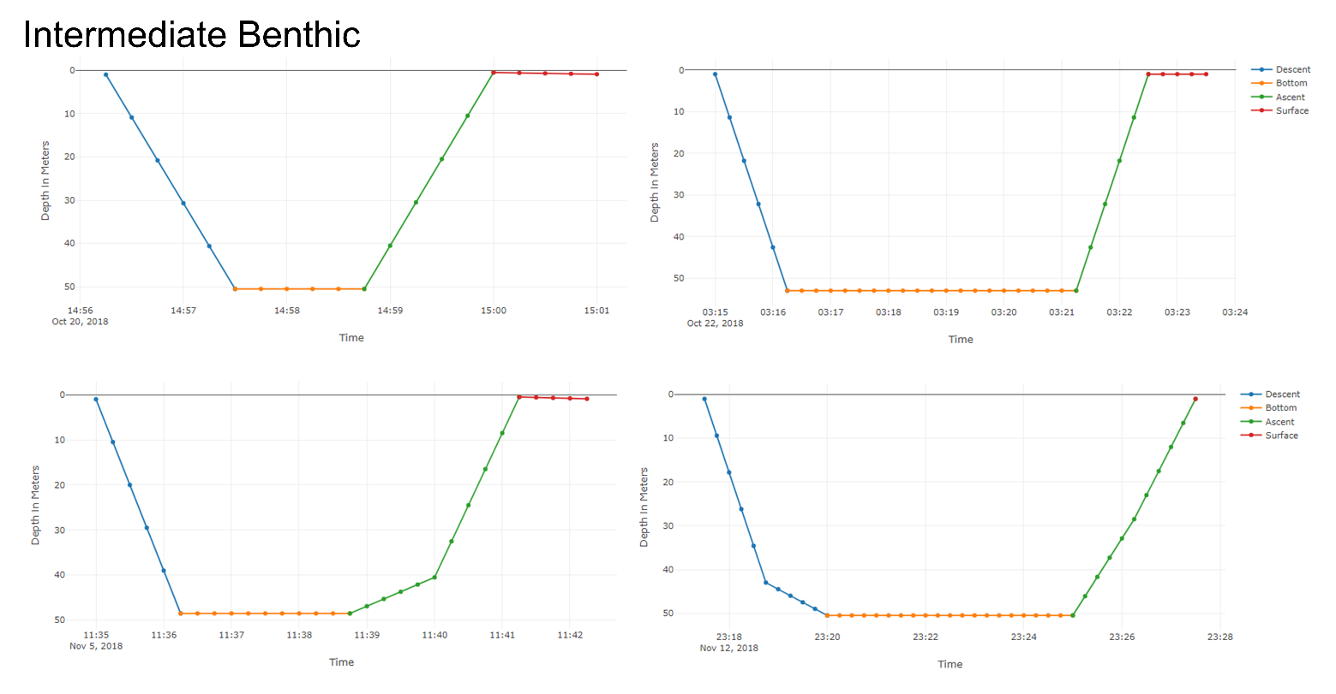
Figure S2l: Examples of Intermediate Benthic type dive profiles. Colours denote phases identified in divebomb. Dives plotted using Plotly in Jupyter notebook.
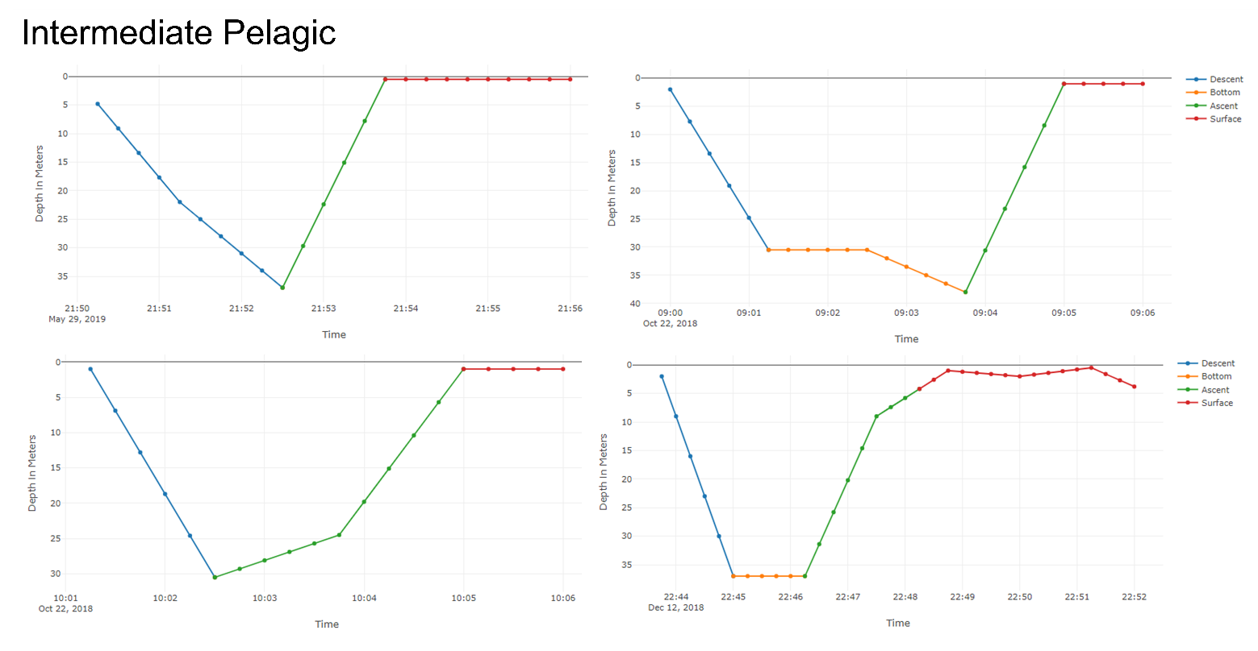
Figure S2m: Examples of Intermediate Pelagic type dive profiles. Colours denote phases identified in divebomb. Dives plotted using Plotly in Jupyter notebook.

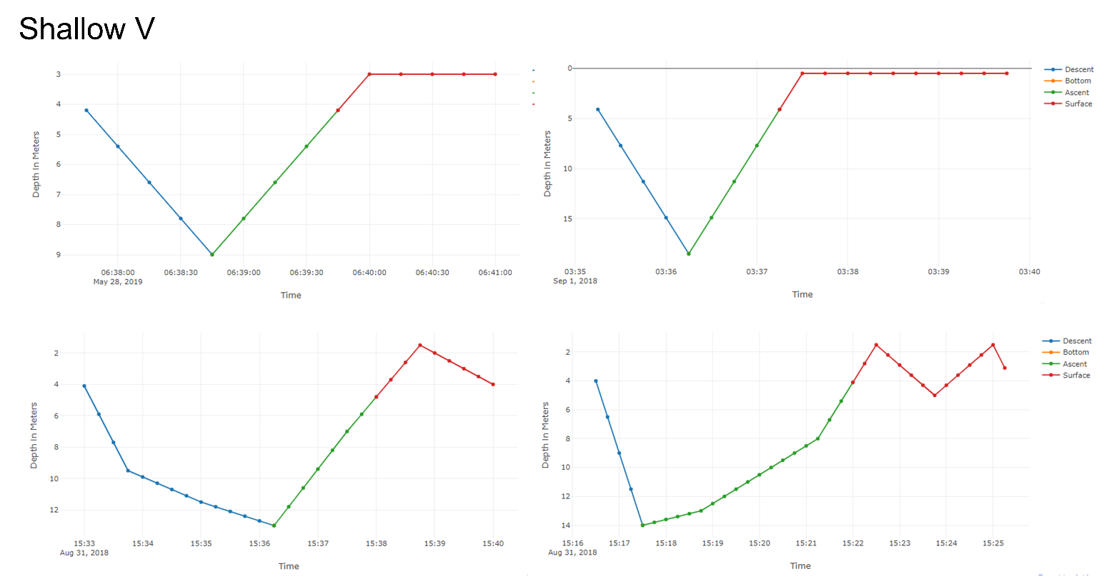
Figure S2n: Examples of Shallow V type dive profiles. Colours denote phases identified in divebomb. Dives plotted using Plotly in Jupyter notebook.
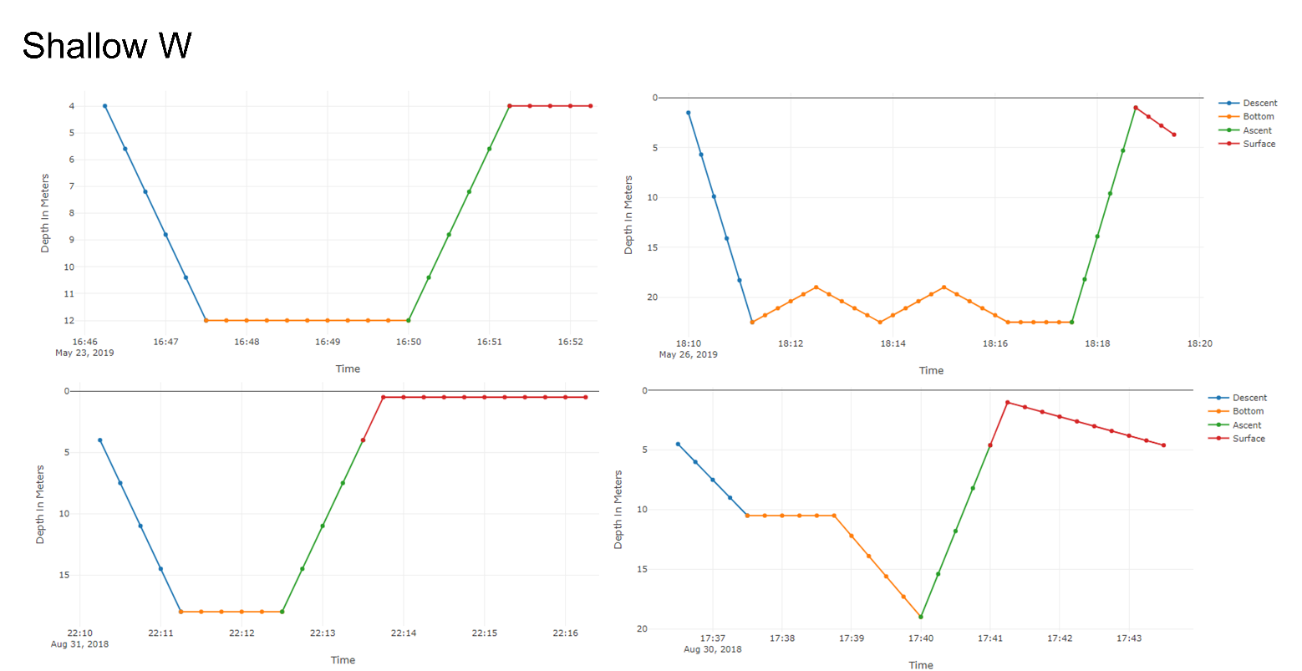
Figure S2o: Examples of Shallow W type dive profiles. Colours denote phases identified in divebomb. Dives plotted using Plotly in Jupyter notebook.

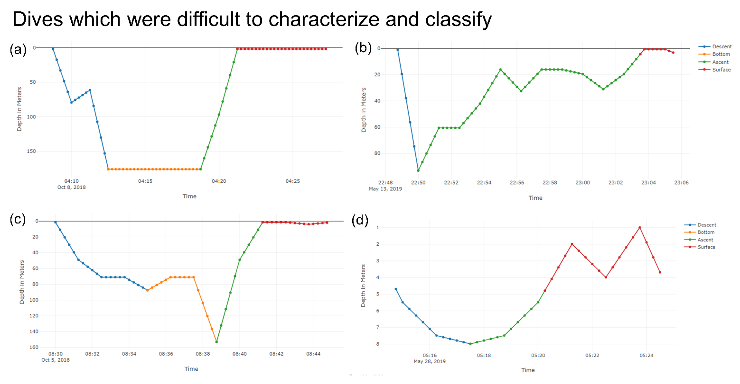
Figure S2p: Examples of dive profiles which may not be well represented by the typical phases of descent, bottom, and ascent. a) When there is a pause or decrease in depth during the descent phase which occurs at a depth less than the ‘at depth threshold’, here at 04:10:00 the animal is neither clearly in the bottom phase but nor is it descending. This dive was classified as a Deep Pelagic W dive. b) No distinct bottom phase, but multiple pauses or increases in depth during the ascent phase. As the animal reaches the maximum depth and then ascends to depths less than the ‘at depth threshold’ before increasing in depths again, this is all characterized as ascent. This dive was classified as an Intermediate Pelagic dive. c) A long pause at depths less than the ‘at depth threshold’, and bottom phase only starts when the ‘at depth threshold’ is passed (= 87 m) and the animal is no longer descending. Bottom phase would possibly be better characterized as starting at 08:32:30, which would require a higher value for ‘at depth threshold’ (for example an ‘at depth threshold’ of 0.55 would give a depth of 69.75 m, beyond which the bottom phase could be considered to have started). This dive was classified as a Deep Pelagic W dive. d) Parabolic-shaped dive with a decreasing descent rate to maximum depth before immediate ascent with increasing ascent rate. As divebomb does not currently provide a metric for change in rates of descent and ascent, parabolic-shaped dives are not well resolved. This dive was classified as a Shallow V dive. Colours denote phases identified in divebomb. Dives plotted using Plotly in Jupyter notebook.

References
Borcard D., Gillet F. & Legendre P. 2018. Numerical Ecology with R. Springer. DOI https://doi.org/10.1007/978-3-319-71404-2
Henning C. 2020. Fpc: Flexible Procedures for Clustering. R Package version 2.2-8. https://cran.r-project.org/web/packages/fpc/
Lefebvre S.L., Lesage V., Michaud R. & Humphries M.M. 2018. Classifying and combining herd surface activities and individual dive profiles to identify summer behaviours of beluga (Delphinapterus leucas) from the St. Lawrence Estuary, Canada. Canadian Journal of Zoology 96, 393-410.
Lesage V., Hammill M.O. & Kovacs K.M. 1999. Functional classification of harbour seal (Phoca vitulina) dives using depth profiles, swimming velocity, and an index of foraging success. Canadian Journal of Zoology 77, 74-87.
Müllner D. 2018. fastcluster: Fast Hierarchical Clustering Routines for R and 'Python'. R package version 1.1.25. https://cran.r-project.org/web/packages/fastcluster/index.html
Nunes A. 2019. divebomb dive classification algorithm. Python package v1.1.2. https://pypi.org/project/divebomb/
Revelle W. 2020. psych: Procedures for Psychological, Psychometric, and Personality Research. R package version 1.9.12.31. https://cran.r-project.org/web/packages/psych/index.html
Vacquié-Garcia J., Lydersen C. & Kovacs K.M. 2019. Diving behaviour of adult male white whales (Delphinapterus leucas) in Svalbard, Norway. Polar Research 38, 3605.
Young D., Benaglia T., Chauveau D., Hunter D., Elmore R., Hettmansperger T., Thomas H. & Xuan F. 2020. mixtools: Tools for Analyzing Finite Mixture Models. R package version 1.2.0. https://cran.r-project.org/web/packages/mixtools/index.html

