Supplementary Materials
Retrospective Survey Items
This Supplementary Materials section provides a full list of items used in the retrospective survey, collected in Table 1.
Supplementary Table 1
A full list of the retrospective survey items.
Item number | Survey question
Item 1 | Young person is actively engaging with the session activities.
Item 2 | Young person is interested in music.
Item 3 | Young person has a good understanding of musical skills / methods / techniques.
Item 4 | Young person has a good knowledge of different musical styles, genres, and cultures.
Item 5 | Young person shows good social skills.
Item 6 | Young person listens to others.
Item 7 | Young person shows awareness of self.
Item 8 | Young person is sensitive to others.
Item 9 | Young person shows appropriate behaviour.
Item 10 | Young person is able to work with staff members.
Item 11 | Young person has a good attitude towards adults (e.g. others accessing the venues).
Item 12 | Young person is confident.
Item 13 | Young person shows general motivation to do things.

Confirmatory Factor Analysis

Description
This section outlines the process of confirmatory factor analysis performed, provides the figure and standardised parameters of the final model and its global and local fit information.

Confirmatory Factor Analysis
Confirmatory factor analysis of the retrospective survey was performed in RStudio software (‘lavaan’ package; Rosseel, 2012), using baseline data which were staff members’ responses to the questions regarding young people’s first music session. The method of full information maximum likelihood was selected for dealing with the missing data.
The model created was based on the three outcome dimensions determined prior to the creation of the survey, namely musical, social and personal outcomes. Item 1 was excluded from the analysis as it was used as an independent variable of engagement. Covariance between personal and social latent variables were established. Moreover, covariances between certain items were also added to the model. These decisions were based on the modification indices of the original model (without covariances) in combination with the qualitative analysis results identifying relationship between confidence, represented by item 12, and peer relationships and social skills, represented in items 5, 6 and 8. The final model is represented in Figure 1, the statistics of global fit are provided in Table 2 and the statistics of local fit are provided in Table 3.

References
Rosseel, Y. (2012). Lavaan: An R package for structural equation modeling. Journal of Statistical Software, 48(2), 1–36. Retrieved from http://www.jstatsoft.org/v48/i02/
Supplementary Figure 1
Final model of the confirmatory factor analysis with standardised parameter estimates
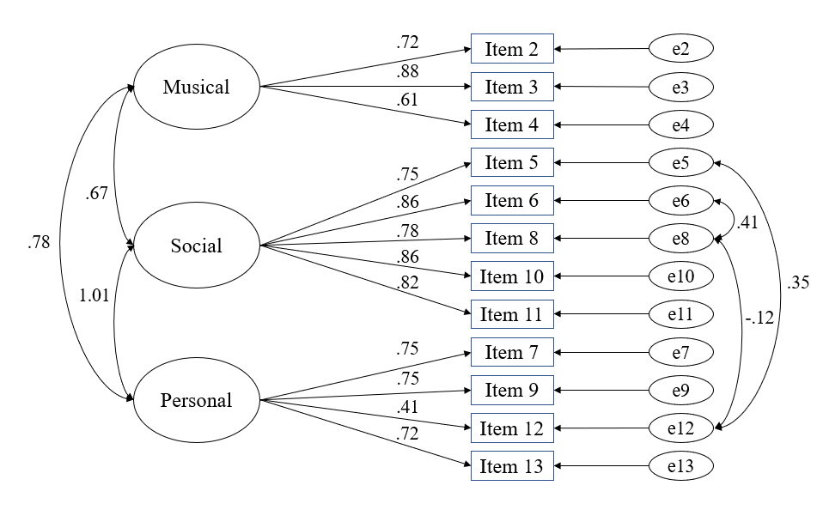

Supplementary Table 2
Confirmatory factor analysis global fit statistics
Model  (N = 99) | x² | df | p value | CFI | RMSEA | SRMR
Final model | 101.33 | 48 | < .001 | 0.93 | 0.11 | 0.06
Note: N stands of number of observations, df for degrees of freedom, CFA for comparative fit index, RMSEA for root mean square error of approximation and SRMR for standardised root mean square residual.

Supplementary Table 3
Confirmatory factor analysis local fit statistics, standardised residuals
 | Item 2 | Item 3 | Item 4 | Item 5 | Item 6 | Item 8 | Item 10 | Item 11 | Item 7 | Item 9 | Item 12 | Item 13
Item 2 | -.04
Item 3 | -0.57 | 0.16
Item 4 | 0.54 | 0.07 | -0.13
Item 5 | 0.24 | -0.13 | 0.14 | -0.14
Item 6 | 0.06 | -1.16 | 0.05 | 0.07 | 0.00
Item 8 | 0.54 | 0.64 | -0.02 | -2.15 | 0.15 | 0.07
Item 10 | -0.19 | 0.53 | -0.39 | 0.28 | -0.90 | -1.52 | 0.00
Item 11 | 0.52 | 0.01 | 1.30 | -0.86 | 0.18 | 0.40 | 0.84 | -0.03
Item 7 | -0.40 | 1.00 | 0.56 | 1.12 | 0.92 | 0.07 | -1.32 | -1.39 | 0.07
Item 9 | -0.82 | -0.80 | -2.21 | -1.66 | 0.22 | 1.53 | 0.58 | 0.50 | 0.24 | 0.01
Item 12 | 2.29 | 0.88 | 0.03 | -0.02 | -1.86 | -1.81 | 0.96 | -1.01 | 0.30 | -1.97 | 0.08
Item 13 | 0.87 | 0.46 | -2.23 | 0.97 | -0.49 | 0.16 | 0.12 | -0.43 | -1.16 | 0.36 | 1.78 | 0.03

