Electronic Supplementary Material

Increasing numbers of killer whale individuals use fisheries as feeding opportunities within subantarctic populations
Morgane Amelot, Floriane Plard, Christophe Guinet, John P.Y. Arnould, Nicolas Gasco, Paul Tixier

Electronic Supplementary Material S1

Bayesian Jolly Seber multistate model

- Model formulation
A multistate Jolly Seber model including data augmentation was built (Kery and Schaub, 2012). The regular Crozet killer whales and the Type-D killer whales datasets were used together with 200 and 100 unknown individual histories for data augmentation, respectively. The model was composed of a state-transition matrix (simulating state changes) and an observation matrix (simulating the events). The transition matrix allowed the model to estimate the annual states of each individual (through the matrix z in the code). The observation matrix is used to linked this matrix z to the data, the annual individual capture histories, through a categorical distribution.
Regular killer whales
Each year, killer whales can be described with one of the following four states: (1) not yet in the population, (2) present in the population but not depredating, (3) present in the population and depredating, and (4) dead. The state-transition matrix was defined as
 | (1) | (2) | (3) | (4)
(1) | 1 - γ | γ(1-g_{t}) | g_{t} γ | 0
(2) | 0 | S_{i,t,1}(1-g_{t}) | g_{t} S_{i,t,1} | 1 - S_{i,t,1}
(3) | 0 | 0 | S_{i,t,2} | 1 - S_{i,t,2}
(4) | 0 | 0 | 0 | 1

With γ the entry probability, and g the probability of starting to depredate. g was defined as a function of time to take into account a potential acceleration in the spread of depredation across individuals caused by a learning process. Finally, S, the survival probability, depended on the age class (adults vs. juveniles) and the depredation behaviour (depredating vs. non-depredating).
Each individual could move only forwards from (1) to (2), (2) to (3) and (3) to (4). The population is simulated as an open population including immigration. Emigration was not explicitly estimated resulting in a possible decrease in apparent survival probability if some KW emigrated. KW were considered to have acquired depredating behaviour after they were once observed depredating based on field observations.
Three events have been defined: (C) observed from the coast but not from the fishing vessels (longliners), (B) observed from the longliners, and (NE): not observed. The observation matrix giving the probability to be observed in each of the three events given the four states was defined as:

 | C | B | NE
(1) | 0 | 0 | 1
(2) | q | 0 | 1 - q
(3) | q(1 – p_{t}) | p_{t} | 1 – p_{t} – q(1 – p_{t})
(4) | 0 | 0 | 1

A given individual present in the population had the probability q of being photographed from the coast, and the probability p of being photographed from the longliners if depredating. q was kept constant, while an effect of the capture effort on p was included, since the number of photographs taken from longliners has increased from to 2003 to 2009. The capture effort was estimated as the number of photographs taken in a given year over the maximum annual number of photographs taken across all years.
Type-D killer whales
The model used for Type-D killer whales was similar to that used for regular KIW but included three states (1, 3, 4) and two events (B, NE). Because no Type-D killer whale was photographed from the coast, q could not be estimated. Moreover, g_{t} and γ could not be estimated independently and g_{t} was estimated alone in this model as the entry probability in the depredating Type-D population.
- Priors and Model runs
Models were run on R (version R-4.0.2) using the nimble library. Three chains were used using 337 500 iterations, a burn-in of 112 500 iterations and a thin of 75 iterations which produces 3000 finale values per chain. The chain convergence was checked using the Gelman Rubin statistics with a threshold value < 1.1.
A set of seven priors was used for the regular killer whale and six for the Type-D (Table 1).
Table 1. Model priors. N stand for the normal distribution
Priors associated to the probabilities of | Immigration | Survival | Survival | Capture from boat | Capture from the coast | Capture | Starting depredation | Starting depredation
Crozet Regular | Mean gamma ~ Unif(0,0.4) | Beta state ~ N(0.001) | Mean S  ~ N(0.001) | Mean p ~ N(0,0.001) | Mean q ~ N(0,0.001) | Beta effort ~ N(0,0.001) | Mean g ~ N(0,0.001) | Beta s ~ N(0,0.001)
Crozet Type-D |  | Beta state ~ N(0.001) | Mean S  ~ N(0.001) | Mean p ~ N(0,0.001) |  | Beta effort ~ N(0,0.001) | Mean g ~ N(0,0.001) | Beta s ~ N(0,0.001)
- Simulation study
A simulation analysis was performed to evaluate the identifiability and the accuracy of the different parameters estimated. Indeed, because some assumptions of the model were violated, it was necessary to test the robustness of the model to the main assumptions that were made. First, it was assumed that recapture of individual killer whales were independent while killer whale populations are socially structured and the recapture probability was linked among the individuals belonging to a social group. Second, sex differences were not considered as some individuals were not sexed in our data, although female killer whales are known to have a higher survival than male killer whales. Finally, the influence of individual distinctiveness value on recapture probability was not included because this value was correlated (rho = 0.38, t-value = 20.9, p-value < 0.001) with age class and the two effects were not identifiable in our model.
To test the influence of these assumptions on the results, «true» killer whales populations including recapture dependence between individuals of a social group, sex differences in survival and recapture heterogeneity in relation to individual distinctiveness value was simulated. Then, two models were run on each of the 150 simulated «true» populations and the results obtained were compared to known values.

  - Simulations of dataset from a «true» killer whale population
The purpose of the simulation approach was to explore models’ robustness to several violations of the Jolly-Seber model (Figure 1).
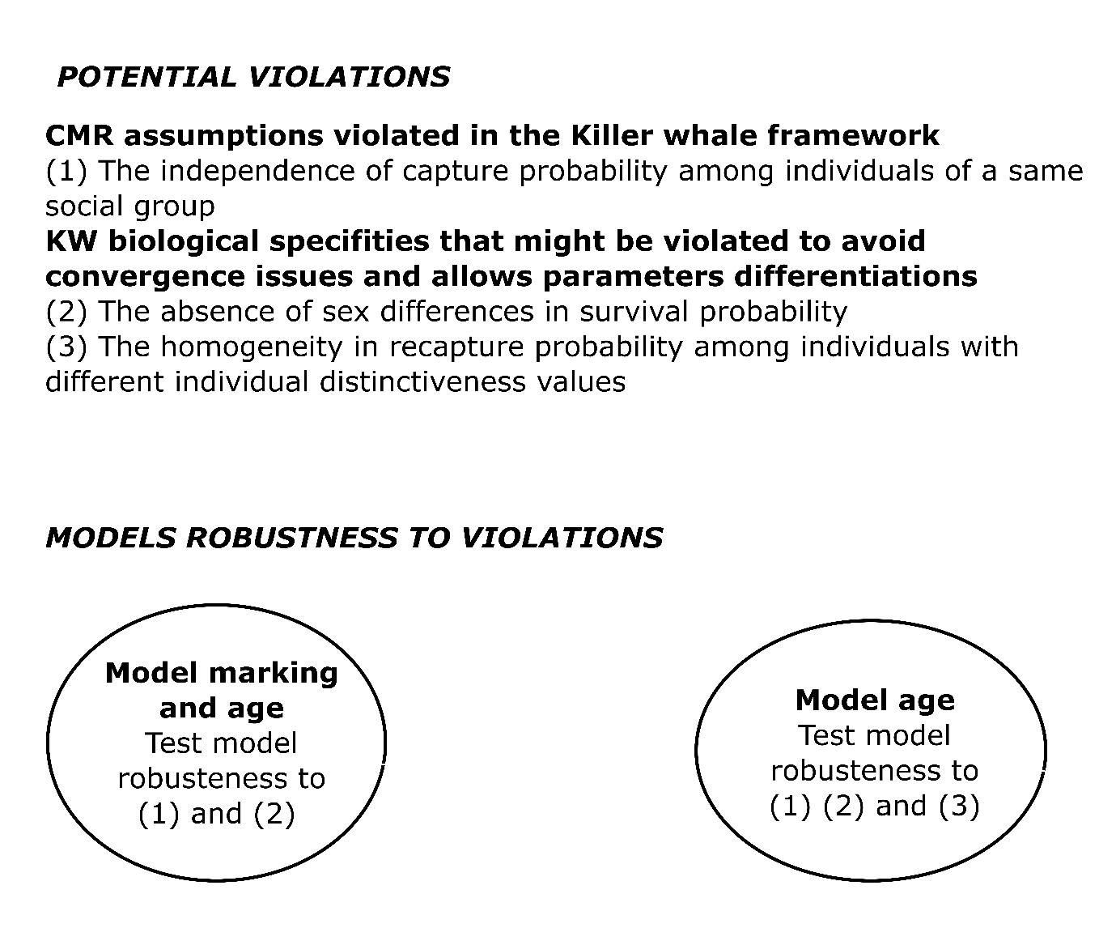
Figure 1. Presentation of the different Jolly-Seber model hypothesis that could be violated considering killer whales ecological specificities
40 juveniles and 220 adults were simulated belonging to 20 different social groups. A social group was assigned to each individual. Annually, each group had a probability gamma (combination of immigration and recruitment) to enter in the population and a transition probability b to become depredator. b was function of time and increased over year according to the potential acceleration in depredating behaviour spread. Entry and transition probabilities were simulated at the social group level while annual survival was simulated at the individual level depending on age using binomial variables (Figure 2, Table 2).
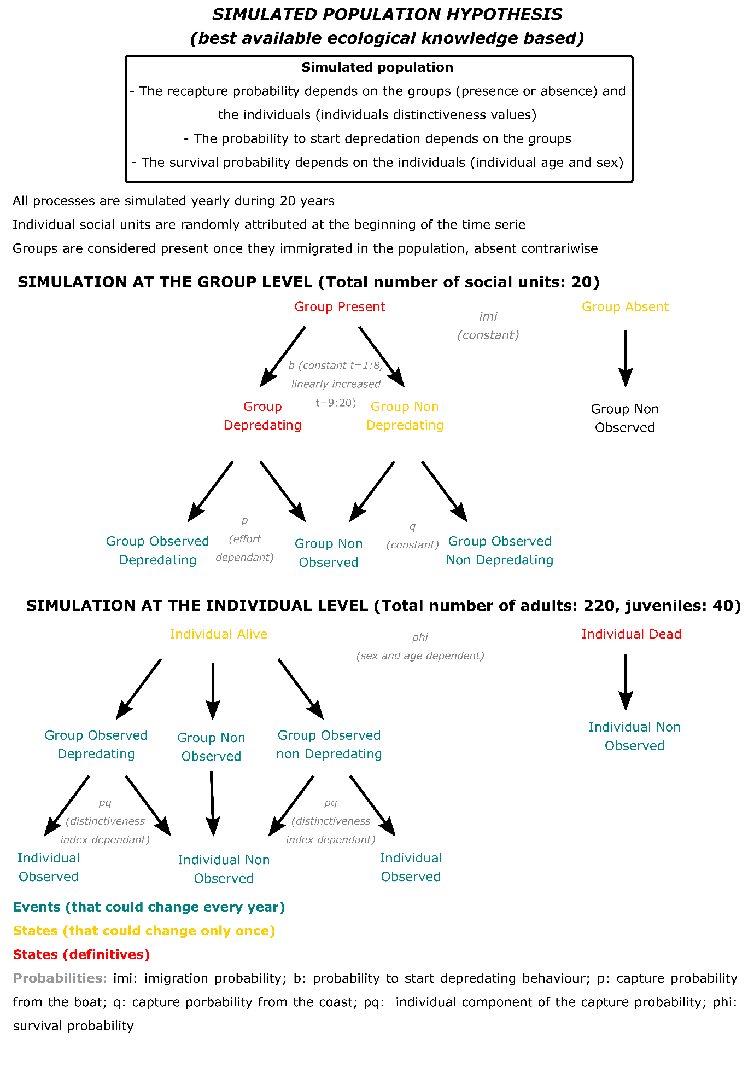
Figure 2. Simulation processes at the group (social units) and individual levels
Each year, it was expected that groups present in the population will be observed from the coast or/and from the longliners if they were interacting with them. The probability of being observed was simulated at the group level using two binomial variables with fixed probability of being observed from the longliners, p, and from the coast, q. The probability of being observed from the longliners also depended on capture effort. Given that the group was observed, a second probability to be captured at the individual level was simulated depending on the individual distinctiveness index (Figure 2, Table 2). The distinctiveness index was set as a continuous variable with 3 possible values: 1, 2, 3. This index was set to 1 for juveniles and to 2 for adults in their first year of occurrence. The probability for an individual distinctiveness value, M, to increase was determined annually using Bernoulli distributions of probability 0.1 for individuals having a distinctiveness index of 1 and 0.3 for individuals having a distinctiveness index of 2.

Table 2. Equation and parameters values of the main probabilities of the simulations
Probabilities | Group |  | Individual
Probability formulas
gamma |  | gamma =0.05
b |  | b $ilogit\left(−0.2+0.1×Tt\right)$
S_{j} |  |  | S_{j,i,t} = $ilogit\left(0.5+0.5×Dt\right)$
S_{am} |  |  | S_{am,i,t} =$ilogit\left(1.5+0.5×Dt\right)$
S_{af} |  |  | S_{af,i,t} $ilogit\left(2+0.5×Dt\right)$
p |  | p_{g} $ilogit$) | p_{i} $ilogit\left(−1.5+2×Mi,t\right)$
q |  | q_{g}$ilogit$) | p_{i} $ilogit\left(−1.5+2×Mi,t\right)$
Probabilities : Gamma, entry probability; b, probability to start depredating behavior; p probability to be observed from boat; q probability to be observed from the coast.; S_{j} Juvenile survival probability; S_{am} Adult male survival probability; S_{j} Adult female survival probability
Parameters : Tt variation of depredation probability time-dependent(Tt_{= 1:8} = -10; Tt _{= 9:20} = 1+(t-8)); Dt depredating index (Dt=0 if the individual did not start depredation, Dt=1 if the individual did start depredation); Mi,t marking level dependent of each individuals status (comprised between 1 and 3); Et is the relative effort for each year, the yearly effort divided by the maximum effort along the time period (the yearly effort was comprised between 500 and 5000 pictures).
ilogit: inverse of the logit function
  - Analysis of each simulated dataset
150 simulated data sets were analysed and the estimated parameters of two different models were compared:
- Model A: including an effect of age on survival and an effect of individual distinctiveness on recapture probability
- Model B: including an effect of age on survival but no effect of individual distinctiveness on recapture probability (identical to the model presented in 1. Model formulation for regular killer whales)

  - Simulation results
Small bias but large uncertainty in parameter estimates were found in both models, apart from the survival probabilities which present higher biases. However, the simulation analysis revealed that bias were lower for model B, excluding the effect of individual distinctiveness on recapture probability than for model A (Figures 3 & 4). Consequently, model B was chosen for the main analysis.
For each parameter the bias and the lower and upper bounds of the 95% credible interval (square brackets) among the 100 simulated and analyzed are presented. Juvenile survival was overestimated in both models and especially model A (bias = 0.24 [0.07;0.38] in model A compared to model B: bias = 0.13 [-0.08;0.28], Figure 1) because individual distinctiveness was correlated with age. Adult survival (bias in model A = 0.02 [-0.07;0.20] and B = 0.02 [-0.07;0.07]) and the probability of individuals starting to depredate (bias in model A = 0.12 [-0.45;0.38] and B = 0.07 [-0.39;0.27]) were also slightly overestimated but close to real values in both models (Figure 3). The annual estimates of the number of depredating killer whales were more accurate than the annual estimates of non-depredating killer whales over time and the accuracy was again slightly higher in model B than in model A (Figure 4). In most simulated scenarios, the number of depredating killer whales was estimated with a precision of +/- 10 individuals, correctly reflecting the increasing number of depredating killer whales from first to final year (Figure 4).
Nevertheless, the high uncertainty around parameters made the parameter reflecting the positive effect of depredation on survival to be significantly positive (95% credible interval excluding 0) in only 33% of simulated data sets analyzed with model A and 30% of simulated data sets analyzed with model B. The temporal trend in the probability of starting to depredate was significantly positive in 80% of simulated data sets analyzed with model A and 78% of simulated data sets analyzed with model B. Thus, the slight positive effect of depredation on such a high survival was very difficult to evidence given the uncertainty of the parameters. But the increase in the probability of starting to depredate should be evidenced in most models.
To summarized the simulation analysis highlighted potential biases linked to the biological specificities of the KW. Firstly, the estimated juvenile survival was probably underestimated by the multistate model. Secondly, the parameter showing the difference in survival between depredating and non depredating KW and to a lesser extent the slope linking the probability of starting depredation to the temporal trend might be slightly underestimated by the model. Nevertheless, the simulation showed that the model was well-performing to estimate population size.

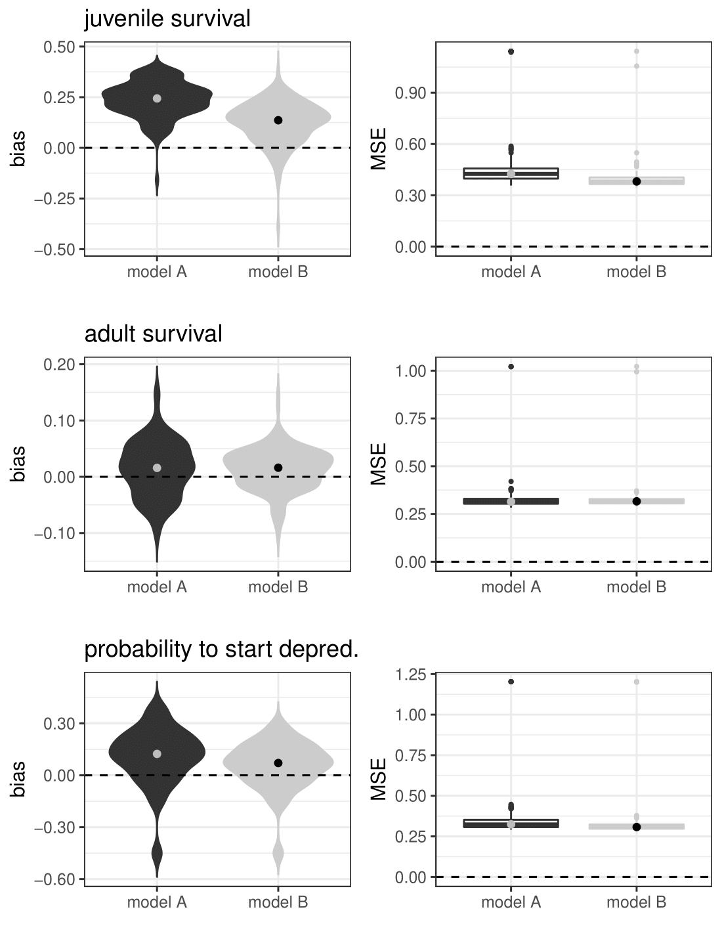
Figure 3. Comparison of bias and mean square errors (MSE) for juvenile and adult survival, and the probability of starting to depredate (estimated in first year) estimated using models A and B from 150 simulated populations. Violin and box plots show the distributions of mean bias and MSE, respectively over 150 simulated populations. The median of each distribution is shown with a point.

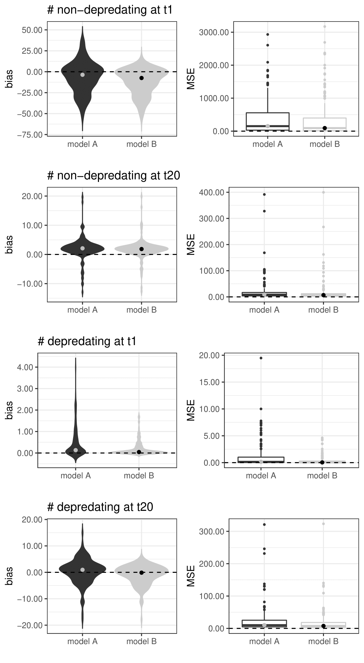
Figure 4. Comparison of bias and mean square errors (MSE) for the number of depredating and non-depredating killer whales in year 1 and 20, estimated using models A and B. Violin and box plots show the distributions of mean bias and MSE, respectively over 150 simulated populations. The median of each distribution is shown with a point.
Reference
Kéry, M., & Schaub, M. (2011). Bayesian population analysis using WinBUGS: a hierarchical perspective. Academic Press.

Electronic Supplementary Material S2
Photoidentification

- Photo-identification data collection
Killer whale photo-identification data were collected and made available for the study from January 2003 to December 2018. Photographs of killer whales were taken by fieldworkers on Possession island and by fishery observers on toothfish longliners. This effort was both opportunistic and dedicated. Dedicated photo-identification effort was conducted by researchers during field trips on Possession island in 2009, 2011 and 2012 as well as on longliners from 2008-2011, 2017 and 2018. Fieldworkers on the island took photographs when observing killer whales from the shore using personal camera equipment. Fishery observers on longliners were provided with Canon DSLRs and 100-400 mm telephoto lenses, and took identification photographs of killer whales during depredation events when longlines were being hauled to the surface.
Fieldworkers and fishery observers were all trained in photo-identification protocols and DSLR camera use prior to departing to Crozet. These protocols were developed in the 1970s in the coastal waters of the north-eastern Pacific (British Columbia, Canada) by Bigg et al. (1976). They rely on obtaining photographs of the dorsal fin and the saddle patch of killer whales with an angle being as perpendicular as possible to individuals when they come to the surface to breath. The natural shapes and markings visible on these two morphological features were used to distinguish individuals and determine identifications. Eye patches, which vary in shape across individuals and represent a stable feature over time were also photographed and used for the identification of individuals following the same approach as in Towers et al. (2019) for Bigg’s killer whales in the north-eastern Pacific.

- Photo-identification data analysis
The photo-identification data were processed through a visual frame-by-frame analysis (Gasco et al., 2016). Information on the date/time, platform, vessel, location, coordinates, photographer, quality of the individual representation on the photograph, ID of the individual as well as angle and the degree of visibility of its features (dorsal fin, saddle patch and eye patch) were entered in the data base. The quality of individual representations on photographs ranged from poor (quality index of 0) to high (quality index of 2) and was based on sharpness, lighting, distance of subject and its angle. The ID of individuals was represented by an alpha-numeric code (Tixier et al., 2014, 2021).
Information associated with each individual killer whale was entered in a separate data set and included its dates of first and last encounter, its level of marking, and if known, its age and sex. The level of distinctiveness of individuals was an index ranging from 0 for poorly distinctive whales (no visible notches or generic fin shape – identification reliant on high quality images) to 2 for highly distinctive individuals (large notches or peculiar fin shape – identification usually possible with low quality images). The sex of subadult and adult males was determined based on the large size and shape of their dorsal fins. Among remaining killer whales, individuals were confirmed as adult females when photographed with an associated calf, or when photographed > 5 years without the dorsal fin growing beyond the size of an adult female. Individuals were assigned an age class based on the methodology and life history parameters used for killer whales in the north-eastern Pacific (Towers et al., 2019, 2020). Calves (< 2 years old) were determined from body size and lack of saddle pigmentation. Juveniles (> 2 years old and < 10 years old) were determined from body size or, when known, from the exact year of birth. Females first photographed as physically mature and having had a calf during the study period were considered to be born at least 10 years prior to the birth year of their first calf. Males first photographed as sub-adults and as fully mature were considered to be born > 15 and > 20 years before the year of first observation, respectively. For the study, individuals from both sex were considered as adults if ≥ 10 years old.

- Photo-identification data summary
A total of 119,133 photographs usable for killer whale photo-identification were taken during 1,913 encounters between 2003 and 2018, and used for the study. The photo-identification effort was the highest in 2018 from fishing vessels with 16,229 photographs, and in 2011 from Possession island with 3,682 photographs (Table 1 & Figure 1a). Regular killer whales were photographed during 1,705 encounters, including 1,295 encounters from fishing vessels during depredation interactions, and 410 encounters along the shore of Possession island (Table 1). Type-D killer whales were photographed during 208 encounters from fishing vessels only. Photographs allowed for a total of 182 regular killer whales to be identified, including 115 adults, and 54 Type-D killer whales, including 37 adults, to be identified. For regular killer whales, the mean number of individuals identified was 52 ± 18 (SD) adults and 13 ± 6 juveniles per year from fishing vessels, and 17 ± 8 adults and 4 ± 3 juveniles per year from Possession island (n = 16 years). For Type-D killer whales, the mean number of individuals identified was 12 ± 11 adults and 3 ± 3 juveniles per year from fishing vessels (n = 16 years – Table 1).
From the photo-identification data, the cumulative number of adult individuals identified for the first time from fishing vessels per year increased from 19 to 115 for regular killer whales, and from 5 to 37 for Type-D killer whales, between 2003 and 2015 (Figure 1b). This number levelled off past 2015 for both forms.
The number of individuals identified depredating for every 100 photographs taken varied from 0.5 in 2018 to 26 in 2004 for regular killer whales, and from 0 in 2004, 2006 and 2007 to 0.7 in 2014 for Type-D killer whales (Figure 2).

Table 1. Summary of the killer whale photo-identification data collected annually at Crozet between 2003 and 2018, and processed for the study, with: for each platform (fishing vessels or the Possession island shore), the total number of photographs taken; and, for each killer whale form (regular or Type-D) in each platform, the number of encounters during which photographs were taken, and the number of individuals identified as adults (≥ 10 years old) or as juveniles (> 2 and < 10 years old).
 |  | Regular killer whales |  |  | Type-D killer whales
year | # photographs | # encounters | # adults identified | # juveniles identified | # encounters | # adults identified | # juveniles identified
Fishing vessels
2003 | 381 | 9 | 23 | 8 | 5 | 5 | 1
2004 | 23 | 9 | 6 | 0 | 0 | 0 | 0
2005 | 2375 | 36 | 41 | 8 | 8 | 5 | 1
2006 | 697 | 19 | 29 | 6 | 0 | 0 | 0
2007 | 4508 | 41 | 52 | 10 | 0 | 0 | 0
2008 | 2544 | 43 | 51 | 12 | 0 | 0 | 1
2009 | 13648 | 134 | 71 | 12 | 6 | 9 | 3
2010 | 6834 | 107 | 68 | 10 | 3 | 8 | 0
2011 | 6381 | 92 | 56 | 14 | 3 | 7 | 1
2012 | 7409 | 127 | 56 | 11 | 22 | 17 | 3
2013 | 3774 | 63 | 60 | 16 | 13 | 18 | 5
2014 | 5039 | 88 | 61 | 20 | 25 | 28 | 6
2015 | 7441 | 107 | 65 | 17 | 38 | 30 | 6
2016 | 9812 | 126 | 60 | 19 | 29 | 28 | 9
2017 | 13990 | 145 | 65 | 20 | 27 | 27 | 10
2018 | 16219 | 149 | 61 | 22 | 29 | 16 | 6
Possession island
2003 | 361 | 19 | 16 | 1 | 0 | 0 | 0
2004 | 115 | 11 | 9 | 1 | 0 | 0 | 0
2005 | 766 | 16 | 26 | 7 | 0 | 0 | 0
2006 | 1020 | 28 | 22 | 4 | 0 | 0 | 0
2007 | 735 | 50 | 31 | 8 | 0 | 0 | 0
2008 | 461 | 17 | 12 | 1 | 0 | 0 | 0
2009 | 1426 | 40 | 31 | 7 | 0 | 0 | 0
2010 | 756 | 18 | 13 | 1 | 0 | 0 | 0
2011 | 3682 | 61 | 17 | 3 | 0 | 0 | 0
2012 | 1892 | 62 | 16 | 2 | 0 | 0 | 0
2013 | 329 | 12 | 9 | 1 | 0 | 0 | 0
2014 | 306 | 24 | 15 | 4 | 0 | 0 | 0
2015 | 1686 | 14 | 15 | 3 | 0 | 0 | 0
2016 | 3527 | 16 | 19 | 7 | 0 | 0 | 0
2017 | 980 | 20 | 13 | 5 | 0 | 0 | 0
2018 | 16 | 2 | 3 | 1 | 0 | 0 | 0

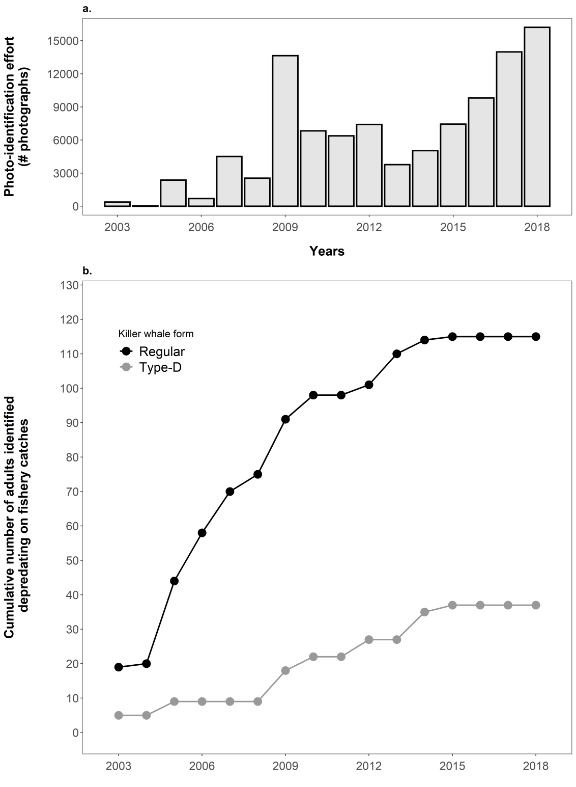
Figure 1. Annual (a) photo-identification effort (number of photographs taken and usable for killer whale photo-identification), and (b) cumulative number of adult killer whale individuals of the two forms (regular and Type-D) identified while depredating on fishery catches at Crozet, between 2003 and 2018.

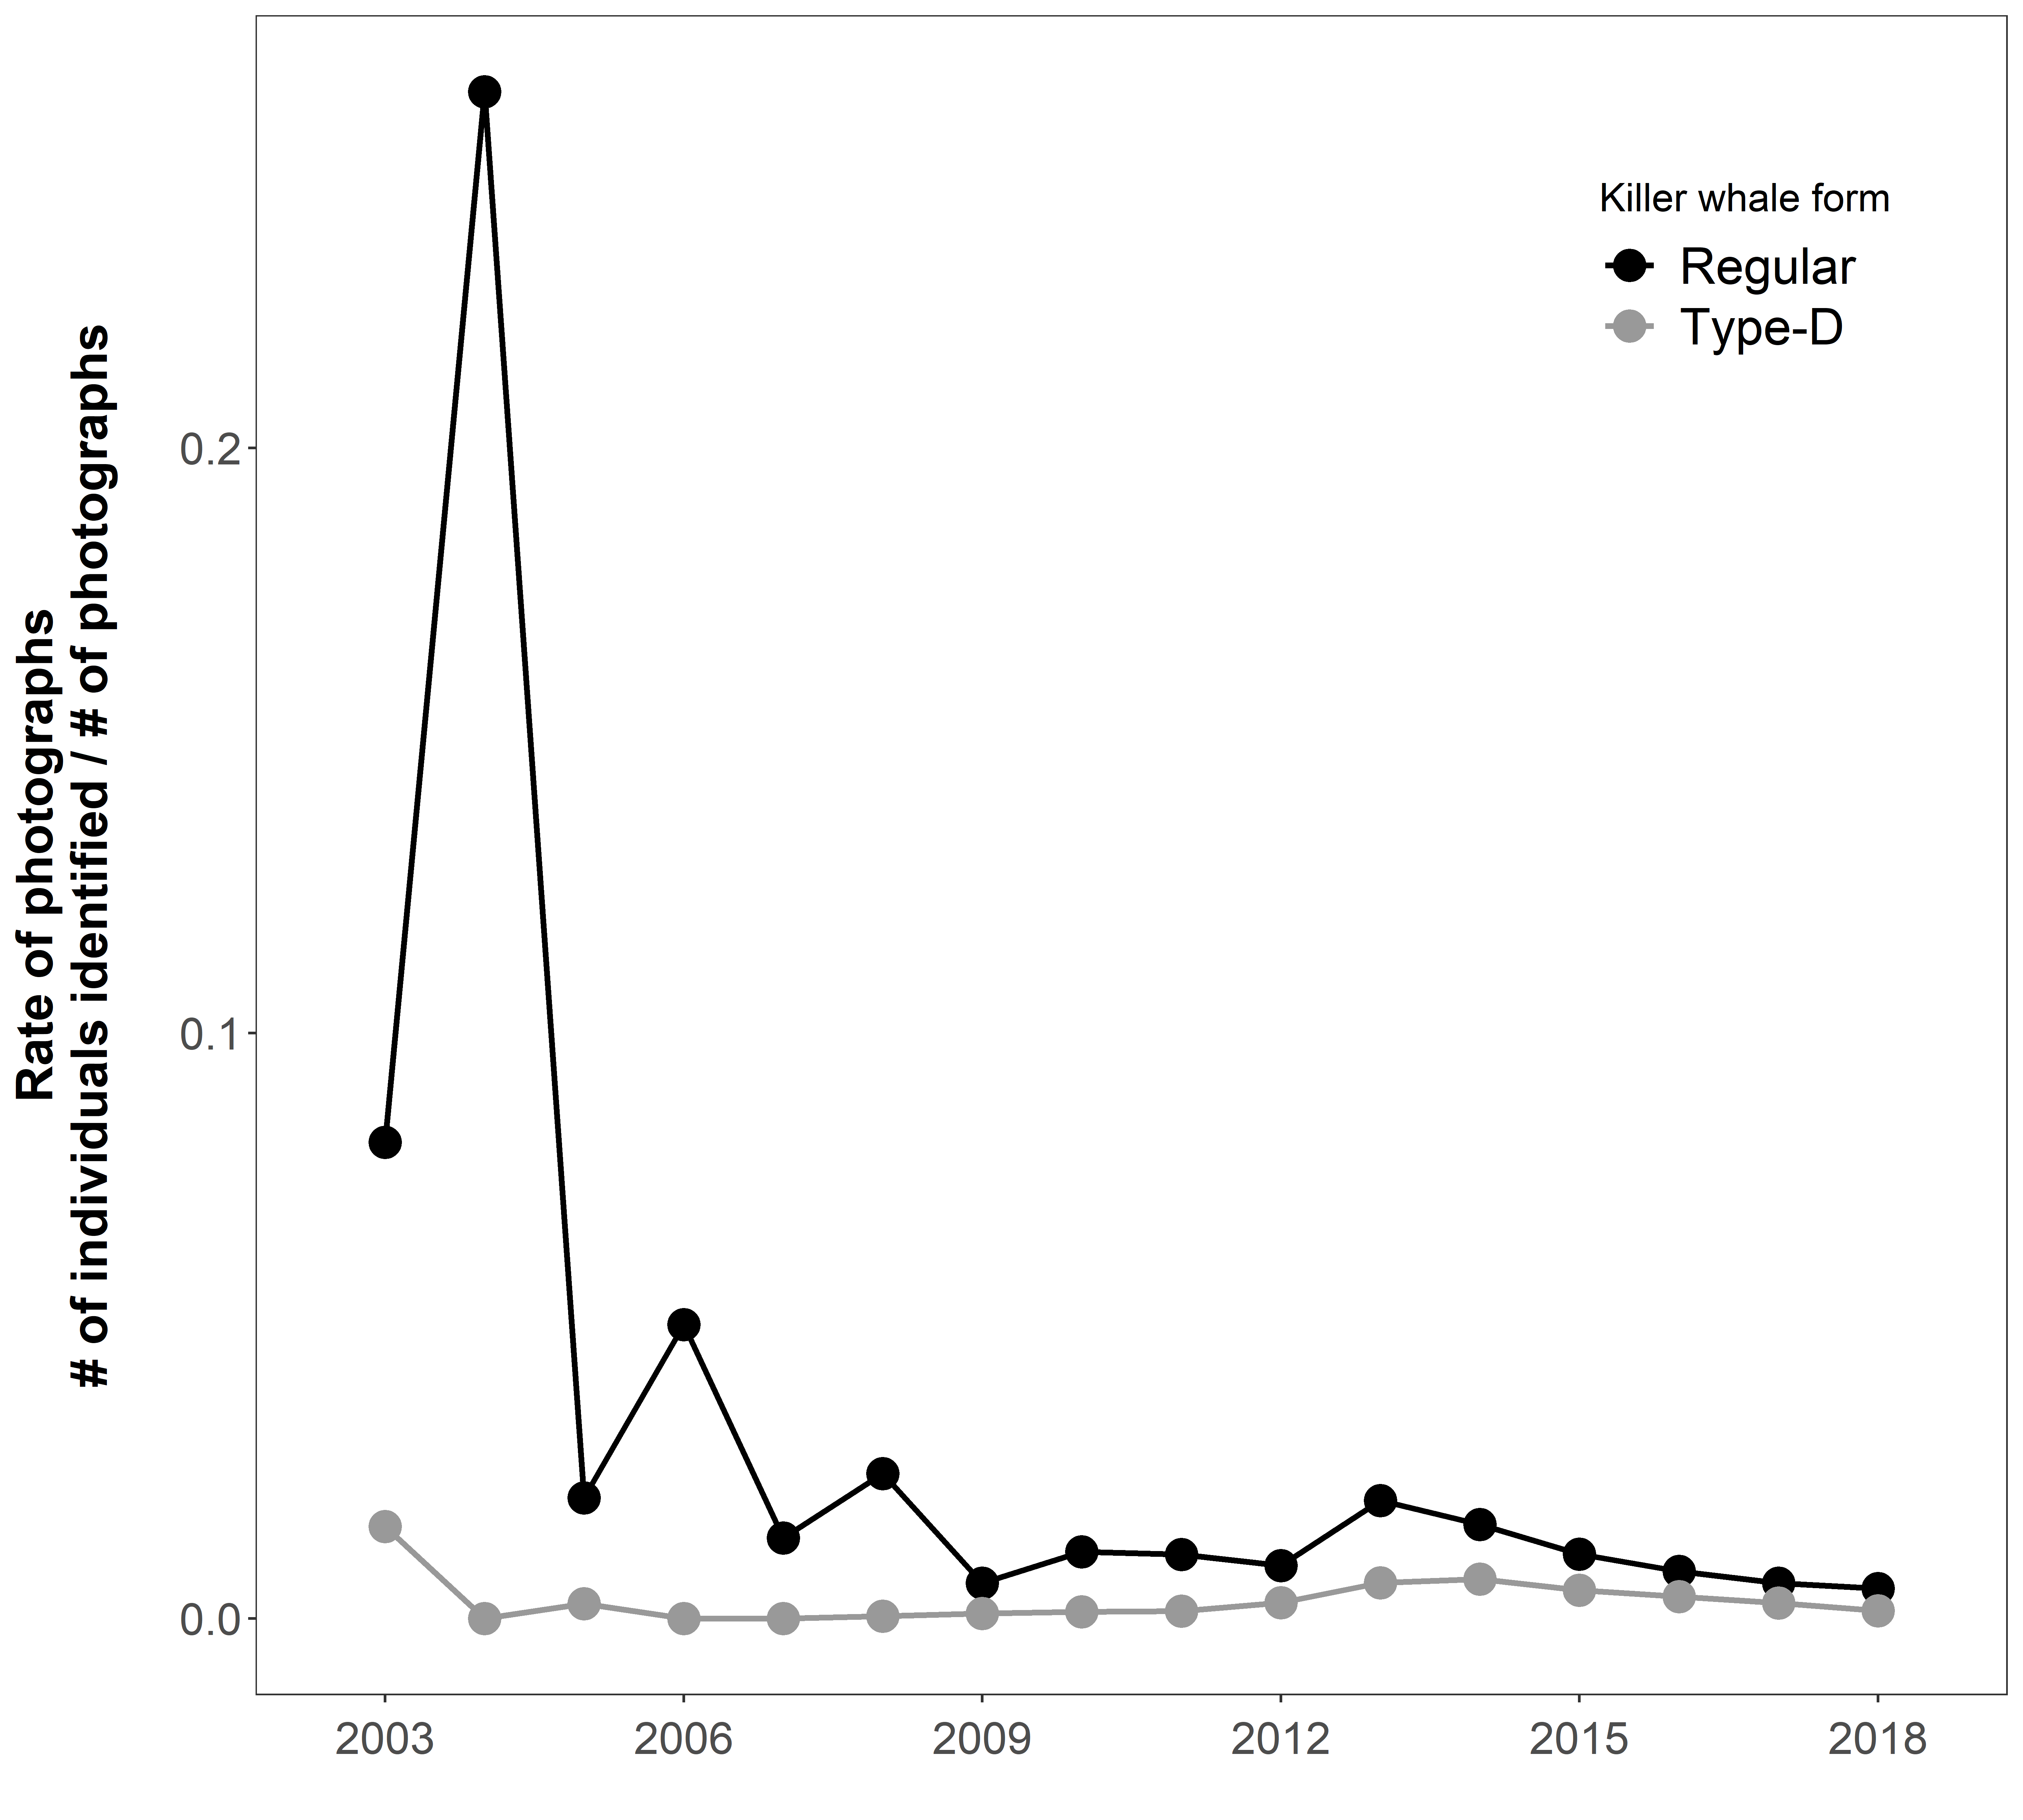

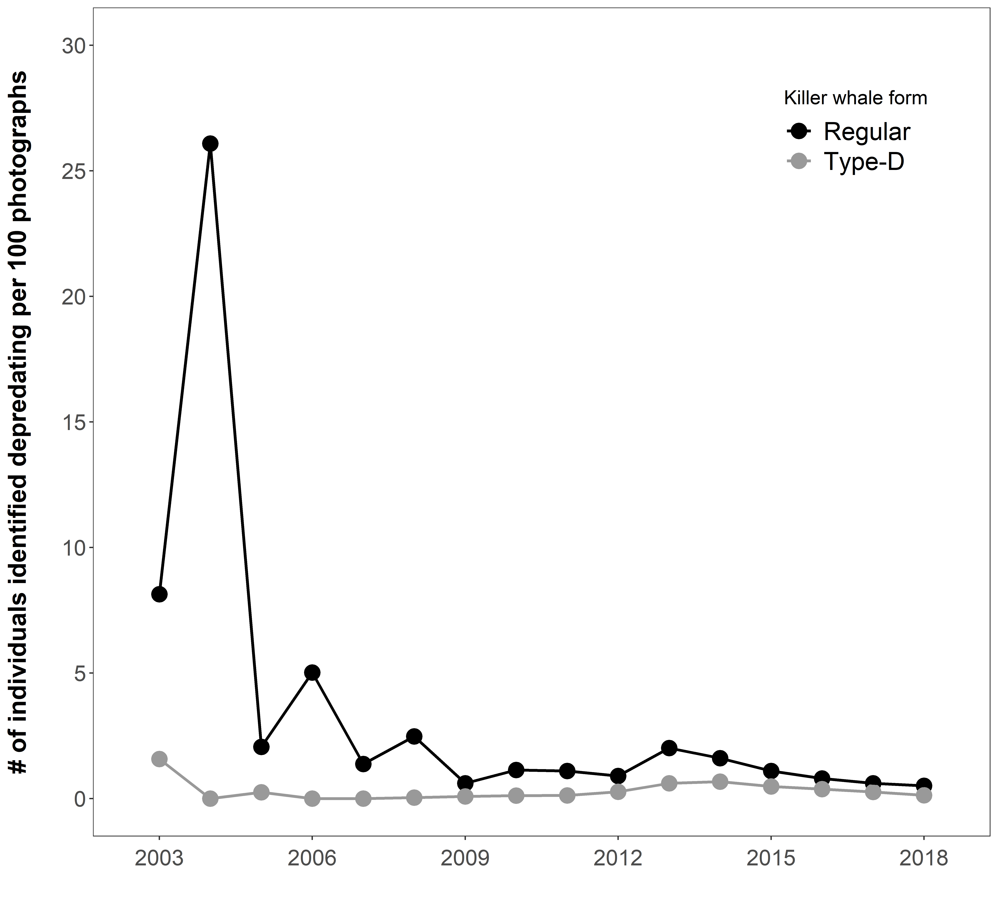
Figure 2. Changes in the number of individuals identified depredating per year for 100 photographs taken from longliners per year and per killer whale form at Crozet (black: regular killer whales; grey: Type-D killer whales) over the 2003-2018 period.
References
Bigg, M. A., McAskie, I. B., & Ellis, G. (1976). Abundance and Movements of Killer Whales off Eastern and Southern Vancouver Island with Comments on Management, Preliminary Report, Arctic Biological Station, Sainte Anne de Bellevue, Quebec, Canada.
Gasco, N., Tixier, P., Soffker, M. & Guinet, C. (2016). Whale depredation data collection guidelines, CCAMLR document, Hobart, Australia, 63pp. https://www.ccamlr.org/en/document/science/whale-depredation-%E2%80%93-data-collection-guidelines
Tixier P., Gasco N., Poupart T., Guinet C. (2014). Type-D killer whales of the Crozet Islands. Villiers en Bois: Centre d’Etudes Biologiques de Chizé-CNRS. DOI: 10.6084/m9.figshare.1060259
Tixier P., Gasco N., Towers J., Guinet C. (2021) Killer whales of the Crozet Archipelago and adjacent waters: photo-identification catalogue, population status and distribution in 2020. Centre d’Etudes Biologiques de Chizé, Centre National de la Recherche Scientifique, France, 167 p.
Towers, J.R., Sutton, G.J., Shaw, T.J.H., Malleson, M., Matkin, D., Gisborne, B., Forde, J., Ellifrit, D., Ellis, G.M., Ford, J.K.B., & Doniol-Valcroze, T. (2019). Photo-identification Catalogue, Population Status, and Distribution of Bigg’s Killer Whales known from Coastal Waters of British Columbia, Canada. Canadian Technical Report of Fisheries and Aquatic Sciences 3311: vi + 299 p.
Towers, J.R., Pilkington, J.F., Gisborne, B., Wright, B.M., Ellis, G.M., Ford, J.K.B., & Doniol-Valcroze, T. (2020). Photo-identification catalogue and status of the northern resident killer whale population in 2019. Canadian Technical Report of Fisheries and Aquatic Sciences 3371: iv + 69 p.

Electronic Supplementary Material S3
Proportion of depredating individuals within Crozet regular killer whale population
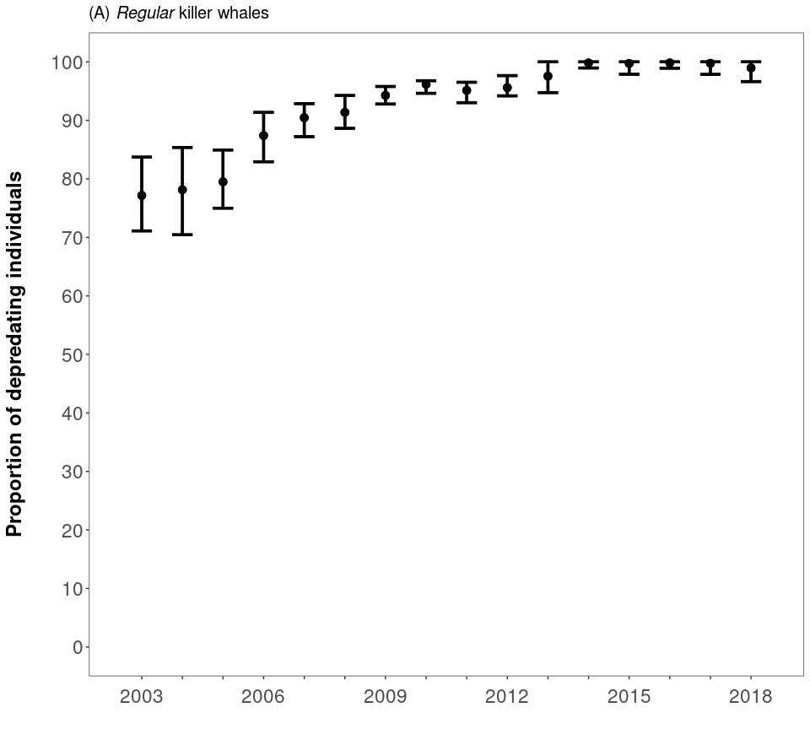

Figure 1. Proportion of depredating individuals within the Crozet regular population and 95% confidence intervals associated.

Electronic Supplementary Material S4
Social network analysis

A social network analysis was conducted using the killer whale photo-identification data collected at Crozet from 2003 to 2018 and the package igraph in R (Csardi & Nepusz, 2006). The analysis aimed to examine the occurrence of associations between individuals, within and across the two forms of killer whales (regular and Type-D) used in the study, and was conducted at two levels:
- The encounter level: individuals were considered as associated if they were photographed during the same encounter. For the data collected from fishing vessels, the duration of an encounter was defined as the time spent hauling one longline set (a main line bearing baited hooks with an anchor, surface line and buoy at each end) during which individual killer whales where photographed while depredating. For the data collected from the shore of Possession island, encounters were defined as starting and ending when individuals were first and last photographed, respectively, either because whales moved out of sight or photographers had to stop their effort.
- The photograph level: individuals were considered as associated if identified on the same photograph.
The analysis included individuals from both forms with a marking level > 0 identified between 2003 and 2018 from all platforms (fishing vessels and Possession island), all individual representations on photographs with a quality index > 0, encounters during which > 1 individual was photographed and identified for the encounter-level analysis, and photographs on which >1 individual was photographed and identified for the photograph-level analysis. From these data, social networks were constructed using the Fruchterman-Reingold force-directed layout algorithm.
For the encounter-level analysis, a total of 91 regular killer whales (including 11 that have only been photographed from Possession island) and 43 Type-D killer whales, as well as 1,413 encounters (1,122 from fishing vessels and 291 from Possession island) were used to construct the social network (Figure 1a). Regular and Type-D killer whales were photographed during the same encounter from fishing vessels on 4 occasions. For the photograph-level analysis, 89 regular killer whales (including 9 that have only been photographed from Possession island) and 42 Type-D killer whales, as well as 8,862 photographs were used (Figure 1b).
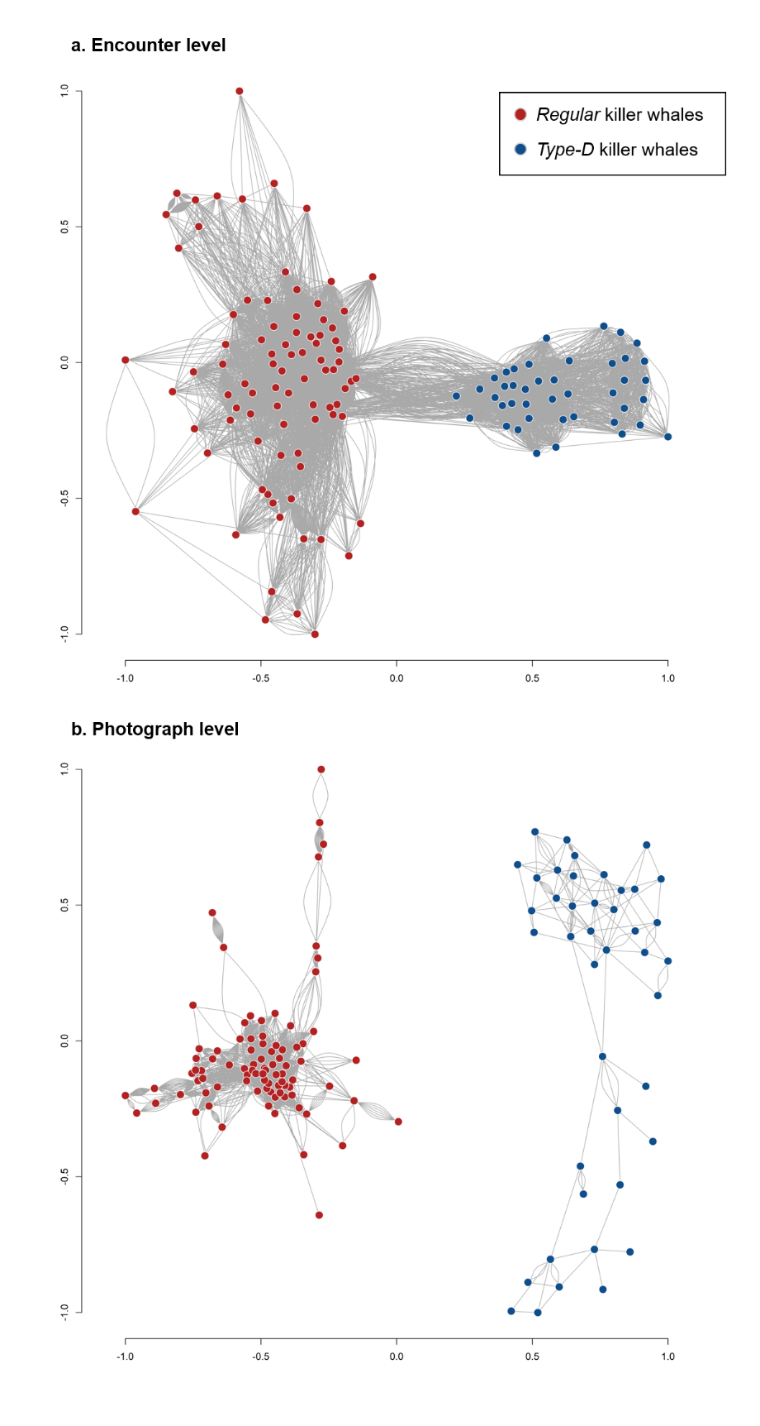.
Figure 1. Social networks of regular (red dots) and Type-D (blue dots) killer whale individuals identified at Crozet between 2003 and 2018 from both fishing vessels and Possession island, with a. individuals considered as associated if photographed during the same encounter, and b. individuals considered as associated if photographed on the same photograph.

References

Csardi G, Nepusz T (2006). “The igraph software package for complex network research.” InterJournal, Complex Systems, 1695. https://igraph.org.

