Use the "Insert Citation" button to add citations to this document.
Supporting Information
Poly (N-vinylpyrrolidone) Modified Phosphomolybdate-based Nanoparticles Mitigates Plasma Protein Corona Formation for Nanodrug Design
Youyi Yu, Behafarid Ghalandari, Guangxia Shen, Liping Wang, Xiao Liu,Aiting Wang, Sijie Li, Haiyang Xie* and Xianting Ding*
State Key Laboratory of Oncogenes and Related Genes, Institute for Personalized Medicine, School of Biomedical Engineering, Shanghai Jiao Tong University, Shanghai, 200030, China.

Table of Contents
- Experimental details
- Electron microscopy analysis
- Size statistics analysis
- FTIR spectra
- The model proteins adsorption conditions
- Fluorescence emission spectra of proteins with CDS-PMo₁₂@PVP₀ NPs
- Fluorescence emission spectra of proteins with CDS-PMo₁₂@PVP₁ NPs
- Stern-Volmer plot, Modified Stern-Volmer plot and the binding logarithmic graph
- The heatmap of differential proteins
- The top ten up-regulated and down-regulated proteins.

1. Experimental details
Synthesis of cesium dodecylsulfate (CDS).
A saturated water solution of sodium dodecylsulfate (1 g, 3.5 mmole) was treated with 5% HCl (a few drops) to get pH ~ 0. This mixture treated with a saturated water solution of cesium carbonate (0.75 g, 5 mmol) and white waxy solid CDS precipitated upon stirring. The product collected by vacuum filtration and dried at temperature (0.96 g, 2.5 mmol, 72% yield).
Synthesis of CDS-PMo₁₂@PVP₀ NPs
An aqueous solution of H₃PMo₁₂O₄₀.3H₂O (0.01 M, 200 μL) was added dropwise to an aqueous solution of CDS (0.01M, 500 μL) at 25 °C under vigorous magnetic stirring, produced a pale-yellow precipitate CDS-PMo₁₂@PVP₀ NPs immediately.
Synthesis of CDS-PMo₁₂@PVP_{x}(x=0.05~1) NPs
A mixture of 200 µL of a 0.01 M H₃PMo₁₂O₄₀ water solution and 800 µL of different concentration (0.05 g/L, 0.1 g/L, 0.25 g/L, 0.5 g/L, and 1 g/L) of a poly (N-vinylpyrrolidone) (PVP) aqueous, then, the mixture was added to 500 µL 0.01 M water solution of CDS, under vigorous magnetic stirring. The formation process of pale-yellow precipitate slowed down (0.5-24 h). The synthesized nanoparticles named as CDS-PMo₁₂@PVP_{0.05,} CDS-PMo₁₂@PVP_{0.1}, CDS-PMo₁₂@PVP_{0.25}, CDS-PMo₁₂@PVP_{0.5} and CDS-PMo₁₂@PVP₁, respectively.
2. Electron microscopy analysis
Sample preparation for Transmittance electron microscopy analysis
Nanoparticles deposition for TEM analysis. Freshly synthesized nanoparticles suspended in ddH₂O and a 3 µL aliquot was deposited on a thin carbon film and dried at room temperature.
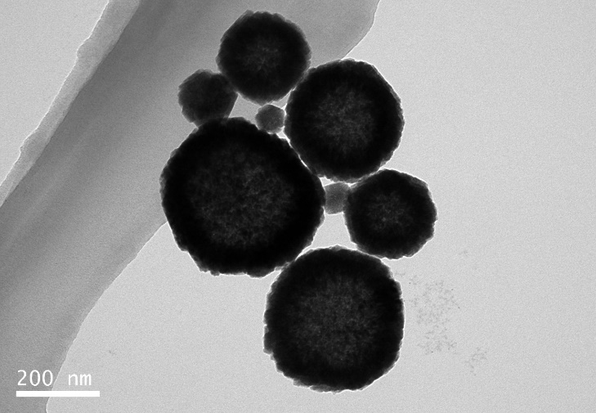

Figure S1 TEM images of the CDS-PMo₁₂@PVP₀ NPs.

- Size statistics analysis
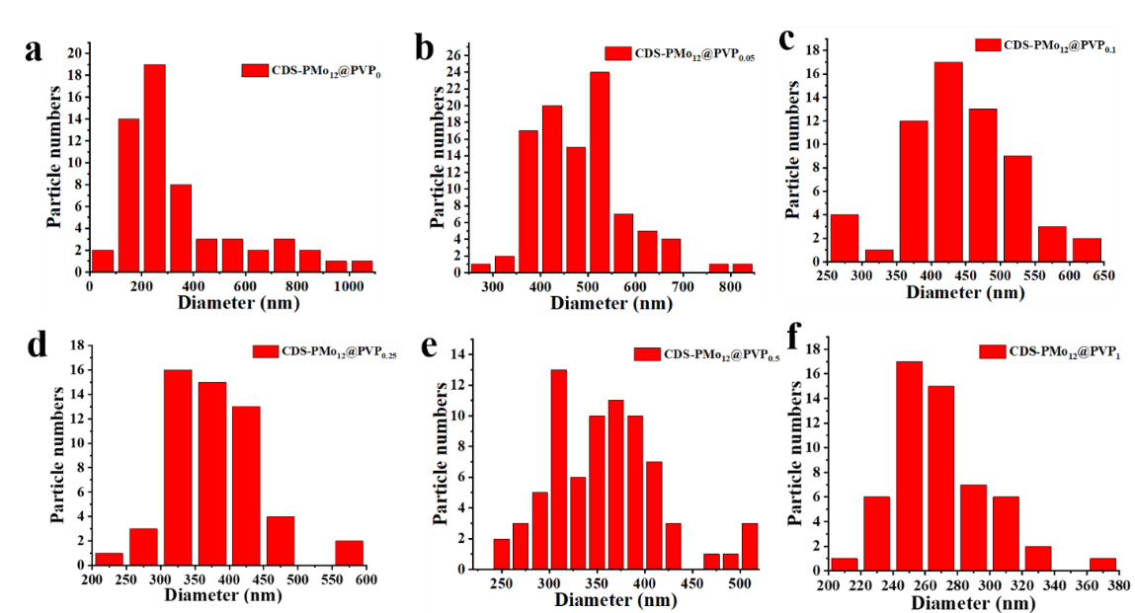
Figure S2 Size distributions of CDS-PMo₁₂@PVP_{x} (x=0~1) NPs. (a) CDS-PMo₁₂@PVP₀, (b) CDS-PMo₁₂@PVP_{0.05}, (c) CDS-PMo₁₂@PVP_{0.1}, (d) CDS-PMo₁₂@PVP_{0.25}, (e) CDS-PMo₁₂@PVP_{0.5} and (f) CDS-PMo₁₂@PVP₁.
- FTIR spectra
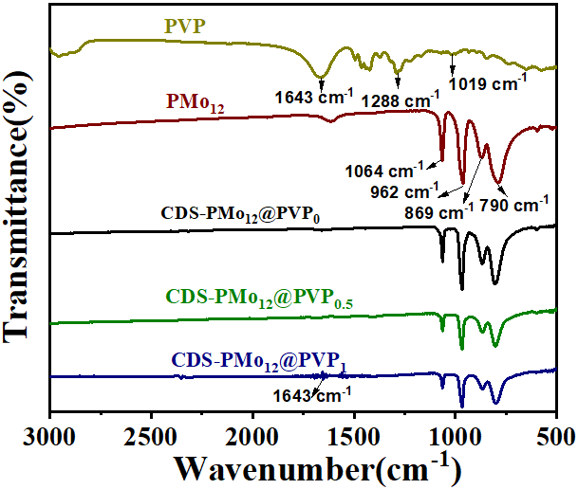
Figure S3 FTIR spectra of the PVP, H₃PMo₁₂O₃₀, CDS-PMo₁₂@PVP_{0,} CDS-PMo₁₂@PVP_{0.5,} and CDS-PMo₁₂@PVP₁ NPs.
- The model proteins adsorption conditions
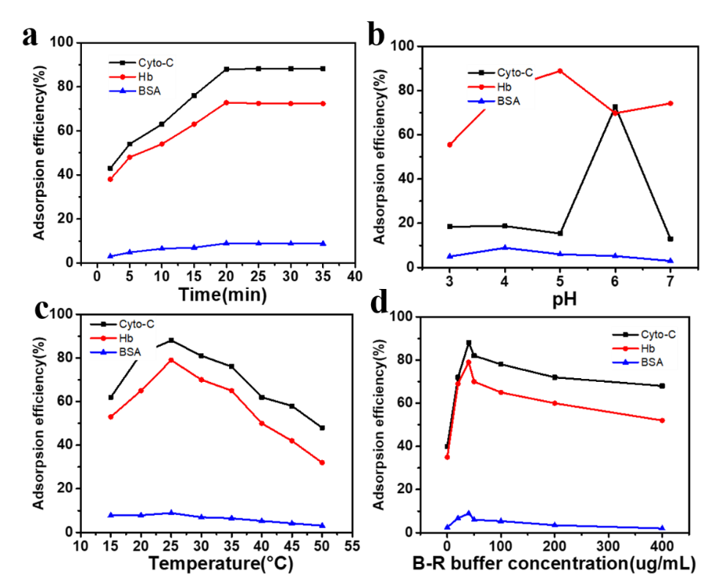
Figure S4 Optimized preparation of absorbent. (a) Adsorption time, (b) pH, (c) temperature and (d) ionic strength of B-R buffer on the adsorption efficiency of BSA, Hb, and Cyt-C. Protein solution: 100 μg/mL, 1.0 mL; CDS-PMo₁₂@PVP₀: 5.0 mg.
- Fluorescence emission spectra of proteins with CDS-PMo₁₂@PVP₀ NPs
Figure S5 Fluorescence emission spectra of (a-b) Cyt-C (d-e) Hb and (g-h) BSA decrease with the increasing amount of CDS-PMo₁₂@PVP₀ NPs at 298 K and 310 K. the maximum fluorescence intensity of (c) Cyt-C, (f) Hb and (i) BSA decrease in the presence of CDS-PMo₁₂@PVP₀ NPs (0-15 µM) at 298 K and 310 K, respectively.

- Fluorescence emission spectra of proteins with CDS-PMo₁₂@PVP₁ NPs
Figure S6 Fluorescence emission spectra of (a-b) Cyt-C (d-e) Hb and (g-h) BSA decrease with the increasing amount of CDS-PMo₁₂@PVP₁ NPs at 298 K and 310 K. the maximum fluorescence intensity of (c) Cyt-C, (f) Hb and (i) BSA decrease in the presence of CDS-PMo₁₂@PVP₁ NPs (0-15 µM) at 298 K and 310 K, respectively.

- Stern-Volmer plot, Modified Stern-Volmer plot and the binding logarithmic graph
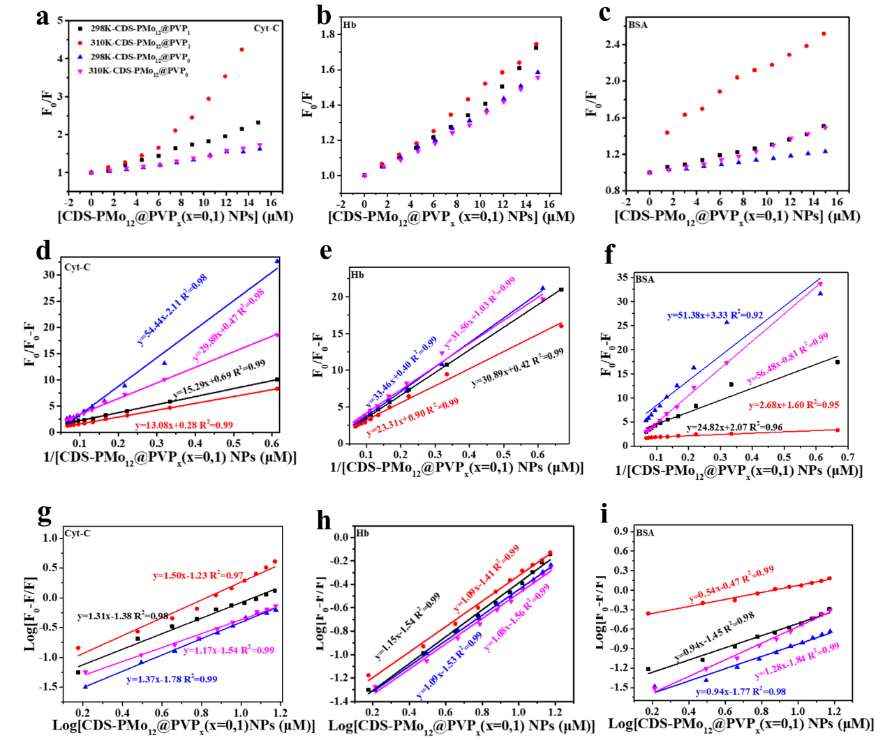
Figure S7 Stern-Volmer plot derived from the fluorescence emission spectrum of the (a) Cyt-C, (b) Hb, and (c) BSA interaction with PMo₁₂ NPs. The Modified Stern-Volmer plot of (d) Cyt-C, (e) Hb, and (f) BSA interaction with PMo₁₂ NPs. The binding logarithmic graph of (g) Cyt-C, (h) Hb, and (i) BSA interaction with PMo₁₂ NPs at 298 K and 310 K, respectively.

- The heatmap of differential proteins
Figure S8 The heatmap of 76 differential proteins of CDS-PMo₁₂@PVP₁ comparing to CDS-PMo₁₂@PVP₀, as identified by LC-MS/MS.

- The top ten up-regulated and down-regulated proteins.
Table S1 The top ten up-regulated and down-regulated proteins of 76 differential proteins.

