Supplementary Material

Table S1. River runoff in the modeling area
River | Water runoff, km³ y⁻¹ | Box with river mouth
Rhine | 91.5 | 64
Elba | 27.2 | 60
Seine | 17.8 | 66
Loire | 26.3 | 95
Garonne | 20.2 | 97
Northern Dvina | 110 | 26
Pechora | 129 | 26
Ob | 394 | 24
Yenisei | 624 | 24
Lena | 515 | 21
Hatanga | 105 | 21
Indigirka | 50 | 20
Kolyma | 120 | 20
Mackenzie | 306 | 8
Nelson | 75 | 141
Saint Lawrence | 311 | 113

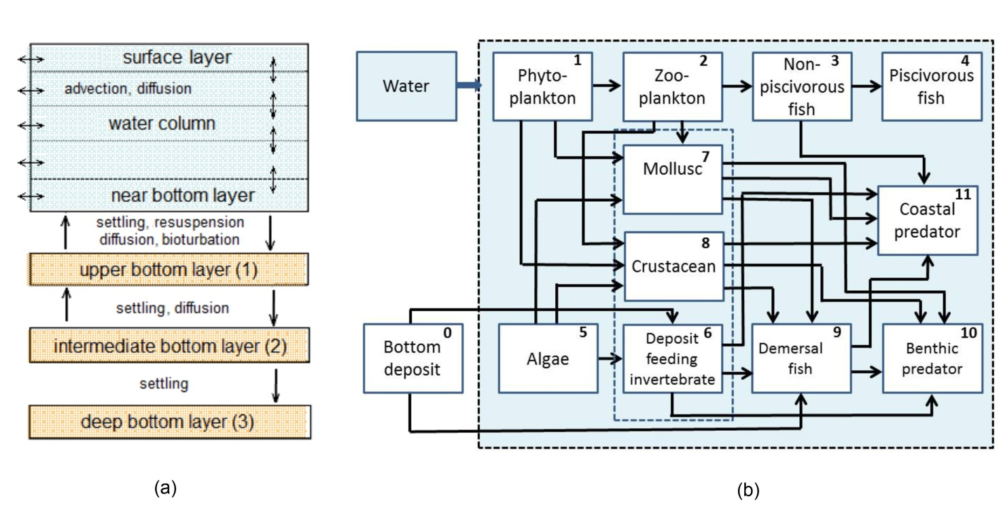
Supplementary Figure 1. (a) Structure of a compartment system in the POSEIDON-R model (Maderich et al., 2018a). (b) Radionuclide transfers from the water and bottom sediment boxes to marine organisms (Bezhenar et al., 2016a). The radionuclide transfers among marine food web compartments are given for 11 types of marine organisms.

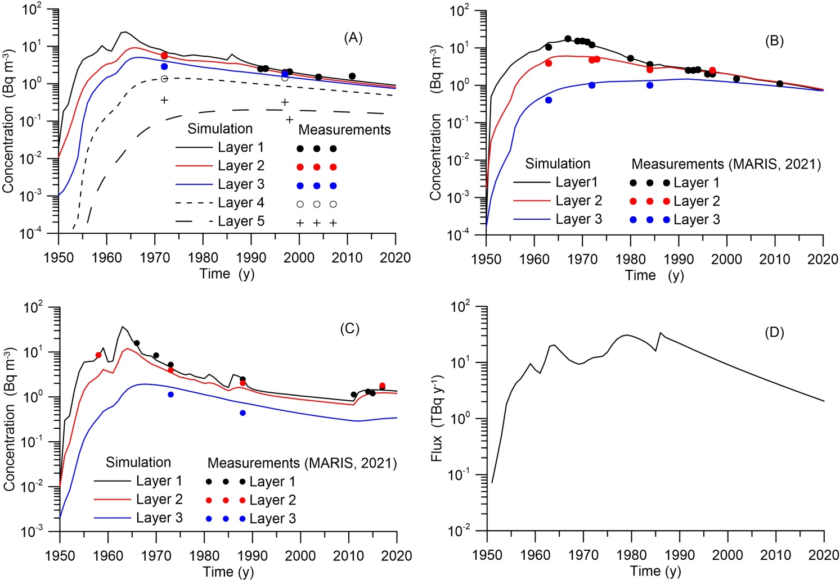
Supplementary Figure 2. Comparison of the model-predicted concentration of ¹³⁷Cs in compartment layers with measurements (MARIS, 2021) in Central Atlantic (A), the Gibraltar Strait (b), Bering Sea (C), and model predicted flux of ¹³⁷Cs in the Danish Straits to the North Sea (D).

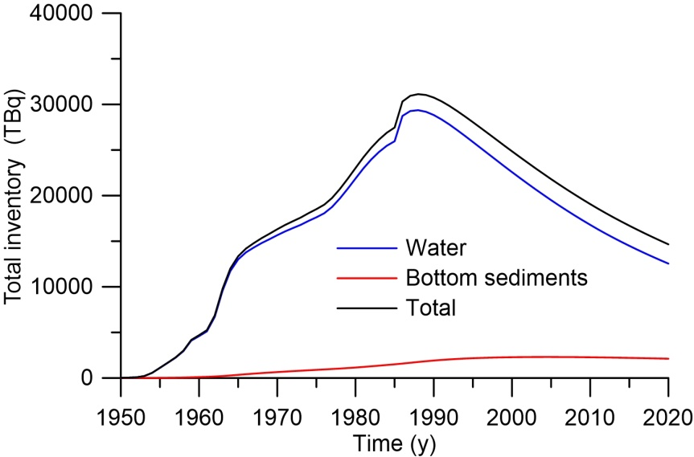
Supplementary Figure 3. Inventory of ¹³⁷Cs in the Arctic Oceans.
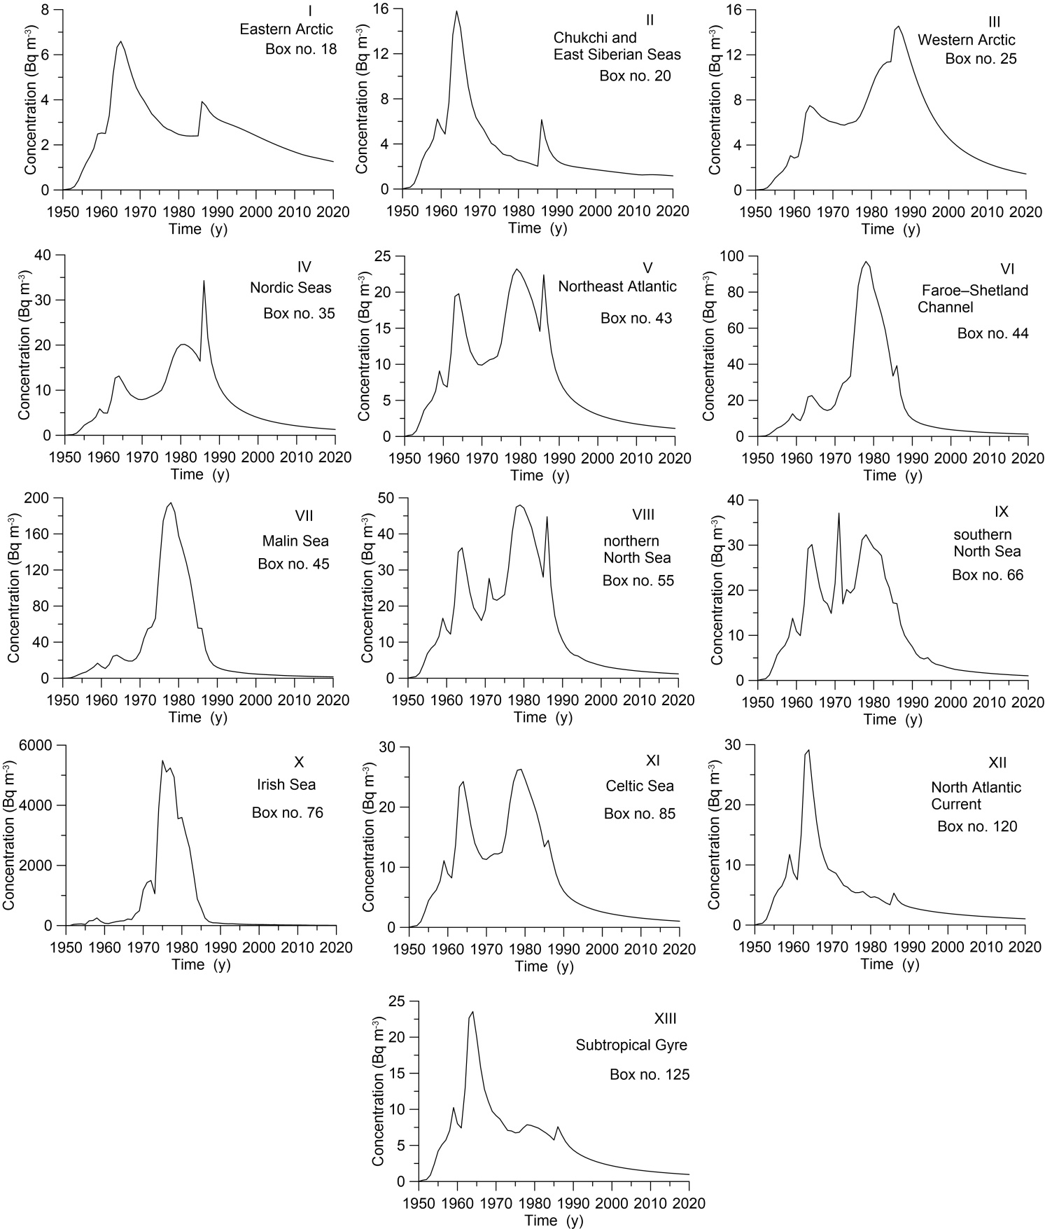
Supplementary Figure 4. Etalon box distribution of 137Cs concentration in water for regions I-XIII in Fig. 10-11.

