Supplemental 2: Chondrichthyan remains retrieved from leopard seal (Hydrurga leptonyx) scats in New Zealand waters

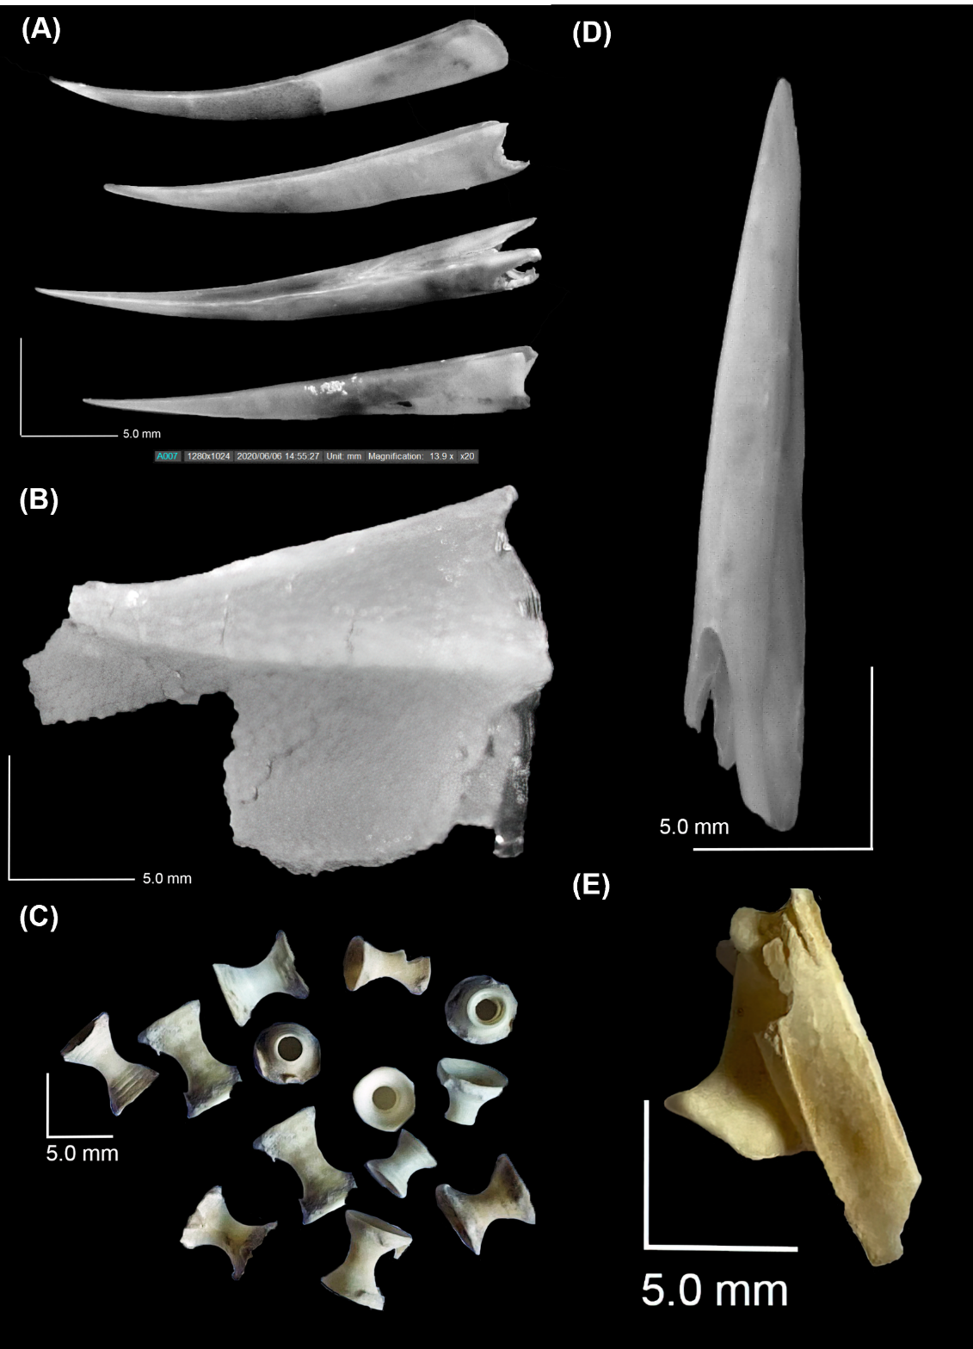
Figure SM2: Examples of hard parts extracted from scats, indicative of chondrichthyan remains including: A) and (D) dorsal fin spine sheaths, (B) right upper jaw, (C) vertebrae and (E) right clasper. Photographs © Chris Lalas, supplied to LeopardSeals.org

Table SM2: Frequency of occurrence (FoO) of recognisable chondrichthyan remains retrieved from leopard seal (Hydrurga leptonyx) scats (n=9) in New Zealand waters. Seven scats contained either intact elements (dorsal spine sheaths or claspers) or pieces of elements (jaws) reliably identified as originating from spiny dogfish (Squalus acanthias; SPD). The other two scats contained only vertebrae (‘Vertebrae present + diagnostic absent’) which could not be reliably designated to SPD but could be designated to the class of chondrichthyans (i.e., they may have been SPD or any of the other species of chondrichthyans).

Recognisable chondrichthyan remains | FoO | Number of elements
 |  | Total | Range
Elements reliably designated to SPD
Dorsal spine sheaths | 5 | 19 | 1-8
Upper jaws (palatoquadrate cartilage) | 2 | 3 | 1-2
Lower jaws (Meckel's cartilage) | 1 | 2 | 2-2
Claspers (part of male pelvic girdle) | 2 | 3 | 1-2
Chondrichthyan vertebrae
Vertebrae present + diagnostic SPD present | 5 | 244 | 12-93
Vertebrae absent + diagnostic SPD present | 2 | - | -
Vertebrae present + diagnostic SPD absent | 2 | 49 | 6-43

