Supplemental Materials 1: Detailed methodology for leopard seal predation assessment

Unpublished records
Sighting networks
Three‘sightings networks’ were established to monitor leopard seal movements within the locations that showed the greatest number of leopard seal sightings (North to South; Northland, Auckland and Otago) (Hupman et al., 2020). In Northland, particularly in the Whangarei/Tutukaka areas the sightings network consisted of LeopardSeals.org researchers/affiliateswho monitored platforms/pontoons known to be used regularly by leopard seals as well as monitoring marinas, beaches and other haul-out sites such as the back of vesselsalong the coastline. Similar protocols were applied in Auckland, however in Otago due to the lack of marinas and sites which were consistently and regularly used by leopard seals, the network relied more heavily on opportunistic data gathering.

Trail cameras
Within the Northland and Auckland regions, a motion detection 12MP 940nm LED Acorn Ltl-5210A Infrared Trail Camera (powered by 8x AA batteries) was used at two known leopard seal haul-out platforms.The locations chosen for monitoring were based on sightings data from LeopardSeals.org researchers/affiliates or citizen scientists (Hupman et al.,2020). A camera was initially attached to a pile mooring at Westhaven Marina, Saint Marys Bay, Waitematā Harbour, Auckland (36°50’, 174°44’) to which a free-floating pontoon (not accessible by land) was attached. The height of the pontoon varied continually with the rise and fall of the tidewhile the camera remained stationary attached to a pile. The camera monitored the haul-out site between 23 December 2016 and 25 April 2018 and the SD card was replaced every week. The camera was then relocated to a private pontoon in Marsden Cove Marina, Marsden Point, Whangarei Harbour, Whangarei (35°50’, 174°28’) (accessible by land). The camera was installed using a tripod placed on an adjacent pontoon and therefore the height of the camera remained constant (~+1.2 m)relative to the pontoon being observed. The camera monitored the haul-out site between 29 April 2018 and 9 August 2019 and the SD card was replaced every week when sightings were reported and every fortnight/three weeks when no sightings were reported in the region.

Individual identification
Individual identification was completed by taking photographs and/or videos (hereafter referred to as photographs) of leopard seals, examining unique pelage patterns together with scars (e.g.,Hirukiet al., 1999; Forcada and Robinson 2006; Hupman et al.,2020).Photographs were taken from multiple angles including face left, face right, body left, body right and body under (Figure 1). Photographswere assessed for quality and categorised as: (a) poor, (b) fair, (c) good, or (d) excellent quality following Hupman et al., (2018). When photographswere categorised as poor or fair quality they were not used for individual identification.

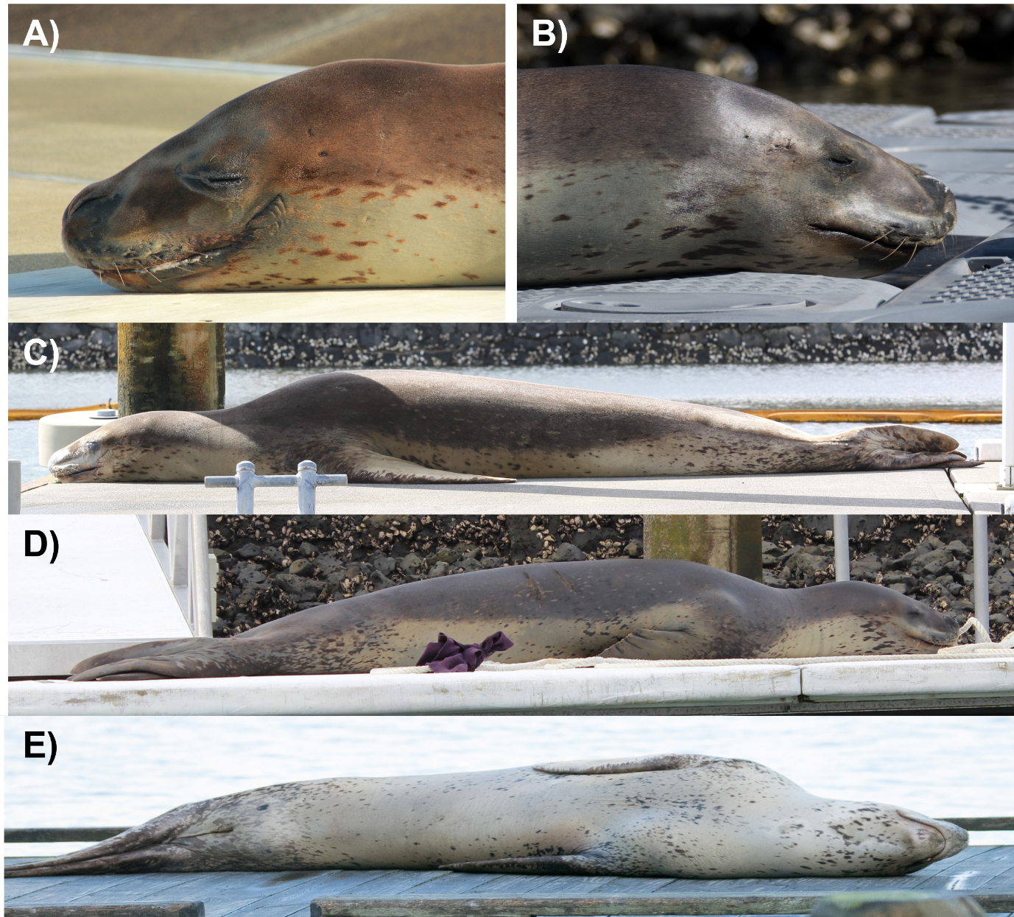
Figure SM1-1: Leopard seal (Hydrurgaleptonyx) photograph angles captured for individual identification.Angles include: A) face left (FL), B) face right (FR), C) body left (BL), D) body right (BR) and E) body under (BU). PhotographS: LeopardSeals.org.

Species confirmation
For species confirmation, each observation of predation or scat was classified with a validation category (using methods adapted from Shaughnessy et al., 2012 and Hupman et al., 2020) as: (1) ‘Certain’ if anobservation of predationor scat was:(a) observed/collected by a LeopardSeals.org researcher/affiliate who confirmed recognisable features of a leopard seal¹; (b) observed/collected by citizen scientistsand was accompanied bya ‘proof of presence’ photograph with recognisable features of a leopard seal;(2) ‘Probable’ if an observation of predation or scat was (a) observed/collected but was not accompanied by a ‘proof of presence’ photograph with recognisable features of a leopard seal, but the observation/collection was made by an experienced observer such as a LeopardSeals.org researcher/affiliate or marine mammal tourism operator and (3) ‘Possible’, in that a citizen scientistreported anobservation of predation or collected a scat sample,but no evidence was available. For this study, only observations of predation or scat classified with a validation category of Certain or Probable were used.

New Zealand Leopard Seal Catalogue (NZLSC)
The NZLSC contains individually identified leopard seals photographed within NZ (Hupman et al., 2020). Each individual within the NZLSC has been assigned a ‘core catalogue’ number and in some circumstances a ‘nickname’ (LeopardSeals.org unpublished data). Core catalogue numbers are formatted as ‘HLNZ-00x’ and areonly assigned to individuals that have a photographof the left side of the face (although other angles, such as right side of face, right and/or left side of the body and/or body under may also be photographed)(LeopardSeals.org unpublished data). This is to ensure that there is no duplication of individuals within the core catalogue. As such, individuals that do not have a photographof the left side of the face but have photographsof other angle(s) (as above) are assigned a ‘pseudo catalogue’ number in the format of ‘HLNZ-P001’ in anticipation that future photographs collected of that individual may include a photograph of the left side of the face and the individual, and therefore can be upgraded into the core catalogue (LeopardSeals.org unpublished data). All matches and/or any new individuals entered into the NZLSCare confirmed by a minimum of two LeopardSeals.org researchers (following methods described in Hupman et al.,2018).

When good or excellent quality leopard seal photographs were not available, individual identification was not attempted, unless one of the following criteria could be met: (1) the leopard seal could be individually identified to the NZLSC in the field by a LeopardSeals.org researcher/affiliate and/or (2) there were photographs available of a leopard seal, sighted on the same day and and the same location collected from another source.

Individual identification was classified as Certain when a sighting was accompanied by a photograph, and the individual in the photograph was able to bematched to an individual in the NZLSC. Individual identification was classified as Probable when a sighting was not accompanied by a photograph, but the individual was: a) identified in the field by a researcher/affiliate familiar with the NZLSC b) recorded on the same date and location as another sighting in which the individual had been matched to the NZLSC or c) recorded in the same region as a known resident individual matched to the NZLSC, and with no other leopard seals having been sighted in this region either 30 days prior or post the record.

Scat collection
At times, multiple scats were located during the same event, either clustered together (within 30 cm of each other) or separated (>30 cm apart). If the defecations were clustered, it was not always possible to determine if they were part of the same bowel movement or not, therefore, although the number of scats was noted, these were considered to be the same event, and were ‘bundled together’ as one scat (hereafter referred to as a ‘scat bundle’). Alternatively, if the scats were separated (>30cm apart), these were considered to be separate bowel movements and therefore these were collected as separate scats and logged separately.

Tooth wear
Tooth wear was assessed during each observation of predation or if the seal was present, during scat collection. Assessment was made when photographs showed the individuals teeth by examining for any evidence of tooth wear. Tooth wear was noted as either present (yes) or absent (no).

Body condition
Body condition was assessed during each observation of predation or if the seal was present, during scat collection. Assessment was made when photographs showed the entire body of the leopard seal (i.e., head to tail) and when the photograph was taken from a perpendicular angle. Leopard seal body condition was scored qualitatively based on the visibility of bony protrusions including the sagittal crest, zygomatic arch, neural spines, rib bones and pelvic bones (see Hupman et al.,2020 for further details). When a body protrusion was visible it was scored as 1 and when it was not visible it was scored as 0 (see Hupman et al.,2020 for further details). Scores were summed, and each leopard seal’s body condition was classified as: (A) severe (score of 5; all bony protrusions were visible); (B) poor (score of 3-4; most bony protrusions were visible); (C) good (score of 1-2; some bony protrusions were visible), or; (D) excellent (score of 0; no bony protrusions were visible) (see Hupman et al.,2020 for further details). If photographs were unavailable, or if the photographs were not suitable for body condition assessment (i.e., not representative of the entire body or not taken from a perpendicular angle), the body condition was classified as undetermined. All undetermined records were excluded from body condition analyses.

Registers
A NZ leopard seal ‘predation register’ (PR) was established. The PR contained details of the observation including the: (a) date, (b) time, (c) season, (d) location (including specific details of the site, location region and latitude/longitude), (e) type (intact prey or embedded spines); (f) observer(s) name, (g) seal’s NZLSC number/’nickname’ (if the animal was an identified individual in the NZLSC), (h) seal sex (male or female), (i) seal ageclass (pup, juvenile or adult; see Hupman et al., 2020 for further details) and (j) unique identification number (see above for further details). The PR also contains details of prey species identification including the:(a) prey identification expert’s name(s) and institution(s), (b) prey species identified and (c) certainty of identification (certain, possible, not identifiable).

A NZ leopard seal ‘scat register’ (SR) was established. The SR contained details of the scat including the: (a) date, (b) time, (c) season, (d) location (including specific details of the site, location, region and latitude/longitude), (e) number of scats (representing either individual scats or scat bundles), (f) collector(s) name(s), (g) seal’s NZLSC number/’nickname’ (if the animal was an identified individual in the NZLSC, (h) seal sex (male or female), (i) seal ageclass (pup, juvenile or adult; see Hupman et al., 2020 for further details) and (j) unique identification number (see above for further details). The SR also includes information on scat processing including the: (a) date, (b) processor(s) name, (c) material type(s) recovered and(d) suspected prey type(s) recovered. Lastly, the SR also contains details of prey species identification including the: (a) method of identification (either morphological or DNA sequencing), (b) prey identificationexpert’s name(s) and institution(s), (c) prey species identified and (d) certainty of identification (certain, possible, not identifiable).

References
Forcada, J., and Robinson, S. L. (2006). Population abundance, structure and turnover estimates for leopard seals during winter dispersal combining tagging and photo-identification data. Polar Biol. 29(12), 1052-1062.
Hall-Aspland, S.A., and Rogers, T.L. (2004). Summer diet of leopard seals (Hydrurgaleptonyx) in Prydz Bay, eastern Antarctica. Polar Biol. 27, 729-734.
Hiruki, L. M., Schwartz, M. K., and Boveng, P. (1999), Hunting and social behaviour of leopard seals (Hydrurgaleptonyx) at Seal Island, South Shetland Islands, Antarctica. Proc. Zool. Soc. Lon. 249, 97-109.
Hupman, K., Stockin, K. A., Pollock, K., Pawley, M. D. M., Dwyer, S. L., Lea, C., et. al. (2018) Challenges of implementing mark-recapture studies on poorly marked gregarious delphinids. PLoS One 13(7), e0198167.
Hupman, K., Visser, I. N., Fyfe, J., Cawthorn, M., Forbes, G., Grabham, A. A., et al.,(2020). From Vagrant to Resident: occurrence, residency and births of leopard seals (Hydrurgaleptonyx) in New Zealand waters. N. Z. J. Mar. 54(1), 1-23.
Laws, R. M. (1993).“Identification of species”. In, Antarctic seals: Research methods and techniques (1st edition), ed. R. M. Laws (Cambridge: Cambridge University Press), 17-21.
McMillan, P. J., Francis, M. P., James, G. D., Paul, L. J., Marriott, P., Mackay, E., et al., (2019). New Zealand fishes. A field guide to common species caught by bottom, midwater, and surface fishing. New Zealand Aquatic Environment and Biodiversity Report 208, prepared for Fisheries New Zealand. Wellington: Ministry of Primary Industries.
Roberts, C.D., Stewart, A.L., and Struthers, C.D. (2015). The Fishes of New Zealand. Wellington: Te Papa Press.
Seersholm, F. V., Cole, T. L., Grealy, A., Rawlence, N. J., Greig, K., Knappe, M., et al.,(2018). Subsistence practices, past biodiversity, and anthropogenic impacts revealed by New Zealand-wide ancient DNA survey. Proceedings of the National Academy of Science115, 7771–7776.
Shaughnessy, P. D., Kemper, C. M., and Ling, J. K. (2012). Records of vagrant phocid seals (family Phocidae) in South Australia. Aust. Mammal. 34(2), 155-169.
Shepherd, L. D., and Campbell, M. (2021). Ancient DNA analysis of an archaeological assemblage of Chondrichthyes vertebrae from South Auckland. New Zealand Journal of Archaeological Science: Reports 36, 1-6.
Simon, C., Frati, F., Beckenbach, A., Crespi, B., Liu, H., and Flook, P. (1994). Evolution, weighting, and phylogenetic utility of mitochondrial gene sequences and compilation of Conserved Polymerase Chain Reaction primers. Ann.Entomol. 87, 651-701.
Valentini, A., Miquel, C., Nawaz, M. A., Bellemain, E., Coissac, E., Pompanon, F., et al.,(2009). New perspectives in diet analysis based on DNA barcoding and parallel pyrosequencing: the trnL approach. Mol. Ecol.Resour. 9, 51-60.
van der Linde, K., Visser, I. N., Bout R, Lalas, C., Shephard, L., Hocking, D., et al. (2021). Leopard seals (Hydrurgaleptonyx) in New Zealand waters predating on chondrichthyans. Frontiers in Marine Science.

Characteristics used to identify leopard seals included their profile (large, very long and slender with a large shoulder and disproportionately large ‘reptilian’ head with a long snout) and colour/pelage pattern (darker dorsally, liberally spotted with light and dark grey, and black spots; relatively sharp line of demarcation along sides; fore flippers light with dark spots; head has broad silver-grey band along upper lip) (Laws 1993; Hupmanet al., 2020).

