Supplementary Material

Supplementary Data: DNA protocols
DNA was extracted from all penguin faecal samples using the QIAamp DNA Stool Mini kit (Qiagen, Germany) following the manufacturer protocol called “Isolation of DNA from Stool for Human DNA Analysis” with minor modifications (QIAGEN, 2012). A negative sample (i.e. procedural blank) was also included to test contamination level during the DNA extraction phase.
A betadisper test was run to test homogeneity of dispersion among breeding stages, which is a condition for adonis (betadisper and adonis functions from package ‘vegan’ in R; Oksanen et al., 2019). Adonis was used to test whether DNA composition among groups was similar or not.

Protocol used during the king penguin prey DNA extraction phase
Briefly, ~200 mg of solid samples, and 200 µl of liquid samples were transferred into 2 ml microcentrifuge tubes. Buffer ASL (1.6 ml) was added to the sample, and the mixture homogenized by vortexing for 1 minute before centrifugation at 14,000 x g for 1 min at room temperature. Supernatant (1.4 ml) was combined with an InihibitEX tablet (included in the kit) in a new 2 ml microcentrifuge tube, and the contents vortexed until the tablet was suspended. The suspension was then incubated for 1 minute at room temperature before centrifugation at 14,000 x g for 3 minutes at room temperature. The supernatant was transferred into a new 1.5 ml microcentrifuge tube and centrifuged again at 14,000 x g for 3 minutes at room temperature. Six hundred µl of supernatant was then combined with 25 µl of proteinase K and 600 µl Buffer AL and vortexed for 15 seconds before incubation at 70 °C for 10 minutes. Six hundred µl of 100% ethanol was added and the mixture vortexed before loading the QIAamp spin columns. Six hundred µl was loaded each time, with centrifugation at 14,000 x g for 1 minute before discarding the flow through. Five hundred µl Buffer AW1 was added to each spin column and centrifuged at 14,000 x g for 3 minutes, and the flow through discarded. The same was repeated for Buffer AW2. Spin columns were placed in new 2 ml microcentrifuge tubes and centrifuged again for 3 minutes to eliminate carryover of Buffer AW2 before being placed in a final new 1 ml microcentrifuge tube. DNA was eluted using 100 µl of Buffer AE by centrifuging at 14,000 x g for 1 minute at room temp. DNA was dehydrated at 60°C and sent for sequencing analysis for Eukaryota, Actinopterygii and Crustacea to the School of Biological Sciences at the University of Western Australia (Perth, Australia). A negative sample (i.e. procedural blank) was also included to test contamination level during the DNA extraction phase.

Protocol used for the king penguin prey DNA analysis (sequencing done by the University of Western Australia).

Faecal DNA metabarcoding overview
The DNA metabarcoding protocol followed the procedure used by (Koziol et al., 2019). Three PCR primer sets were used: “16S Fish” (Deagle et al., 2007; Berry et al., 2019a) “16S Crustacean” (Berry et al., 2019) and “Universal Eukaryote” (Pochon et al., 2013). These primer sets were adapted for the Illumina Miseq platform with fusion tag primers consisting of a unique multiple identifier (MID), sequencing adapters and the marker-specific sequence. PCRs were performed in duplicate for each DNA extract, including extraction and filtration controls, to minimize PCR bias that may result from a single reaction. Template DNA was purified using a Qiagen stool DNA kit.

Polymerase chain reaction amplification of DNA metabarcodes
PCRs had a 25 μl total volume and consisted of the following: 2.5 mM/l MgCl2 (Applied Biosystems, USA), 1× PCR Gold buffer (Applied Biosystems), 0.25 mM/l dNTPs (Astral Scientific, Australia), 0.4 mg/ml bovine serum albumin (Fisher Biotec, Australia), 0.4 μmol/l forward and reverse primer, 1 U AmpliTaq Gold DNA polymerase (Applied Biosystems) and 0.6 μl of a 1:10,000 solution of SYBR Green dye (Life Technologies, USA). Each mastermix was dispensed using a Qiagility PCR platform (Qiagen). Thermal cycling was conducted on a StepOne Plus (Applied Biosystems) real‐time PCR instrument with the following conditions: 95°C for 5 m followed by 50 cycles of 95°C for 30 s, annealing temperature of 51°C (Universal Eukaryote and 16S Crustacean), 54°C (16S Fish); and 72°C elongation for 45 s. PCR mastermixes were made up in a dedicated clean room free of DNA extracts, and all pre‐ and post‐PCR operations were performed in separate laboratories and using UV‐sterilized cabinets to minimize the risk of cross‐contamination.

DNA sequencing library preparation and sequencing
Each sample was prepared for single‐step fusion‐tag library building using unique index tags following the methods of DiBattista et al. (2017). PCR products were pooled to form an equimolar library. Libraries were size‐selected using a Pippin Prep instrument (Sage Sciences, USA) for fragments between 160–450 bp (16S Fish and 16S Crustacean) and 250–600 bp (Universal Eukaryote) and purified from excess PCR reaction components with a Qiaquick PCR purification kit (Qiagen). Final libraries were quantified using a LabChip GX Touch HT (PerkinElmer, USA). Parallel sequencing was performed on an Illumina MiSeq platform (Illumina, USA) with a 300 cycle V2 kit for both 16S assays and a 500 cycle V2 kit for the universal eukaryote assay.

DNA sequence data processing
Paired‐end reads for the Universal Eukaryote assay were stitched together with a minimum requirement of an 11 base pair overlap using AdapterRemoval v2 (Schubert et al., 2016). Low‐quality reads with an average Q score below 20 or that contained nucleotide ambiguities were removed from the data set. Sequences were assigned to each sample using MID tag combinations in Geneious v. r10 software. Only reads with exact matches to MID tags, sequencing adapters and template‐specific primers were kept for downstream analyses. Sequences were further processed in Usearch 9.2 (Edgar, 2010) where reads with expected error rates of 1% and minimum sizes of 70, 100 and 200 bp for 16S Crustacean, 16S Fish and Universal Eukaryote, respectively, were discarded. The remaining sequences were subsampled to 10,000 sequences per sample for 16S Crustacean and 16S Fish, and 40,000 sequences for Universal Eukaryote. Samples were dereplicated into unique sequences and abundance filtered. A minimum of five reads were required for taxonomic assignment.

Taxonomic assignment of DNA metabarcodes
Unique sequences were compared to the National Center for Biotechnology Information nucleotide reference database “GenBank” release 233 (Sayers et al., 2018) using a local Basic Local Alignment Search Tool (blastn) v2.2.31 run by a high‐performance cluster computer (Pawsey Supercomputing Centre; Perth, WA, Australia). Each blastn result was curated by checking alternative perfect matches, the geographic range of identified taxa and whether identified taxa were unequivocal contaminants, such as human sequences.

References
Berry, T. E., Saunders, B. J., Coghlan, M. L., Stat, M., Jarman, S., Richardson, A. J., et al. (2019). Marine environmental DNA biomonitoring reveals seasonal patterns in biodiversity and identifies ecosystem responses to anomalous climatic events. PLoS Genet. 15, e1007943.
Deagle, B. E., Gales, N. J., Evans, K., Jarman, S., Robinson, S., Trebilco, R., et al. (2007). Studying Seabird Diet through Genetic Analysis of Faeces: A Case Study on Macaroni Penguins (Eudyptes chrysolophus). PLoS One 2, e831.
DiBattista, J. D., Coker, D. J., Sinclair-Taylor, T. H., Stat, M., Berumen, M. L., and Bunce, M. (2017). Assessing the utility of eDNA as a tool to survey reef-fish communities in the Red Sea. Coral Reefs 36, 1245–1252.
Edgar, R. C. (2010). Search and clustering orders of magnitude faster than BLAST. Bioinformatics 26, 2460–2461.
Koziol, A., Stat, M., Simpson, T., Jarman, S., DiBattista, J. D., Harvey, E. S., et al. (2019). Environmental DNA metabarcoding studies are critically affected by substrate selection. Mol. Ecol. Resour. 19, 366–376.
Oksanen, J., Blanchet, F. G., Friendly, M., Kindt, R., Legendre, P., McGlinn, D., et al. (2019). Package “vegan” - Community Ecology Package. Version 2.5-5.
Pochon, X., Bott, N. J., Smith, K. F., and Wood, S. A. (2013). Evaluating Detection Limits of Next-Generation Sequencing for the Surveillance and Monitoring of International Marine Pests. PLoS One 8, e73935.
QIAGEN (2012). “QIAamp® DNA Stool Handbook. For DNA purification from stool samples. Second Edition - June 2012.,” in, 44.
Sayers, E. W., Cavanaugh, M., Clark, K., Ostell, J., Pruitt, K. D., and Karsch-Mizrachi, I. (2018). GenBank. Nucleic Acids Res. 47, D94–D99.
Schubert, M., Lindgreen, S., and Orlando, L. (2016). AdapterRemoval v2: rapid adapter trimming, identification, and read merging. BMC Res. Notes 9, 88.

Supplementary Figures and Tables

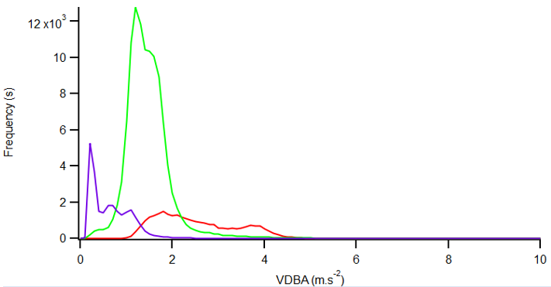
Supplementary Figure 1. Plot showing the frequency (number of s) of Vectorial Dynamic Body Acceleration (VDBA) values for the descent phase of dives (red line), the bottom phase of dives (green line) and the ascent phase of dives (purple line) for one individual.

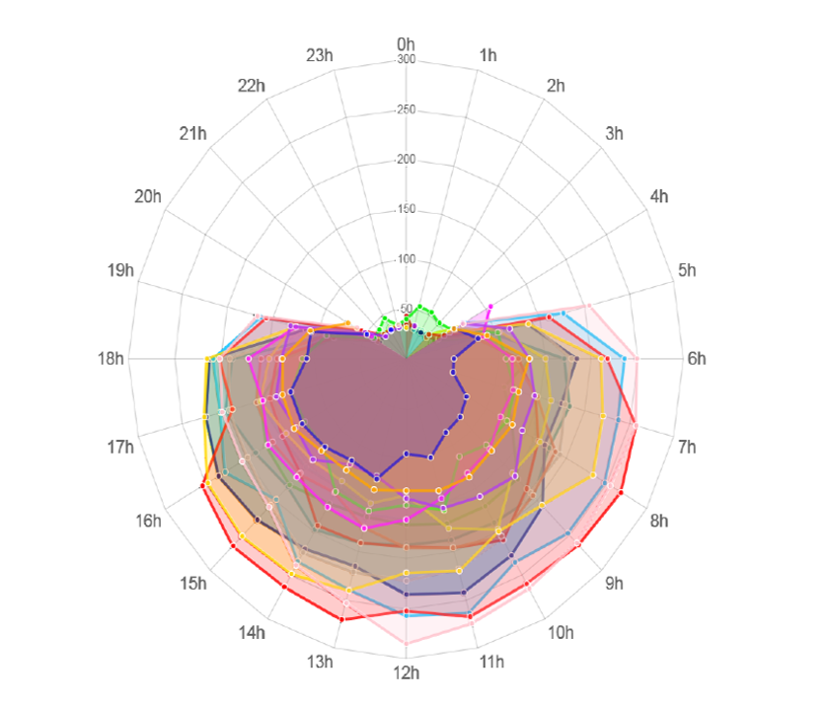
Supplementary Figure 2. Radar chart showing the hourly average dive depth (m) of king penguins from South Georgia. Each colour refers to a single individual. Red arrows represent the sunrise (at 6:05am) and the sunset (at 7:08pm) on the 8th of March 2017, which corresponds to the middle date with birds at sea.

Supplementary Figure 3. Example of an echogram recorded around South Georgia during the Antarctic Circumnavigation Expedition (ACE) (on the 6th of March 2017) showing the presence of dense patches of fish schools (likely to be lanternfish) above a Deep Scattering Layer (screenshot from the Echoview software). Maximum volume backscattering strength (S_{v}; dB re 1m⁻¹) values are shown to emphasize locations of schools.

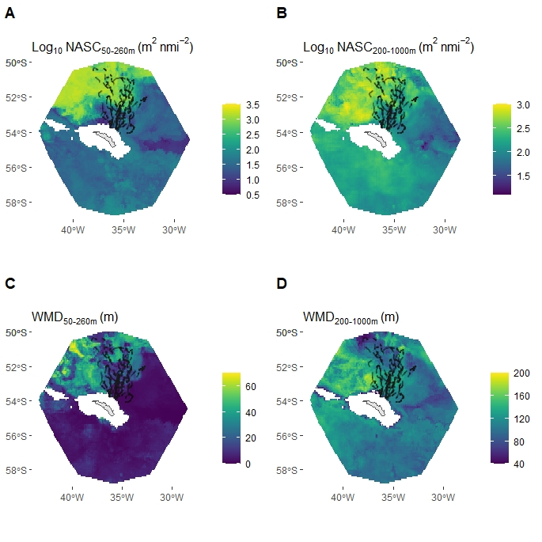
Supplementary Figure 4. Standard deviation of predicted daily daytime nautical-area scattering coefficient (NASC) and weighted-mean depth (WMD) values between 20th February and 18th March 2017 for 17 (bird 14 excluded) chick-rearing king penguins foraging from South Georgia. Foraging domain defined as 1.1 x max foraging range = 508.1 km. Grid cells that had a seabed < 600 m were excluded. All penguin dive locations (with and without prey encounters) shown by black points.

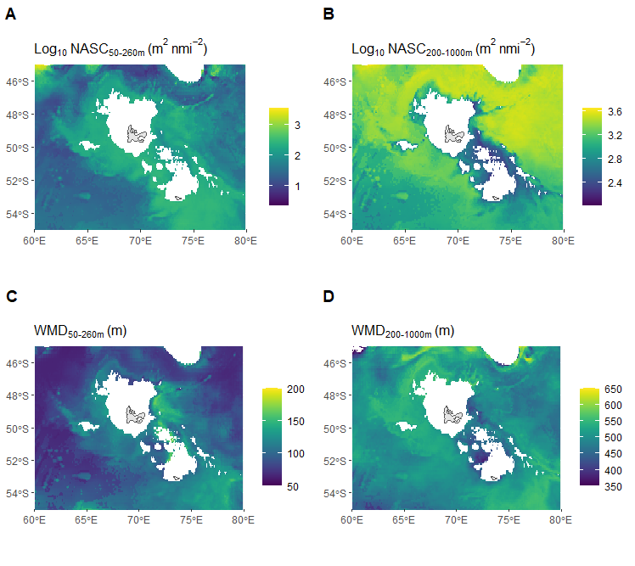
Supplementary Figure 5. Predicted daily NASC and WMD values averaged over the king penguin tracking period (1st February to 18th March 2017) centered on the Kerguelen Islands (known king penguin breeding site). Grid cells that had a seabed < 600m were excluded.
Supplementary Table 1. Trip parameters for each king penguin. Bird number 14 displayed anomalous trip characteristics that were not consistent with birds within this study or previous studies.
Bird ID | Sex | Deployment Date | Deployment Time | Trip Start Date | Trip Start Time | Retrieval Date | Retrieval Time | Trip End Date | Trip End Time | Trip Duration (days) | Path Length (km) | Max distance colony (km)
1 | M | 18/02/2017 | 13:18 | 20/02/2017 | 09:25:12 | 05/03/2017 | 13:40 | 05/03/2017 | 13:30:00 | 13.2 | 1115.7 | 391.7
2 | M | 19/02/2017 | 08:28 | 20/02/2017 | 08:37:00 | 02/03/2017 | 05:50 | 01/03/2017 | 15:39:46 | 9.3 | 926.2 | 328.4
3 | M | 19/02/2017 | 09:05 | 20/02/2017 | 08:03:58 | 27/02/2017 | 11:41 | 27/02/2017 | 11:07:21 | 7.1 | 561.7 | 170
4 | F | 19/02/2017 | 09:40 | 20/02/2017 | 05:52:40 | 26/02/2017 | 10:08 | 26/02/2017 | 07:50:45 | 6 | 576.4 | 227
5 | F | 19/02/2017 | 10:20 | 20/02/2017 | 06:56:41 | 02/03/2017 | 19:10 | 02/03/2017 | 18:40:12 | 10.5 | 853.2 | 270.4
6 | M | 20/02/2017 | 06:01 | 20/02/2017 | 09:30:53 | 28/02/2017 | 08:10 | 26/02/2017 | 21:04:26 | 6.5 | 480.4 | 171.9
7 | F | 20/02/2017 | 09:46 | 20/02/2017 | 14:00:55 | 01/03/2017 | 09:40 | 01/03/2017 | 00:19:15 | 8.4 | 293.9 | 226.1
8 | F | 20/02/2017 | 13:14 | 20/02/2017 | 16:36:06 | 25/02/2017 | 12:17 | 25/02/2017 | 11:24:33 | 4.8 | 300.8 | 101.7
9 | M | 20/02/2017 | 15:10 | 22/02/2017 | 09:27:03 | 05/03/2017 | 11:45 | 28/02/2017 | 23:15:28 | 6.5 | 439.2 | 227.1
10 | F | 20/02/2017 | 17:32 | 21/02/2017 | 08:12:46 | 01/03/2017 | 17:15 | 01/03/2017 | 15:38:54 | 8.3 | 894.5 | 320.3
11 | M | 01/03/2017 | 06:20 | 02/03/2017 | 07:36:05 | 15/03/2017 | 17:41 | 15/03/2017 | 17:41:00 | 13.4 | 1181.2 | 400.5
12 | F | 01/03/2017 | 07:10 | 02/03/2017 | 07:50:38 | 14/03/2017 | 12:00 | 13/03/2017 | 07:15:50 | 11 | 619.3 | 325.2
13 | M | 02/03/2017 | 06:40 | 02/03/2017 | 13:01:20 | 17/03/2017 | 17:30 | 16/03/2017 | 21:33:57 | 14.3 | 984.1 | 354.8
14 | M | 02/03/2017 | 09:25 | 02/03/2017 | 15:00:19 | 20/03/2017 | 11:50 | 20/03/2017 | 11:50:00 | 17.8 | 1837.2 | 672.8
15 | M | 02/03/2017 | 10:45 | 02/03/2017 | 15:35:55 | 10/03/2017 | 11:30 | 10/03/2017 | 05:59:39 | 7.6 | 638 | 248.3
16 | M | 02/03/2017 | 17:05 | 06/03/2017 | 08:58:59 | 22/03/2017 | 12:35 | 22/03/2017 | 12:27:08 | 16.1 | 1356.7 | 461.9
17 | M | 03/03/2017 | 08:25 | 03/03/2017 | 18:24:14 | 14/03/2017 | 06:20 | 13/03/2017 | 22:17:00 | 10.1 | 623.6 | 402.8
18 | F | 08/03/2017 | 14:16 | 09/03/2017 | 08:08:24 | 22/03/2017 | 10:02 | 22/03/2017 | 05:55:43 | 12.9 | 1090.5 | 408.1
Supplementary Table 2. King penguin dive parameters derived from GPS and TDR data (37,275 dives deeper than 4 m). Metrics were calculated in IGOR Pro: the maximum dive depth (deepest point of a dive; m), the dive duration (s), the number of undulations (also called ‘wiggles’, defined as a depth change rate < 0.25 m s⁻¹), the bottom phase duration (defined as the time spent between the first and last wiggle, or the duration of any dive deeper than 75% of the maximum dive depth; s), and the post dive duration (time spent at the surface after a dive). ﻿The beginning and end of the bottom phases were defined based on two possible conditions: (a) the depth was 75 % of the maximum depth of the dive or (b) the first (or last) wiggle was detected. Mean values are given along with standard deviations in parenthesis. Number of days was dependent on the TDR tag battery, which typically ran out before the end of the trip.

Bird ID | Number of days | Number of dives | Maximum dive depth (m) | Dive duration (s) | Post-dive duration (s) | Bottom duration (s) | Number of wiggles | Percentage Descent | Percentage Ascent
1 | 8.3 | 1476 | 79.8 (66.4) | 188.4 (114.4) | 295.4 (2423.5) | 120.7 (65.5) | 8 (4.9) | 0.15 (0.109) | 0.148 (0.103)
2 | 10.3 | 1792 | 58.8 (57.9) | 170.2 (109.1) | 326.5 (2683.8) | 116.6 (67.3) | 8.9 (6.1) | 0.137 (0.12) | 0.133 (0.104)
3 | 7.3 | 1581 | 85.5 (108.6) | 150.8 (128.4) | 247.6 (1906.8) | 87.8 (61.6) | 6.6 (4.9) | 0.169 (0.15) | 0.147 (0.128)
4 | 6.3 | 1567 | 69.7 (73) | 176.6 (108) | 170.5 (1150.3) | 119.3 (63.9) | 10.1 (6.9) | 0.142 (0.116) | 0.137 (0.12)
5 | 10.7 | 1930 | 96.8 (79) | 209.4 (102.2) | 269.2 (1967.2) | 130.4 (55.3) | 9.3 (5.8) | 0.172 (0.114) | 0.158 (0.104)
6 | 6.6 | 1305 | 110.7 (106.9) | 208.7 (134.7) | 230.8 (962) | 121.4 (70) | 8.6 (6.5) | 0.172 (0.131) | 0.162 (0.126)
7 | 8.5 | 2231 | 59.7 (64.4) | 159.5 (108) | 170.9 (1275.7) | 108.3 (65.5) | 9.1 (6.3) | 0.138 (0.124) | 0.132 (0.122)
8 | 4.9 | 1810 | 67 (99.3) | 115.1 (130.2) | 119.3 (615.7) | 66.1 (70.8) | 4.8 (5) | 0.309 (0.195) | 0.29 (0.205)
9 | 6.8 | 1710 | 92.7 (110.9) | 194.3 (130.9) | 148.9 (939.3) | 118.7 (60.4) | 9.3 (6.3) | 0.152 (0.121) | 0.131 (0.121)
10 | 8.4 | 3370 | 44.1 (64) | 103.1 (123.4) | 101.4 (873.1) | 68.7 (78) | 5.8 (5.7) | 0.243 (0.197) | 0.227 (0.197)
11 | 11 | 2215 | 90.2 (89.5) | 210.5 (132.6) | 217.3 (1671.7) | 138.2 (75.9) | 10.6 (7.3) | 0.132 (0.1) | 0.13 (0.105)
12 | 11.1 | 2029 | 97.9 (84.4) | 208.5 (115.6) | 263.3 (1514) | 133.5 (67.2) | 9.6 (5.9) | 0.169 (0.112) | 0.145 (0.11)
13 | 12 | 1444 | 129.2 (99.7) | 221.4 (133) | 495.9 (2560.6) | 121.9 (67.7) | 7.3 (5.3) | 0.207 (0.132) | 0.192 (0.123)
14 | 12 | 5077 | 28.5 (48.9) | 66.4 (102.1) | 137.6 (1316.1) | 42.6 (58.7) | 4 (4.3) | 0.291 (0.224) | 0.274 (0.217)
15 | 7.7 | 2111 | 78.5 (100.7) | 177.1 (142) | 136.1 (788) | 112.9 (80.4) | 9.6 (8.2) | 0.218 (0.178) | 0.199 (0.195)
16 | 11.5 | 1591 | 91.6 (83.3) | 221.1 (133.6) | 385.8 (3740.6) | 142.7 (77.4) | 10.7 (7.1) | 0.143 (0.101) | 0.135 (0.108)
17 | 10.5 | 2159 | 88.7 (94.1) | 201.8 (129) | 220.7 (1848.5) | 134.2 (73) | 10.8 (7.4) | 0.142 (0.131) | 0.135 (0.122)
18 | 11.4 | 1877 | 97.7 (77.3) | 254.8 (122.5) | 269.6 (2047.5) | 177.5 (77.1) | 12.8 (7.3) | 0.137 (0.099) | 0.126 (0.097)

Supplementary Table 3. King penguin prey encounters derived from GPS, TDR and accelerometers (45,958 prey encounters detected deeper than 4 m). Mean values are given along with standard deviations in parenthesis. Number of days was dependent on the accelerometer tag battery, which typically ran out before the TDR tag.

Bird ID | Number of days | Number of prey encounters | Prey encounter depth (m) | Prey encounter duration (s)
1 | 3 | 525 | 59.3 (52.2) | 2.9 (3)
2 | 5.4 | 1817 | 74.2 (38.1) | 3.5 (4.7)
3 | 5.5 | 1759 | 171.3 (80.1) | 4.5 (4.7)
4 | 6.2 | 2857 | 103.9 (58.6) | 4.9 (5.4)
5 | 6 | 2953 | 83.6 (47.9) | 4.3 (5.9)
6 | 5.8 | 3007 | 171 (79.1) | 4.6 (4.7)
7 | 6.7 | 3516 | 95.9 (45.4) | 3.8 (5.2)
8 | 4.2 | 1989 | 188.4 (82.8) | 4.7 (4.6)
9 | 7.1 | 2432 | 185.9 (87.3) | 3.6 (3.1)
10 | 4.5 | 9568 | 89.7 (67.3) | 3.6 (6.7)
11 | 5.2 | 2161 | 151.8 (76.3) | 4.3 (4.5)
12 | 4.8 | 2147 | 97.3 (56) | 3.7 (5.1)
13 | 7.3 | 2494 | 157.4 (67.4) | 3.9 (4.3)
14 | 5.4 | 1634 | 56.5 (57.3) | 2.4 (3.1)
15 | 4.5 | 1551 | 149.5 (86.5) | 4.3 (4.9)
16 | 0 | 0 | NA | NA
17 | 10.5 | 2548 | 146.6 (77.3) | 5 (9.5)
18 | 7.2 | 3000 | 117.9 (53.7) | 3.2 (3.5)

