Supplementary Material

Supplementary Tables
Supplementary Table 1. Summary of granulometric properties of sediments (average ± standard deviation derived from 2 or 3 replicate samples per station). *indicates values derived from only one replicate sample per station. MGS: mean grain size of the sortable silt fraction. Sediments were classified following the Shepard (1954) sediment classification scheme based on relative percentages of sand, silt, and clay.
Station | % gravel | % sand | % silt | % clay | MGS μm | Sediment class.
WJBSh | 5.24 ± 5.24 | 22.06 ± 5.4 | 43.65 ± 7.59 | 29.06 ± 3.01 | 20.56 ± 0.61 | Clavey silt
OGCSl | 0.00 ± 0.00 | 72.21 ± 1.97 | 20.08 ± 1.23 | 7.70 ± 0.74 | 31.42 ± 0.28 | Silty sand
GC | 0.00* | 75.63* | 18.10* | 6.28* | 32.09* | Sand
MNI-1 | 0.00* | 24.08* | 51.51* | 24.41* | 24.62* | Sandy silt
FCoSl | 0.00 ± 0.00 | 44.64 ± 4.15 | 40.60 ± 3.30 | 14.76 ± 0.85 | 30.62 ± 1.20 | Silty sand
NHI-1 | 1.29 ± 1.84 | 73.81 ± 0.22 | 18.15 ± 1.17 | 6.75 ± 0.44 | 38.70 ± 0.43 | Silty sand
NHI-2 | 0.00* | 72.30* | 20.45* | 7.25* | 38.37* | Silty sand
MNI-2 | 0.00 ± 0.00 | 77.13 ± 0.52 | 15.34 ± 0.28 | 7.53 ± 0.24 | 28.82 ± 0.40 | Sand
CC | 0.00 ± 0.00 | 50.43 ± 3.90 | 36.09 ± 2.45 | 13.49 ± 1.45 | 32.75 ± 1.26 | Silty sand
MNI-3 | 0.00* | 53.26* | 30.43* | 16.3* | 30.92* | Silty sand
Supplementary Table 2. Statistic results of ANOVA main tests for all benthic nutrient fluxes considered in our study. *indicates significant p-values (< 0.05). df: degrees of freedom; F: F-statistic; p: p-value.
Nitrate flux
Source | Main test |  | Sum of Squares |  | df | Mean Square | F | p
Depth | ANOVA type III (Tukey) |  | 42212 |  | 1 | 42212 | 0.177 | 0.678
Habitat (depth) |  |  | 210797 |  | 3 | 70266 | 0.295 | 0.828
Res |  |  | 5234503 |  | 22 | 237932
Nitrite flux
Source | Main test |  | Sum of Squares |  | df | Mean Square | F | p
Depth | ANOVA type III (Tukey) |  | 161 |  | 1 | 160.62 | 0.648 | 0.429
Habitat (depth) |  |  | 218 |  | 3 | 72.68 | 0.293 | 0.83
Res |  |  | 5454 |  | 22 | 247.9
Ammonium flux
Source | Main test |  | Sum of Squares |  | df | Mean Square | F | p
Depth | ANOVA type III (Tukey) |  | 2808 |  | 1 | 2808 | 0.076 | 0.7859
Habitat (depth) |  |  | 301903 |  | 3 | 100634 | 2.71 | 0.0697
Res |  |  | 816839 |  | 22 | 37129
Phosphate flux
Source | Main test |  | Sum of Squares |  | df | Mean Square | F | p
Depth | ANOVA type III (Tukey) |  | 247012 |  | 1 | 247012 | 4.275 | 0.0506
Habitat (depth) |  |  | 251192 |  | 3 | 83731 | 1.449 | 0.2557
Res |  |  | 1271225 |  | 22 | 57783
Silicate flux
Source | Main test |  | Sum of Squares |  | df | Mean Square | F | p
Depth | ANOVA type III (Tukey) |  | 8313555 |  | 1 | 8313555 | 2.506 | 0.12768
Habitat (depth) |  |  | 49912070 |  | 3 | 16637357 | 5.015 | 0.00845*
Res |  |  | 72981769 |  | 22 | 3317353
Supplementary Table 3. Statistic results of PERMANOVA main tests of benthic nutrient fluxes. *indicates significant p-values (< 0.05). df: degrees of freedom; SS: sum of squares; MS: mean sum of squares; Pseudo-F: F value by permutation; p(perm): p-value based on 9999 random permutations; Unique perms: number of unique permutations.
Benthic nutrient fluxes

Source | df | SS | MS | Pseudo-F | p (perm) | Unique perms.
Depth | 2 | 30470000 | 15235000 | 0.97979 | 0.5157 | 180
Habitat (depth) | 3 | 50676000 | 16892000 | 4.7058 | 0.0055* | 9947
Res | 25 | 89741000 | 3589600

Supplementary Table 4. Statistic results of ANOVA main tests for all macrofaunal diversity indices considered in our study. *indicates significant p-values (< 0.05). df: degrees of freedom; F: F-statistic; p: p-value.
Total macrofaunal density
Source | Main test |  | Sum of Squares | df | Mean Square | F | p
Depth | ANOVA type III (Tukey) |  | 813140744 | 1 | 813140744 | 103.94 | <0.001*
Habitat (depth) |  |  | 314160502 | 3 | 104720167 | 13.39 | <0.001*
Res |  |  | 179924702 | 23 | 7822813
Total number of taxa
Source | Main test |  | Sum of Squares | df | Mean Square | F | p
Depth | ANOVA type III (Tukey) |  | 74.3 | 1 | 74.3 | 9.371 | 0.0055*
Habitat (depth) |  |  | 71.46 | 3 | 23.82 | 3.004 | 0.0512
Res |  |  | 182.35 | 23 | 7.93
Pielou's evenness (J')
Source | Main test |  | Sum of Squares | df | Mean Square | F | p
Depth | ANOVA type III (Tukey) |  | 0.01648 | 1 | 0.016475 | 13.14 | 0.0014*
Habitat (depth) |  |  | 0.00726 | 3 | 0.00242 | 1.93 | 0.15296
Res |  |  | 0.02884 | 23 | 0.001254
Vertical distribution
Source | Main test |  | Sum of Squares | df | Mean Square | F | p
Depth | ANOVA type III (Tukey) |  | 0.00083 | 1 | 0.00083 | 0.466 | 0.5015
Habitat (depth) |  |  | 0.02031 | 3 | 0.006769 | 3.802 | 0.0238*
Res |  |  | 0.04095 | 23 | 0.001781

Supplementary Table 5. Statistic results of PERMANOVA main tests of macrofaunal community composition. *indicates significant p-values (< 0.05). df: degrees of freedom; SS: sum of squares; MS: mean sum of squares; Pseudo-F: F value by permutation; p(perm): p-value based on 9999 random permutations; Unique perms: number of unique permutations.
Macrofaunal community composition

Source | df | SS | MS | Pseudo-F | p (perm) | Unique perms.
Depth | 2 | 8127 | 4063.5 | 1.4749 | 0.1047 | 180
Habitat (depth) | 3 | 8766.7 | 2922.2 | 2.1136 | 0.001* | 9874
Res | 26 | 35946 | 1382.6

Supplementary Table 6. Statistic results of PERMANOVA main tests of macrofaunal biological trait expression. *indicates significant p-values (< 0.05). df: degrees of freedom; SS: sum of squares; MS: mean sum of squares; Pseudo-F: F value by permutation; p(perm): p-value based on 9999 random permutations; Unique perms: number of unique permutations.
Macrofaunal biological trait expression

Source | df | SS | MS | Pseudo-F | p (perm) | Unique perms.
Depth | 2 | 2200 | 1100 | 2.8484 | 0.1322 | 180
Habitat (depth) | 3 | 1256.7 | 418.88 | 3.5575 | 0.0095* | 9950
Res | 26 | 3061.4 | 117.75

Supplementary Figures
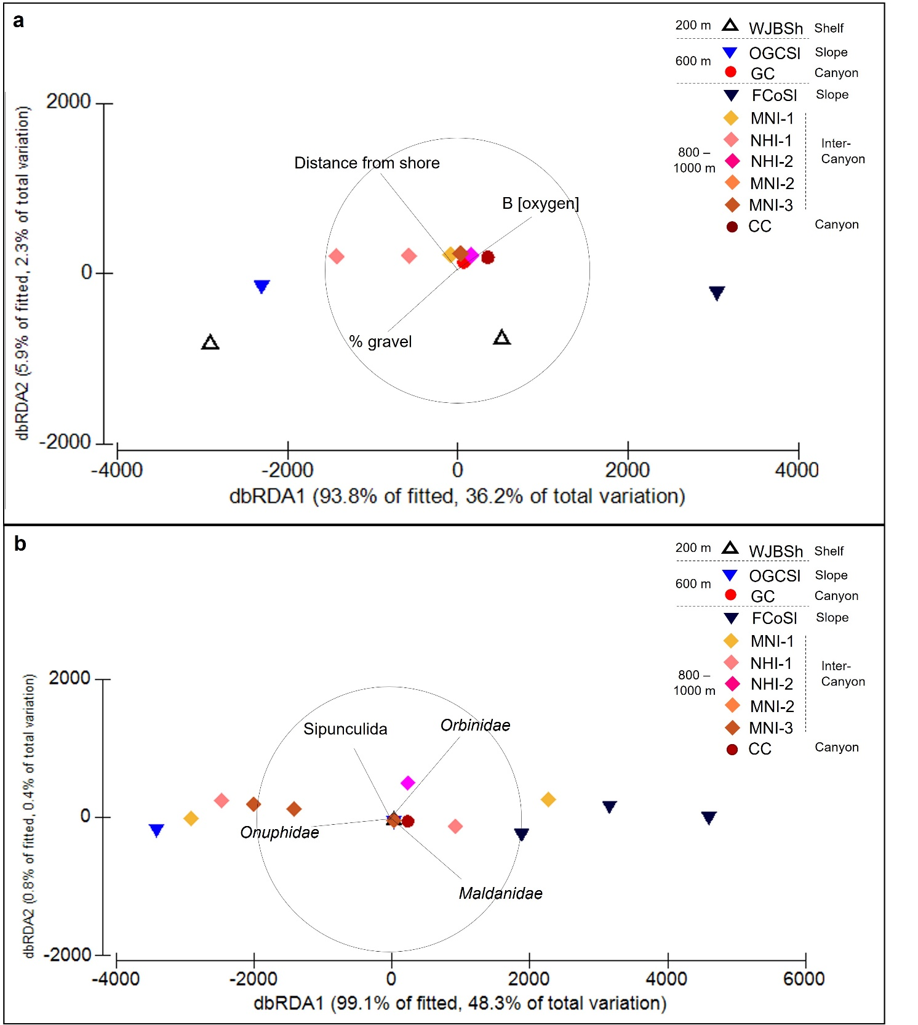
Supplementary Figure 1. Redundancy analysis (dbRDA) from the best distance-based linear model (DistLM) of benthic nutrient fluxes and a) all environmental variables or b) all selected biological variables. Vectors show direction and strength of environmental variables (a) or density of macrofaunal taxa and polychaete families (b) contributing to variation in benthic nutrient fluxes. B [oxygen] refers to the bottom water concentration of oxygen.
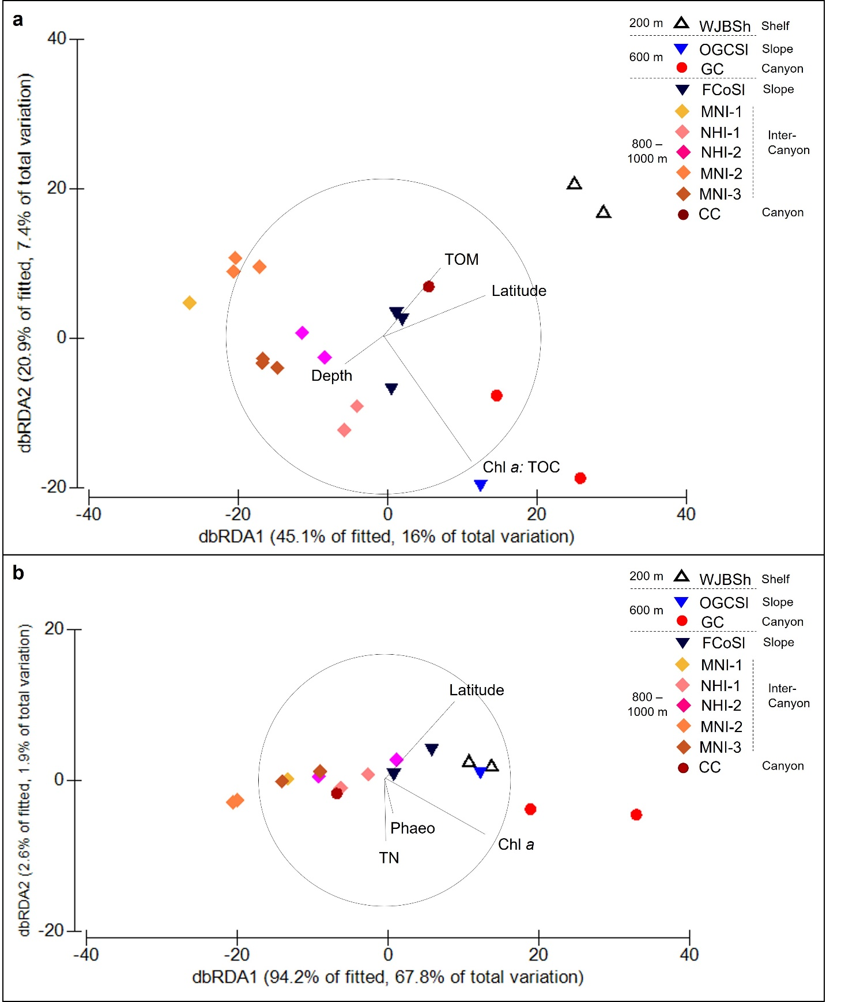
Supplementary Figure 2. Redundancy analysis (dbRDA) from the best distance-based linear model (DistLM) of a) macrofaunal community composition and all environmental variables and b) macrofaunal biological trait expression and all environmental variables. Vectors show the direction and strength of environmental variables contributing to variation of macrofaunal community composition (a) and biological trait expression (b). TOM: total organic matter; Chl a: TOC: chlorophyll a to total organic carbon ratio. TN: total nitrogen; Phaeo: phaeopigments; Chl a: chlorophyll a.

