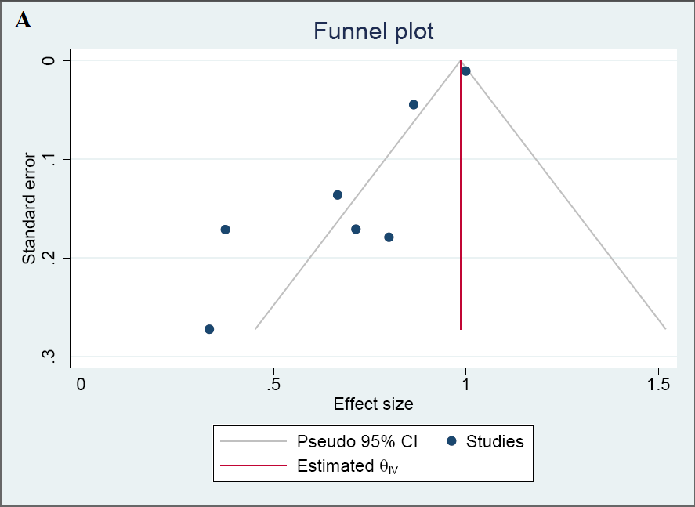

Supplementary Figure 1(A): Funnel plot for detection of publication bias in meta-analysis of proportion of patients with relapse free events. Black dots represent
imputed studies and brown dot represent added studies for trim and fill. (Without trim and fill B)

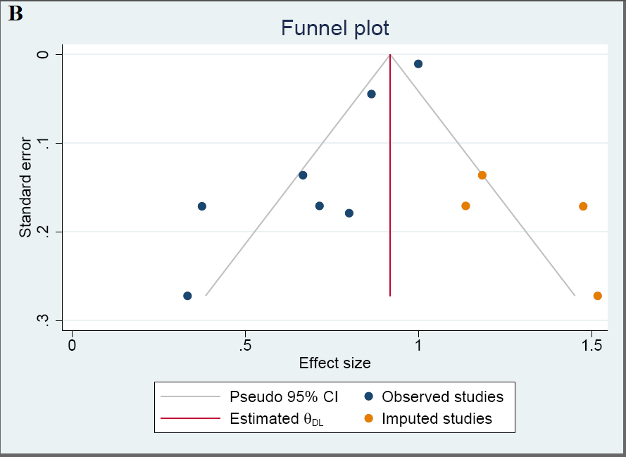

Supplementary Figure 1(B): Funnel plot for detection of publication bias in meta-analysis of proportion of patients with relapse free events. Black dots represent
imputed studies and brown dot represent added studies for trim and fill. (With trim and fill)

