Supplementary information for

The role of the climate, oceanography and prey in driving decadal spatio-temporal patterns of a highly mobile top predator

Amaia Astarloa¹, Maite Louzao¹, Joana Andrade², Lucy Babey³, Simon Berrow⁴, Oliver Boisseau⁵, Tom Brereton⁶, Ghislain Dorémus⁷, Peter G.H. Evans^{8,9}, Nicola K. Hodgins¹⁰, Mark Lewis¹¹, Jose Martinez-Cedeira¹², Malin L. Pinsky¹³, Vincent Ridoux⁶, Camilo Saavedra¹⁴, M. Begoña Santos¹⁴, James T. Thorson¹⁵, James J. Waggitt⁸, Dave Wall⁴, Guillem Chust¹

¹AZTI Marine Research, Basque Research and Technology Alliance (BRTA), Pasaia, Spain
²Sociedade Portuguesa para o Estudo das Aves (SPEA), Lisboa, Portugal
³ORCA, Portsmouth, UK
⁴Irish Whale and Dolphin Group (IWDG), Kilrush, Ireland
⁵Marine Conservation Research, Kelvedon, UK
⁶Marinelife, Bridport, UK
⁷Observatoire PELAGIS, Université de La Rochelle, La Rochelle, France
⁸Sea Watch Foundation (SWF), Amlwch, Isle of Anglesey, UK
⁹School of Ocean Sciences, Bangor University, Menai Bridge, UK
¹⁰Whale and Dolphin Conservation (WDC), Chippenham, UK
¹¹Joint Nature Conservation Committee (JNCC), Peterborough, UK
¹²Coordinadora para o Estudo dos Mamíferos Mariños (CEMMA), Pontevedra, Spain
¹³ Department of Ecology, Evolution and Natural Resources, Rutgers University, New Brunswick, NJ, USA
¹⁴Instituto Español de Oceanografía (IEO), Centro Oceanográfico de Vigo, Vigo, Spain
¹⁵Habitat and Ecological Processes Research Program (HEPR), Alaska Fisheries Science Center, Seattle, USA

Supplementary Table 1. List of data providers

Survey/Dataset | Institution | Responsible
ATLANCET | La Rochelle Université | Vincent.Ridoux  Ghislain Dorémus
BIOMAN | AZTI | Maite Louzao
CEMMA | Coordinadora Para O Estudo Dos Mamíferos Mariños | Jose Martinez Cedeira
CODA | University of St Andrews | Philip Hammond
ESAS | European Seabirds-At-Sea | Mark.Lewis
EVHOE | IFREMER | Vincent Ridoux  Ghislain Dorémus
IBTS | IFREMER | Vincent Ridoux  Ghislain Dorémus
IFAW | Marine Conservation Research | Oliver Boisseau
IWDG | Irish Whale and Dolphin Group | Dave Wall  Simon Berrow
JUVENA | AZTI | Maite Louzao
KOSMOS | University College Cork | Mark Jessopp
MARINELIFE | MARINElife | Tom Brereton
ORCA | Organisation Cetacea | Lucy Babey
PELACUS | Instituto Español de Oceanografía | Camilo Saavedra  M. Begoña Santos
PELGAS | IFREMER | Vincent Ridoux  Ghislain Dorémus
SAMM | La Rochelle Université | Vincent Ridoux  Ghislain Dorémus
SCANS1 | University of St Andrews | Philip Hammond
SCANS2 | University of St Andrews | Philip Hammond
SPEA | Sociedade Portuguesa Para o Estudo das Aves | Joana Andrade
SWF | Sea Watch Foundation | Peter Evans
WDC | Whale and Dolphin Conservation | Nicola Hodgins

Supplementary Table 2. Model terms obtained from spatio-temporal models when increasing the mesh resolution to 500 knots (maximum number that is feasible on our machine).
Second column refers to the AIC score of each model, while the third column refers to the difference in the AIC (ΔAIC) resulting from the comparison of each univariate model with the spatio-temporal model (reference model). Positive values mean that higher AIC were obtained relative to the baseline spatio-temporal model while negative values mean that lower AIC scores were achieved. Numbers in bold mean improvement in model fitting (ΔAIC < -2) and hence, substantial contribution of the given variable.

 | Model | AIC | ΔAIC
Baseline spatio-temporal | No covariates | 27734.97 | 0
Local oceanographic conditions | Temperature | 27738.78 | 3.81
 | Chlorophyll | 27731.53 | -3.44
Regional  climate  indices | NAO | 27723.5 | -11.47
 | EA | 27734.99 | 0.02
 | AMO | 27735.99 | 1.02
Regional  prey  biomasses | Anchovy | 27724.64 | -10.33
 | Sardine | 27730.51 | -4.46
 | Mackerel | 27732.01 | -2.96
 | Horse mackerel | 27731.86 | -3.11
 | Blue whiting | 27734.52 | 0.45
 | Biomass index | 27733.43 | -1.54

Supplementary Table 3. The abundance estimates and the standard deviation predicted by the baseline spatiotemporal model per year.

Year | Estimated abundance | Standard Deviation
1994 | 172755.62 | 75844.48
1995 | 223363.79 | 87180.60
1996 | 150105.29 | 68812.01
1997 | 151698.09 | 66265.23
1998 | 159883.71 | 64753.85
1999 | 180734.38 | 84614.94
2000 | 152133.14 | 81421.06
2001 | 275935.23 | 117673.73
2002 | 115852.53 | 45894.76
2003 | 158658.07 | 76654.18
2004 | 97052.66 | 51242.56
2005 | 248868.61 | 82532.25
2006 | 142497.01 | 61494.84
2007 | 400861.26 | 104699.49
2008 | 157808.90 | 30695.04
2009 | 204242.70 | 41002.09
2010 | 198570.51 | 41354.94
2011 | 354275.87 | 125450.35
2012 | 358549.12 | 49168.55
2013 | 300618.93 | 87666.17
2014 | 329400.27 | 120721.54
2015 | 305980.52 | 79601.28
2016 | 376150.76 | 71517.74
2017 | 299771.62 | 55071.32
2018 | 330139.20 | 132598.42

Supplementary Figure 1. Distribution of the knots (locations) used to estimate common dolphin density.
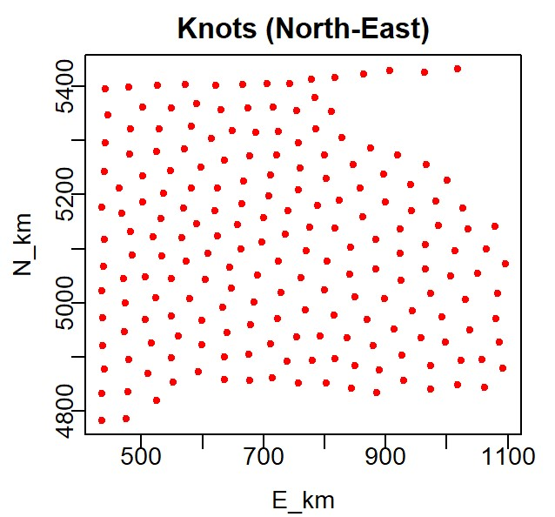

Supplementary Figure 2. Pearson correlation between the biomass estimates of the sardine inhabiting the Bay of Biscay (only available since 2000) and the biomasses of sardine from Cantabrian and Iberian waters (available since 1978) for the 2000-2017 period.
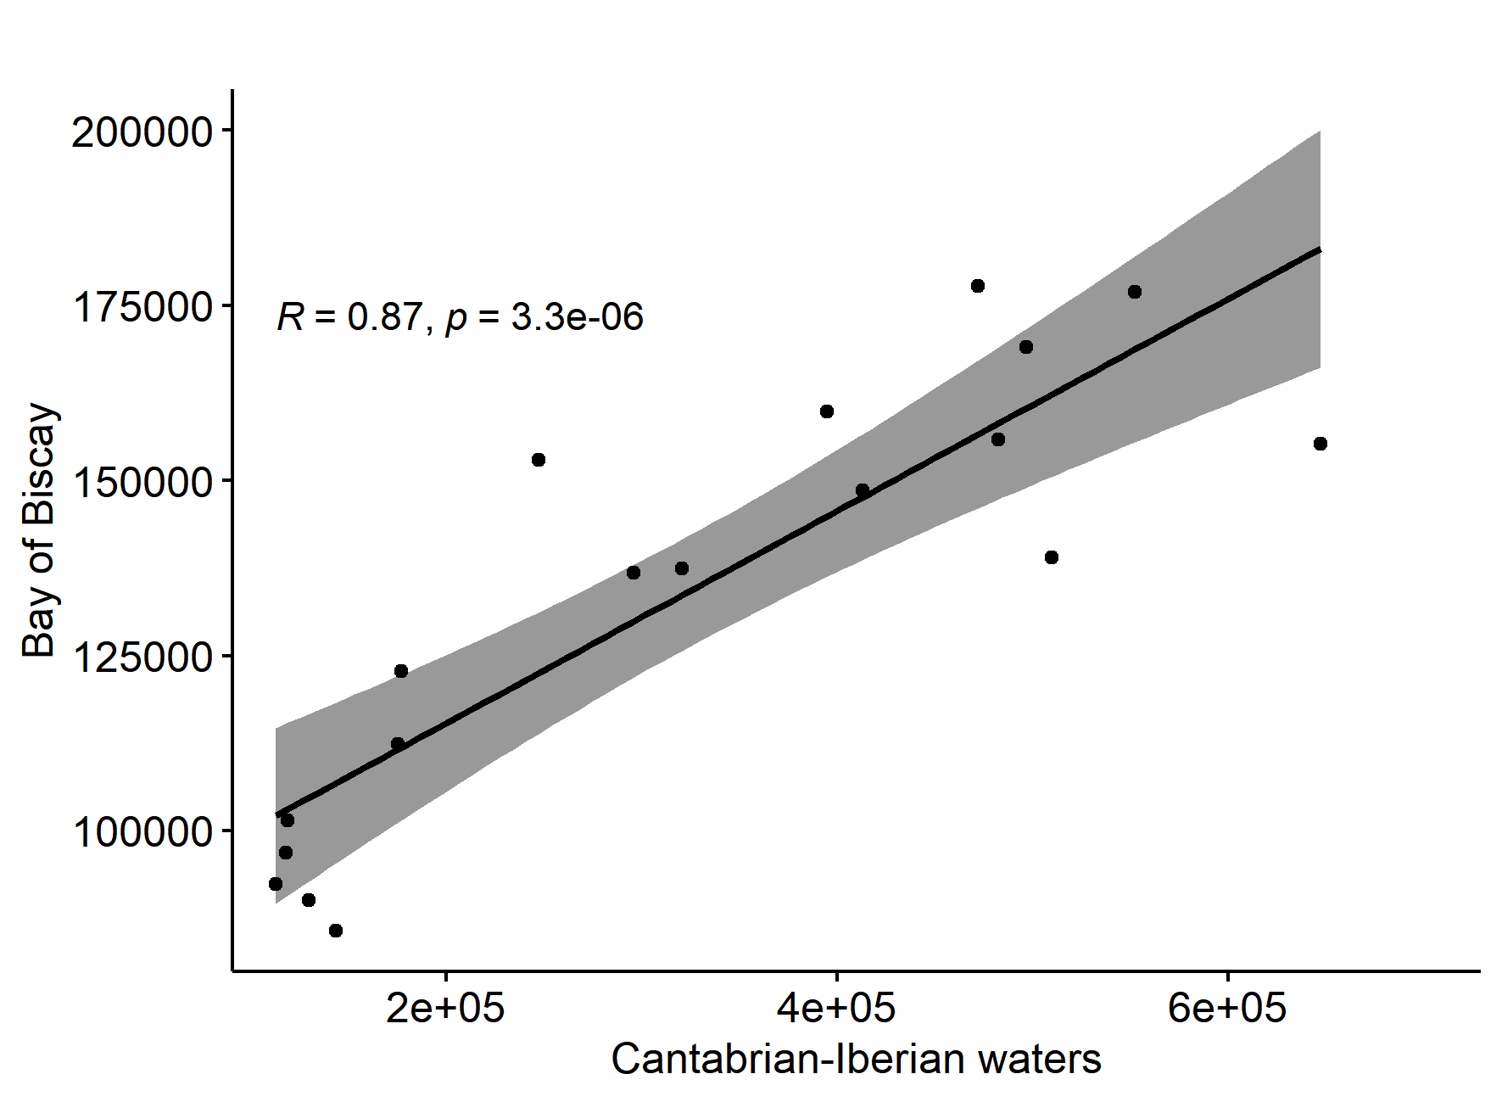
Supplementary Figure 3. Overall survey effort per year (a) and per month (b) in the Bay of Biscay for the study period.
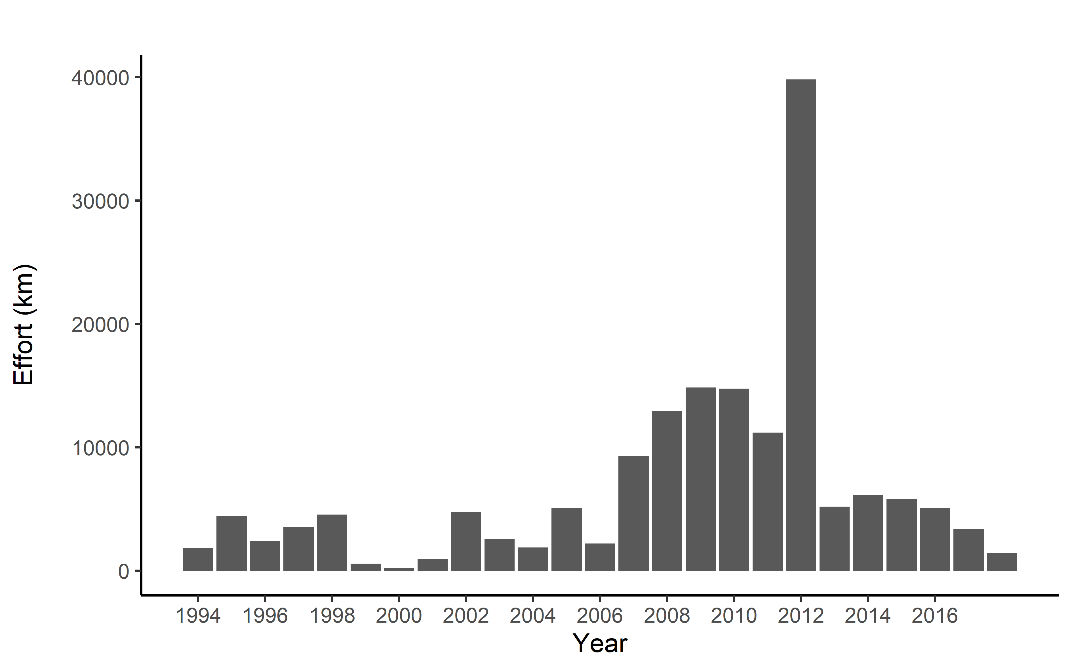
a)

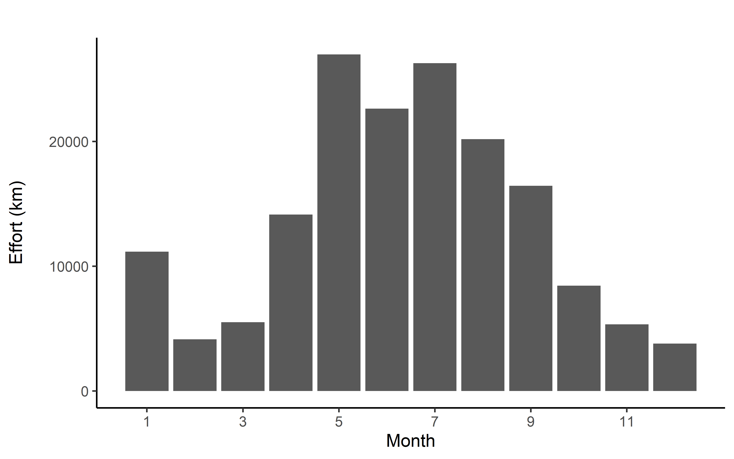
b)

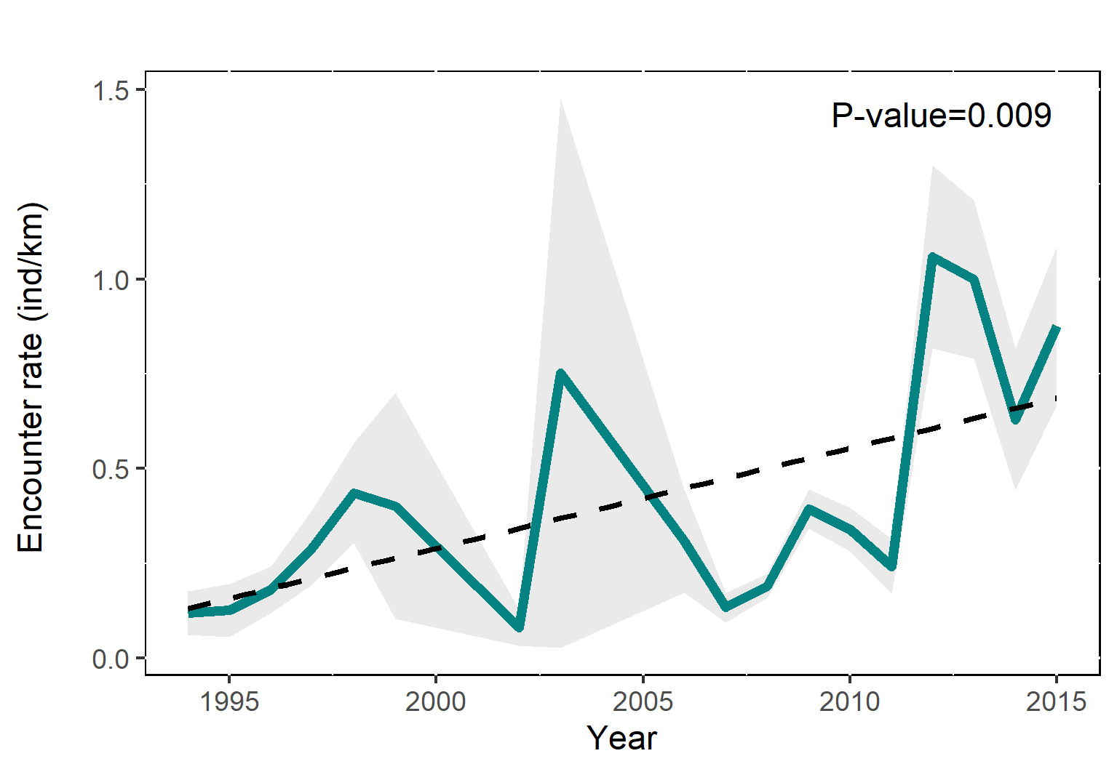
Supplementary Figure 4. Common dolphin’s observed abundance index (encounter rate) estimated from ferry data. Green line indicates the annual mean, while the grey bar shows the standard error.

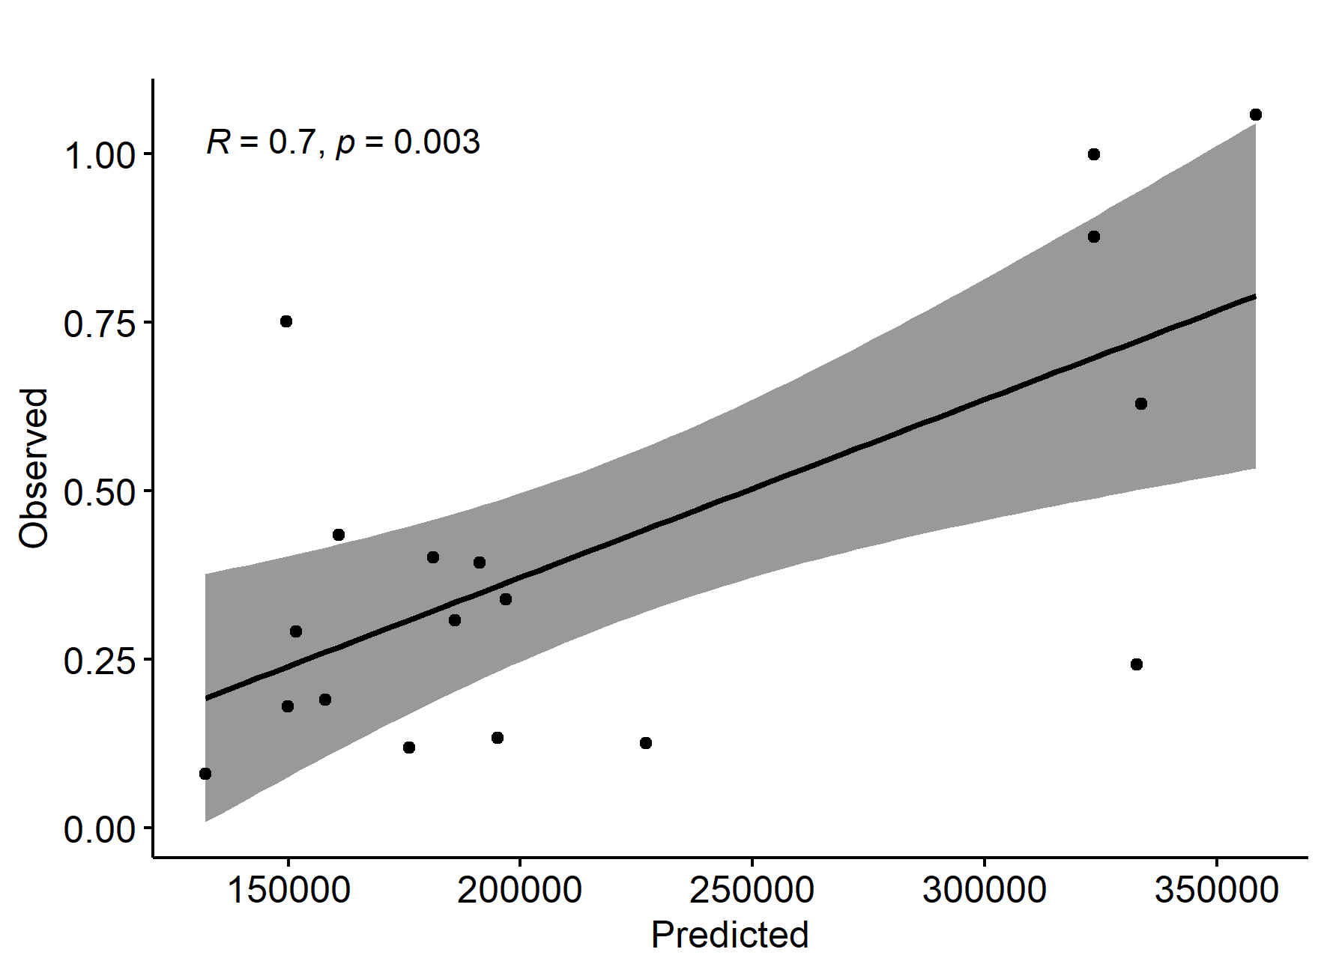
Supplementary Figure 5. Pearson correlation between observed abundance index (above) and predicted abundance index from the baseline spatiotemporal model.
Supplementary Figure 6. The annual mean of temperature and chorophyll a integrated at 100m along the study period, accompanied by the standard error, the linear trend and its significance.
Supplementary Figure 7. The annual mean of NAO, AMO and EA climatic indeces over the study period. Red and blue colors indicate the positive and negative phases of the indices, respectively.

Supplementary Figure 8. Spawning stock biomass of anchovy, sardine, mackerel, horse mackerel and blue whiting (a-e), accompanied by the higher and lower boundaries (95% CI), the linear trend and its significance. Biomass index (f) represents the sum of all previous species.
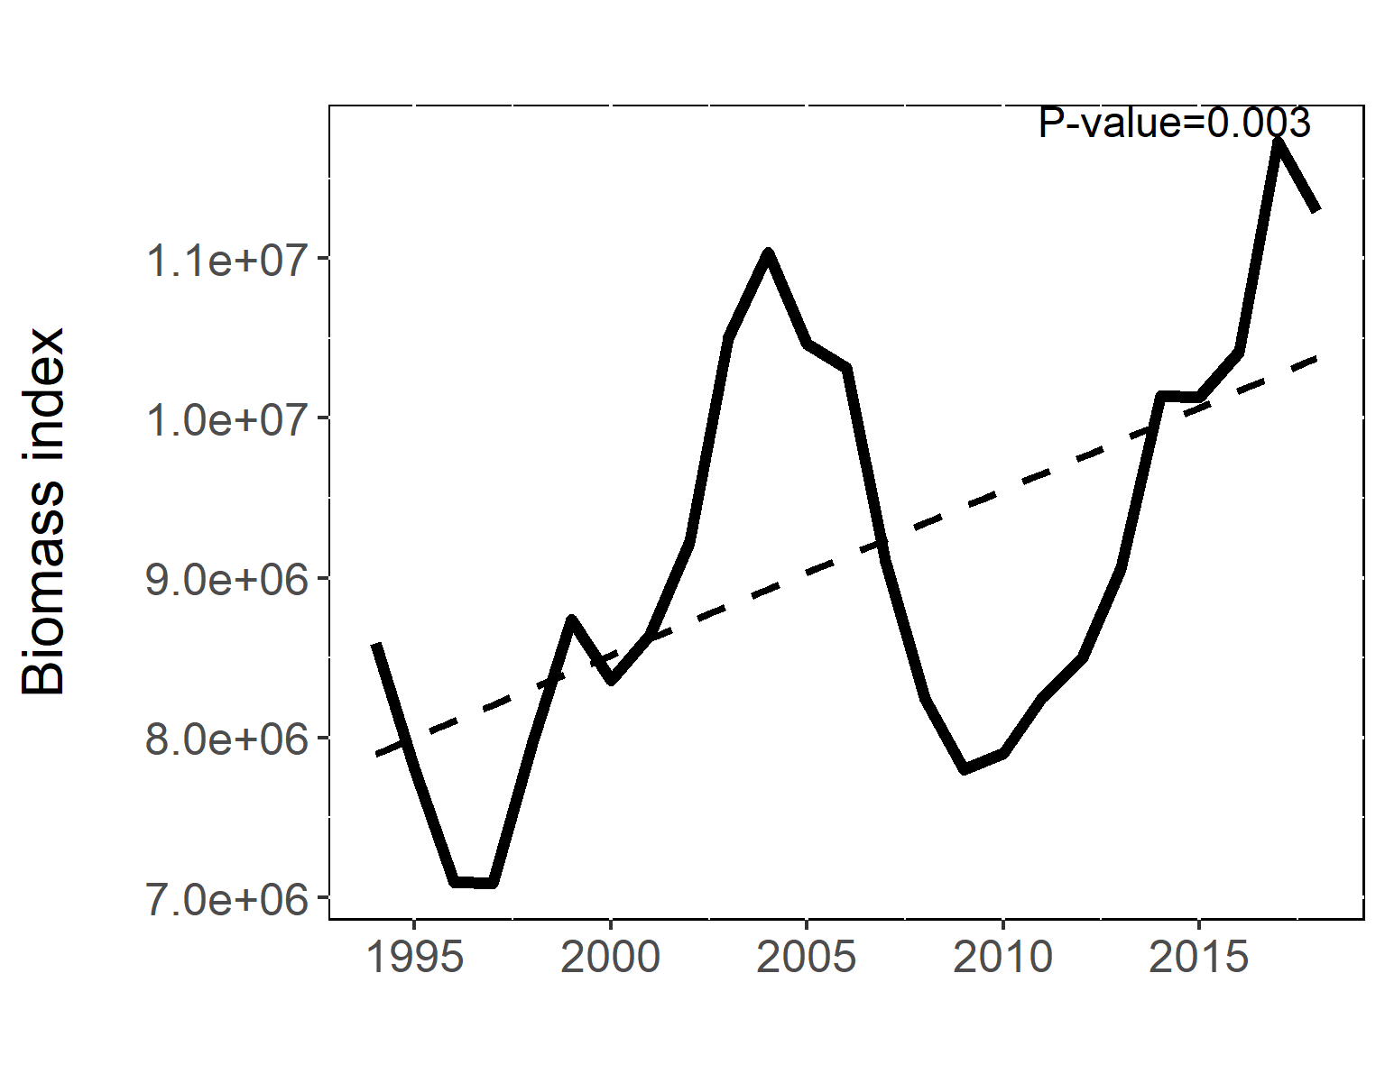
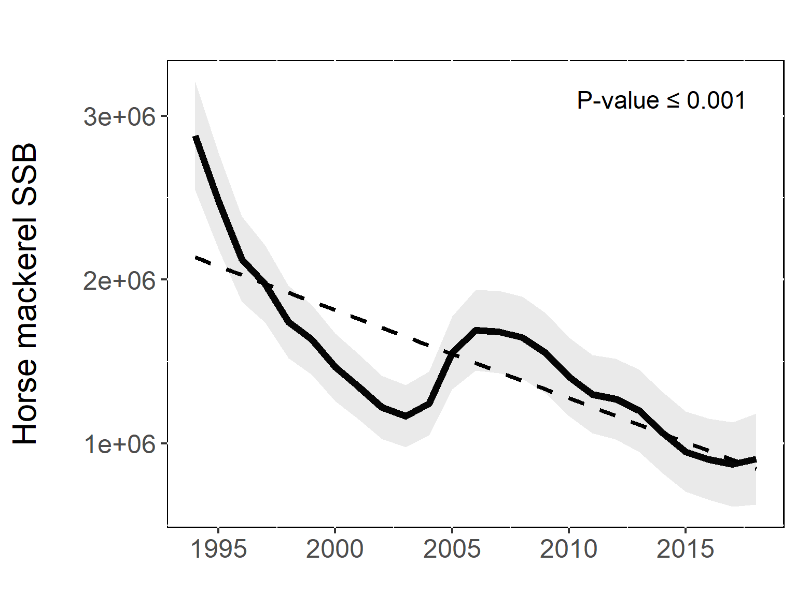
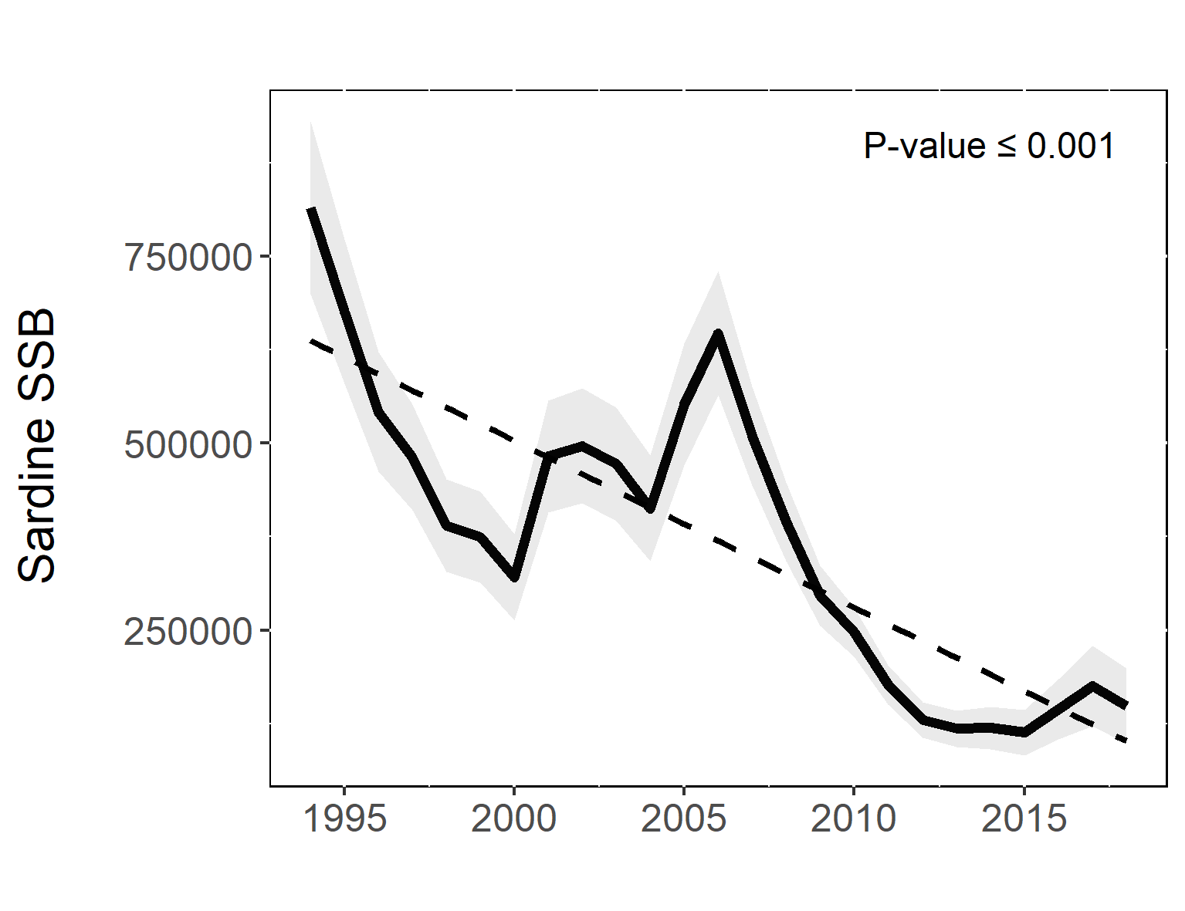
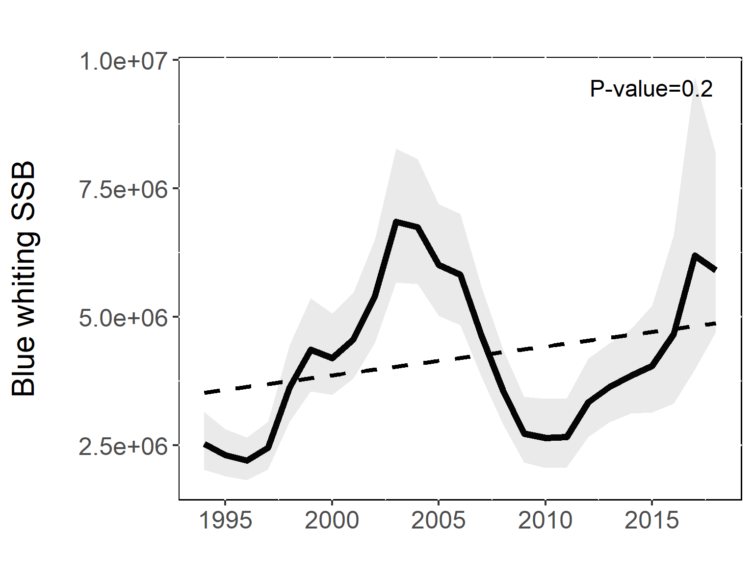
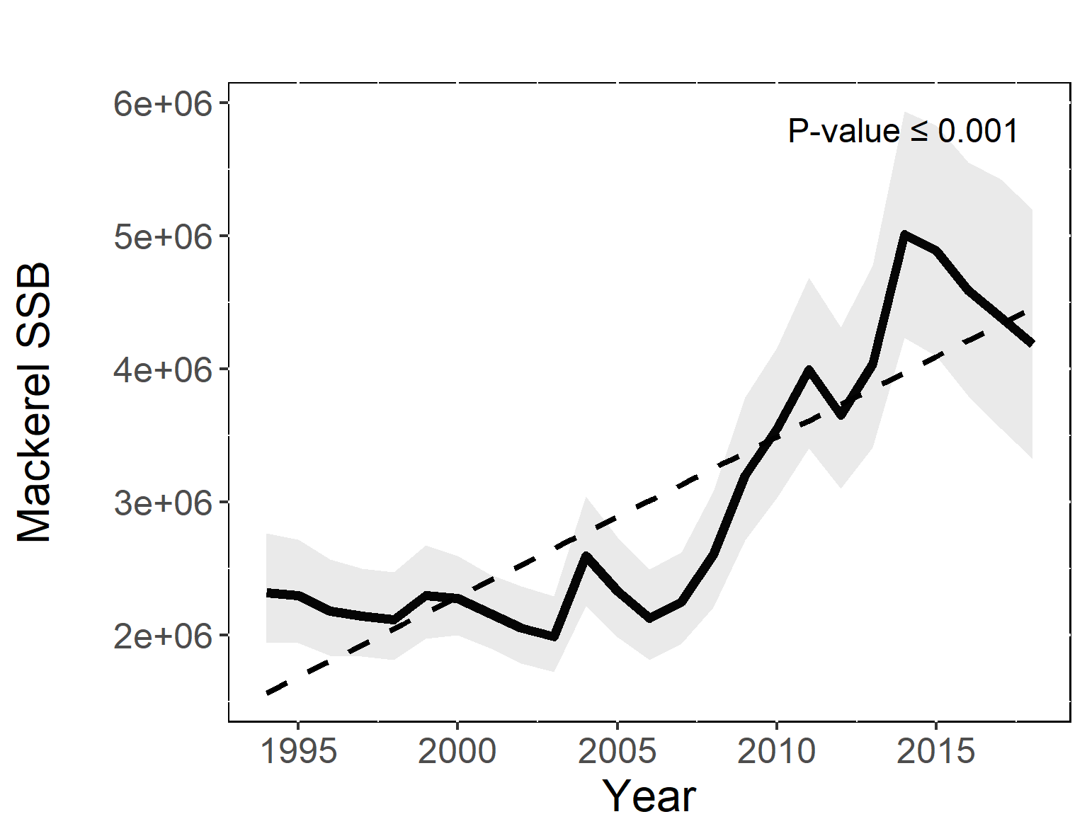
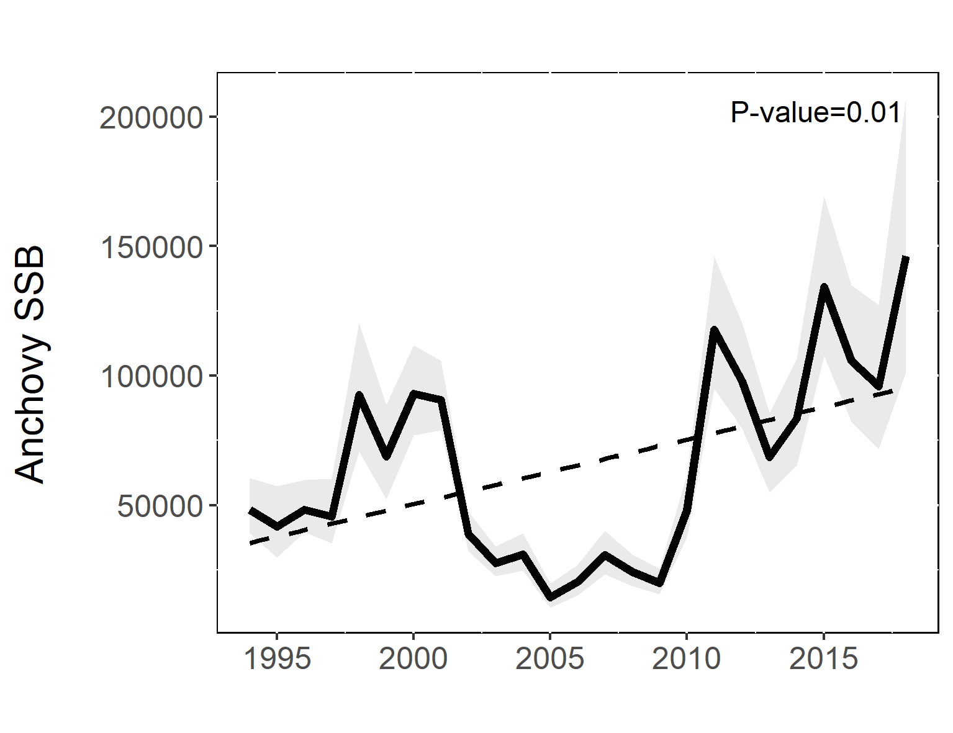

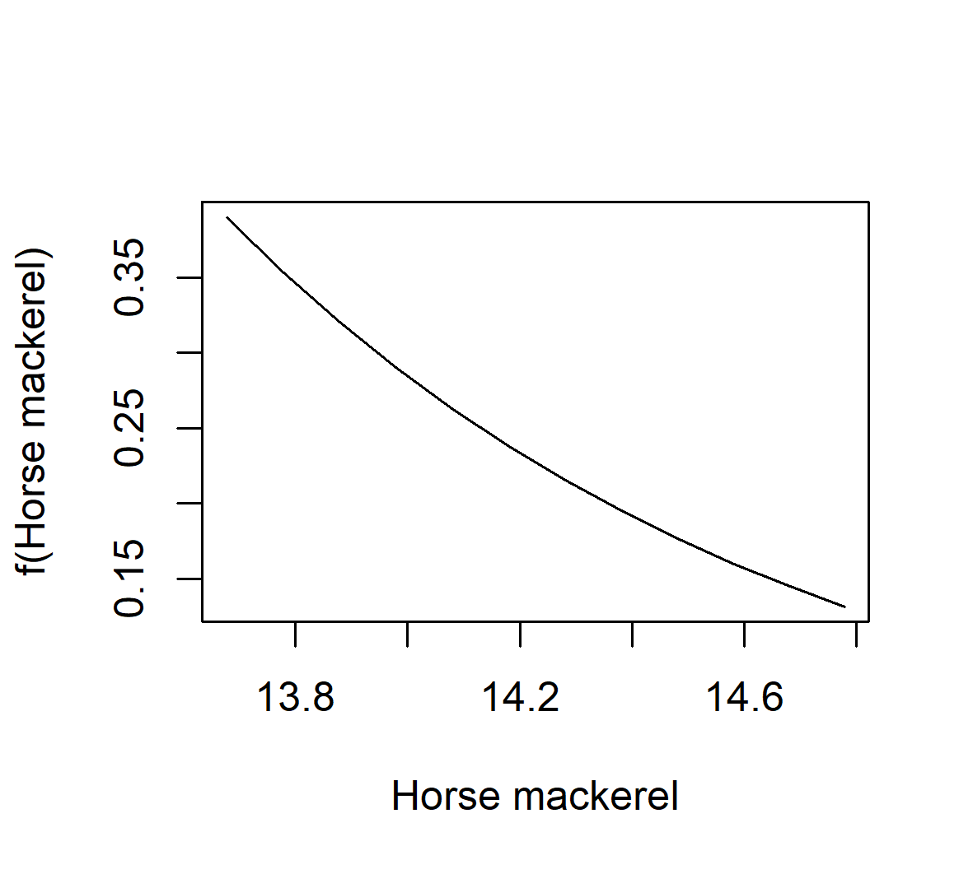
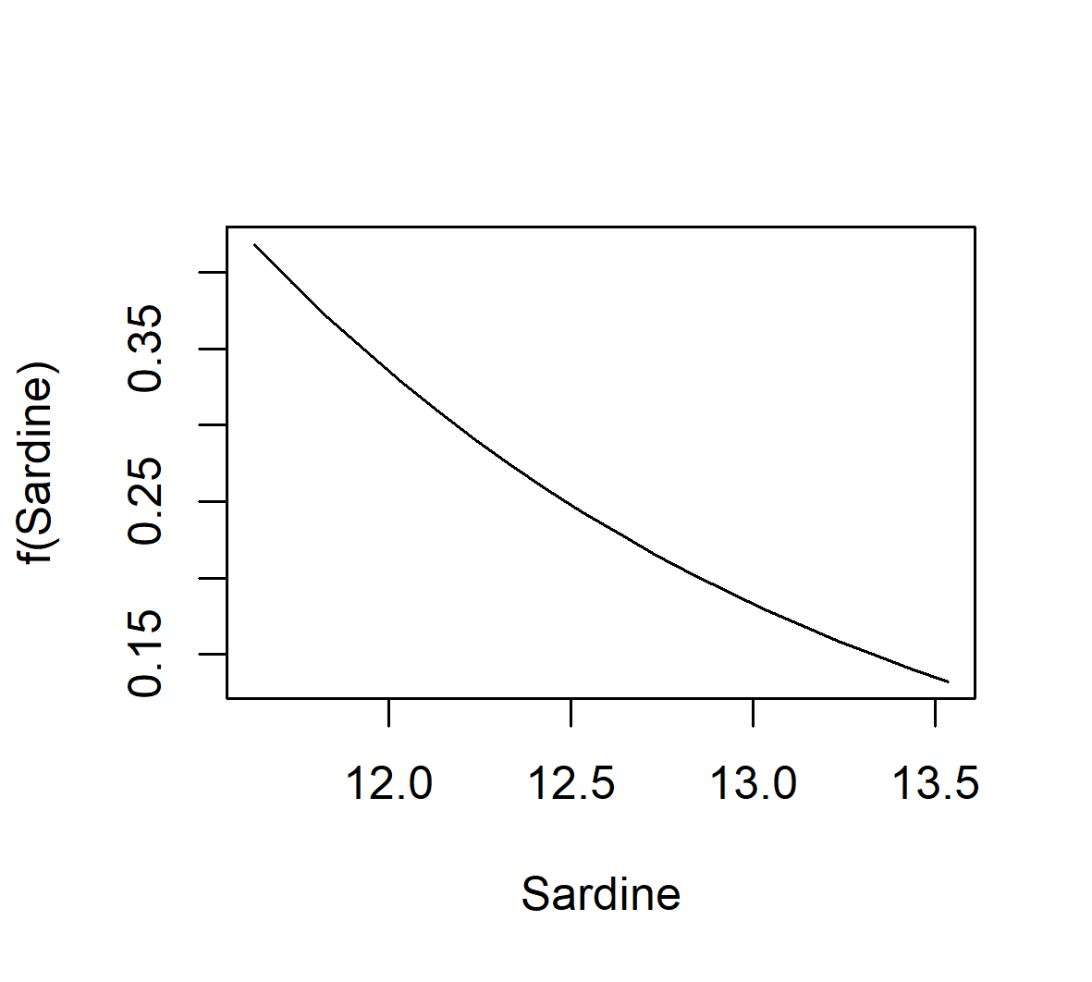
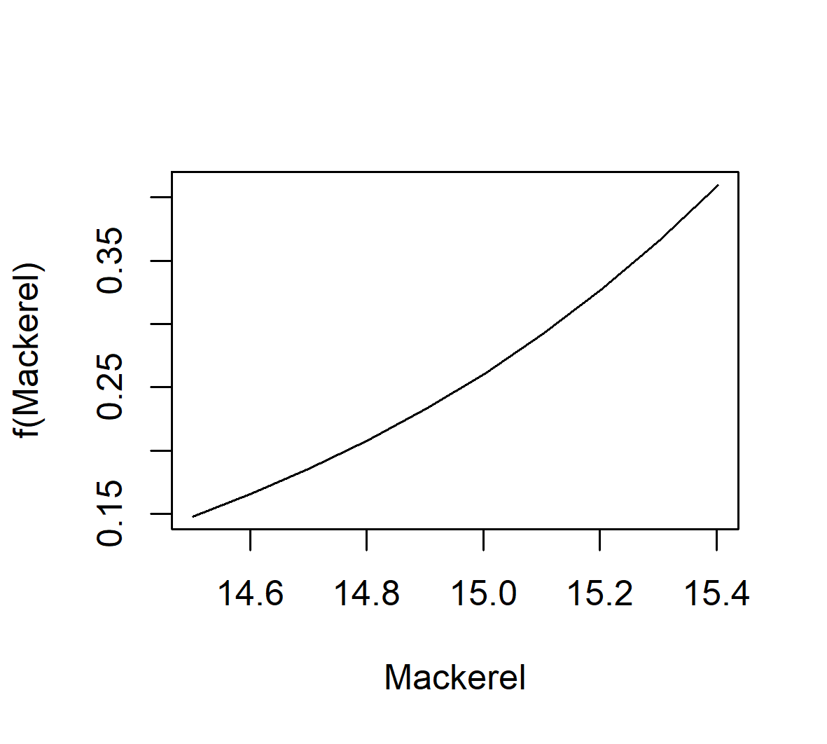
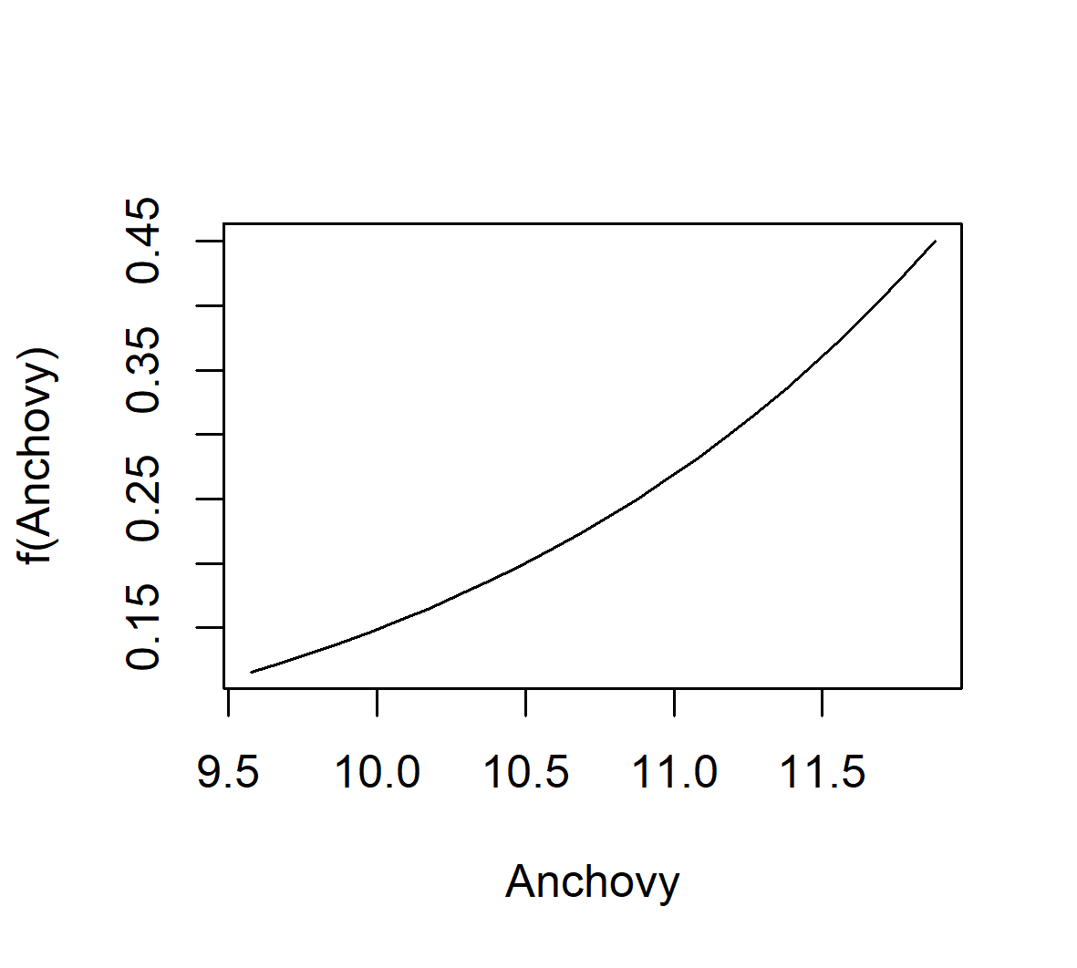
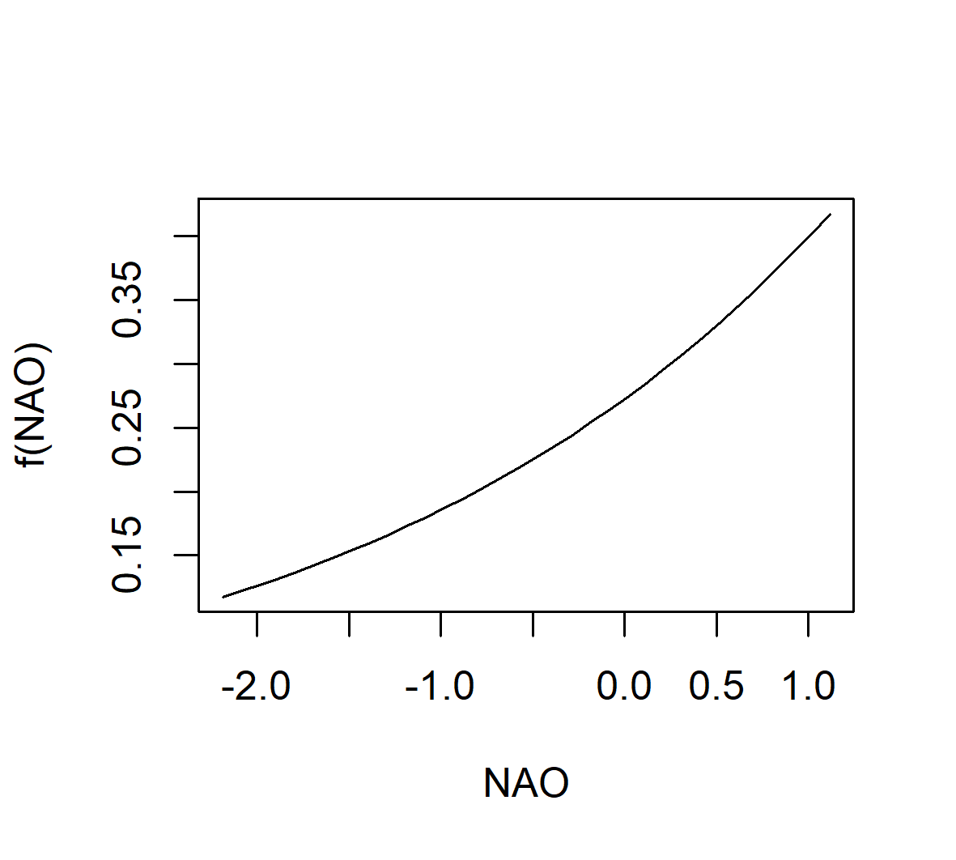
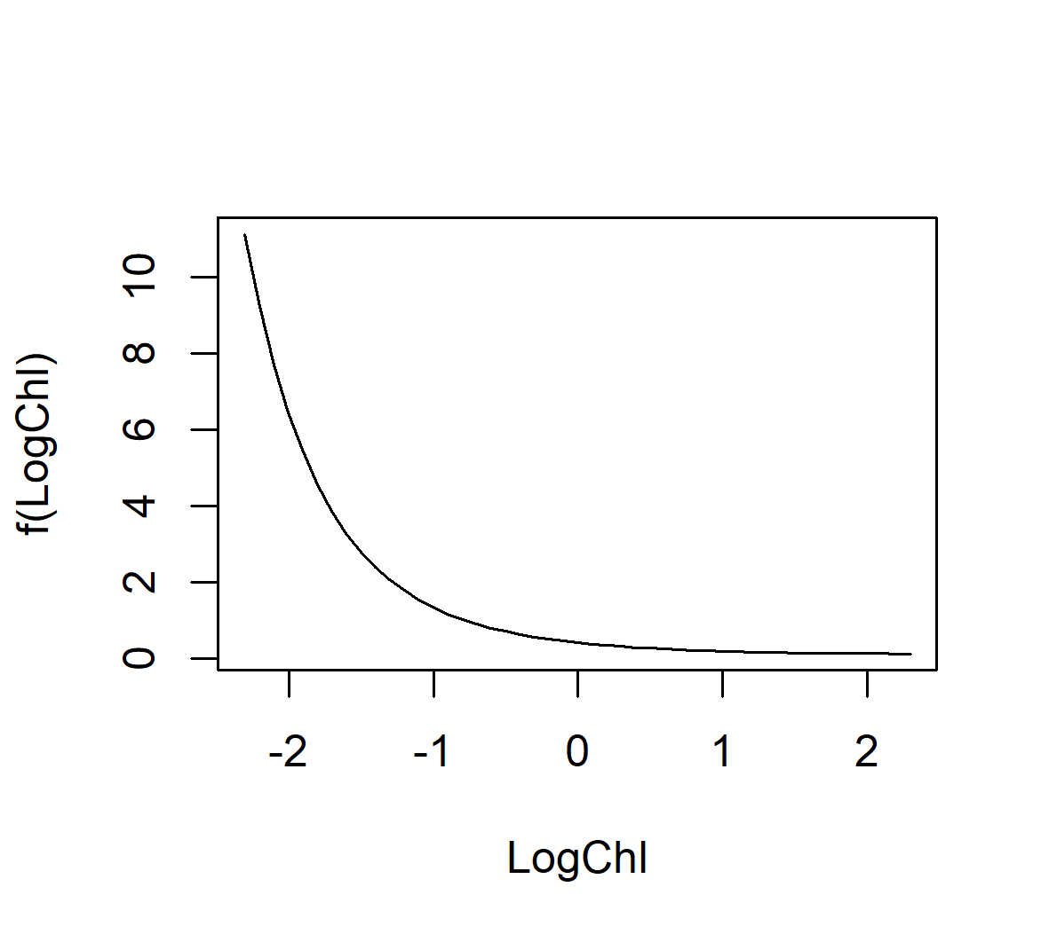
Supplementary Figure 9. Functional relationships estimated from the parameters (intercepts and coefficients) given by the model only for those variables considered important in terms of AIC. Confidence interval could not be estimated with the parameters provided.

Supplementary Figure 10. Abundance estimates predicted by the spatio-temporal model and by the covariates-based model, in which the contribution made by AMO, temperature and blue whiting (those drivers not considered relevant by AIC score) can be visualized.

