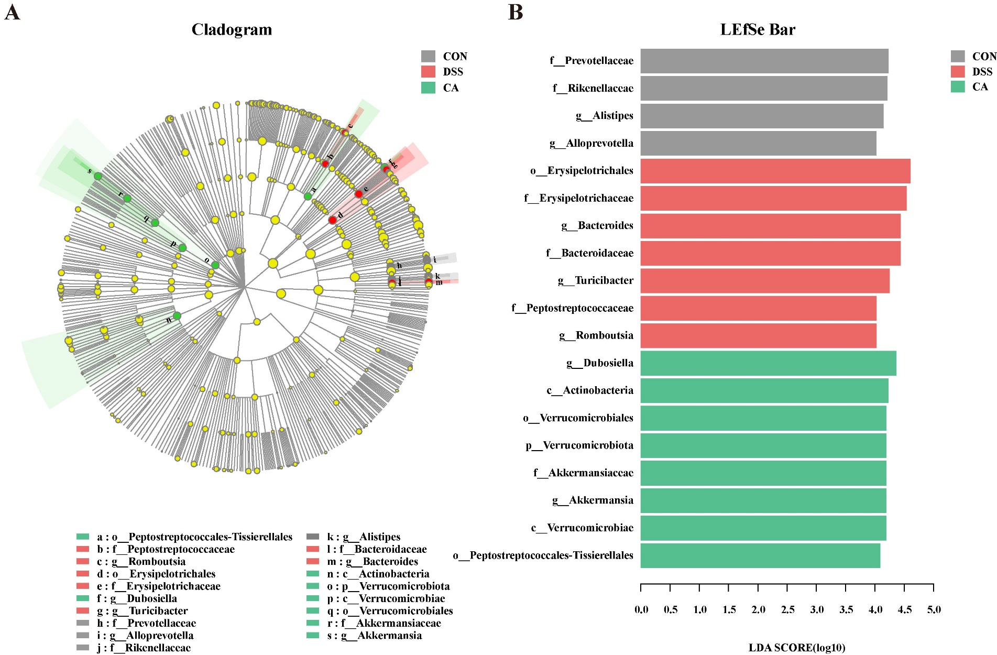
SUPPLEMENTAL FIGURES
FIGURE S1 Effects of CA supplementation on the gut microbiome structure in DSS-induced colitis mice. (A) LEfSe results of each group. (B) Linear discriminant analysis.

