Supplementary Material

# Supplementary Data

Supplementary Data Sheet 1 – Here we provide all data and proxies used in this study.

# Supplementary Figures and Tables

## Supplementary Figures

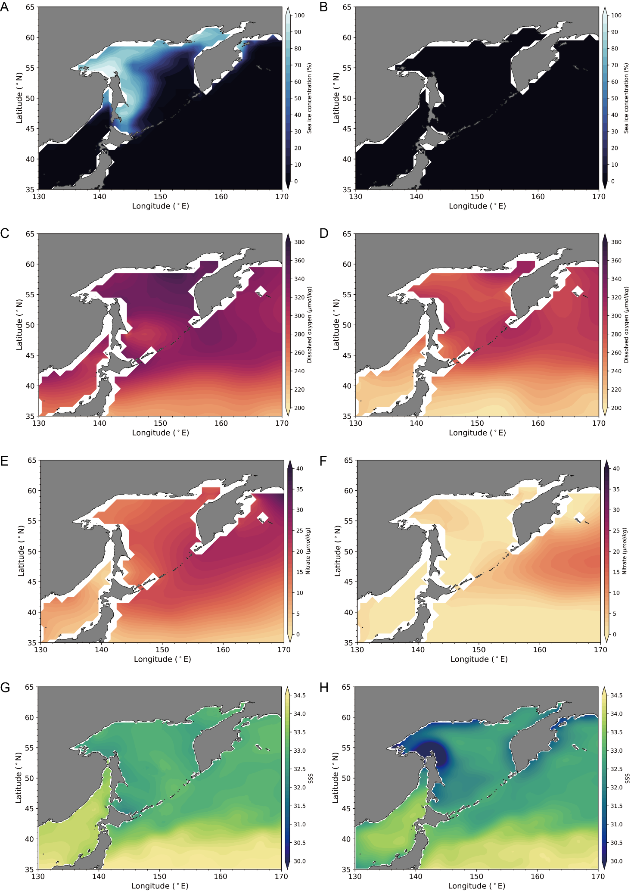

**Supplementary Figure S1.** February (A) and August (B) sea-ice concentration, dissolved oxygen (C-D), nitrate (E-F), and sea surface salinity (SSS) (G-H) in the Okhotsk Sea. See below for further details.

Sea Ice:

URL: https://hadleyserver.metoffice.gov.uk/hadisst/index.html

The Sea-Ice concentration is retrieved from the Hadley Centre Sea Ice and Sea Surface Temperature data set (HadISST). The sea ice data are taken from a variety of sources including digitized sea ice charts and passive microwave retrievals from 1870 to date. The sea ice fields are made more homogeneous by compensating satellite microwave-based sea ice concentrations for the impact of surface melt effects on retrievals in the Arctic and for algorithm deficiencies in the Antarctic, and by making the historical in situ concentrations consistent with the satellite data.

Oxygen; Nitrate; Salinity

URL: https://www.ncei.noaa.gov/access/world-ocean-atlas-2018/

The Nitrate, Oxygen, and Salinity distributions in the study area are retrieved from the World Ocean Atlas 2018, which composed the global ocean observations/profiles by using objective analysis. The data used are observed after 1955.



**Supplementary Figure S2.** Comparison of precession (a), obliquity (b), and 100-kyr eccentricity (c) filters of MD01-2414 log(Ba/Ti) ratios (red) and the LR04 stack (black).



**Supplementary Figure S3.** Comparison between core depth and ages of the sediments; paleomagnetic polarities are indicated on the right part.



**Supplementary Figure S4.** Magnetic susceptibility ( versus ARM, the data of the stronger interglacial intervals (i.e., MISs 1, 5e, 9 11) are highlighted in yellow.

**Supplementary Table S1.**

Dating points and ages (ka) of MD01-2414.

|  |  |  |
| --- | --- | --- |
| Corrected Depth (cm) | Age (ka) | Note |
| 33 | 5.06 | AMS 14C date |
| 113 | 8.70 | AMS 14C date |
| 143 | 9.26 | AMS 14C date |
| 170 | 14.10 | AMS 14C date |
| 210 | 18.20 | AMS 14C date |
| 275 | 35.4 | Orbital tuning |
| 406 | 71.4 | Orbital tuning |
| 461 | 91.4 | Orbital tuning |
| 523 | 106.1 | Orbital tuning |
| 549 | 116.3 | Orbital tuning |
| 671 | 132.8 | Orbital tuning |
| 798 | 165.5 | Orbital tuning |
| 831 | 176.5 | Orbital tuning |
| 872 | 192.3 | Orbital tuning |
| 950 | 220.0 | Orbital tuning |
| 1003 | 233.6 | Orbital tuning |
| 1030 | 244.0 | Orbital tuning |
| 1141 | 280.2 | Orbital tuning |
| 1157 | 291.0 | Orbital tuning |
| 1185 | 307.4 | Orbital tuning |
| 1219 | 317.1 | Orbital tuning |
| 1362 | 339.7 | Orbital tuning |
| 1513 | 384.6 | Orbital tuning |
| 1566 | 396.5 | Orbital tuning |
| 1691 | 428.4 | Orbital tuning |
| 1913 | 481.7 | Orbital tuning |
| 2087 | 533.6 | Orbital tuning |
| 2191 | 580.7 | Orbital tuning |
| 2304 | 622.7 | Orbital tuning |
| 2507 | 680.6 | Orbital tuning |
| 2581 | 714.1 | Orbital tuning |
| 2631 | 725.6 | Orbital tuning |
| 2674 | 743.7 | Orbital tuning |
| 2736 | 757.3 | Orbital tuning |
| 2774 | 780.0 | B/M boundary * |
| 2803 | 792.6 | Orbital tuning |
| 2887 | 814.8 | Orbital tuning |
| 2953 | 842.3 | Orbital tuning |
| 3033 | 866.5 | Orbital tuning |
| 3179 | 898.5 | Orbital tuning |
| 3214 | 917.3 | Orbital tuning |
| 3297 | 937.4 | Orbital tuning |
| 3356 | 959.6 | Orbital tuning |
| 3404 | 971.9 | Orbital tuning |
| 3473 | 991.0 | Top Jaramillo * |
| 3516 | 1014.6 | Orbital tuning |
| 3664 | 1062.3 | Orbital tuning |
| 3704 | 1075.0 | Bottom Jaramillo * |
| 3742 | 1091.8 | Orbital tuning |
| 3814 | 1104.1 | Orbital tuning |
| 3900 | 1132.3 | Orbital tuning |
| 3940 | 1149.7 | Orbital tuning |
| 4068 | 1190.0 | Top Cobb Mt. * |
| 4102 | 1215.0 | Bottom Cobb Mt. * |
| 4215 | 1244.9 | Orbital tuning |
| 4404 | 1285.5 | Orbital tuning |
| 4534 | 1320.9 | Orbital tuning |
| 4680 | 1363.0 | Orbital tuning |
| 4805 | 1408.1 | Orbital tuning |
| 4873 | 1426.1 | Orbital tuning |
| 4948 | 1452.3 | Orbital tuning |
| 5054 | 1469.2 | Orbital tuning |
| 5116 | 1493.6 | Orbital tuning |
| 5170 | 1510.0 | Orbital tuning |
| 5201 | 1524.3 | Radiolarian ** |
| 5216 | 1531.6 | Orbital tuning |
| 5265 | 1549.0 | Orbital tuning |
| *Chou et al. (2011) Marine Geology 284, 149-157  \*\**Eucyrtidium matuyamai* last occurrence | | |