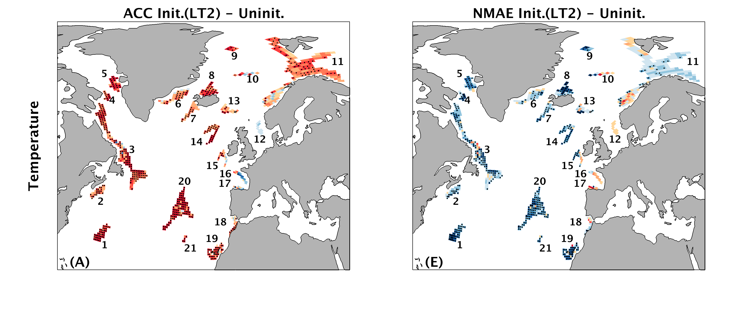
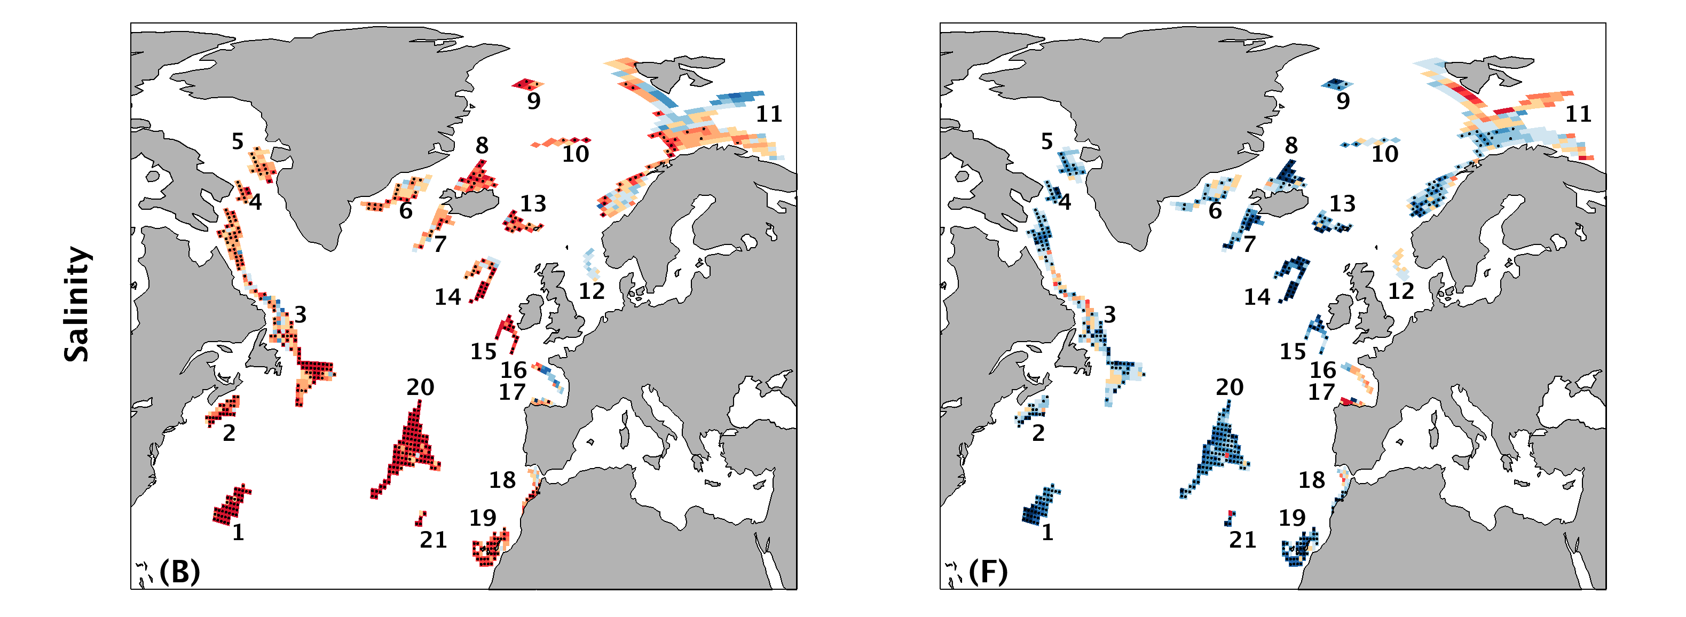
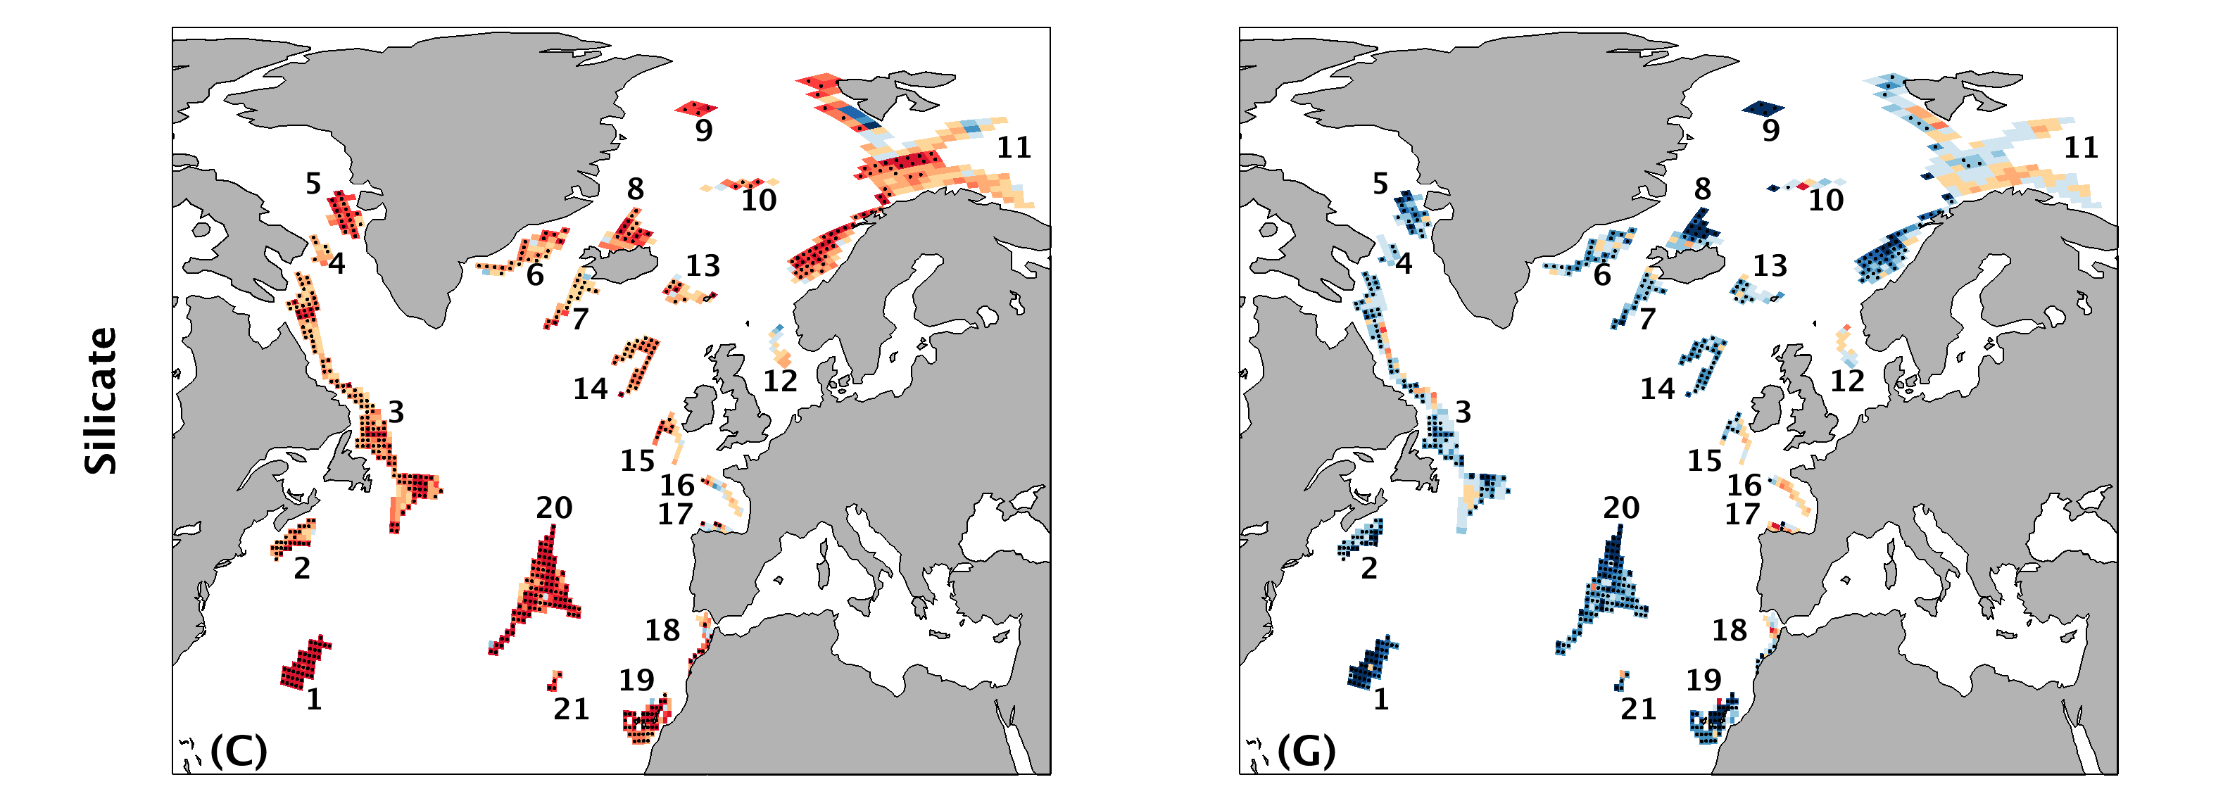
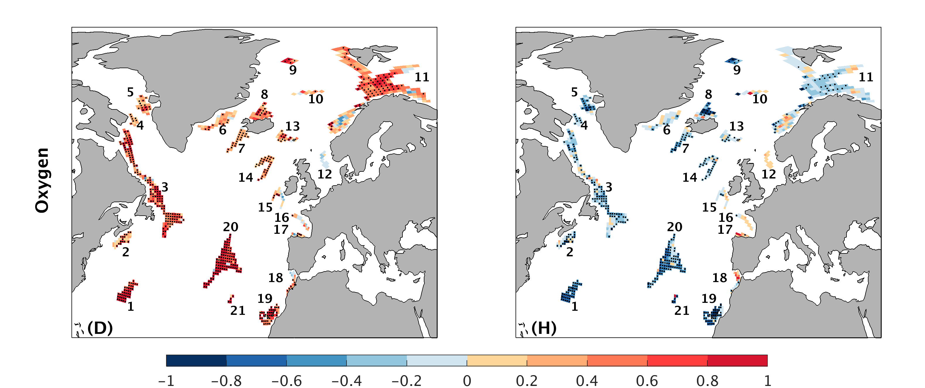
Figure S1. Differences of anomaly correlation coefficients (ACCs) (A-D) and Normalized mean absolute errors (NMAEs) (E-H) between initialized (at a lead time of 2 years) and uninitialized simulations for temperature (A,E), salinity (B,F), silicate (C,G) and oxygen (D,H). Stippling denotes larger ACCs (A-D) and smaller NMAEs (E-H) in the initialized simulations than in the uninitialized simulations at the 95% level based on a bootstrap approach.
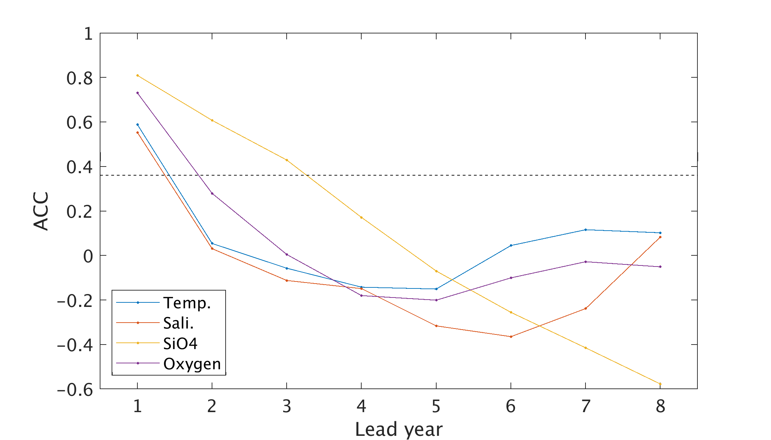
Figure S2. Persistence of yearly anomalies for temperature, salinity, silicate and oxygen averaged over all sponge habitats in this study in the reconstruction simulation. The null hypothesis of no correlation is tested against a t-test at 95% significance level. The critical value is indicated in black dashed line.
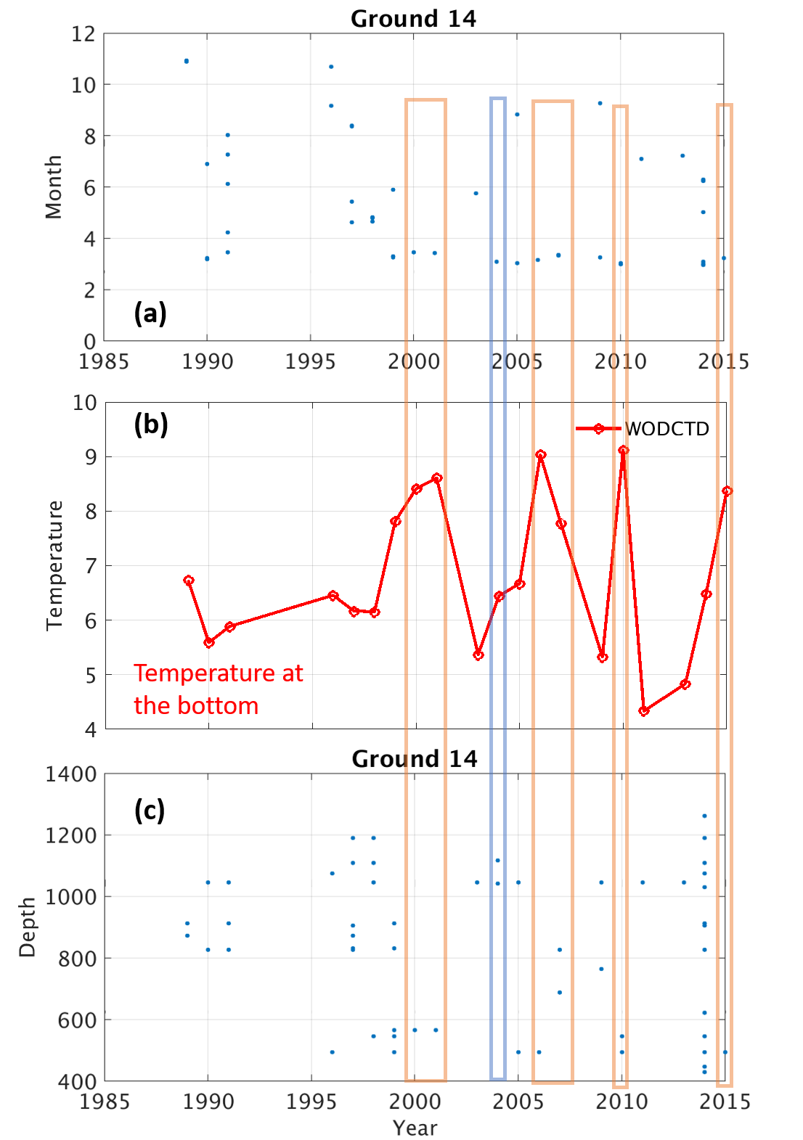
Figure S3. Information of the CTD observations derived from the WOD dataset at habitat 14. (a) The month in which the bottom temperature at the habitat 14 in (b) is taken. (b) The observed bottom temperature at the habitat 14. (4) The depth of the observed bottom temperature shown in (b).

