Figure 1: A Visual Representation of the Main Categories, and Sub-Categories of the Type of Consensus Analysis in Climate Research.
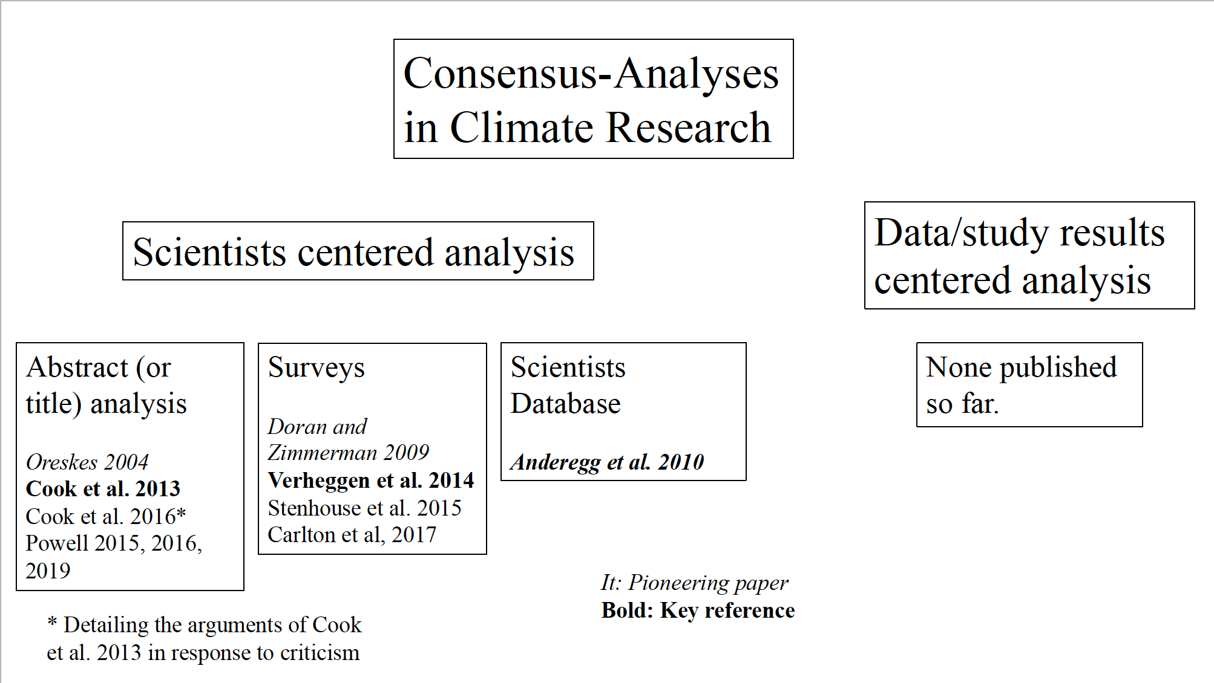

Figure 2: The classification description from the Cook et al. (2013, p. 3) paper. This is directly extracted from their work, and provides a description and example for the different assessment types of the abstracts.
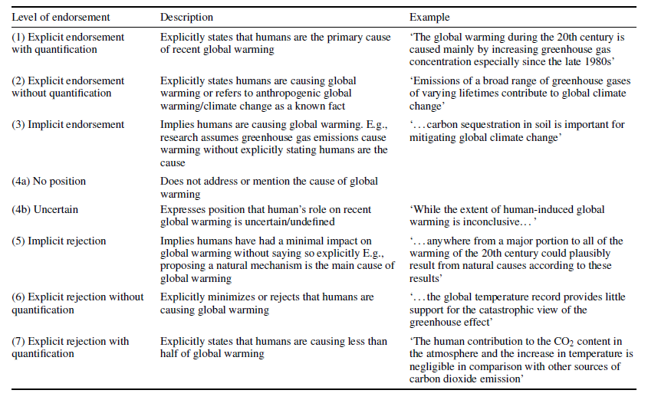

Figure 3: The Analysis results for September 2019. Showing on top the Pie Chart using the Cook et al. (2013) methodology. Then the bottom Pie charts showing the result with the Data-centric methodology.
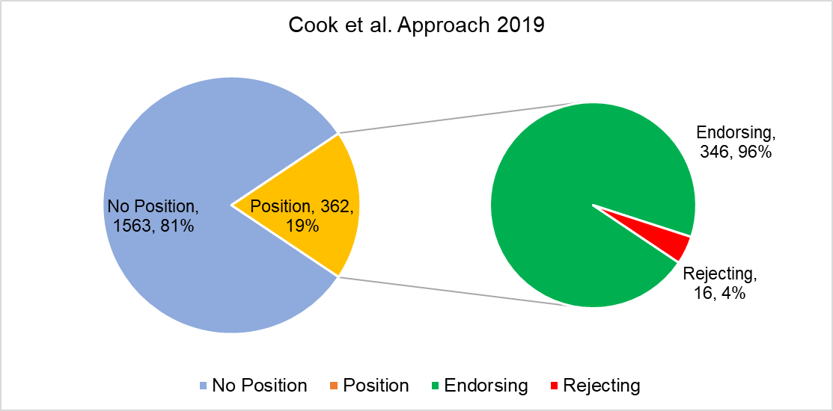

Figure 4: The Analysis results for September 2009. Showing on top the Pie Chart using the Cook et al. (2013) methodology. Then the bottom Pie charts showing the result with the Data-centric methodology.
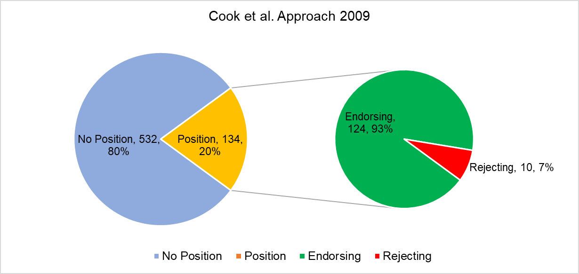

Figure 5: The Analysis results for September 1999. Showing on top the Pie Chart using the Cook et al. (2013) methodology. Then the bottom Pie charts showing the result with the Data-centric methodology.
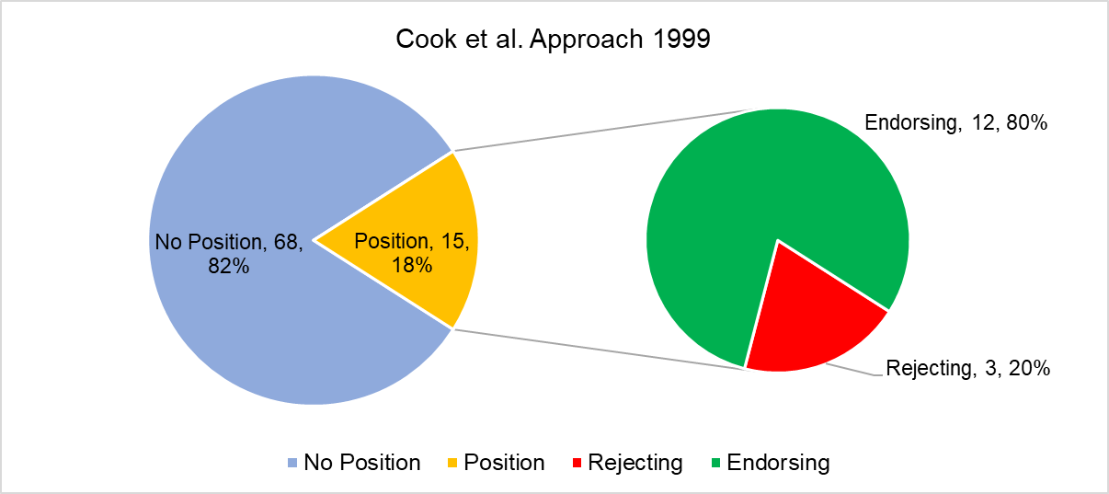

Figure 6: The Analysis results for September 1995. Showing on top the Pie Chart using the Cook et al. (2013) methodology. Then the bottom Pie charts showing the result with the Data-centric methodology.
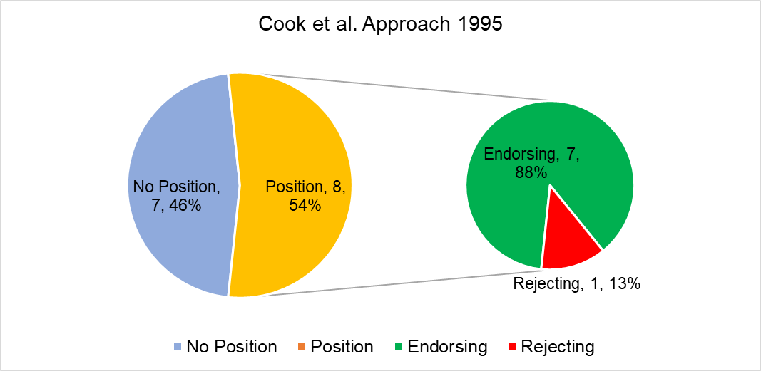

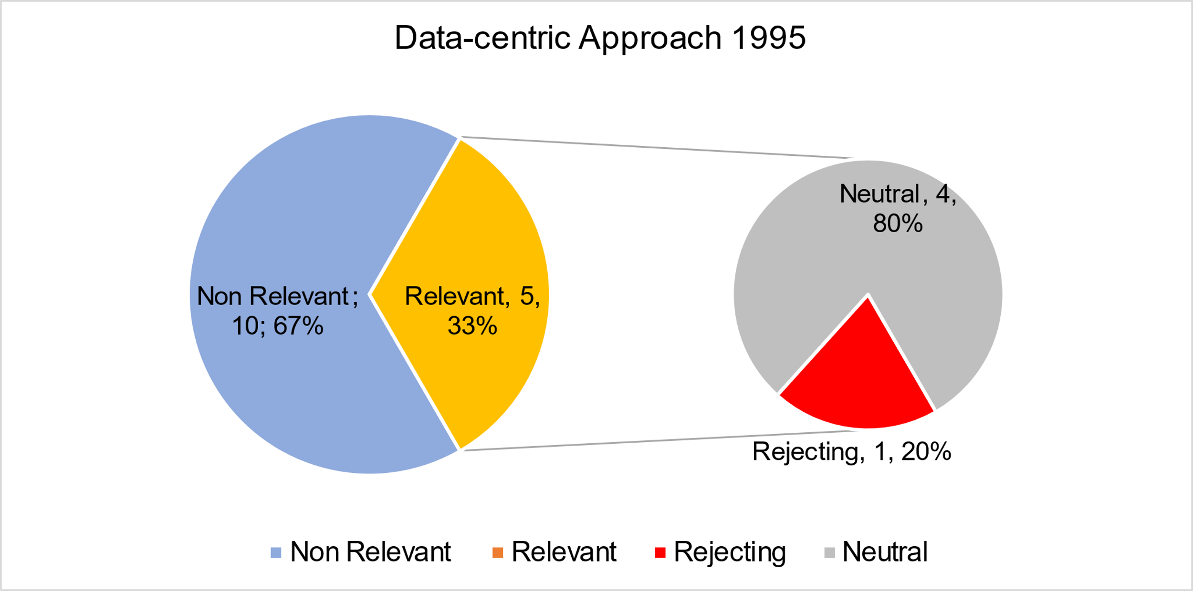

Figure 7: The Analysis results for September 1991. Showing on top the Pie Chart using the Cook et al. (2013) methodology. Then the bottom Pie charts showing the result with the Data-centric methodology

Figure 8: The results for the data from all year combined. Showing on top the Pie Chart using the Cook et al. (2013) methodology. Then the bottom Pie charts showing the result with the Data-centric methodology.

