S1 Fig. Flowchart visualizing the protocol of session one (a) and session two (b). Manipulation means the random assignment to either the goal intention / implementation intention condition.
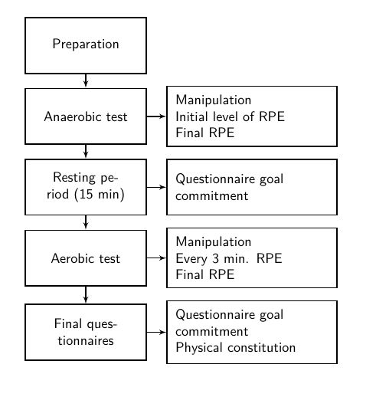
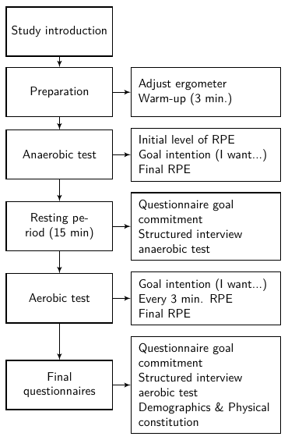
b
a

