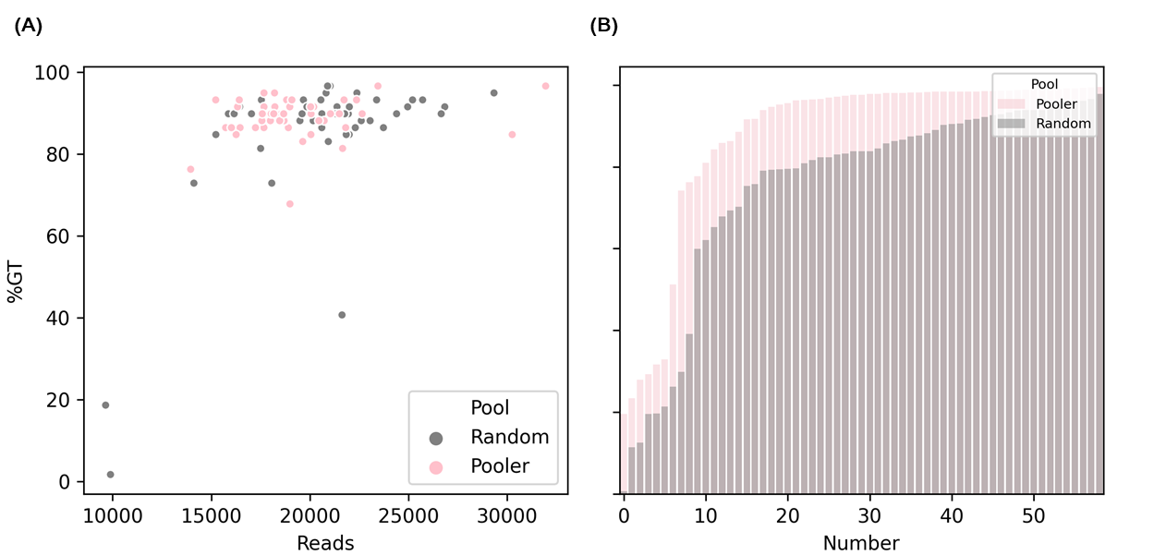
Supplementary Figure S1. Comparison of GT-seq results as a function of primer pooling. (A) Genotyping rates of each sample. (B) Genotyping rates of loci in the reads. Gray and pink indicate random pooling and PrimerPooler pooling, respectively.

