Title: Human influence on Brown trout juvenile body size during metapopulation expansion.
Authors:
L. Aulus-Giacosa, F. Guéraud, P. Gaudin, M. Buoro, J.C. Aymes, J. Labonne, M.Vignon.
Affiliations
Universite de Pau et des Pays de l’Adour, E2S UPPA, INRAE, ECOBIOP, Saint-Pée-sur-Nivelle ou Anglet, France.
Corresponding author L. Aulus-Giacosa

Electronic Supplementary Material 1:
Selection of one-year-old fish through neural network machine learning.

The initial data contained 46241 fish measuring between 50 and 249 mm long. Data collection is part of the Biological Resources Center COLISA (https://doi.org/10.15454/D3ODJM). The exact age of 6191 of these fish was already known thanks to scale reading, a technique that allows to age brown trout and is very efficient for young ages. We used 4000 of these known age fish to train a neural network using simply capture date (Julian date) and body size, using the “knn” function of class R package (ver. 7.3-14). We then predicted the age of the remaining 2191 fish, testing neural networks of varying complexity (See Figure 1 below).

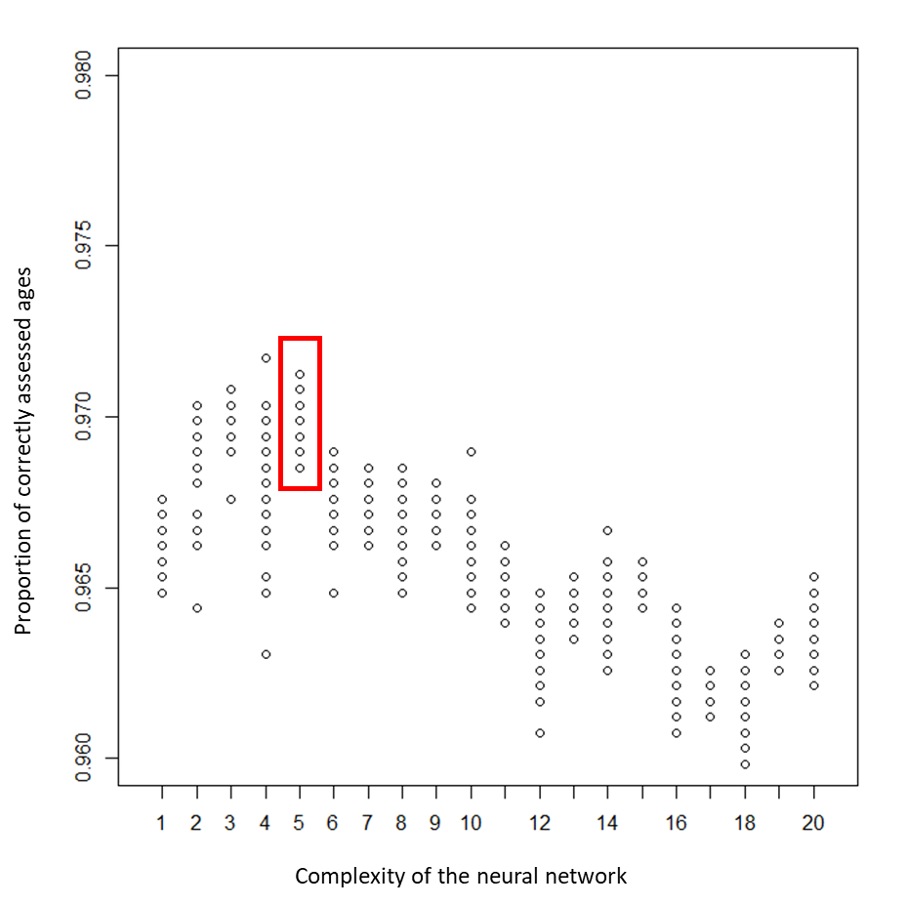
Figure 1: Efficiency of the neural network measured in proportion of exact response as a function of the complexity (number of nodes) of the neural network. The maximum efficiency as well as the most stable prediction was obtained for k= 5 nodes. We therefore used this network for further analyses.
For the best network (k=5), the algorithm predicted age with an efficiency of 97%. Having trained and selected the best neural network, we used it on the remaining data (N=40050) in order to detect fish with age between 1 and 2 years old. We then also discarded a small portion of the remaining dataset (<5%) for fish caught during the winter season, keeping only individuals in the growing season (between the 150th and the 280th day of their second year). This selection was performed to keep the part of the season where a linear relationship could be observed between the logarithm of the body size and the Julian date. It is indeed the timing of the year where significant growth is observed (See Beall and Davaine 1988, at the end of the present document).

Figure 2 shows the result of this analysis, which provided 21639 individuals for our study of body size evolution.
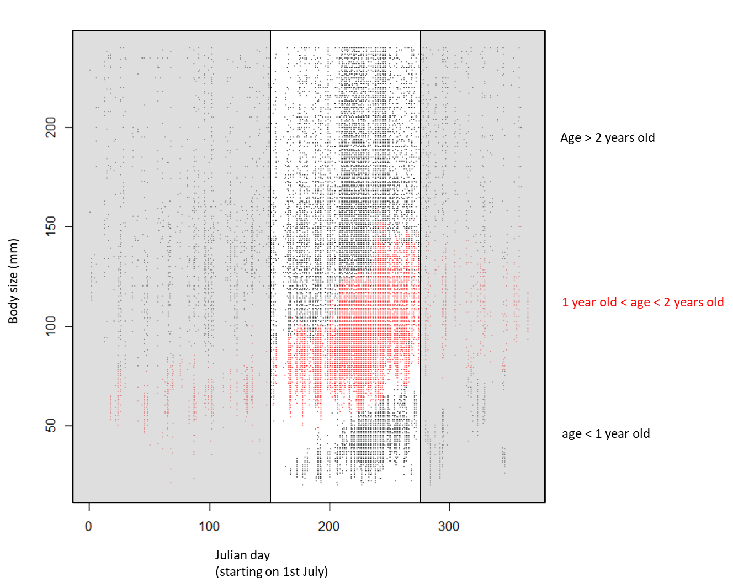

Figure 2: Relationship between body size (in mm) and Julian date of capture in the year in our whole dataset (all shown points) and for one-year-old fish (as detected by the neural network learning, in red). The greyed areas indicate intervals of the year discarded in the analysis.

The distribution of these 21639 fish along axes of interest (Metapopulation age, populations age) is plotted in Figure 3. Although it is not totally homogenous, the sampling covers much of the covariation between these two axes.

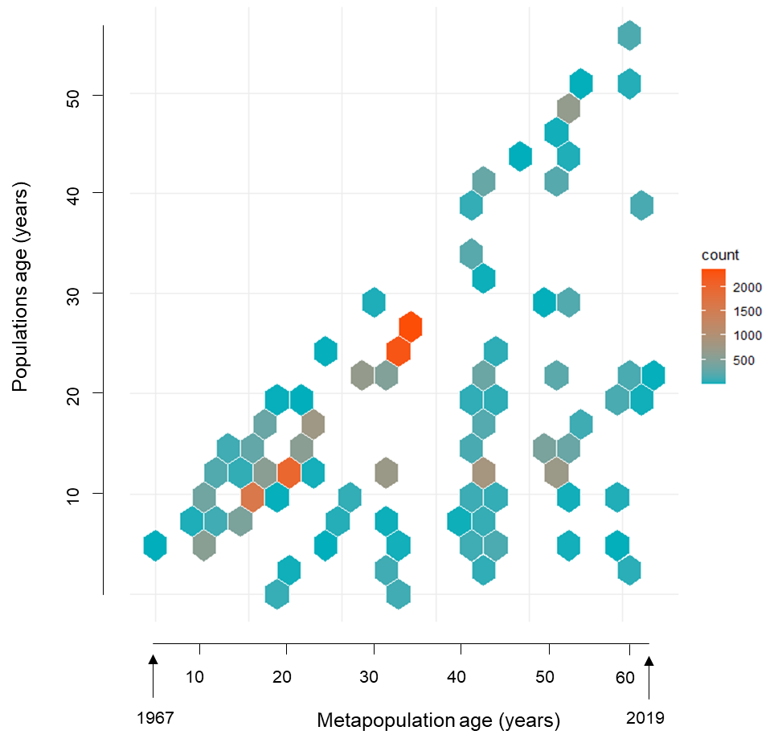

Figure 3: Density of sampling as a function of metapopulation age and populations age.

Beall E, Davaine P (1988) Analyse scalimétrique de la truite de mer (Salmo trutta L.): formation des anneaux et critères d’identification chez les individus sédentaires et migrateurs d’une même population acclimatée aux îles Kerguelen (TAAF). Aquat Living Res 1:3–16.

