Station | P7 | P6 |  | P5 |  | P4 | P3 | P2 | P1
Species | L. helicina | L. helicina | L. retroversa | L. helicina | L. retroversa | L. helicina | L. helicina | L. helicina | L. helicina
n | 7 | 6 | 6 | 51 | 7 | 104 | 139 | − | 1
Size range (mm) | 0.89−1.12 | 0.77−1.02 | 0.92−1.93 | 0.61−1.12 | 0.94−1.12 | 0.58−1.16 | 0.55−1.59 | − | −
Mean diameter (mm) | 0.997 | 0.906 | 1.384 | 0.845 | 0.105 | 0.810 | 0.768 | − | 0.759
SD (mm) | 0.096 | 0.081 | 0.385 | 0.107 | 0.067 | 0.116 | 0.178 | − | 0.000
Supplementary Material

Supplementary Table S2
Size of living L. helicina and L. retroversa measured in size >0.5 mm. Limacina limacina in size range 4–0.5 mm represents juveniles and L. retroversa in size range >1 mm represents adults (Lalli and Gilmer, 1989).

Supplementary Figure S1

Size of living L. helicina and L. retroversa measured in size range >0.5 mm. Limacina helicina in size range 4–0.5 mm represents juveniles and L. retroversa in size range >1 mm represents adults (Lalli and Gilmer, 1989).

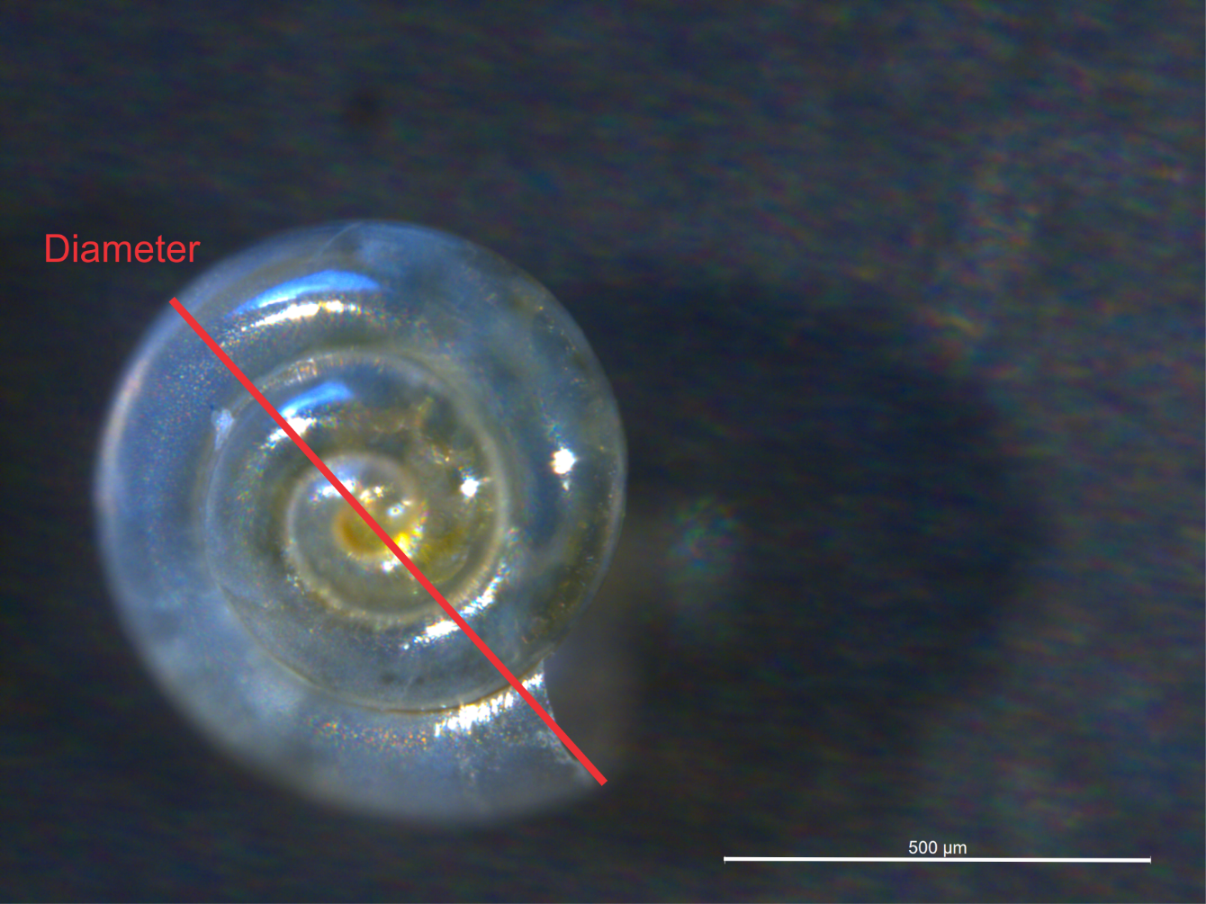

Lalli, C. M., and Gilmer, R.W. (1989). Pelagic snails: the biology of holoplanktonic gastropod mollusks. Stanford Univ. Press, Palo Alto, 259.

