Improving the Activity of Antimicrobial Peptides against Aquatic pathogen bacteria by Amino Acid Substitutions and Changing the Ratio of Hydrophobic Residues

Supplementary Figure 1. Bacterial membrane depolarization. Depolarization of the bacterial membrane after incubation with antimicrobial peptides P-6 was detected using DiSC3-5 (excitation, 622 nm; emission, 670 nm).
Supplementary Figure 2. Bacterial membrane depolarization. Depolarization of the bacterial membrane after incubation with antimicrobial peptides S-6 was detected using DiSC3-5 (excitation, 622 nm; emission, 670 nm).
Supplementary Figure 3. Bacterial membrane depolarization. Depolarization of the bacterial membrane after incubation with antimicrobial peptides L-6 was detected using DiSC3-5 (excitation, 622 nm; emission, 670 nm).
Supplementary Figure 4. Membrane permeation of M. luteus. The effects of 25 μg/ml of 1-6, P-6, S-6 and L-6 on the membrane integrity of the M. luteus cells were analyzed by flow cytometry. The proportion of integrated cells was shown near c.

Supplementary Figure 5. Membrane permeation of V. anguillarum. The effects of 12.5 μg/ml of 1-6, P-6, S-6 and L-6 on the membrane integrity of the V. anguillarum cells were analyzed by flow cytometry. The proportion of integrated cells was shown near c.
Supplementary Figure 6. Membrane permeation of V. anguillarum. The effects of 25 μg/ml of 1-6, P-6, S-6 and L-6 on the membrane integrity of the V. anguillarum cells were analyzed by flow cytometry. The proportion of integrated cells was shown near c.
Supplementary Figure 7. Membrane permeation of L. monocytogenes. The effects of 12.5 μg/ml of 1-6, P-6, S-6 and L-6 on the membrane integrity of the L. monocytogenes cells were analyzed by flow cytometry. The proportion of integrated cells was shown near c.
Supplementary Figure 8. Membrane permeation of L. monocytogenes. The effects of 25 μg/ml of 1-6, P-6, S-6 and L-6 on the membrane integrity of the L. monocytogenes cells were analyzed by flow cytometry. The proportion of integrated cells was shown near c.
Supplementary Figure 9. Membrane permeation of P. mendocina. The effects of 12.5 μg/ml of 1-6, P-6, S-6 and L-6 on the membrane integrity of the P. mendocina cells were analyzed by flow cytometry. The proportion of integrated cells was shown near c.
Supplementary Figure 10. Membrane permeation of P. mendocina. The effects of 25 μg/ml of 1-6, P-6, S-6 and L-6 on the membrane integrity of the P. mendocina cells were analyzed by flow cytometry. The proportion of integrated cells was shown near c.
Supplementary Figure 11. Membrane permeation of V. parahaemolyticus. The effects of 12.5 μg/ml of 1-6, P-6, S-6 and L-6 on the membrane integrity of the V. parahaemolyticus cells were analyzed by flow cytometry. The proportion of integrated cells was shown near c.
Supplementary Figure 12. Membrane permeation of V. parahaemolyticus. The effects of 25 μg/ml of 1-6, P-6, S-6 and L-6 on the membrane integrity of the V. parahaemolyticus cells were analyzed by flow cytometry. The proportion of integrated cells was shown near c.
Supplementary Figure 13. Bacterial membrane depolarization. Depolarization of the bacterial membrane after incubation with antimicrobial peptides was detected using DiSC₃-5 (excitation, 622 nm; emission, 670 nm).
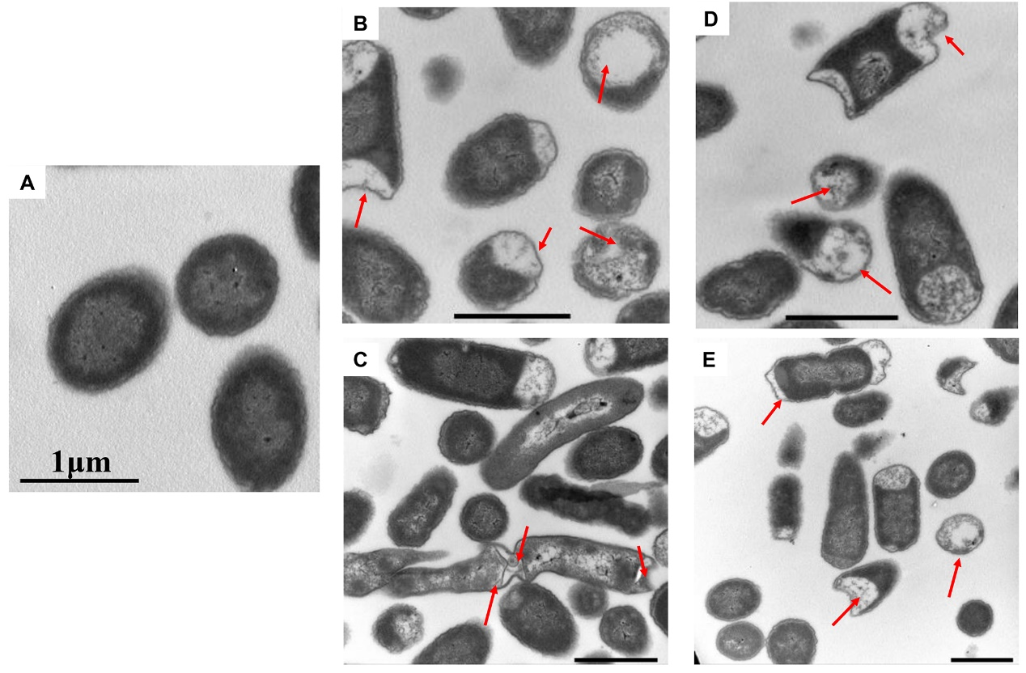
Supplementary Figure 14. Ultra-thin section of M. luteus for electron microscopic observation. M. luteus incubated with PBS (A) or with 1-6(B), P-6(C), S-6(D), and L-6 (E) at 28 °C for 30 min.

