Supplementary Material

Supplementary Figures
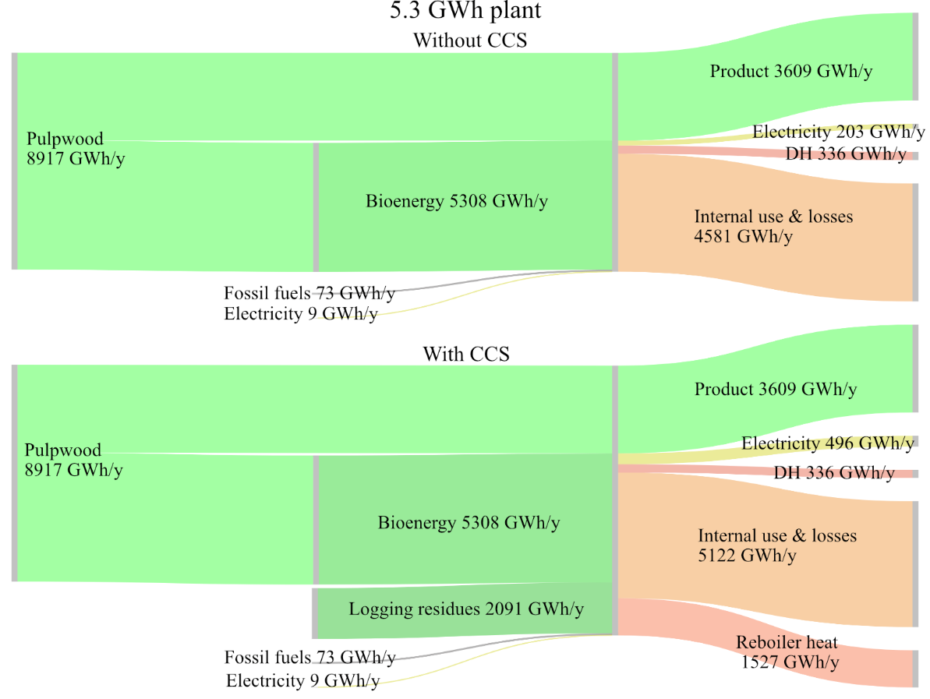
Supplementary Figure 1. Energy balance for the 5.3-GWh plant with and without CCS implementation based on the site potential for capture.

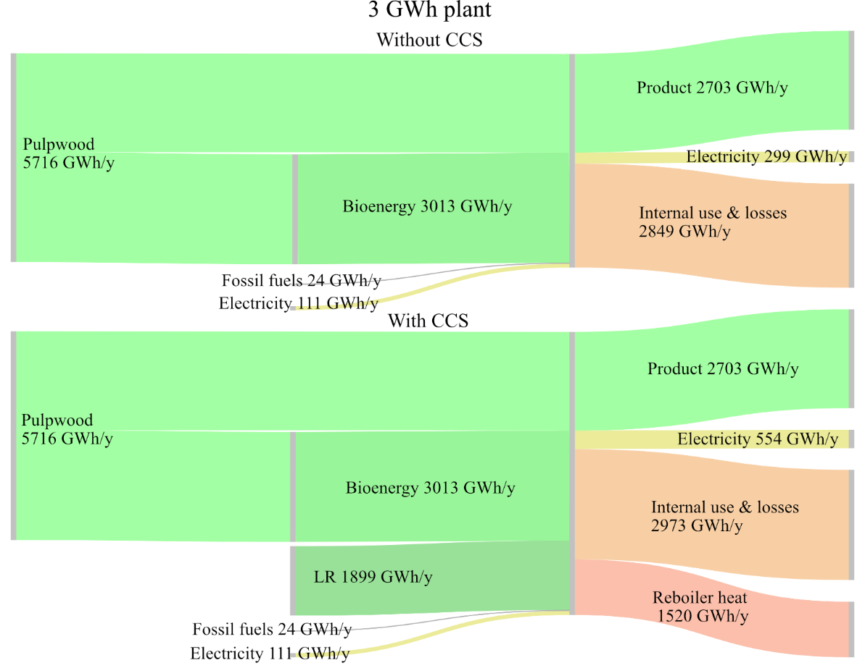
Supplementary Figure 2. Energy balance for the 3-GWh plant with and without CCS implementation based on the site potential for capture.

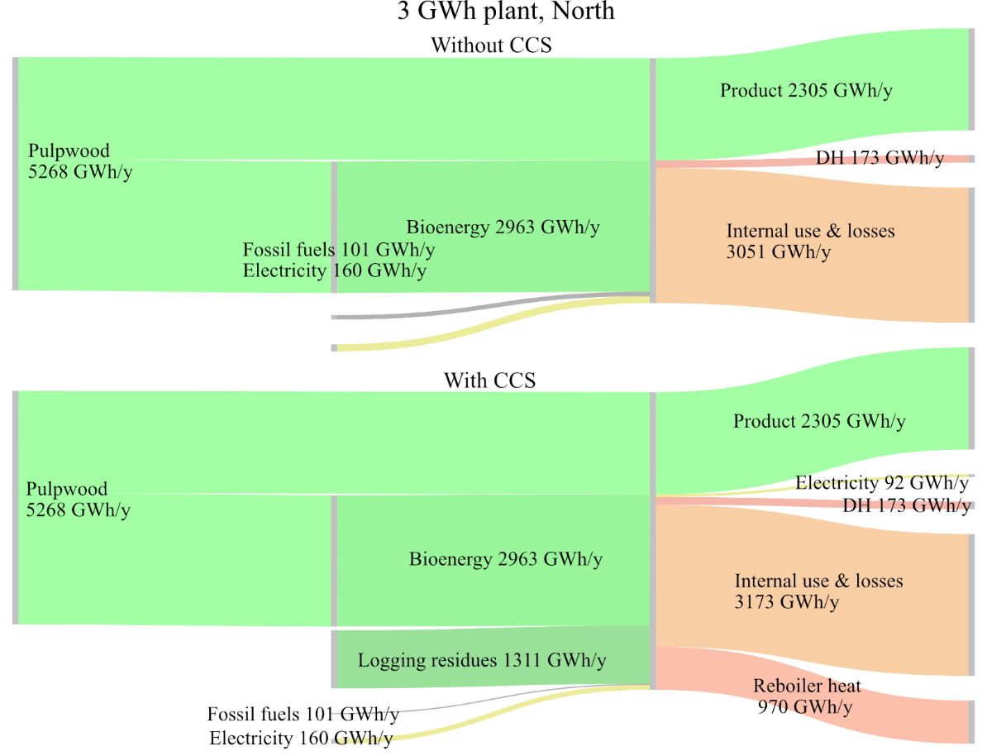
Supplementary Figure 3. Energy balance for the 3-GWh plant, North with and without CCS implementation based on the site potential for capture.

