Vocal plasticity in harbour seal pups - Supplement

Table S1. Additional medical information on the tested seals.

Patient ID | Letter | Date of arrival | Umbilicus status at arrival | Sex | Weight at arrival | Medical problems during rehabilitation?
19-189 | A | 06/22/2019 | freshly absent, almost closed | M | 9.7 | None
19-191 | B | 06/23/2019 | freshly absent | M | 9.7 | None
19-196 | C | 06/24/2019 | freshly absent, almost closed | M | 12 | None
19-198 | D | 06/25/2019 | freshly absent | F | 12.4 | None
19-214 | E | 07/06/2019 | freshly absent, almost closed | M | 10.1 | At arrival was presented with a blocked nose thus was treated accordingly and improved.
19-215 | F | 07/06/2019 | freshly absent, almost closed | M | 8.4 | None
19-222 | G | 07/08/2019 | freshly absent, wide open | F | 7.3 | None
19-223 | H | 07/09/2019 | freshly absent, almost closed | F | 8.8 | Swelling and purulent discharge from wound on the first toe of the left hind flipper. Infectious arthritis was suspected, and amputation surgery was performed due to worsening of the condition despite medical treatment.

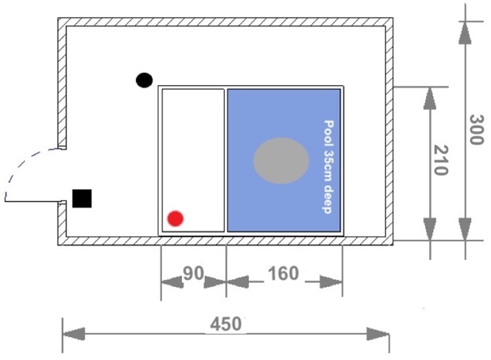
Figure S1. Blueprint of a quarantine. Grey oval: seal pup at the bottom part of the empty pool. Red circle: speaker. Black circle: microphone, tripod and camera. Black square: smartphone and recorder connected at distance. Measurements are in centimeters.

Table S2. Median amplitude, octave slope, and R14 for each seal and each condition show several significant measurements, indicating a presence of the Lombard effect in individual seals’ vocalisations. Amplitude values shown are obtained by normalizing the median call intensities by the intensity of the 65 dB noise recording. Significant effects (after Bonferroni correction by factor 24) compared to the no playback condition (NP) are shown with an asterisk.
 | Amplitude |  |  | Slope (dB/octave) |  |  | R14
 | NP | low | high | NP | low | high | NP | low | high
Seal A | 0.74 | 0.60 | 0.82 | -6.13 | -6.16 | -6.19 | 5.86 | 4.32 | 7.29
Seal B | 0.22 | 0.17 | 0.29 | -6.10 | -6.12 | -6.05 | 11.28 | 13.48 | 9.82
Seal C | 0.21 | 0.45 * | 0.23 | -6.03 | -6.11 | -6.09 | 12.63 | 6.32 | 8.77
Seal D | 0.06 | 0.10 | 0.11 | -6.18 | -6.00 | -6.31 | 10.00 | 7.44 | 5.05
Seal E | 0.06 | 0.05 | 0.08 | -6.13 | -6.19 | -6.40 | 3.84 | 4.25 | 6.71
Seal F | 0.58 | 0.46 | 0.41 | -6.53 | -6.48 * | -6.47 | 7.13 | 8.82 | 6.72
Seal G | 0.27 | 0.48 | 1.15 * | -6.39 | -6.08 * | -6.12 | 6.34 | 2.15 * | 2.40 *
Seal H | 0.19 | 0.09 | -0.15 | -6.16 | -6.16 | -6.89 | 5.83 | 7.86 | 6.51

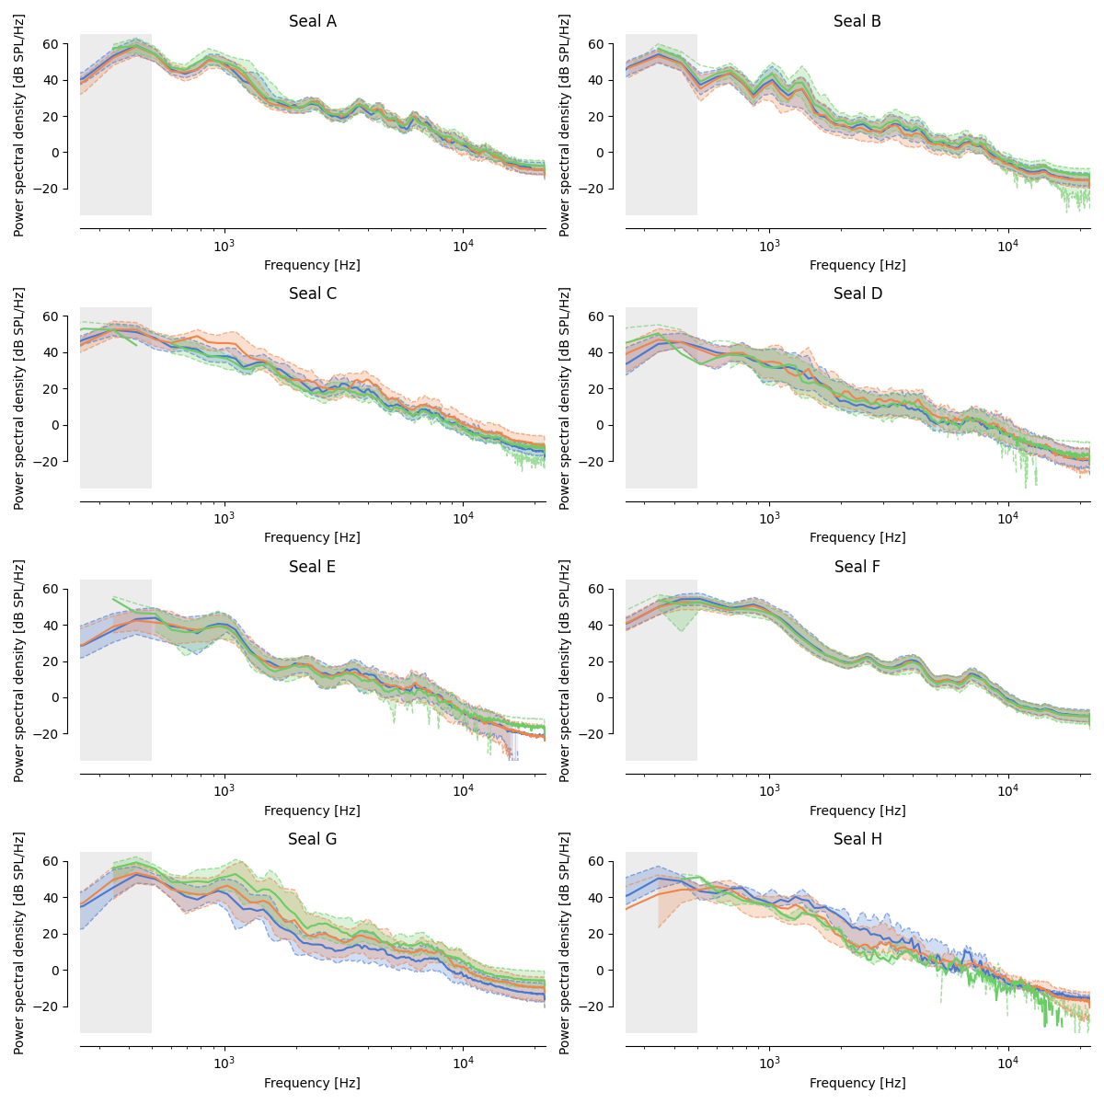
Figure S2. Median spectra per seal show that seal G does exhibit a typical pattern of the Lombard effect, where the frequencies in the 1-4 kHz range are boosted under noisy conditions. (blue: no playback, orange: low noise, green: high noise.)

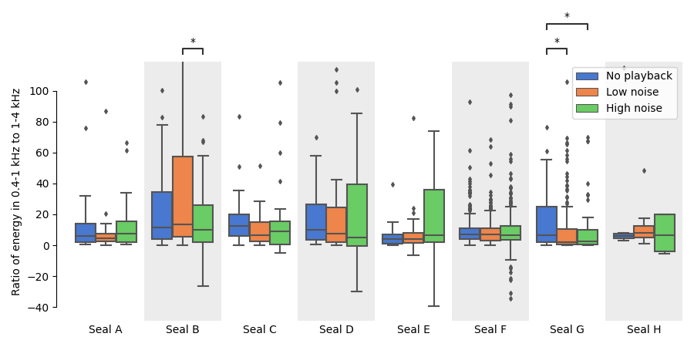
Figure S3. The ratio between the energy in the 0.4-to-1 kHz and in the 1-to-4 kHz frequency bands significantly lowers in noisier experimental conditions for seal B and seal G, indicating a possible manifestation of the Lombard effect.

Supplemental information on stimuli
In May 2019, audio recordings of ambient noise (mostly natural wind noise) were collected on a sandbank in the Wadden Sea. They were used as a basis to create our playback. The sound pressure level (SPL) was measured with a CheckMate SPL Meter (CM-130). Amplitudes were 50 dB (A-weighting) and 72 dB (C-weighting) SPL. Ambient noise - as opposed to, for example, synthetic white or pink noise - was selected to minimize the seals’ exposure to unnatural sounds, however with no aim of faithfully simulating environmental sounds.

Sounds were bandpass filtered in Praat (version 6.0.52; Boersma & Weenink, 2018), resulting in a noise band between 250 and 500 Hz (Figures S4 and S5). This frequency range was chosen to overlap with the F0 range of seal pups’ mother attraction calls (Khan et al., 2006; de Reus et al., in prep; Sauvé et al., 2015). The peak was scaled at 0.95 to feature as much signal as possible before electrical amplification. We selected a 15-second snippet from the whole noise recording with spectral properties as close as possible to constant power spectral density on the noise band. Looping the 15 seconds snippet resulted in a 5 minutes track. This was done with a custom Python script which cross-faded the noise snippet with itself (1 second overlap) several times and the whole resulting sound was cross-faded with a 1-second silent snippet at its beginning and end. Two versions of the exact same playback were created, only differing by 20 dB amplitude.

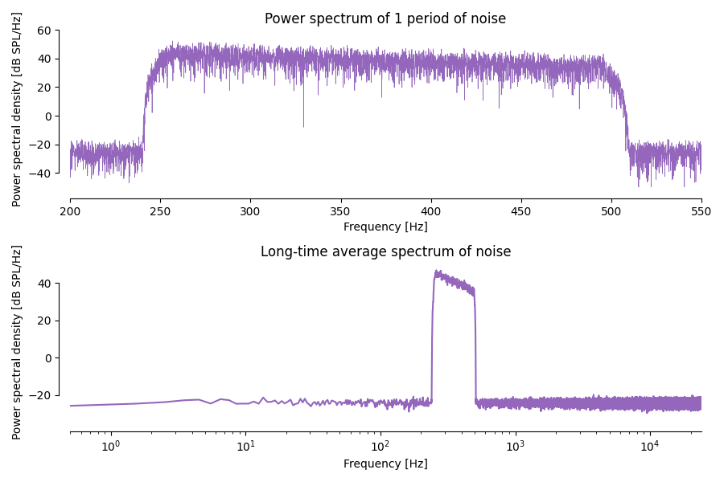
Figure S4. The spectrum of the noise shows the effect of filtering with a Hann window between 250 and 500 Hz. All energy is focussed within this reasonably small range of frequencies.
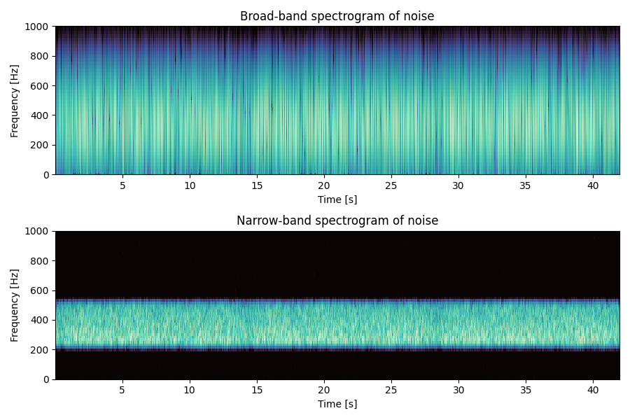
Figure S5. The spectrum of the played-back noise varies slightly over time (illustrated in particular by the broad-band spectrogram, top) but is still entirely focussed in the 250 to 500 Hz range (bottom).

