Supplementary Material:

Functional Response of a Forager on a Wetland Landscape
- Donald L DeAngelis ¹, Simeon Yurek¹, Stephen Tennenbaum ², Hyo Won Lee ²
¹U.S. Geological Survey, Wetland and Aquatic Research Center, Gainesville, FL, USA
²Biological Sciences Department, Florida International University, Miami, FL USA

Figure S1. Geometry of a hypothetical pond permanent pond with surrounding area (‘greater pond’) that can flood. The vertical scale is exaggerated compared to the horizontal scale. In the simulations shown in Appendix 3, $ϕ$ = 0.0035 radians, the radius of the permanent pond is 22 m and has a maximum depth of d_{pond}= 0.75 m when the surrounding area is dry. In the simulations of Appendix 3, the initial added depth, d_{basin} = 0.5 m, such that the initial radius of the greater pond was about 164 m. Table S1 lists values of pond parameters used in the simulations of Section 4 of the paper

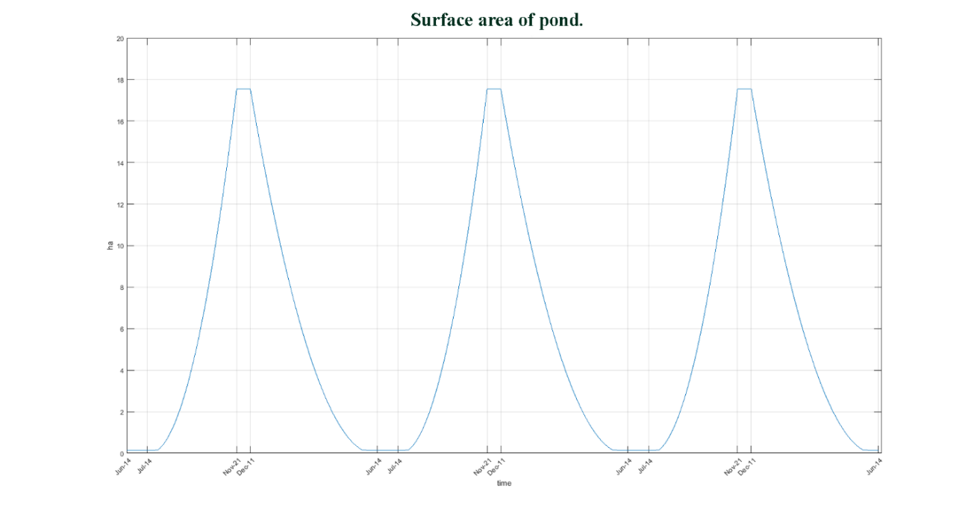

Figure S2. Surface area of the flooded area of the idealize pond (Figure S1), including the entire surrounding basin, over a few years. This shows the large seasonal change in flooded area.

Appendix 1. Strategies for Foraging
The daily foraging time of wading birds is limited. If a wading bird spends a long time in a certain pond, the bird is losing a potential opportunity to forage in a better pond. When the current pond quality is relatively low, the bird would have a high chance to find a better pond. Thus, it would be necessary for birds to use GUT strategies to maximize a daily fish intake. A number of different strategies are possible for foraging in a patchy environment. Which are most effective can depend on the amount of information that forager has of the environment (e.g., foraging quality of patches other than the one it is currently using, distances between patches). Such knowledge can be acquired through memory of patches already sampled, cues given by other foragers using a patch, etc. Some level of information, ranging from zero knowledge to perfect knowledge of patches beside that which a forager is currently using, can influence its giving-up time, GUT, in its current patch. Several possible strategies involving GUT can be considered.
Case1. Random foraging. In the absence of any strategy for foraging during a day, the GUT is simply determined by what is experienced in each particular pond. Therefore, the wading bird responds only to the prey availability in the pond that it is occupying and stays for a time that is proportional to its rate of prey intake raised to a power β.
$$GUT\left(F_{intake rate, i}\right) = α{\left(\frac{aP_{available,i}}{1+ahP_{available,i}}\right)}^{β}+ T_{minimum} .$$
where the values of pond i, and hence $P_{available,i},$ are chosen randomly from the distribution $D\left(P_{available,i}\right).$ The travel time will be the mean of possible travel times between ponds visited, and can be represented as $T_{travel,mean}.$Total net intake of energy will depend on how many ponds can be visited during a day and the amount of energy accumulated from visiting those ponds minus metabolic costs within the ponds and traveling between them. An expected value of energy intake could be calculated, given the GUT’s associated with each pond and the travel times between each combination of ponds. The above example used fish intake rate as a main variable. However, we can also apply relative quality of the ponds or threshold pattern for this case.
Case 2. Minimizing travel time. In this case, the wading bird moves from one pond to the nearest neighbor, with no a priori knowledge of the prey availability. In this case $P_{available,i},$ are again effectively chosen randomly from the probability distribution, $D\left(P_{available,i}\right),$ but T_{travel time} is minimized.

Case 3.Using information from memory of previous day’s foraging to recall high prey availability sites In this case, the wading bird is able to use information that allows it to sample ponds from the high end of the probability density function $D\left(P_{available,i}\right)$. This information could come from memory from foraging on the previous day, assuming that prey densities have not changed substantially since the previous day’s foraging. This strategy might not minimize travel time, but the knowledge of favorable ponds would probably include information to allow roughly minimizing travel times.
Case 4. Using a strategy of within-day memory to optimize pond selection. The wading bird may initially not use the GUT described above, but may simply use the shortest sampling time possible, $T_{minimum}$, for a number, n, of ponds, and then, using its memory, return to those ponds that have highest prey availability. This sort of strategy is well known in many applications, and, in principle at least, an optimal strategy for number of ponds initially sampled could be calculated, given information on $D\left(P_{available,i}\right)$ and travel times between ponds.
Case 5. Inclusion consideration of travel costs in GUT. It is possible that the GUT of a wading bird is influenced by the expected travel times between ponds. Greater expected travel times should influence a wading bird to spend more time in a particular pond than it would if travel times and costs were lower. Unlike marginal value theorem (Charnov 1976), this case assumes that the foraging activity does not change the fish intake rate. We can write the GUT as
$$GUT\left(F_{intake rate, i}\right) = α{\left(\frac{aP_{available,i}}{1+ahP_{available,i}}\right)}^{β}+ T_{minimum}+c{(T_{travel, mean})}^{γ}.$$
where $α(T_{travel, mean})$ is an increasing function of $T_{travel, mean}$. A strategy can be calculated numerically if there is information of $T_{travel, mean}$ and the distribution $D\left(P_{available,i}\right)$.
Case 6. Using the presence of other birds as a visual cue. In this case, the wading birds assume that ponds where other birds foraging would have high quality. This means a pond with a larger GUT would have a higher chance to be found and visited by another bird. One of the ways to describe this situation is changing$D\left(P_{available,i}\right)$. The ponds with higher GUT should have a larger chance to been found and visited by multiple wading birds than the actual frequency of the ponds.

Appendix 2. Aggregation dynamics of fish within pond

Each pond is dynamic over the course of days, and the effect of changed in water depth and fish population density on foraging will be considered in a later section. But within a single foraging period within a day, the water level and fish density may be considered constant. Therefore, the within-pond functional response does not need to consider changing conditions.

However, a given pond at any time will have complexities that have to be taken into account in the within-pond functional response. These complexities include the distribution of water depths and fish densities, as well as the presence of other foraging wading birds.

In order to model the distribution and density of prey fish within a pond, we can use a reaction-diffusion-advection equation, which will provide a simplified but uniform approach from pond to pond. With demography and predation the expression is
$$\frac{∂N}{∂t}=D\left(\frac{δ^{2}N}{{δr}^{2}}+\frac{1}{r}\frac{∂N}{∂r}\right)-\frac{∂}{∂r}\left(vN\right)+R\left(N,P\right)$$
Here the distribution is assumed to be rotationally symmetrical and uniform in angular density$(∂N/∂θ=0)$. The first term in parentheses on the right-hand side is diffusion the second term is advection and the third term is reaction. The advection term has the following characteristics: 1) it should be zero when fish are at the optimal depth or their optimal location, 2) fish that are not at their optimal location will attempt to move toward the optimal location, 3) they will attempt to return to the optimal location more quickly as they increase their distance from it 4) they have a maximum speed $\left(v_{0}\right)$ which they can swim. A convenient function that satisfies all these conditions is $v={-v}_{0}\tanh\left(\frac{r-r_{opt}}{h}\right).$Here r_{opt} is the optimal location, i.e. the distance from the center of the pond that puts the fish at the optimal depth and h is the distance, along a radius, from the optimal location where fish start to significantly slow their swimming. The diffusion coefficient can be approximated as $D≈\frac{v_{0}^{2}}{4ω}$ where ω is the frequency of direction changes (Holmes 1993; Goldstein 1951).
Although in practice, we solve the equation in cylindrical coordinates (our canonical pond is circular) we can solve for the PDE steady-state in 1-d to get an idea of the shape of the distribution we would expect. That solution is
$$P\left(r\right)=C{sech}^{\left(\frac{2ωh}{v_{0}}\right)}\left(\frac{r-r_{opt}}{h}\right),$$
where C is the normalizing constant over the distribution’s domain. This is a bell shaped curve very similar in appearance to a Normal distribution.
We ran some simple simulations in a single pond with runs extending over the course of a few years. For these experiments, we modeled the demographics as a logistic with a carrying capacity density acting at every point in the pond. By the end of the dry season, fish are concentrated in a small ring in the permanent pond where they may exceed their carrying capacity and are subject to high predation. Then as rains return and the pond fills up again the effects of shifting water levels cause the distribution to move along with the changing ideal depth. As shallow areas deepen, the population starts to grow from reproduction in previously unoccupied low-density areas as well as migration from neighboring regions. The result is that the entire distribution broadens and flattens until the increase in water level slows, stabilizes and then reverses. Meanwhile the population continues to grow as the water recedes, leading to high density and the highest total numbers. We thus have two high-density periods one at the end of the dry season due the pond drying up and the other mid dry season from the combined effect of population growth and concentration. The exact timing of these booms and busts are dependent on the relative rates of colonization, reproduction, levels of predation and the timing and speed of water level changes.

Appendix 3. Scenario of Dynamics of Fish with a Pond

The dynamics of wading birds and their fish prey can be shown in an idealized way by simulation the imposition of a dry down of water in the geometric pond shown in Figure S1. The simulation shows that the period of time during which fish availability is sufficient for successful foraging by wading birds can be as short as a week or so, though the concentration of fish with a day may be constant enough to use a within-pond functional response in which the prey density can be considered constant. In this simulation, we assumed that the total fish biomass at the start of the shrinking of the pond stayed the same, except for that removed by wading bird foraging, but that the concentration of fish (fish biomass per square meter) increased with pond areal shrinkage.

Using the geometric pond shown in Figure S1, we started with the pond having maximum water depth of 1.50 m and allowed water level to fall at a rate of 2.5 cm day⁻¹, through outflow and evaporation. We started with a total amount of fish biomass, 60 kg dry weight, spread evenly throughout the greater pond area, equivalent to an average of about 0.41 grams dry weight m⁻². Assuming a Holling type 2 functional response with prey, $P_{available}$,

$${F_{intake rate, i}= f}_{R}\left(P_{available,i}\right)= \frac{aP_{available}}{1+ahP_{available,}} ,$$

where a, the maximum biomass capture rate per day per gram m⁻² biomass density, was estimated as a = 10 grams per bird per fish wet weight biomass density per day. The handling time, h, was estimated as h = 0.005 days, which sets an upper intake limit, by birds, of 200 grams wet weight of fish biomass per day. This is an arbitrary estimate, as this limit depends on fish size, water depth, and time during the day spent foraging, but it is similar to the rate provided by Wolff (1994) for wood storks. To estimate the capture rate, a, a sensitivity analysis was conducted by using a range of values for this parameter in a series of different simulations, along with the observed number of wading birds (Gawlik, 2002).

Concerning the wading birds, we assumed that more birds would be attracted by higher densities of fish; in particular, the daily average number of wading birds recruiting to the pond would be proportional to fish biomass density. Specifically, we assumed that wading birds would be present only if the density of fish biomass was greater than a threshold of 2.0 g m⁻² wet weight (about 0.3 g m⁻² dry weight). Above that density, the number of wading birds would increase by 10 individuals for every increase of fish biomass density by 1 g m⁻² wet weight. Foraging occurs when any part of the greater pond area has water depths suitable for foraging (less than about 30 cm). All of the assumptions made here are for demonstration purposes, and not intended as any specific predictions.

Under a particular scenario, the total biomass of fish, the daily removal by wading birds, and the total cumulative removal are shown through time with wading bird foraging occurring during the dry season (Figure S3). Despite the rapid removal of fish by wading birds, the fish density spiked at a level in excess of 10 g m⁻² dry weight (see dashed line in Figure S3), before dropping drastically as wading birds consumed much of the fish biomass outside of the permanent pond. This simulation is indicative of the brief period in days in which a given pond may be available for wading bird foraging, if foraging level is high. The number of wading birds in the pond also spikes at the same time (Figure S4).

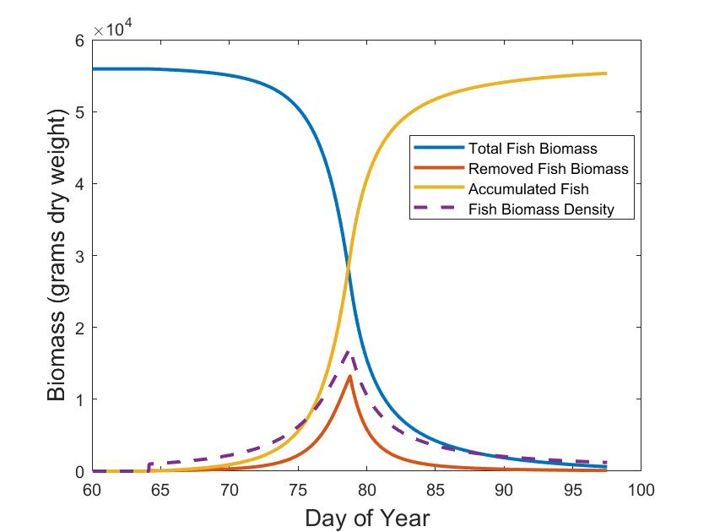
Figure S3. Total fish biomass (grams) in the greater pond area (blue line), per day fish removed by birds (red line), and cumulative fish removed by birds (yellow line). The dashed line shows the fish density (grams dry weight m⁻²x 10⁻³).

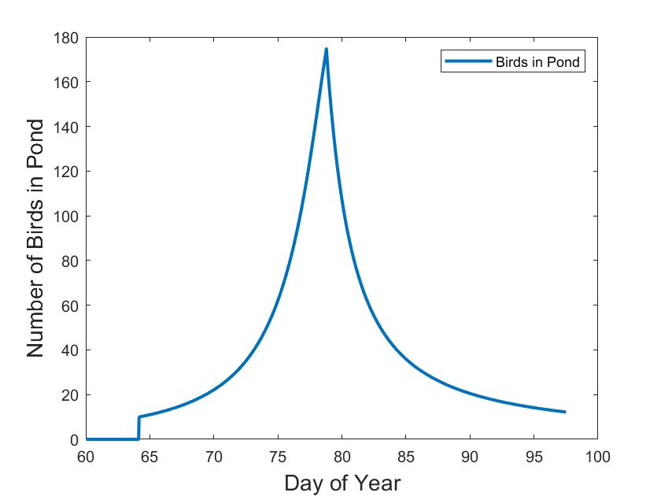
Figure S4. Total birds at the pond through time in the example in Figure S3.

Table S1. Parameter values for 17 simulated ponds and basins in Section 4. The first two columns give horizontal coordinates for pond centers on the landscape. Radii of the basins and ponds are indicated by r_{basin} and r_{pond}, while the elevations for the basin rim (highest point), pond rim, and pond bottom (lowest point) are given by z_{basin}, z_{pond}, and z_{bottom}, respectively.

x y phi r_basin r_pond zbasin zpond zbottom
-904.2 -412.04 4.29 161.85 34.13 -0.115 -0.81 -2.616
-1079.19 -61.06 2.63 143.14 28.61 -0.017 -0.393 -1.662
-754.06 767.82 3.73 181.05 13.17 0.215 -0.461 -0.73
-105.33 -432.79 3.64 187.69 27.82 -0.121 -0.805 -2.004
-17.27 179.5 2.59 145.64 26.2 0.05 -0.327 -1.391
-3.81 628.12 3.58 121.31 17.14 0.176 -0.258 -0.714
790.68 -375.44 2.64 136.46 12.51 -0.105 -0.465 -0.708
1045.49 -43.39 4.44 162.27 11.78 -0.012 -0.733 -0.948
916.46 462.36 4.06 179.74 30.49 0.129 -0.6 -2.041
-493.71 -698.92 2.83 160.9 15.14 -0.196 -0.651 -1.007
-564.6 -74.48 3.7 116.29 26.35 -0.021 -0.451 -1.527
-422.27 206.25 2.82 86.34 34.47 0.058 -0.185 -2.027
-341.41 837.13 4.12 124.89 27.03 0.234 -0.28 -1.413
414.76 -933.7 4.2 213.85 25.24 -0.261 -1.159 -2.147
501.85 -164.36 4.29 128.96 27.38 -0.046 -0.6 -1.762
321.35 445.92 2 118.19 29.53 0.125 -0.112 -1.464
489.79 979.9 3.04 236.63 4.99 0.274 -0.444 -0.483

References:
Charnov EL, (1976) Optimal foraging, the marginal value theorem. Theoretical Population Biology 9:129–136.
Gawlik, D. E. (2002). The effects of prey availability on the numerical response of wading birds. Ecological Monographs 72:329-346.doi:10.1890/0012-9615(2002)072%5B0329:TEOPAO%5D2.0.CO;2
Goldstein, S. (1951). On diffusion by discontinuous movements and on the telegraph equation.Quarterly Journal of Mechanics and Applied Mathematics 4:129-156.doi:10.1093/qjmam/4.2.129
Holmes, E. E., (1993). Are diffusion models too simple? A comparison with telegraph models of invasion. The American Naturalist, 142(5), pp. 779-795.doi:10.1086/285572
Wolff, W. F. (1994). An individual-oriented model of a wading bird nesting colony. Ecological Modelling, 72(1):75-114.doi:10.1016/0304-3800(94)90146-5

The “maximum speed” only refers to the advection term since the diffusion equation allows infinite speeds albeit with infinitesimal probability.

