Data Supplements
Table S1: Sample schedule frequencies for symptom questionnaires based on type of therapy.
Treatment Schedule Name | Cadence
Systemic Therapy (e.g., Chemotherapy or Immunotherapy) 2 week cycle, 6 months | Every 2 weeks
Systemic Therapy (e.g., Chemotherapy or Immunotherapy) 3 week cycle, 6 months | Every 3 weeks
Systemic Therapy (e.g., Chemotherapy or Immunotherapy) 4 week cycle, 6 months | Every 2 weeks
Oral medicine treatment, 6 months | Baseline, on average every 3 weeks

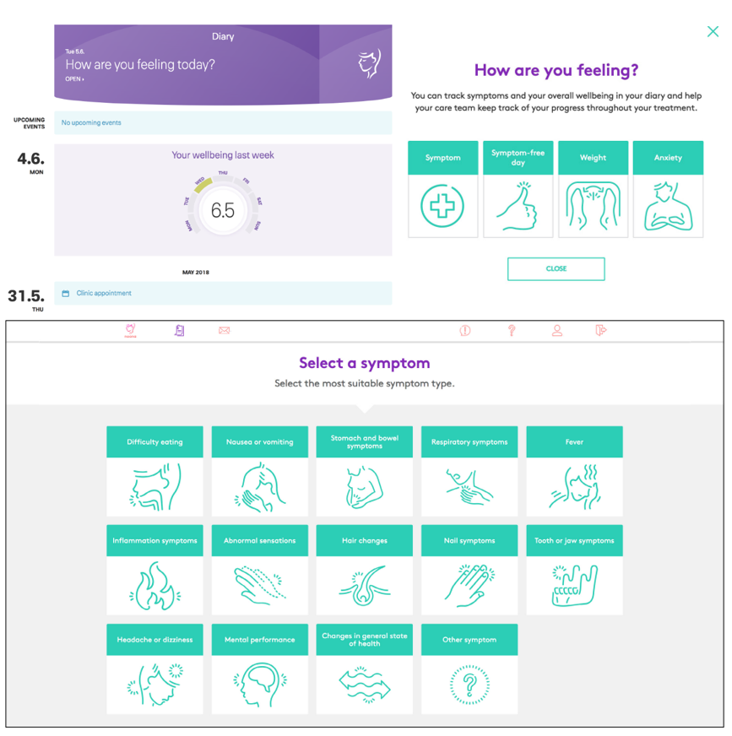
Figure S1: Sample Symptom Questionnaire (SQ) User Interface

