The influence of orbital forcing on ¹⁰Be deposition in Greenland over the glacial period
Anna Sturevik-Storm¹, Minjie Zheng^{2*}, Ala Aldahan^{3*}, Göran Possnert⁴, Raimund Muscheler²
¹ Department of Earth Sciences, Uppsala University, Uppsala, Sweden
²Department of Geology, Lund University, Lund, Sweden
³Department of Geology, United Arab Emirates University, Al Ain, United Arab Emirates
⁴Tandem Laboratory, Uppsala University, Uppsala, Sweden
Corresponding authors: Minjie Zheng (minjie.zheng@geol.lu.se); Ala Aldahan (aaldahan @uaeu.ac.ae)

File content
Figures S1-S10

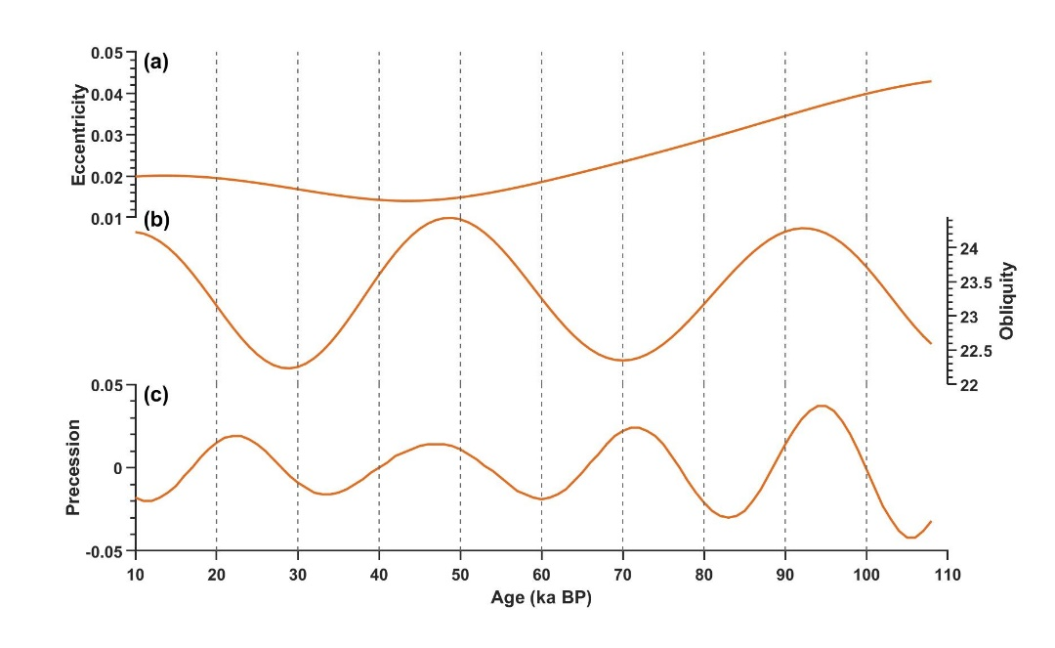
Fig. S1. Variations of the three components of Milankovitch orbital forcing cycles in the glacial period; eccentricity (a) (how round or elliptic the Earth’s orbit is with cycles of 413, 125 and 95 kyr that loosely combine into a 100 ka cycle); obliquity (b) (the axial tilt which changes between 22.1° and 24.5° with a cycle of about 41 ka) and precession (c) (change in direction of the Earth’s axis with a cycle of about 19-23 ka).

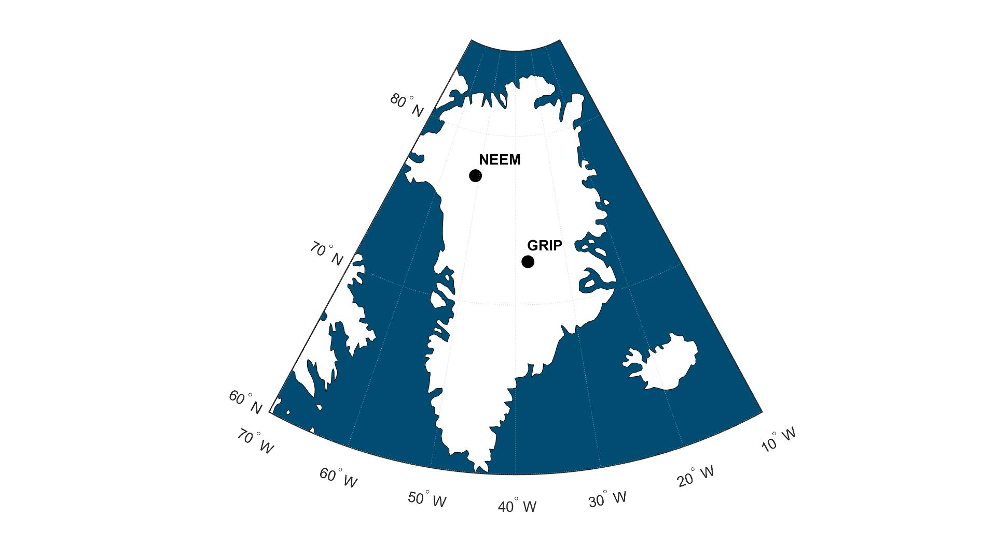
Fig. S2 Locations of the NEEM (The North Greenland Eemian Ice Drilling) and GRIP (The Greenland Ice Core Project) ice core drilling sites in Greenland.

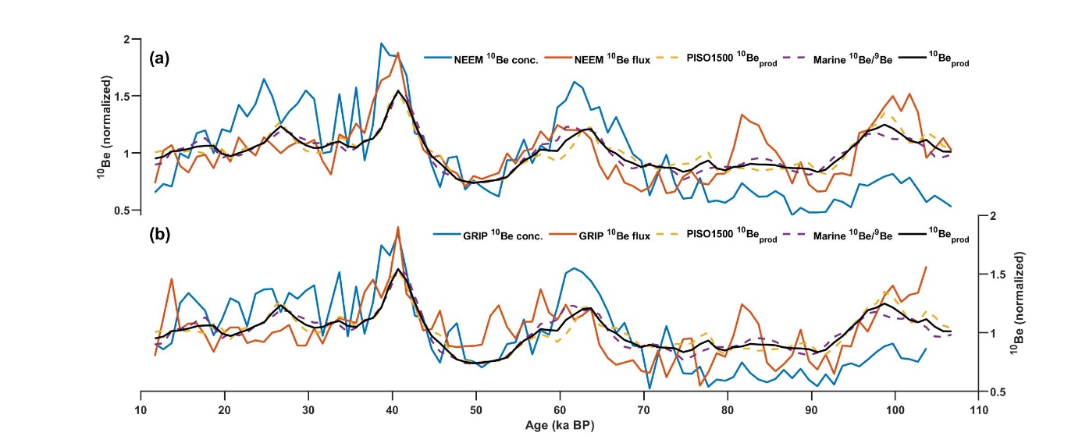
Fig. S3 Display of ¹⁰Be concentrations and fluxes from NEEM (a) and GRIP (b) ice cores, the PISO1500 ¹⁰Be_{prod} inferred from the independent geomagnetic record PISO-1500 from Channell et al. (2009), marine ¹⁰Be/⁹Be stack from Simon et al. (2016) and the ¹⁰Be_{prod} by averaging PISO1500 ¹⁰Be_{prod} and marine ¹⁰Be/⁹Be stack. The PISO-1500 corrected ¹⁰Be production (denoted as PISO1500 ¹⁰Be_{prod}) was performed using the production model from Poluianov et al. (2016) with the local interstellar spectra by Herbst et al. (2017). All data are normalized over the period 11.7-100 ka BP.

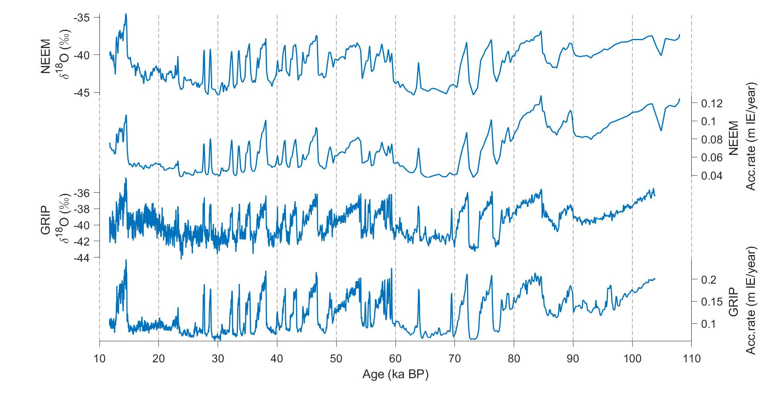
Fig. S4 Profiles of accumulation rates and δ¹⁸O of NEEM and GRIP ice cores.

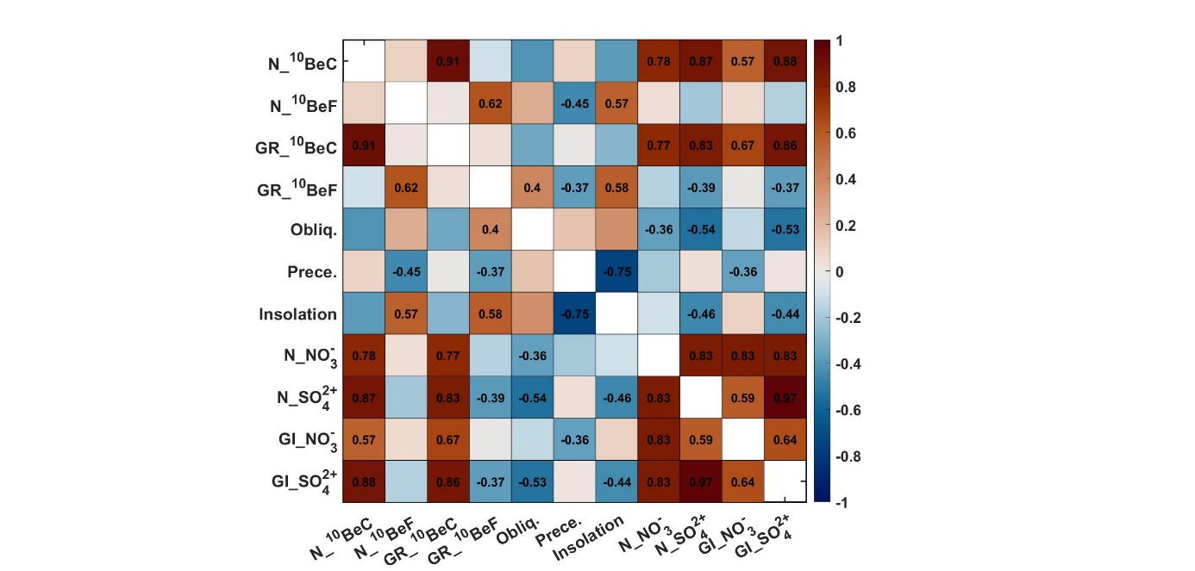
Fig. S5. Pearson correlation matrix for the different datasets used in this study. The numbers within grids indicate the significant values (p<0.05, student-t test adjusted by the autocorrelation following (Hu et al., 2017)). N_¹⁰BeC=NEEM ¹⁰Be conc_{climate}, N_¹⁰BeF=NEEM ¹⁰Be flux_{climate}, GR_¹⁰BeC=GRIP ¹⁰Be conc_{climate} , GR_¹⁰BeF=GRIP¹⁰Be flux_{climate}, Insolation=summer solar insolation TOA 65ºN, Obliq=Obliquity, Prece=Precession, N_${NO}_{3}^{-}$=NEEM ${NO}_{3}^{-}$ (ng g⁻¹), N_SO₄²⁻=NEEM SO₄²⁻ (ng g⁻¹), GI_${NO}_{3}^{-}$=GISP2 ${NO}_{3}^{-}$ (ng g⁻¹), GI_SO₄²⁻=GISP2 SO₄²⁻ (ng g⁻¹).

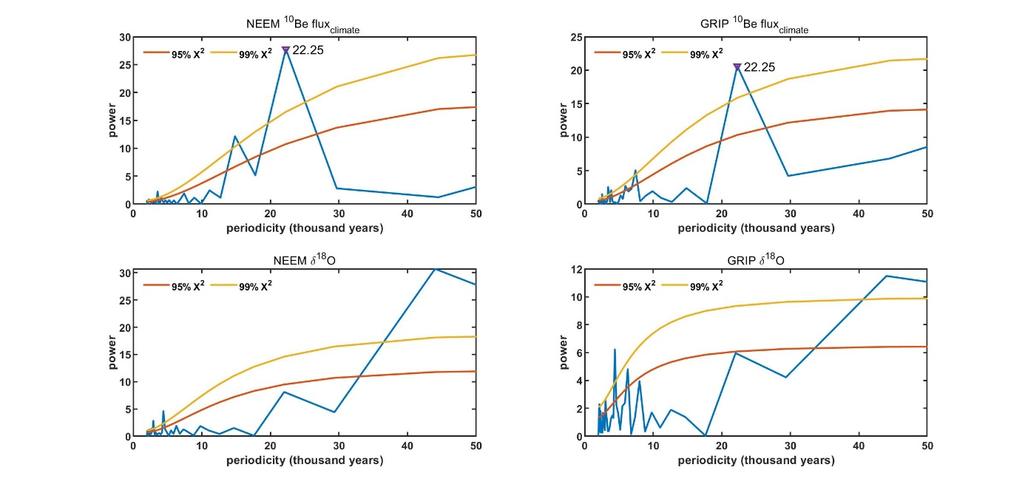
Fig. S6 Fourier spectra for the NEEM and GRIP ¹⁰Be flux_{climate} and NEEM and GRIP δ¹⁸O. Observe the strong periodicity of about 22 ka (precession cycle) in the ¹⁰Be flux_{climate} records which is less prominent in the δ¹⁸O records.
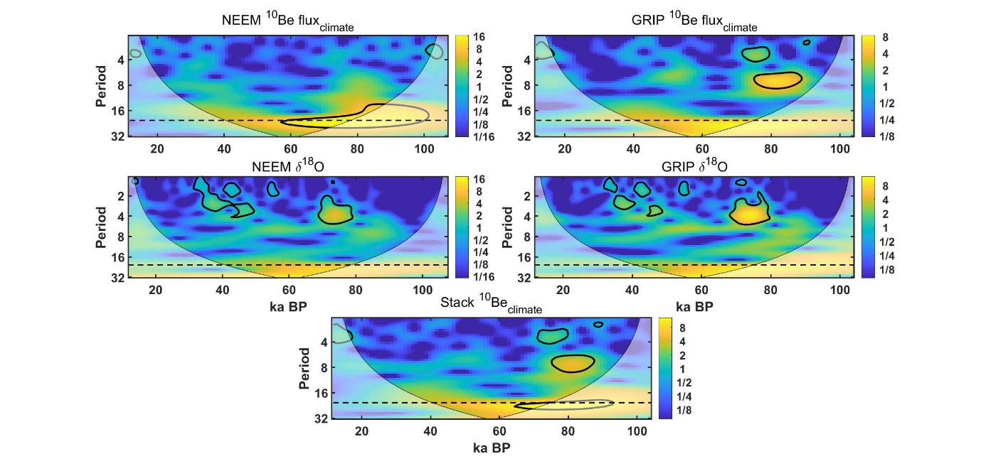
Fig. S7 Wavelet transform analysis of the NEEM and GRIP ¹⁰Be flux_{climate} data and δ¹⁸O indicating occurrence of a clear correlation band around at a periodicity of 21 ka in the ¹⁰Be flux_{climate}. Period is indicated in kiloyears.

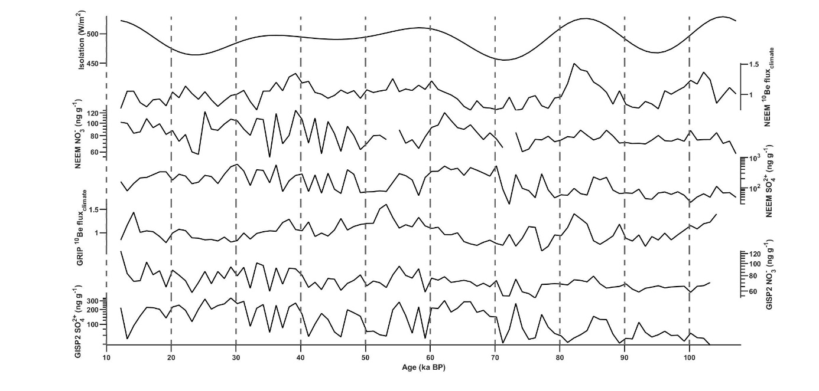
Fig. S8 Data of the summer insolation plotted with the NEEM and GRIP ¹⁰Be flux_{climate} and the NEEM NO₃⁻ (ng g⁻¹) and NEEM SO₄²⁻ (ng g⁻¹), and the GISP2 NO₃⁻ (ng g⁻¹) and GISP2 SO₄²⁻ (ng g⁻¹). All data are resampled at 1000 years.

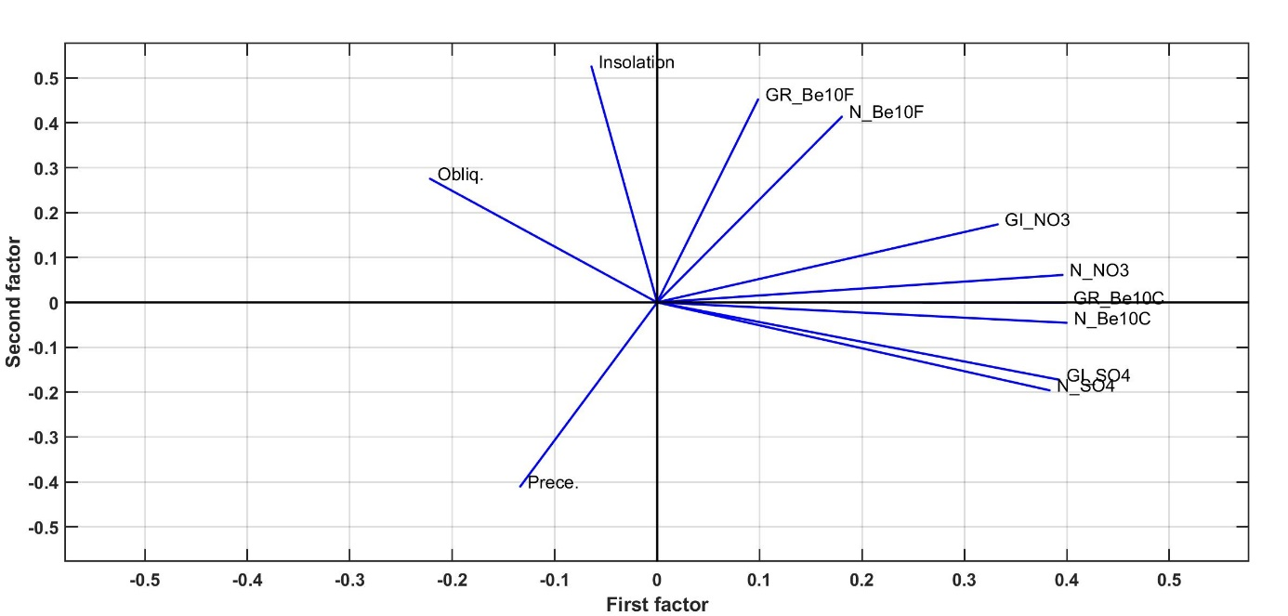
Fig. S9 Factor analysis for the different components showing the clustering of relatively high scoring loads of ¹⁰Be conc_{climate} with chemical data along the first factor indicating a common variability effect on these parameters (aerosols loading and sources). Less significant scoring load occurs for the ¹⁰Be flux_{climate}. Symbols as in Fig. S5.

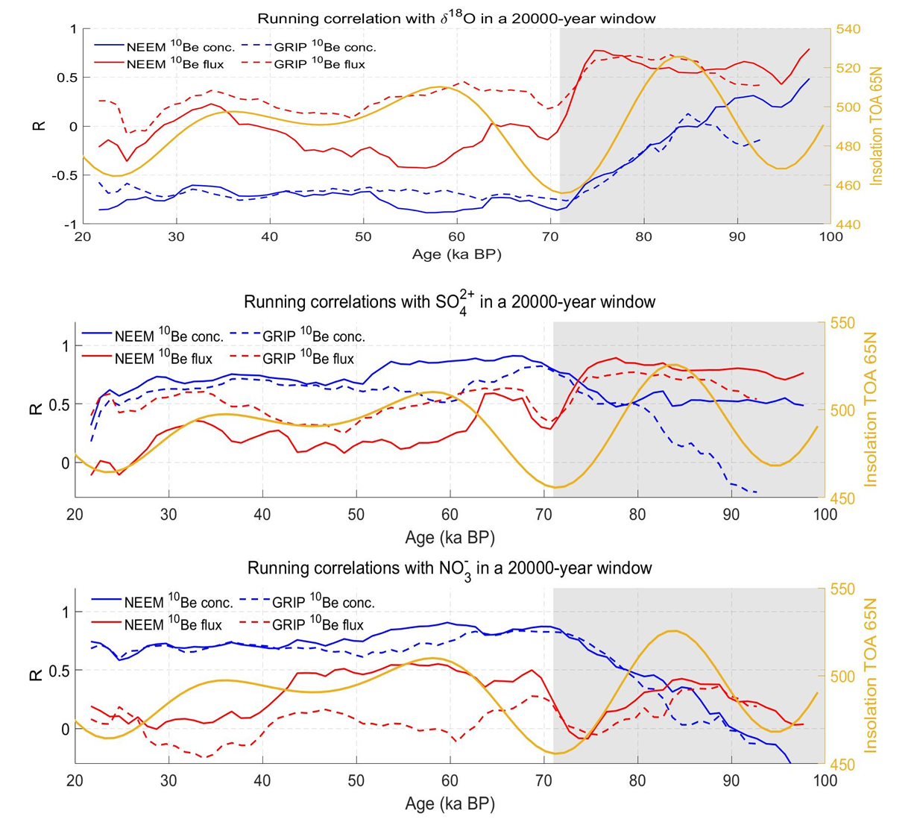
Fig. S10 Running correlations between ¹⁰Be concentration and flux and δ¹⁸O from the NEEM and GRIP ice cores with the summer insolation (W/m²) and ¹⁰Be concentration and flux of the NEEM and GRIP cores and concentration of NO₃⁻ and SO₄²⁻ from the NEEM and GISP showing correlation trends between the parameters that swing simultaneously at about 65 ka. The insolation shows clear swings as it enters MIS-4 and MIS-5 gray zone that may reflect a change in the climatic conditions resulting in changes of the aerosols transport pathways and consequently changes in ¹⁰Be deposition.

References
Channell, J.E.T., Xuan, C., Hodell, D.A., 2009. Stacking paleointensity and oxygen isotope data for the last 1.5 Myr (PISO-1500). Earth and Planetary Science Letters 283, 14-23.
Herbst, K., Muscheler, R., Heber, B., 2017. The new local interstellar spectra and their influence on the production rates of the cosmogenic radionuclides ¹⁰Be and ¹⁴C. Journal of Geophysical Research: Space Physics 122, 23-34.
Hu, J., Emile-Geay, J., Partin, J., 2017. Correlation-based interpretations of paleoclimate data – where statistics meet past climates. Earth and Planetary Science Letters 459, 362-371.
Poluianov, S.V., Kovaltsov, G.A., Mishev, A.L., Usoskin, I.G., 2016. Production of cosmogenic isotopes 7Be, 10Be, 14C, 22Na, and 36Cl in the atmosphere: Altitudinal profiles of yield functions. Journal of Geophysical Research: Atmospheres 121, 8125-8136.
Simon, Q., Thouveny, N., Bourles, D.L., Valet, J.P., Bassinot, F., Menabreaz, L., Guillou, V., Choy, S., Beaufort, L., 2016. Authigenic ¹⁰Be/⁹Be ratio signatures of the cosmogenic nuclide production linked to geomagnetic dipole moment variation since the Brunhes/Matuyama boundary. J Geophys Res Solid Earth 121, 7716-7741.

