Using GRACE Data to Estimate Climate Change Impacts on Earth’s Moment of Inertia (MOI)

Diandong Ren¹ and Aixue Hu²

- School of Electrical Engineering, Computing and Mathematical Sciences, Curtin University, Perth, Australia
- CGD/NCAR, Boulder, CO, USA

Submitted to Frontiers in Earth Sciences

Corresponding Author Address:

Dr. Diandong Ren
E-Mail:Diandong.Ren@curtin.edu.au
Curtin University, Perth, Australia

Supplementary Material: Calculating Earth’s MOI
Earth’s original rotation was a vestige of the original angular momentum of the primordial cloud that coalesced to form the solar system. As this interstellar dust is heterogenous, any asymmetry during gravitational acceleration resulted in the angular momentum of the eventual planet. If the giant-impact hypothesis for the origin of the Moon is correct, this primordial rotation rate would have been reset by the Theia impact 4.5 billion years ago. Tidal effects would then have slowed this rate to its modern value.
Earth's moment of inertia (I) is defined as:
$I=\int_{ϕ=-π/2}^{π/2}{\int_{θ=0}^{2π}{\int_{r=0}^{R}{ρr^{4}\cos^{3}ϕ drdθdϕ}}}$ (A1)
As the earth has an angular velocity of $ω=7.29×{10}^{-5}$rad/s and a moment of inertia I$≈$8.04×10³⁷ kg•m², it therefore has a rotational energy (${0.5Iω}^{2}$) of ~2.138x10²⁹ J. The coordinate convention follows the right-hand rule and all variables in Eq. (A1) are in SI units.
In this study, the total MOI variations are decomposed into various contributors, for a better understanding of its long-term trends and short-term variations. To this end, contributions from polar ice sheets, mountain glaciers, expansion of the atmosphere, and precipitation-driven hydrological cycles are accounted for. Estimation of the respective contributors are presented here for brevity.
- MOI estimates from GRACE gravity anomaly measurements ($I_{total}$)
$I_{total}=\sum_{\begin{aligned}i=1 \\ j=1\end{aligned}}^{\begin{aligned}j=ny \\ i=nx\end{aligned}}{W_{i,j}∆h_{i,j}ρ_{w}R^{2}}$ $\cos^{2}ϕ_{i,j}$ (A2)
where subscripts i, j are integer indices of the latitudinal and longitudinal count of the horizontal global grids, W is grid area, $∆h$is the water equivalent depth (GRACE measurements are in cm, converted into SI unit meters), $ρ_{w}$is water density, R is the earth radius, and$ϕ$ is the latitude. SI units are used so the value of MOI is in kg m².
- MOI from elevated atmospheric mass center of the earth atmosphere ($I_{atm}$)
$I_{atm}=\sum_{\begin{aligned}i=1 \\ j=1\end{aligned}}^{\begin{aligned}j=ny \\ i=nx\end{aligned}}{{\sum_{k=1}^{nz}{∆p_{i,j,k}}W}_{i,j}({R+z)}^{2}}\cos^{2}ϕ_{i,j}/g$ (A3)
where subscribe k is integer count of atmospheric vertical levels, p is atmospheric pressure, z=z(p) is the geopotential height, and g is gravitational acceleration.
- MOI from polar ice sheets and mountain glaciers (I_{ice})
Essentially the same expression as Eq. (A2) is followed except that h is now simulated by an advanced ice sheet modeling system SEGMENT-Ice (Ren et al. 2011b).
- MOI from hydrological cycle as a remainder ($I_{pr}$)
Essentially the same expression as Eq. (A2) is followed except that h is now simulated by an advanced land surface modeling scheme in SEGMENT-Landslide (Ren et al. 2011c).
Atmospheric variables as input to SEGMENT are obtained from a reanalysis system. Anomalies $(ΔI's)$ of all components are calculated by subtracting from each annual value the value of year 2002. The time series of $ΔI$’s are plotted in Fig. 1.

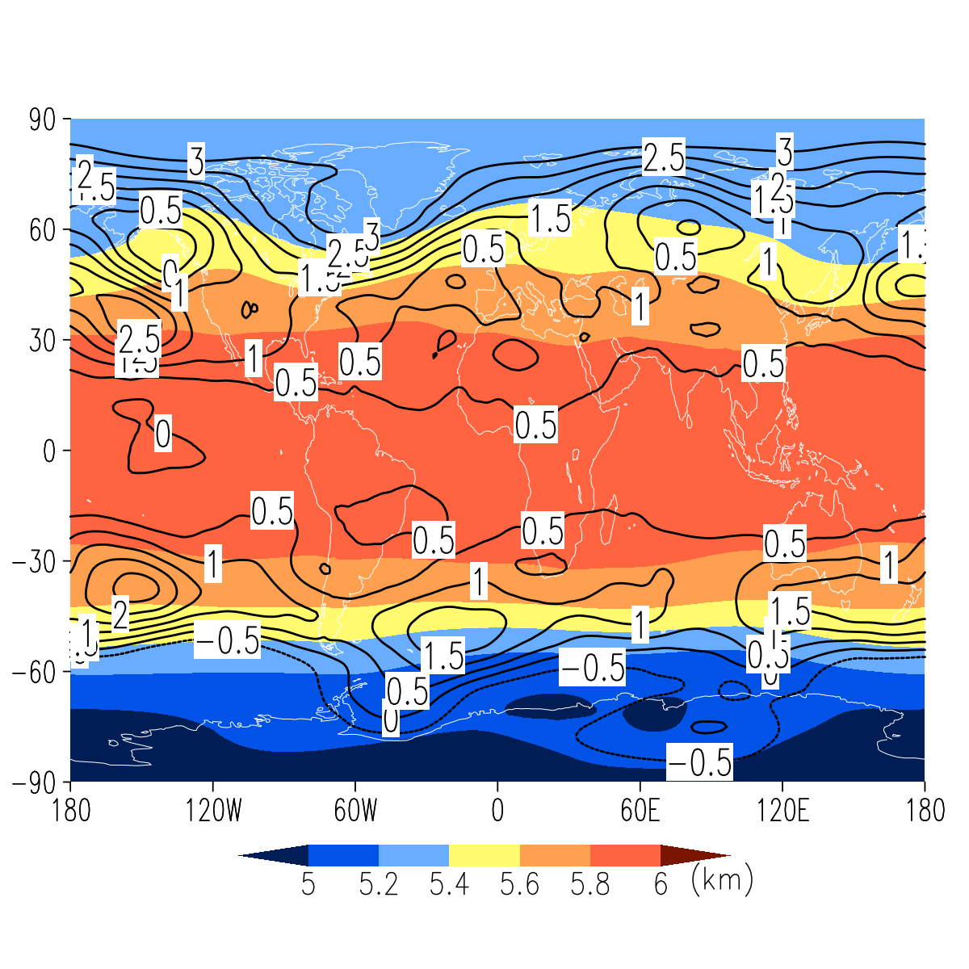
Figure S1: Global atmospheric center of mass increase (isolines, in m/yr) during 1979-2014. The average altitudes of the mass center are shown as color shades. Atmospheric parameters used are from ERA-interim.

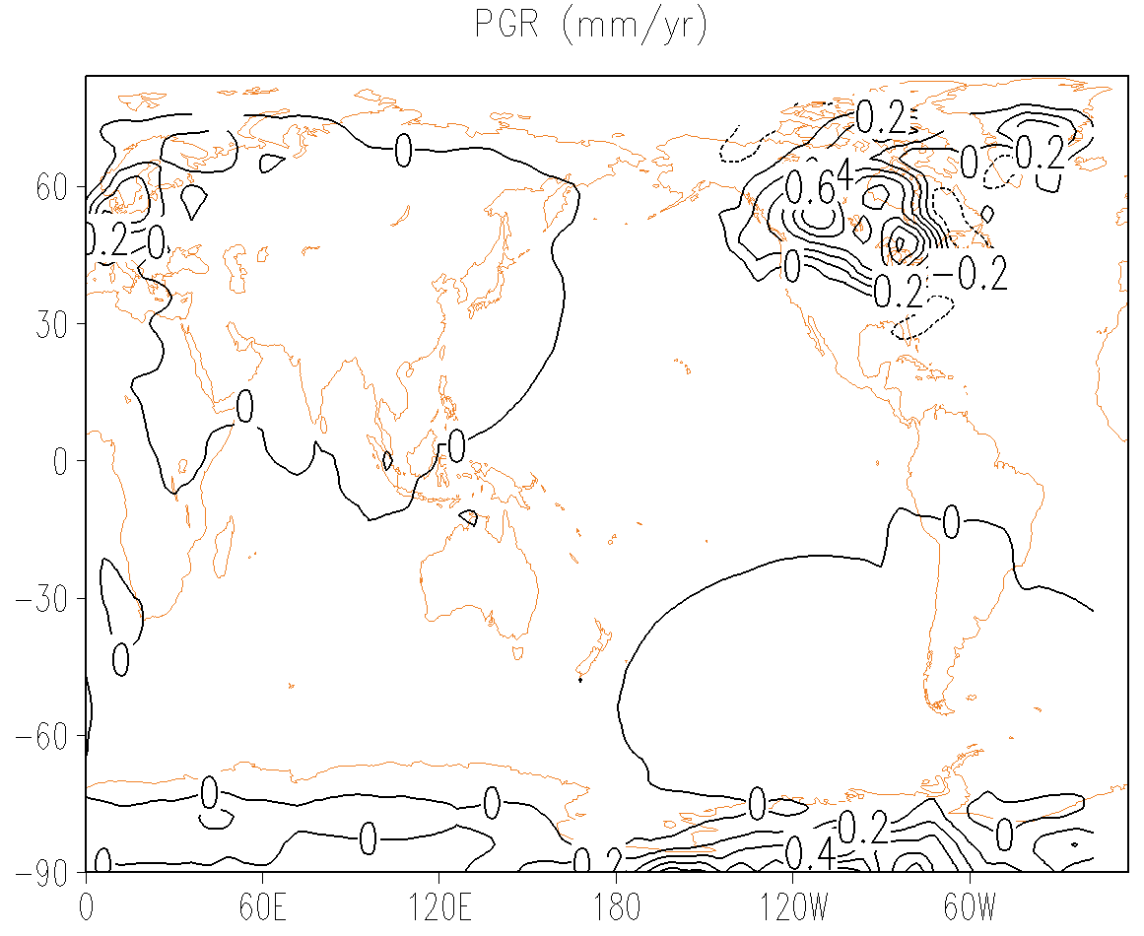
Figure S2: Global mass redistribution rates as a result of postglacial rebound (mm/yr), according to Peltier (2004) GIA model. The glacial isostatic adjustment signals are most prominent over North America and West Antarctica, with uplift rates reaching up to ~0.6 mm/yr water height equivalent (at this ~3 degree resolution, it could be even higher at finer resolution). Consequently, there is a global MOI decreasing rate of 2×10²⁶ kg•m²/yr, which is insignificant compared with other components (Fig.1) discussed in the text, but it is a persistent contributor. Hence, it is a steady background trend that is two orders of magnitude smaller, but persists for many orders of magnitude longer into the future.

