Supplementary Material

# Supplementary Figure 1

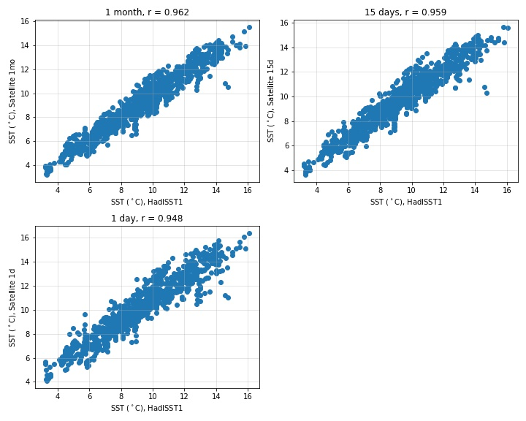

**Supplementary Figure 1.** Spearman correlations between HadISST and MURSST show that they represent SST similarly, and there is little difference between time scales. As expected, the one-month means are the best fit. However, it is more likely that this is due to the temporal resolution.

**Supplementary Figure 2**

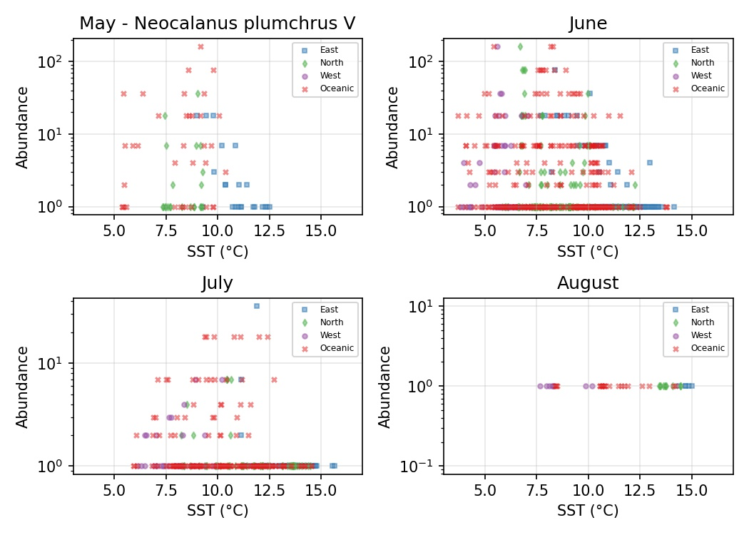

**Supplementary Figure 2.** Log abundance values by temperature for *N. plumchrus*. Colors and symbols denote subregion.

**Supplementary Figure 3**

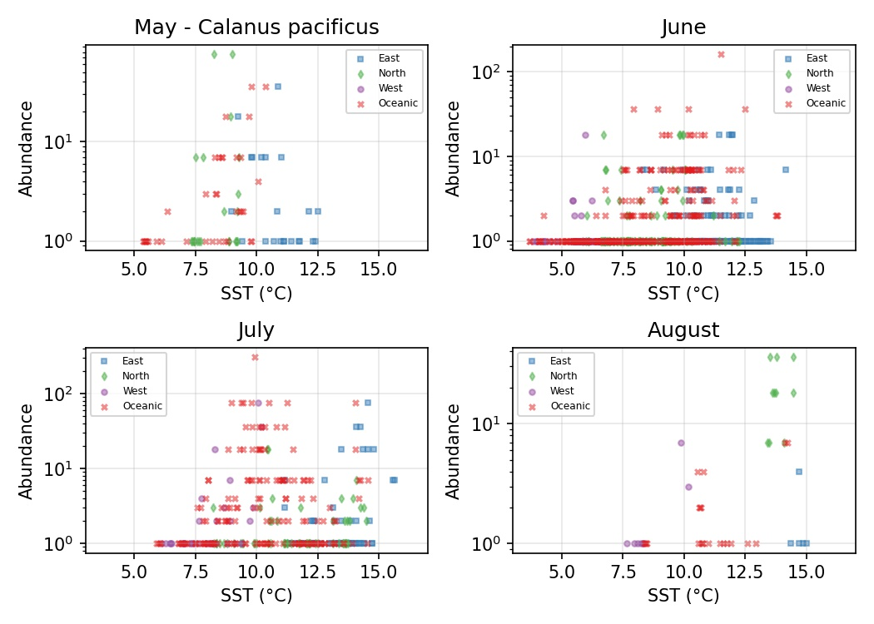

**Supplementary Figure 3.** Log abundance values by temperature for *C. pacificus*. Colors and symbols denote subregion.

**Supplementary Figure 4**

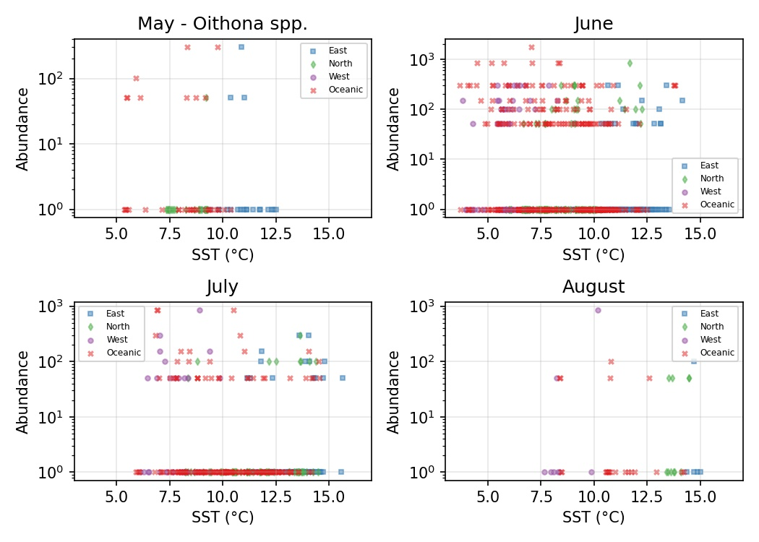

**Supplementary Figure 4.** Log abundance values by temperature for *Oithona spp*. Colors and symbols denote subregion.

**Supplementary Figure 5**

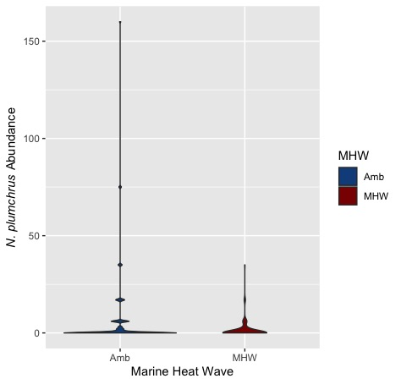

**Supplementary Figure 5.** *N. plumchrus* abundance by marine heat wave status. Amb denotes samples taken in non-marine heat wave years. MHW denotes samples taken during the 2014-2016 marine heatwave.

**Supplementary Figure 6**

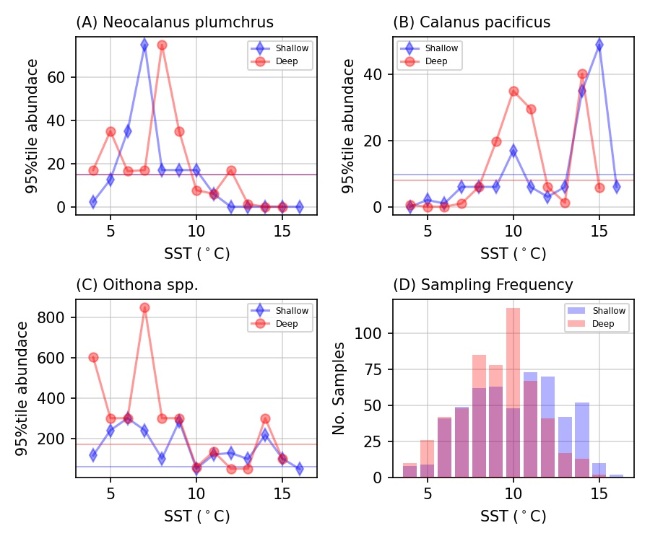

**Supplementary Figure 6.** Plots represent 95th percentile for abundance. Red points represent oceanic samples (>3000m) and blue points represent shelf/slope samples (<3000m). The horizontal lines represent 20% of the maximum 95th percentile of abundance. A. Plot of *N. plumchrus* abundance. B. Plot of *C. pacificus* abundance. C. Plot of *Oithona spp*. abundance. D. Histogram depicting the distribution of temperatures for samples collected from each habitat type.

**Supplementary Figure 7**

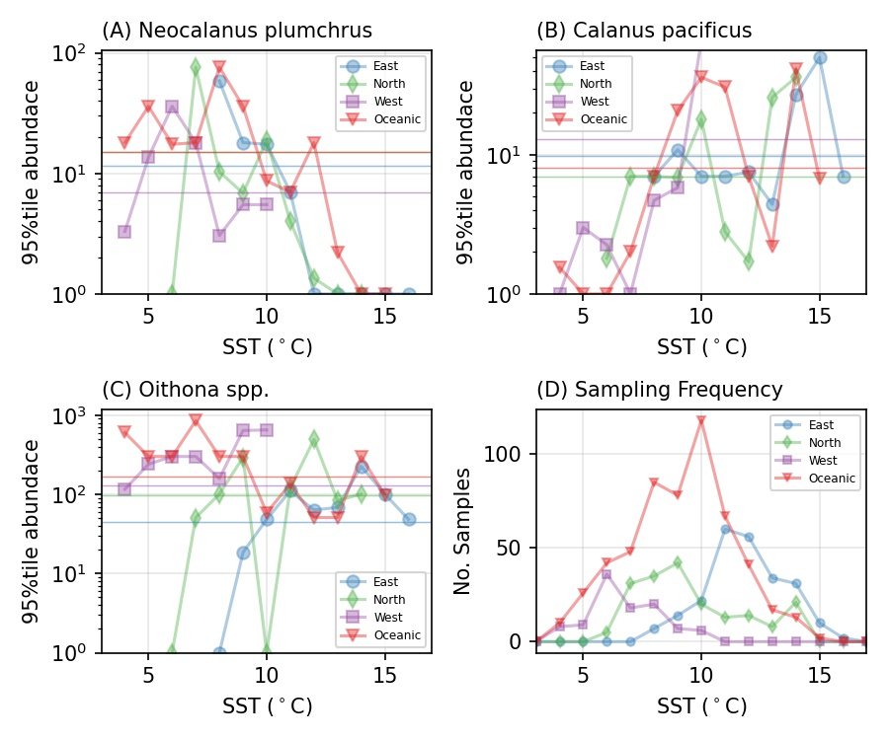

**Supplementary Figure 7.** Plots represent 95th percentile for abundance. Different colors and shapes represent different regions. The horizontal lines represent 20% of the maximum 95th percentile of abundance.A. Plot of *N. plumchrus* abundance. B. Plot of *C. pacificus* abundance. C. Plot of *Oithona spp*. abundance. D. Distribution of temperatures for samples collected from each region.

**Supplementary Figure 8**

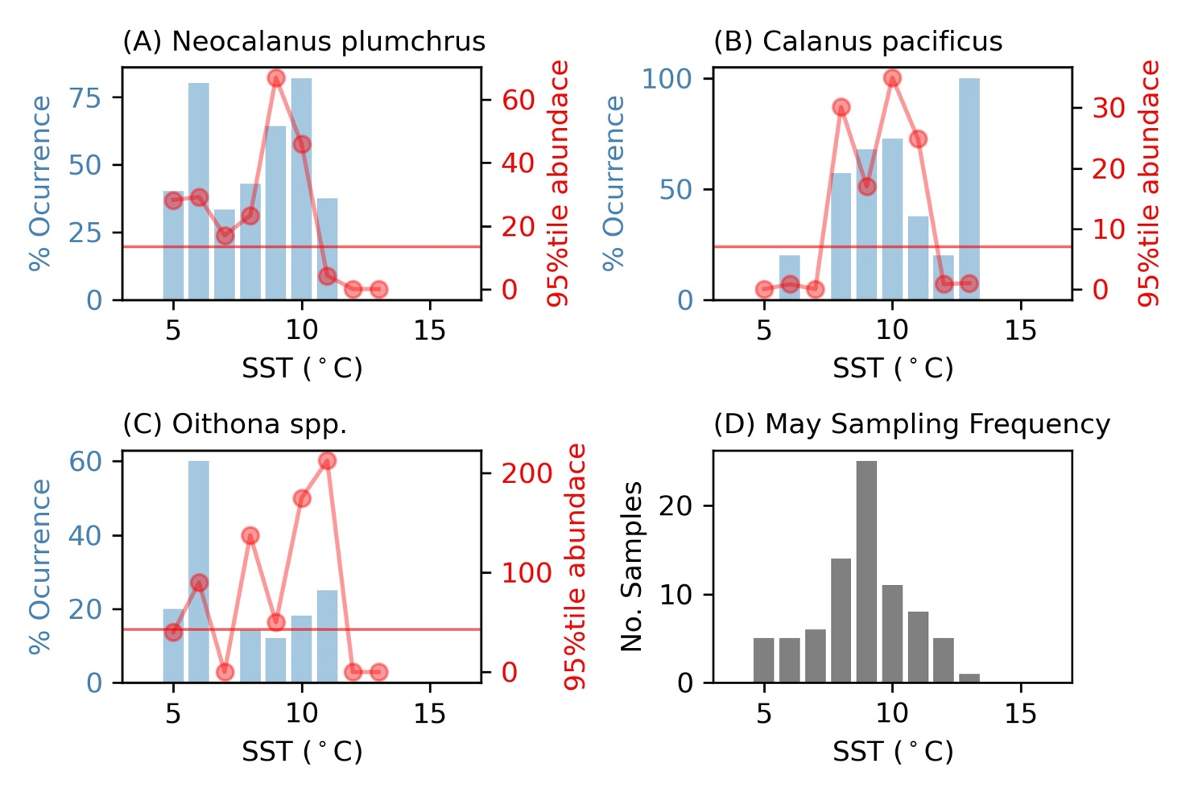

**Supplementary Figure 8.** Thermal threshold analysis for the month of May. Blue bars represent percent occurrence and red dots represent the 95th percentile of abundance. The horizontal line represents 20% of the maximum 95th percentile of occurrence. All data are divided by 1°C SST (based on MUR-SST) bins. A. Plot of *N. plumchrus* occurrence and abundance. B. Plot of *C. pacificus* occurrence and abundance. C. Plot of *Oithona spp*. occurrence and abundance. D. Histogram of sample temperatures.

**Supplementary Figure 9**

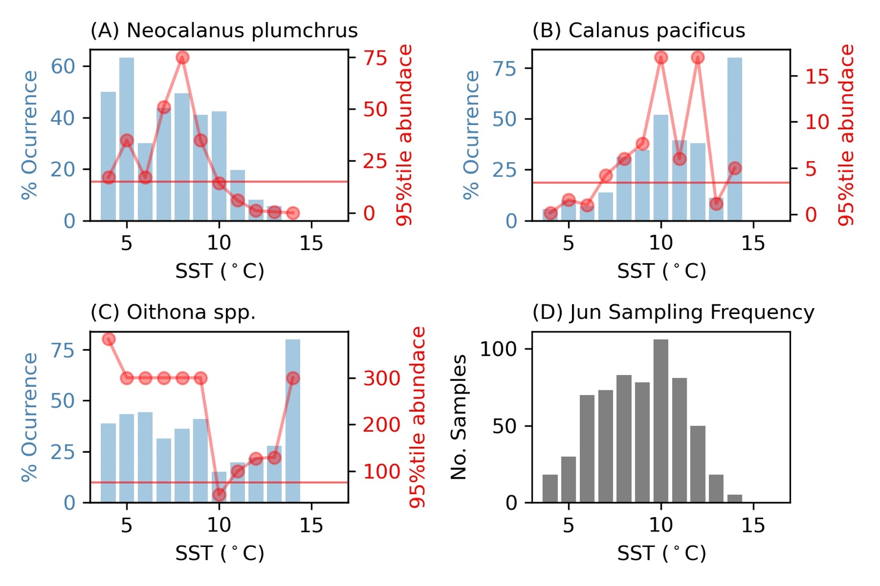

**Supplementary Figure 9.** Thermal threshold analysis for the month of June. Blue bars represent percent occurrence and red dots represent the 95th percentile of abundance. The horizontal line represents 20% of the maximum 95th percentile of occurrence. All data are divided by 1°C SST (based on MUR-SST) bins. A. Plot of *N. plumchrus* occurrence and abundance. B. Plot of *C. pacificus* occurrence and abundance. C. Plot of *Oithona spp*. occurrence and abundance. D. Histogram of sample temperatures.

**Supplementary Figure 10**

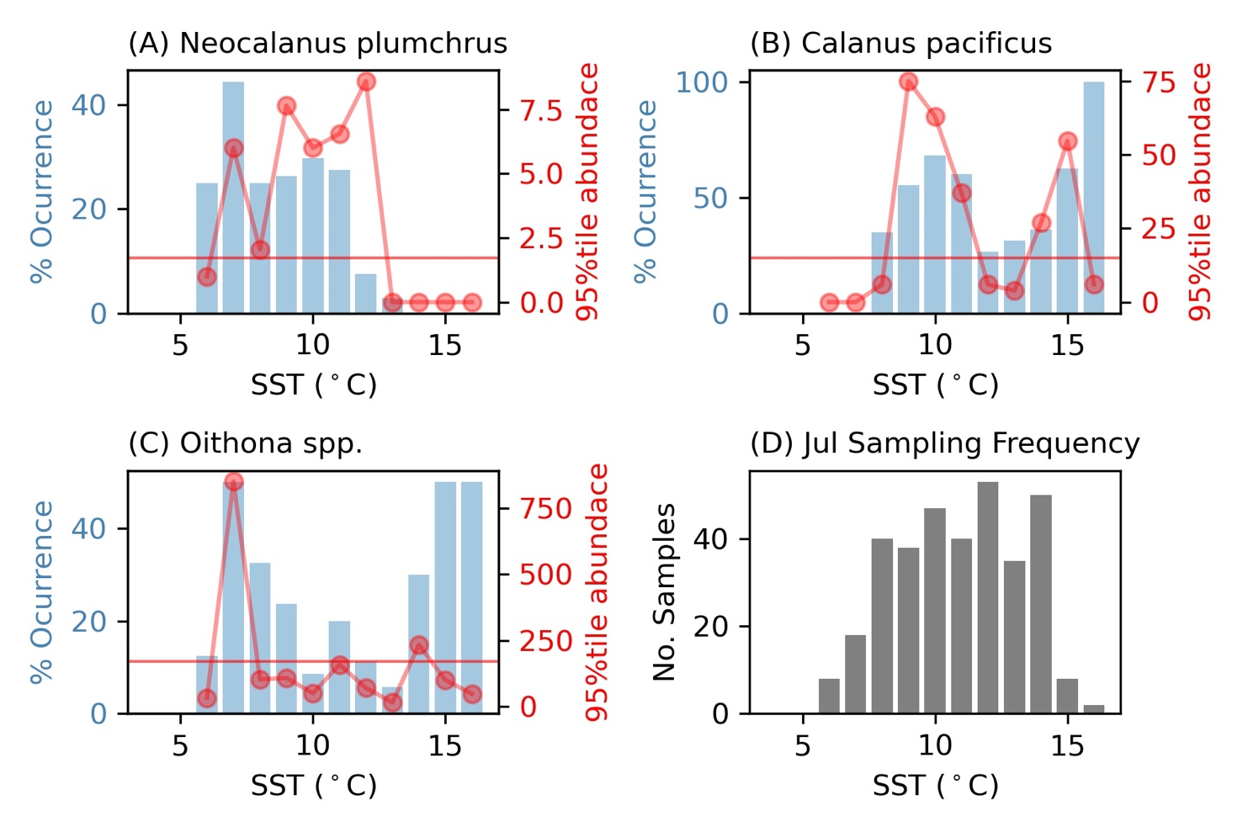

**Supplementary Figure 10.** Thermal threshold analysis for the month of July. Blue bars represent percent occurrence and red dots represent the 95th percentile of abundance. The horizontal line represents 20% of the maximum 95th percentile of occurrence. All data are divided by 1°C SST (based on MUR-SST) bins. A. Plot of *N. plumchrus* occurrence and abundance. B. Plot of *C. pacificus* occurrence and abundance. C. Plot of *Oithona spp*. occurrence and abundance. D. Histogram of sample temperatures.

**Supplementary Figure 11**

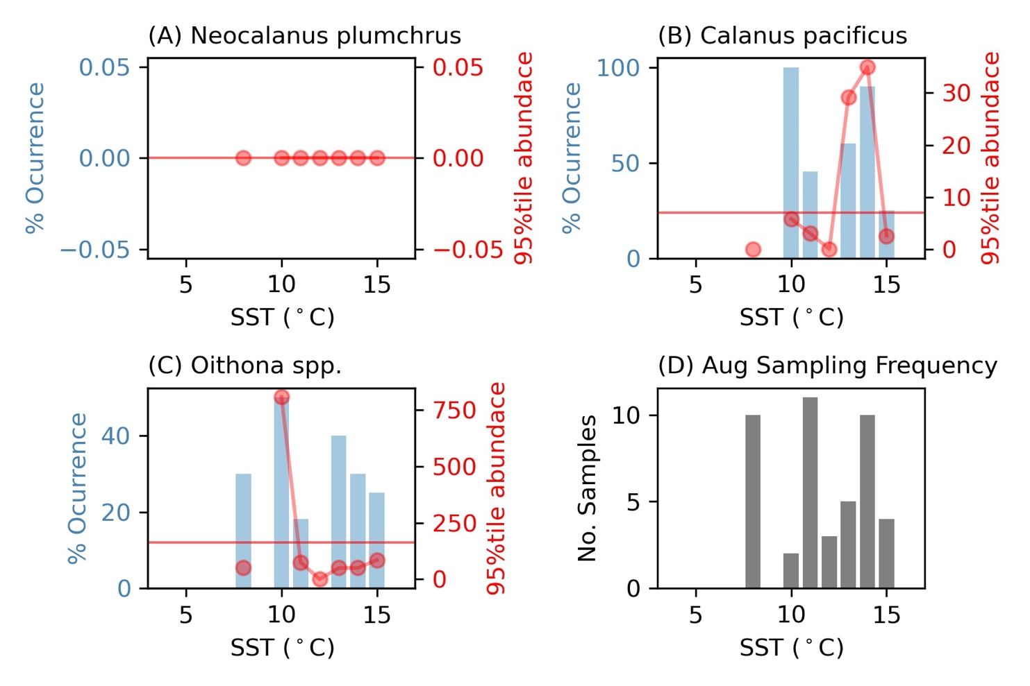

**Supplementary Figure 11.** Thermal threshold analysis for the month of August. Blue bars represent percent occurrence and red dots represent the 95th percentile of abundance. The horizontal line represents 20% of the maximum 95th percentile of occurrence. All data are divided by 1°C SST (based on MUR-SST) bins. A. *N. plumchrus* occurrence and abundance. B. *C. pacificus* occurrence and abundance. C*. Oithona spp*. occurrence and abundance. D. Histogram of sample temperatures.

**Supplementary Figure 12**

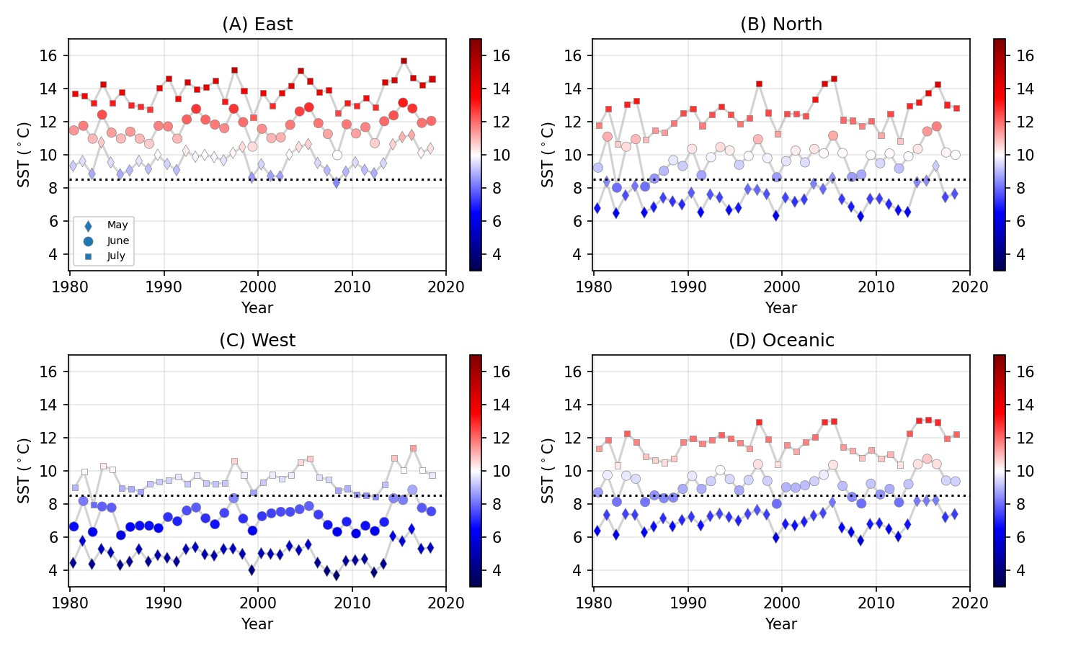

**Supplementary Figure 12.** Monthly mean HADISST per region per year. Color and y-axes indicate temperature. Black dotted line indicates the lower thermal threshold for *C. pacificus* occurrence and abundance (8.5°C). A. SST plots of eastern region. B. SST plots of northern region. C. SST plots of western region. D. SST plots of oceanic region.

**Supplementary Figure 13**



**Supplementary Figure 13.** Distribution plots of focal taxa. The size of points represents abundance and color of points represent year. A. *N. plumchrus* distribution plot. B. *C. pacificus* distribution plot. C. *Oithona spp*. distribution plot.

**Supplementary Table 1**

**Supplementary Table 1.** All models tested for *N. plumchrus* abundance. The highlighted row represents the selected model. Sample size is 1,069 observations.

|  |  |  |  |  |
| --- | --- | --- | --- | --- |
|  |  |  | ***N. plumchrus*** | **Taxon** |
| Region | Depth | Date | Temp | **Model** |
| 3 | 1 | 1 | 1 | **DF** |
| 0.47 | 0.47 | 0.44 | 0.45 | **RSE** |
| 1417.33 | 1417.57 | 1304.28 | 1339.56 | **AIC** |
| 4.23 | 21.94 | 135.22 | 99.94 | **LRS** |
| 0.02 | 0.02 | 0.12 | 0.09 | **R2** |
| Est. SE t val. p  (Int.) 0.32 0.02 16.20 < 2e-16  East -0.18 0.04 -5.07 4.73e-07  North -0.09 0.04 -2.17 0.03  West -0.07 0.05 -1.45 0.15 | Est. SE t val. p  (Int.) 0.33 0.02 16.21 < 2e-16  Shelf -0.13 0.03 -4.70 2.9e-06 | Est. SE t val. p  (Int.) 2.10 0.15 13.65 <2e-16  Date -0.27 0.02 -11.99 <2e-16 | Est. SE t val. p  (Int.) 0.75 0.05 15.09 <2e-16  Temp -0.05 5.20e-03 -10.23 <2e-16 | **Coefficients** |
| East 1.12 North 1.11 West 1.07 | Shelf 1 | Date 1 | Temp 1 | **VIF** |

|  |  |  |  |
| --- | --- | --- | --- |
|  |  | ***N. plumchrus*** | **Taxon** |
| Temp Date Region | Temp Date Depth | Temp Date | **Model** |
| 5 | 3 | 2 | **DF** |
| 0.44 | 0.44 | 0.44 | **RSE** |
| 1274.2 | 1272.9 | 1284.57 | **AIC** |
| 2.7 | 13.67 | 56.99 | **LRS** |
| 0.15 | 0.15 | 0.13 | **R2** |
| Est. SE t val. p  (Int.) 1.99 0.17 12.05 < 2e-16  Temp -0.02 0.01 -2.74 0.01  Date -0.22 0.03 -7.19 1.22e-12  East -0.12 0.04 -2.79 0.01  North -0.06 0.04 -1.51 0.13  West -0.14 0.05 -2.65 0.01 | Est. SE t val. p  (Int.) 1.98 0.16 12.47 < 2e-16  Date -0.22 0.03 -8.08 1.7e-15  Temp -0.02 0.01 -3.61 3.23e-04  Shelf -0.10 0.03 -3.70 2.25e-04 | Est. SE t val. p  (Int.) 1.90 0.16 12.01 < 2e-16  Date -0.20 0.03 -7.64 4.82e-14  Temp -0.03 0.01 -4.68 3.28e-06 | **Coefficients** |
| Temp 2.81 Date 1.83 East 1.74 North 1.14 West 1.31 | Date 1.44 Temp 1.51 Shelf 1.07 | Temp 1.42 Date 1.42 | **VIF** |

**Supplementary Table 2**

**Supplementary Table 2.** All models tested for *C. pacificus* abundance. The highlighted row represents the selected model. Sample size is 1,069 observations.

|  |  |  |  |  |
| --- | --- | --- | --- | --- |
|  |  |  | ***C. pacificus*** | **Taxon** |
| Region | Depth | Date | Temp | **Model** |
| 3 | 1 | 1 | 1 | **DF** |
| 0.43 | 0.43 | 0.43 | 0.43 | **RSE** |
| 1246.13 | 1250.09 | 1246.77 | 1233.61 | **AIC** |
| 7.96 | 11.53 | 14.86 | 28.02 | **LRS** |
| 0.02 | 0.01 | 0.01 | 0.02 | **R2** |
| Est. SE t val. p  (Int.) 0.31 0.02 16.60 < 2e-16  East -0.09 0.03 -2.82 4.95e-03  North -0.04 0.04 -1.14 0.26  West -0.18 0.05 -3.95. 8.39e-05 | Est. SE t val. p  (Int.) 0.31 0.02 16.29 < 2e-16  Shelf -0.09 0.03 -3.40 6.93e-04 | Est. SE t val. p  (Int). -0.32 0.15 -2.11 0.04  Date 0.08 0.02 3.86 1.18e-04 | Est. SE t val. p  (Int.) 0.02 0.05 0.41 0.68  Temp 0.03 4.946e-03 5.32 1.24e-07 | **Coefficients** |
| East 1.12 North 1.11 West 1.07 | Shelf 1 | Date 1 | Temp 1 | **VIF** |

|  |  |  |  |
| --- | --- | --- | --- |
|  |  | ***C. pacificus*** | **Taxon** |
| Temp Region | Temp Depth | Temp Date | **Model** |
| 4 | 2 | 2 | **DF** |
| 0.42 | 0.43 | 0.43 | **RSE** |
| 1205.54 | 1212.76 | 1234.19 | **AIC** |
| 11.22 | 39.34 | 14.58 | **LRS** |
| 0.05 | 0.04 | 0.03 | **R2** |
| Est. SE t val. p  (Int.) -0.04 0.06 -0.65 0.52  Temp 0.04 6.05e-03 6.58 7.51e-11  East -0.21 0.04 -5.68 1.77e-08  North -0.08 0.04 -2.09 0.04  West -0.08 0.05 -1.62 0.11 | Est. SE t val. p  (Int.) 0.03 0.05 0.73 0.47  Temp 0.03 5.03e-03 6.32 3.81e-10  Shelf -0.13 0.03 -4.80 1.82e-06 | Est. SE t val. p  (Int.) -0.16 0.15 -1.01. 0.31  Date 0.03 0.03 1.19 0.23  Temp 0.02 0.01 3.83 1.37e-04 | **Coefficients** |
| Temp 1.54 East 1.45 North 1.13 West 1.21 | Temp 1.05 Shelf 1.05 | Date 1.42 Temp 1.42 | **VIF** |

|  |  |  |
| --- | --- | --- |
|  | ***C. pacificus*** | **Taxon** |
| Temp Date Region | Temp Date Depth | **Model** |
| 5 | 3 | **DF** |
| 0.42 | 0.43 | **RSE** |
| 1207.02 | 1214.37 | **AIC** |
| 11.35 | 12.81 | **LRS** |
| 0.05 | 0.04 | **R2** |
| Est. SE t val. p  (Int.) 0.07 0.16 0.45 0.65  Temp 0.04 0.01 5.34. 1.11e-07  Date -0.02 0.03 -0.72 0.47  East -0.23 0.04 -5.47 5.56e-08  North -0.08 0.04 -2.15 0.03  West -0.07 0.05 -1.35 0.18 | Est. SE t val. p  (Int.) -0.06 0.15 -0.37 0.71  Date 0.02 0.03 0.618 0.54  Temp 0.03 6.03e-03 4.93 9.55e-07  Shelf -0.13 0.03 -4.69 3.15e-06 | **Coefficients** |
| Temp 2.81 Date 1.83 East 1.74 North 1.14 West 1.31 | Date 1.44 Temp 1.51 Shelf 1.07 | **VIF** |

**Supplementary Table 3**

**Supplementary Table 3.** All models tested for *Oithona spp*. abundance. The highlighted row represents the selected model. Sample size is 1,069 observations.

|  |  |  |  |  |
| --- | --- | --- | --- | --- |
|  |  |  | ***Oithona spp.*** | **Taxon** |
| Region | Depth | Date | Temp | **Model** |
| 3 | 1 | 1 | 1 | **DF** |
| 0.9 | 0.91 | 0.91 | 0.9 | **RSE** |
| 2803.6 | 2824.38 | 2827.52 | 2806.31 | **AIC** |
| 35.34 | 10.56 | 7.42 | 28.63 | **LRS** |
| 0.03 | 0.01 | 0.01 | 0.03 | **R2** |
| Est. SE t val. p  (Int.) 0.62 0.04 16.20 < 2e-16  East -0.33 0.07 -4.66 3.52e-06  North -0.19 0.08 -2.48 0.01  West 0.21 0.10 2.21 0.03 | Est. SE t val. p  (Int.) 0.63 0.04 15.98 < 2e-16  Shelf -0.18 0.06 -3.25 1.17e-03 | Est. SE t val. p  (Int.) 1.39 0.31 4.42 1.07e-05  Date -0.13 0.05 -2.73 6.52e-03 | Est. SE t val. p  (Int.) 1.05 0.10 10.62 < 2e-16  Temp -0.06 0.01 -5.38 9.05e-08 | **Coefficients** |
| East 1.12 North 1.11 West  1.07 | Shelf 1 | Date 1 | Temp 1 | **VIF** |

|  |  |  |  |
| --- | --- | --- | --- |
|  |  | ***Oithona spp.*** | **Taxon** |
| Temp Date Region | Temp Date Depth | Temp Date | **Model** |
| 5 | 3 | 2 | **DF** |
| 0.89 | 0.9 | 0.9 | **RSE** |
| 2799.47 | 2805.78 | 2808.27 | **AIC** |
| 10.31 | 0.03 | 0.04 | **LRS** |
| 0.04 | 0.02 | 0.02 | **R2** |
| Est. SE t val. p  (Int.) 1.36 0.34 4.03 5.95e-05  Temp -0.01 0.02 -0.79 0.43  Date -0.09 0.06 -1.50 0.13  East -0.29 0.09 -3.29 1.02e-03  North -0.17 0.08 -2.24 0.03  West 0.17 0.11 1.65 0.10 | Est. SE t val. p  (Int.) 1.08 0.33 3.32 9.45e-04  Date -3.57e-03 0.05 -0.07 0.95  Temp -0.05 0.01 -3.94 8.59e-05  Shelf -0.12 0.06 -2.12 0.03 | Est. SE t val. p  (Int.) 0.99 0.32 3.05 2.35e-03  Date 0.01 0.05 0.20 0.84  Temp -0.06 0.01 -4.63 4.17e-06 | **Coefficients** |
| Temp 2.81 Date 1.83 East 1.74 North 1.14 West  1.31 | Date 1.44 Temp 1.51 Shelf 1.07 | Date 1.42 Temp  1.42 | **VIF** |

|  |  |
| --- | --- |
| ***Oithona spp.*** | **Taxon** |
| Temp Region | **Model** |
| 4 | **DF** |
| 0.89 | **RSE** |
| 2799.72 | **AIC** |
| 12.59 | **LRS** |
| 0.03 | **R2** |
| Est. SE t val. p  (Int.) 0.89 0.12 7.62 5.48e-14  Temp -0.03 0.01 -2.42 0.02  East -0.23 0.08 -2.94 3.4e-03  North -0.16 0.08 -2.11 0.04  West 0.13 0.10 1.28 0.20 | **Coefficients** |
| Temp 1.54 East 1.45 North 1.13 West 1.21 | **VIF** |