Supplementary Material

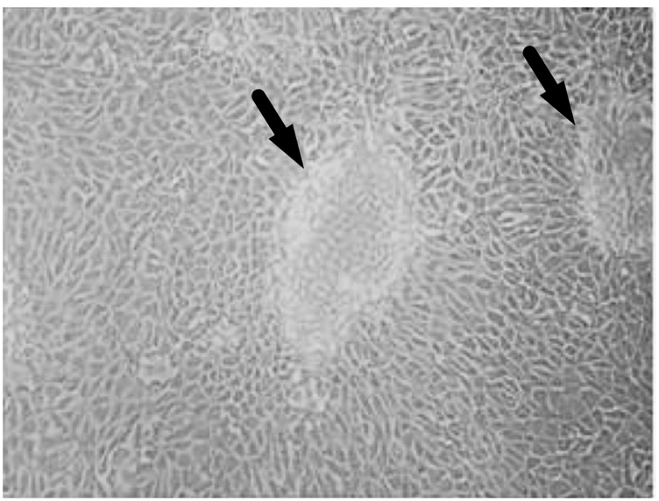
Supplementary Figure 1. Dome formation in primary isolated TECs from mouse kidneys. TECs were isolated from WT and P^{KO} C57BL/6 mice by size fraction and verified by various validated methods (30). A couple of domes (pointed by arrows) were formed and shown as examples in a micrograph from cultured WT TECs, but representing the phenomena of both WT and P^{KO} TECs. The formation of domes was due to an intact transcellular transport process, which is a characteristic of confluent TECs (31). Images were taken under 200× magnification.

