Supplementary Material

Supplementary Data

Supplementary Figures and Tables
Supplementary Table S1: Criteria used to score behaviors indicative of stress in Cucumaria frondosa post-exposure to stress conditions.
Behavior | Score
Full attachment, no movement, tentacles extended or retracted, no body bloating | 0
Body is ball shaped, podia extended, attached, tentacles extended or retracted | 0.5
Body is ball shaped, podia extended, not attached, tentacles extended or retracted | 0.75
Slow movement | 1
Fast movement | 2
Body is ball shaped, rolling, tentacles sometimes extended but not fluffy | 3
Body is ball shaped with severe body contractions (peristaltic motion) | 3.5
Full Active buoyancy adjustment | 4

Supplementary Table S2: Results of two-way ANOVA on density of cellular and hormonal metrics across different treatments (17°C, 5°C, 15 psu, 22 psu).
TREATMENT | TWO-WAY ANOVA | HOLM-SIDAK | DF | RESIDUAL | STATISTIC | p-VALUE
Coelomocytes
Air at 17°C | Exposed vs Control | - | 1 | 20 | F = 11.66 | 0.0030
 |  | 1 h | 1 | 20 | t = 2.43 | 0.025
 |  | 24 h | 1 | 20 | t = 2.40 | 0.026
 | Time (1 h vs 24 h) | - | 1 | 20 | F = 1.88 | 0.19
 | Exposed vs Control x Time | - | 1 | 20 | F = 0.0072 | 0.93
Air at 5°C | Exposed vs Control | - | 1 | 18 | F = 2.97 | 0.0080
 |  | 1 h | 1 | 18 | t = 0.80 | 0.44
 |  | 24 h | 1 | 18 | t = 3.40 | 0.003
 | Time (1 h vs 24 h) | - | 1 | 18 | F = 3.81 | 0.067
 |  | Exposure | 1 | 18 | t = 2.80 | 0.012
 |  | Control | 1 | 18 | t = 0.063 | 0.95
 | Exposed vs Control x Time | - | 1 | 18 | F = 3.4 | 0.082
Salinity at 15 psu | Exposed vs Control | - | 1 | 12 | F = 2.41 | 0.15
 | Time (1 h vs 24 h) | - | 1 | 12 | F = 0.050 | 0.83
 | Exposed vs Control x Time | - | 1 | 12 | F = 4.67 | 0.049
Salinity at 22 psu | Exposed vs Control | - | 1 | 19 | F = 0.38 | 0.54
 | Time (1 h vs 24 h) | - | 1 | 19 | F = 0.076 | 0.79
 | Exposed vs Control x Time | - | 1 | 19 | F = 2.26 | 0.15
Small aggregates
Air at 17°C | Exposed vs Control | - | 1 | 23 | F = 4.38 | 0.048
 |  | 1 h | 1 | 23 | t = 2.73 | 0.012
 |  | 24 h | 1 | 23 | t = 0.42 | 0.68
 | Time (1 h vs 24 h) | - | 1 | 23 | F = 0.082 | 0.78
 | Exposed vs Control x Time | - | 1 | 23 | F = 2.093 | 0.16
Air at 5°C | Exposed vs Control | - | 1 | 16 | F = 2.84 | 0.11
 | Time (1 h vs 24 h) | - | 1 | 16 | F = 0.0078 | 0.93
 | Exposed vs Control x Time | - | 1 | 16 | F = 0.42 | 0.53
Salinity at 15 psu | Exposed vs Control | - | 1 | 13 | F = 0.084 | 0.78
 | Time (1 h vs 24 h) | - | 1 | 13 | F = 0.070 | 0.80
 | Exposed vs Control x Time | - | 1 | 13 | F = 1.45 | 0.25
Salinity at 22 psu | Exposed vs Control | - | 1 | 18 | F = 8.343 | 0.010
 |  | 1 h | 1 | 18 | t = 1.64 | 0.12
 |  | 24 h | 1 | 18 | t = 2.39 | 0.028
 | Time (1 h vs 24 h) | - | 1 | 18 | F = 0.90 | 0.36
 | Exposed vs Control x Time | - | 1 | 18 | F = 6.2 | 0.44
Large aggregates
Air at 17°C | Exposed vs Control | - | 1 | 21 | F = 0.43 | 0.52
 | Time (1 h vs 24 h) | - | 1 | 21 | F = 1.18 | 0.29
 | Exposed vs Control x Time |  | 1 | 21 | F = 0.040 | 0.84
Air at 5°C | Exposed vs Control | - | 1 | 18 | F = 0.11 | 0.75
 | Time (1 h vs 24 h) | - | 1 | 18 | F = 4.57 | 0.047
 |  | Exposure | 1 | 18 | t = 1.71 | 0.10
 |  | Control | 1 | 18 | t = 1.30 | 0.21
 | Exposed vs Control x Time | - | 1 | 18 | F = 0.15 | 0.70
Salinity at 15 psu | Exposed vs Control | - | 1 | 12 | F = 2.41 | 0.15
 | Time (1 h vs 24 h) | - | 1 | 12 | F = 0.049 | 0.83
 | Exposed vs Control x Time | - | 1 | 12 | F = 0.049 | 0.83
Salinity at 22 psu | Exposed vs Control | - | 1 | 17 | F = 0.019 | 0.89
 | Time (1 h vs 24 h) | - | 1 | 18 | F = 0.088 | 0.77
 | Exposed vs Control x Time | - | 1 | 18 | F = 0.11 | 0.74
Cortisol
Air at 17°C | Exposed vs Control | - | 1 | 5 | F = 4.70 | 0.082
 |  | 1 h | 1 | 5 | t = 3.47 | 0.018
 |  | 24 h | 1 | 5 | t = 0.019 | 0.99
 | Time (1 h vs 24 h) | - | 1 | 5 | F = 10.65 | 0.022
 |  | Exposure | 1 | 5 | t = 3.44 | 0.018
 |  | Control | 1 | 5 | t = 0.91 | 0.41
 | Exposed vs Control x Time |  | 1 | 5 | F = 4.58 | 0.086
Air at 5°C | Exposed vs Control |  | 1 | 5 | F = 1.19 | 0.33
 | Time (1 h vs 24 h) | - | 1 | 5 | F = 0.44 | 0.54
 | Exposed vs Control x Time | - | 1 | 5 | F = 0.12 | 0.75
Salinity at 15 psu | Exposed vs Control | - | 1 | 7 | F = 0.99 | 0.35
 | Time (1 h vs 24 h) | - | 1 | 7 | F = 0.62 | 0.46
 | Exposed vs Control x Time | - | 1 | 7 | F = 1.46 | 0.27
Salinity at 22 psu  (ranked) | Exposed vs Control | - | 1 | 4 | F = 1.78 | 0.25
 | Time (1 h vs 24 h) | - | 1 | 4 | F = 1.78 | 0.25
 | Exposed vs Control x Time | - | 1 | 4 | F = 1.78 | 0.25

Supplementary Table S3: Number of free coelomocytes (separated by cell type) per mL of fluid in the Polian vesicle fluid of sea cucumber measured across different treatments (17°C, 5°C, 15 psu 22 psu).
TREATMENT |  |  | Coelomocyte types
 |  |  | Phagocytes | Fusiform cells | Morula cells | Crystal cells
17°C air | 1 h | Control | 366667 | 8333 | 0 | 0
 |  | Exposed | 500000 | 20000 | 15000 | 10000
 | 24 h | Control | 300000 | 11667 | 0 | 0
 |  | Exposed | 950000 | 25000 | 41667 | 0
5°C air | 1 h | Control | 657143 | 5556 | 22222 | 5556
 |  | Exposed | 600000 | 5556 | 33333 | 11111
 | 24 h | Control | 470000 | 16667 | 16667 | 0
 |  | Exposed | 883333 | 66667 | 58333 | 33333
15 psu | 1 h | Control | 533500 | 22083.33 | 0 | 0
 |  | Exposed | 644000 | 29000 | 16875 | 0
 | 24 h | Control | 438125 | 19350 | 13250 | 13500
 |  | Exposed | 566875 | 0 | 0 | 0
22 psu | 1 h | Control | 353929 | 0 | 0 | 0
 |  | Exposed | 408107 | 5964 | 14286 | 4750
 | 24 h | Control | 389500 | 3750 | 2083 | 0
 |  | Exposed | 459500 | 4000 | 6000 | 2000

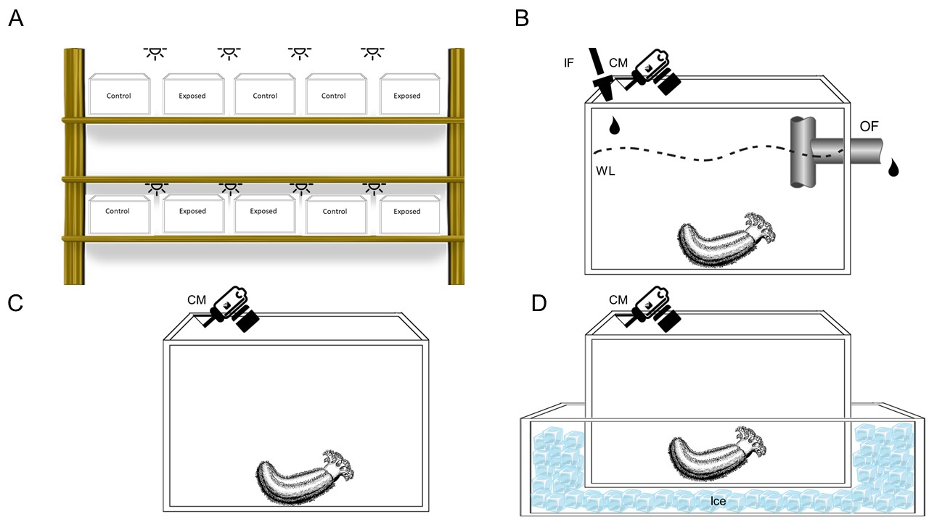
Figure S1: Experimental tank setup: A) Random distribution of tanks/treatments in the experimental setup. B) Tanks used for controls and exposures to low salinity received flow at the desired salinity (35 and 22/15 psu, respectively). CM = camera, IF = inflow, OF = outflow, WL = waterline. C) Tanks used for exposure to 17°C air were empty and exposed to ambient temperature. D) Tanks used for exposure to 5°C air were empty and placed on ice to achieve the desired temperature. All tanks held one sea cucumber and empty tanks had a lid.

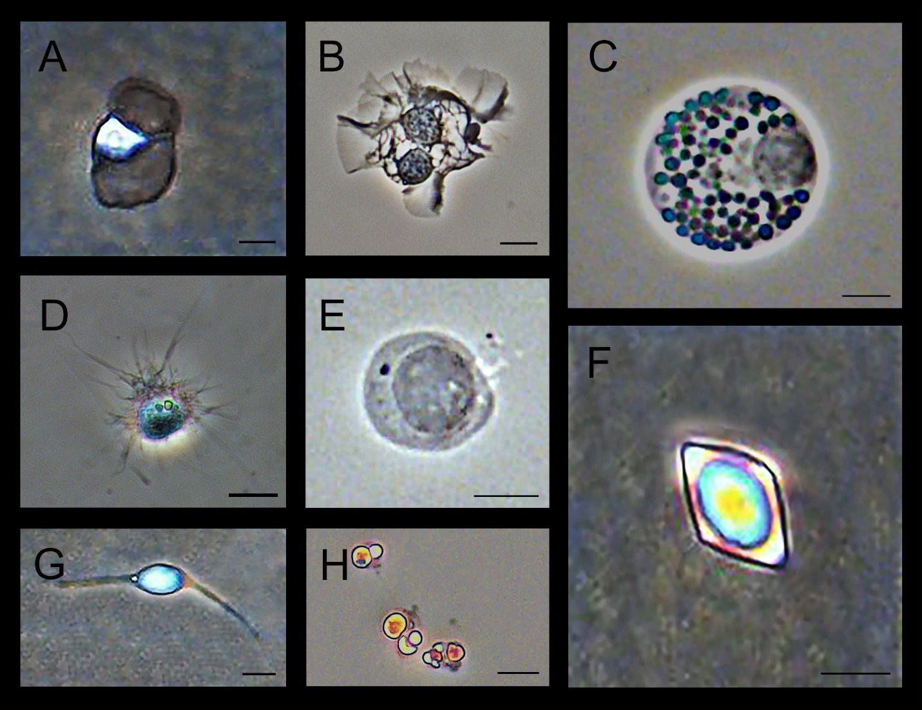
Supplementary Figure S2: Different coelomocyte types found in C. frondosa. A) Inactive (bladder) phagocyte (scale bar = 5 µm). B) Two active (petaloid) phagocytes (scale bar = 10 µm). C) Morula cell (scale bar = 5 µm). D) Active (filopodial) phagocyte (scale bar = 10 µm). E) Progenitor cell (scale bar = 5 µm). F) Crystal cell (scale bar = 9 µm). G) Fusiform cell (scale bar = 4 µm). H) A cluster of hemocytes (scale bar = 8 µm).

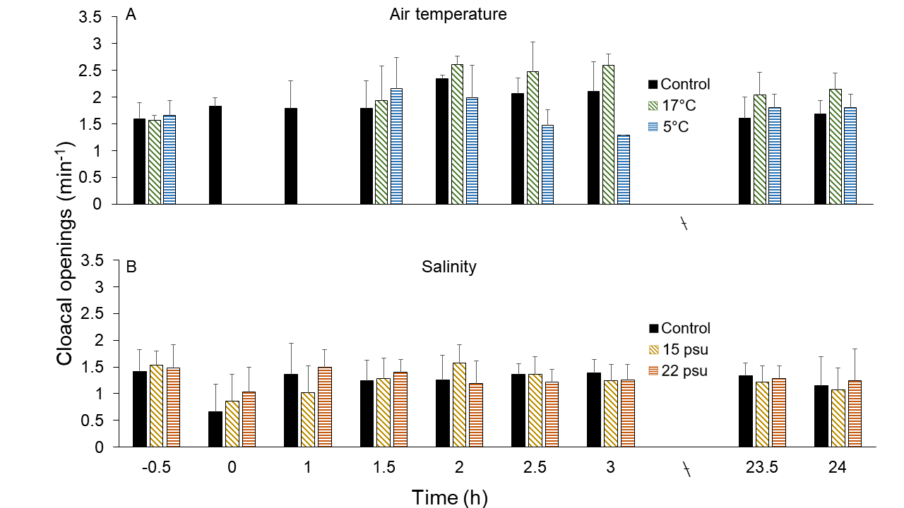

Supplementary Figure S3: Frequency of cloacal openings (min⁻¹) in C. frondosa at various time points before exposure (time 0 h, negative control), after the 1-h exposure (time 1 h) and over a subsequent recovery period of 23 h (until time 24 h; positive control). A) Comparison between controls and individuals exposed to 17°C and 5°C air. B) Comparison between controls and individuals exposed to 15 and 22 psu salinity. Data shown as mean ± SD (n = 5-11).

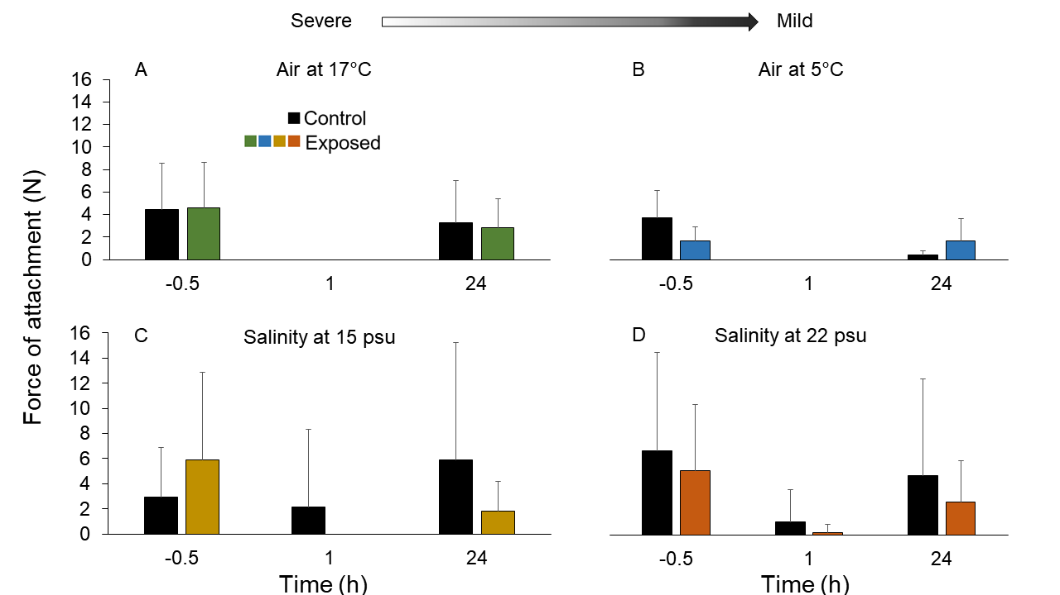
Supplementary Figure S4: Force of attachment of C. frondosa measured in Newtons (N) at various time points before exposure (-0.5 h, negative control), immediately following exposure (1 h, positive control) and after 23 h recovery post exposure (24 h, positive control). The treatments correspond to A) 17°C air, B) 5°C air, C) 15 psu salinity, and D) 22 psu salinity. Data shown as mean ± SD (n = 4-15).

