Supplementary Material

Supplementary Figures

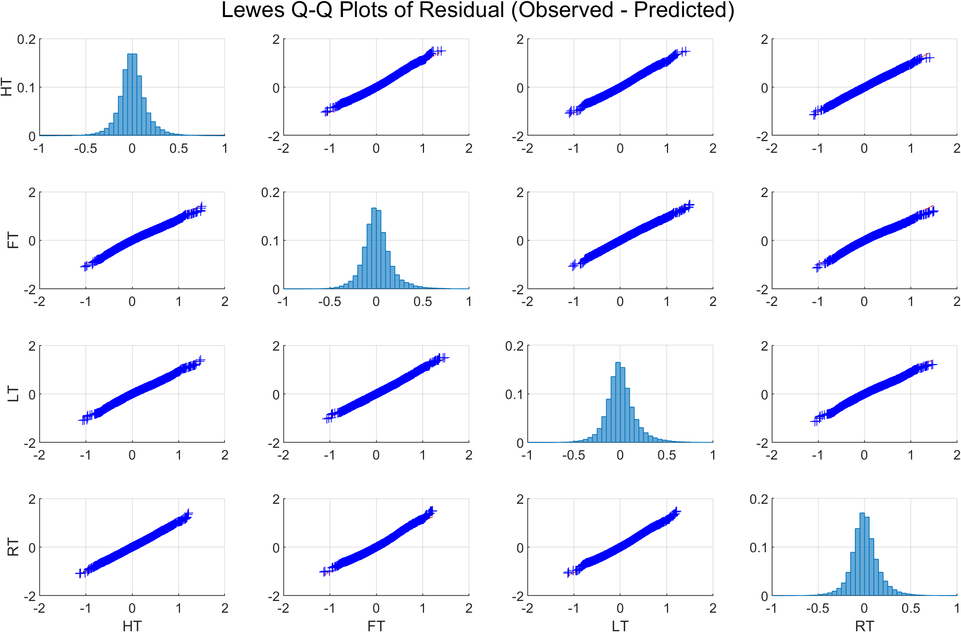
Supplementary Figure 1. Quantile-Quantile plot of hourly residual water levels (observed minus predicted) for the NOAA Lewes tide gauge in the Lower Delaware Bay for 1980 – 2019. Residuals were divided into four time periods based on tidal phase: High Tide (HT), Falling Tide (FT), Low Tide (LT), and Rising Tide (RT). High and Low time periods were defined as 1.5 hours before and after tidal peak. Diagonals show histogram plots in 0.05 m bins for each tidal phase over the same time period. Data show strong agreement with the Normal distribution. Anderson-Darling test statistic is near zero for all comparisons between distributions of each phase. These data at Lewes are representative of gauges within the Delaware and Chesapeake Bays.

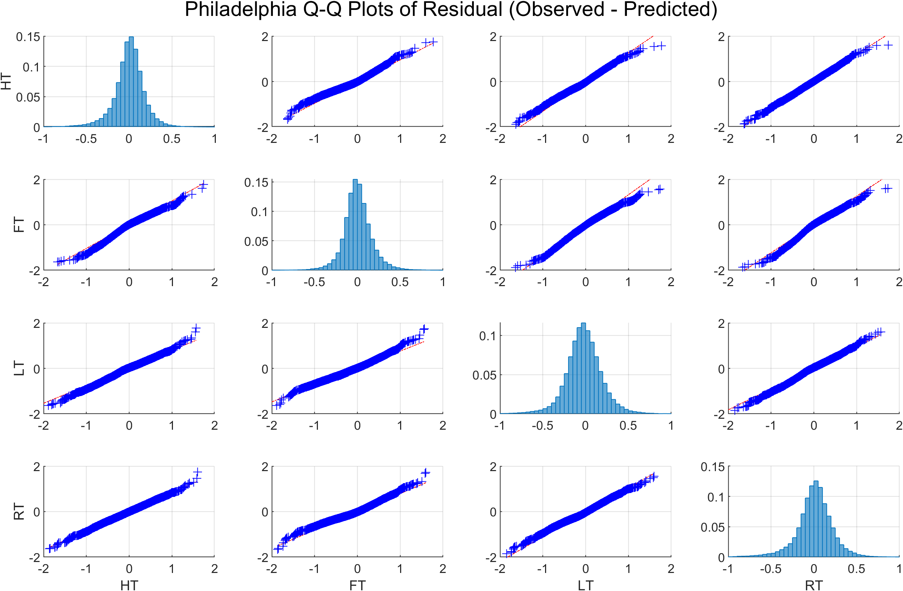
Supplementary Figure 2. Quantile-Quantile plot of hourly residual water levels (observed minus predicted) for the NOAA Philadelphia tide gauge in the Upper Delaware Bay for 1980 – 2019. Residuals were divided into four time periods based on tidal phase: High Tide (HT), Falling Tide (FT), Low Tide (LT), and Rising Tide (RT). High and Low time periods were defined as 1.5 hours before and after tidal peak. Diagonals show histogram plots in 0.05 m bins for each tidal phase over the same time period. Data show strong agreement with the Normal distribution. Although these data at Baltimore show the most variation away from a perfect 1:1 fit at the extremes between each phase, the Anderson-Darling test statistic is near zero for all comparisons between distributions of each phase. Other upper bay gauges show characteristics that are between what is shown at Lewes and Baltimore.

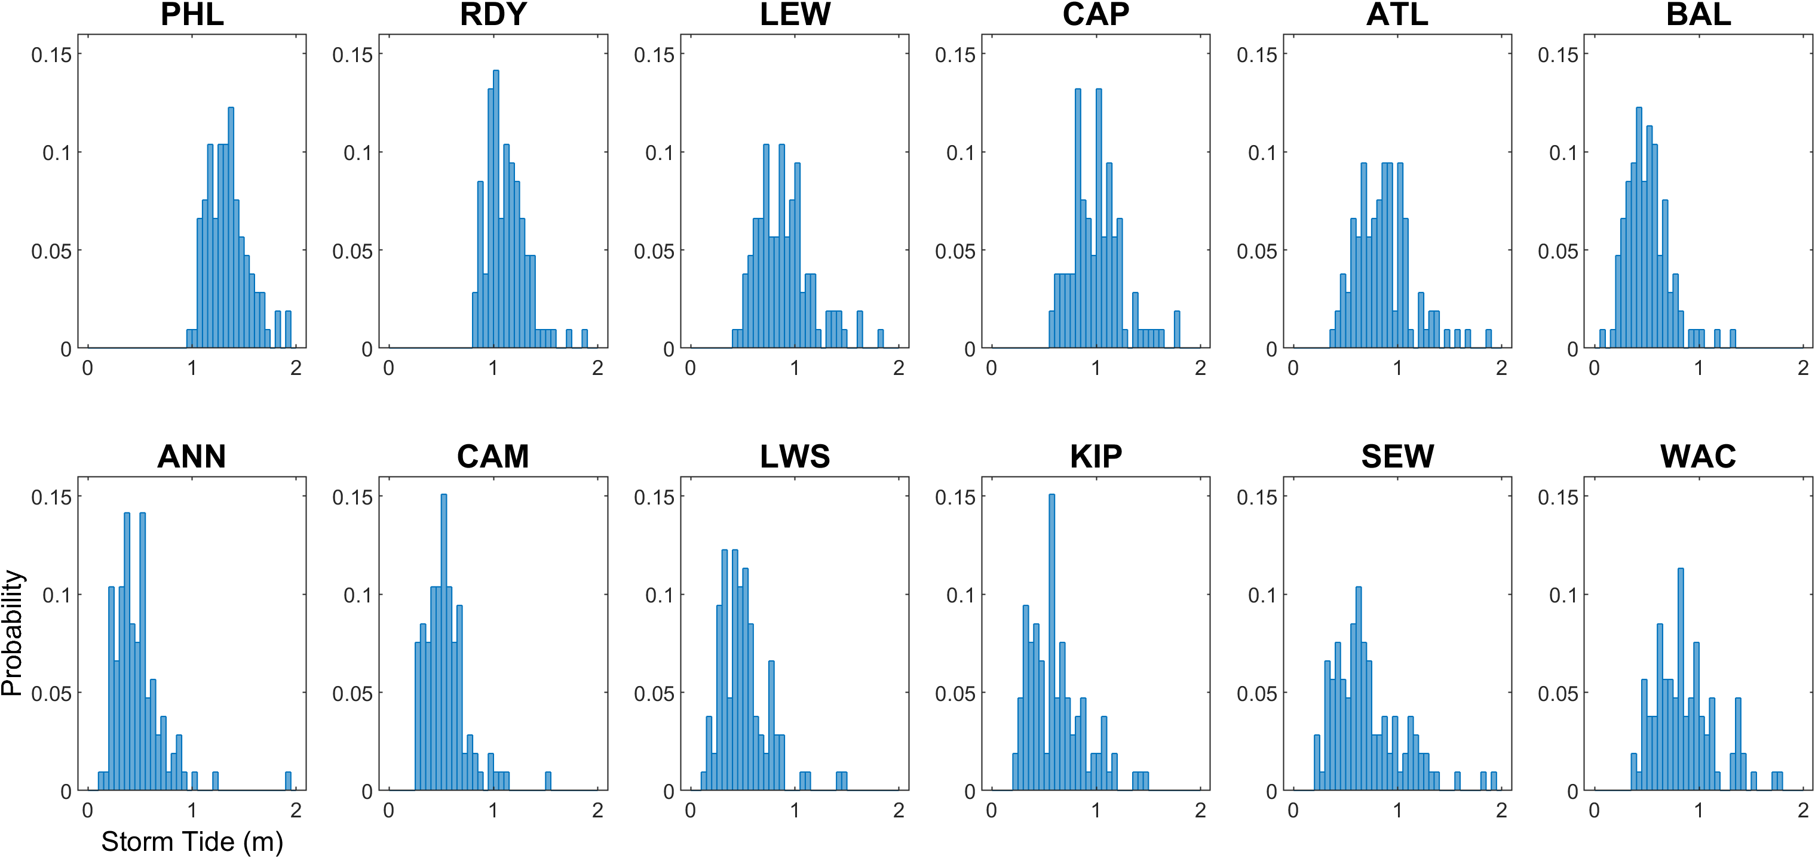
Supplementary Figure 3. Histogram distribution of storm tide for Delmarva tropical cyclones, 1980 – 2019. Values are in meters relative to NAVD88 datum.

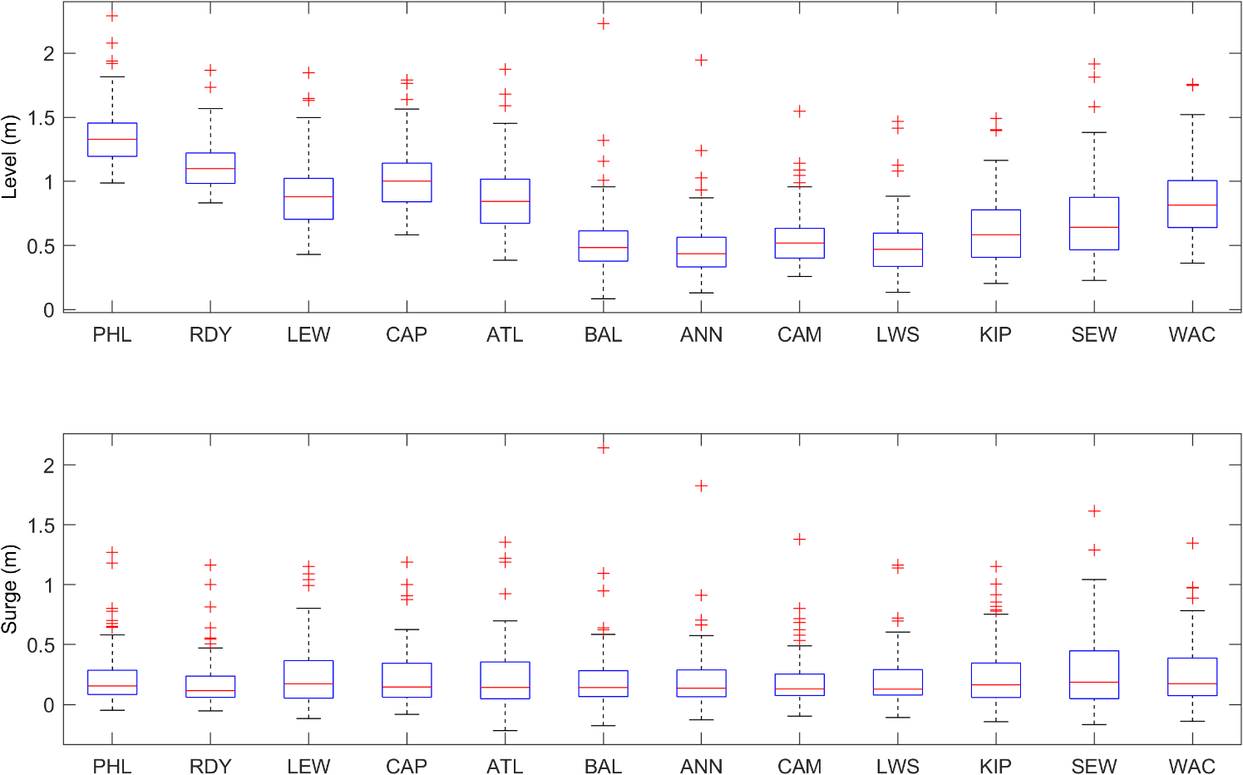
Supplementary Figure 4. Box plots of storm tide and skew surge for Delmarva tropical cyclones, 1980 – 2019. Plus signs above the top hash marks represent storms with values greater than 1.5 times the interquartile range. Values are in meters. Storm tides are meters relative to NAVD88 datum. Box plots more clearly show differences in mean water levels and extent of extremes among gauges.

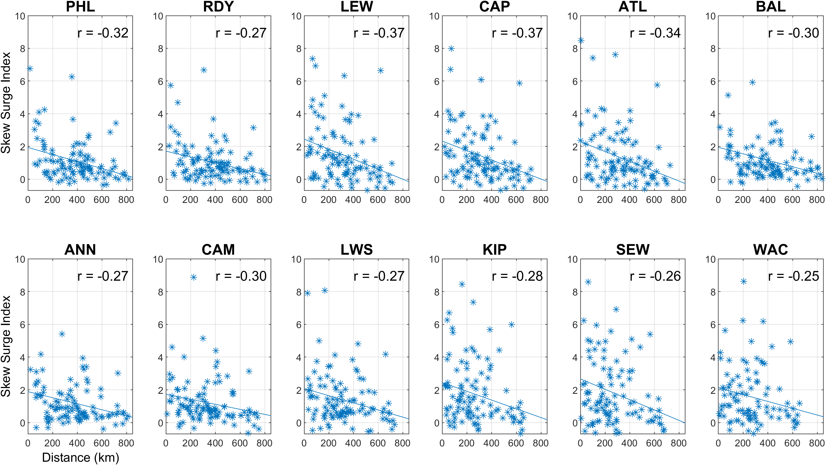
Supplementary Figure 5. Scatterplot and regression line of best fit of skew surge index (SSI) against minimum distance of Delmarva tropical cyclones, 1980 – 2019. Regression line computed based least squares method. All correlations significant at the 0.01 level.

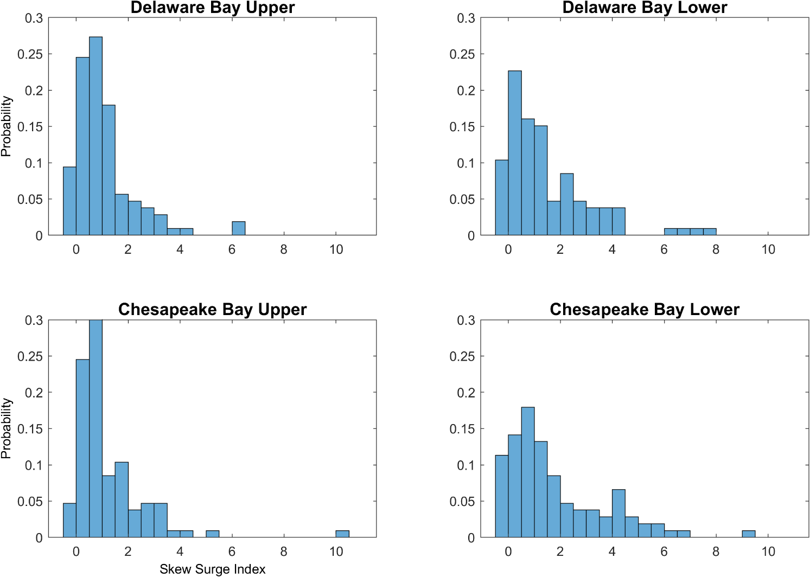
Supplementary Figure 6. Histogram distributions of spatially averaged skew surge index (SSI) of Delmarva tropical cyclones (N = 106) for Delaware and Chesapeake Bay regions, 1980 – 2019.

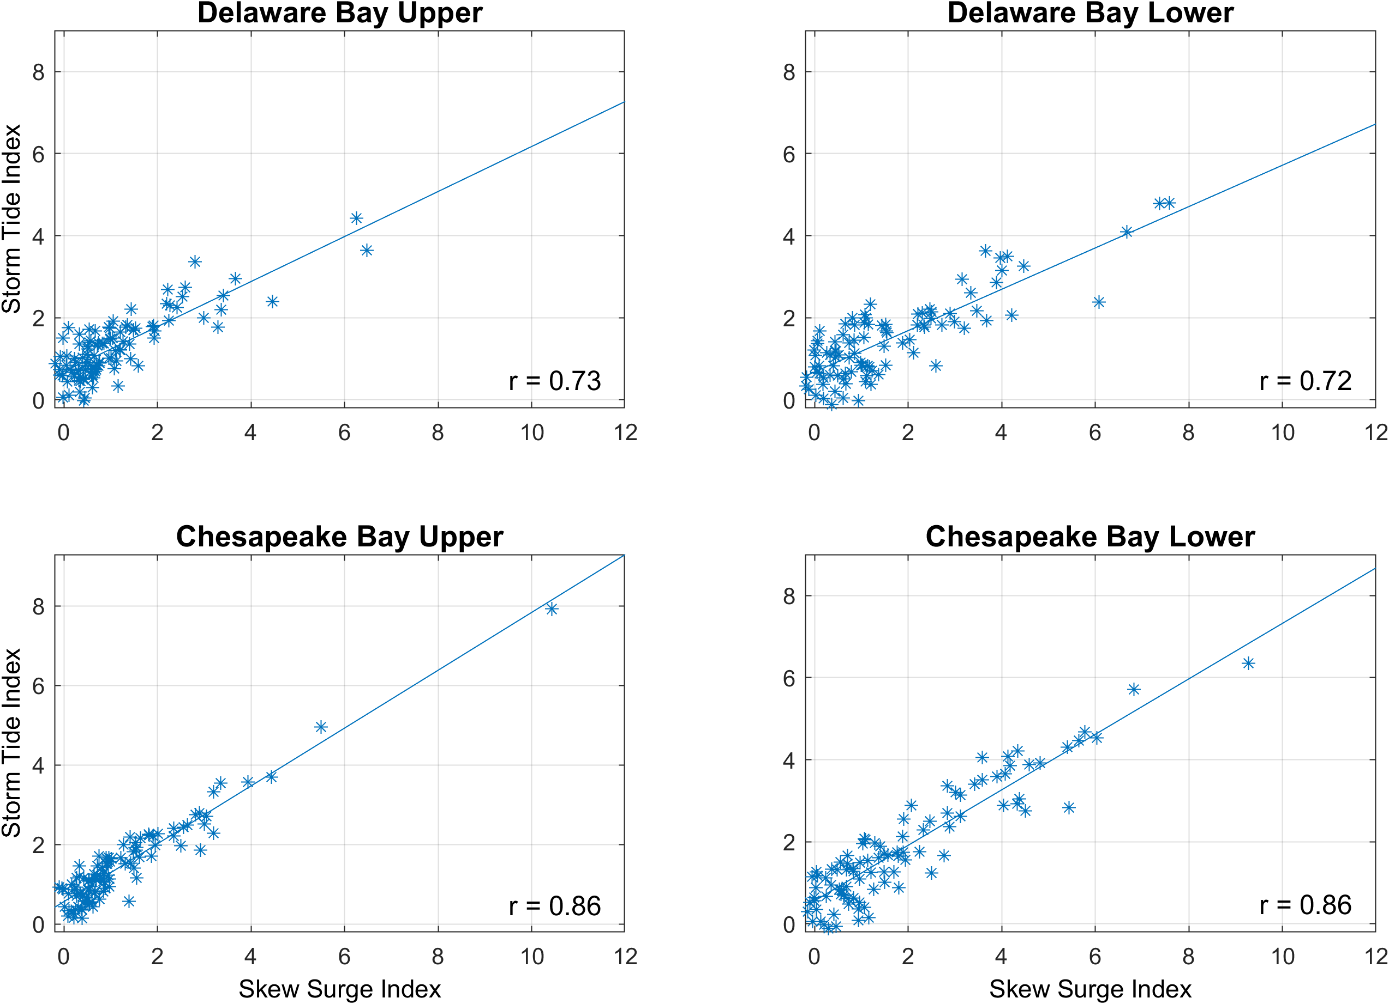
Supplementary Figure 7. Spatially averaged skew surge index (SSI) plotted against storm tide index (STI) for Delmarva tropical cyclones (N = 106) for Delaware and Chesapeake Bay regions, 1980 – 2019. All correlations statistically significant at the 0.01 level.

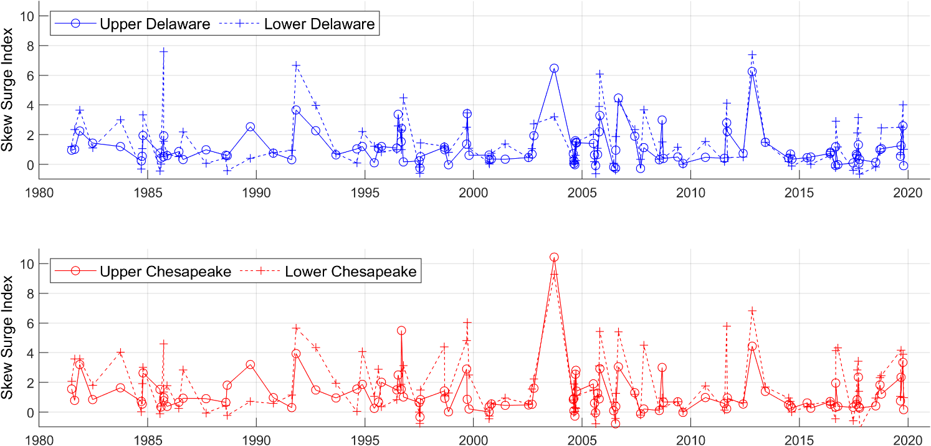
Supplementary Figure 8. Skew surge index (SSI) for Delmarva tropical cyclones spatially averaged over all gauges within each geographic region of Delaware (blue) and Chesapeake (red) Bays, 1980 – 2019. Solid lines with circles represent upper bays; dashed lines with plus signs represent lower bays.

Supplementary Tables

Supplementary Table 1. Cross-correlation coefficients comparing storm tide index (STI) among all 12 NOAA tide gauges within the Delaware and Chesapeake Bay regions for Delmarva tropical cyclones, 1980 - 2019. Correlations were computed pairwise using Spearman Rank correlation method. All correlations are statistically significant at the 0.01 level. Shaded cells highlight groups of gauges with unusually high correlations within the same geographic region.
 | Storm Tide Index (STI) Cross-Correlation
Station | PHL | RDY | LEW | CAP | ATL | BAL | ANN | CAM | LWS | KIP | SEW | WAC
PHL | 1.00 | 0.93 | 0.67 | 0.70 | 0.65 | 0.63 | 0.64 | 0.74 | 0.65 | 0.52 | 0.42 | 0.56
RDY | 0.93 | 1.00 | 0.73 | 0.76 | 0.71 | 0.66 | 0.67 | 0.76 | 0.71 | 0.57 | 0.47 | 0.63
LEW | 0.67 | 0.73 | 1.00 | 0.97 | 0.94 | 0.39 | 0.44 | 0.57 | 0.75 | 0.87 | 0.80 | 0.91
CAP | 0.70 | 0.76 | 0.97 | 1.00 | 0.96 | 0.41 | 0.44 | 0.58 | 0.68 | 0.79 | 0.70 | 0.84
ATL | 0.65 | 0.71 | 0.94 | 0.96 | 1.00 | 0.34 | 0.39 | 0.51 | 0.61 | 0.76 | 0.67 | 0.80
BAL | 0.63 | 0.66 | 0.39 | 0.41 | 0.34 | 1.00 | 0.97 | 0.88 | 0.64 | 0.30 | 0.26 | 0.41
ANN | 0.64 | 0.67 | 0.44 | 0.44 | 0.39 | 0.97 | 1.00 | 0.90 | 0.69 | 0.36 | 0.32 | 0.47
CAM | 0.74 | 0.76 | 0.57 | 0.58 | 0.51 | 0.88 | 0.90 | 1.00 | 0.78 | 0.49 | 0.45 | 0.60
LWS | 0.65 | 0.71 | 0.75 | 0.68 | 0.61 | 0.64 | 0.69 | 0.78 | 1.00 | 0.78 | 0.77 | 0.79
KIP | 0.52 | 0.57 | 0.87 | 0.79 | 0.76 | 0.30 | 0.36 | 0.49 | 0.78 | 1.00 | 0.97 | 0.91
SEW | 0.42 | 0.47 | 0.80 | 0.70 | 0.67 | 0.26 | 0.32 | 0.45 | 0.77 | 0.97 | 1.00 | 0.87
WAC | 0.56 | 0.63 | 0.91 | 0.84 | 0.80 | 0.41 | 0.47 | 0.60 | 0.79 | 0.91 | 0.87 | 1.00

Supplementary Table 2. Cross-correlation coefficients comparing skew surge index (SSI) among all 12 NOAA tide gauges in the Delaware and Chesapeake Bays regions for Delmarva tropical cyclones, 1980 - 2019. Correlations were computed pairwise using Spearman Rank correlation method. All correlations are statistically significant at the 0.01 level. Shaded cells highlight groups of gauges with unusually high correlations within the same geographic region.
 | Skew Surge Index (SSI) Cross-Correlation
Station | PHL | RDY | LEW | CAP | ATL | BAL | ANN | CAM | LWS | KIP | SEW | WAC
PHL | 1.00 | 0.91 | 0.61 | 0.66 | 0.60 | 0.70 | 0.73 | 0.82 | 0.73 | 0.54 | 0.50 | 0.57
RDY | 0.91 | 1.00 | 0.69 | 0.74 | 0.68 | 0.72 | 0.76 | 0.82 | 0.80 | 0.60 | 0.55 | 0.64
LEW | 0.61 | 0.69 | 1.00 | 0.98 | 0.96 | 0.46 | 0.53 | 0.61 | 0.84 | 0.89 | 0.86 | 0.90
CAP | 0.66 | 0.74 | 0.98 | 1.00 | 0.95 | 0.50 | 0.57 | 0.66 | 0.84 | 0.84 | 0.81 | 0.88
ATL | 0.60 | 0.68 | 0.96 | 0.95 | 1.00 | 0.46 | 0.52 | 0.59 | 0.78 | 0.83 | 0.79 | 0.86
BAL | 0.70 | 0.72 | 0.46 | 0.50 | 0.46 | 1.00 | 0.97 | 0.88 | 0.68 | 0.38 | 0.37 | 0.48
ANN | 0.73 | 0.76 | 0.53 | 0.57 | 0.52 | 0.97 | 1.00 | 0.91 | 0.73 | 0.45 | 0.44 | 0.55
CAM | 0.82 | 0.82 | 0.61 | 0.66 | 0.59 | 0.88 | 0.91 | 1.00 | 0.80 | 0.52 | 0.50 | 0.62
LWS | 0.73 | 0.80 | 0.84 | 0.84 | 0.78 | 0.68 | 0.73 | 0.80 | 1.00 | 0.79 | 0.79 | 0.82
KIP | 0.54 | 0.60 | 0.89 | 0.84 | 0.83 | 0.38 | 0.45 | 0.52 | 0.79 | 1.00 | 0.98 | 0.91
SEW | 0.50 | 0.55 | 0.86 | 0.81 | 0.79 | 0.37 | 0.44 | 0.50 | 0.79 | 0.98 | 1.00 | 0.90
WAC | 0.57 | 0.64 | 0.90 | 0.88 | 0.86 | 0.48 | 0.55 | 0.62 | 0.82 | 0.91 | 0.90 | 1.00

Supplementary Table 3. Delmarva tropical cyclones with the largest difference in spatially averaged skew surge index (SSI) between the Delaware and Chesapeake Bays, 1980 – 2019. Diff column is the absolute value of the difference in SSI. Year and Month note the time of storm’s closest approach to Delmarva. Status represents the most common value of USA_STATUS attribute in the IBTrACS database while the storm is within the 750 km buffer. EX = Extratropical, HU = Hurricane, TS = Tropical Storm, TD = Tropical Depression, SS = Subtropical Storm, DB = Disturbance. Refer to IBTrACS Version 4 Technical Documentation for more details.
 | Delaware Bay > Chesapeake Bay SSI |  |  |  |  |  | Chesapeake Bay > Delaware Bay SSI
Rank | Name | Yr | Mon | Status | Diff |  | Name | Yr | Mon | Status | Diff
1 | GLORIA | 1985 | 9 | HU | 3.17 |  | ISABEL | 2003 | 9 | HU | 5.15
2 | NOT_NAMED | 2005 | 10 | EX | 1.45 |  | FRAN | 1996 | 9 | TD | 2.83
3 | SANDY | 2012 | 10 | EX | 1.29 |  | DENNIS | 1999 | 9 | TS | 1.27
4 | WILMA | 2005 | 10 | HU | 1.17 |  | MATTHEW | 2016 | 10 | HU | 1.24
5 | JOSEPHINE | 1996 | 10 | EX | 1.00 |  | BONNIE | 1998 | 8 | HU | 1.14
6 | BERYL | 2006 | 7 | TS | 0.98 |  | CHRIS | 1988 | 8 | EX | 1.14
7 | NOEL | 2007 | 11 | EX | 0.90 |  | FLORENCE | 2018 | 9 | HU | 1.07
8 | BERTHA | 1996 | 7 | TS | 0.89 |  | HUGO | 1989 | 9 | HU | 1.04
9 | BARRY | 2007 | 6 | EX | 0.82 |  | IVAN | 2004 | 9 | EX | 1.02
10 | NOT_NAMED | 1991 | 10 | EX | 0.80 |  | DORIAN | 2019 | 9 | HU | 1.01

Supplementary Table 4. Top 25 Delmarva tropical cyclones, ranked by spatially averaged skew surge index (SSI) for the upper and lower Delaware Bay, 1980 – 2019. Year and Month note the time of storm’s closest approach to Delmarva. Status represents the most common value of USA_STATUS attribute in the IBTrACS database while the storm is within the 750 km buffer. EX = Extratropical, HU = Hurricane, TS = Tropical Storm, TD = Tropical Depression, SS = Subtropical Storm, DB = Disturbance. Refer to IBTrACS Version 4 Technical Documentation for more details.
 | Upper Delaware Bay |  |  |  |  | Lower Delaware Bay
Rank | Name | Year | Month | Status |  | Name | Year | Month | Status
1 | ISABEL | 2003 | 9 | HU |  | GLORIA | 1985 | 9 | HU
2 | SANDY | 2012 | 10 | EX |  | SANDY | 2012 | 10 | EX
3 | ERNESTO | 2006 | 9 | EX |  | NOT_NAMED | 1991 | 10 | EX
4 | NOT_NAMED | 1991 | 10 | EX |  | WILMA | 2005 | 10 | HU
5 | FLOYD | 1999 | 9 | HU |  | JOSEPHINE | 1996 | 10 | EX
6 | BERTHA | 1996 | 7 | TS |  | ERNESTO | 2006 | 9 | EX
7 | WILMA | 2005 | 10 | HU |  | IRENE | 2011 | 8 | HU
8 | HANNA | 2008 | 9 | TS |  | MELISSA | 2019 | 10 | EX
9 | IRENE | 2011 | 8 | HU |  | DANIELLE | 1992 | 9 | TS
10 | MELISSA | 2019 | 10 | EX |  | NOT_NAMED | 2005 | 10 | EX
11 | HUGO | 1989 | 9 | HU |  | NOEL | 2007 | 11 | EX
12 | FRAN | 1996 | 9 | TD |  | NOT_NAMED | 1981 | 11 | SS
13 | DANIELLE | 1992 | 9 | TS |  | FLOYD | 1999 | 9 | HU
14 | NOT_NAMED | 1981 | 11 | SS |  | JOSEPHINE | 1984 | 10 | HU
15 | KATIA | 2011 | 9 | HU |  | ISABEL | 2003 | 9 | HU
16 | NOT_NAMED | 2005 | 10 | EX |  | JOSE | 2017 | 9 | TS
17 | JOSEPHINE | 1984 | 10 | HU |  | DEAN | 1983 | 9 | TS
18 | KYLE | 2002 | 10 | TS |  | HERMINE | 2016 | 9 | EX
19 | GLORIA | 1985 | 9 | HU |  | KYLE | 2002 | 10 | TS
20 | BARRY | 2007 | 6 | EX |  | BERTHA | 1996 | 7 | TS
21 | FRANCES | 2004 | 9 | EX |  | DENNIS | 1999 | 9 | TS
22 | EDOUARD | 1996 | 9 | HU |  | DORIAN | 2019 | 9 | HU
23 | ANDREA | 2013 | 6 | EX |  | MICHAEL | 2018 | 10 | EX
24 | IVAN | 2004 | 9 | EX |  | DENNIS | 1981 | 8 | TS
25 | ISABEL | 2003 | 9 | HU |  | GLORIA | 1985 | 9 | HU

Supplementary Table 5. Same as Supplementary Table 4 except applied to Chesapeake Bay regions.
 | Upper Chesapeake Bay |  |  |  |  | Lower Chesapeake Bay
Rank | Name | Year | Month | Status |  | Name | Year | Month | Status
1 | ISABEL | 2003 | 9 | HU |  | ISABEL | 2003 | 9 | HU
2 | FRAN | 1996 | 9 | TD |  | SANDY | 2012 | 10 | EX
3 | SANDY | 2012 | 10 | EX |  | FLOYD | 1999 | 9 | HU
4 | NOT_NAMED | 1991 | 10 | EX |  | IRENE | 2011 | 8 | HU
5 | MELISSA | 2019 | 10 | EX |  | NOT_NAMED | 1991 | 10 | EX
6 | NOT_NAMED | 1981 | 11 | SS |  | WILMA | 2005 | 10 | HU
7 | HUGO | 1989 | 9 | HU |  | ERNESTO | 2006 | 9 | EX
8 | ERNESTO | 2006 | 9 | EX |  | DENNIS | 1999 | 9 | TS
9 | HANNA | 2008 | 9 | TS |  | GLORIA | 1985 | 9 | HU
10 | WILMA | 2005 | 10 | HU |  | NOEL | 2007 | 11 | EX
11 | DENNIS | 1999 | 9 | TS |  | BONNIE | 1998 | 8 | HU
12 | IVAN | 2004 | 9 | EX |  | DANIELLE | 1992 | 9 | TS
13 | JOSEPHINE | 1984 | 10 | HU |  | MATTHEW | 2016 | 10 | HU
14 | FRANCES | 2004 | 9 | EX |  | DORIAN | 2019 | 9 | HU
15 | BERTHA | 1996 | 7 | TS |  | HERMINE | 2016 | 9 | EX
16 | JOSE | 2017 | 9 | TS |  | GORDON | 1994 | 11 | HU
17 | DORIAN | 2019 | 9 | HU |  | DEAN | 1983 | 9 | TS
18 | OPAL | 1995 | 10 | EX |  | MELISSA | 2019 | 10 | EX
19 | HERMINE | 2016 | 9 | EX |  | NOT_NAMED | 1981 | 11 | SS
20 | CINDY | 2005 | 7 | EX |  | DENNIS | 1981 | 8 | TS
21 | GORDON | 1994 | 11 | HU |  | JOSE | 2017 | 9 | TS
22 | FLORENCE | 2018 | 9 | HU |  | JOSEPHINE | 1996 | 10 | EX
23 | CHRIS | 1988 | 8 | EX |  | NOT_NAMED | 2005 | 10 | EX
24 | DEAN | 1983 | 9 | TS |  | JOSEPHINE | 1984 | 10 | HU
25 | ISABEL | 2003 | 9 | HU |  | ISABEL | 2003 | 9 | HU

Supplementary Table 6. Delmarva tropical cyclones (TC) that were removed from current analysis due to the potential influence of other, non-tropical weather systems on water levels in the Delaware or Chesapeake Bays. The decision to remove a TC from analysis was subjective based on weather maps, technical reports, and water level data, as described in the Materials and Methods section of the main paper text. Storm ID, USA_ATCF_ID, and Name are TC identifiers taken directly from IBTrACS database. Date/Time denotes the date and time of the TC’s closest approach to Delmarva.
Storm ID | USA_ATCF_ID | Name | Date/Time
1980204N23287 | AL031980 | NOT_NAMED | 1980-07-24 21:00
1980234N36287 | AL071980 | CHARLEY | 1980-08-20 12:00
1981183N24281 | AL071981 | NOT_NAMED | 1981-07-04 00:00
1981215N36292 | AL091981 | CINDY | 1981-08-02 18:00
1984220N37292 | AL041984 | NOT_NAMED | 1984-08-06 12:00
1985224N18279 | AL041985 | DANNY | 1985-08-19 12:00
1985280N18291 | AL111985 | ISABEL | 1985-10-15 12:00
1987220N34283 | AL021987 | ARLENE | 1987-08-08 00:00
1988234N13339 | AL151988 | NOT_NAMED | 1988-08-30 09:00
1988323N15286 | AL121988 | KEITH | 1988-11-24 09:00
1990206N34285 | AL031990 | BERTHA | 1990-07-24 12:00
1990283N23281 | AL151990 | MARCO | 1990-10-13 12:00
1991181N26282 | AL011991 | ANA | 1991-07-03 18:00
1993251N25293 | AL071993 | FLOYD | 1993-09-08 21:00
1994201N32281 | AL021994 | NOT_NAMED | 1994-07-21 06:00
1995186N32288 | AL021995 | BARRY | 1995-07-08 09:00
1995212N22287 | AL051995 | ERIN | 1995-08-06 12:00
1996248N15319 | AL081996 | HORTENSE | 1996-09-14 06:00
1997152N29283 | AL011997 | NOT_NAMED | 1997-06-01 21:00
1998236N13326 | AL041998 | DANIELLE | 1998-09-01 15:00
2000279N29279 | AL162000 | LESLIE | 2000-10-07 12:00
2001255N26276 | AL082001 | GABRIELLE | 2001-09-16 18:00
2002218N32283 | AL032002 | CRISTOBAL | 2002-08-05 18:00
2002258N10300 | AL102002 | ISIDORE | 2002-09-27 18:00
2003108N29294 | AL012003 | ANA | 2003-04-19 15:00
2003179N20271 | AL032003 | BILL | 2003-07-03 00:00
2003247N27272 | AL122003 | HENRI | 2003-09-08 18:00
2004241N29295 | AL082004 | HERMINE | 2004-08-30 18:00
2005236N23285 | AL122005 | KATRINA | 2005-08-31 06:00
2007127N36286 | AL012007 | ANDREA | 2007-05-06 12:00
2008229N18293 | AL062008 | FAY | 2008-08-28 06:00
2012140N33283 | AL012012 | ALBERTO | 2012-05-22 21:00
2013204N11340 | AL042013 | DORIAN | 2013-08-04 06:00
2013248N16294 | AL072013 | GABRIELLE | 2013-09-13 06:00
2015167N27266 | AL022015 | BILL | 2015-06-21 00:00
2015313N22289 | AL122015 | KATE | 2015-11-11 00:00
2016257N27280 | AL112016 | JULIA | 2016-09-20 21:00
2019192N29274 | AL022019 | BARRY | 2019-07-17 18:00

