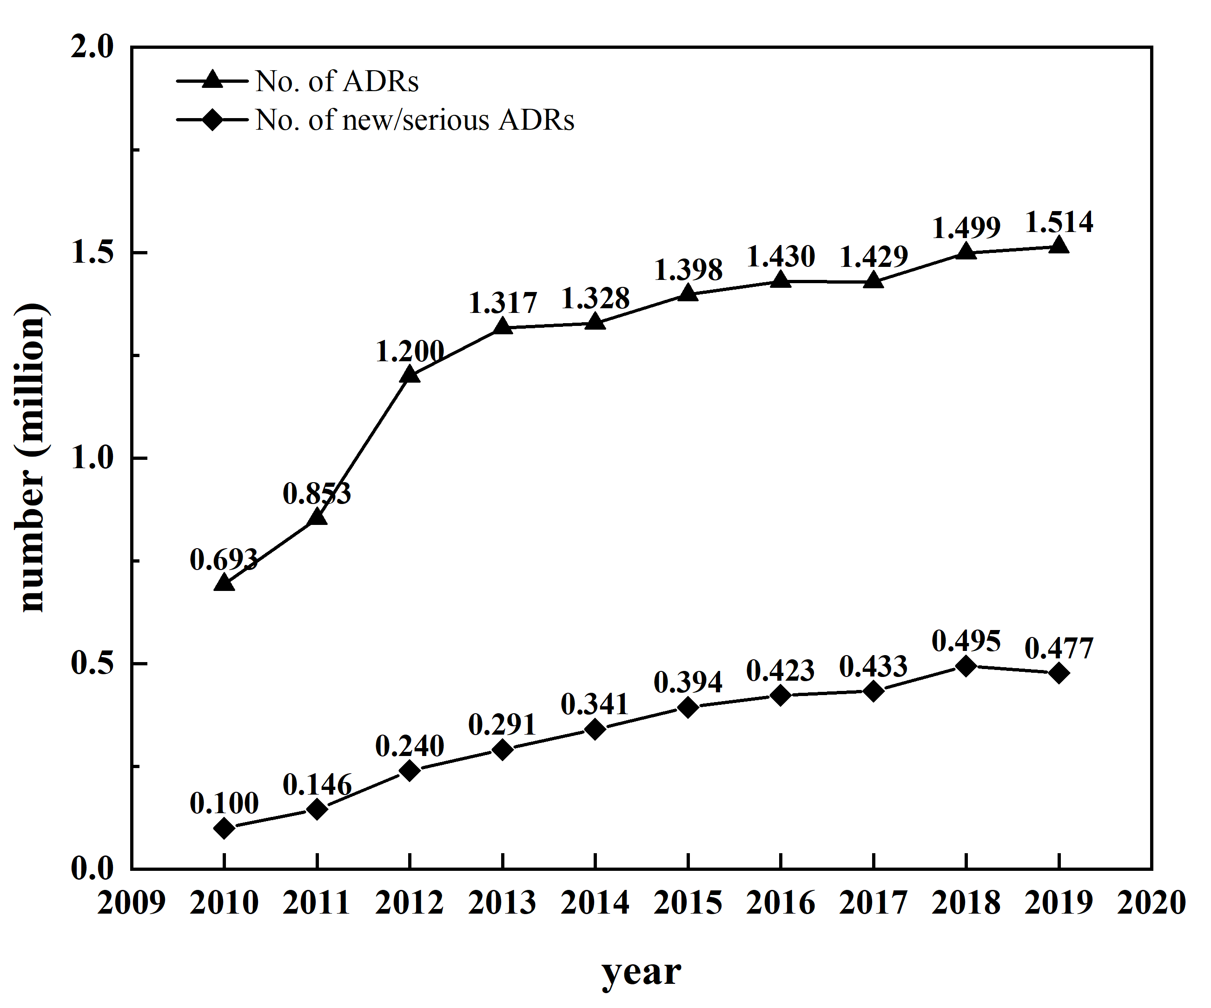
Supplementary figure1. National annual reports of ADRs monitoring in China from 2010 to 2019

