Supporting Information

Supplementary Figure 1

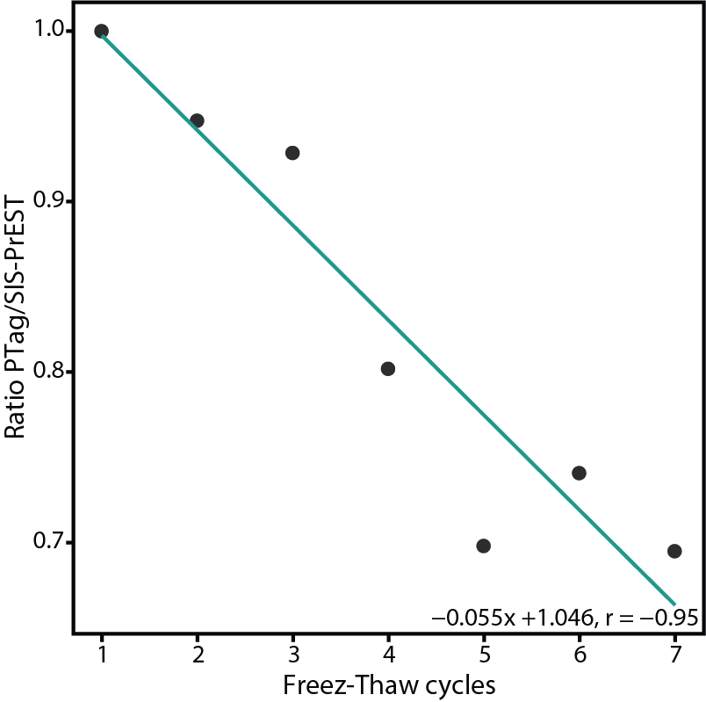
Supplementary Figure 1: PTag decay over 7 freeze-thaw cycles. Linear model used for normalization of PTag decay over multiple freeze-thaw cycles.

