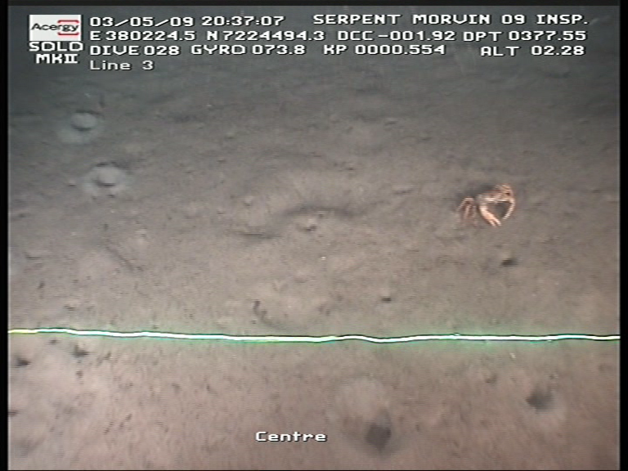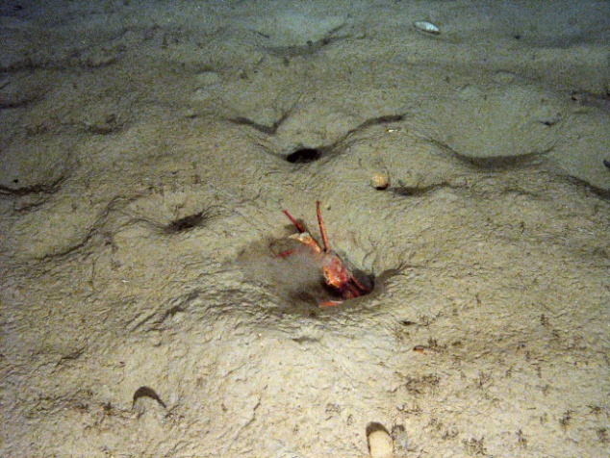

Figure S1: Burrows in the soft sediment at Morvin. Decapod crustaceans, likely Geryon sp. were often seen entering these burrows.

