APPENDIX 1. Example case

APPENDIX 2. Collective intelligence rule

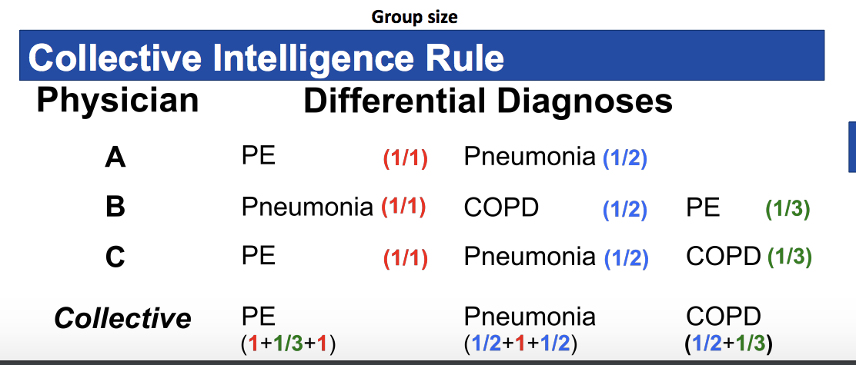

The collective intelligence is calculated using a weighted formula that considers both the frequency that a specific diagnosis appears on each respondent’s list but also where that diagnosis appears on that list. As shown in the example above, pulmonary embolus (PE) is listed as the most likely diagnosis in the collective because it not only appears on all three clinicians’ lists, but also overall in the highest position (#1 for physician A and C; #3 for physician B).

APPENDIX 3. Sample Collective intelligence output

APPENDIX 4: One-line summaries of included cases with specialist-consensus recommendations for each case

Endocrinology (12)
- 62F many medical problems w recently discovered hypokalemia and adrenal adenoma. Please advise on next steps to determine if patient is adrenalectomy candidate
  - Plasma metanephrine
  - Dexamethasone suppression
  - Renin level in AM
  - Aldosterone level in AM
- 62M HTN, HLD, asthma w persistent hypercalcemia. Please provide advice on further evaluation
  - Acquire vitamin 1-25 level
- 63M HCV/EtOH cirrhosis c/b HCC with hypoglycemia on routine outpatient labs. Please advise on next steps
  - Serum fasting glucose
- 59 F w elevated alk phos x 15 years. Please assist with work-up.
  - Vitamin D level
- 51F w incidental adrenal adenoma. Please assist with work-up
  - Plasma metanephrine
  - Dexamethasone suppression
- 39M with headache and low TSH & low FT4. Please assist with next evaluation steps.
  - Prolactin
- 65F primary hyperparathyroidism and thyroid nodule with osteopenia. Please provide advice on next steps
  - Sestamibi scan
- 21F ovarian cysts, irregular menses, elevated DHEA-S. Please advise on next steps
  - 17-hydroxyprogesterone level
- 47M with recent complaint of erectile dysfunction with no ejaculation x 6mo
  - AM testosterone
  - Prolactin
  - LH
- 49M DM with incidental buffalo hump. Please advise on next steps
  - Dexamethasone suppression test
- 67F osteoporosis and recent compression fx with alendronate contraindications. Please advise on next steps / management / alternative medications.
  - Vitamin D level
- 50M with pituitary macroadenoma. Please advise on appropriate labs to order
  - FSH
  - Prolactin
  - Cortisol

Gynecology (13)
- 25F G0, h/o ovarian cystic teratoma s/p right oophorectomy (path with mature cystic teratoma) reporting chronic dysmenorrhea. Please advise on next steps in management
  - Hormonal treatment
- 40 yo F with Bartholin cyst. Please advise on next steps
  - Sitz bath
- 25F h/o anovulatory uterine bleeding. Please advise on work-up and management
  - Transvaginal ultrasound
  - IUD or cyclic provera
- 63 Korean F s/p hysterectomy 12 years prior on Estradiol. Advise on if, when, and/or how to stop HRT.
  - Stop HRT or taper off
- 27 yo G3P1 @ 27+1 w/ new occurrence of 2 small R labial genital warts. Please advise on next steps.
  - TCA or cryotherapy for symptoms
- 45F w dysuria, hematuria. On CT urogram incidentally found to have adnexal cystic lesion.
  - Pelvic ultrasound
- 42F obese female w h/o unopposed estrogen and inability to conceive. Please provide advice on follow-up EMB and prolactin checks
  - Daily provera continuously or progestin IUD
- 37F w/ recurrent BV. Please advise on next steps
  - Suppressive therapy with metronidazole gel twice weekly for 4-6 months
- 52y G2P2 with hx of adenomyosis/menorrhagia now 1yr post menopause with cervical polyp noted on routine pap. Please advise on next steps.
  - Remove polyp
- 50 y obese F with hypothyroid, HTN, intermittent anemia, h/o irregular & heavy menses. Please advise on next steps.
  - IUD placement or hormonal management
  - Endometrial biopsy
- 33yo with amenorrhea for several years. Please provide guidance on next steps for evaluation and treatment.
  - Prolactin
  - Pelvic ultrasound
- 40F with abnormal pap. Please provide guidance on timing of repeat pap.
  - HPV testing
- 69 postmenopausal F presenting to new PCP appt w/ c/o intermittent vaginal bleeding s/p previous evaluation. Please provide guidance on further evaluation.
  - Pelvic ultrasound or endometrial biopsy with cervical exam

Neurology (10)
- 62M bipolar and seizure disorder p/w recent “syncopal” episodes. Please advise on next steps before neuro evaluation
  - Brain MRI
  - EEG
  - Dilantin level
- 40F h/o alcohol use p/w memory complaints x years. Please advise on next evaluation steps.
  - Metabolic panel
  - LFT
  - HIV
  - TSH
  - B12
  - Refer to neuropsych
- 62M h/o Billroth I p/w bilateral LE neuropathy. Please provide assistance with next steps
  - Methylmalonic Acid
- 50M HCV, opiate dependence p/w worsening bilateral LE peripheral neuropathy. Please advise on next steps to determine etiology
  - Hemoglobin A1c
  - TSH
  - Serum protein electrophoresis (SPEP)
- 67F w R hand essential tremor x 2 years, worsening. Please advise on next steps
  - Propranolol
- 50M controlled HIV, migraines p/w slurred speech + expressive aphasia a few weeks prior. Please advise on next step
  - Start antiplatelet
  - Echocardiogram
- 26 M w left foot drop. Pls advise on next steps.
  - Lumbar MRI
- 40F w worsening migraines x 8-10 years. Please advise on steps prior to neurological evaluation.
  - Headache diary
- 53F HTN, PTSD, h/o BPPV w chronic dizziness. Please assist in next steps to evaluate if dizziness is related to PTSD vs neuro etiology.
  - Vestibular physical therapy
- 63M restless leg symptoms. Please advise on next steps.
  - Ropinorole

APPENDIX 5

Appendix 5a: Appropriateness of Collective Intelligence Recommendations

 | Level of Appropriateness
Specialty | Strict | Moderate | Lenient | None
Endocrinology | 0 / 12 (0%) | 4 / 12 (33%) | 3 / 12 (25%) | 5 / 12 (42%)
Gynecology | 5 / 13 (38%) | 3 / 13 (23%) | 2 / 13 (15%) | 3 / 13 (23%)
Neurology | 2 / 10 (20%) | 1 / 10 (10%) | 4 / 10 (40%) | 3 / 10 (30%)
Overall | 7 / 35 (20%) | 8 / 35 (23%) | 9 / 35 (26%) | 11 / 35 (31%)

Appendix 5b: Appropriateness of Individual Physicians

 | Level of Appropriateness
Specialty | Strict | Moderate | Lenient | None
Endocrinology | 3 / 36 (8%) | 4 / 36 (11%) | 5 / 36 (14%) | 24 / 36 (67%)
Gynecology | 14 / 39 (36%) | 2 / 39 (5%) | 2 / 39 (5%) | 21 / 39 (54%)
Neurology | 6 / 30 (20%) | 3 / 30 (10%) | 8 / 30 (27%) | 13 / 30 (43%)
Overall | 23 / 105 (22%) | 9 / 105 (9%) | 15 / 105 (14%) | 58 / 105 (55%)

When using a binary definition of appropriateness (none vs strict/moderate/lenient), there was a significant difference between individuals vs collective intelligence recommendations among all cases (X² = 5.95, p=0.015) but not for any specialty: endocrine (X² = 2.35, p=0.125); gynecology (X² = 3.71, p=0.054); or neurology (X² = 0.56, p=0.46).

