**Supplementary data**

**Journal:** Proceedings of the Royal Society B. Biological Sciences

**Paper title:** Using the Goldilocks Principle to model coral ecosystem engineering

**Paper DOI:** 10.1098/rspb.2020-2562

**Authors:** Hennige, S.J. 1*, Larsson, A.I. 2, Orejas, C. 3, Gori, A. 4, de Clippele, L. 1, Lee, Y.C. 5, Jimeno, G. 6, Georgoulas, K. 1,Kamenos N,A. 7, Roberts, J.M.1

1 Changing Oceans Group, School of GeoSciences, University of Edinburgh, Edinburgh, UK.

2 Dept. of Marine Sciences, Tjärnö Marine Laboratory, University of Gothenburg, Sweden

3 Instituto Español de Oceanografía. Centro Oceanográfico de Baleares, Palma de Mallorca, Spain

4 Departament de Biologia Evolutiva, Ecologia i Ciències Ambientals, Universitat de Barcelona, Barcelona, Spain.

5 School of Engineering, Computing and Mathematics, University of Plymouth, Devon, UK.

6 School of Engineering and Physical Sciences, Heriot-Watt University, Edinburgh, UK

7 School of Geographical and Earth Sciences, University of Glasgow, UK

*Corresponding Author: [s.hennige@ed.ac.uk](mailto:s.hennige@ed.ac.uk); Changing Oceans, School of GeoSciences, University of Edinburgh, Edinburgh, UK.

**Supplementary Figure 1:** *A hemispherical coral seed is located at the centre of the domain along the x-axis at the beginning of the simulation. Red and blue particles denote the live coral and water particles, respectively.*



**Supplementary Figure 2:** *SPH simulations of coral growth based on death rules specified at different growth-step intervals. Here, a maximum growth rate of 1 particle for every growth-step in the direction of optimal flow velocities between 3 – 6 cm s-1 is considered. The direction of flow is indicated by the red arrow at the top layer moving at velocity, 50 cm s-1. Live coral is denoted red and dead coral is grey. Numbers in each panel indicate the growth-step (e.g. 20, 80, 140, 230). (A) Coral growth with no death rule applied; (B) coral growth with a death rule applied if coral does not experience optimal flow within 2 growth-steps; (C) coral growth with a death rule applied if coral does not experience optimal flow within 5 growth-steps; (D) coral growth with a death rule applied if coral does not experience optimal flow within 10 growth-steps; (E) coral growth with a death rule applied if coral does not experience optimal flow within 20 growth-steps; (F) coral growth with a death rule applied if coral does not experience optimal flow within 30 growth-steps; (G) coral growth with a death rule applied if coral does not experience optimal flow within 40 growth-steps.*

**Supplementary Figure 3:** (*A)**SPH simulation contour plot (with streamlines) delineating the velocity field and profile around a simulated coral colony (colours black and dark grey denoting life and dead coral particles).* *Direction of flow is from left to right (e.g. as in Supplementary Figure 2), with top layer velocity at 50 cm s-1 and the coral positioned centrally;**(B) Points highlight optimal flow velocity regions (3 – 6 cm s-1) for growth shown in (A).*

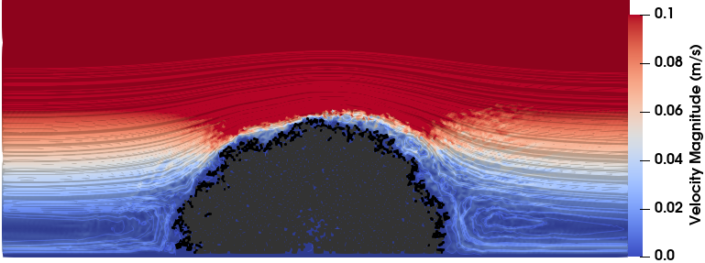

**Supplementary Table 1:** Initial parameters used in the SPH model. Note that the reference speed of sound was chosen to be 20 times larger than the maximum velocity in the numerical simulation.

|  |  |
| --- | --- |
| **Simulated Fluid** | **Water** |
| Density (kg/m3 ) | 1000 |
| Viscosity (Pa s) | 0.001 |
| Initial Particle Separation (m) | 0.05 |
| Smoothing Length (m) | 0.065 |
| Maximum Velocity (m/s) | 0.5 |
| Speed of Sound (m/s) | 10 |

**Supplementary Code 1:** Growth Functions used at each growth step within the model.

**FOR** every live coral particle, *i*, in the domain,

**FOR** every fluid particle, *j*, that is adjacent to coral particle, *i*, and within the ‘cut-off’ distance 1.5 Δx,

**IF** the average velocity of the fluid particle, *j*, between the previous growth step (*n* - 1) and the current growth step (*n*) is within the optimal flow range (3 - 6 cm/s),

**THEN**

Convert the fluid particle into live coral particle

**END IF**

**END FOR**

**END FOR**

**Death Rule Function:** Used every *x* growth steps. Here, *x* is an integer and *x* = 1 means it is going to be used at every growth-step to simulate a fast death rule. Higher values of *x* would indicate that the coral particles survive more consecutive growth-steps in sub-optimal conditions. Each coral particle has an energetic reserve value, and if that value is lower or equal to zero, the coral particle dies.

**FOR** every live coral particle, *i*, in the domain,

**IF** the average velocity of surrounding fluid particles adjacent coral particle, *i*, and within the ‘cut-off’ distance 1.5 Δx is outside the optimal flow range (3 - 6 cm/s),

**THEN**

Reduce ‘Energetic Value’ by 1

**IF** ‘Energetic Value’ <= 0

**THEN**

Convert live coral particle into dead coral particle

**END IF**

**END IF**

**END FOR**