Table S1. GenBank ID of the selected 90 vertebrate genomes.
Class | Species Name |  | GenBank ID |  | N50 (bp)
Mammals | Ailuropoda melanoleuca |  | GCF_000004335.2 |  | 1,281,781
 | Balaenoptera acutorostrata |  | GCF_000493695.1 |  | 12,843,668
 | Bos taurus |  | GCF_000003055.6 |  | 105,708,250
 | Fukomys damarensis |  | GCF_000743615.1 |  | 5,314,287
 | Homo sapiens |  | GCF_000001405.37 |  | 145,138,636
 | Macaca fascicularis |  | GCF_000364345.1 |  | 152,835,861
 | Mus musculus |  | GCF_000001635.25 |  | 130,694,993
 | Ornithorhynchus anatinus |  | GCF_004115215.1 |  | 991,605
 | Pan paniscus |  | GCF_000258655.2 |  | 144,709,823
 | Physeter catodon |  | GCF_002837175.1 |  | 37,183,148
 | Rattus norvegicus |  | GCF_000001895.5 |  | 145,729,302
 | Tupaia chinensis |  | GCF_000334495.1 |  | 3,670,124
Birds | Anas platyrhynchos |  | GCF_000355885.1 |  | 1,233,631
 | Aptenodytes forsteri |  | GCF_000699145.1 |  | 5,071,598
 | Chaetura pelagica |  | GCF_000747805.1 |  | 3,841,852
 | Charadrius vociferus |  | GCF_000708025.1 |  | 3,657,050
 | Corvus brachyrhynchos |  | GCF_000691975.1 |  | 6,953,989
 | Columba livia |  | GCA_000337935.2 |  | 3,148,738
 | Cuculus canorus |  | GCF_000709325.1 |  | 2,989,832
 | Egretta garzetta |  | GCF_000687185.1 |  | 3,067,157
 | Falco peregrinus |  | GCF_000337955.1 |  | 3,935,757
 | Gallus gallus |  | GCA_000002315.4 |  | 82,310,166
 | Geospiza fortis |  | GCF_000277835.1 |  | 5,255,844
 | Haliaeetus leucocephalus |  | GCF_000737465.1 |  | 9,145,499
 | Manacus vitellinus |  | GCF_001715985.1 |  | 16,644,750
 | Meleagris gallopavo |  | GCF_000146605.3 |  | 59,006,440
 | Melopsittacus undulatus |  | GCF_000238935.1 |  | 10,614,383
 | Nestor notabilis |  | GCF_000696875.1 |  | 61,475
 | Nipponia nippon |  | GCF_000708225.1 |  | 5,211,696
 | Opisthocomus hoazin |  | GCA_000692075.1 |  | 2,937,227
 | Picoides_pubescens |  | GCF_000699005.1 |  | 2,093,929
 | Pseudopodoces humilis |  | GCF_000331425.1 |  | 16,337,386
 | Pygoscelis adeliae |  | GCF_000699105.1 |  | 5,118,896
 | Struthio camelus |  | GCF_000698965.1 |  | 3,593,425
 | Taeniopygia guttata |  | GCF_000151805.1 |  | 62,374,962
 | Tinamus guttatus |  | GCF_000705375.1 |  | 246,268
Reptiles | Alligator mississippiensis |  | GCF_000281125.3 |  | 18,600,682
 | Alligator sinensis |  | GCF_000455745.1 |  | 2,188,296
 | Anolis carolinensis |  | GCF_000090745.1 |  | 150,641,573
 | Chelonia mydas |  | GCF_000344595.1 |  | 3,864,108
 | Chrysemys picta bellii |  | GCF_000090745.1 |  | 7,072,151
 | Crocodylus porosus |  | GCF_001723895.1 |  | 84,437,661
 | Gavialis gangeticus |  | GCF_001723915.1 |  | 96,076,944
 | Gekko japanicus |  | GCF_001447785.1 |  | 707,733
 | Ophiophagus_hannah |  | GCA_000516915.1 |  | 241,519
 | Pelodiscus sinensis |  | GCF_000230535.1 |  | 3,350,749
 | Python bivittatus |  | GCF_000186305.1 |  | 213,970
 | Thamnophis sirtalis |  | GCF_001077635.1 |  | 647,592
Amphibians |  | Xenopus laevis |  | GCF_001663975.1 |  | 136,570,856
 |  | Xenopus tropicalis |  | GCF_000004195.3 |  | 135,134,832
 |  | Nanorana parkeri |  | GCF_000935625.1 |  | 1,069,101
Teleosts |  | Anabarilius grahami |  | GCA_003731715.1 |  | 4,409,934
 |  | Astatotilapia burtoni |  | GCF_000239415.1 |  | 1,194,190
 |  | Astyanax mexicanus |  | GCF_000372685.1 |  | 1,775,308
 |  | Boleophthalmus pectinirostris |  | GCF_000788275.1 |  | 2,375,582
 |  | Coilia nasus |  | GCA_007927635.1 |  | 34,854,322
 |  | Ctenopharyngodon idellus |  | PRJEB5920 |  | 6,428,943
 |  | Cynoglossus semilaevis |  | GCF_000523025.1 |  | 20,010,643
 |  | Cyprinus carpio |  | GCF_000951625.1 |  | 66,838
 |  | Danio rerio |  | GCF_000002035.4 |  | 53,345,113
 |  | Dicentrarchus labrax |  | GCA_000689215.1 |  | 26,439,989
 |  | Esox lucius |  | GCA_000721915.3 |  | 32,939,842
 |  | Fundulus heteroclitus |  | GCF_000826765.1 |  | 1,252,252
 |  | Gasterosteus aculeatus |  | GCA_000180675.1 |  | 83,204
 |  | Gadus morhua |  | GCF_902167405.1 |  | 393,166
 |  | Hippocampus comes |  | GCF_001891065.1 |  | 1,971,390
 |  | Ictalurus punctatus |  | GCF_001660625.1 |  | 27,425,808
 |  | Larimichthys crocea |  | GCF_000972845.1 |  | 1,034,540
 |  | Lates calcarifer |  | GCF_001640805.1 |  | 1,191,366
 |  | Lepisosteus oculatus |  | GCF_000242695.1 |  | 50,348,508
 |  | Monopterus albus |  | GCF_001952655.1 |  | 2,106,322
 |  | Neolamprologus brichardi |  | GCF_000239395.1 |  | 4,430,025
 |  | Oncorhynchus mykiss |  | GCF_002163495.1 |  | 71,056,191
 |  | Oreochromis niloticus |  | GCF_001858045.1 |  | 37,007,722
 |  | Oryzias latipes |  | GCF_000313675.1 |  | 29,600,056
 |  | Periophthalmus magnuspinnatus |  | GCA_000787105.1 |  | 296,161
 |  | Poecilia formosa |  | GCF_000485575.1 |  | 1,574,226
 |  | Protosalanx hyalocranius |  | PRJNA328051 |  | 432,316
 |  | Pseudoliparis swirei |  | PRJNA472845 |  | 418,461
 |  | Pygocentrus nattereri |  | GCF_001682695.1 |  | 1,440,044
 |  | Salmo salar |  | GCF_000233375.4 |  | 80,503,876
 |  | Sinocyclocheilus anshuiensis |  | GCF_001515605.1 |  | 1,284,143
 |  | Sinocyclocheilus grahami |  | GCF_001515645 |  | 1,156,368
 |  | Sinocyclocheilus rhinocerous |  | GCF_001515625 |  | 945,738
 |  | Takifugu rubripes |  | GCF_000180615.1 |  | 11,516,971
 |  | Tetraodon nigroviridis |  | GCA_000180735.1 |  | 734,039
 |  | Xiphophorus maculatus |  | GCF_000241075.1 |  | 1,303,070
Chondrichthyes |  | Callorhynchus milii |  | GCF_000165045.1 |  | 4,521,921

Table S2. Queries used for extraction of genes from the melanin synthesis pathway.
Gene | O. latipes | H. sapiens | G. gallus | X. laevis | A. carolinensis
tyra/tyr | ENSORLP00000041517 | ENSP00000263321 | ENSP00000263321 | ENSACAP00000014741 | ENSACAP00000014741
tyrb | ENSORLP00000005706
tyrp1a/tyrp1 | ENSORLP00000005420 | ENSP00000373570 | ENSP00000373570 | ENSACAP00000011189 | ENSACAP00000011189
tyrp1b | ENSORLP00000033423
tyrp2 | ENSORLP00000022234 | ENSP00000392762 | ENSGALP00000035733 | ENSXETP00000023918 | ENSACAP00000002600
pmela/pmel | ENSORLP00000018803 | ENSP00000402758 | ENSGALP00000051268 | ENSXETP00000020810 | ENSACAP00000005360
pmelb | ENSORLP00000020625
mitfa/mitf | ENSORLP00000037247 | ENSP00000391803 | ENSGALP00000070157 | ENSXETP00000000313 | ENSACAP00000013404
mitfb | ENSORLP00000033348
slc24a5 | ENSORLP00000045188 | ENSP00000341550 | ENSGALP00000038183 | ENSXETP00000039854 | ENSACAP00000004671

Table S3. Copy numbers of genes for melanin synthesis in 38 examined Actinopterygii species.
species | tyra | tyrb | tyrp1a | tyrp1b | tyrp2 | pmela | pmelb | mitfa | mitfb | slc24a5
Anabarilius_grahami | 1 | 0 | 1 | 1 | 1 | 1 | 1 | 1 | 1 | 1
Astatotilapia_burtoni | 1 | 1 | 1 | 1 | 1 | 1 | 1 | 1 | 1 | 1
Astyanax_mexicanus | 1 | 1 | 1 | 1 | 1 | 1 | 1 | 0 | 0 | 0 (1)
Boleophthalmus_pectinirostris | 1 | 1 | 1 | 1 | 1 | 1 | 1 | 1 | 1 | 1
Coilia_nasus | 1 | 0 | 1 | 1 | 1 | 1 | 1 | 1 | 1 | 1
Ctenopharyngodon_idellus | 1 | 0 | 1 | 1 | 1 | 1 | 2 | 1 | 1 | 1
Cynoglossus_semilaevis | 1 | 1 | 1 | 1 | 1 | 1 | 1 | 1 | 1 | 1
Cyprinus_carpio | 2 | 0 | 1 | 1 | 1 | 0 (1) | 1 | 1 | 2 | 1
Danio_rerio | 1 | 0 | 1 | 1 | 1 | 1 | 1 | 1 | 1 | 1
Dicentrarchus_labrax | 1 | 1 | 1 | 1 | 1 | 1 | 1 | 1 | 1 | 1
Esox_lucius | 1 | 1 | 1 | 1 | 1 | 1 | 1 | 1 | 1 | 1
Fundulus_heteroclitus | 1 | 1 | 1 | 1 | 1 | 1 | 1 | 1 | 1 | 1
Gasterosteus_aculeatus | 1 | 1 | 1 | 1 | 1 | 1 | 1 | 1 | 1 | 1
Guadus_morhua | 0 | 1 | 1 | 1 | 0 | 1 | 1 | 1 | 1 | 1
Hippocampus_comes | 1 | 1 | 1 | 1 | 1 | 1 | 1 | 1 | 1 | 1
Ictalurus_punctatus | 1 | 1 | 1 | 1 | 1 | 1 | 1 | 1 | 0 | 1
Larimichthys_crocea | 1 | 0 | 1 | 1 | 1 | 2 | 1 | 1 | 1 | 1
Lates_calcarifer | 1 | 1 | 1 | 1 | 1 | 2 | 1 | 2 | 1 | 1
Monopterus_albus | 1 | 1 | 1 | 1 | 1 | 1 | 1 | 1 | 2 | 1
Neolamprologus_brichardi | 1 | 1 | 1 | 1 | 1 | 1 | 1 | 1 | 1 | 1
Oncorhynchus_mykiss | 1 | 1 | 2 | 1 | 2 | 1 | 2 | 1 | 3 | 1
Oreochromis_niloticus | 1 | 1 | 1 | 1 | 1 | 1 | 1 | 1 | 1 | 3
Oryzias_latipes | 1 | 1 | 1 | 1 | 1 | 1 | 1 | 1 | 1 | 1
Periophthalmus_magnuspinnatus | 1 | 1 | 1 | 1 | 1 | 1 | 1 | 1 | 1 | 1
Poecilia_formosa | 1 | 1 | 1 | 1 | 1 | 1 | 1 | 1 | 1 | 1
Protosalanx_hyalocranius | 1 | 1 | 1 | 1 | 1 | 1 | 1 | 0 (1) | 1 | 1
Pseudoliparis_swirei | 0 | 2 | 1 | 1 | 1 | 1 | 0 (1) | 1 | 1 | 1
Pundamilia_nyererei | 1 | 1 | 1 | 1 | 1 | 1 | 1 | 1 | 1 | 1
Pygocentrus_nattereri | 1 | 1 | 1 | 1 | 1 | 1 | 1 | 1 | 1 | 1
Salmo_salar | 1 | 2 | 2 | 0 | 2 | 2 | 2 | 1 | 2 | 1
Sinocyclocheilus_anshuiensis | 2 | 0 | 0 | 2 | 1 (1) | 2 | 0 (2) | 1 | 2 | 1
Sinocyclocheilus_grahami | 2 | 0 | 1 | 2 | 2 | 2 | 1 | 1 | 1 | 2
Sinocyclocheilus_rhinocerous | 1 | 0 | 1 | 2 | 1 (1) | 1 | 1 (1) | 1 | 2 | 1
Takifugu_rubripes | 1 | 1 | 1 | 0 | 1 | 1 | 1 | 1 | 1 | 1
Tetraodon_nigroviridis | 1 | 1 | 1 | 0 | 1 | 1 | 1 | 1 | 1 | 1
Xiphophorus_maculatus | 1 | 1 | 1 | 1 | 1 | 1 | 1 | 1 | 1 | 1
Total | 37 | 29 | 37 | 36 | 38 (2) | 40 (1) | 37 (4) | 39 (1) | 41 | 38 (1)
Those species with melanin loss were marked in red.
The copy numbers of pseudogenes were provided in brackets.

Table S4. Copy numbers of genes for melanin synthesis in 53 examined tetrapod species.
Class | species | tyr | tyrp1 | tyrp2 | pmel | mitf | slc24a5
Mammals | Ailuropoda_melanoleuca | 0 | 1 | 1 | 1 | 1 | 1
 | Balaenoptera_acutorostrata | 1 | 1 | 1 | 1 | 1 | 1
 | Bos_taurus | 1 | 1 | 1 | 1 | 1 | 1
 | Castor_canadensis | 0 | 1 | 1 | 1 | 1 | 1
 | Fukomys_damarensis | 1 | 0 | 1 | 1 | 1 | 1
 | Homo_sapiens | 1 | 1 | 1 | 1 | 1 | 1
 | Macaca_fascicularis | 1 | 1 | 1 | 1 | 1 | 1
 | Mus_musculus | 1 | 1 | 1 | 1 | 1 | 1
 | Ornithorhynchus_anatinus | 1 | 1 | 1 | 1 | 1 | 1
 | Pan_paniscus | 1 | 1 | 1 | 1 | 1 | 1
 | Physeter_catodon | 1 | 1 | 0 (1) | 1 | 1 | 1
 | Rattus_norvegicus | 1 | 1 | 1 | 1 | 1 | 1
 | Tupaia_chinensis | 1 | 1 | 1 | 1 | 1 | 1
 | Total | 11 | 12 | 12 (1) | 13 | 13 | 13
Birds | Anas_platyrhynchos | 1 | 1 | 1 | 0 | 1 | 1
 | Aptenodytes_forsteri | 1 | 1 | 1 | 0 | 1 | 1
 | Calypte_anna | 1 | 1 | 1 | 0 | 1 | 1
 | Chaetura_pelagica | 1 | 1 | 1 | 0 | 1 | 1
 | Charadrius_vociferus | 1 | 1 | 0 (1) | 0 | 1 | 1
 | Columba_livia | 1 | 1 | 1 | 1 | 1 | 1
 | Corvus_brachyrhynchos | 1 | 1 | 1 | 0 | 1 | 1
 | Cuculus_canorus | 1 | 1 | 1 | 0 | 1 | 1
 | Egretta_garzetta | 1 | 1 | 1 | 0 | 1 | 1
 | Falco_peregrinus | 1 | 1 | 1 | 0 | 1 | 1
 | Gallus_gallus | 1 | 1 | 1 | 1 | 1 | 1
 | Geospiza_fortis | 1 | 1 | 1 | 0 | 1 | 1
 | Haliaeetus_leucocephalus | 1 | 1 | 1 | 1 | 1 | 1
 | Manacus_vitellinus | 1 | 1 | 1 | 0 | 1 | 1
 | Meleagris_gallopavo | 1 | 1 | 1 | 1 | 1 | 1
 | Melopsittacus_undulatus | 1 | 1 | 1 | 0 | 1 | 1
 | Nestor_notabilis | 1 | 1 | 1 | 0 | 1 | 1
 | Nipponia_nippon | 1 | 1 | 0 (1) | 0 | 1 | 1
 | Opisthocomus_hoazin | 1 | 1 | 1 | 0 | 1 | 1
 | Picoides_pubescens | 1 | 1 | 1 | 0 | 1 | 1
 | Pseudopodoces_humilis | 1 | 1 | 1 | 1 | 1 | 1
 | Pygoscelis_adeliae | 1 | 1 | 1 | 0 | 1 | 1
 | Struthio_camelus | 1 | 1 | 1 | 0 | 1 | 1
 | Taeniopygia_guttata | 1 | 1 | 1 | 0 | 1 | 1
 | Tinamus_guttatus | 1 | 1 | 1 | 0 | 1 | 1
 | Total | 25 | 25 | 23(2) | 5 | 25 | 25
Reptiles | Alligator_mississippiensis | 1 | 1 | 1 | 1 | 1 | 1
 | Alligator_sinensis | 1 | 1 | 1 | 1 | 1 | 1
 | Anolis_carolinensis | 1 | 1 | 1 | 1 | 1 | 1
 | Chelonia_mydas | 1 | 1 | 1 | 0 | 1 | 1
 | Chrysemys_picta | 1 | 1 | 1 | 1 | 1 | 1
 | Crocodylus_porosus | 1 | 1 | 1 | 0 | 1 | 1
 | Gavialis_gangeticus | 1 | 1 | 1 | 0 | 1 | 1
 | Gekko_japonicus | 1 | 1 | 1 | 1 | 1 | 1
 | Ophiophagus_hannah | 0 | 1 | 1 | 1 | 1 | 1
 | Pelodiscus_sinensis | 1 | 1 | 1 | 0 | 1 | 1
 | Python_bivittatus | 0 | 1 | 1 | 1 | 1 | 1
 | Thamnophis_sirtalis | 0 | 1 | 1 | 1 | 1 | 1
 | Total | 9 | 12 | 12 | 8 | 12 | 12
Amphibians | Nanorana_parkeri | 1 | 2 | 1 | 1 | 1 | 1
 | Xenopus_laevis | 1 | 2 | 2 | 2 | 2 | 2
 | Xenopus_tropicalis | 1 | 1 | 1 | 1 | 1 | 1
 | Total | 3 | 5 | 4 | 4 | 4 | 4

Table S5. The detailed locations in scaffolds/chromosomes for genes from the melanin synthesis pathway in various fishes.
(See the separated Excel file)

Table S6. The detailed locations in scaffolds/chromosomes for genes from melanin synthesis pathway in various tetrapod species.
(See the separated Excel file)

Supplementary File 1. The perl script named Solar.pl used for tBLASTn alignment filtering.

Supplementary File 2. Coding sequences of all reported genes in this study.
(See the separated compressed files)

Supplementary File 3. Protein sequence alignments of reported genes in this study.
(See the separated compressed files)

Supplementary File 4. Protein sequence alignments of mitfa, pmelb, and slc24a5 genes in Figures 2, 3 and 4.
(See the separated compressed files)

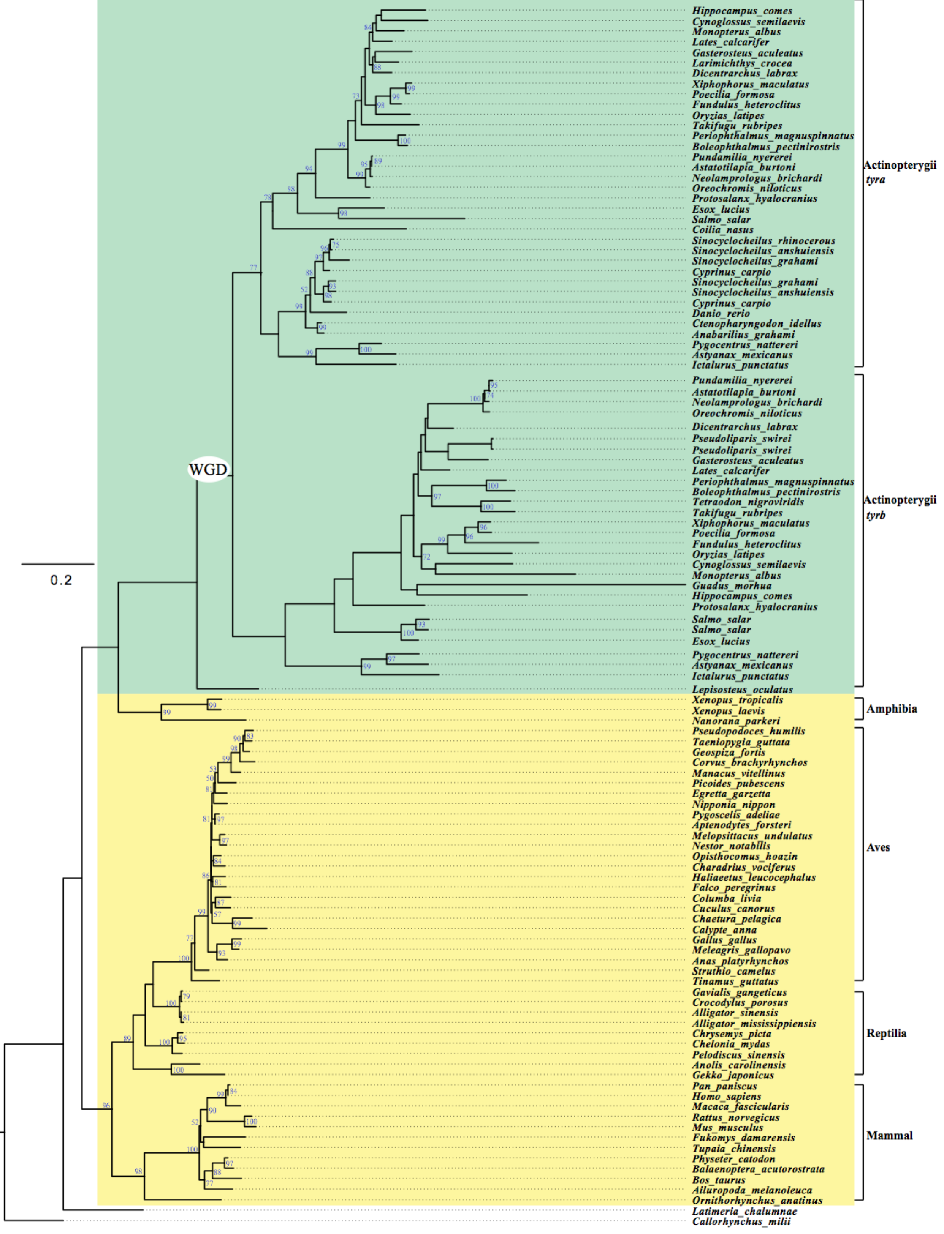
Figure S1. A phylogenetic tree of tyr in various vertebrates. The scale bar denotes substitutions per site. Bootstrap values above 50% were provided at the branches.

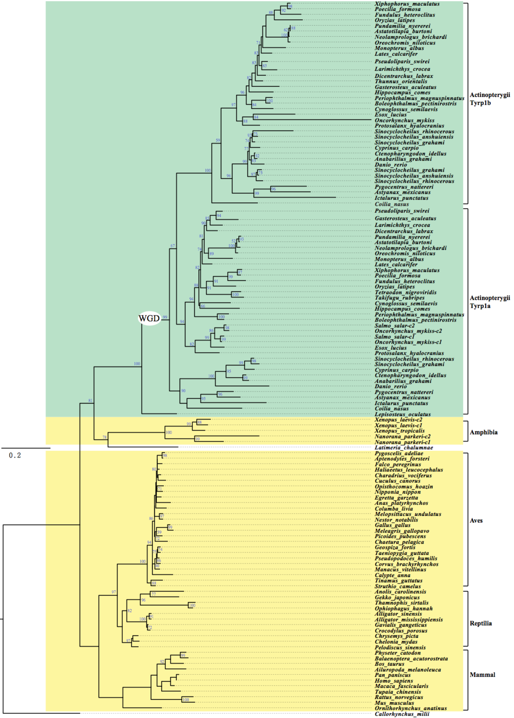
Figure S2. A phylogenetic tree of tyrp1 in various vertebrates. The scale bar denotes substitutions per site. Bootstrap values above 50% were provided at the branches.
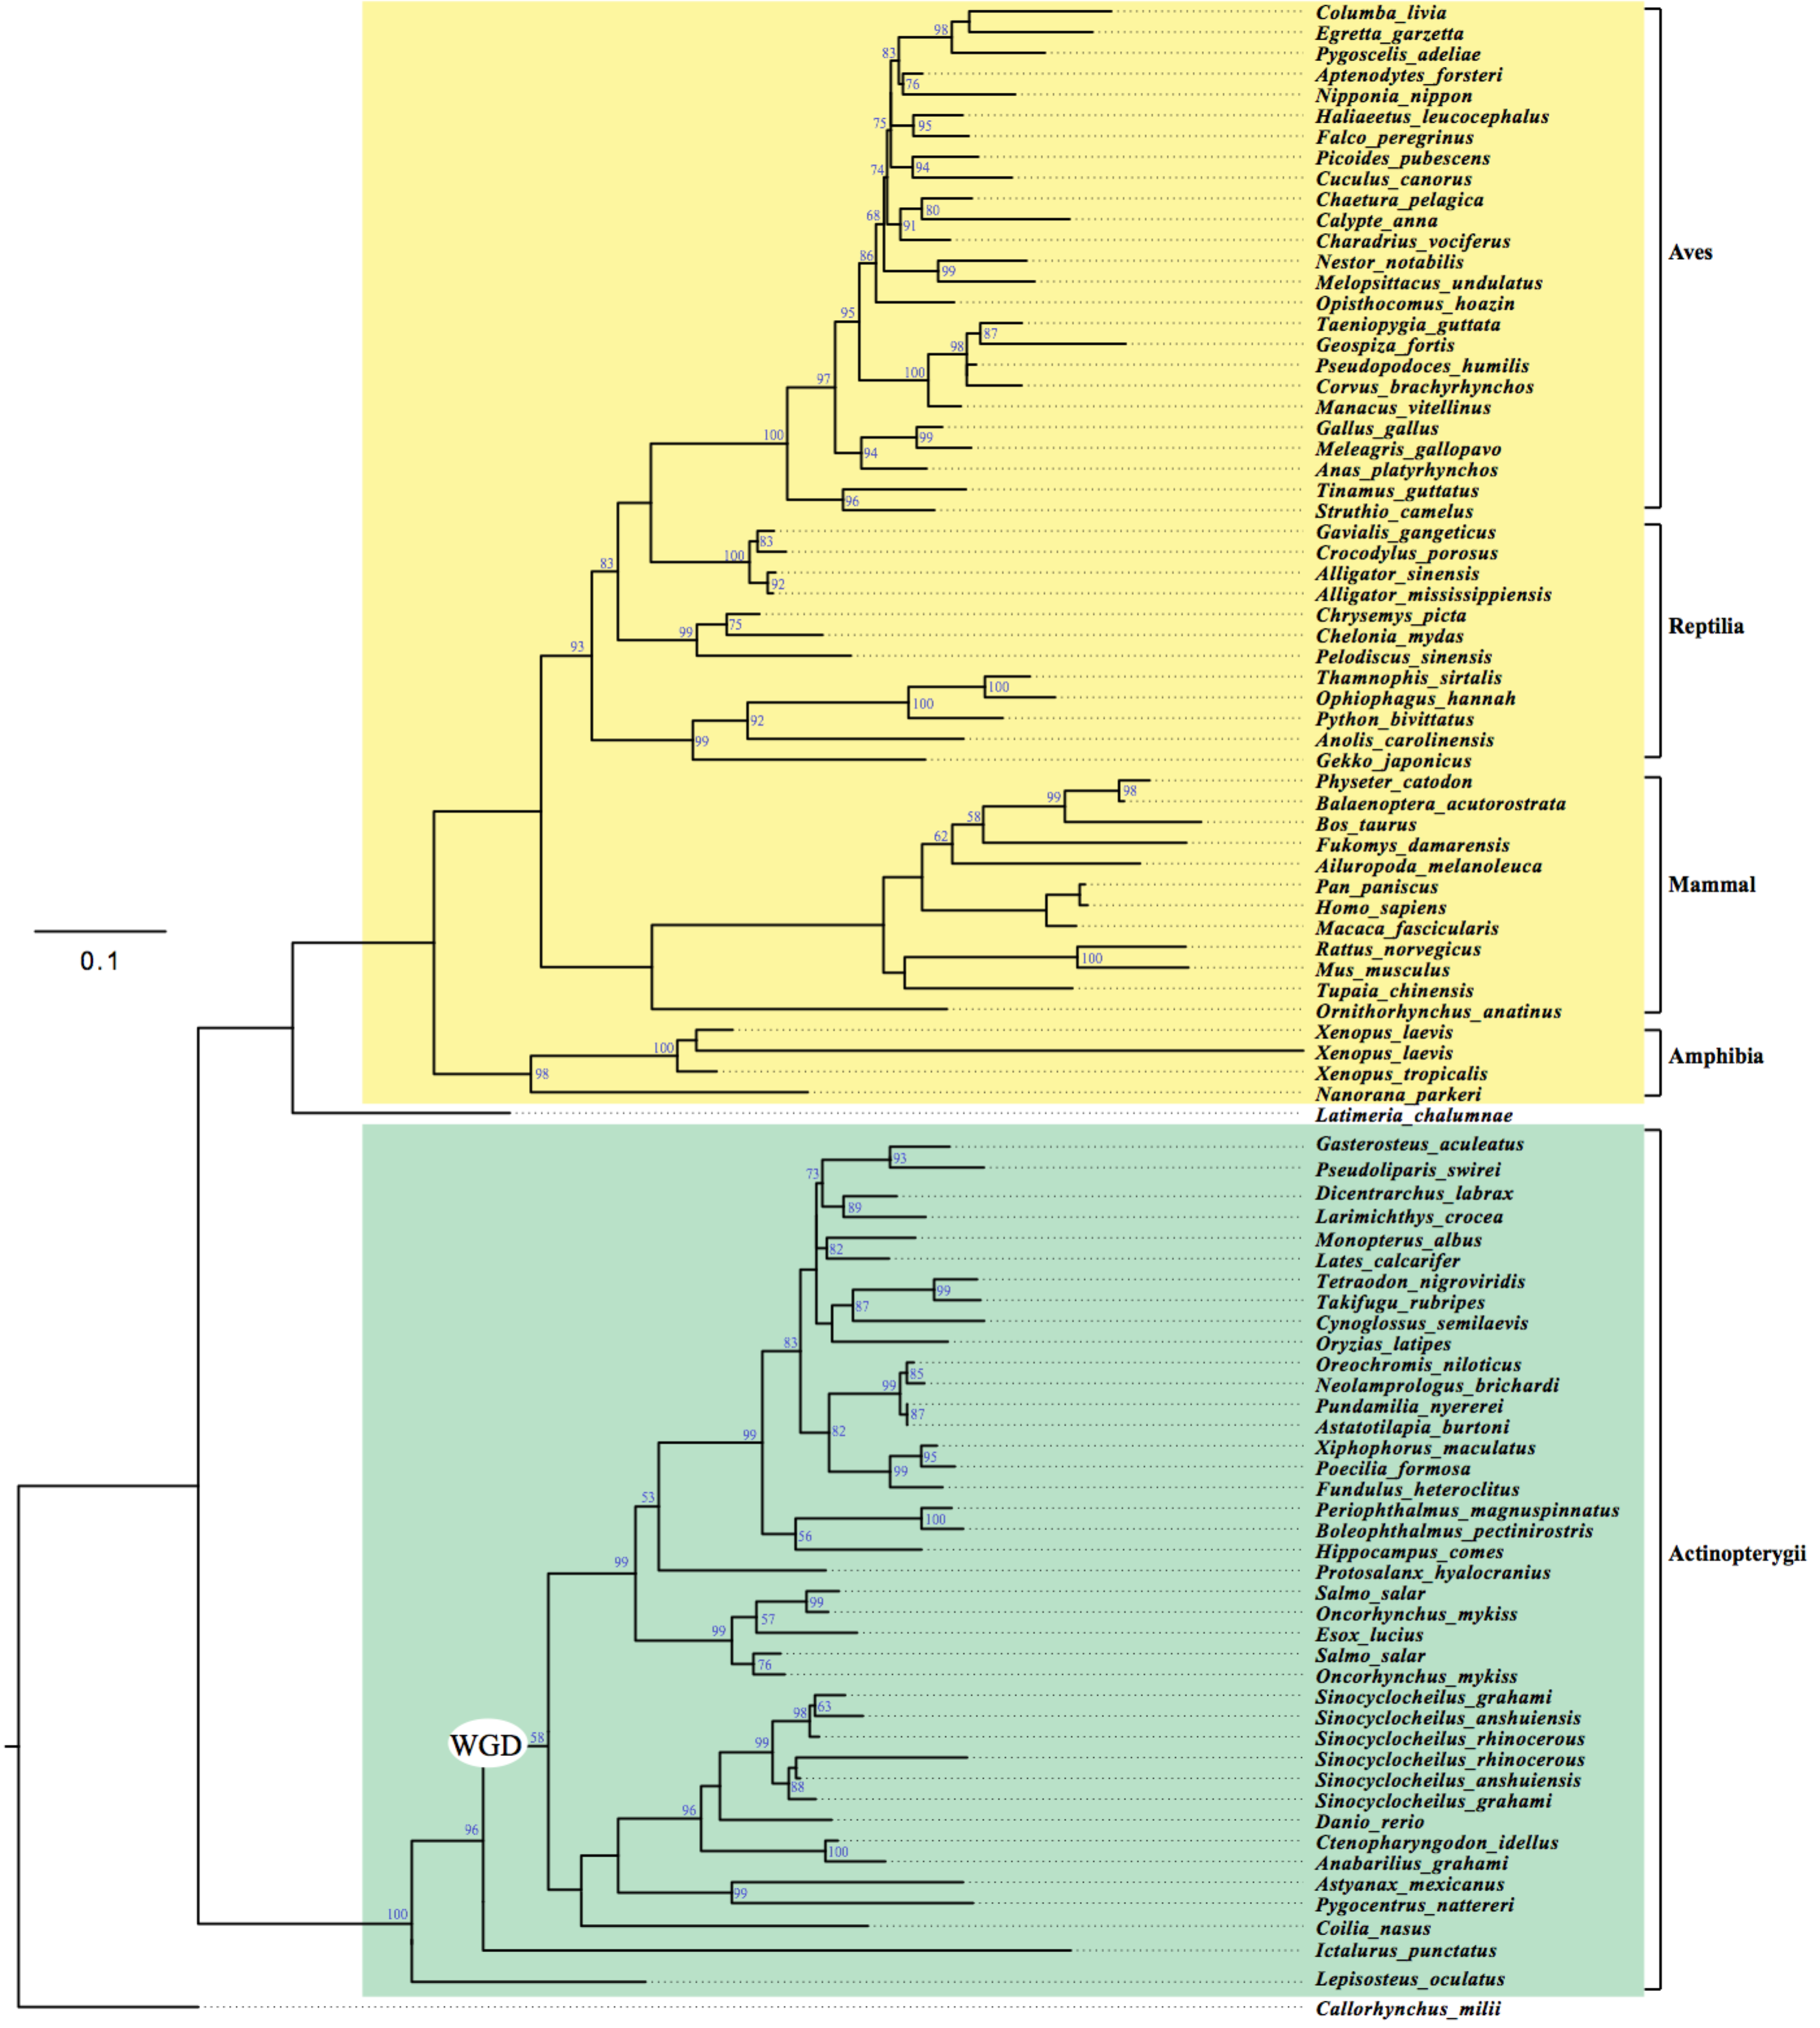
Figure S3. A phylogenetic tree of tyrp2 in various vertebrates. The scale bar denotes substitutions per site. Bootstrap values above 50% were provided at the branches.
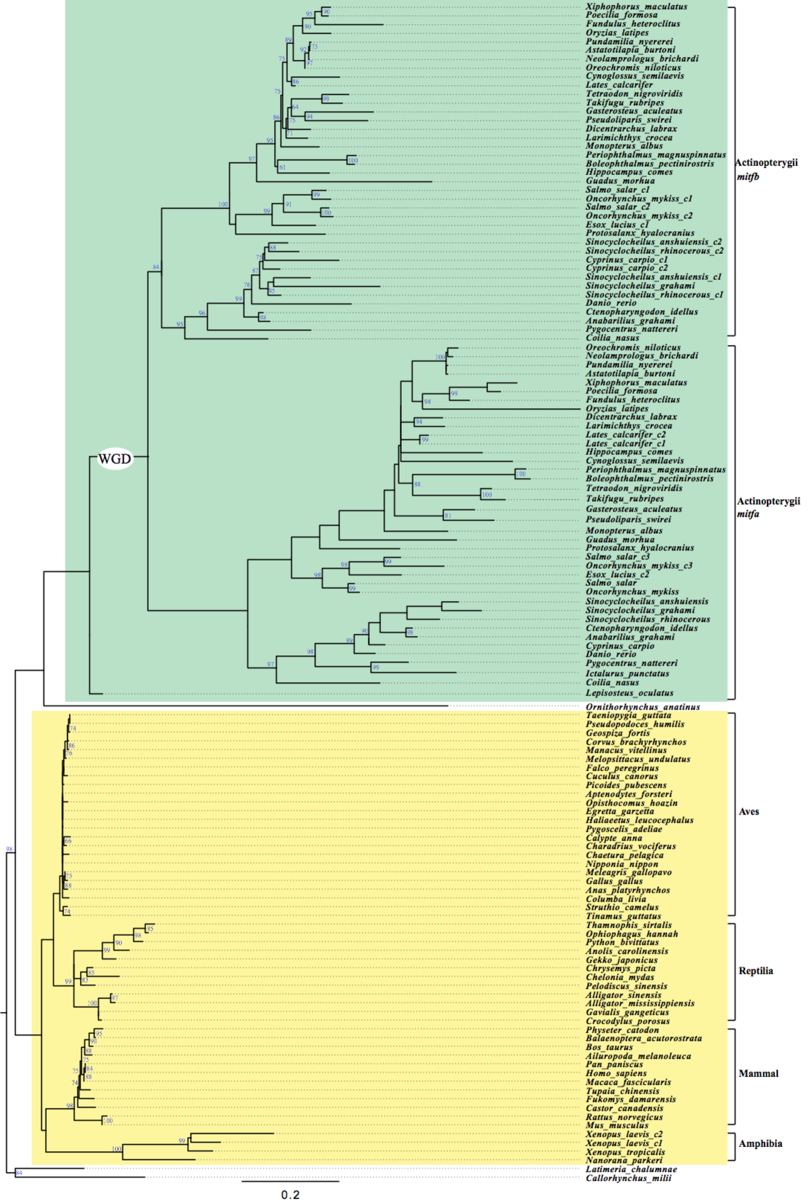
Figure S4. A phylogenetic tree of mitf in various vertebrates. The scale bar denotes substitutions per site. Bootstrap values above 50% were provided at the branches.
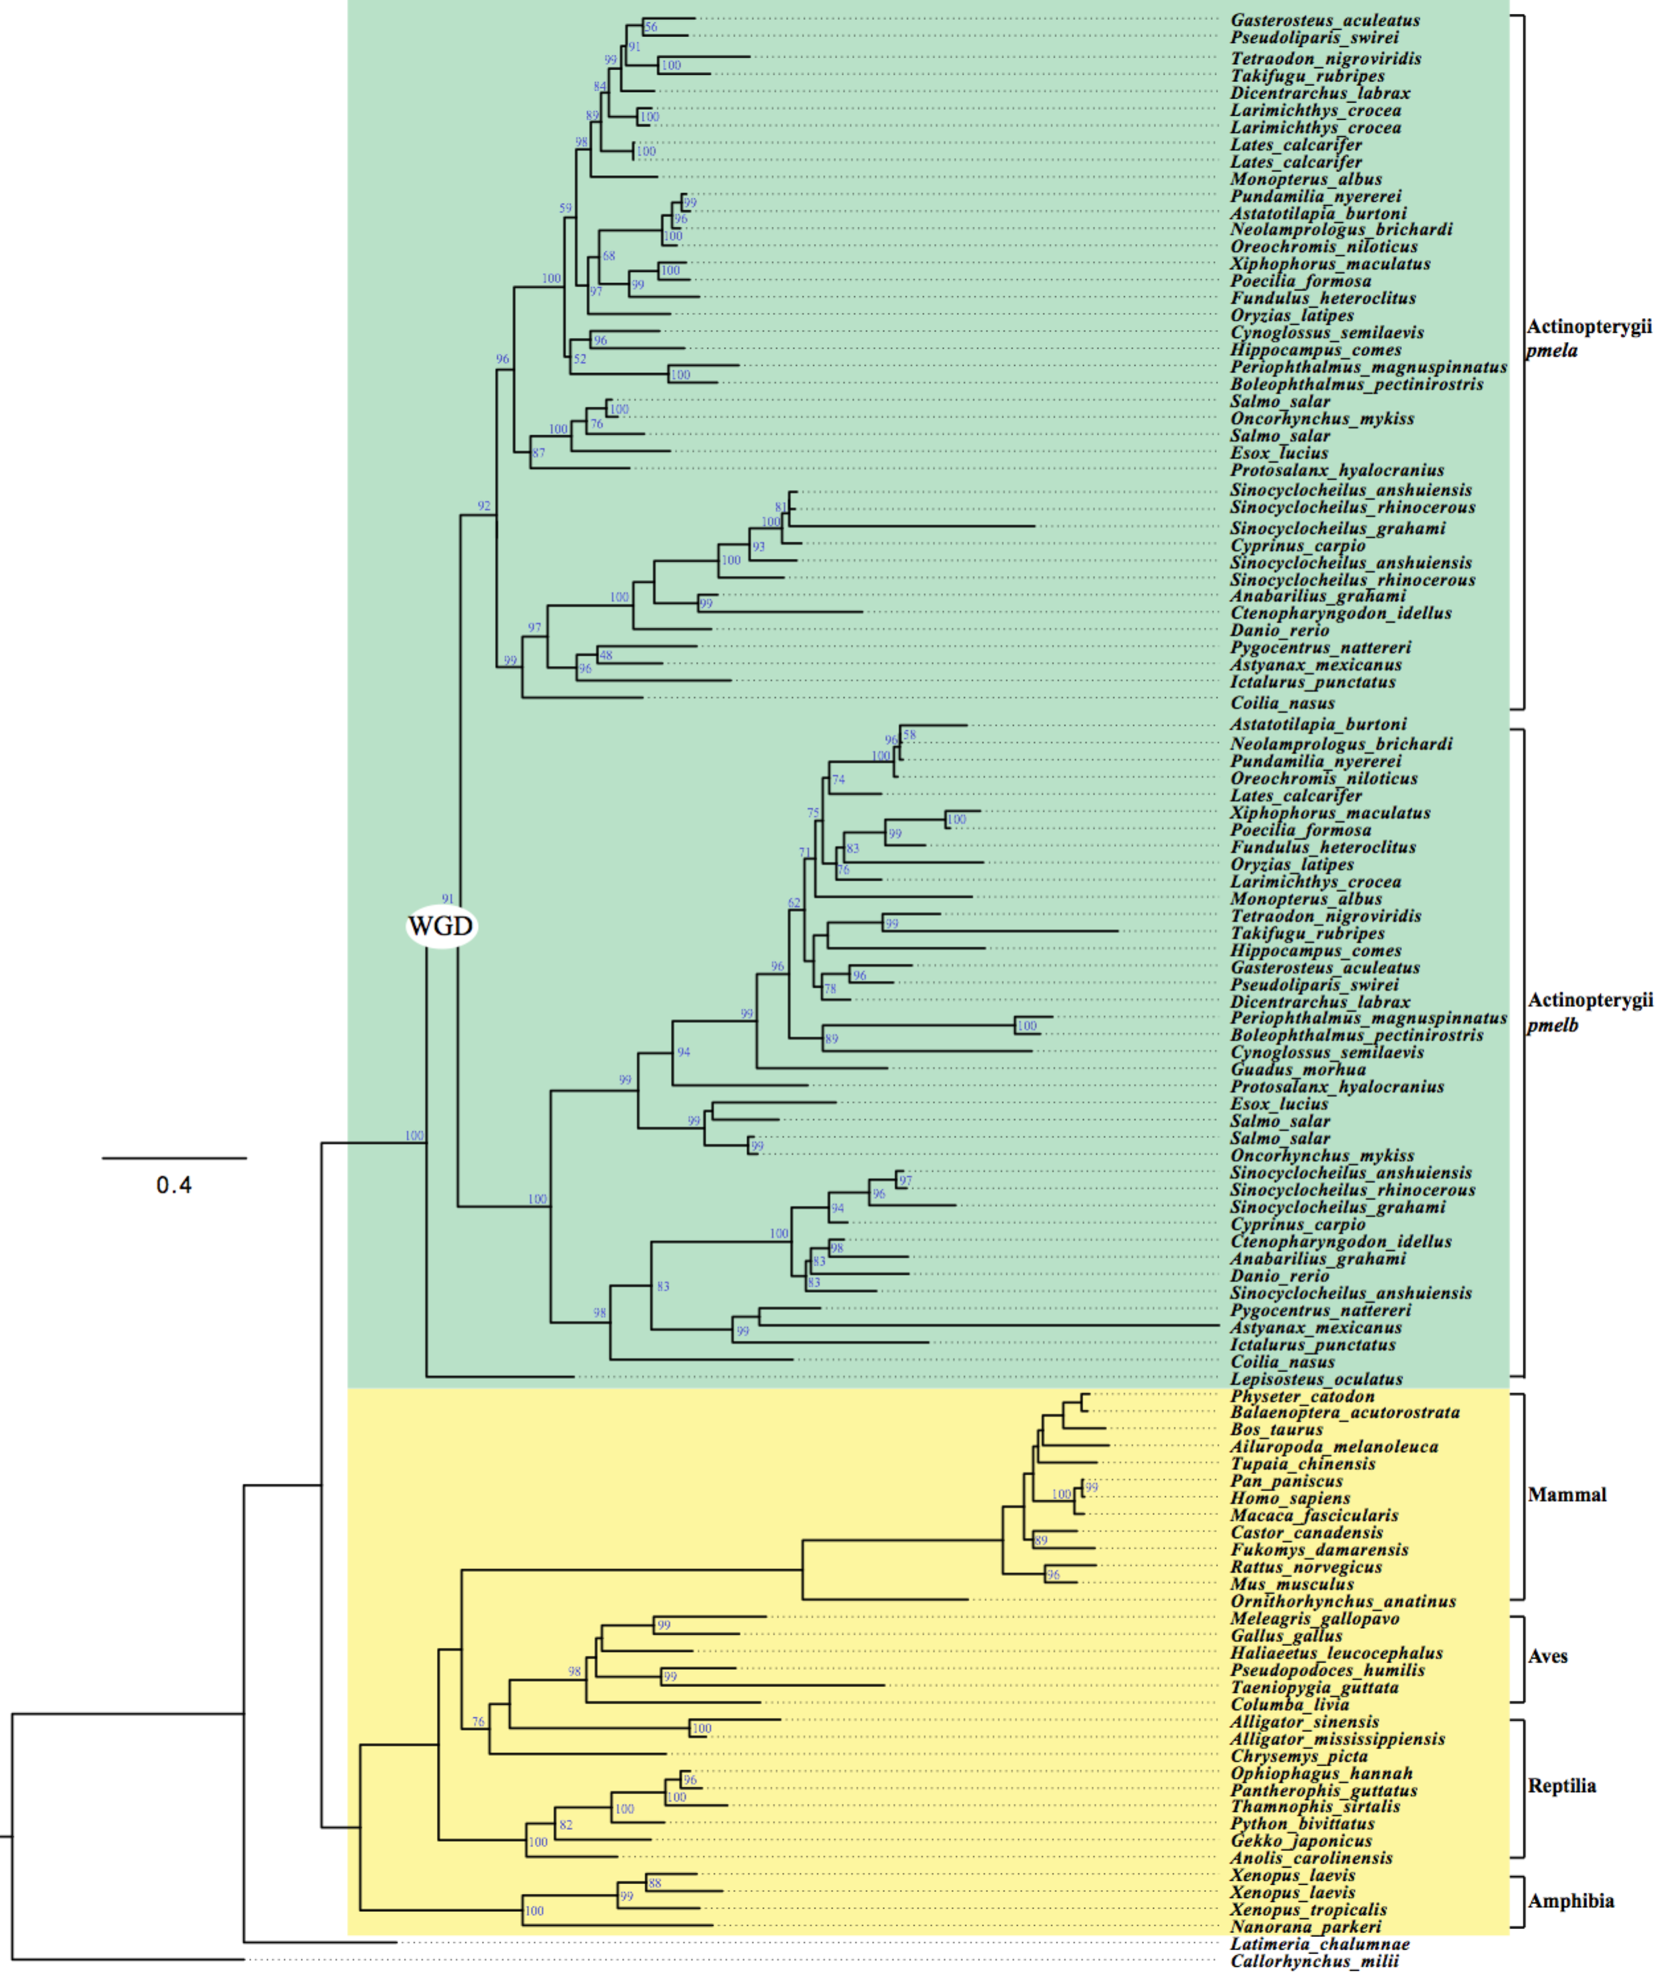
Figure S5. A phylogenetic tree of pmel in various vertebrates. The scale bar denotes substitutions per site. Bootstrap values above 50% were provided at the branches.

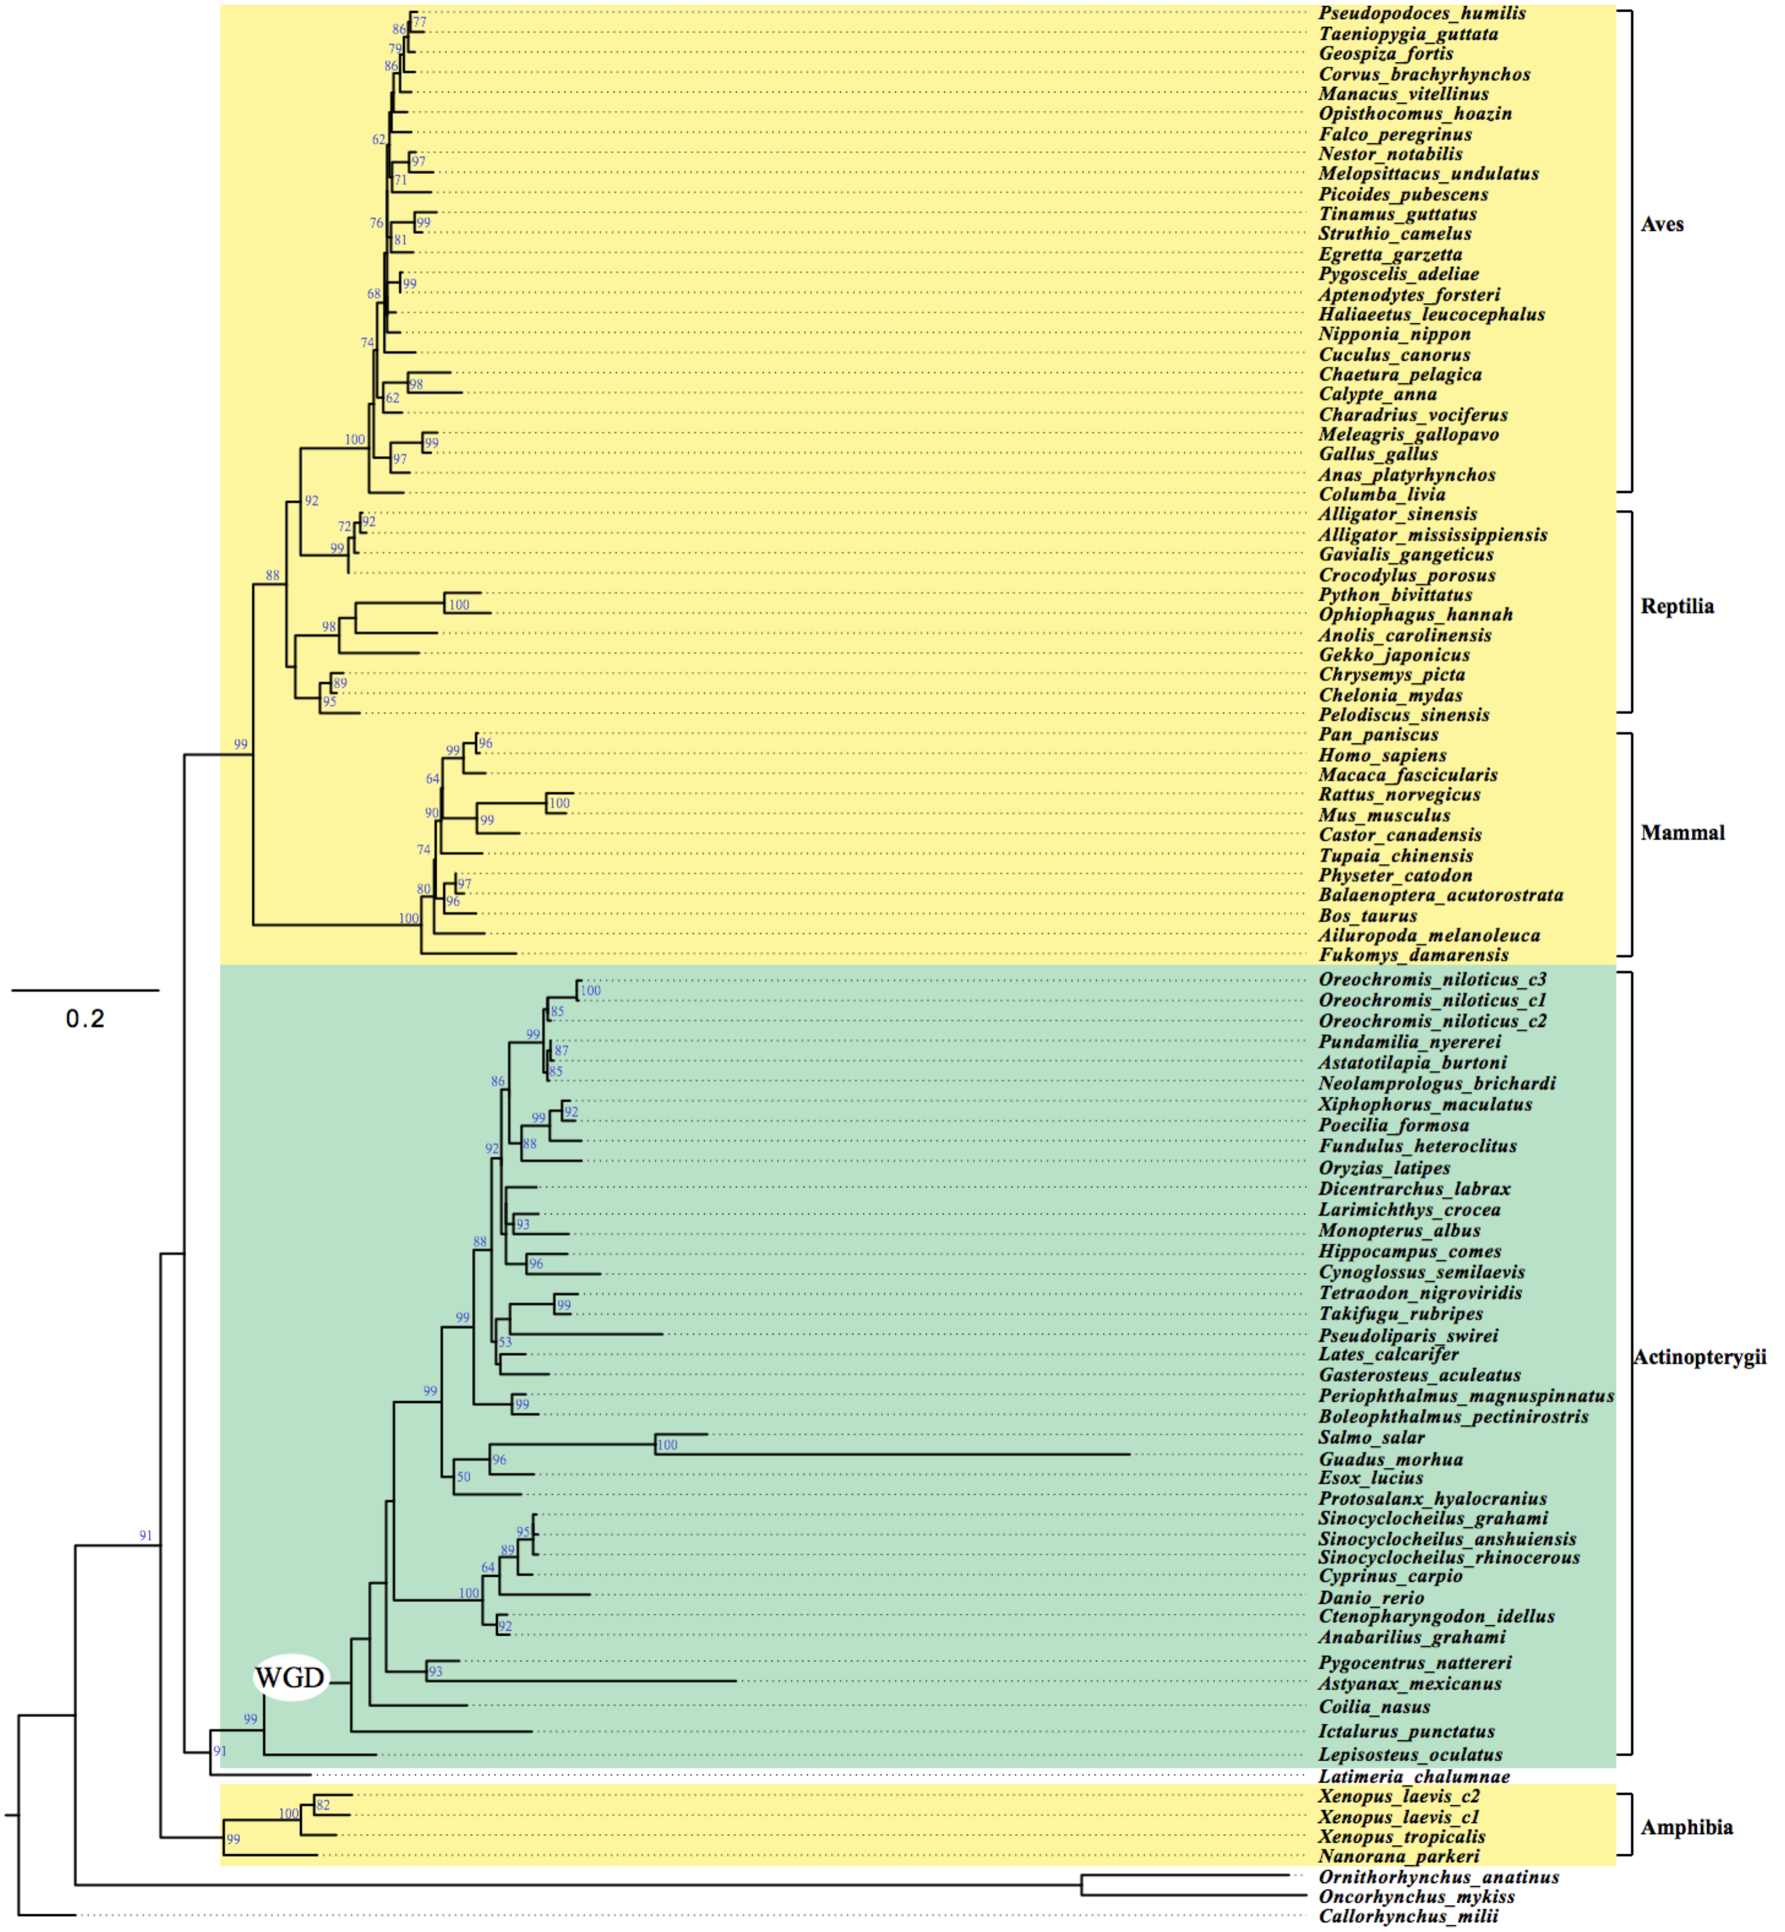

Figure S6. A phylogenetic tree of slc24a5 in various vertebrates. The scale bar denotes substitutions per site. Bootstrap values above 50% were provided at the branches.

