Supplementary Material

Supplementary Table 1: List of all taxa identified in Ramfjord using a metabarcoding approach, and the percentage of sequence reads obtain during each sampling event.
Phylum  Subphylum | Class  Order | Species | Nov | Dec | Jan | Feb | Mar | Apr | May | Jun | Aug | Sep | Sep  _2 | Oct | Nov  2019 | Dec  2019 | Feb  2020
Bryozoa | Gymnolaemata | Membranipora  membranacea | 0.000 | 0.002 | 0.006 | 0.000 | 0.000 | 0.000 | 0.000 | 0.000 | 0.000 | 0.000 | 0.019 | 0.002 | 0.015 | 0.110 | 0.000
Chaetognatha | Sagittoidea | Eukhronia  hamata | 5.218 | 1.091 | 0.006 | 0.007 | 0.246 | 0.001 | 0.003 | 0.001 | 0.135 | 0.000 | 0.383 | 0.000 | 0.000 | 0.000 | 0.000
Chaetognatha | Sagittoidea | Parasagitta  elegans | 20.351 | 23.599 | 16.878 | 0.785 | 0.735 | 0.505 | 1.969 | 4.720 | 10.37 | 7.488 | 18.09 | 4.746 | 0.077 | 6.259 | 0.014
Chlorophyta | Mamiellales | Bathycoccus  prasinos | 0.000 | 0.002 | 0.000 | 0.001 | 0.000 | 0.000 | 0.001 | 0.000 | 0.002 | 0.016 | 0.016 | 0.007 | 0.819 | 0.633 | 0.260
Chordata | Ascidiacea | Ascidiacea  indet | 0.048 | 0.003 | 0.003 | 0.005 | 0.000 | 0.001 | 0.002 | 0.000 | 0.022 | 0.019 | 0.204 | 0.000 | 0.000 | 0.000 | 0.000
Chordata | Ascidiacea | Ascidiella  aspersa | 0.000 | 0.003 | 0.000 | 0.152 | 0.000 | 0.009 | 0.000 | 0.000 | 0.000 | 0.000 | 0.001 | 0.000 | 0.000 | 0.000 | 0.000
Cnidaria | Anthozoa | Actiniaria  indet. | 0.000 | 0.000 | 0.000 | 0.000 | 0.000 | 0.000 | 0.000 | 0.000 | 0.000 | 0.000 | 0.000 | 0.000 | 0.000 | 0.313 | 0.024
Cnidaria | Anthozoa | Urticina  felina | 0.000 | 0.000 | 0.000 | 0.000 | 0.000 | 0.000 | 0.000 | 0.000 | 0.000 | 0.000 | 0.000 | 0.000 | 0.000 | 0.169 | 0.006
Cnidaria | Hydrozoa | Clytia  hemisphaerica | 0.000 | 0.100 | 0.068 | 0.064 | 0.000 | 0.012 | 0.022 | 0.008 | 0.031 | 1.934 | 4.668 | 6.833 | 0.251 | 4.152 | 0.005
Cnidaria | Hydrozoa | Corymorpha  sp. | 0.000 | 0.006 | 0.010 | 0.007 | 0.000 | 0.001 | 0.003 | 0.001 | 0.003 | 0.310 | 0.235 | 0.078 | 0.085 | 0.000 | 0.000
Cnidaria | Hydrozoa | Euphysa  aurata | 0.002 | 0.545 | 0.009 | 0.014 | 0.002 | 0.004 | 0.023 | 0.002 | 0.007 | 0.229 | 0.759 | 0.068 | 0.000 | 0.000 | 0.487
Cnidaria | Hydrozoa | Lizzia  blondina | 0.000 | 0.002 | 0.002 | 0.001 | 0.000 | 0.000 | 0.000 | 0.000 | 0.000 | 0.025 | 0.115 | 0.000 | 0.000 | 0.000 | 0.000
Cnidaria | Hydrozoa | Melicertum  octocostatum | 0.000 | 0.004 | 0.000 | 0.001 | 0.000 | 0.000 | 0.000 | 0.000 | 0.000 | 0.000 | 0.000 | 0.000 | 0.000 | 0.000 | 0.000
Cnidaria | Hydrozoa | Mitrocomella  polydiademata | 0.000 | 0.004 | 0.006 | 0.003 | 0.000 | 0.000 | 0.012 | 0.000 | 0.001 | 0.000 | 0.000 | 0.000 | 0.000 | 0.000 | 0.000
Cnidaria | Hydrozoa | Nanomia  cara | 3.692 | 0.546 | 4.517 | 0.132 | 1.808 | 0.648 | 4.981 | 0.027 | 1.584 | 0.021 | 0.051 | 24.64 | 8.197 | 6.157 | 0.301
Cnidaria | Hydrozoa | Obelia  geniculata | 0.000 | 0.002 | 0.002 | 0.000 | 0.000 | 0.001 | 0.000 | 0.000 | 0.000 | 0.002 | 0.035 | 0.000 | 0.000 | 0.000 | 0.000
Cnidaria | Hydrozoa | Obelia  longissima | 0.000 | 0.000 | 0.000 | 0.001 | 0.000 | 0.000 | 0.007 | 0.000 | 0.000 | 0.000 | 0.011 | 0.000 | 0.000 | 0.000 | 0.000
Cnidaria | Hydrozoa | Plotocnide  borealis | 0.002 | 0.003 | 0.004 | 0.003 | 0.000 | 0.000 | 0.002 | 0.146 | 0.041 | 0.002 | 0.001 | 0.000 | 0.000 | 0.000 | 0.000
Cnidaria | Hydrozoa | Rathkea  octopunctata | 0.000 | 0.000 | 0.000 | 0.000 | 0.000 | 0.000 | 0.000 | 0.000 | 0.000 | 0.000 | 0.000 | 0.001 | 0.124 | 0.164 | 0.000
Cnidaria | Scyphozoa | Aurelia  aurita | 1.474 | 0.069 | 1.073 | 0.011 | 0.004 | 0.004 | 0.638 | 0.001 | 0.005 | 0.101 | 0.142 | 0.001 | 0.011 | 0.000 | 0.000
Cnidaria | Scyphozoa | Cyanea  sp. RUYNKAR | 0.023 | 0.000 | 0.000 | 0.000 | 0.268 | 0.000 | 0.000 | 0.000 | 0.000 | 0.000 | 0.000 | 0.000 | 0.000 | 0.000 | 0.000
Crustacea | Amphipoda | Themisto  abyssorum | 0.000 | 0.004 | 0.007 | 0.007 | 0.000 | 0.001 | 0.001 | 0.001 | 3.194 | 0.090 | 0.033 | 0.000 | 0.026 | 0.000 | 0.000
Crustacea | Cirripedia | Akentrogonida  indet. | 0.000 | 0.011 | 0.176 | 0.202 | 0.000 | 0.006 | 0.000 | 0.000 | 0.000 | 0.000 | 0.000 | 0.000 | 0.000 | 0.000 | 0.000
Crustacea | Cirripedia | Balanus  sp. | 0.005 | 0.074 | 0.083 | 0.068 | 0.205 | 22.23 | 0.132 | 0.005 | 0.131 | 0.019 | 0.023 | 0.004 | 0.003 | 0.003 | 0.007
Crustacea | Cirripedia | Balanus  balanus | 0.000 | 0.153 | 0.196 | 0.167 | 1.365 | 30.83 | 4.346 | 0.009 | 0.799 | 0.047 | 1.628 | 0.000 | 0.007 | 0.007 | 0.000
Crustacea | Cirripedia | Semibalanus  balanoides | 0.000 | 0.000 | 0.000 | 0.001 | 0.000 | 0.130 | 0.011 | 0.000 | 0.001 | 0.000 | 0.000 | 0.000 | 0.000 | 0.000 | 0.000
Crustacea | Cirripedia | Verruca  stroemia | 0.000 | 0.006 | 0.003 | 0.005 | 0.000 | 0.003 | 0.001 | 0.009 | 0.001 | 0.011 | 0.010 | 0.000 | 0.000 | 0.000 | 0.000
Crustacea | Cladocera | Evadne  nordmanni | 0.000 | 0.008 | 0.008 | 0.005 | 0.000 | 0.002 | 0.002 | 0.001 | 0.119 | 0.118 | 0.115 | 0.027 | 0.000 | 0.001 | 0.001
Crustacea | Cladocera | Podon  leuckartii | 0.000 | 0.007 | 0.006 | 0.006 | 0.000 | 0.001 | 0.001 | 0.001 | 0.001 | 0.085 | 0.015 | 0.000 | 0.000 | 0.000 | 0.000
Crustacea | Copepoda | Acartia  longiremis | 2.952 | 1.946 | 7.315 | 3.021 | 4.479 | 0.485 | 2.487 | 5.394 | 14.89 | 33.52 | 8.340 | 4.276 | 5.822 | 8.987 | 2.844
Crustacea | Copepoda | Calanus  finmarchicus | 2.054 | 0.675 | 0.349 | 16.482 | 5.525 | 0.716 | 1.383 | 3.215 | 2.944 | 3.127 | 2.300 | 2.059 | 0.374 | 0.657 | 3.514
Crustacea | Copepoda | Calanus  glacialis | 1.181 | 0.428 | 0.637 | 2.707 | 0.745 | 0.807 | 3.906 | 6.907 | 3.414 | 2.990 | 2.738 | 1.165 | 0.181 | 0.014 | 1.997
Crustacea | Copepoda | Calanus  helgolandicus | 0.167 | 0.425 | 0.072 | 0.000 | 0.005 | 0.000 | 0.000 | 0.000 | 0.000 | 0.004 | 0.008 | 0.102 | 0.049 | 0.097 | 0.220
Crustacea | Copepoda | Calanus  hyperboreus | 1.633 | 0.663 | 0.220 | 0.075 | 0.167 | 0.684 | 4.466 | #### | 11.66 | 0.014 | 0.273 | 0.103 | 0.009 | 0.045 | 0.892
Crustacea | Copepoda | Candacia  armata | 0.150 | 0.055 | 0.140 | 0.000 | 0.000 | 0.000 | 0.000 | 0.000 | 0.000 | 0.000 | 0.000 | 0.216 | 0.073 | 0.213 | 0.001
Crustacea | Copepoda | Centropages  hamatus | 0.000 | 0.009 | 0.017 | 0.005 | 0.000 | 0.001 | 0.002 | 0.000 | 0.003 | 0.080 | 0.208 | 0.176 | 0.052 | 0.000 | 0.000
Crustacea | Copepoda | Centropages  typicus | 0.030 | 0.000 | 0.000 | 0.000 | 0.001 | 0.000 | 0.000 | 0.000 | 0.000 | 0.000 | 0.000 | 0.231 | 0.069 | 0.009 | 0.001
Crustacea | Copepoda | Cyclopoida  indet. | 0.465 | 0.182 | 0.065 | 0.230 | 0.312 | 0.002 | 0.000 | 0.001 | 0.000 | 0.002 | 0.015 | 0.000 | 0.000 | 0.000 | 0.000
Crustacea | Copepoda | Diaixis  hibernica | 0.008 | 0.000 | 0.017 | 0.342 | 0.033 | 0.000 | 0.009 | 0.000 | 0.000 | 0.000 | 0.000 | 0.000 | 0.000 | 0.000 | 0.000
Crustacea | Copepoda | Harpacticoida  indet | 0.240 | 0.176 | 0.657 | 1.216 | 0.298 | 0.002 | 0.588 | 0.001 | 0.002 | 0.020 | 0.001 | 0.000 | 0.000 | 0.000 | 0.000
Crustacea | Copepoda | Longipedia  coronata | 0.014 | 0.004 | 0.265 | 0.000 | 0.000 | 0.000 | 0.000 | 0.003 | 0.000 | 0.007 | 0.016 | 0.013 | 0.003 | 0.004 | 0.000
Crustacea | Copepoda | Metridia  longa | 0.285 | 0.627 | 0.198 | 0.136 | 0.098 | 0.012 | 0.508 | 0.140 | 0.126 | 0.156 | 0.040 | 0.077 | 0.016 | 0.017 | 0.161
Crustacea | Copepoda | Metridia  lucens | 0.186 | 0.825 | 0.058 | 0.067 | 0.004 | 0.013 | 0.098 | 0.125 | 0.224 | 0.110 | 0.702 | 0.652 | 0.476 | 0.640 | 0.428
Crustacea | Copepoda | Microcalanus  pusillus | 5.653 | 8.236 | 12.789 | 17.044 | 10.762 | 1.383 | 3.756 | #### | 8.149 | 16.60 | 4.428 | 4.918 | 1.605 | 1.098 | 20.759
Crustacea | Copepoda | Microsetella  norvegica | 0.156 | 0.013 | 0.180 | 0.024 | 0.189 | 0.000 | 0.000 | 0.000 | 0.000 | 0.000 | 0.000 | 0.000 | 0.000 | 0.000 | 0.000
Crustacea | Copepoda | Oithona  similis | 9.355 | 4.604 | 4.624 | 1.455 | 4.590 | 0.296 | 0.324 | 0.882 | 3.292 | 8.030 | 7.393 | 5.779 | 16.575 | 9.183 | 11.982
Crustacea | Copepoda | Triconia  borealis | 0.187 | 0.106 | 0.250 | 0.051 | 0.062 | 0.001 | 0.074 | 0.058 | 0.025 | 0.019 | 0.005 | 0.007 | 0.007 | 0.001 | 0.007
Crustacea | Copepoda | Paracalanus  parvus | 1.352 | 2.418 | 3.986 | 0.211 | 0.054 | 0.004 | 0.007 | 0.004 | 0.287 | 0.033 | 1.994 | 2.533 | 3.431 | 2.800 | 0.049
Crustacea | Copepoda | Paraeuchaeta  norvegica | 0.031 | 0.002 | 0.026 | 0.013 | 0.004 | 0.004 | 0.022 | 0.110 | 0.000 | 0.001 | 0.000 | 0.000 | 0.000 | 0.000 | 0.000
Crustacea | Copepoda | Pseudocalanus  acuspes | 7.133 | 4.460 | 7.409 | 30.569 | 15.107 | 5.341 | ##### | #### | 21.526 | 20.173 | 16.905 | 9.715 | 16.088 | 11.851 | 20.553
Crustacea | Copepoda | Pseudocalanus  elongatus | 3.614 | 3.036 | 3.250 | 0.770 | 1.076 | 0.069 | 0.026 | 0.035 | 0.016 | 0.012 | 1.535 | 2.975 | 5.703 | 7.512 | 6.344
Crustacea | Copepoda | Pseudocalanus  mimus | 0.000 | 0.080 | 0.158 | 0.032 | 0.000 | 0.012 | 0.265 | 0.026 | 0.042 | 0.040 | 0.074 | 0.039 | 0.059 | 0.020 | 0.063
Crustacea | Copepoda | Pseudocalanus  minutus | 1.588 | 0.434 | 1.237 | 1.099 | 0.467 | 0.032 | 0.107 | 0.109 | 0.042 | 0.182 | 0.082 | 20.108 | 15.357 | 12.085 | 19.566
Crustacea | Copepoda | Pseudocalanus  moultoni | 3.599 | 3.972 | 4.743 | 2.666 | 1.655 | 0.284 | 1.174 | 1.117 | 0.756 | 1.263 | 3.197 | 5.563 | 12.784 | 8.570 | 4.639
Crustacea | Copepoda | Temora  longicornis | 1.490 | 0.305 | 1.588 | 0.036 | 0.469 | 0.009 | 0.039 | 0.027 | 0.196 | 0.516 | 7.797 | 1.164 | 0.056 | 0.162 | 0.016
Crustacea | Decapoda |  | 0.013 | 0.000 | 0.000 | 0.000 | 0.237 | 0.000 | 0.000 | 0.000 | 0.000 | 0.000 | 0.000 | 0.000 | 0.000 | 0.000 | 0.000
Crustacea | Decapoda | Eualus  pusiolus | 0.000 | 0.003 | 0.002 | 0.004 | 0.000 | 0.034 | 0.001 | 0.000 | 0.416 | 0.001 | 0.000 | 0.000 | 0.000 | 0.000 | 0.000
Crustacea | Decapoda | Hyas  coarctatus | 0.000 | 0.002 | 0.002 | 0.003 | 0.000 | 0.001 | 0.360 | 0.001 | 0.001 | 0.000 | 0.001 | 0.000 | 0.000 | 0.000 | 0.000
Crustacea | Decapoda | Munida  sarsi | 0.000 | 0.008 | 0.006 | 0.010 | 0.000 | 0.002 | 0.002 | 0.001 | 4.320 | 0.002 | 0.002 | 0.000 | 0.000 | 0.000 | 0.000
Crustacea | Decapoda | Pagurus  pubescens | 0.000 | 0.008 | 0.006 | 0.007 | 0.000 | 0.163 | 0.725 | 0.050 | 0.002 | 0.001 | 0.002 | 0.000 | 0.000 | 0.000 | 0.000
Crustacea | Decapoda | Pandalus  borealis | 1.866 | 0.000 | 0.000 | 0.000 | 16.496 | 0.000 | 0.000 | 0.000 | 0.000 | 0.000 | 0.000 | 0.000 | 0.000 | 0.000 | 0.000
Crustacea | Decapoda | Pandalus  sp. | 0.019 | 0.000 | 0.000 | 0.000 | 0.327 | 0.000 | 0.000 | 0.000 | 0.000 | 0.000 | 0.000 | 0.000 | 0.000 | 0.000 | 0.000
Crustacea | Decapoda | Sabinea  septemcarinata | 0.000 | 0.001 | 0.002 | 0.001 | 0.000 | 0.189 | 0.000 | 0.000 | 0.001 | 0.000 | 0.001 | 0.000 | 0.000 | 0.000 | 0.000
Crustacea | Euphausiacea | Thysanoessa  inermis | 1.363 | 25.862 | 0.520 | 0.026 | 0.108 | 1.702 | 0.131 | 0.333 | 0.008 | 0.014 | 0.011 | 0.003 | 0.003 | 0.064 | 0.004
Crustacea | Euphausiacea | Thysanoessa  raschii | 6.479 | 0.012 | 2.266 | 0.012 | 0.014 | 0.278 | 0.024 | 0.028 | 0.005 | 0.041 | 0.004 | 0.000 | 0.000 | 0.000 | 0.000
Crustacea | Euphausiacea | Meganyctiphanes  norvegica | 0.004 | 0.095 | 0.053 | 0.122 | 0.062 | 0.069 | 0.038 | 0.007 | 0.024 | 0.005 | 7.829 | 0.000 | 0.000 | 0.000 | 0.000
Crustacea | Isopoda |  | 0.016 | 0.150 | 0.310 | 0.000 | 0.007 | 0.014 | 0.014 | 0.000 | 0.000 | 0.000 | 0.055 | 0.050 | 0.025 | 0.014 | 0.072
Ctenophora | Ctenophora | Ctenophora  indet. | 0.814 | 4.058 | 0.306 | 0.023 | 0.706 | 0.209 | 0.402 | #### | 0.054 | 0.083 | 0.025 | 0.002 | 0.029 | 0.134 | 0.040
Curstacea | Copepoda | Longipedia  sp. | 0.026 | 0.004 | 0.029 | 0.004 | 0.000 | 0.001 | 0.001 | 0.001 | 0.003 | 0.005 | 0.118 | 0.046 | 0.003 | 0.000 | 0.000
Echinoderm | Echinoidea | Strongylocentrotus  droebachiensis | 0.000 | 0.045 | 0.062 | 0.037 | 0.119 | 4.572 | 0.042 | 0.193 | 0.025 | 0.011 | 0.009 | 0.000 | 0.000 | 0.000 | 0.000
Echinoderm | Echinoidea | Strongylocentrotus  pallidus | 0.000 | 0.000 | 0.000 | 0.000 | 1.344 | 0.000 | 0.000 | 0.000 | 0.000 | 0.000 | 0.000 | 0.000 | 0.000 | 0.000 | 0.000
Echinodermata | Asteroidea | Asterias  rubens | 0.000 | 0.021 | 0.023 | 0.024 | 0.000 | 0.006 | 0.005 | 0.225 | 0.587 | 1.074 | 0.203 | 0.000 | 0.000 | 0.000 | 0.000
Echinodermata | Asteroidea | Ctenodiscus  australis | 0.118 | 0.010 | 0.114 | 0.251 | 1.566 | 0.043 | 0.001 | 0.000 | 0.000 | 0.001 | 0.001 | 0.000 | 0.000 | 0.000 | 0.016
Echinodermata | Asteroidea | Solaster  endeca | 0.000 | 0.003 | 0.006 | 0.005 | 0.000 | 0.673 | 0.001 | 0.000 | 0.002 | 0.001 | 0.002 | 0.000 | 0.000 | 0.000 | 0.000
Echinodermata | Echinoidea | Echinocardium  cordatum | 0.000 | 0.004 | 0.003 | 0.004 | 0.000 | 0.001 | 0.001 | 0.001 | 0.002 | 0.001 | 0.042 | 0.000 | 0.000 | 0.000 | 0.000
Echinodermata | Echinoidea | Echinus  esculentus | 0.000 | 0.000 | 0.000 | 0.001 | 0.000 | 0.000 | 0.000 | 0.000 | 0.000 | 0.000 | 0.000 | 0.000 | 0.000 | 0.000 | 0.000
Echinodermata | Holothuroidea | Cucumaria  frondosa | 0.000 | 0.038 | 0.056 | 0.039 | 0.000 | 9.397 | 0.008 | 0.003 | 0.029 | 0.014 | 0.013 | 0.000 | 0.000 | 0.000 | 0.000
Echinodermata | Holothuroidea | Labidoplax  buskii | 0.446 | 0.381 | 0.755 | 0.030 | 0.002 | 0.000 | 0.000 | 0.000 | 0.000 | 0.000 | 0.000 | 0.000 | 0.001 | 0.077 | 0.000
Echinodermata | Holothuroidea | Thyonidium  drummondii | 0.000 | 0.009 | 0.008 | 0.005 | 0.000 | 0.559 | 0.001 | 0.001 | 0.006 | 0.002 | 0.001 | 0.000 | 0.000 | 0.000 | 0.000
Echinodermata | Ophiuroidea | Ophiocten  affinis | 0.000 | 0.001 | 0.000 | 0.001 | 0.000 | 0.000 | 0.000 | 0.009 | 0.000 | 0.000 | 0.008 | 0.000 | 0.000 | 0.000 | 0.000
Echinodermata | Ophiuroidea | Ophiopholis  aculeata | 0.003 | 0.035 | 0.028 | 0.035 | 0.047 | 0.021 | 0.021 | 0.803 | 0.014 | 0.013 | 0.005 | 0.001 | 0.006 | 0.002 | 0.001
Echinodermata | Ophiuroidea | Ophiura  albida | 0.000 | 0.003 | 0.002 | 0.001 | 0.000 | 0.001 | 0.001 | 0.007 | 0.000 | 0.014 | 0.021 | 0.000 | 0.000 | 0.000 | 0.000
Echinodermata | Ophiuroidea | Ophiura  robusta | 0.006 | 0.002 | 0.003 | 0.002 | 0.045 | 0.001 | 0.002 | 0.148 | 0.001 | 0.002 | 0.000 | 0.000 | 0.000 | 0.000 | 0.000
Haptophyta | Prymnesiophyceae | Phaeocystis  spp. | 0.000 | 0.096 | 0.085 | 0.078 | 0.000 | 3.238 | ##### | 0.036 | 0.045 | 0.016 | 0.021 | 0.019 | 0.312 | 0.253 | 0.045
Mollusc | Polyplacophora | Tonicella  marmorea | 0.000 | 0.000 | 0.000 | 0.000 | 0.000 | 0.000 | 0.000 | 0.000 | 0.000 | 0.000 | 0.000 | 0.000 | 0.037 | 0.234 | 0.000
Mollusca | Bivalvia | Hiatella  sp. | 0.010 | 0.008 | 0.004 | 0.015 | 0.150 | 0.002 | 0.001 | 0.004 | 0.001 | 0.002 | 0.001 | 0.004 | 0.009 | 0.010 | 0.004
Mollusca | Gastropoda | Aporrhais  pespelecani | 0.000 | 0.000 | 0.000 | 0.001 | 0.000 | 0.000 | 0.000 | 0.005 | 0.000 | 0.000 | 0.003 | 0.000 | 0.000 | 0.000 | 0.000
Mollusca | Gastropoda | Eubranchus  exiguus | 0.102 | 0.009 | 0.027 | 0.122 | 0.041 | 0.000 | 0.000 | 0.000 | 0.000 | 0.000 | 0.000 | 0.000 | 0.000 | 0.000 | 0.000
Mollusca | Gastropoda | Lacuna  vincta | 0.000 | 0.000 | 0.000 | 0.000 | 0.000 | 0.000 | 0.007 | 0.001 | 0.001 | 0.000 | 0.024 | 0.000 | 0.000 | 0.000 | 0.000
Mollusca | Gastropoda | Limapontia  capitata | 0.004 | 0.000 | 0.000 | 0.000 | 0.408 | 0.000 | 0.000 | 0.000 | 0.000 | 0.000 | 0.000 | 0.000 | 0.000 | 0.000 | 0.000
Mollusca | Gastropoda | Microchlamylla  gracilis | 0.001 | 0.012 | 0.002 | 0.000 | 0.012 | 0.001 | 0.000 | 0.000 | 0.120 | 0.020 | 0.010 | 0.003 | 0.030 | 0.193 | 0.019
Mollusca | Gastropoda | Oenopota  sp. | 0.000 | 0.000 | 0.002 | 0.000 | 0.811 | 0.129 | 0.001 | 0.000 | 0.000 | 0.001 | 0.000 | 0.000 | 0.000 | 0.000 | 0.000
mollusca | Gastropoda | Placida  dendritica | 0.006 | 0.015 | 0.000 | 0.000 | 0.028 | 0.003 | 0.018 | 0.000 | 0.000 | 0.000 | 0.000 | 0.000 | 0.043 | 0.174 | 0.154
Mollusca | Gastropoda | Velutina  velutina | 0.000 | 0.000 | 0.000 | 0.000 | 0.216 | 0.011 | 0.005 | 0.000 | 0.000 | 0.000 | 0.000 | 0.000 | 0.000 | 0.000 | 0.000
Mollusca | Gastropoda |  | 0.000 | 0.000 | 0.000 | 0.000 | 0.000 | 0.000 | 0.000 | 0.000 | 0.000 | 0.000 | 0.000 | 0.000 | 0.058 | 0.219 | 0.024
Nematoda |  |  | 0.003 | 0.225 | 0.002 | 0.001 | 0.001 | 0.008 | 0.072 | 0.095 | 0.001 | 0.000 | 0.000 | 0.000 | 0.000 | 0.000 | 0.000
Nemertea |  | Malacobdella  grossa | 0.001 | 0.008 | 0.012 | 0.634 | 0.379 | 1.577 | 0.014 | 0.015 | 0.005 | 0.002 | 0.125 | 0.000 | 0.000 | 0.000 | 0.000
Nemertea |  | Micrura  varicolor | 0.002 | 0.000 | 0.000 | 0.034 | 0.536 | 0.001 | 0.000 | 0.000 | 0.000 | 0.000 | 0.000 | 0.000 | 0.000 | 0.000 | 0.000
Ochrphyta | Dinophyceae indet. | Chaetoceros  spp. | 0.000 | 0.012 | 0.011 | 0.008 | 0.000 | 0.002 | 0.021 | 0.004 | 0.010 | 0.026 | 0.452 | 0.000 | 0.000 | 0.000 | 0.000
Ochrphyta |  |  | 0.005 | 0.101 | 0.056 | 0.104 | 0.022 | 0.057 | 0.579 | 0.134 | 0.033 | 0.011 | 0.059 | 0.031 | 0.106 | 0.066 | 0.023
Pices | Pleuronectiformes | Hippoglossoides  platessoides | 0.000 | 0.004 | 0.007 | 0.004 | 0.000 | 0.203 | 0.001 | 0.001 | 0.002 | 0.001 | 0.001 | 0.000 | 0.000 | 0.000 | 0.000
Pices | Gadiformes | Melanogrammus  aeglefinus | 0.010 | 0.000 | 0.000 | 0.000 | 0.130 | 0.000 | 0.000 | 0.000 | 0.000 | 0.000 | 0.000 | 0.000 | 0.000 | 0.000 | 0.000
Pices | Pleuronectiforme | Microstomus  kitt | 0.000 | 0.003 | 0.000 | 0.002 | 0.000 | 0.000 | 0.000 | 0.000 | 0.000 | 0.000 | 0.000 | 0.000 | 0.000 | 0.000 | 0.000
Plathyhelminthes |  |  | 0.016 | 0.000 | 0.000 | 0.000 | 0.283 | 0.000 | 0.000 | 0.000 | 0.000 | 0.000 | 0.000 | 0.000 | 0.000 | 0.000 | 0.000
Polychaeta | Amphinomida | Paramphinome  jeffreysii | 0.002 | 0.000 | 0.000 | 0.025 | 0.267 | 0.004 | 0.006 | 0.011 | 0.001 | 0.000 | 0.000 | 0.000 | 0.000 | 0.000 | 0.000
Polychaeta | Capitellida | Capitella  capitata | 0.233 | 0.189 | 0.356 | 0.069 | 0.048 | 0.000 | 0.000 | 0.000 | 0.000 | 0.000 | 0.000 | 0.000 | 0.000 | 0.000 | 0.000
Polychaeta | Capitellida | Capitellida | 0.585 | 0.000 | 0.000 | 0.000 | 0.004 | 0.000 | 0.000 | 0.000 | 0.000 | 0.000 | 0.000 | 0.000 | 0.000 | 0.000 | 0.000
Polychaeta | Eunicida indet. | Eunicida  indet. | 0.000 | 0.000 | 0.000 | 0.000 | 0.000 | 0.000 | 0.000 | 0.000 | 0.000 | 0.000 | 0.000 | 0.023 | 0.009 | 0.216 | 0.000
Polychaeta | Eunicida | Dorvilleidae  indet. | 0.093 | 0.000 | 0.112 | 0.000 | 0.001 | 0.000 | 0.000 | 0.000 | 0.000 | 0.000 | 0.000 | 0.000 | 0.000 | 0.000 | 0.000
Polychaeta | Eunicida | Nothria  conchylega CMC02 | 0.003 | 0.012 | 0.081 | 0.009 | 0.025 | 0.002 | 0.004 | 0.071 | 0.551 | 0.261 | 0.141 | 0.000 | 0.000 | 0.000 | 0.000
Polychaeta | Maldanidae | Euclymene  zonalis | 0.000 | 0.097 | 0.195 | 0.000 | 0.000 | 0.000 | 0.000 | 0.000 | 0.000 | 0.000 | 0.000 | 0.000 | 0.000 | 0.000 | 0.000
Polychaeta | Orbiniidae | Scoloplos  armiger | 0.008 | 0.009 | 0.022 | 0.012 | 0.116 | 0.145 | 0.009 | 0.000 | 0.004 | 0.001 | 0.001 | 0.000 | 0.000 | 0.000 | 0.000
Polychaeta | Phyllodocida | Phyllodocida | 0.000 | 0.075 | 0.271 | 0.001 | 0.000 | 0.018 | 0.020 | 0.000 | 0.000 | 0.000 | 0.000 | 0.000 | 0.000 | 0.000 | 0.000
Polychaeta | Phyllodocida | Aglaophamus  malmgreni | 0.134 | 0.126 | 0.406 | 0.000 | 0.002 | 0.000 | 0.000 | 0.000 | 0.000 | 0.000 | 0.000 | 0.047 | 0.111 | 0.052 | 0.001
Polychaeta | Phyllodocida | Antinoella  finmarchica | 0.113 | 0.000 | 0.000 | 0.000 | 0.000 | 0.000 | 0.000 | 0.000 | 0.000 | 0.000 | 0.000 | 0.000 | 0.000 | 0.000 | 0.000
Polychaeta | Phyllodocida | Bylgides  sarsi | 0.000 | 0.000 | 0.000 | 0.000 | 0.359 | 0.000 | 0.000 | 0.000 | 0.000 | 0.000 | 0.000 | 0.000 | 0.000 | 0.000 | 0.000
Polychaeta | Phyllodocida | Gyptis  mackiei | 0.002 | 0.000 | 0.000 | 1.036 | 0.041 | 0.000 | 0.000 | 0.000 | 0.000 | 0.000 | 0.000 | 0.000 | 0.000 | 0.000 | 0.000
Polychaeta | Phyllodocida | Harmothoe  sarsi | 0.000 | 0.000 | 0.000 | 0.000 | 0.000 | 0.000 | 0.111 | 0.000 | 0.000 | 0.000 | 0.000 | 0.000 | 0.000 | 0.000 | 0.000
Polychaeta | Phyllodocida | Harmothoe  sp. CMC01 | 0.000 | 0.003 | 0.023 | 0.002 | 0.107 | 0.000 | 0.001 | 0.000 | 0.000 | 0.000 | 0.061 | 0.005 | 0.152 | 0.019 | 0.000
Polychaeta | Phyllodocida | Lepidonotus  squamatus | 0.000 | 0.002 | 0.002 | 0.002 | 0.000 | 0.000 | 0.000 | 0.000 | 0.000 | 0.000 | 0.000 | 0.000 | 0.000 | 0.000 | 0.000
Polychaeta | Phyllodocida | Nereimyra  punctata | 0.000 | 0.001 | 0.000 | 0.002 | 0.118 | 0.001 | 0.045 | 0.000 | 0.000 | 0.000 | 0.000 | 0.000 | 0.000 | 0.000 | 0.000
Polychaeta | Phyllodocida | Pholoe  baltica | 0.000 | 0.003 | 0.003 | 0.004 | 0.000 | 0.001 | 0.002 | 0.149 | 0.006 | 0.001 | 0.002 | 0.000 | 0.000 | 0.000 | 0.000
Polychaeta | Phyllodocida | Phyllodoce  grenlandica | 0.022 | 0.000 | 0.003 | 0.866 | 2.949 | 0.031 | 0.380 | 0.000 | 0.001 | 0.000 | 0.000 | 0.000 | 0.000 | 0.000 | 0.000
Polychaeta | Phyllodocida | Phyllodoce  sp. | 0.056 | 0.000 | 0.000 | 0.785 | 0.530 | 0.005 | 0.000 | 0.000 | 0.000 | 0.000 | 0.000 | 0.000 | 0.000 | 0.000 | 0.000
Polychaeta | Phyllodocida | Tomopteris  sp. | 0.634 | 0.003 | 0.198 | 0.004 | 0.002 | 0.132 | 0.633 | 0.000 | 0.001 | 0.001 | 0.001 | 0.054 | 0.070 | 0.000 | 0.649
Polychaeta | Sabellida | Hydroides  elegans | 0.000 | 0.000 | 0.000 | 0.000 | 0.000 | 0.000 | 0.000 | 0.000 | 0.000 | 0.000 | 0.000 | 0.000 | 0.114 | 0.000 | 0.000
Polychaeta | Sabellida | Sabellida | 0.020 | 0.415 | 0.663 | 0.000 | 0.001 | 0.000 | 0.000 | 0.000 | 0.000 | 0.000 | 0.000 | 0.000 | 0.000 | 0.000 | 0.000
Polychaeta | Scalibregmatidae | Scalibregma  inflatum | 0.002 | 0.000 | 0.000 | 0.000 | 0.161 | 0.000 | 0.000 | 0.000 | 0.000 | 0.000 | 0.000 | 0.000 | 0.000 | 0.000 | 0.000
Polychaeta | Spionida | Spionida | 0.000 | 0.002 | 0.003 | 0.007 | 0.000 | 0.184 | 0.000 | 0.000 | 0.002 | 0.001 | 0.001 | 0.000 | 0.000 | 0.000 | 0.000
Polychaeta | Spionida | Spionidae  indet | 0.007 | 2.823 | 5.858 | 0.108 | 6.580 | 11.066 | 0.349 | 0.160 | 0.085 | 0.041 | 0.040 | 0.057 | 2.347 | 8.664 | 0.048
Polychaeta | Spionida | Laonice  cirrata | 0.003 | 0.000 | 0.496 | 0.001 | 0.005 | 0.000 | 0.001 | 0.000 | 0.000 | 0.000 | 0.089 | 0.178 | 0.002 | 0.000 | 0.001
Polychaeta | Spionida | Scolelepis  sp. | 0.001 | 0.002 | 0.005 | 0.002 | 0.407 | 0.202 | 0.001 | 0.000 | 0.001 | 0.001 | 0.001 | 0.000 | 0.000 | 0.000 | 0.000
Polychaeta | Spionida | Spio  sp. | 0.000 | 0.000 | 0.000 | 0.000 | 0.528 | 0.000 | 0.000 | 0.000 | 0.000 | 0.000 | 0.000 | 0.000 | 0.000 | 0.000 | 0.000
Polychaeta | Spionida | Spiophanes  kroyeri | 0.004 | 0.161 | 0.019 | 0.000 | 0.037 | 0.000 | 0.000 | 0.000 | 0.000 | 0.000 | 0.000 | 0.000 | 0.000 | 0.014 | 0.000
Polychaeta | Spionida | Spiophanes  sp. | 0.116 | 0.159 | 0.319 | 0.000 | 0.016 | 0.000 | 0.000 | 0.000 | 0.000 | 0.000 | 0.000 | 0.000 | 0.000 | 0.000 | 0.000
Polychaeta | Terebellida | Ampharete  finmarchica | 0.002 | 0.000 | 0.129 | 0.000 | 0.003 | 0.000 | 0.000 | 0.000 | 0.000 | 0.000 | 0.000 | 0.000 | 0.000 | 0.000 | 0.000
Polychaeta | Terebellida | Amphitrite  cirrata | 0.004 | 0.000 | 0.000 | 0.122 | 3.264 | 0.061 | 0.000 | 0.000 | 0.001 | 0.000 | 0.000 | 0.000 | 0.000 | 0.000 | 0.000
Polychaeta | Terebellida | Chaetozone  setosa | 0.016 | 0.002 | 0.009 | 1.075 | 0.035 | 0.001 | 0.001 | 0.000 | 0.001 | 0.001 | 0.004 | 0.000 | 0.000 | 0.000 | 0.028
Polychaeta | Terebellida | Flabelligera  affinis | 0.045 | 0.000 | 0.000 | 0.000 | 0.374 | 0.000 | 0.000 | 0.000 | 0.000 | 0.000 | 0.000 | 0.000 | 0.000 | 0.000 | 0.000
Polychaeta | Terebellida | Lanassa  venusta | 0.000 | 0.000 | 0.000 | 0.110 | 0.001 | 0.000 | 0.000 | 0.000 | 0.000 | 0.000 | 0.000 | 0.000 | 0.000 | 0.000 | 0.000
Polychaeta | Terebellida | Neoamphitrite  grayi | 0.001 | 0.000 | 0.002 | 1.314 | 0.002 | 0.000 | 0.000 | 0.000 | 0.000 | 0.000 | 0.001 | 0.000 | 0.000 | 0.000 | 0.000
Polychaeta | Terebellida | Pectinaria  koreni | 0.000 | 0.003 | 0.000 | 0.000 | 0.000 | 0.001 | 0.000 | 0.008 | 0.606 | 0.002 | 0.019 | 0.000 | 0.000 | 0.000 | 0.000
Polychaeta | Terebellida | Pista  maculata | 0.000 | 0.000 | 0.000 | 0.365 | 0.000 | 0.000 | 0.000 | 0.000 | 0.000 | 0.000 | 0.000 | 0.000 | 0.000 | 0.000 | 0.000
Polychaeta | Terebellida | Polycirrus  medusa | 0.001 | 0.066 | 0.000 | 1.426 | 0.000 | 0.000 | 0.000 | 0.000 | 0.000 | 0.000 | 0.000 | 0.000 | 0.000 | 0.000 | 0.000
Polychaeta | Terebellida | Polycirrus  sp. | 0.083 | 0.000 | 0.000 | 0.179 | 0.270 | 0.000 | 0.000 | 0.000 | 0.000 | 0.000 | 0.000 | 0.000 | 0.000 | 0.000 | 0.000
Polychaeta | Terebellida | Terebellida | 0.079 | 0.442 | 0.029 | 0.000 | 0.001 | 0.000 | 0.000 | 0.000 | 0.000 | 0.000 | 0.000 | 0.000 | 0.000 | 0.022 | 0.004
Polychaete | Maldanidae | Maldane  sarsi | 0.000 | 0.000 | 0.502 | 0.000 | 0.000 | 0.000 | 0.000 | 0.000 | 0.000 | 0.000 | 0.000 | 0.000 | 0.102 | 0.014 | 0.000
Polychaete | Phyllodocida | Eunoe  oerstedi | 0.000 | 0.000 | 0.000 | 0.000 | 0.144 | 0.000 | 0.000 | 0.000 | 0.000 | 0.000 | 0.000 | 0.000 | 0.000 | 0.000 | 0.000
Polychaete | Terebellida | Melinna  elisabethae | 0.000 | 0.124 | 0.000 | 0.000 | 0.001 | 0.000 | 0.000 | 0.000 | 0.000 | 0.000 | 0.000 | 0.000 | 0.000 | 0.000 | 0.000
Polychaete | Terebellida | Terebellidae  indet. | 0.002 | 0.187 | 0.000 | 0.215 | 0.002 | 0.000 | 0.000 | 0.000 | 0.000 | 0.000 | 0.000 | 0.000 | 0.000 | 0.000 | 0.000
Polychaete | Terebellida | Thelepus  cincinnatus | 0.166 | 0.048 | 0.454 | 1.100 | 0.248 | 0.000 | 0.000 | 0.000 | 0.000 | 0.000 | 0.000 | 0.000 | 0.003 | 0.017 | 0.000
Pyrrophycophyta |  |  | 0.000 | 0.659 | 1.938 | 1.284 | 0.000 | 0.004 | 0.065 | 0.025 | 0.149 | 0.016 | 0.411 | 0.000 | 0.000 | 0.000 | 0.000
Pyrrophycophyta | Bacillariophyceae | Dinophyceae  indet. | 0.000 | 1.330 | 2.948 | 3.365 | 0.000 | 0.022 | 0.052 | 0.285 | 0.327 | 0.181 | 2.253 | 0.492 | 3.183 | 3.506 | 2.256
Rotifera | Ploima |  | 0.000 | 0.007 | 0.013 | 0.007 | 0.033 | 0.001 | 0.019 | 0.729 | 0.006 | 0.001 | 0.001 | 0.003 | 0.010 | 0.017 | 0.005

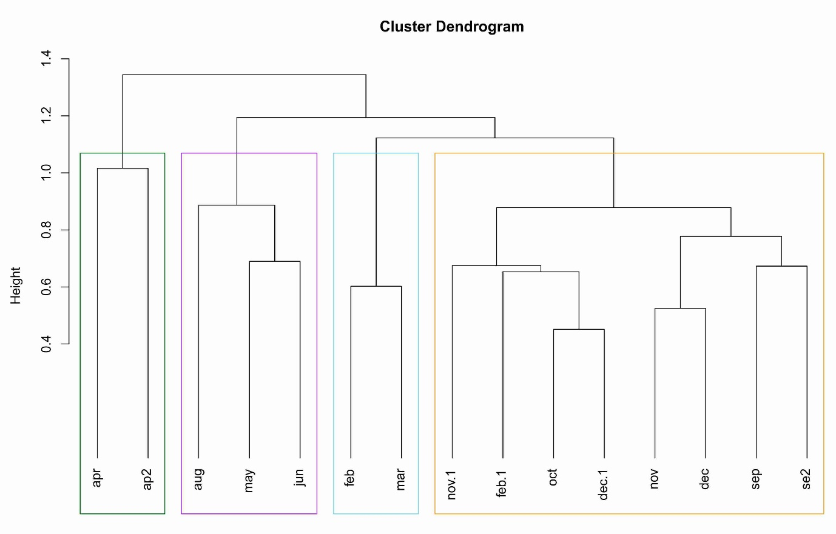Supplementary Figure 1: Cluster dendrogram (based on chi-square distances) based on abundance of zooplankton derived from morphological analysis. Distinct assemblages are frame in different colours: light blue for winter cluster, orange for the autumn/ winter cluster, dark blue for the spring/summer cluster and the green frame for the spring bloom.

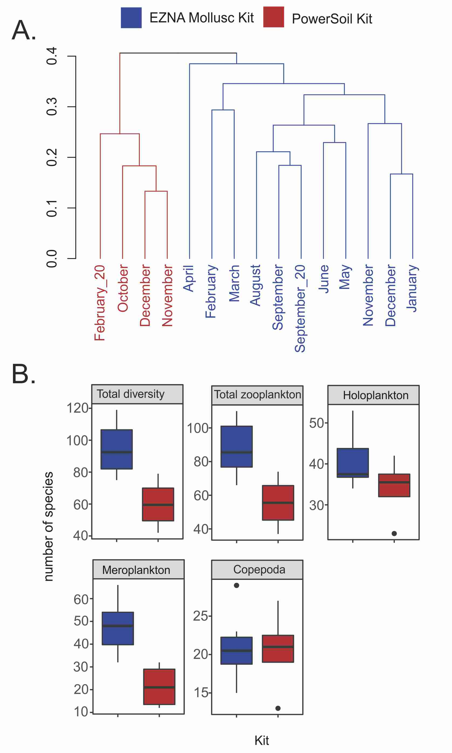
supplementary Figure 2: Effect of the extraction kit on the diversity. (A) Results of cluster analysis (fourth root transformed relative read counts, Bray-Curtis similarity). Blue - EZNA Mollusc extraction Kit; red - PowerSoil DNA extraction kit. (B) The average number of taxa detected using the EZNA Mollusc DNA extraction kit (blue) vs. the PowerSoil DNA extraction kit (red), for all organisms, zooplankton, holoplankton, meroplankton and the Copepoda.
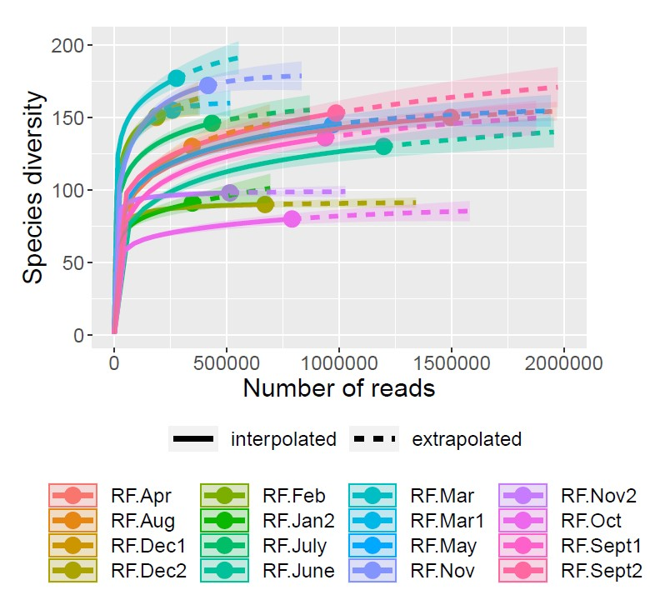
Supplementary Figure 3: Rarefaction plot showing effective species richness (Hill number of order 0) obtained using R package iNEXT. Saturation plateaus are achieved for most of the sampling events with the used sequencing depth. So, species richness estimations can be directly compared.
.

