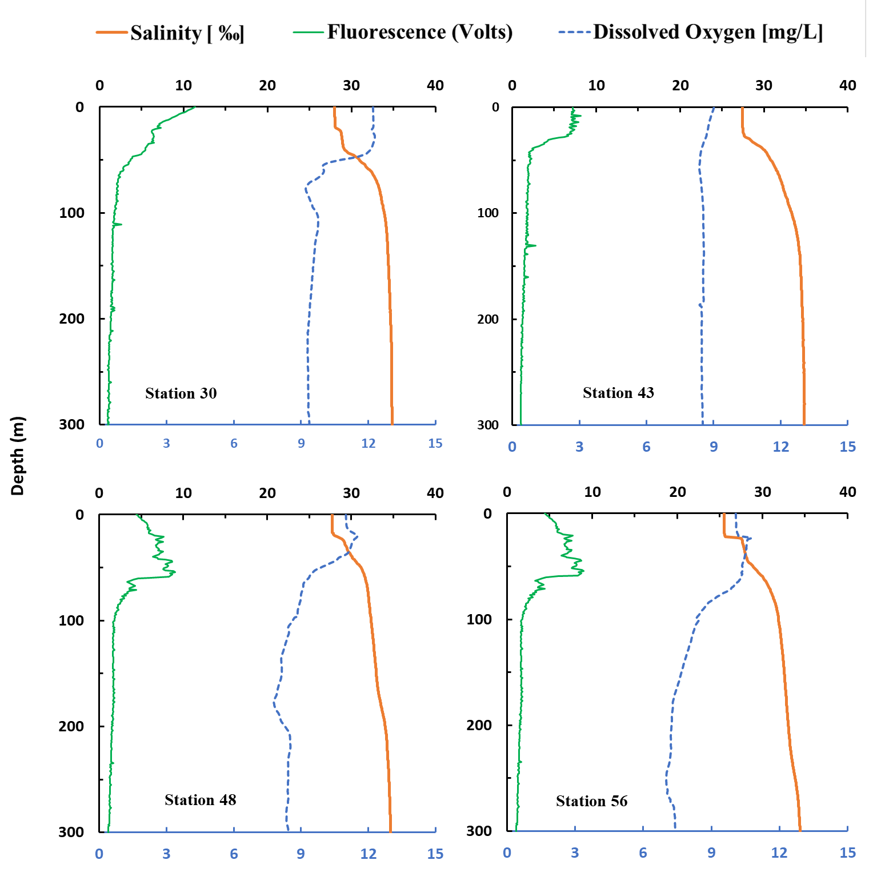
Figure S1. Water column CTD profiles showing Salinity [‰], Fluorescence (0- 5 VDC volts), and Dissolved Oxygen [mg L⁻¹] for all the sampling station. The fluorescence has been magnified 100 times to show on the same x-scale. The top x-axis represents the salinity and fluorescence, and the bottom x-axis represents the dissolved oxygen.

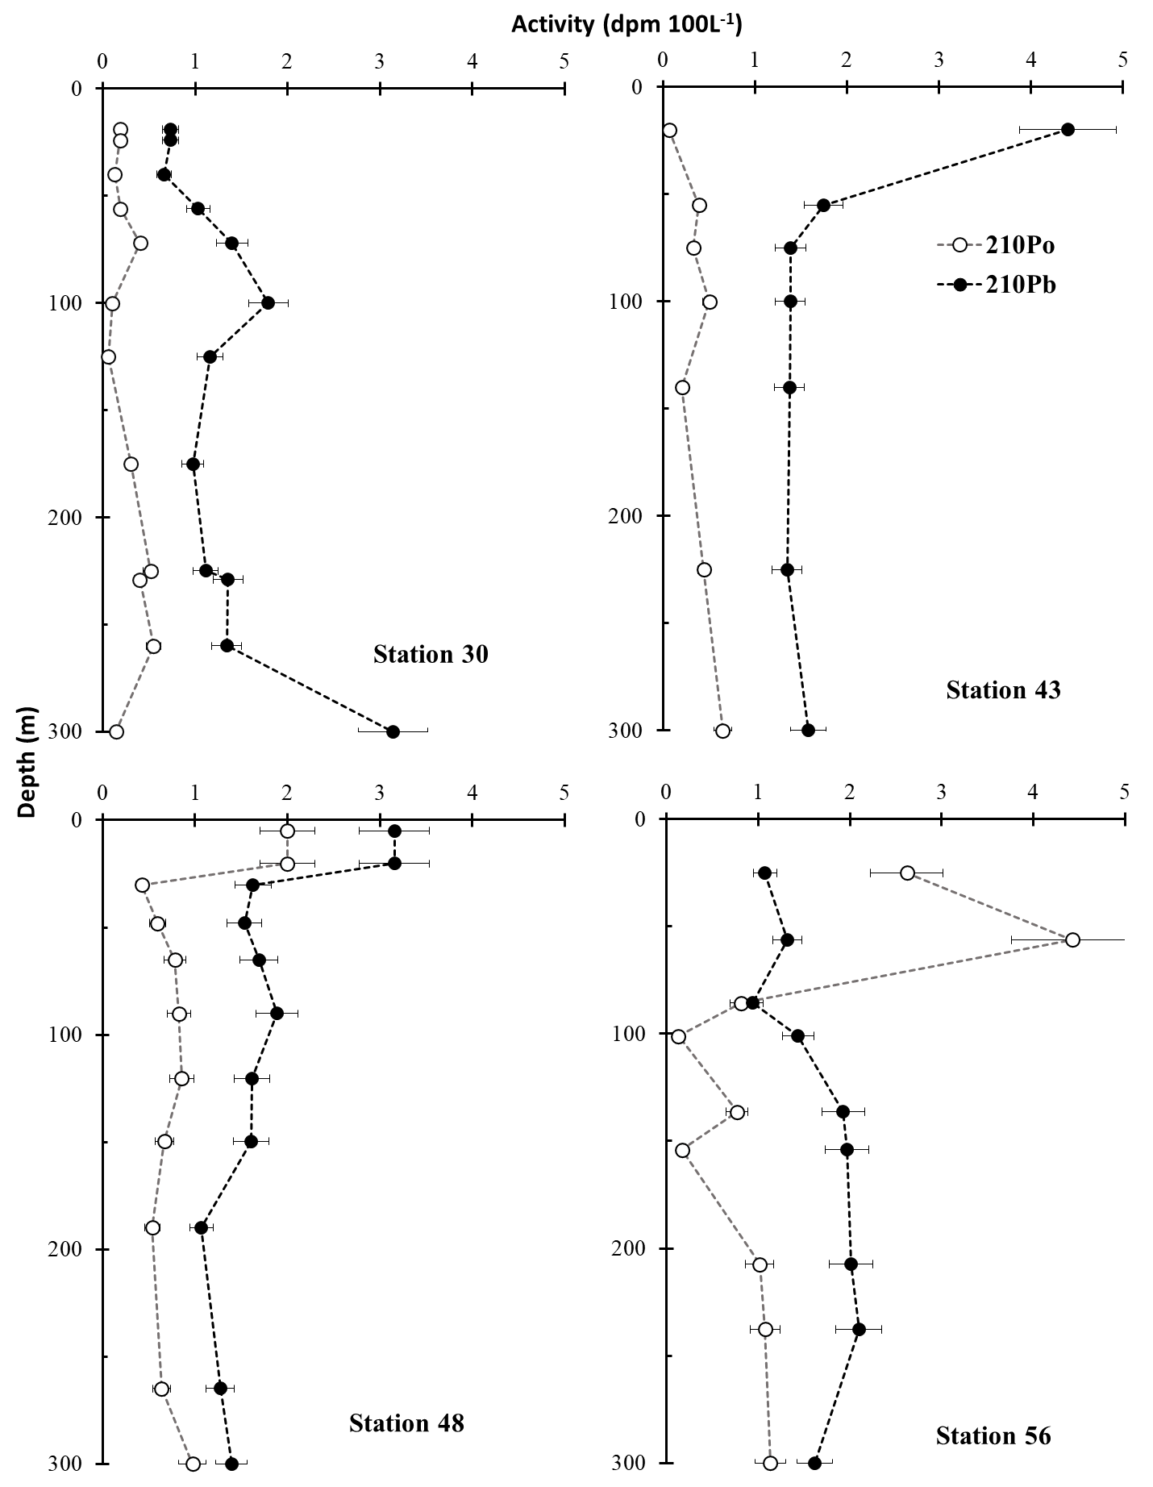
Figure S2. The activity depth profile of particulate (large and small) ²¹⁰Po (open circle) and ²¹⁰Pb (filled circle) for the sampling station in the upper 300m.
Figure S3. POC, PIC, PN, and bSi concentration on the large particle samples for upper 300m water column depth.

Table S1. POC fluxes in large and small particle fraction sizes using ²¹⁰Po flux.
 | POC Flux (mg C m⁻² d⁻¹) Large Particles |  |  | POC Flux (mg C m⁻² d⁻¹) Small Particles
Station | 100m | 150m | 200m | 100m | 150m | 200m
30 | 2.62 ± 0.26 | 5.43 ± 0.49 | 4.86 ± 0.39 | 6.97 ± 0.69 | 9.77 ± 0.87 | 4.86 ± 0.41
43 | 7.43 ± 0.42 | 7.23 ± 0.42 | 3.16 ± 0.22 | 9.25 ± 0.52 | 10.82 ± 0.63 | 7.83 ± 0.54
48 | 2.08 ± 0.11 | 1.88 ± 0.11 | 1.13 ± 0.07 | 5.35 ± 0.29 | 7.77 ± 0.46 | 6.85 ± 0.43
56 | 1.59 ± 0.16 | 0.75 ± 0.07 | 1.11 ± 0.09 | 3.35 ± 0.04 | 0.28 ± 0.03 | 1.11 ± 0.09

Table S2. PN fluxes in large and small particles fraction sizes using ²¹⁰Po flux.
 | PN Flux (mg N m⁻² d⁻¹) Large Particles |  |  | PN Flux (mg N m⁻² d⁻¹d) Small Particles
Station | 100m | 150m | 200m | 100m | 150m | 200m
30 | 0.28 ± 0.04 | 0.51 ± 0.04 | 0.48 ± 0.04 | 1.07 ± 0.11 | 1.31 ± 0.87 | 1.05 ± 0.09
43 | 0.78 ± 0.04 | 0.65 ± 0.04 | 0.35 ± 0.02 | 1.71 ± 0.09 | 1.09 ± 0.06 | 1.18 ± 0.08
48 | 0.21 ± 0.01 | 0.19 ± 0.01 | 0.12 ± 0.01 | 1.02 ± 0.06 | 1.46 ± 0.09 | 1.09 ± 0.07
56 | 0.19 ± 0.02 | 0.08 ± 0.01 | 0.13 ± 0.01 | 0.32 ± 0.03 | 0.19 ± 0.01 | 0.15 ± 0.01

Table S3. PIC flux estimated based on the ²¹⁰Pb and ²¹⁰Po fluxes in large particles.
 | PIC Flux (mg C m⁻² d⁻¹) using Pb fluxes |  |  | PIC Flux (mg C m⁻² d⁻¹) using Po Flux
Station | 100m | 150m | 200m | 100m | 150m | 200m
30 | 0.018 ± 0.003 | 0.014 ± 0.002 | 0.019 ± 0.003 | 0.08 ± 0.01 | 0.11 ± 0.01 | 0.13 ± 0.01
43 | 0.042 ± 0.007 | 0.145 ± 0.023 | 0.059 ± 0.009 | 0.41 ± 0.02 | 1.07 ± 0.06 | 0.59 ± 0.04
48 | 0.017 ± 0.003 | 0.029 ± 0.005 | 0.036 ± 0.005 | 0.08 ± 0.01 | 0.12 ± 0.01 | 0.19 ± 0.01
56 | -0.021 ± -0.004 | 0.01 ± 0.001 | -0.018 ± 0.001 | -0.11 ± -0.01 | 0.01 ± 0.01 | -0.11 ± -0.01

Table S4. bSi flux estimated based on the ²¹⁰Pb and ²¹⁰Po fluxes in large particles.
 | bSi Flux (mg Si m⁻² d⁻¹) using Pb fluxes |  |  | bSI Flux (mg Si m⁻² d⁻¹) using Po Flux
Station | 100m | 150m | 200m | 100m | 150m | 200m
30 | 1.01 ± 0.17 | 1.23 ± 0.21 | 0.36 ± 0.06 | 4.22 ± 0.46 | 8.69 ± 0.78 | 2.39 ± 0.21
43 | 1.55 ± 0.27 | 2.88 ± 0.47 | 1.26 ± 0.19 | 14.51 ± 0.82 | 11.72 ± 1.25 | 12.66 ± 0.87
48 | 0.82 ± 0.11 | 0.33 ± 0.05 | 0.57 ± 0.08 | 3.63 ± 0.21 | 1.36 ± 0.08 | 2.93 ± 0.19
56 | 0.67 ± 0.12 | 0.14 ± 0.02 | 0.14 ± 0.02 | 3.29 ± 0.33 | 0.77 ± 0.07 | 0.88 ± 0.08

