# Supplementary information

**Table S1. Percentage of OF-C according to the methods, i.e. differential, synchronic isotopic and asynchronic isotopic.** Mean of three OF-C estimations ± standard deviation (only two blocks in year 3 for the Arenosol and year 10 for the Andosol).



**Table S2. Weight of each parameter in the sensitivity analysis of the isotopic mixing equation.** Average δ13C is the average δ13C from three plots at T13. The variation is the standard deviation divided by the average. Importance variable method detailed in part 2.8.

|  |  |  |  |  |
| --- | --- | --- | --- | --- |
|  | Equation variable | Average *δ*13C | Variation [%] | Weight of the variable [%] |
| Arenosol compost | *δ*13COF | -20.33 | 14 | 95 |
| *δ*13COFsoil | -18.45 | 2 | 5 |
| *δ*13CCTRLsoil | -16.02 | 3 | 1 |
| Arenosol slurry | *δ*13COF | -24.35 | 6 | 58 |
| *δ*13COFsoil | -19.37 | 2 | 26 |
| *δ*13CCTRLsoil | -16.02 | 3 | 16 |
| Andosol compost | *δ*13COF | -20.33 | 14 | 92 |
| *δ*13COFsoil | -22.75 | 1 | 6 |
| *δ*13CCTRLsoil | -24.58 | 2 | 2 |

**Figure S1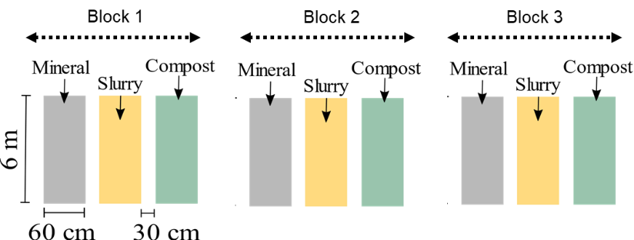. Schematic representation of the experimental design of Arenosol and Andosol trials.** Consisting of nine plots divided into three blocks with three different treatments, leading to three plots per modality. The plots were randomly distributed within each block.

**Figure S2. Bulk density estimations (results and parameters) using Alexander’s law on total carbon content.** Note that a linear regressions on the total carbon from Figure 4 data was done to fit Alexander’s law by the least squared method with measurements performed on the Arenosol (5-10 cm) in year 0 an year 14 and on the Andosol (0-10 cm) in year 3 and 16. Alexander coefficients underwent least squares adjustment on carbon linear regression data, by fitting both measured values in each soils.

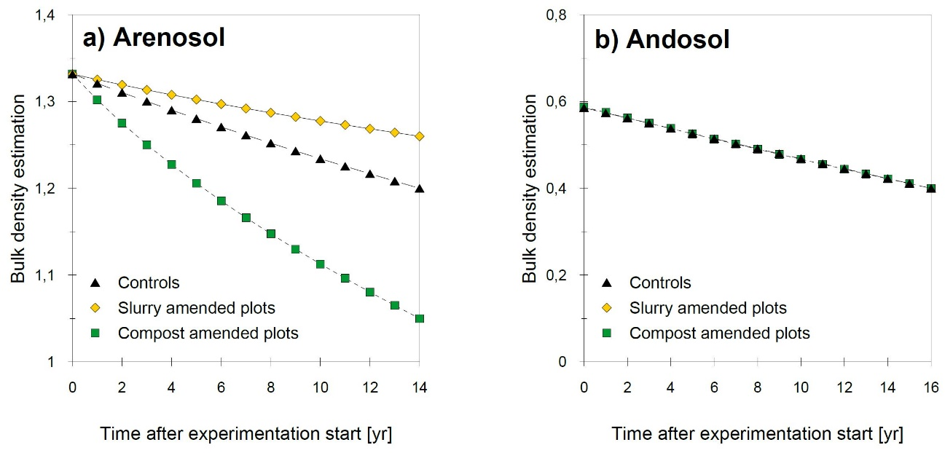

|  |  |  |  |  |  |
| --- | --- | --- | --- | --- | --- |
|  | Arenosol | | | Andosol | |
|  | Controls | Compost amended soils | Slurry amended soils | Controls | Compost amended soils |
| Alexander's coefficient (*Acoef)* | 1.74 | 1.58 | 1.46 | 3.61 | 1.71 |
| Slope (*Aslope)* | 0.13 | 0.09 | 0.04 | 0.30 | 0.11 |

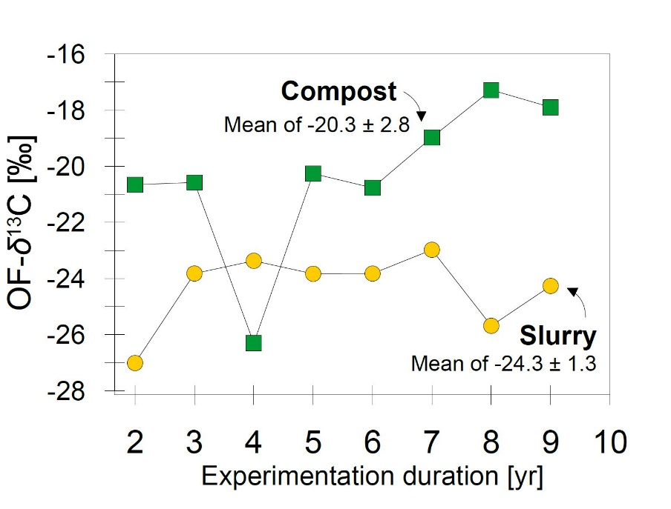**Figure S3, OF-δ13C over time from years 2 to 9 for the bovine manure compost (green square) and bovine slurry (yellow dot) treatments**.