Supplementary Materials：Correlation matrix for 53 countries/regions participated in digital reading test
- Albania
Figure S1. Correlations between different variables.
- Australia
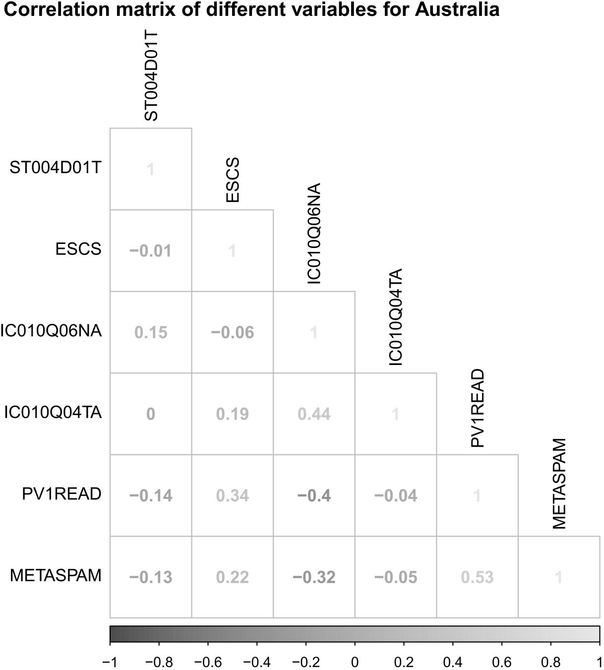
Figure S2. Correlations between different variables.
- Austria
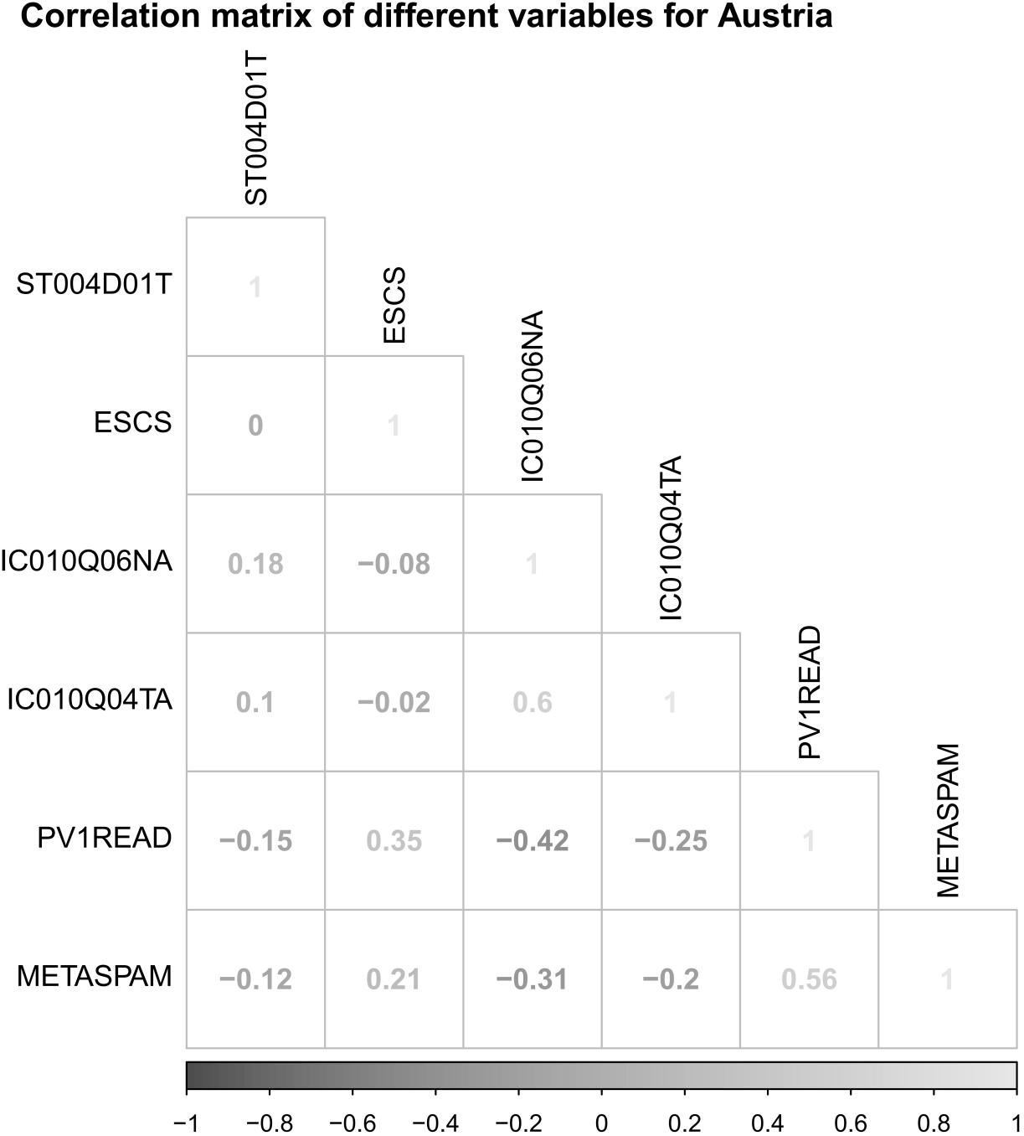
Figure S3. Correlations between different variables.

- Belgium
Figure S4. Correlations between different variables.

- Brazil
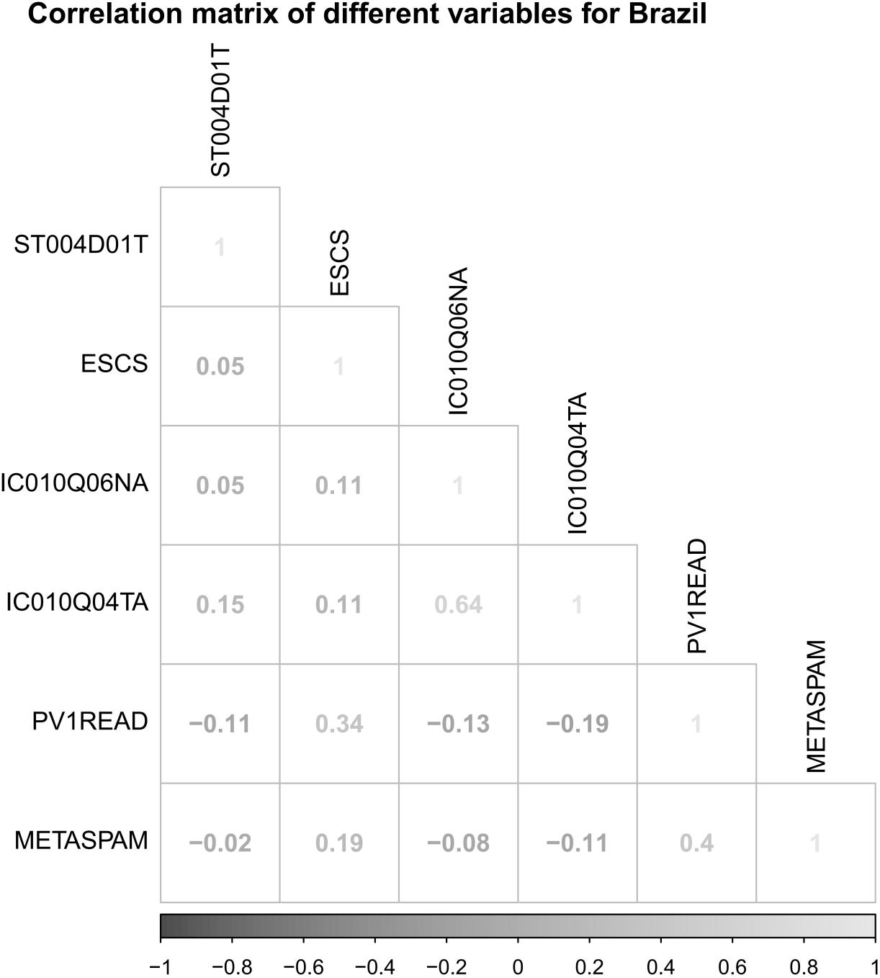
Figure S5. Correlations between different variables.

- Brunei Darussalam
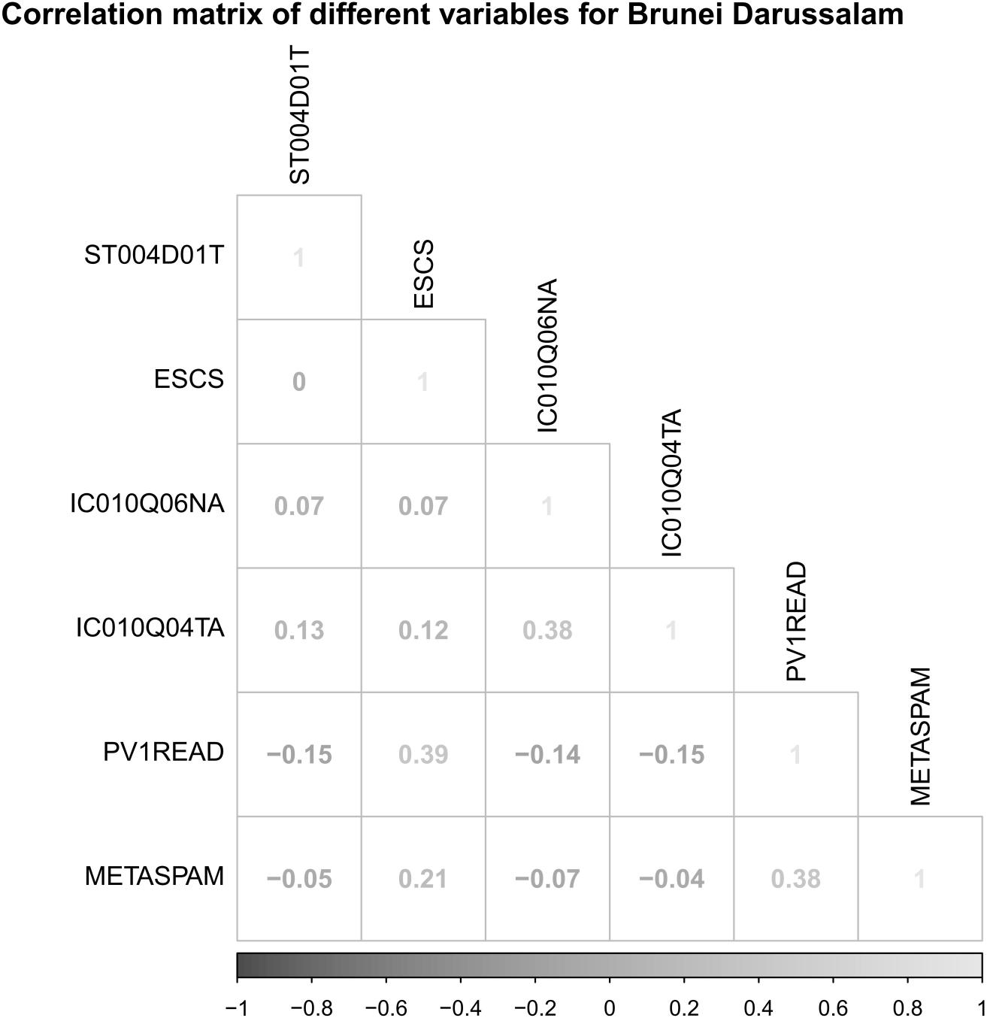
Figure S6. Correlations between different variables.

- Bulgaria
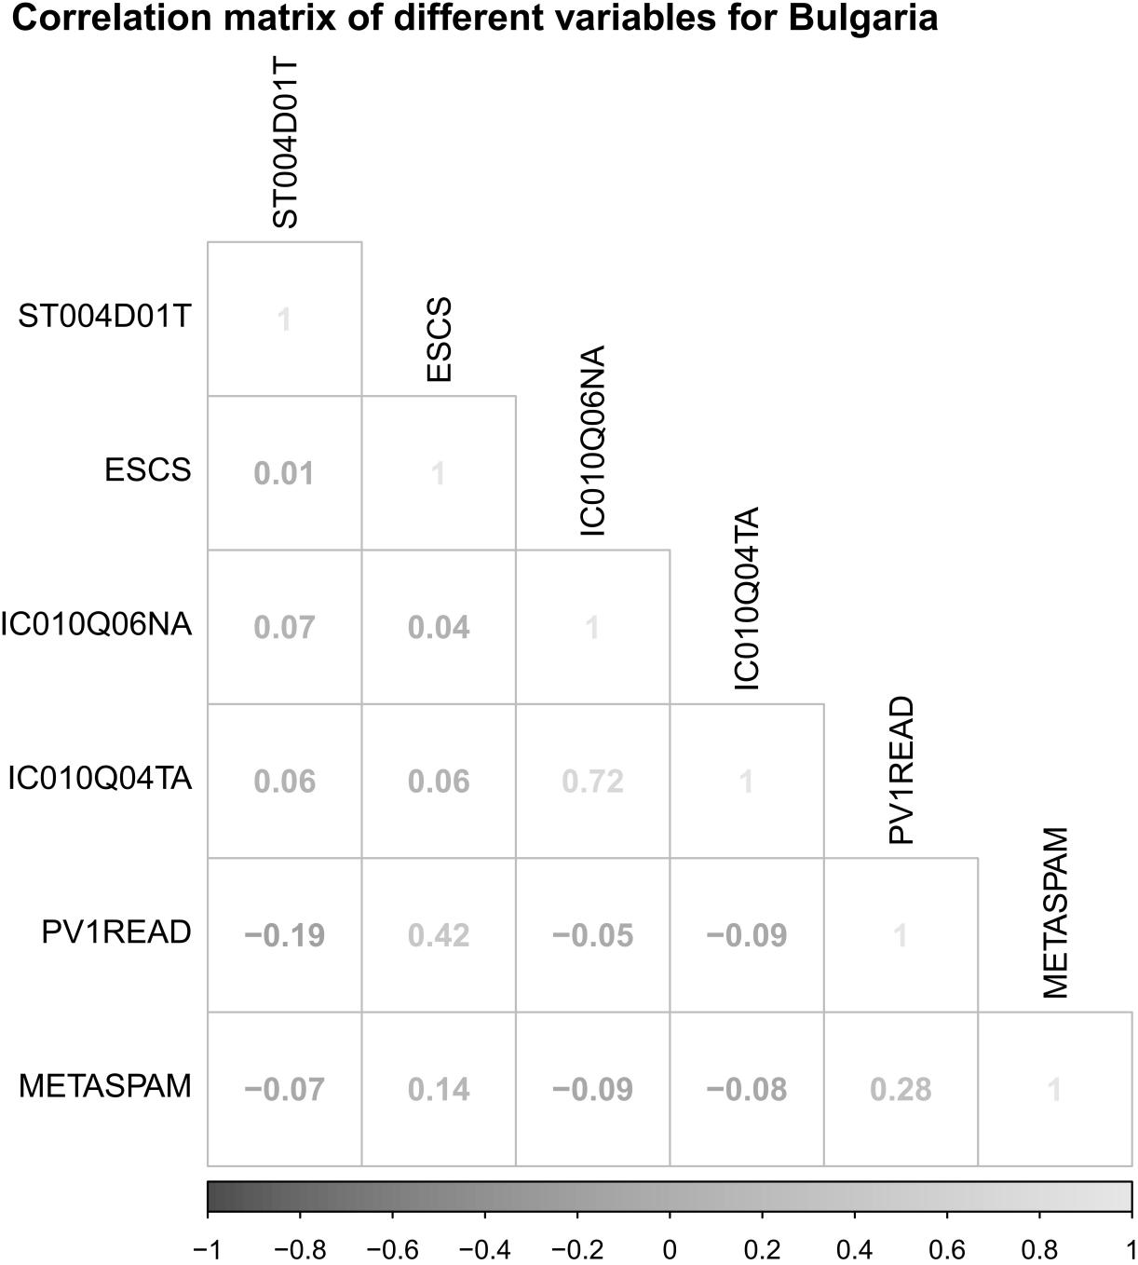
Figure S7. Correlations between different variables.

- Chile
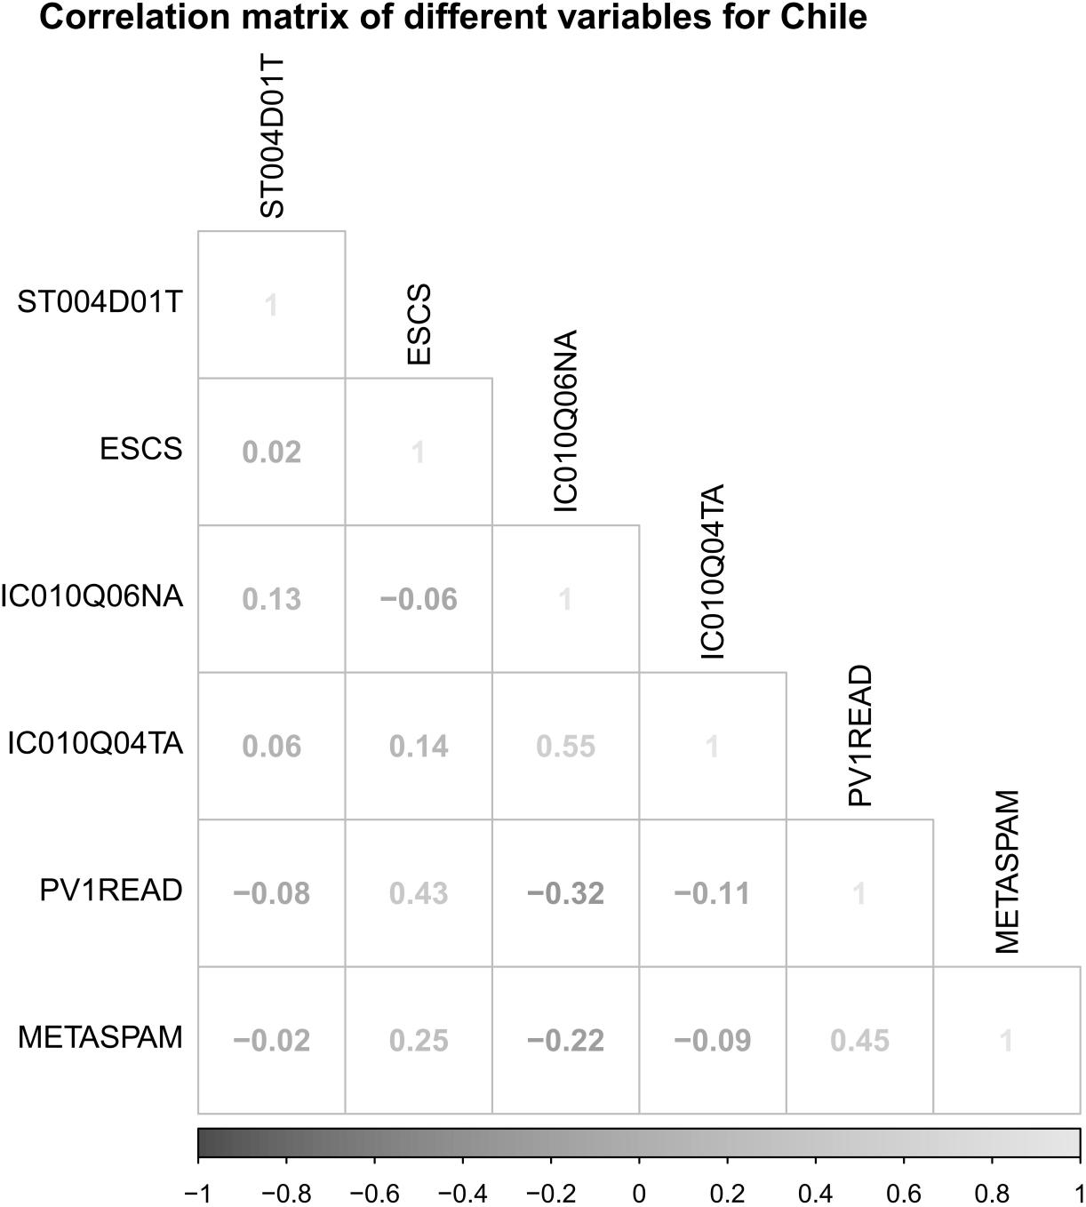
Figure S8. Correlations between different variables.

- Chinese Taipei
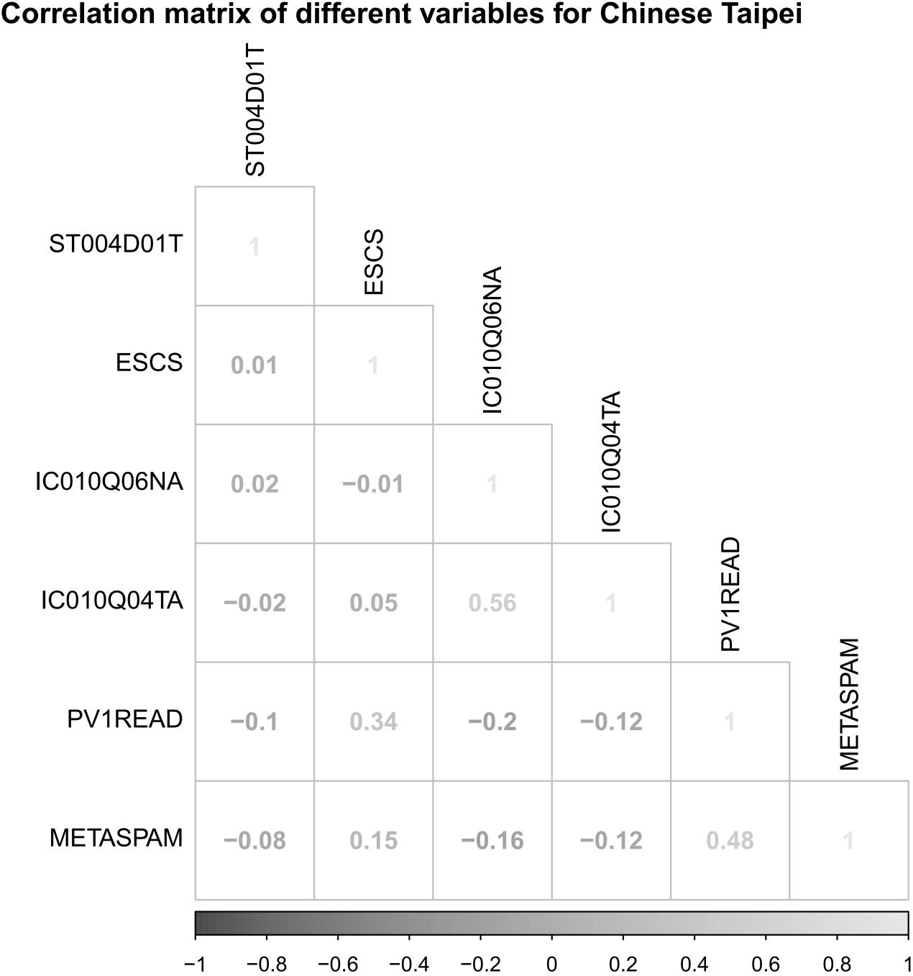
Figure S9. Correlations between different variables.

- Costa Rica
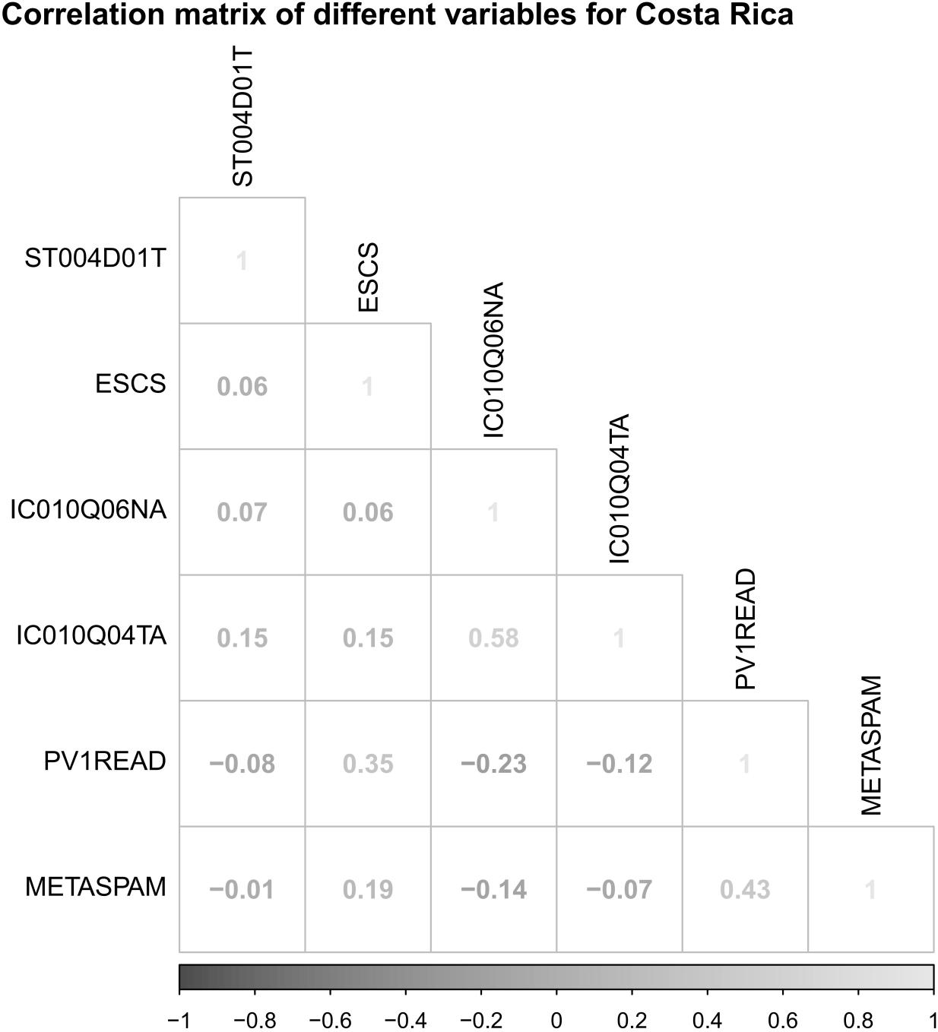
Figure S10. Correlations between different variables.

- Croatia
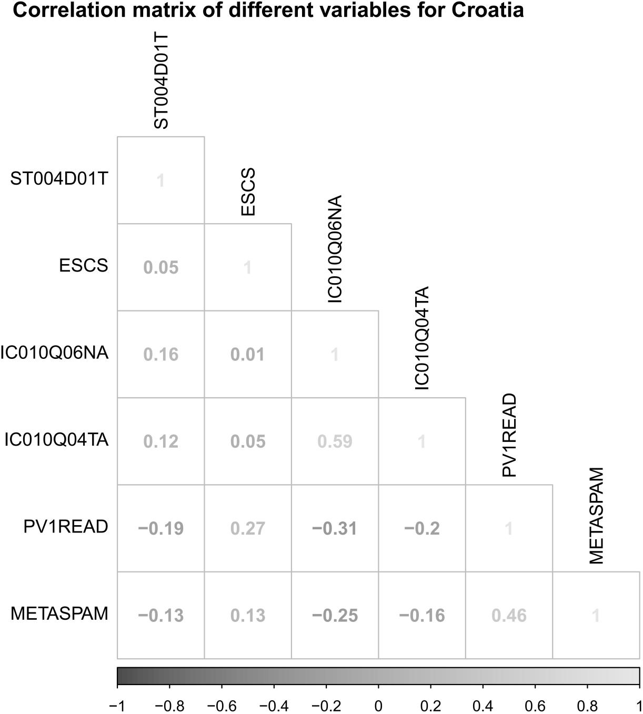
Figure S11. Correlations between different variables.

- Czech Republic
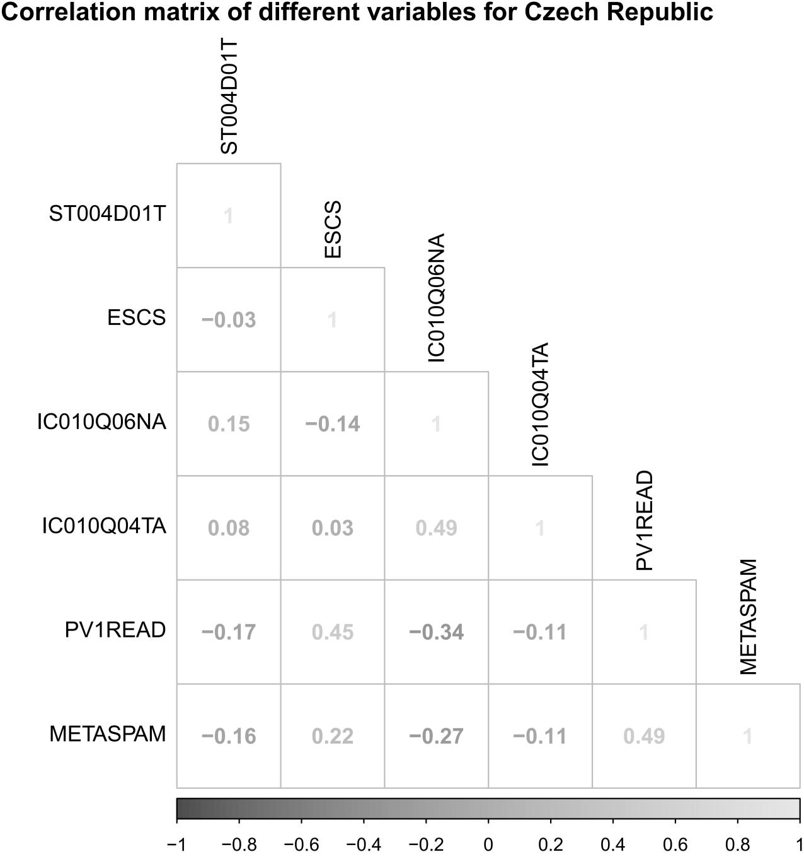
Figure S12. Correlations between different variables.

- Denmark
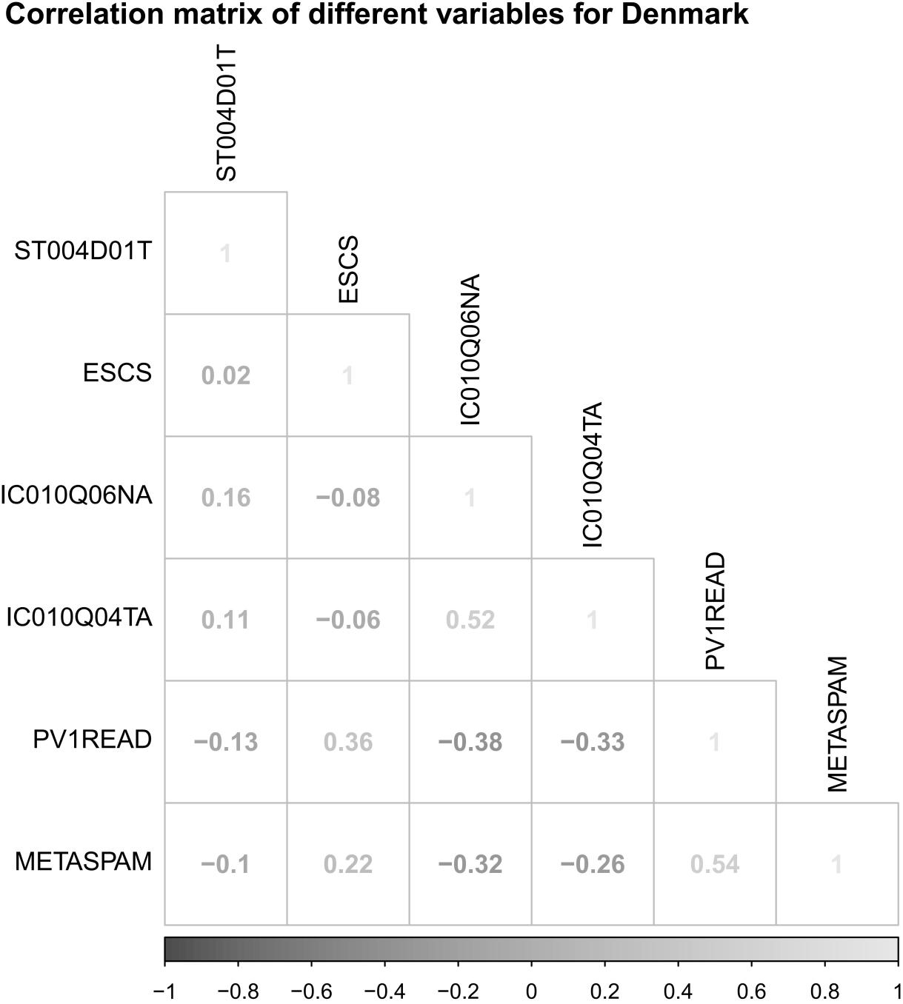
Figure S13. Correlations between different variables.

- Dominican Republic
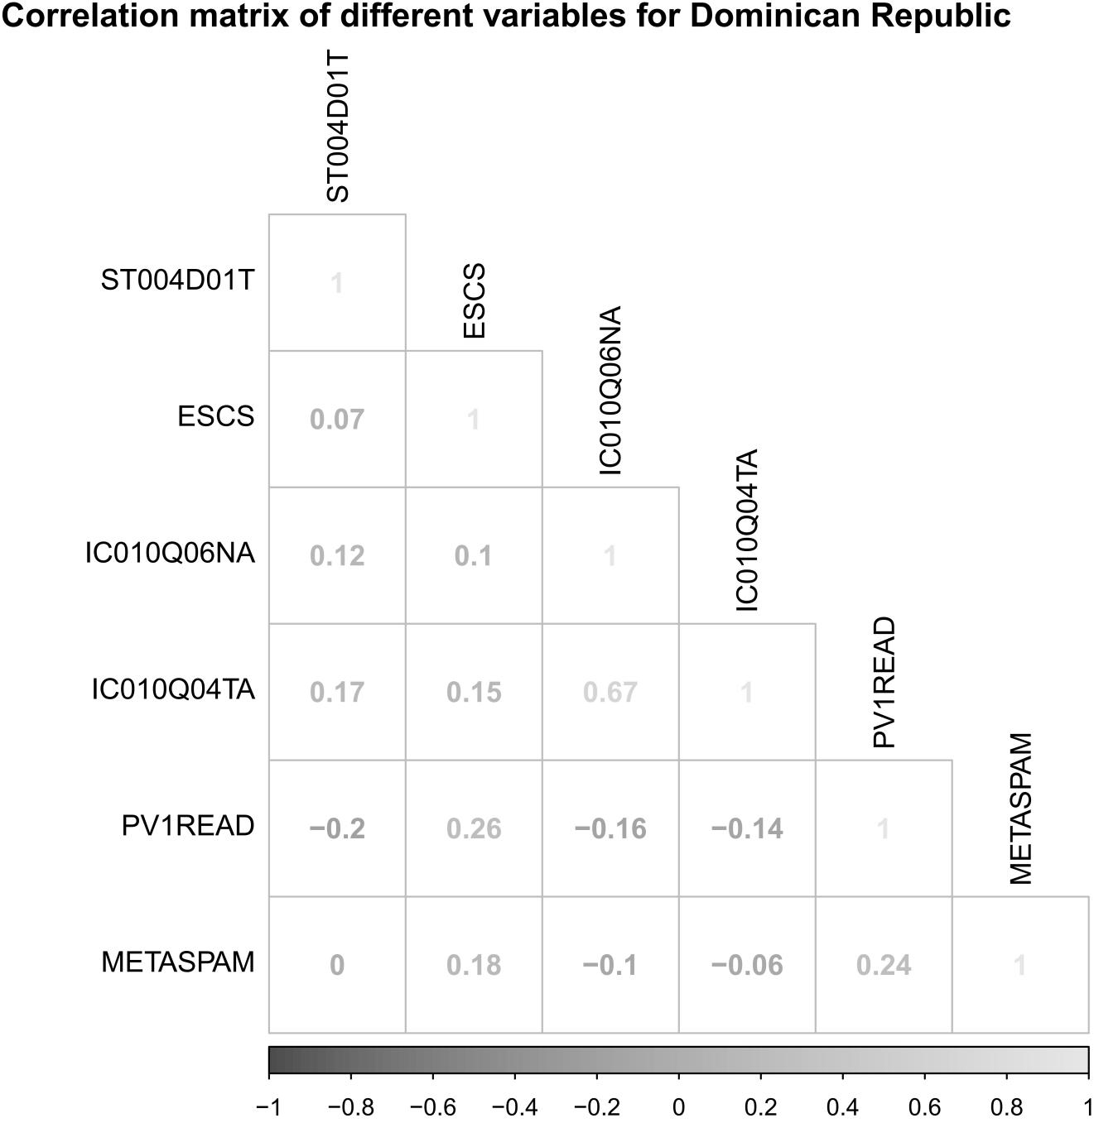
Figure S14. Correlations between different variables.

- Estonia
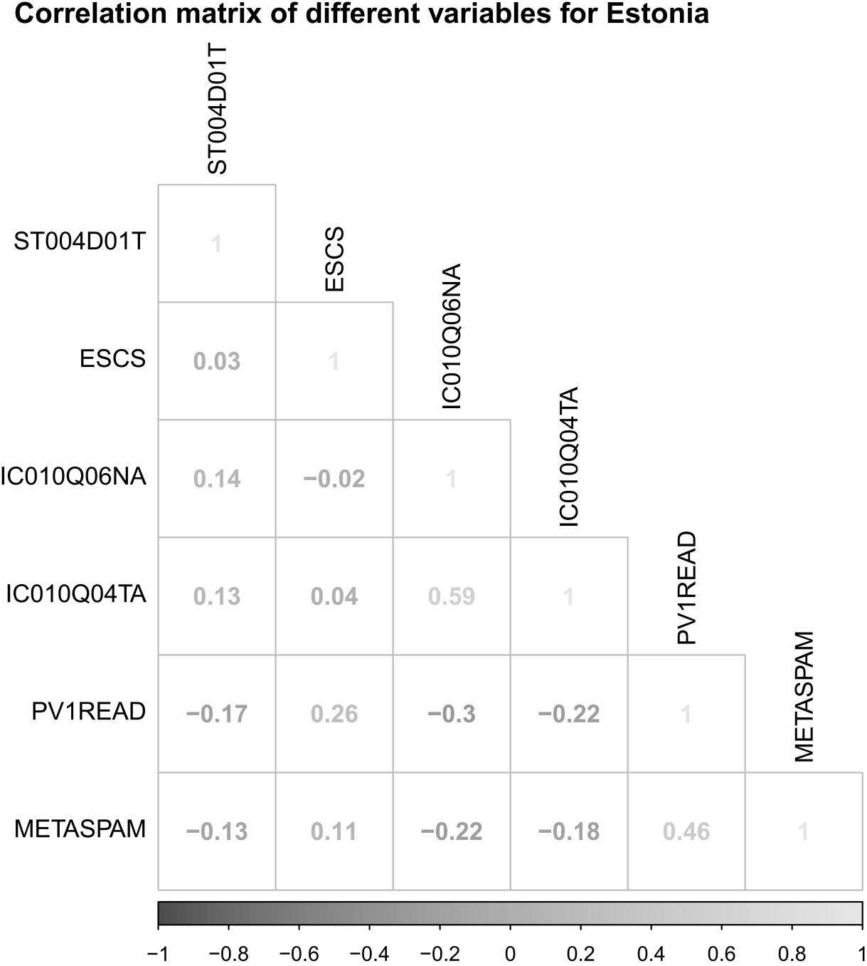
Figure S15. Correlations between different variables.

- Finland
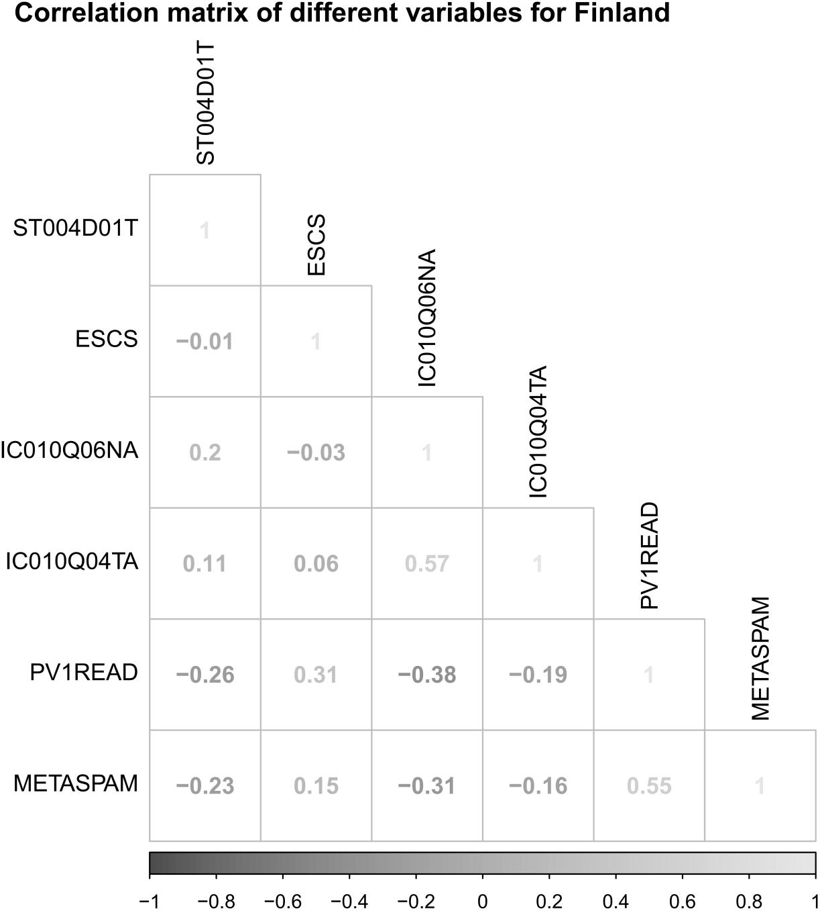
Figure S16. Correlations between different variables.

- France
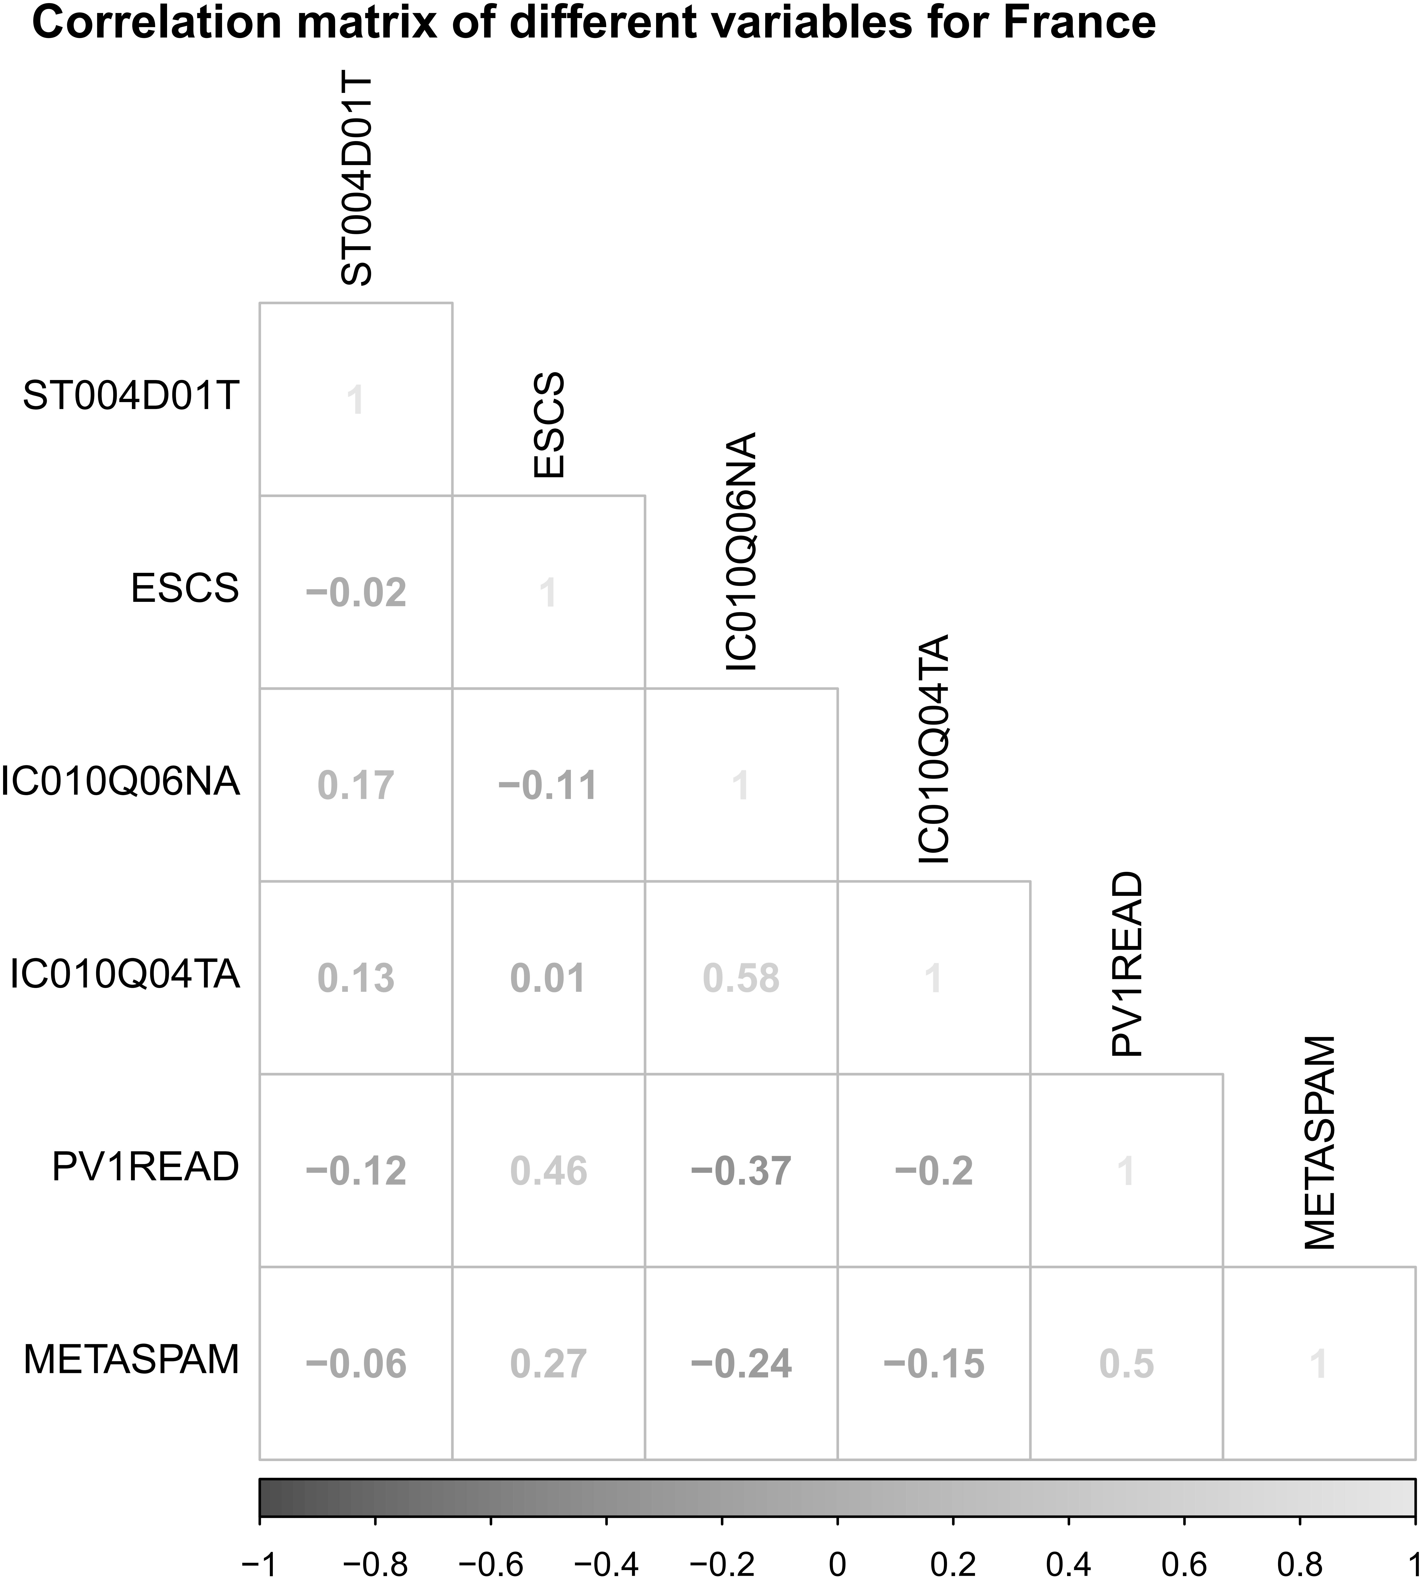
Figure S17. Correlations between different variables.

- Georgia
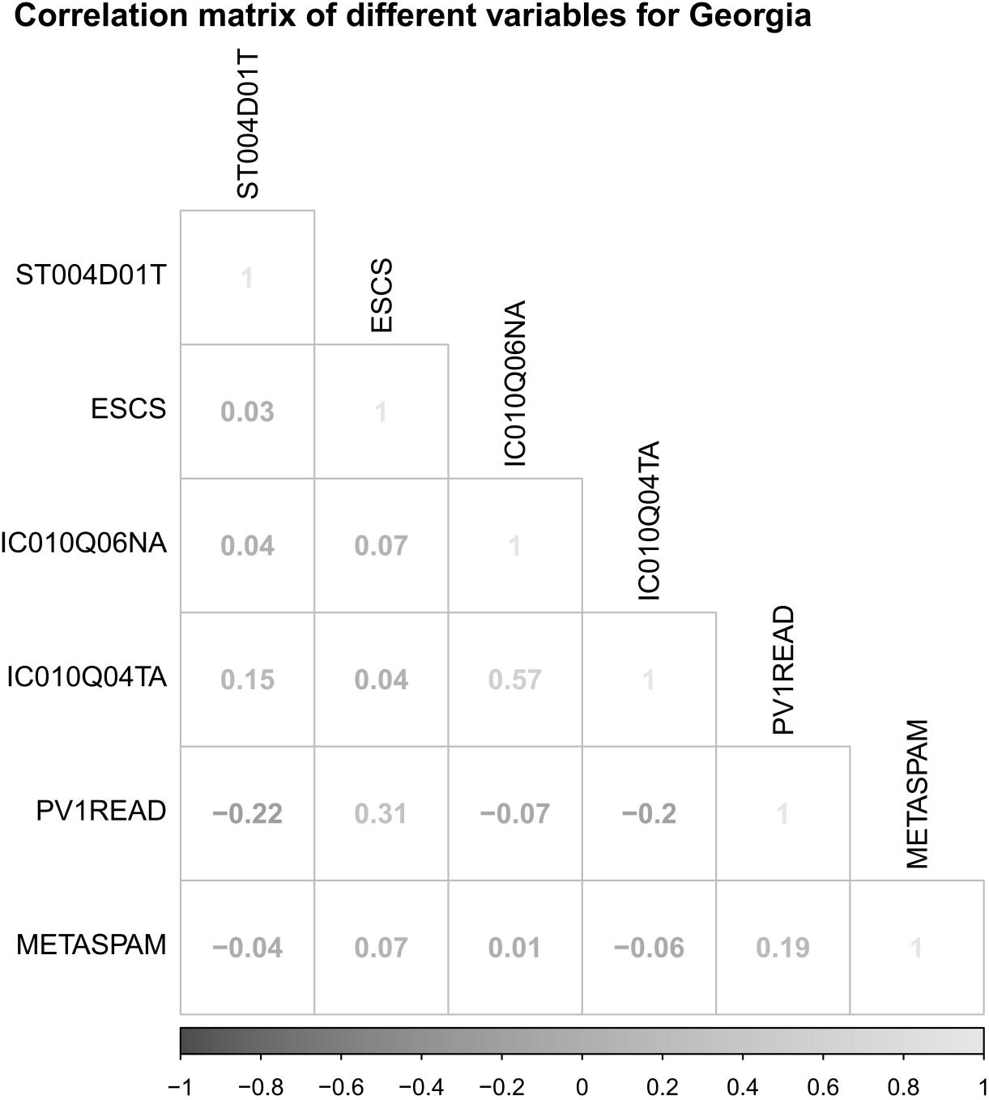
Figure S18. Correlations between different variables.

- Greece
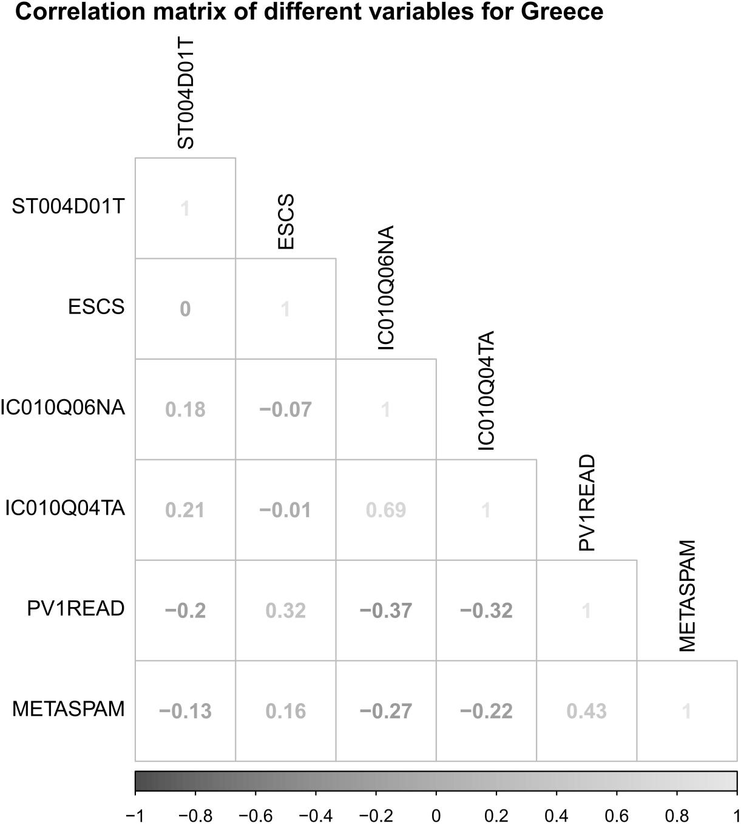
Figure S19. Correlations between different variables.

- Hong Kong
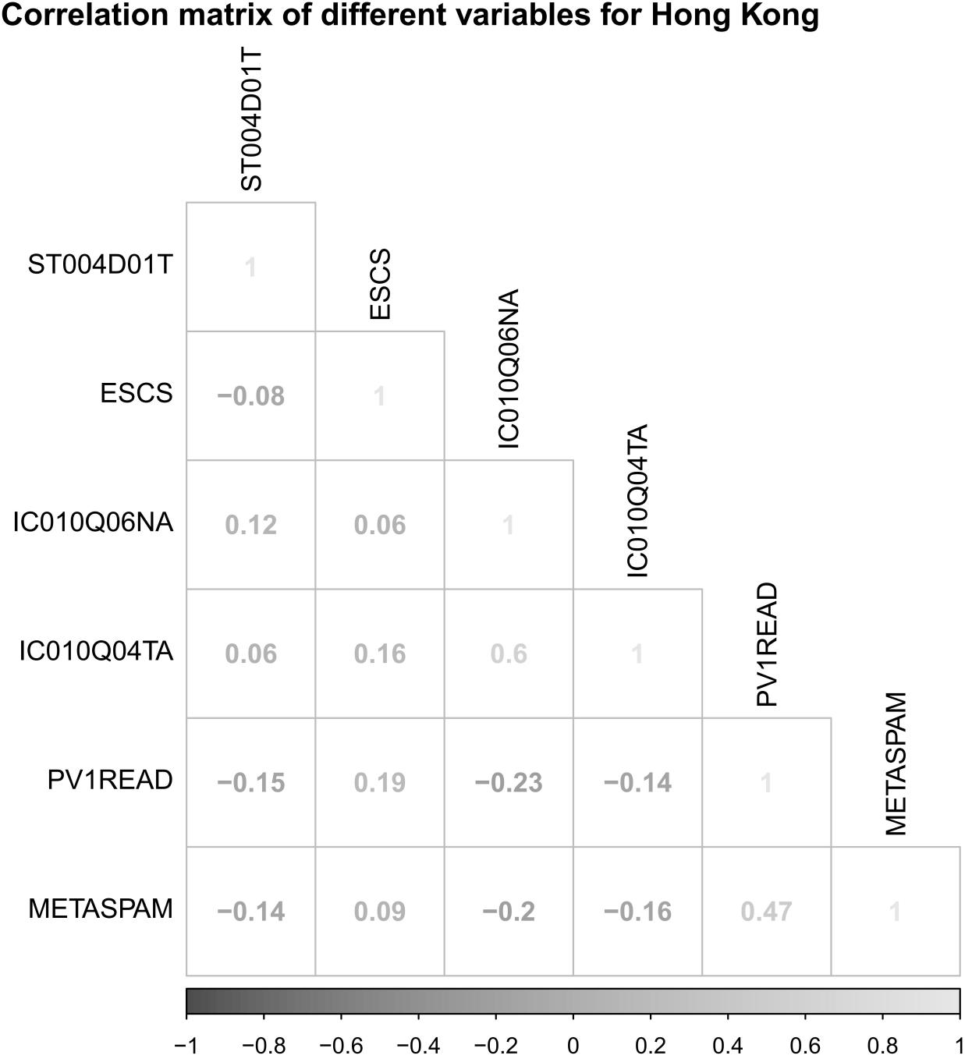
Figure S20. Correlations between different variables.

- Hungary
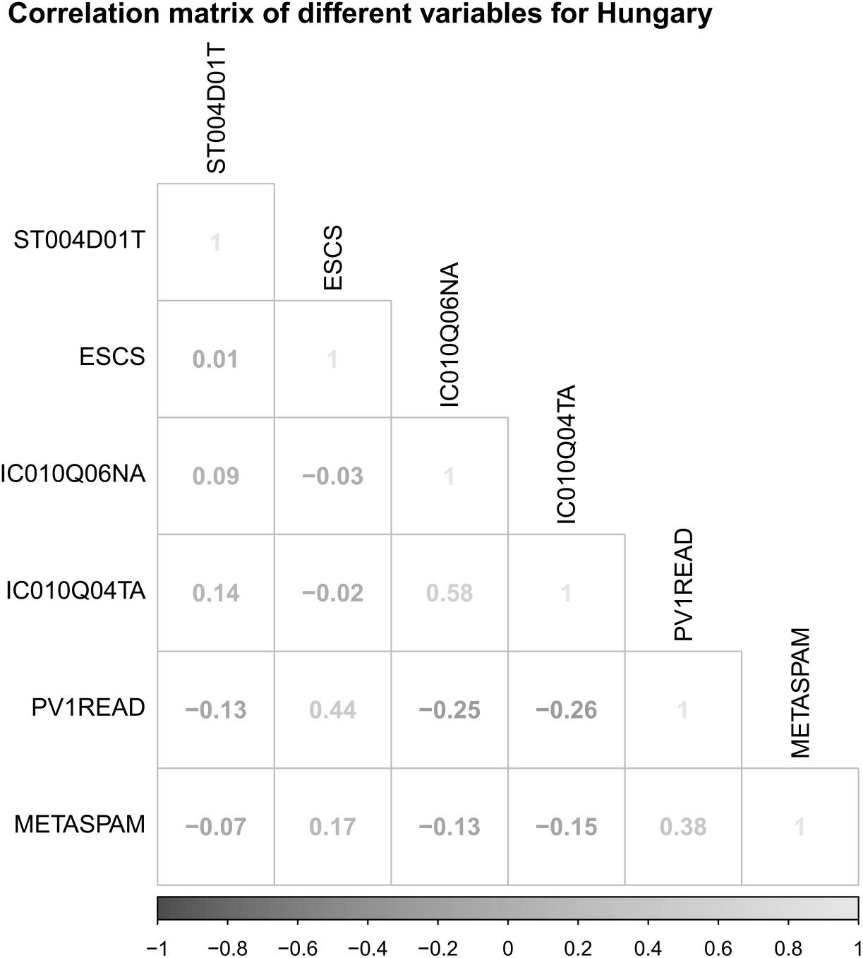
Figure S21. Correlations between different variables.

- Iceland
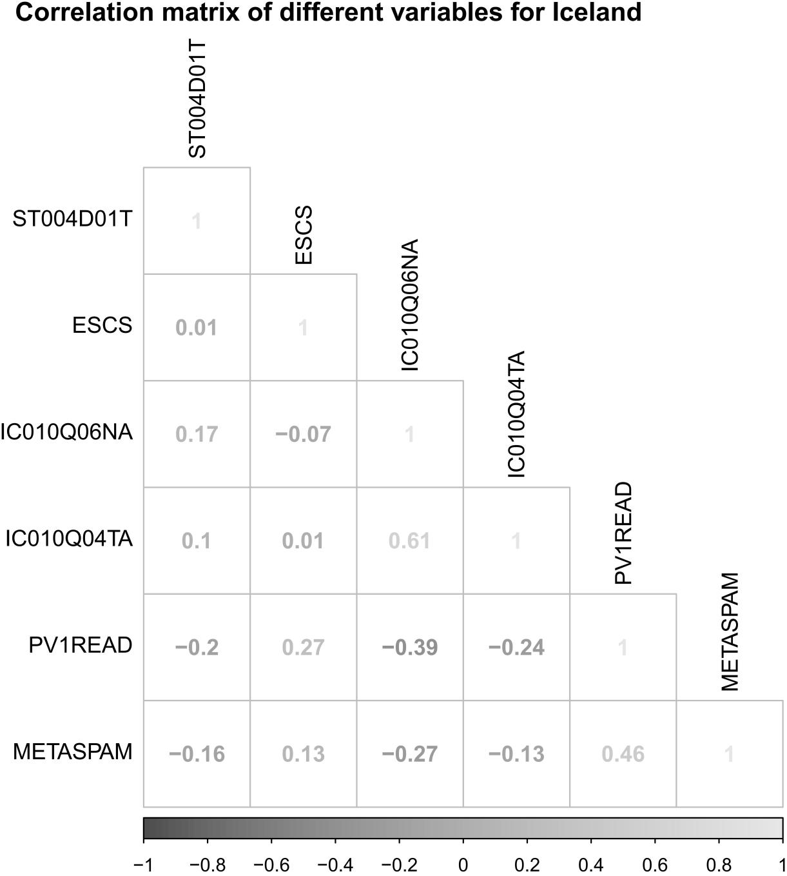
Figure S22. Correlations between different variables.

- Ireland
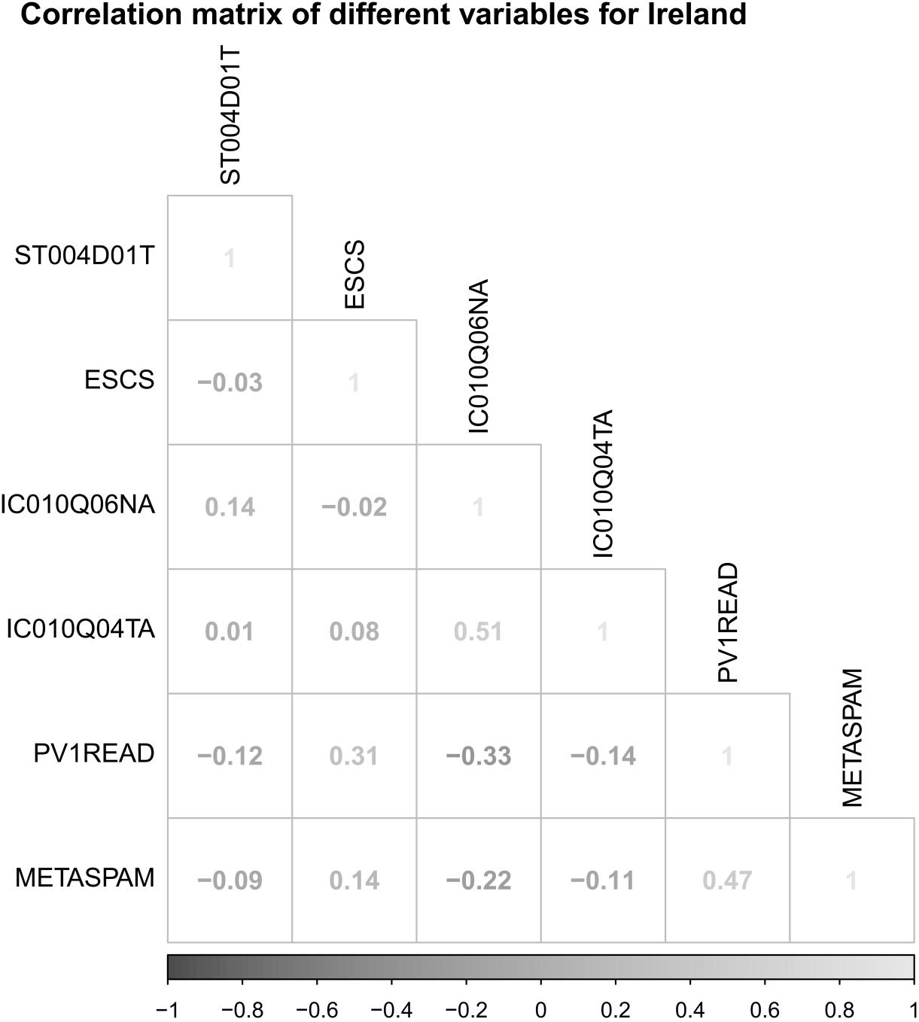
Figure S23. Correlations between different variables.

- Israel
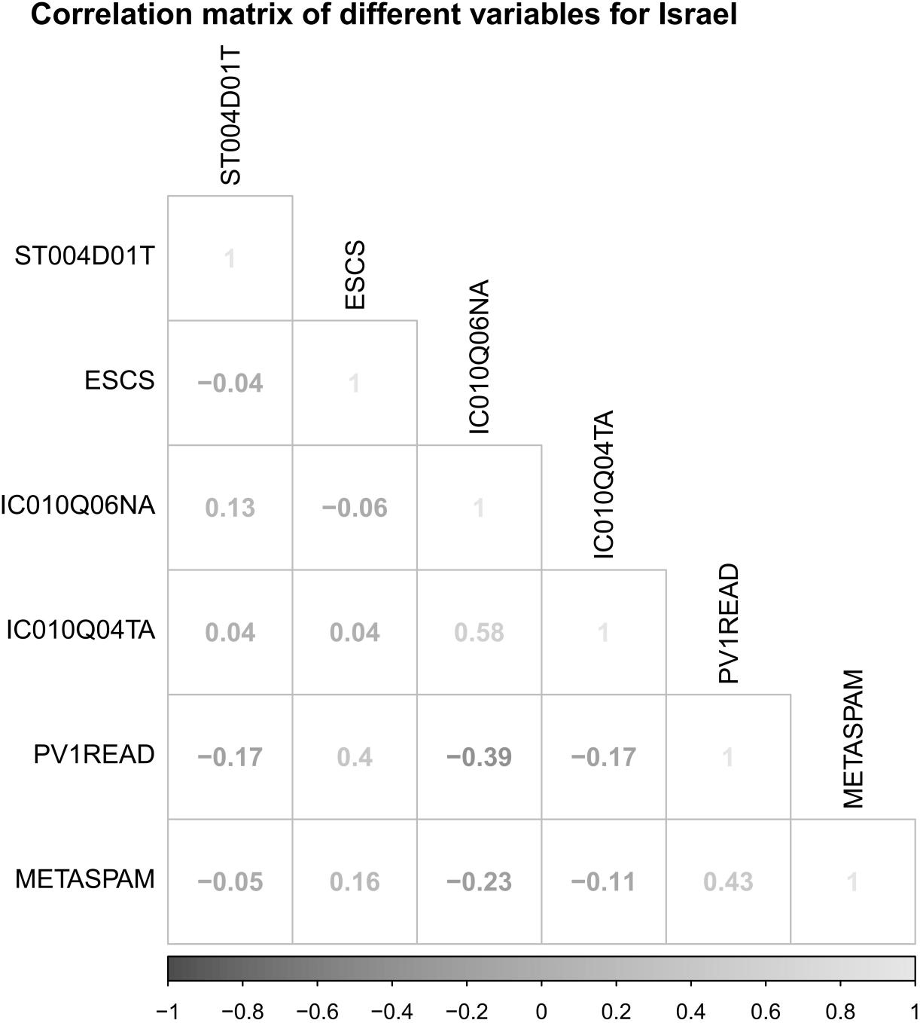
Figure S24. Correlations between different variables.

- Italy
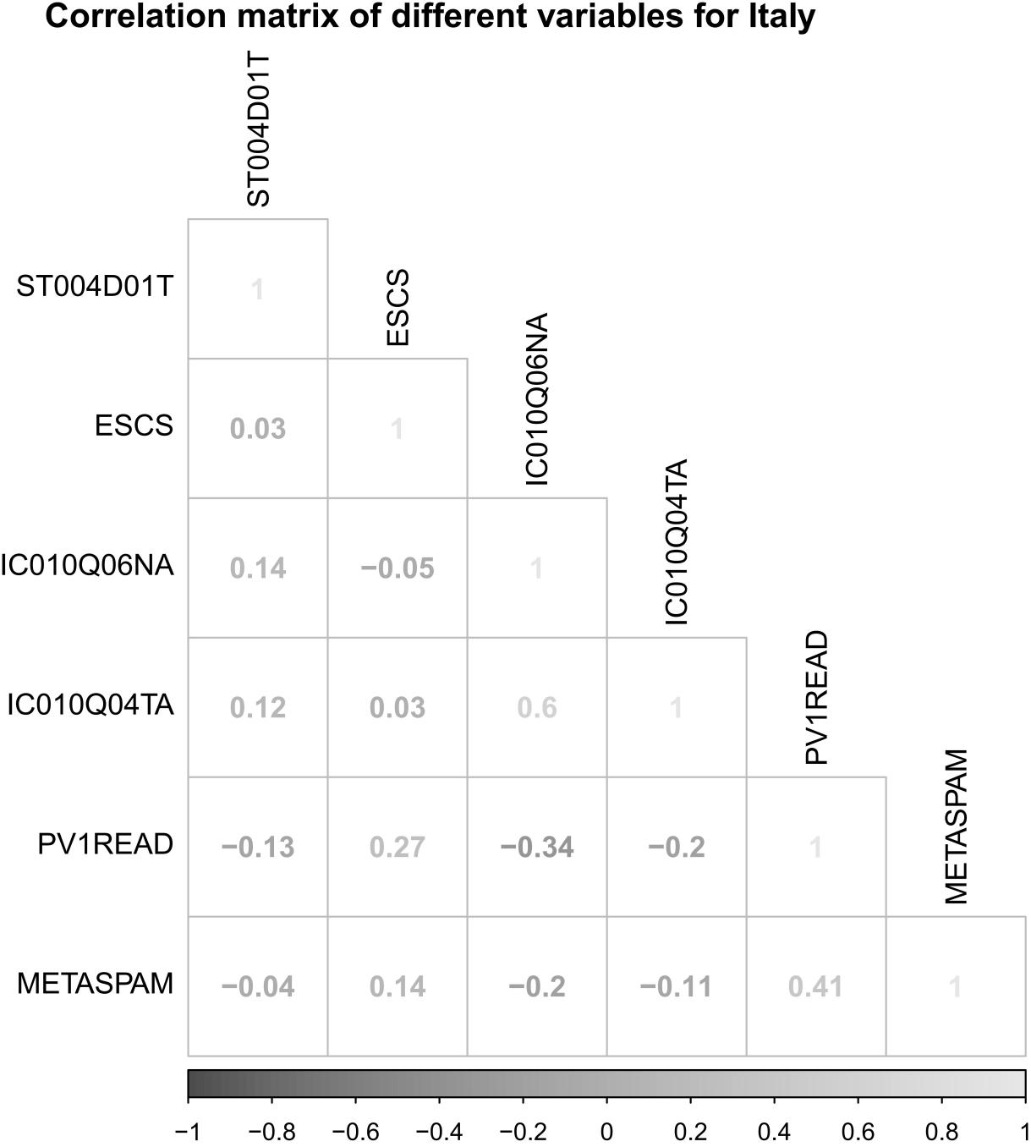
Figure S25. Correlations between different variables.

- Japan
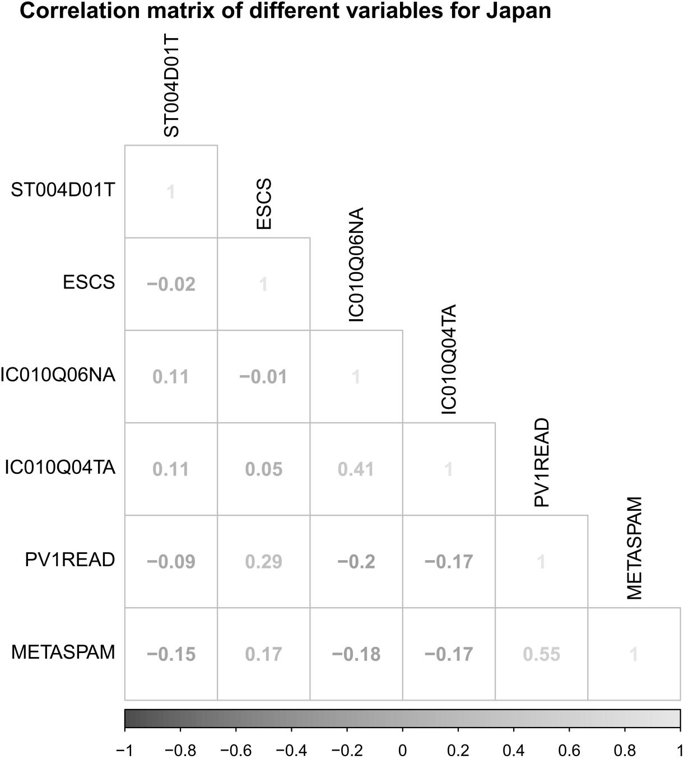
Figure S26. Correlations between different variables.

- Kazakhstan
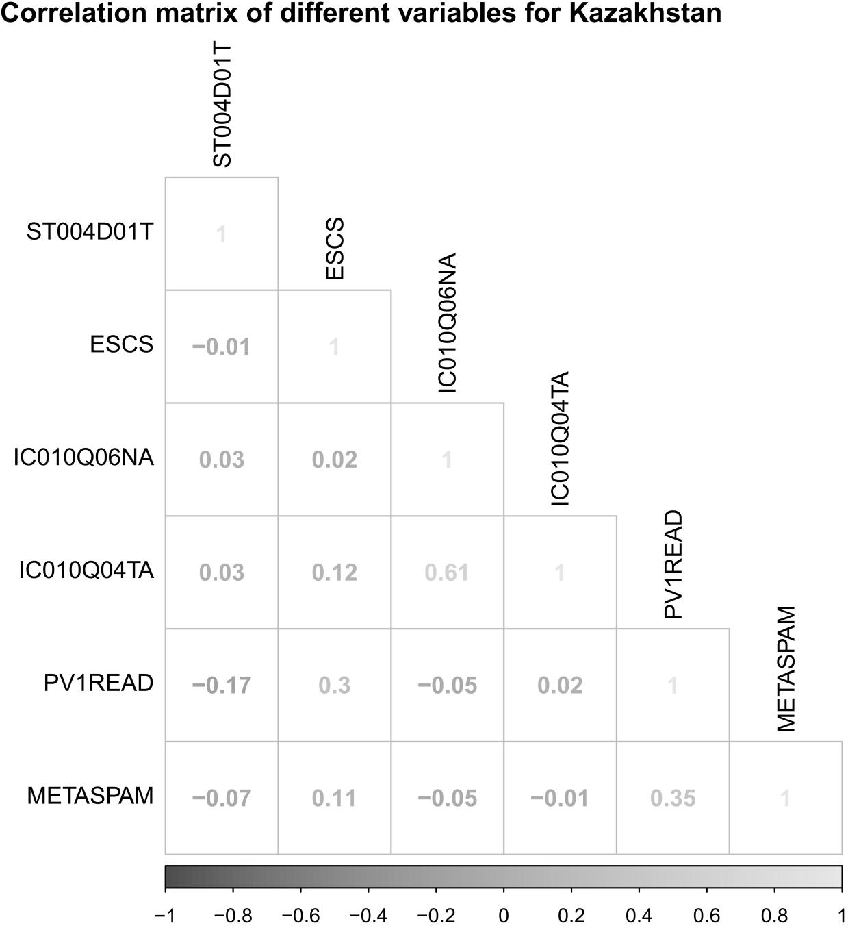
Figure S27. Correlations between different variables.

- Korea
Figure S28. Correlations between different variables.

- Latvia
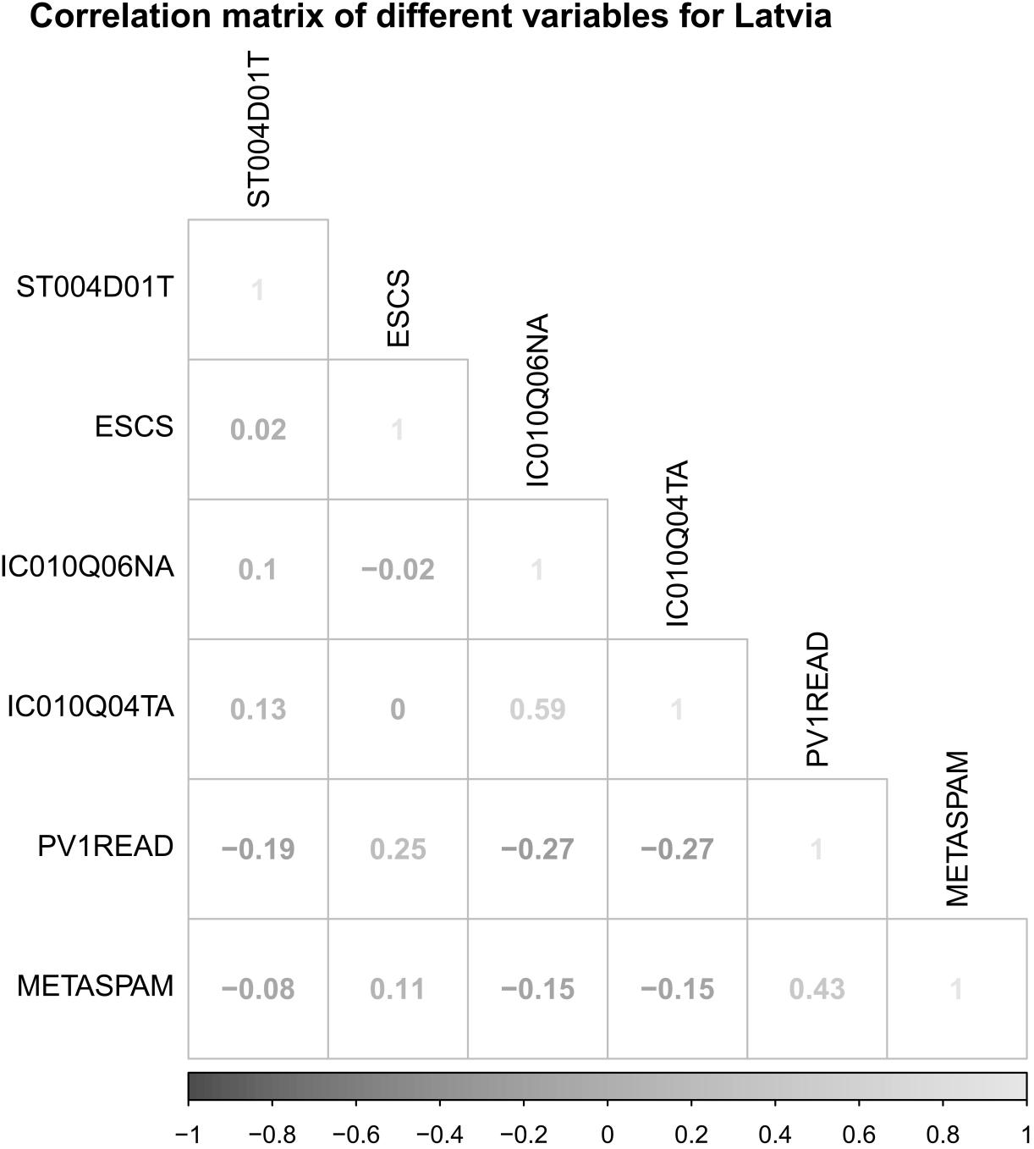
Figure S29. Correlations between different variables.

- Lithuania
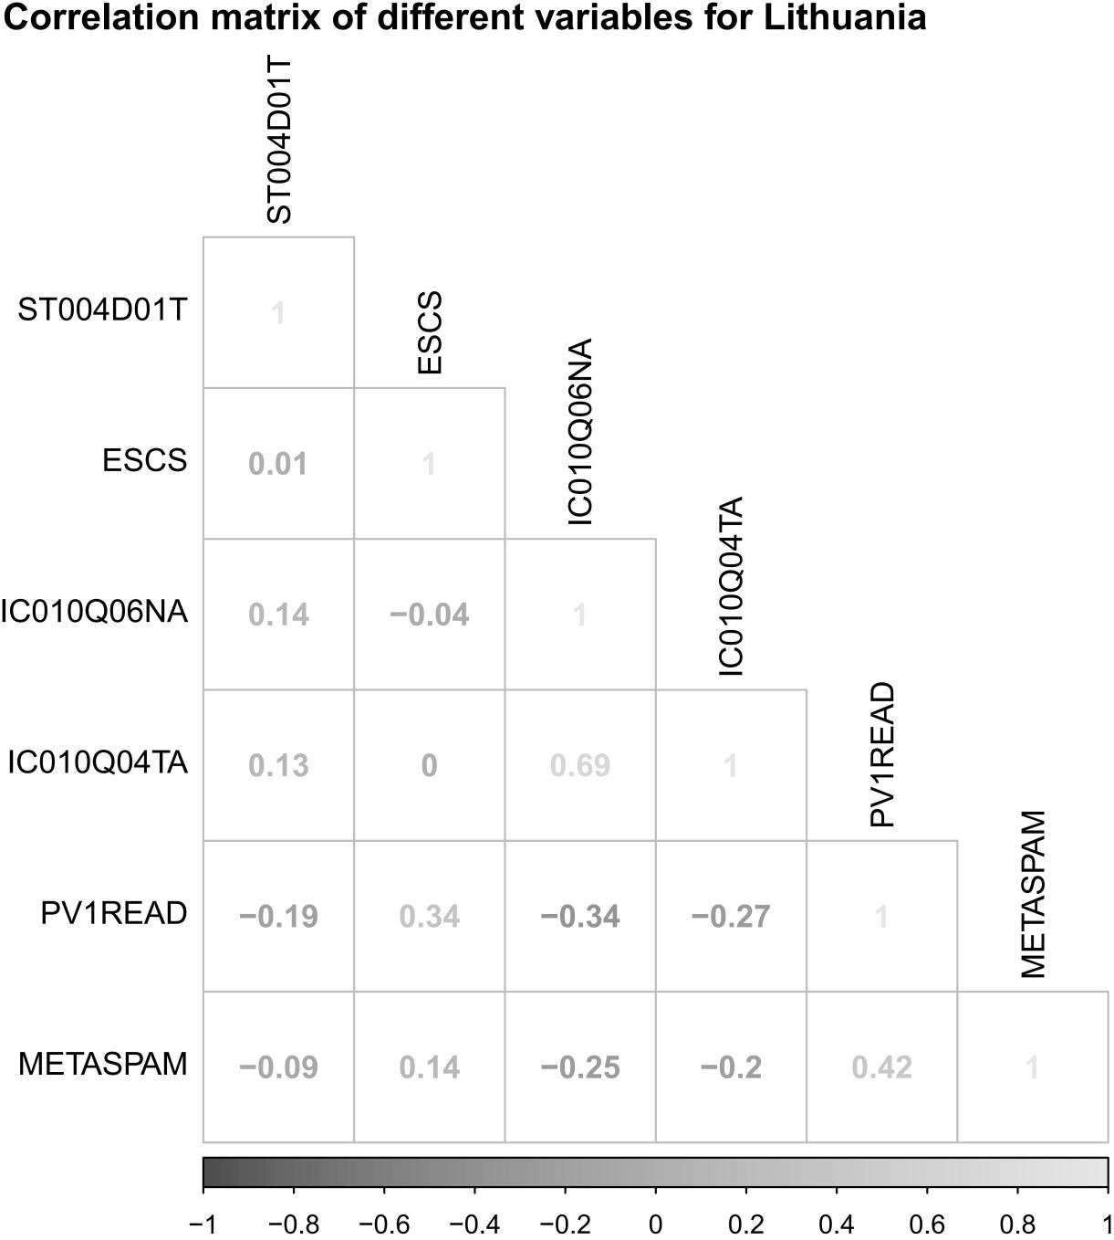
Figure S30. Correlations between different variables.

- Luxembourg
Figure S31. Correlations between different variables.

- Macao
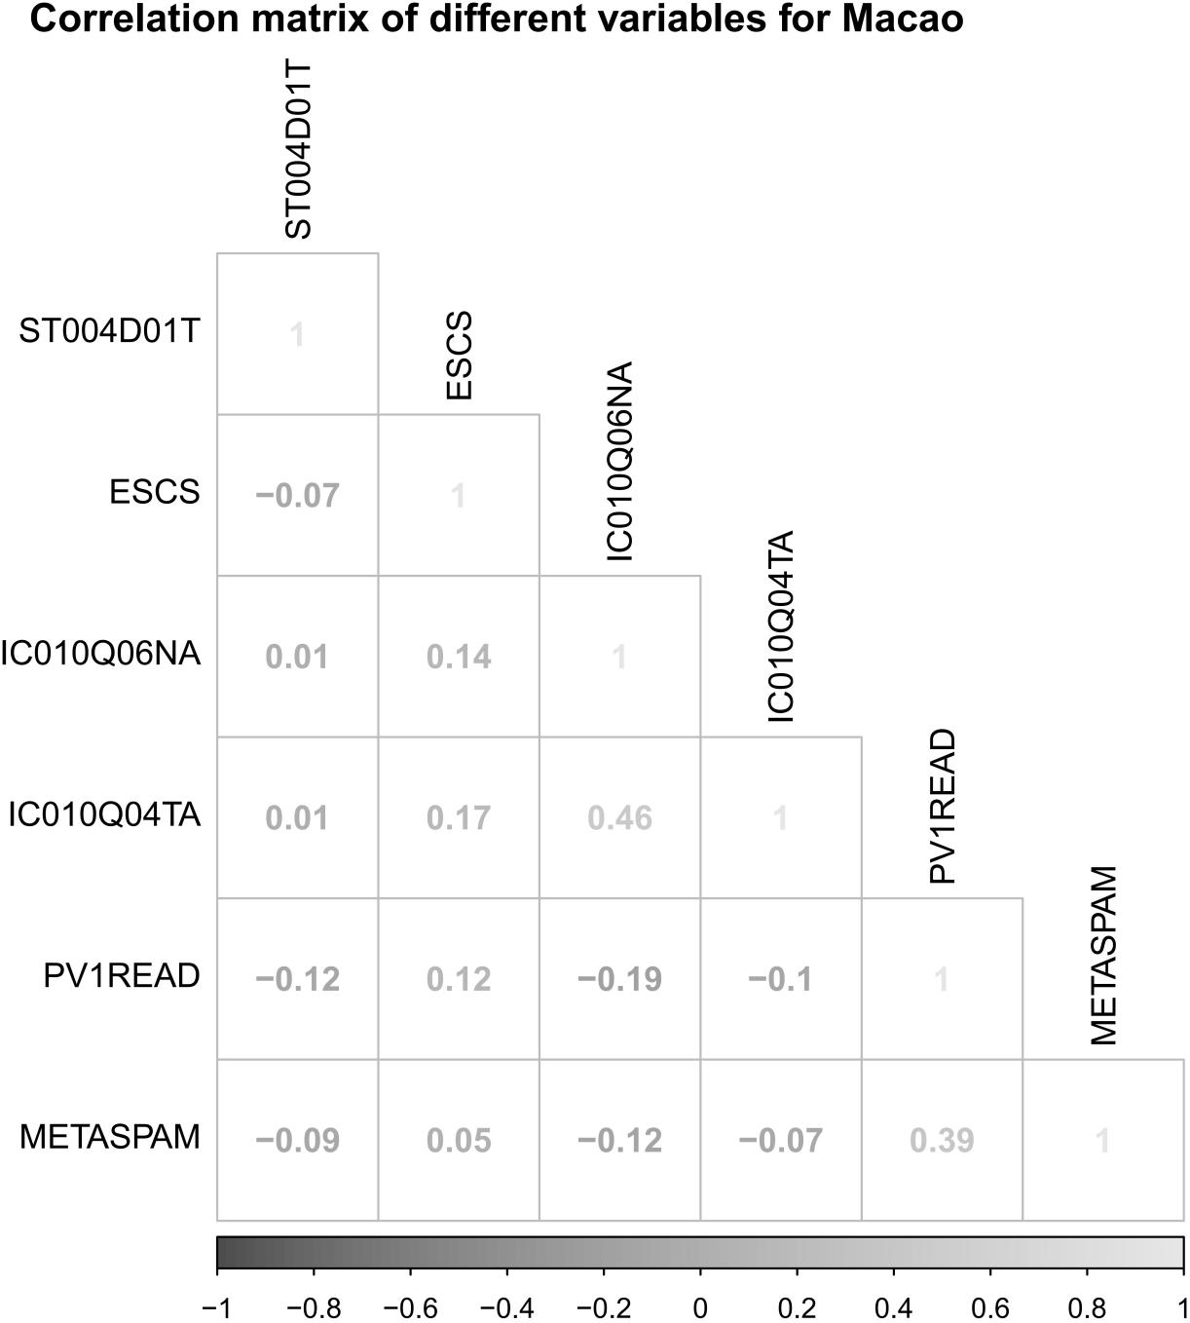
Figure S32. Correlations between different variables.

- Malta
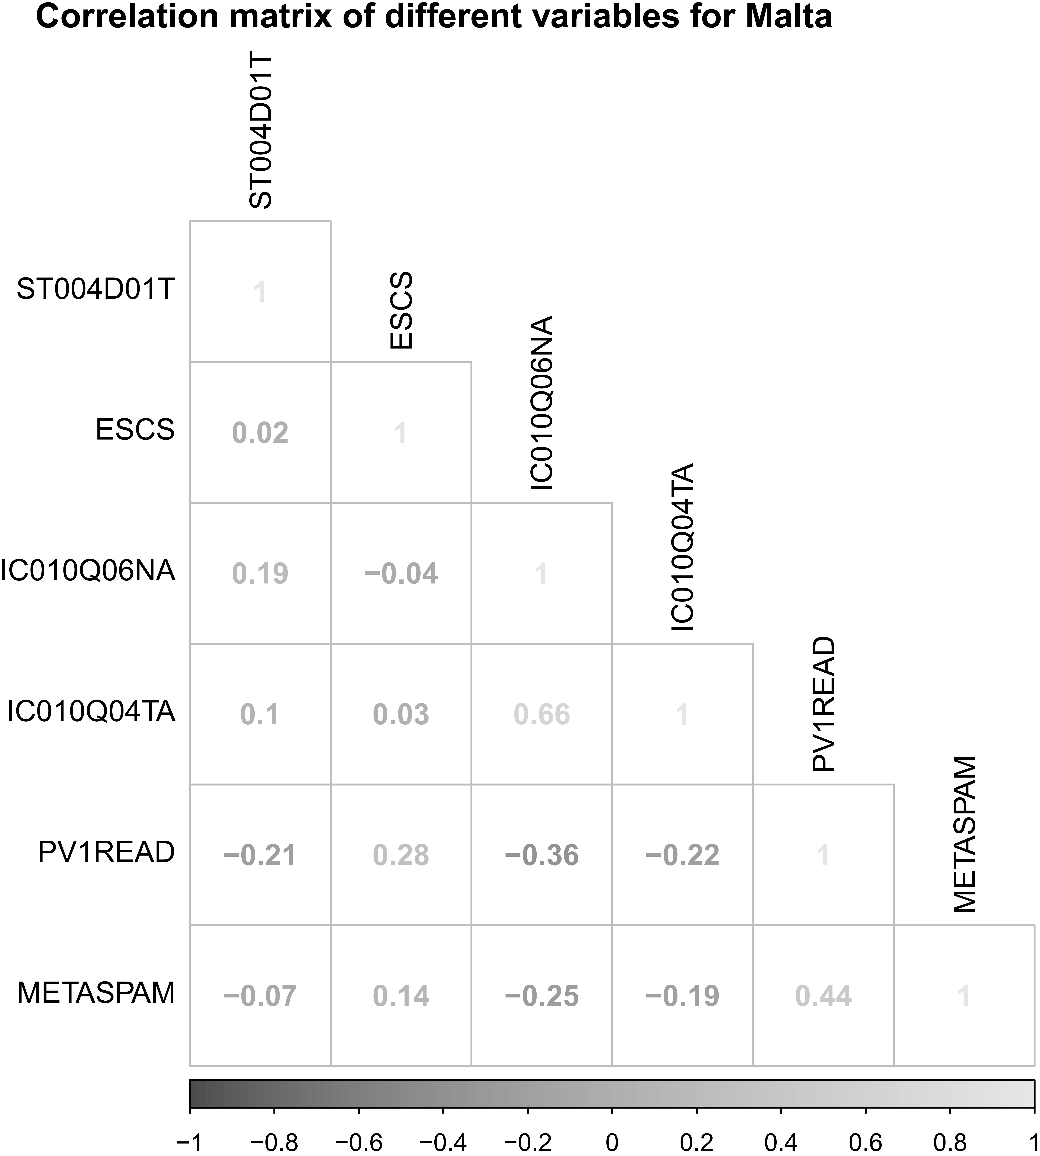
Figure S33. Correlations between different variables.

- Mexico
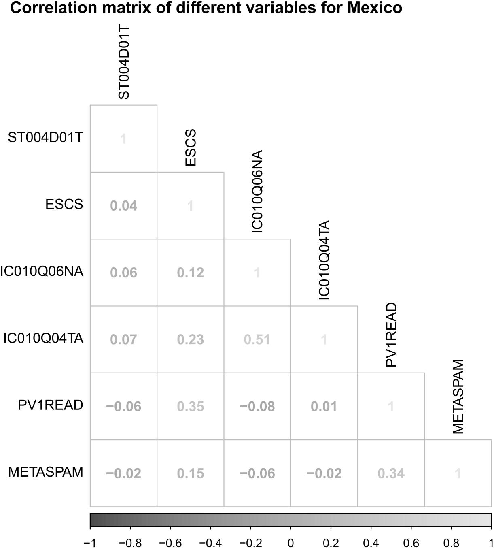
Figure S34. Correlations between different variables.

- Morocco
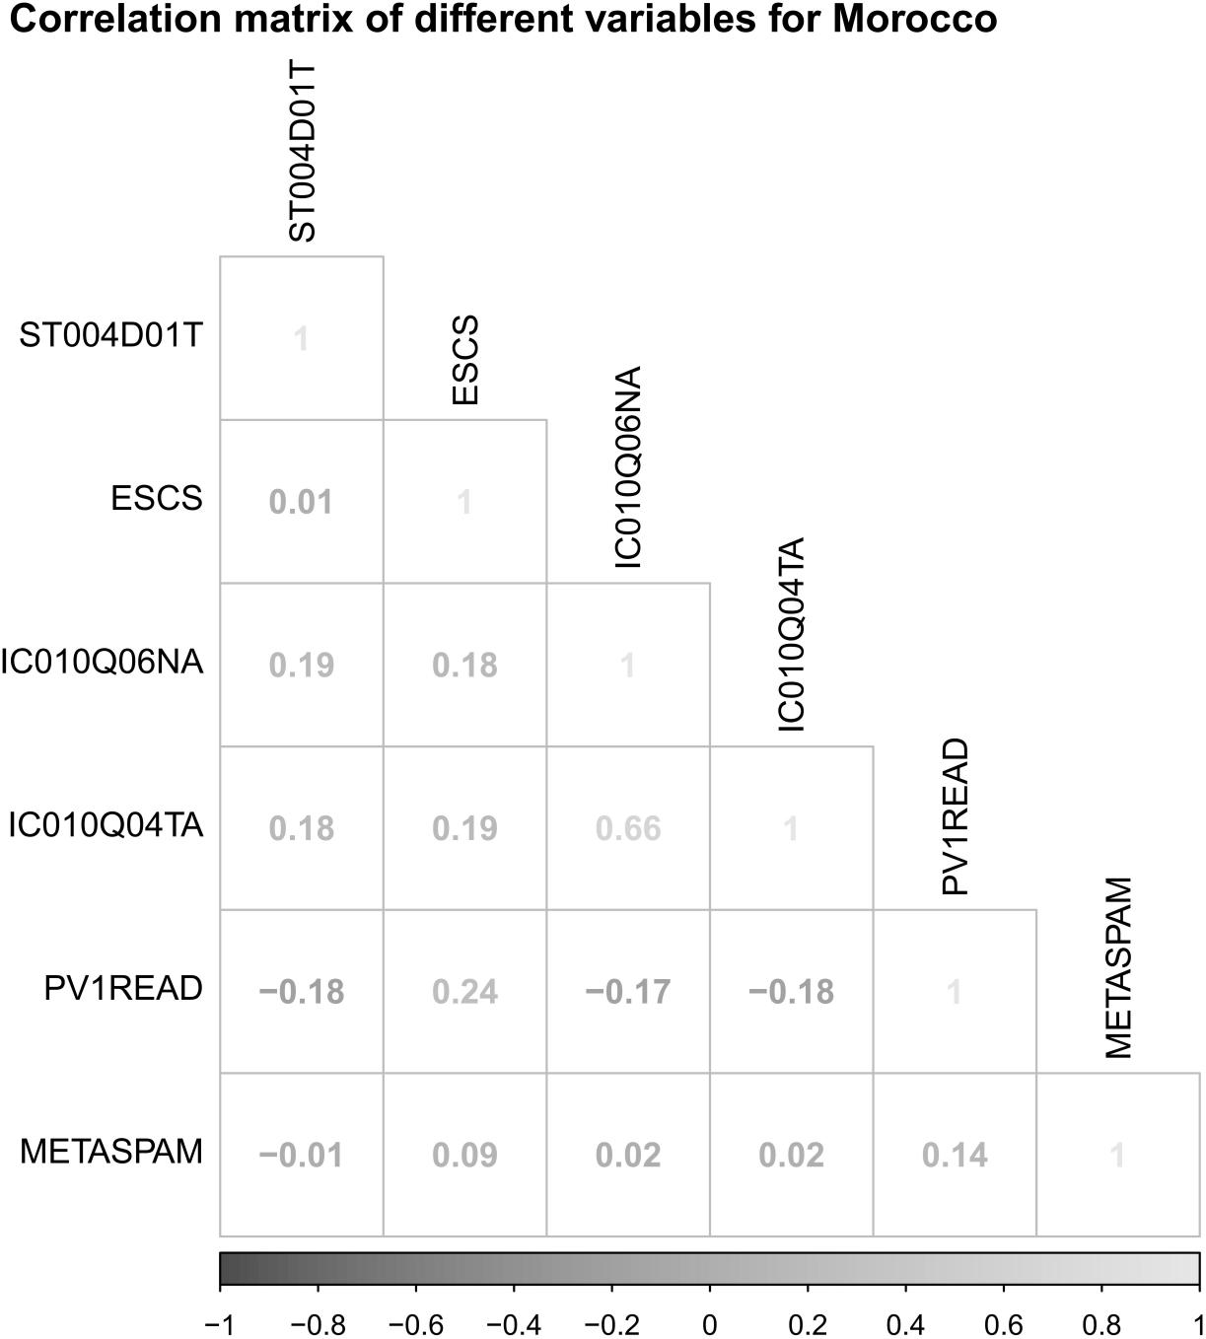
Figure S35. Correlations between different variables.

- New Zealand
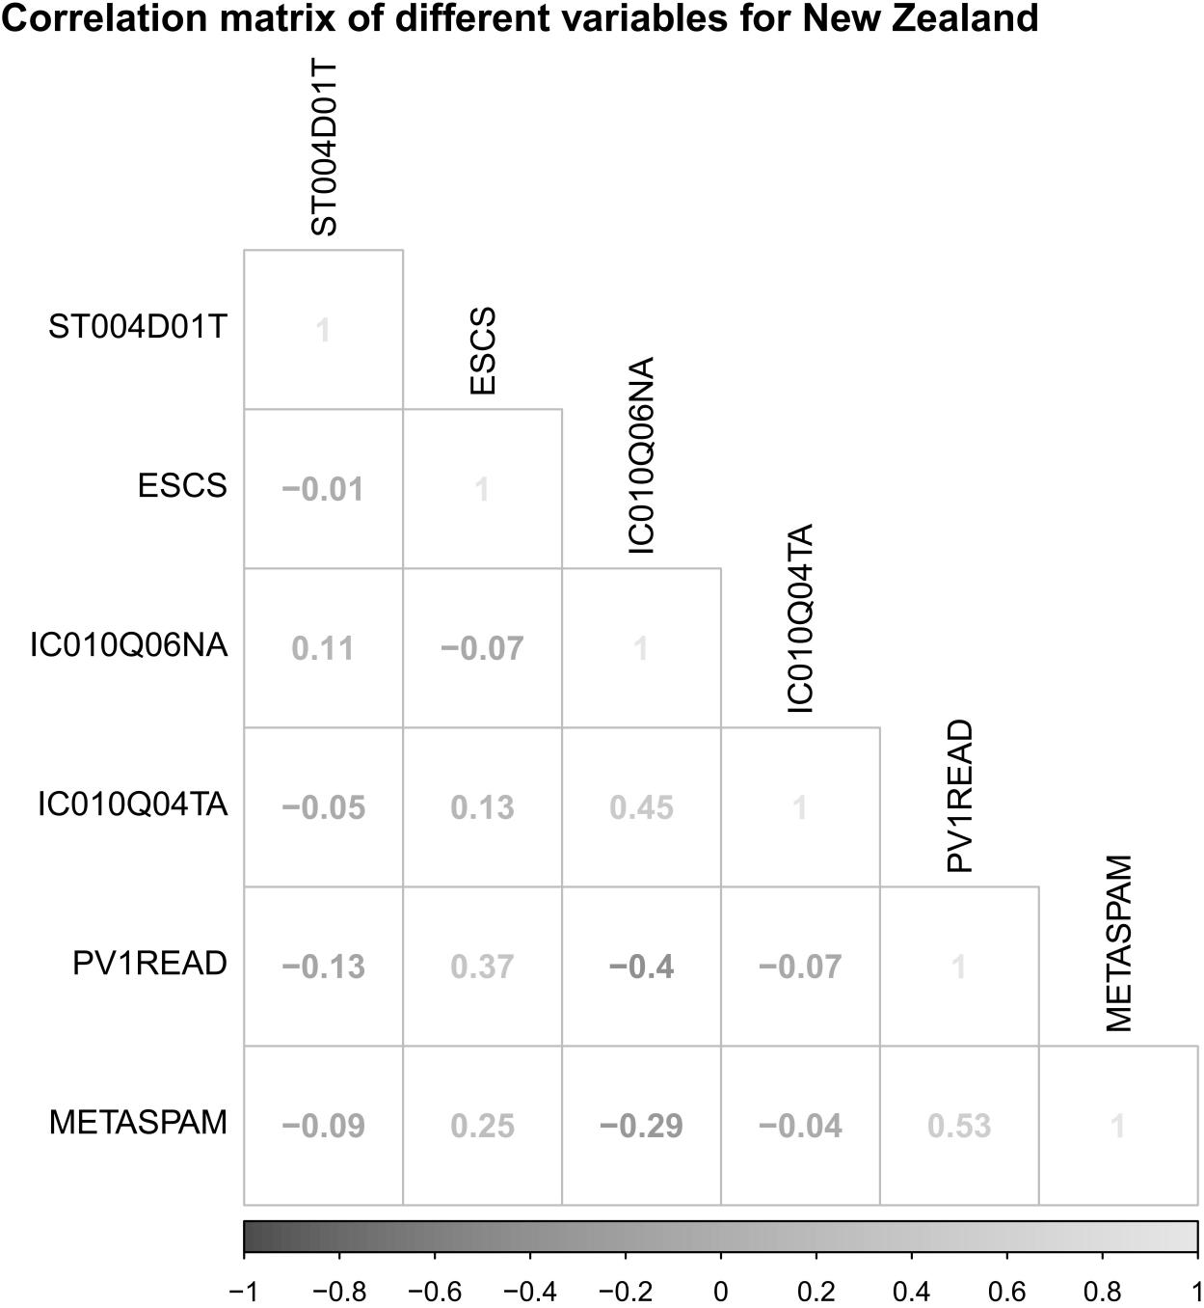
Figure S36. Correlations between different variables.

- Panama
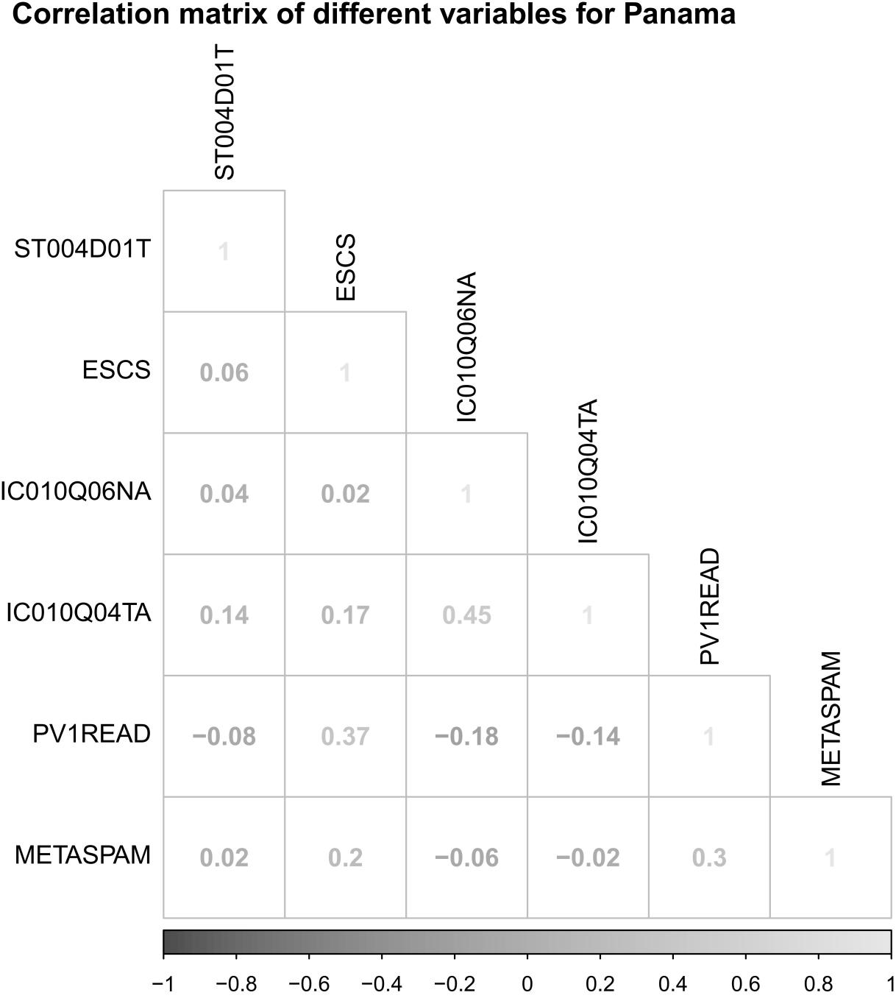
Figure S37. Correlations between different variables.

- Poland
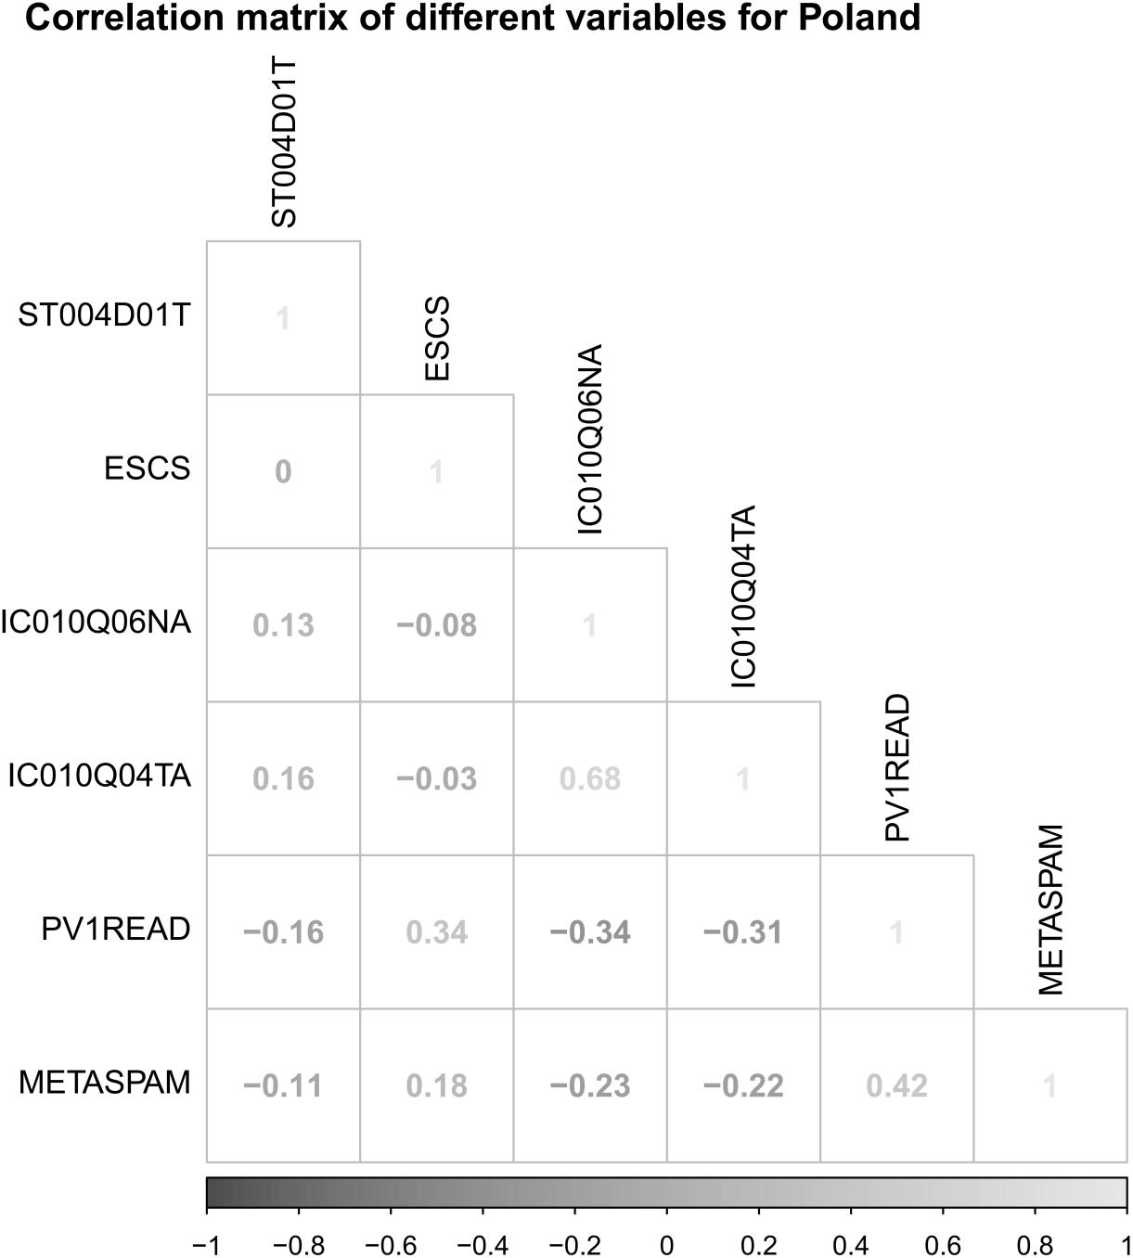
Figure S38. Correlations between different variables.

- Russian Federation
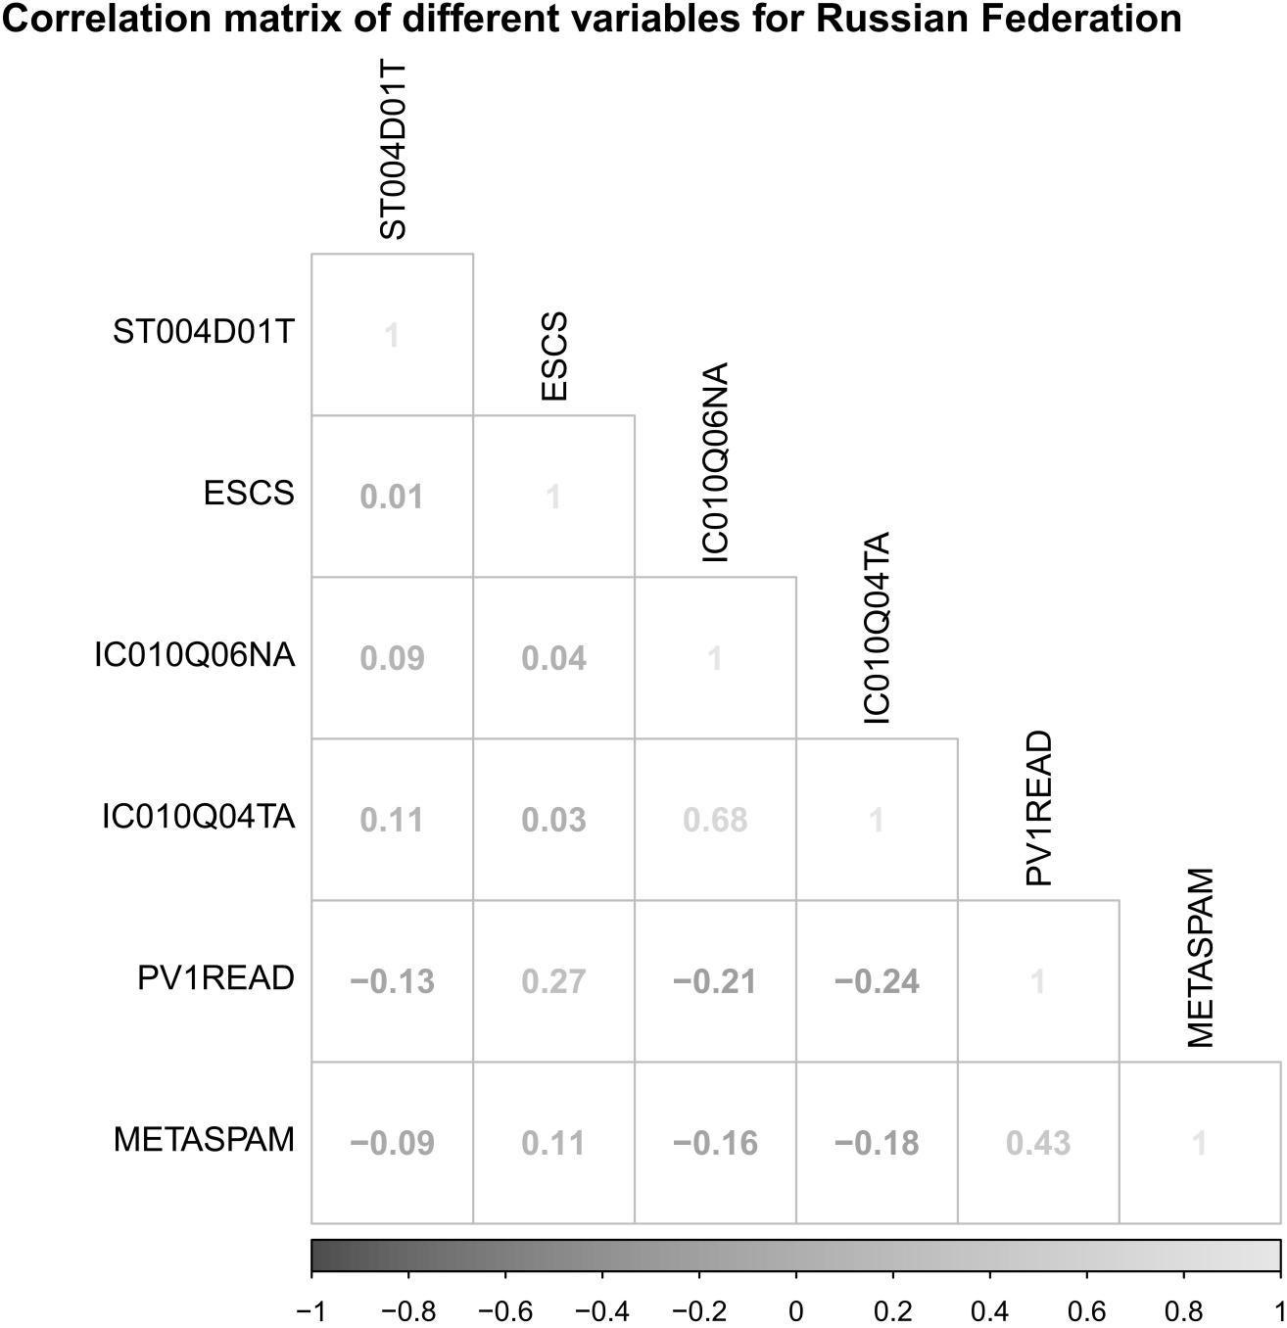
Figure S39. Correlations between different variables.

- Serbia
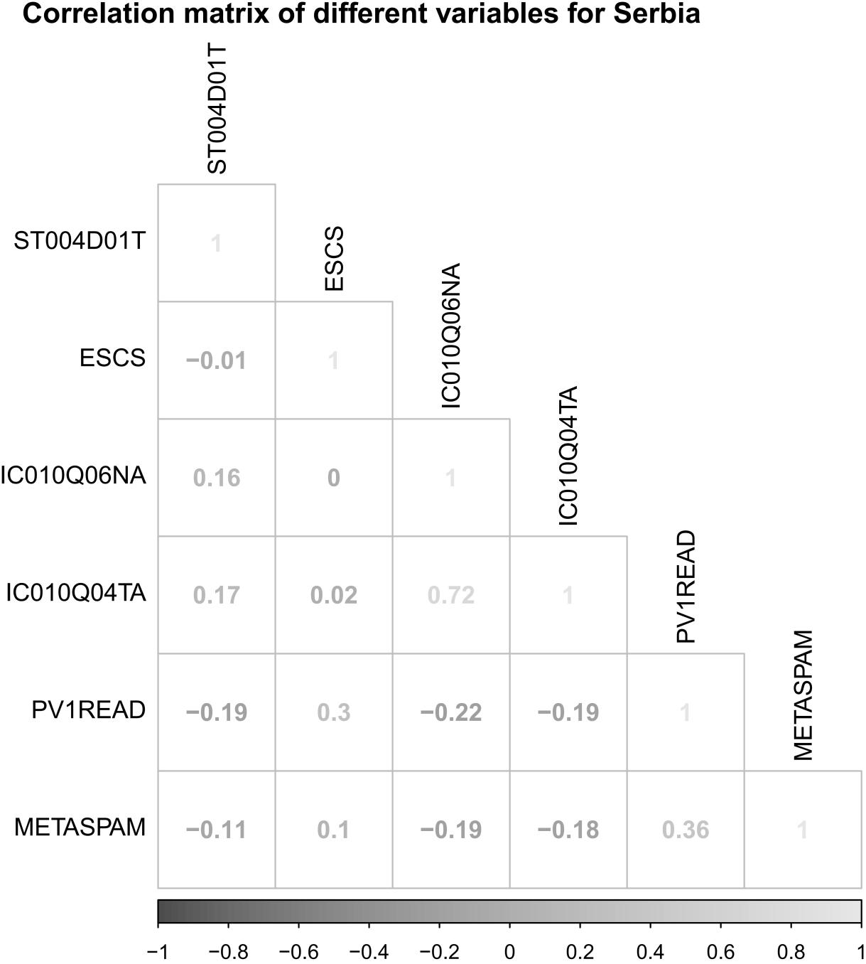
Figure S40. Correlations between different variables.

- Singapore
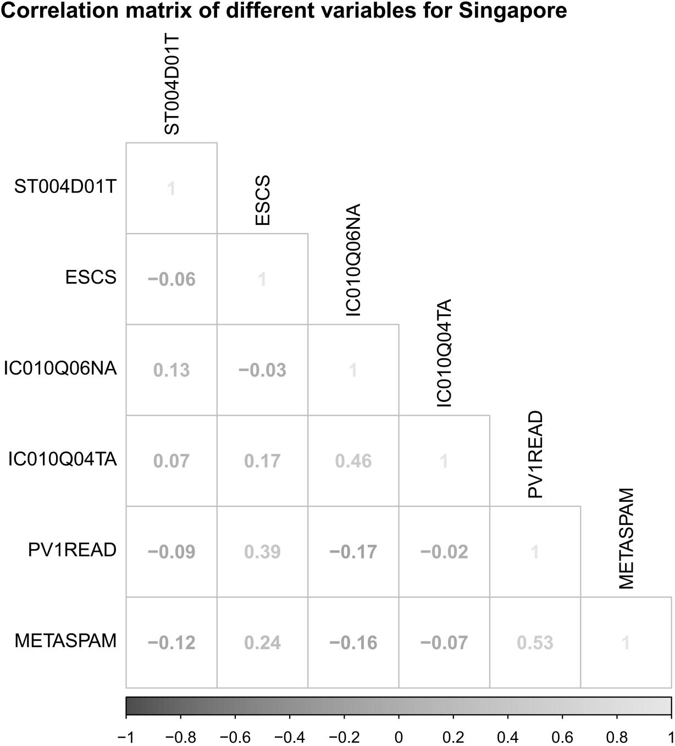
Figure S41. Correlations between different variables.

- Slovak Republic
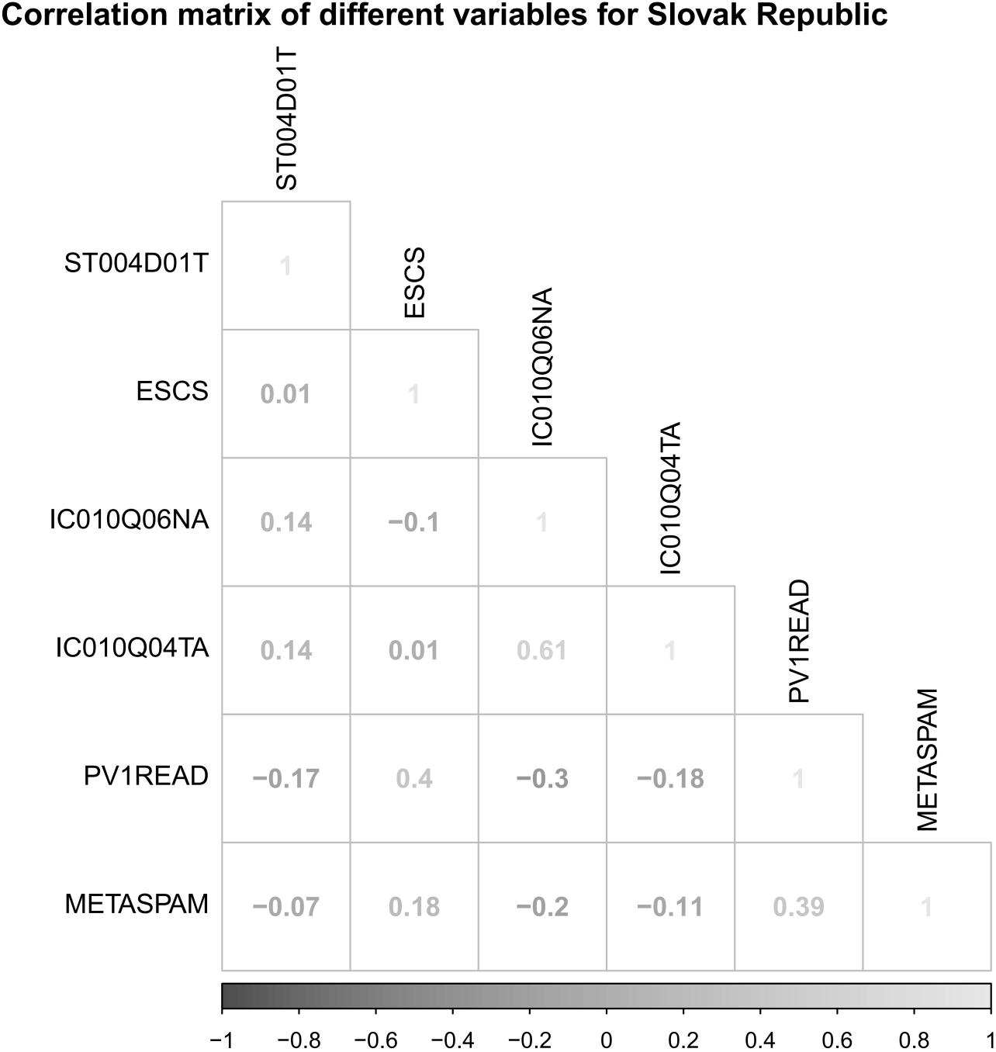
Figure S42. Correlations between different variables.

- Slovenia
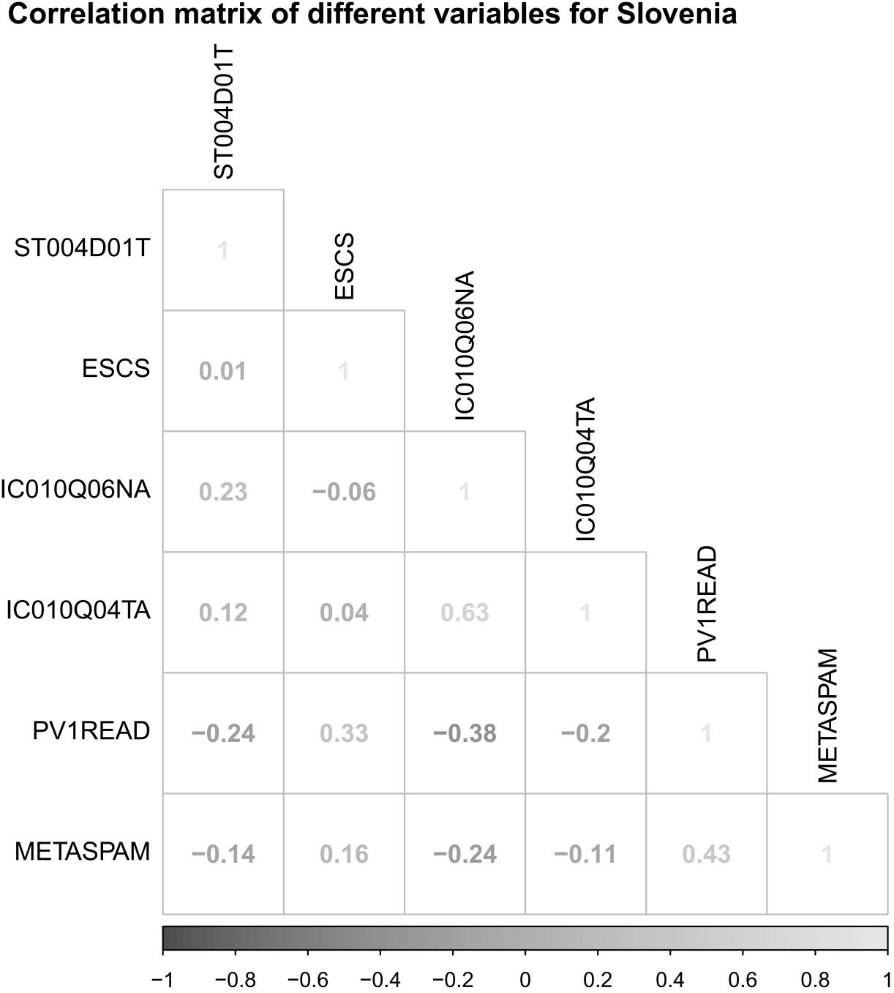
Figure S43. Correlations between different variables.

- Spain
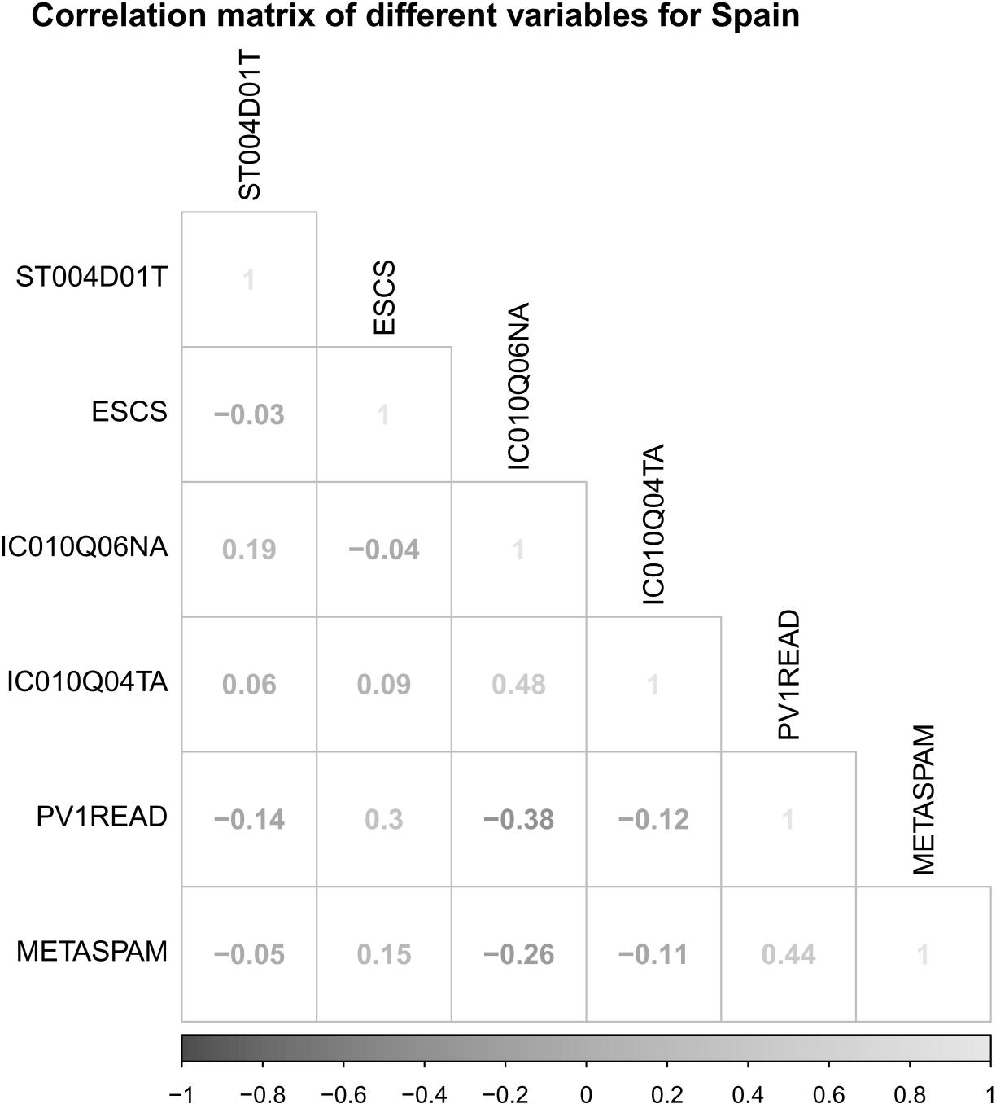
Figure S44. Correlations between different variables.

- Sweden
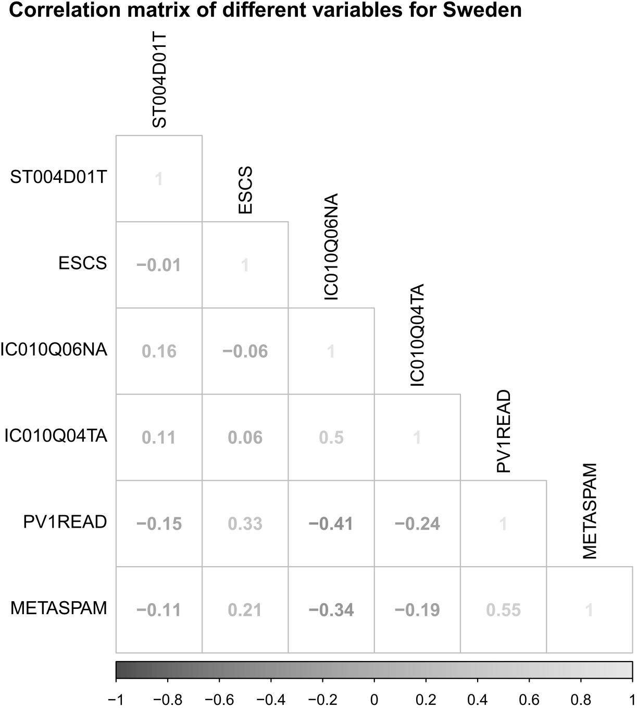
Figure S45. Correlations between different variables.

- Switzerland
Figure S46. Correlations between different variables.

- Thailand
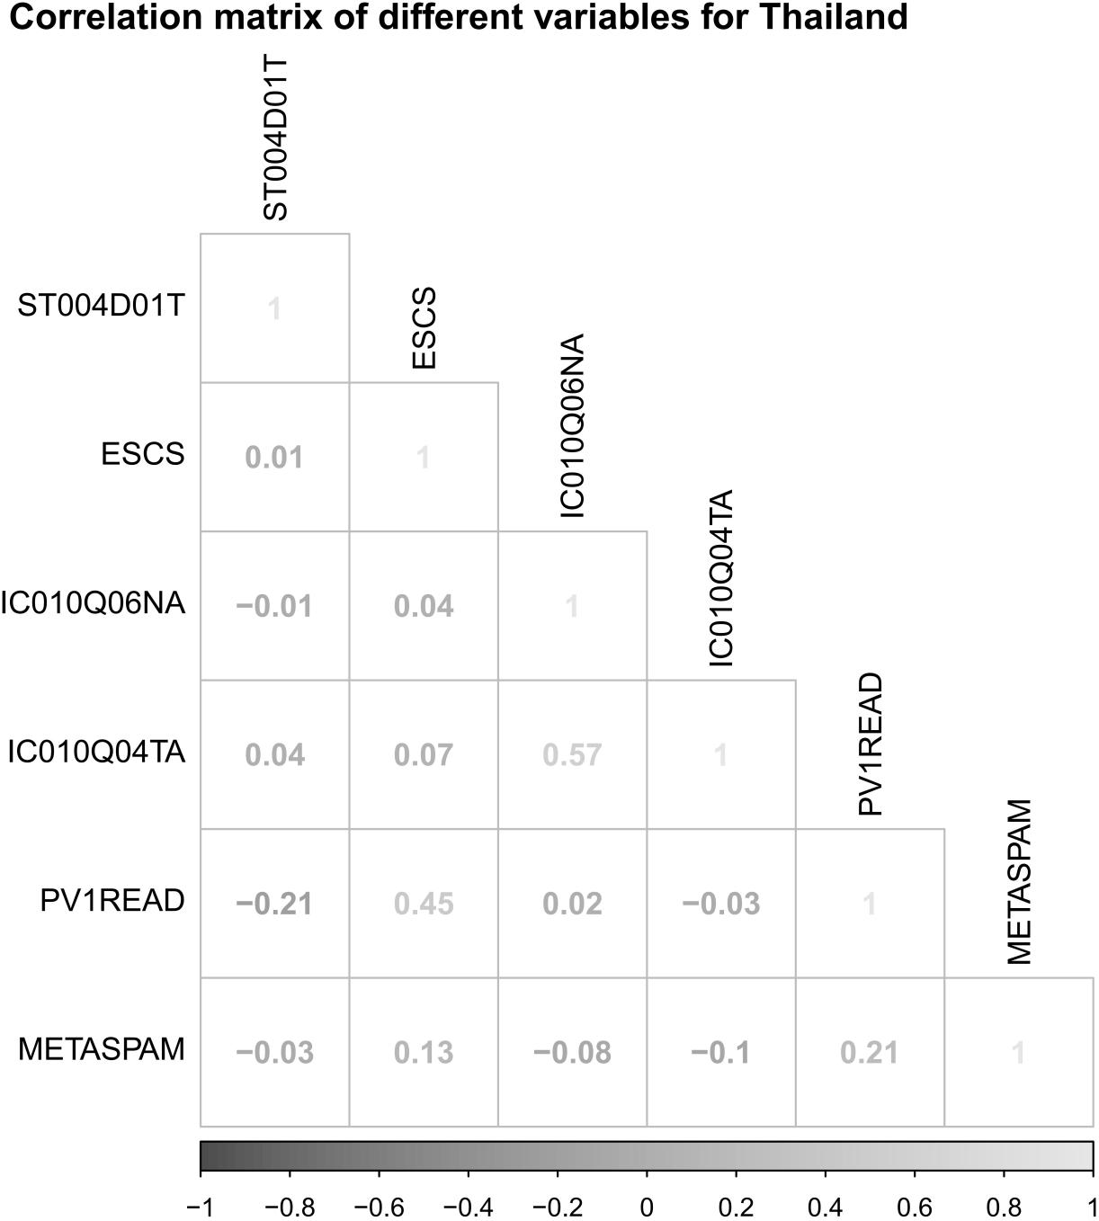
Figure S47. Correlations between different variables.

- Turkey
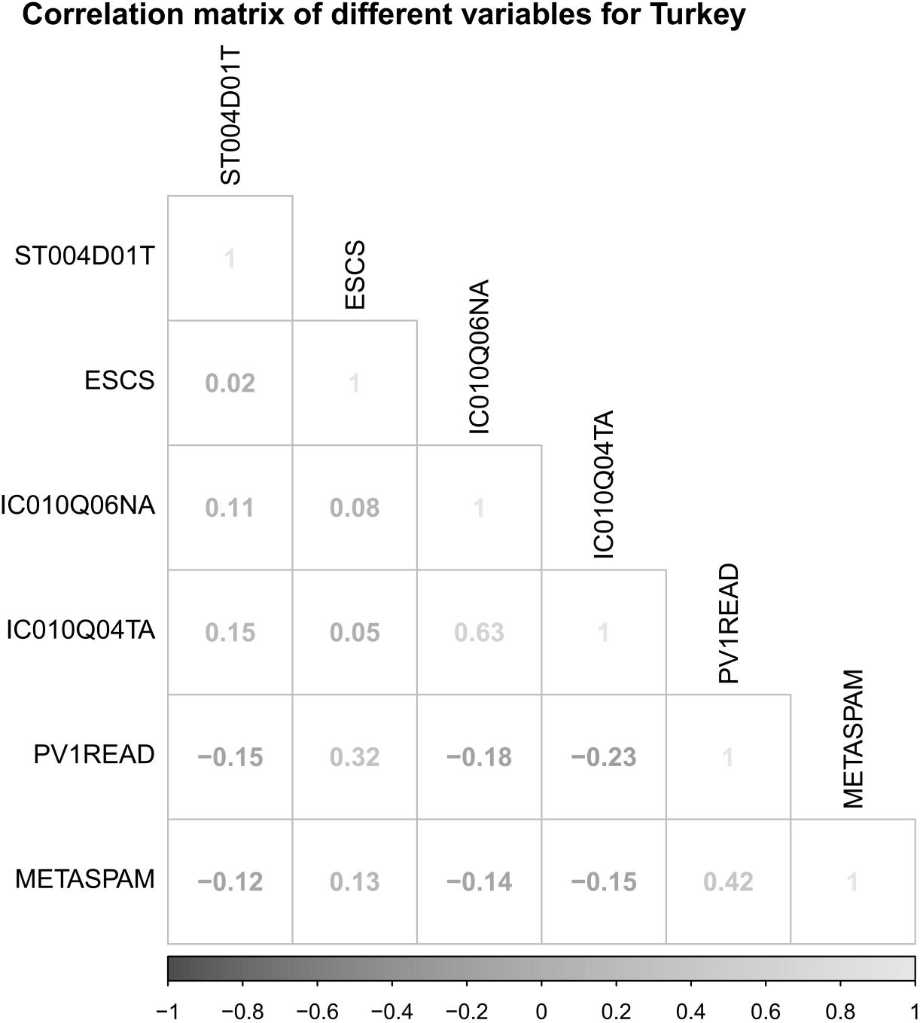
Figure S48. Correlations between different variables.

- United Kingdom
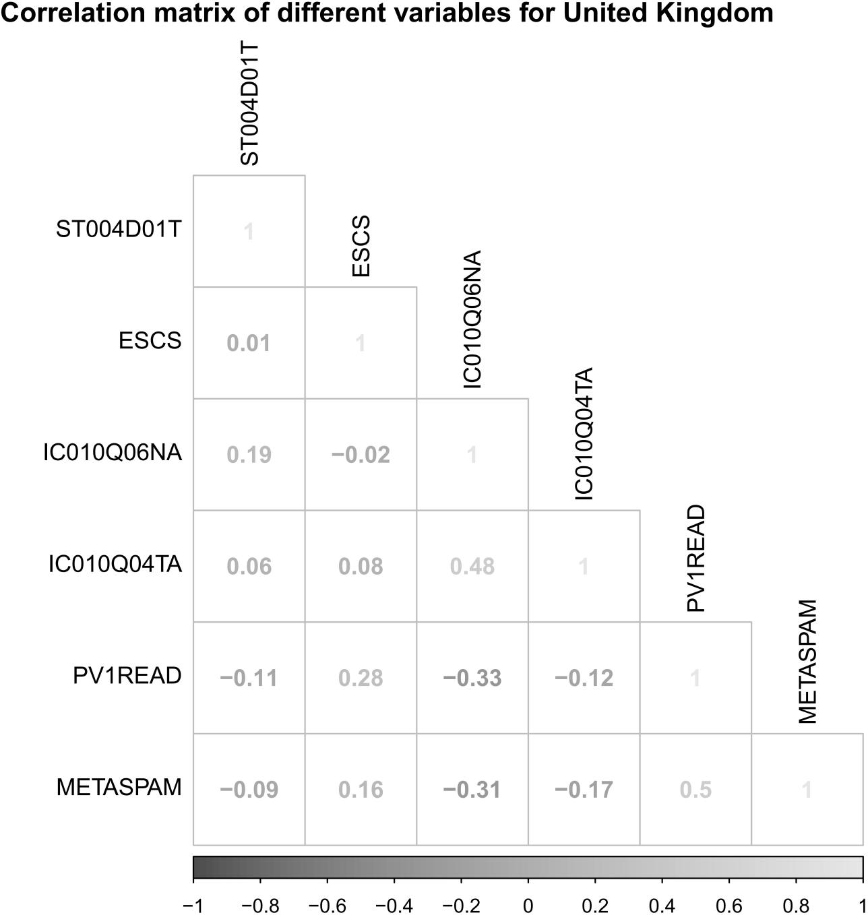
Figure S49. Correlations between different variables.

- United States
Figure S50. Correlations between different variables.

- Uruguay
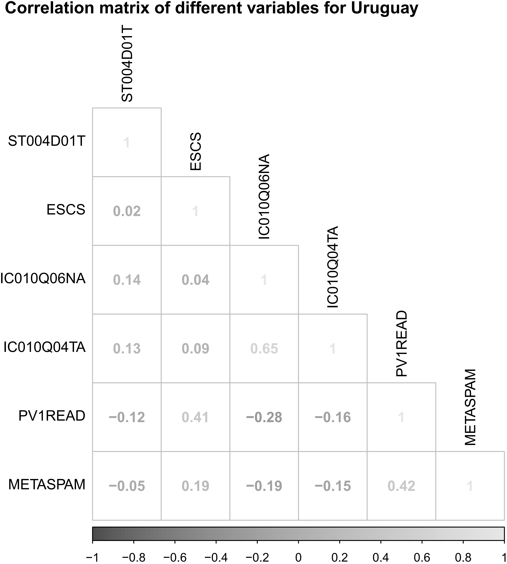
Figure S51. Correlations between different variables.

- Moscow Region (RUS)
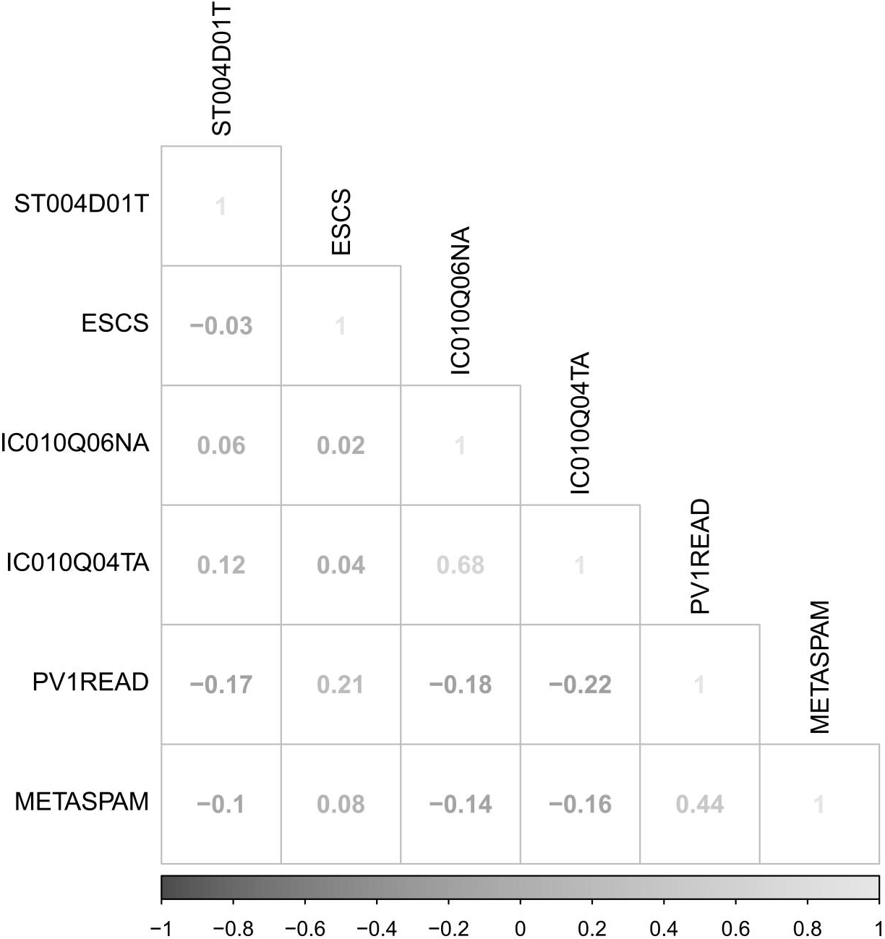
Figure S52. Correlations between different variables.

- Tatarstan (RUS)
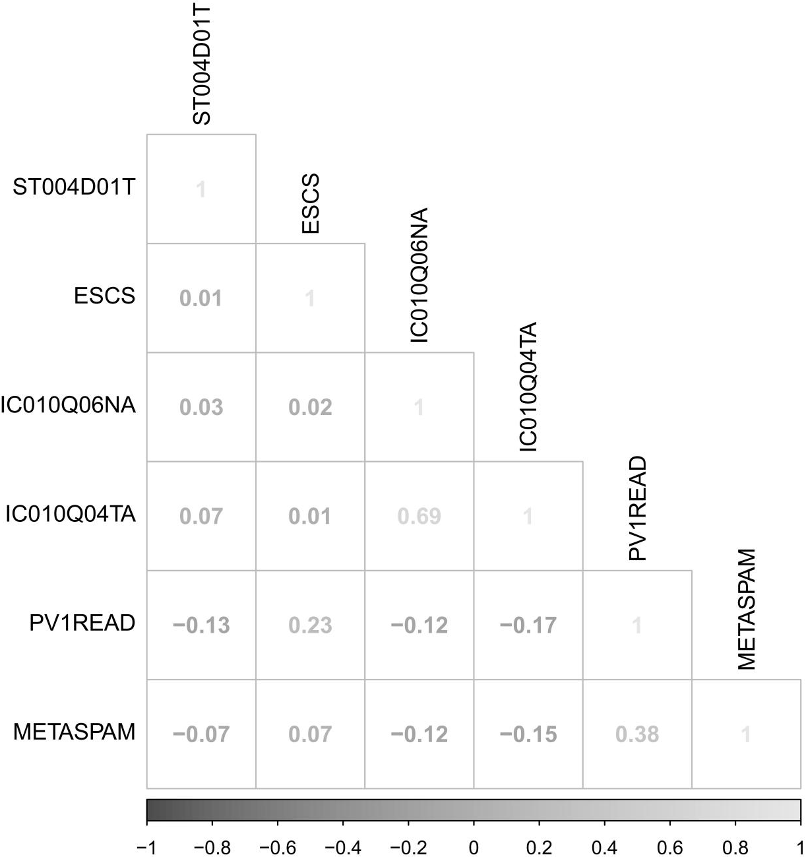
Figure S53. Correlations between different variables.

Table S1. The effects of SCMC on metacognition in the frequency of “once or twice a month”.
Country/Region | b | SE | z | p | CI. lower | CI. upper
Albania | -0.0983 | 0.0366 | -2.6800 | 0.0073 | -0.1721 | -0.0237
Australia | -0.5127 | 0.0265 | -19.3400 | 0.0000 | -0.5662 | -0.4585
Austria | -0.4377 | 0.0325 | -13.4600 | 0.0000 | -0.5039 | -0.3757
Belgium | -0.3866 | 0.0338 | -11.4400 | 0.0000 | -0.4500 | -0.3187
Brazil | -0.1126 | 0.0261 | -4.3100 | 0.0000 | -0.1656 | -0.0631
Brunei Darussalam | -0.1114 | 0.0328 | -3.4000 | 0.0007 | -0.1744 | -0.0398
Bulgaria | -0.2093 | 0.0426 | -4.9200 | 0.0000 | -0.2867 | -0.1285
Chile | -0.2988 | 0.0308 | -9.6980 | 0.0000 | -0.3572 | -0.2390
Chinese Taipei | -0.2400 | 0.0283 | -8.4900 | 0.0000 | -0.2930 | -0.1850
Costa Rica | -0.2397 | 0.0329 | -7.2800 | 0.0000 | -0.3032 | -0.1769
Croatia | -0.3541 | 0.0347 | -10.2000 | 0.0000 | -0.4258 | -0.2915
Czech Republic | -0.3685 | 0.0316 | -11.6700 | 0.0000 | -0.4265 | -0.3034
Denmark | -0.3397 | 0.0319 | -10.6700 | 0.0000 | -0.4036 | -0.2766
Dominican Republic | -0.1291 | 0.0323 | -4.0040 | 0.0001 | -0.1913 | -0.0676
Estonia | -0.2414 | 0.0370 | -6.5200 | 0.0000 | -0.3164 | -0.1725
Finland | -0.4878 | 0.0393 | -12.4200 | 0.0000 | -0.5647 | -0.4135
France | -0.3173 | 0.0389 | -8.1500 | 0.0000 | -0.3958 | -0.2385
Georgia | -0.0310 | 0.0373 | -0.8290 | 0.4070 | -0.1059 | 0.0409
Greece | -0.3900 | 0.0365 | -10.6900 | 0.0000 | -0.4577 | -0.3218
Hong Kong | -0.2058 | 0.0350 | -5.8800 | 0.0000 | -0.2742 | -0.1360
Hungary | -0.0423 | 0.0365 | -1.1600 | 0.2470 | -0.1115 | 0.0287
Iceland | -0.3509 | 0.0441 | -7.9600 | 0.0000 | -0.4379 | -0.2666
Ireland | -0.4140 | 0.0500 | -8.2800 | 0.0000 | -0.5139 | -0.3209
Israel | -0.4445 | 0.0297 | -14.9800 | 0.0000 | -0.5002 | -0.3854
Italy | -0.3034 | 0.0252 | -12.0300 | 0.0000 | -0.3542 | -0.2550
Japan | -0.3051 | 0.0574 | -5.3170 | 0.0000 | -0.4101 | -0.1801
Kazakhstan | -0.1710 | 0.0222 | -7.7100 | 0.0000 | -0.2159 | -0.1258
Korea | -0.1237 | 0.0315 | -3.9300 | 0.0001 | -0.1861 | -0.0632
Latvia | -0.1352 | 0.0363 | -3.7300 | 0.0002 | -0.2037 | -0.0625
Lithuania | -0.2897 | 0.0318 | -9.1200 | 0.0000 | -0.3522 | -0.2252
Luxembourg | -0.3885 | 0.0428 | -9.0800 | 0.0000 | -0.4711 | -0.3023
Macao | -0.0814 | 0.0481 | -1.6900 | 0.0907 | -0.1800 | 0.0060
Malta | -0.2798 | 0.0503 | -5.5600 | 0.0000 | -0.3833 | -0.1844
Mexico | -0.0935 | 0.0340 | -2.7500 | 0.0059 | -0.1630 | -0.0230
Morocco | -0.0198 | 0.0315 | -0.6290 | 0.5290 | -0.0825 | 0.0430
New Zealand | -0.4309 | 0.0421 | -10.2300 | 0.0000 | -0.5196 | -0.3541
Panama | -0.1003 | 0.0321 | -3.1300 | 0.0018 | -0.1627 | -0.0374
Poland | -0.2881 | 0.0369 | -7.8100 | 0.0000 | -0.3627 | -0.2177
Russian Federation | -0.1848 | 0.0331 | -5.5900 | 0.0000 | -0.2503 | -0.1224
Serbia | -0.3482 | 0.0308 | -11.2900 | 0.0000 | -0.4045 | -0.2790
Singapore | -0.1440 | 0.0355 | -4.0500 | 0.0001 | -0.2124 | -0.0715
Slovak Republic | -0.3670 | 0.0348 | -10.5600 | 0.0000 | -0.4374 | -0.2975
Slovenia | -0.3614 | 0.0327 | -11.0600 | 0.0000 | -0.4230 | -0.2963
Spain | -0.3954 | 0.0168 | -23.6000 | 0.0000 | -0.4281 | -0.3597
Sweden | -0.4234 | 0.0442 | -9.5900 | 0.0000 | -0.5121 | -0.3407
Switzerland | -0.2755 | 0.0392 | -7.0200 | 0.0000 | -0.3478 | -0.1915
Thailand | -0.0970 | 0.0488 | -1.9900 | 0.0470 | -0.1977 | -0.0062
Turkey | -0.1292 | 0.0306 | -4.2300 | 0.0000 | -0.1886 | -0.0701
United Kingdom | -0.6076 | 0.0325 | -18.6900 | 0.0000 | -0.6688 | -0.5418
United States | -0.3962 | 0.0404 | -9.8200 | 0.0000 | -0.4693 | -0.3143
Uruguay | -0.3189 | 0.0337 | -9.4600 | 0.0000 | -0.3809 | -0.2573
Moscow Region (RUS) | -0.0843 | 0.0678 | -1.2400 | 0.2140 | -0.2141 | 0.0536
Tatarstan (RUS) | -0.2951 | 0.0405 | -7.2900 | 0.0000 | -0.3782 | -0.2193

Table S2. The effects of SCMC on metacognition in the frequency of “once or twice a week”.
Country/Region | b | SE | z | p | CI. lower | CI. upper
Albania | -0.0724 | 0.0372 | -1.9500 | 0.0516 | -0.1413 | 0.0052
Australia | -0.7046 | 0.0218 | -32.3400 | 0.0000 | -0.7469 | -0.6603
Austria | -0.6443 | 0.0338 | -19.0700 | 0.0000 | -0.7129 | -0.5805
Belgium | -0.5158 | 0.0338 | -15.2800 | 0.0000 | -0.5764 | -0.4494
Brazil | -0.1513 | 0.0257 | -5.9000 | 0.0000 | -0.2017 | -0.1003
Brunei Darussalam | -0.2250 | 0.0320 | -7.0400 | 0.0000 | -0.2940 | -0.1679
Bulgaria | -0.1901 | 0.0411 | -4.6200 | 0.0000 | -0.2712 | -0.1108
Chile | -0.4027 | 0.0311 | -12.9580 | 0.0000 | -0.4656 | -0.3415
Chinese Taipei | -0.3060 | 0.0319 | -9.6000 | 0.0000 | -0.3720 | -0.2450
Costa Rica | -0.3419 | 0.0329 | -10.4000 | 0.0000 | -0.4088 | -0.2790
Croatia | -0.4669 | 0.0351 | -13.3000 | 0.0000 | -0.5415 | -0.3995
Czech Republic | -0.5012 | 0.0356 | -14.0600 | 0.0000 | -0.5740 | -0.4331
Denmark | -0.6132 | 0.0331 | -18.5500 | 0.0000 | -0.6779 | -0.5496
Dominican Republic | -0.0827 | 0.0348 | -2.3760 | 0.0175 | -0.1525 | -0.0136
Estonia | -0.4506 | 0.0364 | -12.3800 | 0.0000 | -0.5165 | -0.3762
Finland | -0.6813 | 0.0426 | -16.0000 | 0.0000 | -0.7588 | -0.5961
France | -0.4208 | 0.0383 | -11.0000 | 0.0000 | -0.4992 | -0.3486
Georgia | 0.0232 | 0.0393 | 0.5900 | 0.5550 | -0.0593 | 0.0931
Greece | -0.4178 | 0.0346 | -12.0900 | 0.0000 | -0.4925 | -0.3505
Hong Kong | -0.3649 | 0.0321 | -11.3800 | 0.0000 | -0.4256 | -0.2973
Hungary | -0.1953 | 0.0366 | -5.3300 | 0.0000 | -0.2721 | -0.1217
Iceland | -0.5319 | 0.0461 | -11.5400 | 0.0000 | -0.6233 | -0.4417
Ireland | -0.4831 | 0.0507 | -9.5300 | 0.0000 | -0.5781 | -0.3763
Israel | -0.4151 | 0.0307 | -13.5100 | 0.0000 | -0.4771 | -0.3540
Italy | -0.3948 | 0.0250 | -15.7800 | 0.0000 | -0.4388 | -0.3382
Japan | -0.4680 | 0.0647 | -7.2310 | 0.0000 | -0.5857 | -0.3408
Kazakhstan | -0.2153 | 0.0211 | -10.1900 | 0.0000 | -0.2552 | -0.1743
Korea | -0.3364 | 0.0321 | -10.4700 | 0.0000 | -0.3934 | -0.2648
Latvia | -0.3421 | 0.0376 | -9.1000 | 0.0000 | -0.4168 | -0.2629
Lithuania | -0.5126 | 0.0314 | -16.3200 | 0.0000 | -0.5717 | -0.4470
Luxembourg | -0.6581 | 0.0357 | -18.4300 | 0.0000 | -0.7246 | -0.5877
Macao | -0.3363 | 0.0454 | -7.4100 | 0.0000 | -0.4254 | -0.2482
Malta | -0.4924 | 0.0464 | -10.6200 | 0.0000 | -0.5864 | -0.4036
Mexico | -0.1352 | 0.0312 | -4.3300 | 0.0000 | -0.1967 | -0.0742
Morocco | 0.0181 | 0.0330 | 0.5480 | 0.5840 | -0.0444 | 0.0839
New Zealand | -0.6084 | 0.0380 | -16.0000 | 0.0000 | -0.6816 | -0.5354
Panama | -0.0867 | 0.0324 | -2.6740 | 0.0075 | -0.1496 | -0.0217
Poland | -0.3933 | 0.0355 | -11.0900 | 0.0000 | -0.4613 | -0.3198
Russian Federation | -0.3536 | 0.0329 | -10.7400 | 0.0000 | -0.4186 | -0.2934
Serbia | -0.4143 | 0.0304 | -13.6200 | 0.0000 | -0.4760 | -0.3525
Singapore | -0.2612 | 0.0319 | -8.1800 | 0.0000 | -0.3182 | -0.1920
Slovak Republic | -0.4055 | 0.0336 | -12.0600 | 0.0000 | -0.4765 | -0.3392
Slovenia | -0.4928 | 0.0325 | -15.1500 | 0.0000 | -0.5603 | -0.4312
Spain | -0.5451 | 0.0161 | -33.9300 | 0.0000 | -0.5758 | -0.5151
Sweden | -0.6652 | 0.0401 | -16.5900 | 0.0000 | -0.7462 | -0.5855
Switzerland | -0.5552 | 0.0377 | -14.7200 | 0.0000 | -0.6267 | -0.4828
Thailand | -0.1700 | 0.0448 | -3.8000 | 0.0001 | -0.2547 | -0.0831
Turkey | -0.2877 | 0.0311 | -9.2500 | 0.0000 | -0.3441 | -0.2277
United Kingdom | -0.7488 | 0.0290 | -25.8000 | 0.0000 | -0.8049 | -0.6879
United States | -0.4824 | 0.0400 | -12.0500 | 0.0000 | -0.5608 | -0.4049
Uruguay | -0.2937 | 0.0348 | -8.4300 | 0.0000 | -0.3631 | -0.2263
Moscow Region (RUS) | -0.3447 | 0.0655 | -5.2600 | 0.0000 | -0.4747 | -0.2203
Tatarstan (RUS) | -0.3806 | 0.0388 | -9.8000 | 0.0000 | -0.4605 | -0.3061

Table S3. The effects of SCMC on metacognition in the frequency of “almost every day”.
Country/Region | b | SE | z | p | CI. lower | CI. upper
Albania | -0.1763 | 0.0383 | -4.6000 | 0.0000 | -0.2498 | -0.1044
Australia | -0.6086 | 0.0296 | -20.5500 | 0.0000 | -0.6650 | -0.5491
Austria | -0.6136 | 0.0468 | -13.1100 | 0.0000 | -0.7022 | -0.5201
Belgium | -0.4585 | 0.0404 | -11.3500 | 0.0000 | -0.5365 | -0.3750
Brazil | -0.2365 | 0.0274 | -8.6300 | 0.0000 | -0.2891 | -0.1786
Brunei Darussalam | -0.2184 | 0.0410 | -5.3300 | 0.0000 | -0.2984 | -0.1370
Bulgaria | -0.3510 | 0.0444 | -7.9100 | 0.0000 | -0.4381 | -0.2644
Chile | -0.4838 | 0.0342 | -14.1350 | 0.0000 | -0.5494 | -0.4125
Chinese Taipei | -0.3920 | 0.0468 | -8.3700 | 0.0000 | -0.4820 | -0.3050
Costa Rica | -0.3341 | 0.0339 | -9.8700 | 0.0000 | -0.4006 | -0.2663
Croatia | -0.5114 | 0.0401 | -12.7500 | 0.0000 | -0.5881 | -0.4325
Czech Republic | -0.4521 | 0.0468 | -9.6600 | 0.0000 | -0.5419 | -0.3627
Denmark | -0.6676 | 0.0417 | -16.0100 | 0.0000 | -0.7531 | -0.5829
Dominican Republic | -0.2828 | 0.0359 | -7.8770 | 0.0000 | -0.3575 | -0.2131
Estonia | -0.4819 | 0.0468 | -10.2900 | 0.0000 | -0.5656 | -0.3822
Finland | -0.8262 | 0.0618 | -13.3600 | 0.0000 | -0.9422 | -0.7029
France | -0.4896 | 0.0450 | -10.8800 | 0.0000 | -0.5742 | -0.3993
Georgia | 0.0519 | 0.0406 | 1.2770 | 0.2020 | -0.0292 | 0.1266
Greece | -0.5042 | 0.0400 | -12.6200 | 0.0000 | -0.5890 | -0.4267
Hong Kong | -0.4795 | 0.0461 | -10.4100 | 0.0000 | -0.5746 | -0.3939
Hungary | -0.2443 | 0.0425 | -5.7500 | 0.0000 | -0.3323 | -0.1633
Iceland | -0.5059 | 0.0688 | -7.3500 | 0.0000 | -0.6414 | -0.3682
Ireland | -0.5778 | 0.0692 | -8.3400 | 0.0000 | -0.7255 | -0.4508
Israel | -0.4830 | 0.0437 | -11.0500 | 0.0000 | -0.5698 | -0.3896
Italy | -0.3725 | 0.0293 | -12.7200 | 0.0000 | -0.4274 | -0.3145
Japan | -0.6515 | 0.0849 | -7.6720 | 0.0000 | -0.8217 | -0.4855
Kazakhstan | -0.1993 | 0.0233 | -8.5500 | 0.0000 | -0.2412 | -0.1454
Korea | -0.4035 | 0.0429 | -9.4000 | 0.0000 | -0.4857 | -0.3176
Latvia | -0.3485 | 0.0436 | -7.9900 | 0.0000 | -0.4318 | -0.2513
Lithuania | -0.5453 | 0.0357 | -15.2600 | 0.0000 | -0.6164 | -0.4770
Luxembourg | -0.5804 | 0.0476 | -12.1800 | 0.0000 | -0.6711 | -0.4872
Macao | -0.2745 | 0.0594 | -4.6200 | 0.0000 | -0.3966 | -0.1635
Malta | -0.5382 | 0.0519 | -10.3800 | 0.0000 | -0.6412 | -0.4386
Mexico | -0.2394 | 0.0311 | -7.7100 | 0.0000 | -0.3010 | -0.1777
Morocco | 0.0395 | 0.0395 | 0.9990 | 0.3180 | -0.0344 | 0.1168
New Zealand | -0.6455 | 0.0476 | -13.5600 | 0.0000 | -0.7418 | -0.5490
Panama | -0.1960 | 0.0328 | -5.9820 | 0.0000 | -0.2602 | -0.1317
Poland | -0.4998 | 0.0391 | -12.7800 | 0.0000 | -0.5764 | -0.4177
Russian Federation | -0.3805 | 0.0335 | -11.3500 | 0.0000 | -0.4469 | -0.3108
Serbia | -0.3619 | 0.0391 | -9.2700 | 0.0000 | -0.4436 | -0.2919
Singapore | -0.4172 | 0.0396 | -10.5300 | 0.0000 | -0.4932 | -0.3367
Slovak Republic | -0.4051 | 0.0392 | -10.3400 | 0.0000 | -0.4864 | -0.3306
Slovenia | -0.4769 | 0.0398 | -11.9900 | 0.0000 | -0.5513 | -0.3928
Spain | -0.5796 | 0.0191 | -30.4300 | 0.0000 | -0.6182 | -0.5428
Sweden | -0.7630 | 0.0466 | -16.3600 | 0.0000 | -0.8481 | -0.6637
Switzerland | -0.5706 | 0.0461 | -12.3800 | 0.0000 | -0.6619 | -0.4801
Thailand | -0.2519 | 0.0433 | -5.8200 | 0.0000 | -0.3381 | -0.1748
Turkey | -0.2663 | 0.0375 | -7.1000 | 0.0000 | -0.3364 | -0.1850
United Kingdom | -0.7308 | 0.0440 | -16.6100 | 0.0000 | -0.8119 | -0.6419
United States | -0.5879 | 0.0498 | -11.7900 | 0.0000 | -0.6945 | -0.4875
Uruguay | -0.4707 | 0.0375 | -12.5600 | 0.0000 | -0.5406 | -0.3922
Moscow Region (RUS) | -0.2768 | 0.0666 | -4.1600 | 0.0000 | -0.3979 | -0.1388
Tatarstan (RUS) | -0.4202 | 0.0400 | -10.5100 | 0.0000 | -0.4972 | -0.3403

Table S4. The effects of SCMC on metacognition in the frequency of “every day”.
Country/Region | b | SE | z | p | CI. lower | CI. upper
Albania | -0.2402 | 0.0406 | -5.9200 | 0.0000 | -0.3197 | -0.1648
Australia | -0.5824 | 0.0332 | -17.5600 | 0.0000 | -0.6455 | -0.5179
Austria | -0.7565 | 0.0634 | -11.9300 | 0.0000 | -0.8812 | -0.6317
Belgium | -0.7439 | 0.0390 | -19.0900 | 0.0000 | -0.8185 | -0.6662
Brazil | -0.3075 | 0.0306 | -10.0600 | 0.0000 | -0.3702 | -0.2463
Brunei Darussalam | -0.1332 | 0.0527 | -2.5300 | 0.0115 | -0.2469 | -0.0317
Bulgaria | -0.3544 | 0.0509 | -6.9700 | 0.0000 | -0.4451 | -0.2508
Chile | -0.5235 | 0.0420 | -12.4740 | 0.0000 | -0.6090 | -0.4437
Chinese Taipei | -0.4490 | 0.0484 | -9.2800 | 0.0000 | -0.5340 | -0.3500
Costa Rica | -0.3533 | 0.0342 | -10.3200 | 0.0000 | -0.4223 | -0.2877
Croatia | -0.5222 | 0.0399 | -13.1000 | 0.0000 | -0.6051 | -0.4460
Czech Republic | -0.5281 | 0.0464 | -11.3800 | 0.0000 | -0.6186 | -0.4388
Denmark | -0.7571 | 0.0455 | -16.6500 | 0.0000 | -0.8452 | -0.6643
Dominican Republic | -0.3176 | 0.0430 | -7.3910 | 0.0000 | -0.4067 | -0.2318
Estonia | -0.4733 | 0.0496 | -9.5400 | 0.0000 | -0.5730 | -0.3712
Finland | -0.5914 | 0.0978 | -6.0500 | 0.0000 | -0.7803 | -0.4024
France | -0.5606 | 0.0471 | -11.9000 | 0.0000 | -0.6569 | -0.4674
Georgia | -0.0589 | 0.0473 | -1.2470 | 0.2120 | -0.1495 | 0.0363
Greece | -0.5948 | 0.0383 | -15.5200 | 0.0000 | -0.6688 | -0.5231
Hong Kong | -0.5821 | 0.0523 | -11.1400 | 0.0000 | -0.6895 | -0.4747
Hungary | -0.3486 | 0.0502 | -6.9400 | 0.0000 | -0.4484 | -0.2471
Iceland | -0.6637 | 0.0894 | -7.4200 | 0.0000 | -0.8395 | -0.4808
Ireland | -0.7226 | 0.0728 | -9.9200 | 0.0000 | -0.8676 | -0.5841
Israel | -0.6145 | 0.0531 | -11.5800 | 0.0000 | -0.7130 | -0.5014
Italy | -0.4835 | 0.0377 | -12.8200 | 0.0000 | -0.5564 | -0.4052
Japan | -0.5862 | 0.0619 | -9.4660 | 0.0000 | -0.7020 | -0.4575
Kazakhstan | -0.1814 | 0.0258 | -7.0200 | 0.0000 | -0.2358 | -0.1336
Korea | -0.4526 | 0.0462 | -9.8000 | 0.0000 | -0.5497 | -0.3612
Latvia | -0.3108 | 0.0494 | -6.2900 | 0.0000 | -0.3987 | -0.2102
Lithuania | -0.5661 | 0.0433 | -13.0800 | 0.0000 | -0.6454 | -0.4740
Luxembourg | -0.7384 | 0.0509 | -14.5000 | 0.0000 | -0.8441 | -0.6421
Macao | -0.2993 | 0.0573 | -5.2300 | 0.0000 | -0.3996 | -0.1821
Malta | -0.5700 | 0.0538 | -10.5900 | 0.0000 | -0.6743 | -0.4612
Mexico | -0.2063 | 0.0363 | -5.6800 | 0.0000 | -0.2755 | -0.1354
Morocco | -0.1215 | 0.0549 | -2.2140 | 0.0269 | -0.2352 | -0.0165
New Zealand | -0.5798 | 0.0551 | -10.5200 | 0.0000 | -0.6836 | -0.4578
Panama | -0.2356 | 0.0351 | -6.7220 | 0.0000 | -0.3074 | -0.1682
Poland | -0.5131 | 0.0428 | -12.0000 | 0.0000 | -0.6050 | -0.4326
Russian Federation | -0.4274 | 0.0356 | -12.0200 | 0.0000 | -0.4967 | -0.3587
Serbia | -0.4783 | 0.0431 | -11.1000 | 0.0000 | -0.5651 | -0.3885
Singapore | -0.3113 | 0.0418 | -7.4500 | 0.0000 | -0.3902 | -0.2208
Slovak Republic | -0.5114 | 0.0450 | -11.3600 | 0.0000 | -0.6028 | -0.4238
Slovenia | -0.4476 | 0.0488 | -9.1700 | 0.0000 | -0.5407 | -0.3474
Spain | -0.6381 | 0.0225 | -28.3300 | 0.0000 | -0.6830 | -0.5975
Sweden | -0.7302 | 0.0471 | -15.4900 | 0.0000 | -0.8273 | -0.6441
Switzerland | -0.5303 | 0.0486 | -10.9100 | 0.0000 | -0.6167 | -0.4272
Thailand | -0.3105 | 0.0441 | -7.0300 | 0.0000 | -0.4032 | -0.2250
Turkey | -0.4244 | 0.0441 | -9.6300 | 0.0000 | -0.5072 | -0.3353
United Kingdom | -0.8257 | 0.0490 | -16.8600 | 0.0000 | -0.9218 | -0.7327
United States | -0.6376 | 0.0519 | -12.2800 | 0.0000 | -0.7386 | -0.5309
Uruguay | -0.4666 | 0.0508 | -9.1800 | 0.0000 | -0.5722 | -0.3706
Moscow Region (RUS) | -0.3836 | 0.0709 | -5.4100 | 0.0000 | -0.5282 | -0.2428
Tatarstan (RUS) | -0.3991 | 0.0437 | -9.1400 | 0.0000 | -0.4858 | -0.3147

Table S5. The effects of metacognition on digital reading in the frequency of “once or twice a month”.
Country/Region | b | SE | z | p | CI. lower | CI. upper
Albania | 0.1259 | 0.0122 | 10.3400 | 0.0000 | 0.1026 | 0.1494
Australia | 0.3782 | 0.0075 | 50.5900 | 0.0000 | 0.3644 | 0.3942
Austria | 0.4049 | 0.0099 | 41.0800 | 0.0000 | 0.3844 | 0.4235
Belgium | 0.3489 | 0.0095 | 36.7100 | 0.0000 | 0.3310 | 0.3678
Brazil | 0.3601 | 0.0087 | 41.2800 | 0.0000 | 0.3430 | 0.3767
Brunei Darussalam | 0.3075 | 0.0107 | 28.8000 | 0.0000 | 0.2836 | 0.3268
Bulgaria | 0.2423 | 0.0130 | 18.6100 | 0.0000 | 0.2159 | 0.2668
Chile | 0.3246 | 0.0101 | 32.0290 | 0.0000 | 0.3046 | 0.3434
Chinese Taipei | 0.4010 | 0.0097 | 41.3900 | 0.0000 | 0.3840 | 0.4220
Costa Rica | 0.3588 | 0.0101 | 35.3900 | 0.0000 | 0.3396 | 0.3794
Croatia | 0.3567 | 0.0104 | 34.2400 | 0.0000 | 0.3352 | 0.3756
Czech Republic | 0.3537 | 0.0101 | 34.9100 | 0.0000 | 0.3344 | 0.3741
Denmark | 0.4062 | 0.0101 | 40.3700 | 0.0000 | 0.3857 | 0.4263
Dominican Republic | 0.2348 | 0.0139 | 16.9400 | 0.0000 | 0.2074 | 0.2612
Estonia | 0.3833 | 0.0120 | 31.9000 | 0.0000 | 0.3591 | 0.4072
Finland | 0.4125 | 0.0111 | 37.2800 | 0.0000 | 0.3918 | 0.4341
France | 0.3396 | 0.0110 | 30.9800 | 0.0000 | 0.3174 | 0.3611
Georgia | 0.1828 | 0.0128 | 14.2550 | 0.0000 | 0.1588 | 0.2093
Greece | 0.2993 | 0.0111 | 26.9400 | 0.0000 | 0.2785 | 0.3226
Hong Kong | 0.4144 | 0.0113 | 36.6900 | 0.0000 | 0.3942 | 0.4398
Hungary | 0.2747 | 0.0121 | 22.8000 | 0.0000 | 0.2510 | 0.2984
Iceland | 0.3445 | 0.0159 | 21.6800 | 0.0000 | 0.3149 | 0.3781
Ireland | 0.3729 | 0.0113 | 32.9300 | 0.0000 | 0.3510 | 0.3955
Israel | 0.3086 | 0.0103 | 30.0800 | 0.0000 | 0.2881 | 0.3290
Italy | 0.3187 | 0.0085 | 37.6100 | 0.0000 | 0.3024 | 0.3358
Japan | 0.4983 | 0.0107 | 46.3600 | 0.0000 | 0.4780 | 0.5203
Kazakhstan | 0.3560 | 0.0069 | 51.4100 | 0.0000 | 0.3414 | 0.3701
Korea | 0.4272 | 0.0104 | 41.2200 | 0.0000 | 0.4046 | 0.4463
Latvia | 0.3575 | 0.0122 | 29.2300 | 0.0000 | 0.3343 | 0.3827
Lithuania | 0.3074 | 0.0106 | 29.0300 | 0.0000 | 0.2861 | 0.3288
Luxembourg | 0.3473 | 0.0109 | 31.9900 | 0.0000 | 0.3234 | 0.3675
Macao | 0.3468 | 0.0153 | 22.7100 | 0.0000 | 0.3176 | 0.3777
Malta | 0.3285 | 0.0149 | 21.9800 | 0.0000 | 0.2992 | 0.3580
Mexico | 0.3204 | 0.0114 | 28.1800 | 0.0000 | 0.2977 | 0.3419
Morocco | 0.1448 | 0.0123 | 11.7970 | 0.0000 | 0.1204 | 0.1683
New Zealand | 0.3733 | 0.0107 | 34.9200 | 0.0000 | 0.3524 | 0.3947
Panama | 0.2803 | 0.0126 | 22.3220 | 0.0000 | 0.2547 | 0.3052
Poland | 0.2936 | 0.0116 | 25.2100 | 0.0000 | 0.2706 | 0.3173
Russian Federation | 0.3740 | 0.0102 | 36.6700 | 0.0000 | 0.3536 | 0.3934
Serbia | 0.3126 | 0.0119 | 26.2500 | 0.0000 | 0.2868 | 0.3350
Singapore | 0.4515 | 0.0106 | 42.5000 | 0.0000 | 0.4325 | 0.4743
Slovak Republic | 0.2700 | 0.0108 | 25.1200 | 0.0000 | 0.2486 | 0.2902
Slovenia | 0.3059 | 0.0116 | 26.3400 | 0.0000 | 0.2825 | 0.3270
Spain | 0.3283 | 0.0047 | 69.2100 | 0.0000 | 0.3190 | 0.3378
Sweden | 0.4042 | 0.0115 | 35.2500 | 0.0000 | 0.3826 | 0.4264
Switzerland | 0.3767 | 0.0112 | 33.6600 | 0.0000 | 0.3554 | 0.4001
Thailand | 0.1826 | 0.0095 | 19.1400 | 0.0000 | 0.1644 | 0.2015
Turkey | 0.3490 | 0.0106 | 32.9200 | 0.0000 | 0.3276 | 0.3688
United Kingdom | 0.3988 | 0.0074 | 53.8500 | 0.0000 | 0.3835 | 0.4135
United States | 0.3760 | 0.0127 | 29.6400 | 0.0000 | 0.3510 | 0.4020
Uruguay | 0.3286 | 0.0120 | 27.3000 | 0.0000 | 0.3035 | 0.3497
Moscow Region (RUS) | 0.3924 | 0.0195 | 20.0800 | 0.0000 | 0.3561 | 0.4326
Tatarstan (RUS) | 0.3480 | 0.0121 | 28.8400 | 0.0000 | 0.3227 | 0.3702

Table S6. The indirect effects of SCMC on digital reading in the frequency of “once or twice a month”.
Country/Region | b | SE | z | p | CI. lower | CI. upper
Albania | -0.0124 | 0.0048 | -2.5700 | 0.0103 | -0.0227 | -0.0031
Australia | -0.1939 | 0.0105 | -18.4300 | 0.0000 | -0.2150 | -0.1734
Austria | -0.1772 | 0.0137 | -12.9800 | 0.0000 | -0.2032 | -0.1500
Belgium | -0.1349 | 0.0123 | -10.9900 | 0.0000 | -0.1593 | -0.1109
Brazil | -0.0406 | 0.0095 | -4.2900 | 0.0000 | -0.0596 | -0.0228
Brunei Darussalam | -0.0342 | 0.0101 | -3.3900 | 0.0007 | -0.0538 | -0.0122
Bulgaria | -0.0507 | 0.0107 | -4.7200 | 0.0000 | -0.0716 | -0.0301
Chile | -0.0970 | 0.0105 | -9.2810 | 0.0000 | -0.1168 | -0.0777
Chinese Taipei | -0.0963 | 0.0116 | -8.3300 | 0.0000 | -0.1180 | -0.0728
Costa Rica | -0.0860 | 0.0121 | -7.0900 | 0.0000 | -0.1107 | -0.0638
Croatia | -0.1263 | 0.0128 | -9.9100 | 0.0000 | -0.1544 | -0.1034
Czech Republic | -0.1303 | 0.0118 | -11.0100 | 0.0000 | -0.1520 | -0.1050
Denmark | -0.1380 | 0.0133 | -10.3600 | 0.0000 | -0.1659 | -0.1119
Dominican Republic | -0.0303 | 0.0080 | -3.7730 | 0.0002 | -0.0477 | -0.0160
Estonia | -0.0925 | 0.0144 | -6.4400 | 0.0000 | -0.1218 | -0.0657
Finland | -0.2013 | 0.0172 | -11.7200 | 0.0000 | -0.2335 | -0.1696
France | -0.1078 | 0.0135 | -8.0000 | 0.0000 | -0.1349 | -0.0811
Georgia | -0.0057 | 0.0068 | -0.8270 | 0.4080 | -0.0197 | 0.0074
Greece | -0.1167 | 0.0115 | -10.1500 | 0.0000 | -0.1392 | -0.0951
Hong Kong | -0.0853 | 0.0147 | -5.8100 | 0.0000 | -0.1128 | -0.0560
Hungary | -0.0116 | 0.0101 | -1.1500 | 0.2500 | -0.0312 | 0.0079
Iceland | -0.1209 | 0.0159 | -7.5800 | 0.0000 | -0.1531 | -0.0909
Ireland | -0.1544 | 0.0191 | -8.0700 | 0.0000 | -0.1937 | -0.1202
Israel | -0.1372 | 0.0103 | -13.3000 | 0.0000 | -0.1580 | -0.1178
Italy | -0.0967 | 0.0084 | -11.5200 | 0.0000 | -0.1133 | -0.0808
Japan | -0.1520 | 0.0287 | -5.2970 | 0.0000 | -0.2069 | -0.0907
Kazakhstan | -0.0609 | 0.0080 | -7.5800 | 0.0000 | -0.0766 | -0.0447
Korea | -0.0529 | 0.0135 | -3.9100 | 0.0001 | -0.0800 | -0.0268
Latvia | -0.0483 | 0.0131 | -3.7000 | 0.0002 | -0.0733 | -0.0223
Lithuania | -0.0891 | 0.0101 | -8.7900 | 0.0000 | -0.1104 | -0.0690
Luxembourg | -0.1349 | 0.0156 | -8.6500 | 0.0000 | -0.1677 | -0.1061
Macao | -0.0282 | 0.0166 | -1.7000 | 0.0898 | -0.0615 | 0.0020
Malta | -0.0919 | 0.0166 | -5.5300 | 0.0000 | -0.1267 | -0.0599
Mexico | -0.0300 | 0.0109 | -2.7400 | 0.0061 | -0.0526 | -0.0075
Morocco | -0.0029 | 0.0046 | -0.6250 | 0.5320 | -0.0119 | 0.0059
New Zealand | -0.1608 | 0.0164 | -9.8200 | 0.0000 | -0.1959 | -0.1311
Panama | -0.0281 | 0.0091 | -3.0860 | 0.0020 | -0.0452 | -0.0096
Poland | -0.0846 | 0.0113 | -7.4700 | 0.0000 | -0.1074 | -0.0632
Russian Federation | -0.0691 | 0.0123 | -5.6100 | 0.0000 | -0.0932 | -0.0454
Serbia | -0.1088 | 0.0105 | -10.4000 | 0.0000 | -0.1298 | -0.0872
Singapore | -0.0650 | 0.0161 | -4.0500 | 0.0001 | -0.0962 | -0.0326
Slovak Republic | -0.0991 | 0.0101 | -9.8300 | 0.0000 | -0.1206 | -0.0792
Slovenia | -0.1105 | 0.0110 | -10.0500 | 0.0000 | -0.1315 | -0.0896
Spain | -0.1298 | 0.0058 | -22.2900 | 0.0000 | -0.1414 | -0.1178
Sweden | -0.1711 | 0.0185 | -9.2700 | 0.0000 | -0.2105 | -0.1377
Switzerland | -0.1038 | 0.0150 | -6.9200 | 0.0000 | -0.1319 | -0.0733
Thailand | -0.0177 | 0.0090 | -1.9700 | 0.0489 | -0.0360 | -0.0012
Turkey | -0.0451 | 0.0107 | -4.2100 | 0.0000 | -0.0663 | -0.0243
United Kingdom | -0.2423 | 0.0135 | -17.9000 | 0.0000 | -0.2687 | -0.2150
United States | -0.1490 | 0.0160 | -9.3000 | 0.0000 | -0.1812 | -0.1178
Uruguay | -0.1048 | 0.0114 | -9.1600 | 0.0000 | -0.1280 | -0.0840
Moscow Region (RUS) | -0.0331 | 0.0266 | -1.2400 | 0.2150 | -0.0834 | 0.0216
Tatarstan (RUS) | -0.1027 | 0.0144 | -7.1100 | 0.0000 | -0.1318 | -0.0754

Table S7. The indirect effects of SCMC on digital reading in the frequency of “once or twice a week”.
Country/Region | b | SE | z | p | CI. lower | CI. upper
Albania | -0.0091 | 0.0048 | -1.9100 | 0.0566 | -0.0185 | 0.0003
Australia | -0.2665 | 0.0096 | -27.8000 | 0.0000 | -0.2854 | -0.2471
Austria | -0.2609 | 0.0149 | -17.4700 | 0.0000 | -0.2901 | -0.2323
Belgium | -0.1800 | 0.0126 | -14.2800 | 0.0000 | -0.2043 | -0.1558
Brazil | -0.0545 | 0.0093 | -5.8600 | 0.0000 | -0.0733 | -0.0356
Brunei Darussalam | -0.0692 | 0.0100 | -6.8900 | 0.0000 | -0.0913 | -0.0506
Bulgaria | -0.0461 | 0.0103 | -4.4700 | 0.0000 | -0.0660 | -0.0257
Chile | -0.1307 | 0.0110 | -11.8480 | 0.0000 | -0.1536 | -0.1098
Chinese Taipei | -0.1230 | 0.0132 | -9.3300 | 0.0000 | -0.1500 | -0.0975
Costa Rica | -0.1227 | 0.0122 | -10.0600 | 0.0000 | -0.1480 | -0.1000
Croatia | -0.1666 | 0.0135 | -12.3400 | 0.0000 | -0.1943 | -0.1411
Czech Republic | -0.1773 | 0.0136 | -13.0300 | 0.0000 | -0.2046 | -0.1514
Denmark | -0.2491 | 0.0144 | -17.2500 | 0.0000 | -0.2814 | -0.2226
Dominican Republic | -0.0194 | 0.0084 | -2.3040 | 0.0212 | -0.0369 | -0.0032
Estonia | -0.1727 | 0.0148 | -11.6600 | 0.0000 | -0.2011 | -0.1432
Finland | -0.2811 | 0.0188 | -14.9200 | 0.0000 | -0.3193 | -0.2444
France | -0.1429 | 0.0137 | -10.4100 | 0.0000 | -0.1707 | -0.1170
Georgia | 0.0042 | 0.0072 | 0.5910 | 0.5550 | -0.0113 | 0.0170
Greece | -0.1251 | 0.0112 | -11.1800 | 0.0000 | -0.1480 | -0.1046
Hong Kong | -0.1512 | 0.0138 | -10.9300 | 0.0000 | -0.1756 | -0.1208
Hungary | -0.0537 | 0.0104 | -5.1500 | 0.0000 | -0.0764 | -0.0342
Iceland | -0.1832 | 0.0177 | -10.3600 | 0.0000 | -0.2167 | -0.1507
Ireland | -0.1801 | 0.0198 | -9.1200 | 0.0000 | -0.2194 | -0.1423
Israel | -0.1281 | 0.0104 | -12.3100 | 0.0000 | -0.1484 | -0.1079
Italy | -0.1258 | 0.0086 | -14.5800 | 0.0000 | -0.1421 | -0.1073
Japan | -0.2332 | 0.0326 | -7.1620 | 0.0000 | -0.2930 | -0.1682
Kazakhstan | -0.0766 | 0.0078 | -9.8400 | 0.0000 | -0.0918 | -0.0615
Korea | -0.1437 | 0.0142 | -10.1300 | 0.0000 | -0.1687 | -0.1144
Latvia | -0.1223 | 0.0137 | -8.9000 | 0.0000 | -0.1497 | -0.0953
Lithuania | -0.1576 | 0.0111 | -14.2200 | 0.0000 | -0.1795 | -0.1370
Luxembourg | -0.2286 | 0.0142 | -16.1300 | 0.0000 | -0.2560 | -0.1990
Macao | -0.1166 | 0.0163 | -7.1600 | 0.0000 | -0.1521 | -0.0869
Malta | -0.1618 | 0.0163 | -9.9100 | 0.0000 | -0.1954 | -0.1320
Mexico | -0.0433 | 0.0101 | -4.2800 | 0.0000 | -0.0624 | -0.0237
Morocco | 0.0026 | 0.0048 | 0.5420 | 0.5880 | -0.0063 | 0.0126
New Zealand | -0.2271 | 0.0159 | -14.2600 | 0.0000 | -0.2589 | -0.1965
Panama | -0.0243 | 0.0092 | -2.6440 | 0.0082 | -0.0429 | -0.0061
Poland | -0.1155 | 0.0115 | -10.0300 | 0.0000 | -0.1394 | -0.0936
Russian Federation | -0.1323 | 0.0127 | -10.4300 | 0.0000 | -0.1577 | -0.1086
Serbia | -0.1295 | 0.0107 | -12.1100 | 0.0000 | -0.1520 | -0.1088
Singapore | -0.1179 | 0.0147 | -8.0500 | 0.0000 | -0.1448 | -0.0876
Slovak Republic | -0.1095 | 0.0100 | -11.0000 | 0.0000 | -0.1312 | -0.0915
Slovenia | -0.1507 | 0.0116 | -12.9600 | 0.0000 | -0.1735 | -0.1279
Spain | -0.1790 | 0.0059 | -30.6100 | 0.0000 | -0.1902 | -0.1674
Sweden | -0.2689 | 0.0181 | -14.8800 | 0.0000 | -0.3058 | -0.2359
Switzerland | -0.2092 | 0.0156 | -13.4000 | 0.0000 | -0.2416 | -0.1805
Thailand | -0.0311 | 0.0084 | -3.7100 | 0.0002 | -0.0480 | -0.0155
Turkey | -0.1004 | 0.0112 | -8.9500 | 0.0000 | -0.1214 | -0.0777
United Kingdom | -0.2986 | 0.0127 | -23.5600 | 0.0000 | -0.3251 | -0.2748
United States | -0.1814 | 0.0161 | -11.3000 | 0.0000 | -0.2132 | -0.1501
Uruguay | -0.0965 | 0.0122 | -7.9200 | 0.0000 | -0.1216 | -0.0725
Moscow Region (RUS) | -0.1352 | 0.0264 | -5.1200 | 0.0000 | -0.1893 | -0.0856
Tatarstan (RUS) | -0.1324 | 0.0144 | -9.2200 | 0.0000 | -0.1623 | -0.1058

Table S8. The indirect effects of SCMC on digital reading in the frequency of “almost every day”.
Country/Region | b | SE | z | p | CI. lower | CI. upper
Albania | -0.0222 | 0.0053 | -4.1600 | 0.0000 | -0.0329 | -0.0123
Australia | -0.2302 | 0.0118 | -19.5900 | 0.0000 | -0.2524 | -0.2066
Austria | -0.2484 | 0.0199 | -12.4900 | 0.0000 | -0.2856 | -0.2075
Belgium | -0.1600 | 0.0146 | -10.9900 | 0.0000 | -0.1894 | -0.1303
Brazil | -0.0852 | 0.0101 | -8.4000 | 0.0000 | -0.1050 | -0.0644
Brunei Darussalam | -0.0672 | 0.0129 | -5.2200 | 0.0000 | -0.0934 | -0.0429
Bulgaria | -0.0850 | 0.0119 | -7.1600 | 0.0000 | -0.1091 | -0.0633
Chile | -0.1571 | 0.0123 | -12.8100 | 0.0000 | -0.1796 | -0.1314
Chinese Taipei | -0.1570 | 0.0192 | -8.1900 | 0.0000 | -0.1970 | -0.1230
Costa Rica | -0.1199 | 0.0128 | -9.4000 | 0.0000 | -0.1471 | -0.0954
Croatia | -0.1824 | 0.0153 | -11.9200 | 0.0000 | -0.2129 | -0.1542
Czech Republic | -0.1599 | 0.0173 | -9.2300 | 0.0000 | -0.1940 | -0.1276
Denmark | -0.2711 | 0.0181 | -14.9700 | 0.0000 | -0.3066 | -0.2350
Dominican Republic | -0.0664 | 0.0097 | -6.8360 | 0.0000 | -0.0866 | -0.0492
Estonia | -0.1847 | 0.0187 | -9.8800 | 0.0000 | -0.2225 | -0.1479
Finland | -0.3409 | 0.0269 | -12.6900 | 0.0000 | -0.3952 | -0.2908
France | -0.1663 | 0.0161 | -10.3300 | 0.0000 | -0.1987 | -0.1371
Georgia | 0.0095 | 0.0074 | 1.2800 | 0.2010 | -0.0052 | 0.0236
Greece | -0.1509 | 0.0131 | -11.5200 | 0.0000 | -0.1789 | -0.1279
Hong Kong | -0.1987 | 0.0197 | -10.0800 | 0.0000 | -0.2375 | -0.1627
Hungary | -0.0671 | 0.0121 | -5.5300 | 0.0000 | -0.0935 | -0.0453
Iceland | -0.1743 | 0.0250 | -6.9600 | 0.0000 | -0.2274 | -0.1255
Ireland | -0.2154 | 0.0269 | -8.0100 | 0.0000 | -0.2711 | -0.1626
Israel | -0.1491 | 0.0145 | -10.3000 | 0.0000 | -0.1784 | -0.1194
Italy | -0.1187 | 0.0098 | -12.0700 | 0.0000 | -0.1378 | -0.1003
Japan | -0.3246 | 0.0426 | -7.6230 | 0.0000 | -0.4118 | -0.2442
Kazakhstan | -0.0710 | 0.0085 | -8.3300 | 0.0000 | -0.0858 | -0.0520
Korea | -0.1724 | 0.0188 | -9.1900 | 0.0000 | -0.2097 | -0.1363
Latvia | -0.1246 | 0.0161 | -7.7200 | 0.0000 | -0.1568 | -0.0908
Lithuania | -0.1676 | 0.0122 | -13.7300 | 0.0000 | -0.1935 | -0.1440
Luxembourg | -0.2016 | 0.0178 | -11.3500 | 0.0000 | -0.2376 | -0.1689
Macao | -0.0952 | 0.0209 | -4.5500 | 0.0000 | -0.1376 | -0.0553
Malta | -0.1768 | 0.0188 | -9.4300 | 0.0000 | -0.2159 | -0.1408
Mexico | -0.0767 | 0.0103 | -7.4800 | 0.0000 | -0.0969 | -0.0569
Morocco | 0.0057 | 0.0058 | 0.9860 | 0.3240 | -0.0055 | 0.0172
New Zealand | -0.2409 | 0.0188 | -12.7900 | 0.0000 | -0.2778 | -0.2021
Panama | -0.0549 | 0.0096 | -5.7200 | 0.0000 | -0.0740 | -0.0365
Poland | -0.1467 | 0.0130 | -11.2500 | 0.0000 | -0.1736 | -0.1212
Russian Federation | -0.1423 | 0.0131 | -10.8500 | 0.0000 | -0.1686 | -0.1148
Serbia | -0.1131 | 0.0133 | -8.5000 | 0.0000 | -0.1400 | -0.0891
Singapore | -0.1884 | 0.0184 | -10.2300 | 0.0000 | -0.2261 | -0.1512
Slovak Republic | -0.1094 | 0.0113 | -9.7100 | 0.0000 | -0.1329 | -0.0882
Slovenia | -0.1459 | 0.0135 | -10.7700 | 0.0000 | -0.1732 | -0.1200
Spain | -0.1903 | 0.0068 | -28.1100 | 0.0000 | -0.2043 | -0.1775
Sweden | -0.3084 | 0.0208 | -14.8400 | 0.0000 | -0.3496 | -0.2660
Switzerland | -0.2150 | 0.0186 | -11.5900 | 0.0000 | -0.2539 | -0.1809
Thailand | -0.0460 | 0.0083 | -5.5400 | 0.0000 | -0.0641 | -0.0319
Turkey | -0.0929 | 0.0134 | -6.9200 | 0.0000 | -0.1186 | -0.0659
United Kingdom | -0.2914 | 0.0180 | -16.2100 | 0.0000 | -0.3256 | -0.2554
United States | -0.2210 | 0.0201 | -10.9900 | 0.0000 | -0.2674 | -0.1847
Uruguay | -0.1547 | 0.0136 | -11.3500 | 0.0000 | -0.1811 | -0.1279
Moscow Region (RUS) | -0.1086 | 0.0267 | -4.0700 | 0.0000 | -0.1610 | -0.0559
Tatarstan (RUS) | -0.1462 | 0.0148 | -9.8600 | 0.0000 | -0.1753 | -0.1172

Table S9. The indirect effects of SCMC on digital reading in the frequency of “every day”.
Country/Region | b | SE | z | p | CI. lower | CI. upper
Albania | -0.0303 | 0.0062 | -4.9100 | 0.0000 | -0.0429 | -0.0196
Australia | -0.2203 | 0.0132 | -16.6800 | 0.0000 | -0.2466 | -0.1939
Austria | -0.3063 | 0.0265 | -11.5700 | 0.0000 | -0.3585 | -0.2521
Belgium | -0.2595 | 0.0155 | -16.7600 | 0.0000 | -0.2899 | -0.2301
Brazil | -0.1107 | 0.0114 | -9.7600 | 0.0000 | -0.1335 | -0.0890
Brunei Darussalam | -0.0410 | 0.0162 | -2.5200 | 0.0117 | -0.0742 | -0.0090
Bulgaria | -0.0859 | 0.0133 | -6.4700 | 0.0000 | -0.1112 | -0.0596
Chile | -0.1699 | 0.0149 | -11.3850 | 0.0000 | -0.2006 | -0.1409
Chinese Taipei | -0.1800 | 0.0201 | -8.9400 | 0.0000 | -0.2170 | -0.1410
Costa Rica | -0.1268 | 0.0128 | -9.9200 | 0.0000 | -0.1536 | -0.1027
Croatia | -0.1863 | 0.0151 | -12.3100 | 0.0000 | -0.2172 | -0.1591
Czech Republic | -0.1868 | 0.0175 | -10.6900 | 0.0000 | -0.2233 | -0.1550
Denmark | -0.3075 | 0.0199 | -15.4600 | 0.0000 | -0.3450 | -0.2670
Dominican Republic | -0.0746 | 0.0114 | -6.5330 | 0.0000 | -0.0978 | -0.0510
Estonia | -0.1814 | 0.0199 | -9.0900 | 0.0000 | -0.2224 | -0.1437
Finland | -0.2440 | 0.0415 | -5.8800 | 0.0000 | -0.3256 | -0.1660
France | -0.1904 | 0.0172 | -11.0800 | 0.0000 | -0.2209 | -0.1527
Georgia | -0.0108 | 0.0087 | -1.2370 | 0.2160 | -0.0286 | 0.0066
Greece | -0.1780 | 0.0129 | -13.8200 | 0.0000 | -0.2040 | -0.1538
Hong Kong | -0.2412 | 0.0226 | -10.6600 | 0.0000 | -0.2873 | -0.1953
Hungary | -0.0958 | 0.0145 | -6.6100 | 0.0000 | -0.1250 | -0.0676
Iceland | -0.2287 | 0.0324 | -7.0500 | 0.0000 | -0.2942 | -0.1667
Ireland | -0.2694 | 0.0287 | -9.3800 | 0.0000 | -0.3295 | -0.2180
Israel | -0.1897 | 0.0180 | -10.5600 | 0.0000 | -0.2216 | -0.1528
Italy | -0.1541 | 0.0128 | -12.0300 | 0.0000 | -0.1790 | -0.1296
Japan | -0.2921 | 0.0311 | -9.3920 | 0.0000 | -0.3523 | -0.2294
Kazakhstan | -0.0646 | 0.0093 | -6.9100 | 0.0000 | -0.0836 | -0.0470
Korea | -0.1934 | 0.0203 | -9.5400 | 0.0000 | -0.2375 | -0.1548
Latvia | -0.1111 | 0.0181 | -6.1400 | 0.0000 | -0.1456 | -0.0752
Lithuania | -0.1740 | 0.0146 | -11.8800 | 0.0000 | -0.2020 | -0.1447
Luxembourg | -0.2564 | 0.0193 | -13.2600 | 0.0000 | -0.2954 | -0.2199
Macao | -0.1038 | 0.0204 | -5.0800 | 0.0000 | -0.1419 | -0.0635
Malta | -0.1873 | 0.0194 | -9.6700 | 0.0000 | -0.2277 | -0.1505
Mexico | -0.0661 | 0.0120 | -5.5200 | 0.0000 | -0.0892 | -0.0426
Morocco | -0.0176 | 0.0081 | -2.1740 | 0.0297 | -0.0348 | -0.0022
New Zealand | -0.2164 | 0.0219 | -9.8900 | 0.0000 | -0.2608 | -0.1723
Panama | -0.0660 | 0.0103 | -6.4140 | 0.0000 | -0.0865 | -0.0459
Poland | -0.1506 | 0.0141 | -10.6800 | 0.0000 | -0.1791 | -0.1217
Russian Federation | -0.1599 | 0.0137 | -11.6700 | 0.0000 | -0.1879 | -0.1336
Serbia | -0.1495 | 0.0146 | -10.2300 | 0.0000 | -0.1783 | -0.1204
Singapore | -0.1406 | 0.0191 | -7.3500 | 0.0000 | -0.1784 | -0.1010
Slovak Republic | -0.1381 | 0.0135 | -10.2600 | 0.0000 | -0.1664 | -0.1130
Slovenia | -0.1369 | 0.0159 | -8.6000 | 0.0000 | -0.1696 | -0.1060
Spain | -0.2095 | 0.0080 | -26.2600 | 0.0000 | -0.2259 | -0.1947
Sweden | -0.2952 | 0.0212 | -13.9500 | 0.0000 | -0.3377 | -0.2546
Switzerland | -0.1998 | 0.0193 | -10.3500 | 0.0000 | -0.2365 | -0.1601
Thailand | -0.0567 | 0.0087 | -6.5500 | 0.0000 | -0.0755 | -0.0408
Turkey | -0.1481 | 0.0160 | -9.2800 | 0.0000 | -0.1800 | -0.1166
United Kingdom | -0.3293 | 0.0206 | -16.0200 | 0.0000 | -0.3692 | -0.2887
United States | -0.2397 | 0.0208 | -11.5400 | 0.0000 | -0.2824 | -0.1980
Uruguay | -0.1533 | 0.0179 | -8.5500 | 0.0000 | -0.1907 | -0.1193
Moscow Region (RUS) | -0.1505 | 0.0289 | -5.2000 | 0.0000 | -0.2139 | -0.0969
Tatarstan (RUS) | -0.1389 | 0.0158 | -8.7900 | 0.0000 | -0.1697 | -0.1088

Table S10. The direct effects of SCMC on digital reading in the frequency of “once or twice a month”.
Country/Region | b | SE | z | p | CI. lower | CI. upper
Albania | -0.3284 | 0.0366 | -8.9900 | 0.0000 | -0.3926 | -0.2494
Australia | -0.4817 | 0.0237 | -20.3600 | 0.0000 | -0.5288 | -0.4358
Austria | -0.4230 | 0.0285 | -14.8500 | 0.0000 | -0.4771 | -0.3693
Belgium | -0.4353 | 0.0301 | -14.4500 | 0.0000 | -0.4941 | -0.3766
Brazil | -0.3134 | 0.0252 | -12.4300 | 0.0000 | -0.3623 | -0.2628
Brunei Darussalam | -0.3931 | 0.0273 | -14.3900 | 0.0000 | -0.4469 | -0.3383
Bulgaria | -0.3614 | 0.0395 | -9.1600 | 0.0000 | -0.4359 | -0.2849
Chile | -0.3444 | 0.0274 | -12.5690 | 0.0000 | -0.3997 | -0.2904
Chinese Taipei | -0.1710 | 0.0233 | -7.3400 | 0.0000 | -0.2140 | -0.1220
Costa Rica | -0.2628 | 0.0311 | -8.4400 | 0.0000 | -0.3259 | -0.2047
Croatia | -0.3497 | 0.0318 | -11.0000 | 0.0000 | -0.4137 | -0.2897
Czech Republic | -0.3315 | 0.0276 | -12.0100 | 0.0000 | -0.3858 | -0.2763
Denmark | -0.3073 | 0.0262 | -11.7200 | 0.0000 | -0.3570 | -0.2541
Dominican Republic | -0.5509 | 0.0361 | -15.2640 | 0.0000 | -0.6190 | -0.4780
Estonia | -0.2846 | 0.0327 | -8.7100 | 0.0000 | -0.3488 | -0.2219
Finland | -0.4167 | 0.0323 | -12.8900 | 0.0000 | -0.4793 | -0.3515
France | -0.4995 | 0.0344 | -14.5400 | 0.0000 | -0.5685 | -0.4333
Georgia | -0.2178 | 0.0361 | -6.0270 | 0.0000 | -0.2842 | -0.1467
Greece | -0.5628 | 0.0345 | -16.3300 | 0.0000 | -0.6351 | -0.4999
Hong Kong | -0.2045 | 0.0306 | -6.6800 | 0.0000 | -0.2618 | -0.1432
Hungary | -0.1049 | 0.0302 | -3.4800 | 0.0005 | -0.1653 | -0.0443
Iceland | -0.4121 | 0.0404 | -10.1900 | 0.0000 | -0.4926 | -0.3352
Ireland | -0.5268 | 0.0419 | -12.5600 | 0.0000 | -0.6146 | -0.4504
Israel | -0.5154 | 0.0253 | -20.3600 | 0.0000 | -0.5631 | -0.4652
Italy | -0.4301 | 0.0231 | -18.6500 | 0.0000 | -0.4743 | -0.3842
Japan | -0.1763 | 0.0507 | -3.4790 | 0.0005 | -0.2863 | -0.0810
Kazakhstan | -0.3622 | 0.0194 | -18.6500 | 0.0000 | -0.3973 | -0.3200
Korea | -0.1201 | 0.0280 | -4.2900 | 0.0000 | -0.1747 | -0.0685
Latvia | -0.2876 | 0.0337 | -8.5300 | 0.0000 | -0.3504 | -0.2177
Lithuania | -0.3533 | 0.0289 | -12.2300 | 0.0000 | -0.4097 | -0.2970
Luxembourg | -0.4827 | 0.0355 | -13.6100 | 0.0000 | -0.5523 | -0.4130
Macao | -0.2157 | 0.0425 | -5.0800 | 0.0000 | -0.3048 | -0.1340
Malta | -0.4078 | 0.0433 | -9.4100 | 0.0000 | -0.4918 | -0.3191
Mexico | -0.2955 | 0.0329 | -8.9900 | 0.0000 | -0.3554 | -0.2243
Morocco | -0.5012 | 0.0313 | -16.0120 | 0.0000 | -0.5649 | -0.4401
New Zealand | -0.4284 | 0.0368 | -11.6300 | 0.0000 | -0.5001 | -0.3517
Panama | -0.4331 | 0.0334 | -12.9710 | 0.0000 | -0.4976 | -0.3679
Poland | -0.3943 | 0.0354 | -11.1200 | 0.0000 | -0.4673 | -0.3251
Russian Federation | -0.2564 | 0.0302 | -8.4800 | 0.0000 | -0.3140 | -0.1963
Serbia | -0.4401 | 0.0287 | -15.3400 | 0.0000 | -0.4926 | -0.3772
Singapore | -0.1329 | 0.0295 | -4.5100 | 0.0000 | -0.1881 | -0.0725
Slovak Republic | -0.4822 | 0.0309 | -15.6000 | 0.0000 | -0.5469 | -0.4247
Slovenia | -0.4159 | 0.0291 | -14.3100 | 0.0000 | -0.4697 | -0.3533
Spain | -0.5236 | 0.0160 | -32.7400 | 0.0000 | -0.5573 | -0.4925
Sweden | -0.3551 | 0.0366 | -9.7100 | 0.0000 | -0.4259 | -0.2804
Switzerland | -0.4083 | 0.0344 | -11.8600 | 0.0000 | -0.4763 | -0.3364
Thailand | -0.1505 | 0.0406 | -3.7100 | 0.0002 | -0.2293 | -0.0724
Turkey | -0.2327 | 0.0267 | -8.7100 | 0.0000 | -0.2822 | -0.1782
United Kingdom | -0.5419 | 0.0279 | -19.4500 | 0.0000 | -0.6002 | -0.4889
United States | -0.4980 | 0.0385 | -12.9200 | 0.0000 | -0.5799 | -0.4255
Uruguay | -0.4641 | 0.0321 | -14.4700 | 0.0000 | -0.5297 | -0.4049
Moscow Region (RUS) | -0.2893 | 0.0620 | -4.6600 | 0.0000 | -0.4200 | -0.1778
Tatarstan (RUS) | -0.3595 | 0.0389 | -9.2500 | 0.0000 | -0.4380 | -0.2850

Table S11. The direct effects of SCMC on digital reading in the frequency of “once or twice a week”.
Country/Region | b | SE | z | p | CI. lower | CI. upper
Albania | -0.3160 | 0.0334 | -9.4700 | 0.0000 | -0.3757 | -0.2503
Australia | -0.6282 | 0.0196 | -32.0700 | 0.0000 | -0.6660 | -0.5870
Austria | -0.5591 | 0.0280 | -19.9800 | 0.0000 | -0.6211 | -0.5092
Belgium | -0.7289 | 0.0311 | -23.4700 | 0.0000 | -0.7858 | -0.6655
Brazil | -0.3569 | 0.0242 | -14.7800 | 0.0000 | -0.4076 | -0.3119
Brunei Darussalam | -0.3093 | 0.0261 | -11.8500 | 0.0000 | -0.3610 | -0.2561
Bulgaria | -0.3848 | 0.0371 | -10.3800 | 0.0000 | -0.4572 | -0.3157
Chile | -0.4527 | 0.0296 | -15.2980 | 0.0000 | -0.5106 | -0.3972
Chinese Taipei | -0.2080 | 0.0277 | -7.5100 | 0.0000 | -0.2590 | -0.1530
Costa Rica | -0.3813 | 0.0309 | -12.3200 | 0.0000 | -0.4433 | -0.3236
Croatia | -0.4544 | 0.0327 | -13.8800 | 0.0000 | -0.5209 | -0.3883
Czech Republic | -0.3730 | 0.0311 | -11.9900 | 0.0000 | -0.4307 | -0.3096
Denmark | -0.4963 | 0.0269 | -18.4500 | 0.0000 | -0.5503 | -0.4388
Dominican Republic | -0.3700 | 0.0343 | -10.7960 | 0.0000 | -0.4337 | -0.3039
Estonia | -0.4328 | 0.0331 | -13.0600 | 0.0000 | -0.4980 | -0.3692
Finland | -0.5536 | 0.0354 | -15.6300 | 0.0000 | -0.6178 | -0.4764
France | -0.6062 | 0.0364 | -16.6500 | 0.0000 | -0.6767 | -0.5362
Georgia | -0.3115 | 0.0366 | -8.5140 | 0.0000 | -0.3817 | -0.2374
Greece | -0.6810 | 0.0326 | -20.8900 | 0.0000 | -0.7400 | -0.6117
Hong Kong | -0.2458 | 0.0314 | -7.8300 | 0.0000 | -0.3112 | -0.1862
Hungary | -0.3483 | 0.0331 | -10.5300 | 0.0000 | -0.4090 | -0.2791
Iceland | -0.5846 | 0.0431 | -13.5700 | 0.0000 | -0.6697 | -0.5036
Ireland | -0.5358 | 0.0510 | -10.5000 | 0.0000 | -0.6356 | -0.4402
Israel | -0.7464 | 0.0287 | -26.0200 | 0.0000 | -0.7990 | -0.6867
Italy | -0.5718 | 0.0242 | -23.6700 | 0.0000 | -0.6225 | -0.5262
Japan | -0.2324 | 0.0539 | -4.3110 | 0.0000 | -0.3352 | -0.1297
Kazakhstan | -0.2947 | 0.0174 | -16.9600 | 0.0000 | -0.3263 | -0.2589
Korea | -0.2464 | 0.0269 | -9.1500 | 0.0000 | -0.2993 | -0.1938
Latvia | -0.5414 | 0.0331 | -16.3800 | 0.0000 | -0.6120 | -0.4832
Lithuania | -0.5396 | 0.0271 | -19.9200 | 0.0000 | -0.5901 | -0.4818
Luxembourg | -0.6801 | 0.0341 | -19.9600 | 0.0000 | -0.7475 | -0.6164
Macao | -0.3822 | 0.0451 | -8.4700 | 0.0000 | -0.4652 | -0.2902
Malta | -0.7016 | 0.0399 | -17.5900 | 0.0000 | -0.7790 | -0.6200
Mexico | -0.2450 | 0.0302 | -8.1100 | 0.0000 | -0.2997 | -0.1820
Morocco | -0.4301 | 0.0322 | -13.3430 | 0.0000 | -0.4971 | -0.3691
New Zealand | -0.6326 | 0.0324 | -19.5400 | 0.0000 | -0.6936 | -0.5668
Panama | -0.4287 | 0.0318 | -13.4940 | 0.0000 | -0.4972 | -0.3719
Poland | -0.5452 | 0.0306 | -17.8000 | 0.0000 | -0.6090 | -0.4856
Russian Federation | -0.4069 | 0.0293 | -13.8700 | 0.0000 | -0.4709 | -0.3531
Serbia | -0.4203 | 0.0289 | -14.5200 | 0.0000 | -0.4797 | -0.3636
Singapore | -0.2041 | 0.0262 | -7.7800 | 0.0000 | -0.2553 | -0.1554
Slovak Republic | -0.5276 | 0.0300 | -17.6100 | 0.0000 | -0.5893 | -0.4707
Slovenia | -0.5810 | 0.0299 | -19.4700 | 0.0000 | -0.6373 | -0.5199
Spain | -0.5917 | 0.0152 | -38.8800 | 0.0000 | -0.6195 | -0.5591
Sweden | -0.5266 | 0.0350 | -15.0500 | 0.0000 | -0.5953 | -0.4567
Switzerland | -0.5585 | 0.0347 | -16.1100 | 0.0000 | -0.6260 | -0.4926
Thailand | -0.0959 | 0.0383 | -2.5000 | 0.0123 | -0.1675 | -0.0180
Turkey | -0.3283 | 0.0288 | -11.3900 | 0.0000 | -0.3848 | -0.2741
United Kingdom | -0.4206 | 0.0218 | -19.3300 | 0.0000 | -0.4579 | -0.3732
United States | -0.5236 | 0.0345 | -15.1900 | 0.0000 | -0.5912 | -0.4530
Uruguay | -0.5395 | 0.0319 | -16.9200 | 0.0000 | -0.6028 | -0.4800
Moscow Region (RUS) | -0.3125 | 0.0578 | -5.4100 | 0.0000 | -0.4267 | -0.2031
Tatarstan (RUS) | -0.3826 | 0.0372 | -10.2800 | 0.0000 | -0.4575 | -0.3105

Table S12. The direct effects of SCMC on digital reading in the frequency of “almost every day”.
Country/Region | b | SE | z | p | CI. lower | CI. upper
Albania | -0.3386 | 0.0334 | -10.1300 | 0.0000 | -0.4039 | -0.2726
Australia | -0.5367 | 0.0238 | -22.6000 | 0.0000 | -0.5833 | -0.4897
Austria | -0.6568 | 0.0434 | -15.1200 | 0.0000 | -0.7454 | -0.5777
Belgium | -0.6216 | 0.0414 | -15.0200 | 0.0000 | -0.7017 | -0.5409
Brazil | -0.3481 | 0.0234 | -14.8700 | 0.0000 | -0.3908 | -0.3007
Brunei Darussalam | -0.3363 | 0.0382 | -8.7900 | 0.0000 | -0.4033 | -0.2541
Bulgaria | -0.3306 | 0.0407 | -8.1200 | 0.0000 | -0.4139 | -0.2538
Chile | -0.4873 | 0.0352 | -13.8560 | 0.0000 | -0.5576 | -0.4192
Chinese Taipei | -0.3730 | 0.0433 | -8.6200 | 0.0000 | -0.4490 | -0.2820
Costa Rica | -0.5379 | 0.0300 | -17.9100 | 0.0000 | -0.5965 | -0.4765
Croatia | -0.5316 | 0.0375 | -14.1900 | 0.0000 | -0.6055 | -0.4561
Czech Republic | -0.4887 | 0.0384 | -12.7200 | 0.0000 | -0.5634 | -0.4141
Denmark | -0.5941 | 0.0384 | -15.4600 | 0.0000 | -0.6712 | -0.5171
Dominican Republic | -0.3700 | 0.0343 | -10.7960 | 0.0000 | -0.4337 | -0.3039
Estonia | -0.4745 | 0.0429 | -11.0600 | 0.0000 | -0.5582 | -0.3910
Finland | -0.5026 | 0.0563 | -8.9200 | 0.0000 | -0.6104 | -0.3854
France | -0.5859 | 0.0402 | -14.5900 | 0.0000 | -0.6617 | -0.5041
Georgia | -0.3357 | 0.0401 | -8.3810 | 0.0000 | -0.4115 | -0.2550
Greece | -0.5899 | 0.0345 | -17.1000 | 0.0000 | -0.6550 | -0.5187
Hong Kong | -0.3778 | 0.0459 | -8.2300 | 0.0000 | -0.4621 | -0.2831
Hungary | -0.5028 | 0.0379 | -13.2600 | 0.0000 | -0.5759 | -0.4258
Iceland | -0.6457 | 0.0667 | -9.6800 | 0.0000 | -0.7836 | -0.5196
Ireland | -0.6398 | 0.0606 | -10.5600 | 0.0000 | -0.7528 | -0.5196
Israel | -0.5524 | 0.0396 | -13.9400 | 0.0000 | -0.6413 | -0.4785
Italy | -0.5858 | 0.0292 | -20.1000 | 0.0000 | -0.6400 | -0.5242
Japan | -0.4799 | 0.0732 | -6.5520 | 0.0000 | -0.6210 | -0.3337
Kazakhstan | -0.2356 | 0.0200 | -11.7800 | 0.0000 | -0.2759 | -0.1986
Korea | -0.2562 | 0.0422 | -6.0700 | 0.0000 | -0.3369 | -0.1746
Latvia | -0.5409 | 0.0374 | -14.4800 | 0.0000 | -0.6101 | -0.4565
Lithuania | -0.5616 | 0.0341 | -16.4700 | 0.0000 | -0.6299 | -0.4946
Luxembourg | -0.7846 | 0.0419 | -18.7100 | 0.0000 | -0.8680 | -0.7039
Macao | -0.3455 | 0.0561 | -6.1600 | 0.0000 | -0.4545 | -0.2312
Malta | -0.7210 | 0.0467 | -15.4500 | 0.0000 | -0.8143 | -0.6332
Mexico | -0.2988 | 0.0285 | -10.5000 | 0.0000 | -0.3515 | -0.2402
Morocco | -0.4587 | 0.0430 | -10.6750 | 0.0000 | -0.5421 | -0.3718
New Zealand | -0.6434 | 0.0405 | -15.9100 | 0.0000 | -0.7294 | -0.5684
Panama | -0.4757 | 0.0321 | -14.8250 | 0.0000 | -0.5383 | -0.4089
Poland | -0.5976 | 0.0357 | -16.7600 | 0.0000 | -0.6705 | -0.5303
Russian Federation | -0.4433 | 0.0311 | -14.2600 | 0.0000 | -0.5063 | -0.3833
Serbia | -0.3423 | 0.0365 | -9.3700 | 0.0000 | -0.4150 | -0.2692
Singapore | -0.2274 | 0.0324 | -7.0200 | 0.0000 | -0.2903 | -0.1579
Slovak Republic | -0.5275 | 0.0329 | -16.0300 | 0.0000 | -0.5913 | -0.4613
Slovenia | -0.6628 | 0.0357 | -18.5800 | 0.0000 | -0.7285 | -0.5896
Spain | -0.6616 | 0.0186 | -35.4900 | 0.0000 | -0.6981 | -0.6246
Sweden | -0.6616 | 0.0433 | -15.3000 | 0.0000 | -0.7485 | -0.5851
Switzerland | -0.5390 | 0.0441 | -12.2200 | 0.0000 | -0.6257 | -0.4505
Thailand | -0.1651 | 0.0381 | -4.3300 | 0.0000 | -0.2392 | -0.0862
Turkey | -0.3758 | 0.0349 | -10.7500 | 0.0000 | -0.4418 | -0.3043
United Kingdom | -0.3646 | 0.0356 | -10.2400 | 0.0000 | -0.4333 | -0.2980
United States | -0.5559 | 0.0429 | -12.9500 | 0.0000 | -0.6487 | -0.4702
Uruguay | -0.5336 | 0.0364 | -14.6500 | 0.0000 | -0.6041 | -0.4593
Moscow Region (RUS) | -0.3431 | 0.0597 | -5.7400 | 0.0000 | -0.4647 | -0.2317
Tatarstan (RUS) | -0.3711 | 0.0381 | -9.7300 | 0.0000 | -0.4483 | -0.2973

Table S13. The direct effects of SCMC on digital reading in the frequency of “every day”.
Country/Region | b | SE | z | p | CI. lower | CI. upper
Albania | -0.2986 | 0.0377 | -7.9300 | 0.0000 | -0.3685 | -0.2235
Australia | -0.4104 | 0.0292 | -14.0700 | 0.0000 | -0.4681 | -0.3539
Austria | -0.5341 | 0.0487 | -10.9800 | 0.0000 | -0.6232 | -0.4312
Belgium | -0.5234 | 0.0366 | -14.3000 | 0.0000 | -0.5946 | -0.4528
Brazil | -0.2828 | 0.0268 | -10.5400 | 0.0000 | -0.3300 | -0.2286
Brunei Darussalam | -0.3343 | 0.0440 | -7.5900 | 0.0000 | -0.4235 | -0.2469
Bulgaria | -0.1438 | 0.0462 | -3.1200 | 0.0018 | -0.2375 | -0.0547
Chile | -0.5208 | 0.0384 | -13.5680 | 0.0000 | -0.5939 | -0.4471
Chinese Taipei | -0.3510 | 0.0435 | -8.0600 | 0.0000 | -0.4360 | -0.2640
Costa Rica | -0.3862 | 0.0303 | -12.7600 | 0.0000 | -0.4448 | -0.3239
Croatia | -0.4007 | 0.0346 | -11.5900 | 0.0000 | -0.4725 | -0.3355
Czech Republic | -0.4059 | 0.0403 | -10.0700 | 0.0000 | -0.4875 | -0.3304
Denmark | -0.3997 | 0.0380 | -10.5300 | 0.0000 | -0.4765 | -0.3271
Dominican Republic | -0.3145 | 0.0384 | -8.1880 | 0.0000 | -0.3906 | -0.2354
Estonia | -0.4456 | 0.0430 | -10.3600 | 0.0000 | -0.5341 | -0.3637
Finland | -0.5332 | 0.0802 | -6.6500 | 0.0000 | -0.6828 | -0.3559
France | -0.4907 | 0.0401 | -12.2400 | 0.0000 | -0.5670 | -0.4113
Georgia | -0.1700 | 0.0425 | -3.9990 | 0.0001 | -0.2564 | -0.0891
Greece | -0.4966 | 0.0311 | -15.9700 | 0.0000 | -0.5591 | -0.4344
Hong Kong | -0.4432 | 0.0511 | -8.6800 | 0.0000 | -0.5566 | -0.3436
Hungary | -0.4404 | 0.0406 | -10.8400 | 0.0000 | -0.5183 | -0.3564
Iceland | -0.6917 | 0.0855 | -8.0900 | 0.0000 | -0.8606 | -0.5257
Ireland | -0.6734 | 0.0585 | -11.5100 | 0.0000 | -0.7899 | -0.5536
Israel | -0.5254 | 0.0479 | -10.9600 | 0.0000 | -0.6194 | -0.4353
Italy | -0.4795 | 0.0349 | -13.7300 | 0.0000 | -0.5550 | -0.4139
Japan | -0.4475 | 0.0524 | -8.5440 | 0.0000 | -0.5475 | -0.3419
Kazakhstan | -0.1849 | 0.0242 | -7.6400 | 0.0000 | -0.2289 | -0.1360
Korea | -0.2682 | 0.0414 | -6.4700 | 0.0000 | -0.3462 | -0.1856
Latvia | -0.4382 | 0.0397 | -11.0500 | 0.0000 | -0.5144 | -0.3548
Lithuania | -0.5193 | 0.0375 | -13.8500 | 0.0000 | -0.5899 | -0.4405
Luxembourg | -0.6399 | 0.0478 | -13.3900 | 0.0000 | -0.7331 | -0.5443
Macao | -0.4228 | 0.0544 | -7.7700 | 0.0000 | -0.5312 | -0.3219
Malta | -0.4333 | 0.0439 | -9.8600 | 0.0000 | -0.5318 | -0.3549
Mexico | -0.2590 | 0.0329 | -7.8700 | 0.0000 | -0.3244 | -0.1983
Morocco | -0.2937 | 0.0531 | -5.5290 | 0.0000 | -0.3991 | -0.1841
New Zealand | -0.5509 | 0.0444 | -12.4000 | 0.0000 | -0.6472 | -0.4689
Panama | -0.3422 | 0.0338 | -10.1120 | 0.0000 | -0.4111 | -0.2788
Poland | -0.4705 | 0.0395 | -11.9300 | 0.0000 | -0.5544 | -0.3987
Russian Federation | -0.3630 | 0.0303 | -11.9800 | 0.0000 | -0.4254 | -0.3024
Serbia | -0.2672 | 0.0390 | -6.8400 | 0.0000 | -0.3404 | -0.1918
Singapore | -0.1868 | 0.0352 | -5.3100 | 0.0000 | -0.2568 | -0.1205
Slovak Republic | -0.4680 | 0.0363 | -12.8800 | 0.0000 | -0.5351 | -0.3933
Slovenia | -0.4747 | 0.0398 | -11.9300 | 0.0000 | -0.5523 | -0.3964
Spain | -0.5573 | 0.0201 | -27.7000 | 0.0000 | -0.5934 | -0.5136
Sweden | -0.4857 | 0.0409 | -11.8800 | 0.0000 | -0.5647 | -0.4063
Switzerland | -0.5228 | 0.0371 | -14.1000 | 0.0000 | -0.5936 | -0.4524
Thailand | -0.0494 | 0.0388 | -1.2700 | 0.2030 | -0.1258 | 0.0288
Turkey | -0.2754 | 0.0386 | -7.1300 | 0.0000 | -0.3517 | -0.1963
United Kingdom | -0.4448 | 0.0421 | -10.5800 | 0.0000 | -0.5311 | -0.3690
United States | -0.5886 | 0.0466 | -12.6200 | 0.0000 | -0.6850 | -0.4961
Uruguay | -0.4482 | 0.0489 | -9.1800 | 0.0000 | -0.5545 | -0.3618
Moscow Region (RUS) | -0.3613 | 0.0632 | -5.7200 | 0.0000 | -0.4957 | -0.2429
Tatarstan (RUS) | -0.3305 | 0.0418 | -7.9100 | 0.0000 | -0.4125 | -0.2481

Table S14. The total effects of SCMC on digital reading in the frequency of “once or twice a month”.
Country/Region | b | SE | z | p | CI. lower | CI. upper
Albania | -0.3408 | 0.0360 | -9.4600 | 0.0000 | -0.4114 | -0.2716
Australia | -0.6756 | 0.0246 | -27.4000 | 0.0000 | -0.7230 | -0.6277
Austria | -0.6002 | 0.0305 | -19.6700 | 0.0000 | -0.6671 | -0.5444
Belgium | -0.5702 | 0.0324 | -17.5800 | 0.0000 | -0.6383 | -0.5067
Brazil | -0.3539 | 0.0265 | -13.4000 | 0.0000 | -0.4026 | -0.2997
Brunei Darussalam | -0.4274 | 0.0291 | -14.6800 | 0.0000 | -0.4834 | -0.3697
Bulgaria | -0.4121 | 0.0403 | -10.2200 | 0.0000 | -0.4945 | -0.3348
Chile | -0.4414 | 0.0295 | -14.9660 | 0.0000 | -0.5004 | -0.3859
Chinese Taipei | -0.2680 | 0.0257 | -10.4200 | 0.0000 | -0.3130 | -0.2140
Costa Rica | -0.3488 | 0.0339 | -10.2800 | 0.0000 | -0.4185 | -0.2874
Croatia | -0.4760 | 0.0347 | -13.7200 | 0.0000 | -0.5422 | -0.4096
Czech Republic | -0.4618 | 0.0303 | -15.2500 | 0.0000 | -0.5156 | -0.3980
Denmark | -0.4453 | 0.0295 | -15.1000 | 0.0000 | -0.5031 | -0.3872
Dominican Republic | -0.5812 | 0.0365 | -15.9240 | 0.0000 | -0.6521 | -0.5125
Estonia | -0.3771 | 0.0365 | -10.3300 | 0.0000 | -0.4493 | -0.3103
Finland | -0.6180 | 0.0360 | -17.1500 | 0.0000 | -0.6869 | -0.5475
France | -0.6073 | 0.0366 | -16.5700 | 0.0000 | -0.6781 | -0.5368
Georgia | -0.2234 | 0.0372 | -6.0000 | 0.0000 | -0.2929 | -0.1516
Greece | -0.6796 | 0.0366 | -18.5400 | 0.0000 | -0.7555 | -0.6133
Hong Kong | -0.2898 | 0.0342 | -8.4600 | 0.0000 | -0.3537 | -0.2173
Hungary | -0.1165 | 0.0318 | -3.6600 | 0.0003 | -0.1807 | -0.0524
Iceland | -0.5330 | 0.0423 | -12.5900 | 0.0000 | -0.6167 | -0.4513
Ireland | -0.6812 | 0.0454 | -15.0100 | 0.0000 | -0.7715 | -0.5940
Israel | -0.6526 | 0.0266 | -24.5500 | 0.0000 | -0.7040 | -0.5989
Italy | -0.5268 | 0.0239 | -22.0700 | 0.0000 | -0.5728 | -0.4802
Japan | -0.3283 | 0.0601 | -5.4640 | 0.0000 | -0.4384 | -0.2095
Kazakhstan | -0.4231 | 0.0215 | -19.6600 | 0.0000 | -0.4622 | -0.3766
Korea | -0.1729 | 0.0305 | -5.6800 | 0.0000 | -0.2375 | -0.1185
Latvia | -0.3360 | 0.0363 | -9.2600 | 0.0000 | -0.3997 | -0.2598
Lithuania | -0.4424 | 0.0312 | -14.1700 | 0.0000 | -0.5011 | -0.3767
Luxembourg | -0.6176 | 0.0377 | -16.3900 | 0.0000 | -0.6981 | -0.5438
Macao | -0.2439 | 0.0462 | -5.2700 | 0.0000 | -0.3432 | -0.1615
Malta | -0.4998 | 0.0476 | -10.5100 | 0.0000 | -0.5953 | -0.4087
Mexico | -0.3254 | 0.0350 | -9.2900 | 0.0000 | -0.3949 | -0.2540
Morocco | -0.5041 | 0.0318 | -15.8320 | 0.0000 | -0.5664 | -0.4442
New Zealand | -0.5892 | 0.0403 | -14.6100 | 0.0000 | -0.6778 | -0.5137
Panama | -0.4612 | 0.0351 | -13.1290 | 0.0000 | -0.5304 | -0.3912
Poland | -0.4789 | 0.0376 | -12.7200 | 0.0000 | -0.5506 | -0.4012
Russian Federation | -0.3255 | 0.0332 | -9.8000 | 0.0000 | -0.3866 | -0.2572
Serbia | -0.5490 | 0.0309 | -17.7500 | 0.0000 | -0.6043 | -0.4846
Singapore | -0.1980 | 0.0329 | -6.0200 | 0.0000 | -0.2611 | -0.1325
Slovak Republic | -0.5813 | 0.0320 | -18.1400 | 0.0000 | -0.6481 | -0.5202
Slovenia | -0.5265 | 0.0299 | -17.6200 | 0.0000 | -0.5797 | -0.4562
Spain | -0.6534 | 0.0164 | -39.7900 | 0.0000 | -0.6862 | -0.6213
Sweden | -0.5262 | 0.0423 | -12.4300 | 0.0000 | -0.6079 | -0.4418
Switzerland | -0.5120 | 0.0372 | -13.7700 | 0.0000 | -0.5868 | -0.4392
Thailand | -0.1682 | 0.0420 | -4.0100 | 0.0001 | -0.2488 | -0.0831
Turkey | -0.2778 | 0.0283 | -9.8100 | 0.0000 | -0.3298 | -0.2202
United Kingdom | -0.7842 | 0.0302 | -25.9600 | 0.0000 | -0.8435 | -0.7275
United States | -0.6470 | 0.0411 | -15.7300 | 0.0000 | -0.7275 | -0.5626
Uruguay | -0.5689 | 0.0345 | -16.4700 | 0.0000 | -0.6418 | -0.5080
Moscow Region (RUS) | -0.3223 | 0.0678 | -4.7600 | 0.0000 | -0.4658 | -0.1982
Tatarstan (RUS) | -0.4622 | 0.0428 | -10.8100 | 0.0000 | -0.5487 | -0.3817

Table S15. The total effects of SCMC on digital reading in the frequency of “once or twice a week”.
Country/Region | b | SE | z | p | CI. lower | CI. upper
Albania | -0.3252 | 0.0344 | -9.4500 | 0.0000 | -0.3883 | -0.2548
Australia | -0.8947 | 0.0209 | -42.8000 | 0.0000 | -0.9397 | -0.8557
Austria | -0.8200 | 0.0303 | -27.0600 | 0.0000 | -0.8767 | -0.7589
Belgium | -0.9088 | 0.0296 | -30.7000 | 0.0000 | -0.9630 | -0.8488
Brazil | -0.4114 | 0.0260 | -15.8000 | 0.0000 | -0.4666 | -0.3658
Brunei Darussalam | -0.3785 | 0.0291 | -13.0000 | 0.0000 | -0.4305 | -0.3201
Bulgaria | -0.4309 | 0.0392 | -10.9800 | 0.0000 | -0.5091 | -0.3572
Chile | -0.5834 | 0.0299 | -19.5020 | 0.0000 | -0.6412 | -0.5250
Chinese Taipei | -0.3310 | 0.0304 | -10.8800 | 0.0000 | -0.3900 | -0.2710
Costa Rica | -0.5039 | 0.0329 | -15.3300 | 0.0000 | -0.5671 | -0.4405
Croatia | -0.6209 | 0.0344 | -18.0400 | 0.0000 | -0.6905 | -0.5543
Czech Republic | -0.5503 | 0.0318 | -17.3100 | 0.0000 | -0.6106 | -0.4868
Denmark | -0.7453 | 0.0303 | -24.5700 | 0.0000 | -0.8047 | -0.6865
Dominican Republic | -0.3894 | 0.0352 | -11.0710 | 0.0000 | -0.4534 | -0.3193
Estonia | -0.6055 | 0.0342 | -17.7000 | 0.0000 | -0.6714 | -0.5403
Finland | -0.8346 | 0.0387 | -21.5900 | 0.0000 | -0.9073 | -0.7508
France | -0.7492 | 0.0380 | -19.7100 | 0.0000 | -0.8218 | -0.6702
Georgia | -0.3072 | 0.0377 | -8.1440 | 0.0000 | -0.3774 | -0.2303
Greece | -0.8060 | 0.0332 | -24.2500 | 0.0000 | -0.8641 | -0.7326
Hong Kong | -0.3970 | 0.0340 | -11.6600 | 0.0000 | -0.4659 | -0.3321
Hungary | -0.4019 | 0.0339 | -11.8400 | 0.0000 | -0.4645 | -0.3355
Iceland | -0.7679 | 0.0448 | -17.1600 | 0.0000 | -0.8582 | -0.6872
Ireland | -0.7160 | 0.0531 | -13.4800 | 0.0000 | -0.8224 | -0.6133
Israel | -0.8745 | 0.0291 | -30.0300 | 0.0000 | -0.9274 | -0.8151
Italy | -0.6976 | 0.0251 | -27.8200 | 0.0000 | -0.7488 | -0.6492
Japan | -0.4655 | 0.0624 | -7.4580 | 0.0000 | -0.5885 | -0.3458
Kazakhstan | -0.3713 | 0.0192 | -19.3100 | 0.0000 | -0.4057 | -0.3323
Korea | -0.3901 | 0.0302 | -12.9100 | 0.0000 | -0.4475 | -0.3317
Latvia | -0.6637 | 0.0356 | -18.6600 | 0.0000 | -0.7390 | -0.5964
Lithuania | -0.6972 | 0.0277 | -25.1600 | 0.0000 | -0.7480 | -0.6370
Luxembourg | -0.9086 | 0.0346 | -26.2900 | 0.0000 | -0.9795 | -0.8430
Macao | -0.4988 | 0.0477 | -10.4500 | 0.0000 | -0.5853 | -0.3983
Malta | -0.8634 | 0.0420 | -20.5800 | 0.0000 | -0.9394 | -0.7758
Mexico | -0.2883 | 0.0323 | -8.9300 | 0.0000 | -0.3473 | -0.2192
Morocco | -0.4275 | 0.0326 | -13.1230 | 0.0000 | -0.4940 | -0.3635
New Zealand | -0.8597 | 0.0337 | -25.5400 | 0.0000 | -0.9293 | -0.7945
Panama | -0.4530 | 0.0325 | -13.9620 | 0.0000 | -0.5237 | -0.3948
Poland | -0.6607 | 0.0312 | -21.2100 | 0.0000 | -0.7245 | -0.6007
Russian Federation | -0.5392 | 0.0316 | -17.0700 | 0.0000 | -0.6073 | -0.4786
Serbia | -0.5498 | 0.0307 | -17.8900 | 0.0000 | -0.6077 | -0.4898
Singapore | -0.3221 | 0.0300 | -10.7300 | 0.0000 | -0.3821 | -0.2654
Slovak Republic | -0.6371 | 0.0304 | -20.9300 | 0.0000 | -0.6980 | -0.5769
Slovenia | -0.7318 | 0.0308 | -23.7400 | 0.0000 | -0.7913 | -0.6704
Spain | -0.7706 | 0.0153 | -50.4100 | 0.0000 | -0.7984 | -0.7373
Sweden | -0.7955 | 0.0370 | -21.5000 | 0.0000 | -0.8681 | -0.7226
Switzerland | -0.7677 | 0.0365 | -21.0300 | 0.0000 | -0.8399 | -0.6990
Thailand | -0.1270 | 0.0394 | -3.2200 | 0.0013 | -0.2034 | -0.0514
Turkey | -0.4287 | 0.0303 | -14.1600 | 0.0000 | -0.4888 | -0.3708
United Kingdom | -0.7192 | 0.0247 | -29.1200 | 0.0000 | -0.7615 | -0.6648
United States | -0.7050 | 0.0368 | -19.1800 | 0.0000 | -0.7759 | -0.6329
Uruguay | -0.6360 | 0.0333 | -19.1200 | 0.0000 | -0.6991 | -0.5705
Moscow Region (RUS) | -0.4477 | 0.0628 | -7.1300 | 0.0000 | -0.5735 | -0.3223
Tatarstan (RUS) | -0.5150 | 0.0399 | -12.9000 | 0.0000 | -0.6002 | -0.4406

Table S16. The total effects of SCMC on digital reading in the frequency of “almost every day”.
Country/Region | b | SE | z | p | CI. lower | CI. upper
Albania | -0.3608 | 0.0337 | -10.7000 | 0.0000 | -0.4256 | -0.2913
Australia | -0.7669 | 0.0259 | -29.6000 | 0.0000 | -0.8200 | -0.7193
Austria | -0.9052 | 0.0450 | -20.1100 | 0.0000 | -0.9905 | -0.8202
Belgium | -0.7816 | 0.0439 | -17.8100 | 0.0000 | -0.8655 | -0.6936
Brazil | -0.4333 | 0.0247 | -17.5000 | 0.0000 | -0.4801 | -0.3850
Brunei Darussalam | -0.4035 | 0.0380 | -10.6100 | 0.0000 | -0.4753 | -0.3317
Bulgaria | -0.4156 | 0.0410 | -10.1300 | 0.0000 | -0.4949 | -0.3308
Chile | -0.6444 | 0.0356 | -18.0930 | 0.0000 | -0.7148 | -0.5758
Chinese Taipei | -0.5300 | 0.0469 | -11.3000 | 0.0000 | -0.6170 | -0.4310
Costa Rica | -0.6578 | 0.0311 | -21.1400 | 0.0000 | -0.7162 | -0.5956
Croatia | -0.7141 | 0.0387 | -18.4500 | 0.0000 | -0.7900 | -0.6350
Czech Republic | -0.6486 | 0.0396 | -16.3900 | 0.0000 | -0.7276 | -0.5723
Denmark | -0.8652 | 0.0406 | -21.2900 | 0.0000 | -0.9452 | -0.7854
Dominican Republic | -0.5377 | 0.0347 | -15.5160 | 0.0000 | -0.6007 | -0.4602
Estonia | -0.6592 | 0.0455 | -14.4800 | 0.0000 | -0.7485 | -0.5641
Finland | -0.8434 | 0.0609 | -13.8500 | 0.0000 | -0.9611 | -0.7216
France | -0.7522 | 0.0422 | -17.8100 | 0.0000 | -0.8316 | -0.6632
Georgia | -0.3262 | 0.0407 | -8.0200 | 0.0000 | -0.4009 | -0.2406
Greece | -0.7409 | 0.0356 | -20.8000 | 0.0000 | -0.8067 | -0.6698
Hong Kong | -0.5764 | 0.0495 | -11.6500 | 0.0000 | -0.6688 | -0.4763
Hungary | -0.5699 | 0.0388 | -14.6900 | 0.0000 | -0.6446 | -0.4902
Iceland | -0.8200 | 0.0673 | -12.1900 | 0.0000 | -0.9518 | -0.6882
Ireland | -0.8552 | 0.0653 | -13.1000 | 0.0000 | -0.9804 | -0.7235
Israel | -0.7015 | 0.0399 | -17.6000 | 0.0000 | -0.7798 | -0.6267
Italy | -0.7045 | 0.0301 | -23.3900 | 0.0000 | -0.7614 | -0.6449
Japan | -0.8045 | 0.0812 | -9.9030 | 0.0000 | -0.9648 | -0.6393
Kazakhstan | -0.3066 | 0.0216 | -14.2300 | 0.0000 | -0.3490 | -0.2648
Korea | -0.4286 | 0.0444 | -9.6600 | 0.0000 | -0.5130 | -0.3348
Latvia | -0.6655 | 0.0392 | -16.9700 | 0.0000 | -0.7374 | -0.5829
Lithuania | -0.7293 | 0.0349 | -20.8800 | 0.0000 | -0.7997 | -0.6588
Luxembourg | -0.9862 | 0.0437 | -22.5900 | 0.0000 | -1.0658 | -0.9007
Macao | -0.4407 | 0.0589 | -7.4800 | 0.0000 | -0.5559 | -0.3252
Malta | -0.8978 | 0.0470 | -19.1000 | 0.0000 | -0.9914 | -0.8079
Mexico | -0.3755 | 0.0301 | -12.4700 | 0.0000 | -0.4322 | -0.3158
Morocco | -0.4530 | 0.0429 | -10.5660 | 0.0000 | -0.5317 | -0.3633
New Zealand | -0.8844 | 0.0429 | -20.6100 | 0.0000 | -0.9693 | -0.8000
Panama | -0.5306 | 0.0327 | -16.2460 | 0.0000 | -0.5969 | -0.4663
Poland | -0.7443 | 0.0359 | -20.7100 | 0.0000 | -0.8176 | -0.6760
Russian Federation | -0.5856 | 0.0331 | -17.7200 | 0.0000 | -0.6532 | -0.5233
Serbia | -0.4554 | 0.0373 | -12.2200 | 0.0000 | -0.5302 | -0.3783
Singapore | -0.4158 | 0.0369 | -11.2600 | 0.0000 | -0.4848 | -0.3402
Slovak Republic | -0.6369 | 0.0343 | -18.5900 | 0.0000 | -0.7006 | -0.5694
Slovenia | -0.8087 | 0.0370 | -21.8600 | 0.0000 | -0.8737 | -0.7341
Spain | -0.8519 | 0.0189 | -45.1700 | 0.0000 | -0.8879 | -0.8143
Sweden | -0.9700 | 0.0468 | -20.7400 | 0.0000 | -1.0601 | -0.8784
Switzerland | -0.7540 | 0.0433 | -17.4300 | 0.0000 | -0.8412 | -0.6712
Thailand | -0.2111 | 0.0389 | -5.4300 | 0.0000 | -0.2854 | -0.1317
Turkey | -0.4687 | 0.0377 | -12.4400 | 0.0000 | -0.5343 | -0.3866
United Kingdom | -0.6560 | 0.0403 | -16.2700 | 0.0000 | -0.7327 | -0.5790
United States | -0.7769 | 0.0463 | -16.7800 | 0.0000 | -0.8791 | -0.6880
Uruguay | -0.6883 | 0.0360 | -19.1200 | 0.0000 | -0.7559 | -0.6153
Moscow Region (RUS) | -0.4517 | 0.0645 | -7.0000 | 0.0000 | -0.5814 | -0.3299
Tatarstan (RUS) | -0.5173 | 0.0414 | -12.5000 | 0.0000 | -0.5977 | -0.4384

Table S17. The total effects of SCMC on digital reading in the frequency of “every day”.
Country/Region | b | SE | z | p | CI. lower | CI. upper
Albania | -0.3289 | 0.0376 | -8.7500 | 0.0000 | -0.3998 | -0.2535
Australia | -0.6307 | 0.0327 | -19.3000 | 0.0000 | -0.6978 | -0.5665
Austria | -0.8405 | 0.0525 | -16.0100 | 0.0000 | -0.9360 | -0.7268
Belgium | -0.7830 | 0.0393 | -19.9400 | 0.0000 | -0.8591 | -0.7074
Brazil | -0.3935 | 0.0283 | -13.9000 | 0.0000 | -0.4466 | -0.3380
Brunei Darussalam | -0.3752 | 0.0461 | -8.1300 | 0.0000 | -0.4612 | -0.2802
Bulgaria | -0.2297 | 0.0459 | -5.0100 | 0.0000 | -0.3234 | -0.1424
Chile | -0.6907 | 0.0389 | -17.7370 | 0.0000 | -0.7657 | -0.6143
Chinese Taipei | -0.5310 | 0.0474 | -11.1900 | 0.0000 | -0.6210 | -0.4340
Costa Rica | -0.5130 | 0.0322 | -15.9200 | 0.0000 | -0.5755 | -0.4477
Croatia | -0.5870 | 0.0368 | -15.9700 | 0.0000 | -0.6632 | -0.5159
Czech Republic | -0.5927 | 0.0416 | -14.2400 | 0.0000 | -0.6718 | -0.5062
Denmark | -0.7073 | 0.0399 | -17.7400 | 0.0000 | -0.7920 | -0.6326
Dominican Republic | -0.3891 | 0.0396 | -9.8380 | 0.0000 | -0.4650 | -0.3050
Estonia | -0.6270 | 0.0454 | -13.8100 | 0.0000 | -0.7177 | -0.5361
Finland | -0.7772 | 0.0772 | -10.0700 | 0.0000 | -0.9316 | -0.6335
France | -0.6811 | 0.0425 | -16.0200 | 0.0000 | -0.7631 | -0.5997
Georgia | -0.1808 | 0.0432 | -4.1860 | 0.0000 | -0.2665 | -0.0984
Greece | -0.6747 | 0.0316 | -21.3500 | 0.0000 | -0.7374 | -0.6143
Hong Kong | -0.6844 | 0.0556 | -12.3100 | 0.0000 | -0.8057 | -0.5817
Hungary | -0.5362 | 0.0429 | -12.5000 | 0.0000 | -0.6180 | -0.4500
Iceland | -0.9203 | 0.0895 | -10.2900 | 0.0000 | -1.1023 | -0.7358
Ireland | -0.9428 | 0.0597 | -15.7900 | 0.0000 | -1.0717 | -0.8295
Israel | -0.7015 | 0.0399 | -17.6000 | 0.0000 | -0.7798 | -0.6267
Italy | -0.6336 | 0.0359 | -17.6600 | 0.0000 | -0.7116 | -0.5641
Japan | -0.7396 | 0.0567 | -13.0450 | 0.0000 | -0.8508 | -0.6287
Kazakhstan | -0.2495 | 0.0256 | -9.7600 | 0.0000 | -0.2997 | -0.1987
Korea | -0.4616 | 0.0454 | -10.1700 | 0.0000 | -0.5587 | -0.3766
Latvia | -0.5493 | 0.0417 | -13.1800 | 0.0000 | -0.6319 | -0.4621
Lithuania | -0.6933 | 0.0384 | -18.0800 | 0.0000 | -0.7616 | -0.6109
Luxembourg | -0.8964 | 0.0488 | -18.3800 | 0.0000 | -0.9883 | -0.7992
Macao | -0.5266 | 0.0566 | -9.3100 | 0.0000 | -0.6370 | -0.4147
Malta | -0.6205 | 0.0468 | -13.2700 | 0.0000 | -0.7226 | -0.5344
Mexico | -0.3251 | 0.0357 | -9.1100 | 0.0000 | -0.3970 | -0.2595
Morocco | -0.3113 | 0.0524 | -5.9360 | 0.0000 | -0.4138 | -0.2012
New Zealand | -0.7673 | 0.0472 | -16.2500 | 0.0000 | -0.8726 | -0.6809
Panama | -0.4082 | 0.0349 | -11.6960 | 0.0000 | -0.4794 | -0.3413
Poland | -0.6211 | 0.0393 | -15.8200 | 0.0000 | -0.7085 | -0.5531
Russian Federation | -0.5229 | 0.0318 | -16.4200 | 0.0000 | -0.5854 | -0.4579
Serbia | -0.4167 | 0.0402 | -10.3800 | 0.0000 | -0.4952 | -0.3396
Singapore | -0.3274 | 0.0414 | -7.9100 | 0.0000 | -0.4037 | -0.2439
Slovak Republic | -0.6060 | 0.0375 | -16.1800 | 0.0000 | -0.6776 | -0.5309
Slovenia | -0.6116 | 0.0423 | -14.4700 | 0.0000 | -0.6968 | -0.5308
Spain | -0.7668 | 0.0205 | -37.4700 | 0.0000 | -0.8052 | -0.7232
Sweden | -0.7809 | 0.0445 | -17.5600 | 0.0000 | -0.8691 | -0.7016
Switzerland | -0.7226 | 0.0406 | -17.7800 | 0.0000 | -0.7994 | -0.6383
Thailand | -0.1061 | 0.0399 | -2.6600 | 0.0078 | -0.1842 | -0.0265
Turkey | -0.4235 | 0.0403 | -10.5000 | 0.0000 | -0.4996 | -0.3465
United Kingdom | -0.7740 | 0.0441 | -17.5700 | 0.0000 | -0.8639 | -0.6911
United States | -0.8283 | 0.0503 | -16.4700 | 0.0000 | -0.9245 | -0.7299
Uruguay | -0.6016 | 0.0490 | -12.2800 | 0.0000 | -0.7071 | -0.5137
Moscow Region (RUS) | -0.5118 | 0.0675 | -7.5900 | 0.0000 | -0.6466 | -0.3867
Tatarstan (RUS) | -0.4694 | 0.0446 | -10.5300 | 0.0000 | -0.5570 | -0.3788

Table S18. The effects of ASCMC on metacognition in the frequency of “once or twice a month”.
Country/Region | b | SE | z | p | CI. lower | CI. upper
Albania | -0.0093 | 0.0348 | -0.2680 | 0.7890 | -0.0768 | 0.0631
Australia | 0.1022 | 0.0251 | 4.0700 | 0.0000 | 0.0500 | 0.1534
Austria | -0.0914 | 0.0291 | -3.1400 | 0.0017 | -0.1461 | -0.0318
Belgium | 0.0461 | 0.0239 | 1.9300 | 0.0539 | 0.0020 | 0.0902
Brazil | -0.1889 | 0.0236 | -8.0100 | 0.0000 | -0.2347 | -0.1417
Brunei Darussalam | -0.0422 | 0.0281 | -1.5010 | 0.1330 | -0.1007 | 0.0136
Bulgaria | -0.1241 | 0.0405 | -3.0600 | 0.0022 | -0.2068 | -0.0487
Chile | -0.0080 | 0.0262 | -0.3040 | 0.7610 | -0.0566 | 0.0414
Chinese Taipei | -0.0907 | 0.0277 | -3.2700 | 0.0011 | -0.1455 | -0.0360
Costa Rica | -0.0456 | 0.0299 | -1.5220 | 0.1280 | -0.1047 | 0.0138
Croatia | -0.0978 | 0.0283 | -3.4520 | 0.0006 | -0.1557 | -0.0425
Czech Republic | 0.0280 | 0.0261 | 1.0700 | 0.2850 | -0.0218 | 0.0821
Denmark | -0.1342 | 0.0260 | -5.1500 | 0.0000 | -0.1865 | -0.0839
Dominican Republic | -0.0343 | 0.0314 | -1.0930 | 0.2740 | -0.0943 | 0.0289
Estonia | 0.0245 | 0.0342 | 0.7150 | 0.4750 | -0.0409 | 0.0956
Finland | -0.0334 | 0.0288 | -1.1600 | 0.2460 | -0.0902 | 0.0208
France | -0.0398 | 0.0286 | -1.3900 | 0.1650 | -0.0974 | 0.0173
Georgia | -0.0927 | 0.0323 | -2.8700 | 0.0041 | -0.1515 | -0.0283
Greece | -0.1856 | 0.0324 | -5.7200 | 0.0000 | -0.2489 | -0.1238
Hong Kong | -0.0157 | 0.0314 | -0.5000 | 0.6170 | -0.0754 | 0.0505
Hungary | -0.0602 | 0.0346 | -1.7420 | 0.0814 | -0.1326 | 0.0085
Iceland | -0.0165 | 0.0401 | -0.4120 | 0.6810 | -0.0911 | 0.0640
Ireland | -0.0609 | 0.0309 | -1.9700 | 0.0490 | -0.1253 | -0.0030
Israel | 0.0197 | 0.0300 | 0.6550 | 0.5120 | -0.0411 | 0.0779
Italy | -0.0043 | 0.0220 | -0.1940 | 0.8460 | -0.0462 | 0.0401
Japan | -0.3443 | 0.0615 | -5.6010 | 0.0000 | -0.4716 | -0.2297
Kazakhstan | -0.0927 | 0.0212 | -4.3700 | 0.0000 | -0.1330 | -0.0497
Korea | 0.1073 | 0.0299 | 3.5900 | 0.0003 | 0.0497 | 0.1671
Latvia | -0.0950 | 0.0370 | -2.5700 | 0.0102 | -0.1756 | -0.0303
Lithuania | -0.1971 | 0.0313 | -6.2900 | 0.0000 | -0.2618 | -0.1364
Luxembourg | -0.0154 | 0.0309 | -0.4990 | 0.6180 | -0.0732 | 0.0482
Macao | 0.0498 | 0.0389 | 1.2820 | 0.2000 | -0.0297 | 0.1266
Malta | 0.0503 | 0.0506 | 0.9940 | 0.3200 | -0.0534 | 0.1505
Mexico | 0.0770 | 0.0289 | 2.6650 | 0.0077 | 0.0196 | 0.1373
Morocco | 0.0503 | 0.0305 | 1.6458 | 0.0998 | -0.0077 | 0.1114
New Zealand | 0.1229 | 0.0342 | 3.5900 | 0.0003 | 0.0510 | 0.1854
Panama | -0.0212 | 0.0295 | -0.7190 | 0.4720 | -0.0780 | 0.0348
Poland | -0.1599 | 0.0335 | -4.7800 | 0.0000 | -0.2225 | -0.0943
Russian Federation | -0.1977 | 0.0323 | -6.1200 | 0.0000 | -0.2631 | -0.1371
Serbia | -0.2578 | 0.0295 | -8.7300 | 0.0000 | -0.3164 | -0.2006
Singapore | -0.0275 | 0.0303 | -0.9080 | 0.3640 | -0.0903 | 0.0317
Slovak Republic | -0.0936 | 0.0339 | -2.7600 | 0.0057 | -0.1606 | -0.0246
Slovenia | 0.0487 | 0.0322 | 1.5157 | 0.1300 | -0.0120 | 0.1145
Spain | 0.0262 | 0.0130 | 2.0100 | 0.0441 | 0.0004 | 0.0518
Sweden | 0.0400 | 0.0330 | 1.2100 | 0.2250 | -0.0218 | 0.1054
Switzerland | 0.0421 | 0.0297 | 1.4200 | 0.1570 | -0.0151 | 0.1025
Thailand | -0.0013 | 0.0398 | -0.0326 | 0.9740 | -0.0829 | 0.0748
Turkey | -0.2072 | 0.0299 | -6.9200 | 0.0000 | -0.2649 | -0.1466
United Kingdom | -0.0091 | 0.0187 | -0.4840 | 0.6290 | -0.0481 | 0.0252
United States | 0.0404 | 0.0392 | 1.0306 | 0.3030 | -0.0409 | 0.1103
Uruguay | -0.0371 | 0.0331 | -1.1200 | 0.2630 | -0.1008 | 0.0361
Moscow Region (RUS) | -0.1131 | 0.0627 | -1.8000 | 0.0713 | -0.2304 | 0.0165
Tatarstan (RUS) | -0.2242 | 0.0379 | -5.9100 | 0.0000 | -0.2991 | -0.1561

Table S19. The effects of ASCMC on metacognition in the frequency of “once or twice a week”.
Country/Region | b | SE | z | p | CI. lower | CI. upper
Albania | -0.0871 | 0.0368 | -2.3670 | 0.0179 | -0.1598 | -0.0126
Australia | -0.0963 | 0.0237 | -4.0600 | 0.0000 | -0.1422 | -0.0500
Austria | -0.4235 | 0.0318 | -13.3200 | 0.0000 | -0.4854 | -0.3580
Belgium | -0.2946 | 0.0328 | -8.9700 | 0.0000 | -0.3585 | -0.2328
Brazil | -0.2498 | 0.0255 | -9.8100 | 0.0000 | -0.2995 | -0.1996
Brunei Darussalam | -0.1639 | 0.0330 | -4.9690 | 0.0000 | -0.2258 | -0.0992
Bulgaria | -0.1894 | 0.0405 | -4.6800 | 0.0000 | -0.2646 | -0.1122
Chile | -0.2222 | 0.0301 | -7.3820 | 0.0000 | -0.2825 | -0.1643
Chinese Taipei | -0.2838 | 0.0314 | -9.0500 | 0.0000 | -0.3412 | -0.2164
Costa Rica | -0.1604 | 0.0313 | -5.1270 | 0.0000 | -0.2243 | -0.1009
Croatia | -0.2402 | 0.0335 | -7.1690 | 0.0000 | -0.3108 | -0.1801
Czech Republic | -0.2067 | 0.0355 | -5.8170 | 0.0000 | -0.2769 | -0.1376
Denmark | -0.4881 | 0.0292 | -16.7300 | 0.0000 | -0.5452 | -0.4296
Dominican Republic | -0.0278 | 0.0352 | -0.7890 | 0.4300 | -0.0958 | 0.0442
Estonia | -0.3391 | 0.0394 | -8.6140 | 0.0000 | -0.4306 | -0.2724
Finland | -0.4120 | 0.0401 | -10.2800 | 0.0000 | -0.4899 | -0.3303
France | -0.3254 | 0.0391 | -8.3200 | 0.0000 | -0.4053 | -0.2526
Georgia | -0.0500 | 0.0345 | -1.4500 | 0.1470 | -0.1181 | 0.0181
Greece | -0.2931 | 0.0332 | -8.8200 | 0.0000 | -0.3597 | -0.2287
Hong Kong | -0.2670 | 0.0338 | -7.9000 | 0.0000 | -0.3339 | -0.2006
Hungary | -0.2636 | 0.0389 | -6.7750 | 0.0000 | -0.3501 | -0.1910
Iceland | -0.2930 | 0.0461 | -6.3600 | 0.0000 | -0.3835 | -0.1991
Ireland | -0.2361 | 0.0425 | -5.5600 | 0.0000 | -0.3242 | -0.1598
Israel | -0.1621 | 0.0329 | -4.9220 | 0.0000 | -0.2293 | -0.0977
Italy | -0.2033 | 0.0236 | -8.6000 | 0.0000 | -0.2503 | -0.1587
Japan | -0.6727 | 0.0774 | -8.6950 | 0.0000 | -0.8116 | -0.5110
Kazakhstan | -0.0887 | 0.0201 | -4.4100 | 0.0000 | -0.1270 | -0.0488
Korea | -0.1353 | 0.0321 | -4.2200 | 0.0000 | -0.1912 | -0.0619
Latvia | -0.2705 | 0.0403 | -6.7200 | 0.0000 | -0.3494 | -0.1869
Lithuania | -0.3870 | 0.0314 | -12.3300 | 0.0000 | -0.4517 | -0.3285
Luxembourg | -0.3501 | 0.0367 | -9.5450 | 0.0000 | -0.4239 | -0.2759
Macao | -0.2007 | 0.0455 | -4.4100 | 0.0000 | -0.2915 | -0.1142
Malta | -0.2803 | 0.0506 | -5.5400 | 0.0000 | -0.3748 | -0.1814
Mexico | -0.0054 | 0.0306 | -0.1760 | 0.8610 | -0.0631 | 0.0573
Morocco | 0.0021 | 0.0327 | 0.0651 | 0.9480 | -0.0693 | 0.0626
New Zealand | -0.0650 | 0.0356 | -1.8300 | 0.0680 | -0.1437 | -0.0006
Panama | -0.1690 | 0.0345 | -4.9000 | 0.0000 | -0.2363 | -0.1005
Poland | -0.3723 | 0.0358 | -10.3900 | 0.0000 | -0.4369 | -0.2981
Russian Federation | -0.3639 | 0.0314 | -11.6000 | 0.0000 | -0.4241 | -0.3008
Serbia | -0.4083 | 0.0316 | -12.9200 | 0.0000 | -0.4750 | -0.3500
Singapore | -0.2028 | 0.0326 | -6.2213 | 0.0000 | -0.2690 | -0.1407
Slovak Republic | -0.1912 | 0.0351 | -5.4500 | 0.0000 | -0.2597 | -0.1214
Slovenia | -0.1503 | 0.0345 | -4.3595 | 0.0000 | -0.2186 | -0.0812
Spain | -0.2001 | 0.0145 | -13.7800 | 0.0000 | -0.2280 | -0.1723
Sweden | -0.3026 | 0.0365 | -8.2900 | 0.0000 | -0.3777 | -0.2351
Switzerland | -0.2719 | 0.0356 | -7.6300 | 0.0000 | -0.3394 | -0.2016
Thailand | -0.1077 | 0.0371 | -2.8989 | 0.0037 | -0.1841 | -0.0326
Turkey | -0.2677 | 0.0312 | -8.5900 | 0.0000 | -0.3277 | -0.2086
United Kingdom | -0.4259 | 0.0225 | -18.9500 | 0.0000 | -0.4735 | -0.3844
United States | 0.0054 | 0.0382 | 0.1410 | 0.8880 | -0.0668 | 0.0828
Uruguay | -0.2234 | 0.0340 | -6.5700 | 0.0000 | -0.2900 | -0.1538
Moscow Region (RUS) | -0.3786 | 0.0634 | -5.9700 | 0.0000 | -0.4882 | -0.2415
Tatarstan (RUS) | -0.3923 | 0.0370 | -10.6100 | 0.0000 | -0.4617 | -0.3131

Table S20. The effects of ASCMC on metacognition in the frequency of “almost every day”.
Country/Region | b | SE | z | p | CI. lower | CI. upper
Albania | -0.1632 | 0.0373 | -4.3720 | 0.0000 | -0.2354 | -0.0914
Australia | -0.1796 | 0.0295 | -6.0900 | 0.0000 | -0.2419 | -0.1222
Austria | -0.4388 | 0.0505 | -8.6900 | 0.0000 | -0.5293 | -0.3309
Belgium | -0.4336 | 0.0474 | -9.1600 | 0.0000 | -0.5281 | -0.3367
Brazil | -0.2667 | 0.0307 | -8.6800 | 0.0000 | -0.3221 | -0.2036
Brunei Darussalam | -0.2206 | 0.0478 | -4.6170 | 0.0000 | -0.3136 | -0.1291
Bulgaria | -0.2833 | 0.0448 | -6.3200 | 0.0000 | -0.3714 | -0.1943
Chile | -0.3625 | 0.0394 | -9.1930 | 0.0000 | -0.4349 | -0.2841
Chinese Taipei | -0.3983 | 0.0538 | -7.4000 | 0.0000 | -0.5003 | -0.2797
Costa Rica | -0.1949 | 0.0382 | -5.1020 | 0.0000 | -0.2727 | -0.1206
Croatia | -0.4389 | 0.0416 | -10.5550 | 0.0000 | -0.5183 | -0.3574
Czech Republic | -0.2952 | 0.0554 | -5.3330 | 0.0000 | -0.4066 | -0.1877
Denmark | -0.6067 | 0.0446 | -13.6100 | 0.0000 | -0.6945 | -0.5180
Dominican Republic | -0.2138 | 0.0394 | -5.4330 | 0.0000 | -0.2921 | -0.1354
Estonia | -0.4756 | 0.0489 | -9.7330 | 0.0000 | -0.5719 | -0.3820
Finland | -0.6082 | 0.0609 | -9.9800 | 0.0000 | -0.7300 | -0.4757
France | -0.5501 | 0.0494 | -11.1500 | 0.0000 | -0.6505 | -0.4594
Georgia | -0.1428 | 0.0439 | -3.2600 | 0.0011 | -0.2256 | -0.0481
Greece | -0.4307 | 0.0405 | -10.6400 | 0.0000 | -0.5149 | -0.3565
Hong Kong | -0.4922 | 0.0467 | -10.5400 | 0.0000 | -0.5853 | -0.3998
Hungary | -0.3735 | 0.0495 | -7.5470 | 0.0000 | -0.4756 | -0.2828
Iceland | -0.2186 | 0.0748 | -2.9230 | 0.0035 | -0.3599 | -0.0684
Ireland | -0.5781 | 0.0671 | -8.6200 | 0.0000 | -0.7057 | -0.4336
Israel | -0.3118 | 0.0495 | -6.3030 | 0.0000 | -0.4036 | -0.2114
Italy | -0.2365 | 0.0310 | -7.6390 | 0.0000 | -0.2960 | -0.1776
Japan | -0.8787 | 0.1109 | -7.9230 | 0.0000 | -1.0968 | -0.6557
Kazakhstan | -0.0636 | 0.0228 | -2.7900 | 0.0053 | -0.1110 | -0.0165
Korea | -0.1961 | 0.0508 | -3.8600 | 0.0001 | -0.2966 | -0.0958
Latvia | -0.3840 | 0.0489 | -7.8500 | 0.0000 | -0.4828 | -0.2872
Lithuania | -0.4432 | 0.0382 | -11.6100 | 0.0000 | -0.5158 | -0.3656
Luxembourg | -0.4289 | 0.0516 | -8.3070 | 0.0000 | -0.5259 | -0.3212
Macao | -0.2587 | 0.0657 | -3.9360 | 0.0001 | -0.3809 | -0.1309
Malta | -0.4121 | 0.0590 | -6.9820 | 0.0000 | -0.5249 | -0.3023
Mexico | -0.1588 | 0.0355 | -4.4730 | 0.0000 | -0.2251 | -0.0878
Morocco | 0.0400 | 0.0434 | 0.9213 | 0.3570 | -0.0448 | 0.1253
New Zealand | -0.1599 | 0.0493 | -3.2400 | 0.0012 | -0.2602 | -0.0643
Panama | -0.1132 | 0.0399 | -2.8360 | 0.0046 | -0.1942 | -0.0339
Poland | -0.4991 | 0.0405 | -12.3300 | 0.0000 | -0.5829 | -0.4215
Russian Federation | -0.3948 | 0.0357 | -11.0700 | 0.0000 | -0.4613 | -0.3218
Serbia | -0.3100 | 0.0400 | -7.7400 | 0.0000 | -0.3855 | -0.2251
Singapore | -0.2863 | 0.0418 | -6.8420 | 0.0000 | -0.3715 | -0.2107
Slovak Republic | -0.2770 | 0.0429 | -6.4500 | 0.0000 | -0.3612 | -0.1955
Slovenia | -0.2489 | 0.0446 | -5.5788 | 0.0000 | -0.3350 | -0.1655
Spain | -0.2937 | 0.0191 | -15.4100 | 0.0000 | -0.3340 | -0.2591
Sweden | -0.5410 | 0.0479 | -11.3000 | 0.0000 | -0.6316 | -0.4476
Switzerland | -0.4424 | 0.0494 | -8.9500 | 0.0000 | -0.5351 | -0.3403
Thailand | -0.2460 | 0.0372 | -6.6149 | 0.0000 | -0.3231 | -0.1740
Turkey | -0.3582 | 0.0412 | -8.6900 | 0.0000 | -0.4399 | -0.2791
United Kingdom | -0.6016 | 0.0432 | -13.9200 | 0.0000 | -0.6941 | -0.5197
United States | -0.0985 | 0.0470 | -2.0969 | 0.0360 | -0.1947 | -0.0065
Uruguay | -0.4324 | 0.0397 | -10.9000 | 0.0000 | -0.5095 | -0.3539
Moscow Region (RUS) | -0.3281 | 0.0627 | -5.2300 | 0.0000 | -0.4506 | -0.1992
Tatarstan (RUS) | -0.4150 | 0.0398 | -10.4300 | 0.0000 | -0.4934 | -0.3385

Table S21. The effects of ASCMC on metacognition in the frequency of “every day”.
Country/Region | b | SE | z | p | CI. lower | CI. upper
Albania | -0.2624 | 0.0448 | -5.8540 | 0.0000 | -0.3510 | -0.1692
Australia | -0.2341 | 0.0387 | -6.0500 | 0.0000 | -0.3136 | -0.1628
Austria | -0.7197 | 0.0638 | -11.2800 | 0.0000 | -0.8425 | -0.5907
Belgium | -0.6702 | 0.0514 | -13.0500 | 0.0000 | -0.7664 | -0.5714
Brazil | -0.4010 | 0.0357 | -11.2300 | 0.0000 | -0.4668 | -0.3230
Brunei Darussalam | -0.0132 | 0.0725 | -0.1820 | 0.8560 | -0.1635 | 0.1229
Bulgaria | -0.2634 | 0.0550 | -4.7900 | 0.0000 | -0.3692 | -0.1508
Chile | -0.4099 | 0.0520 | -7.8830 | 0.0000 | -0.5005 | -0.2963
Chinese Taipei | -0.5088 | 0.0583 | -8.7300 | 0.0000 | -0.6226 | -0.3962
Costa Rica | -0.3109 | 0.0445 | -6.9950 | 0.0000 | -0.3956 | -0.2250
Croatia | -0.5099 | 0.0491 | -10.3810 | 0.0000 | -0.6047 | -0.4113
Czech Republic | -0.5093 | 0.0590 | -8.6320 | 0.0000 | -0.6242 | -0.3895
Denmark | -0.8722 | 0.0547 | -15.9400 | 0.0000 | -0.9756 | -0.7590
Dominican Republic | -0.2773 | 0.0477 | -5.8160 | 0.0000 | -0.3717 | -0.1819
Estonia | -0.4241 | 0.0636 | -6.6690 | 0.0000 | -0.5388 | -0.2879
Finland | -0.5505 | 0.0980 | -5.6200 | 0.0000 | -0.7428 | -0.3565
France | -0.5965 | 0.0552 | -10.8100 | 0.0000 | -0.7009 | -0.4862
Georgia | -0.2173 | 0.0543 | -4.0000 | 0.0001 | -0.3203 | -0.1122
Greece | -0.6122 | 0.0459 | -13.3400 | 0.0000 | -0.6969 | -0.5156
Hong Kong | -0.6241 | 0.0544 | -11.4700 | 0.0000 | -0.7222 | -0.5066
Hungary | -0.5480 | 0.0652 | -8.4030 | 0.0000 | -0.6713 | -0.4224
Iceland | -0.4997 | 0.0917 | -5.4500 | 0.0000 | -0.6707 | -0.3182
Ireland | -0.6995 | 0.0826 | -8.4700 | 0.0000 | -0.8831 | -0.5477
Israel | -0.5083 | 0.0570 | -8.9250 | 0.0000 | -0.6146 | -0.3928
Italy | -0.4208 | 0.0443 | -9.5060 | 0.0000 | -0.5086 | -0.3382
Japan | -0.9169 | 0.1012 | -9.0590 | 0.0000 | -1.1026 | -0.6998
Kazakhstan | -0.0676 | 0.0295 | -2.2900 | 0.0219 | -0.1240 | -0.0059
Korea | -0.4099 | 0.0612 | -6.7000 | 0.0000 | -0.5218 | -0.2847
Latvia | -0.3630 | 0.0644 | -5.6400 | 0.0000 | -0.4822 | -0.2296
Lithuania | -0.5973 | 0.0465 | -12.8500 | 0.0000 | -0.6927 | -0.5075
Luxembourg | -0.6800 | 0.0611 | -11.1330 | 0.0000 | -0.7977 | -0.5601
Macao | -0.3202 | 0.0912 | -3.5110 | 0.0004 | -0.5039 | -0.1509
Malta | -0.4726 | 0.0684 | -6.9100 | 0.0000 | -0.6095 | -0.3472
Mexico | -0.1916 | 0.0509 | -3.7660 | 0.0002 | -0.2833 | -0.0851
Morocco | -0.1117 | 0.0598 | -1.8668 | 0.0619 | -0.2202 | 0.0088
New Zealand | -0.3082 | 0.0621 | -4.9600 | 0.0000 | -0.4317 | -0.1875
Panama | -0.2598 | 0.0519 | -5.0110 | 0.0000 | -0.3557 | -0.1498
Poland | -0.5724 | 0.0543 | -10.5500 | 0.0000 | -0.6835 | -0.4656
Russian Federation | -0.5063 | 0.0385 | -13.1600 | 0.0000 | -0.5919 | -0.4329
Serbia | -0.4865 | 0.0528 | -9.2200 | 0.0000 | -0.5915 | -0.3909
Singapore | -0.2763 | 0.0513 | -5.3807 | 0.0000 | -0.3765 | -0.1780
Slovak Republic | -0.3894 | 0.0558 | -6.9800 | 0.0000 | -0.5041 | -0.2804
Slovenia | -0.3550 | 0.0621 | -5.7193 | 0.0000 | -0.4817 | -0.2396
Spain | -0.5325 | 0.0257 | -20.7100 | 0.0000 | -0.5840 | -0.4831
Sweden | -0.6221 | 0.0577 | -10.7900 | 0.0000 | -0.7346 | -0.5052
Switzerland | -0.5150 | 0.0671 | -7.6800 | 0.0000 | -0.6483 | -0.3805
Thailand | -0.3175 | 0.0428 | -7.4184 | 0.0000 | -0.3951 | -0.2219
Turkey | -0.4562 | 0.0512 | -8.9000 | 0.0000 | -0.5575 | -0.3542
United Kingdom | -0.7994 | 0.0574 | -13.9180 | 0.0000 | -0.9080 | -0.6917
United States | -0.2598 | 0.0604 | -4.2983 | 0.0000 | -0.3793 | -0.1447
Uruguay | -0.4948 | 0.0575 | -8.6100 | 0.0000 | -0.6030 | -0.3745
Moscow Region (RUS) | -0.4026 | 0.0781 | -5.1500 | 0.0000 | -0.5519 | -0.2407
Tatarstan (RUS) | -0.4103 | 0.0467 | -8.7900 | 0.0000 | -0.5062 | -0.3152

Table S22. The effects of metacognition on digital reading in the frequency of “once or twice a month”.
Country/Region | b | SE | z | p | CI. lower | CI. upper
Albania | 0.1294 | 0.0124 | 10.4160 | 0.0000 | 0.1040 | 0.1531
Australia | 0.4577 | 0.0072 | 63.6700 | 0.0000 | 0.4436 | 0.4719
Austria | 0.4471 | 0.0100 | 44.7000 | 0.0000 | 0.4274 | 0.4676
Belgium | 0.3854 | 0.0095 | 40.8000 | 0.0000 | 0.3678 | 0.4053
Brazil | 0.3494 | 0.0090 | 38.7700 | 0.0000 | 0.3312 | 0.3669
Brunei Darussalam | 0.3128 | 0.0107 | 29.3290 | 0.0000 | 0.2920 | 0.3341
Bulgaria | 0.2409 | 0.0131 | 18.4000 | 0.0000 | 0.2172 | 0.2680
Chile | 0.3539 | 0.0104 | 33.9970 | 0.0000 | 0.3342 | 0.3741
Chinese Taipei | 0.4085 | 0.0098 | 41.6700 | 0.0000 | 0.3906 | 0.4292
Costa Rica | 0.3810 | 0.0102 | 37.5310 | 0.0000 | 0.3598 | 0.4000
Croatia | 0.3851 | 0.0105 | 36.5220 | 0.0000 | 0.3658 | 0.4072
Czech Republic | 0.4250 | 0.0099 | 42.9100 | 0.0000 | 0.4049 | 0.4443
Denmark | 0.2470 | 0.0146 | 16.9420 | 0.0000 | 0.2180 | 0.2753
Dominican Republic | 0.2470 | 0.0146 | 16.9420 | 0.0000 | 0.2180 | 0.2753
Estonia | 0.3937 | 0.0121 | 32.4330 | 0.0000 | 0.3707 | 0.4180
Finland | 0.4530 | 0.0112 | 40.5700 | 0.0000 | 0.4300 | 0.4748
France | 0.3632 | 0.0108 | 33.6900 | 0.0000 | 0.3427 | 0.3825
Georgia | 0.1710 | 0.0133 | 12.8800 | 0.0000 | 0.1455 | 0.1963
Greece | 0.3278 | 0.0109 | 29.9700 | 0.0000 | 0.3061 | 0.3492
Hong Kong | 0.4257 | 0.0115 | 37.0100 | 0.0000 | 0.4043 | 0.4477
Hungary | 0.2616 | 0.0119 | 22.0650 | 0.0000 | 0.2383 | 0.2860
Iceland | 0.3868 | 0.0159 | 24.3710 | 0.0000 | 0.3599 | 0.4209
Ireland | 0.3990 | 0.0113 | 35.3000 | 0.0000 | 0.3743 | 0.4197
Israel | 0.3660 | 0.0110 | 33.3830 | 0.0000 | 0.3447 | 0.3862
Italy | 0.3494 | 0.0086 | 40.7280 | 0.0000 | 0.3313 | 0.3661
Japan | 0.5002 | 0.0107 | 46.8040 | 0.0000 | 0.4778 | 0.5195
Kazakhstan | 0.3620 | 0.0071 | 50.8400 | 0.0000 | 0.3480 | 0.3760
Korea | 0.4349 | 0.0106 | 40.8700 | 0.0000 | 0.4134 | 0.4550
Latvia | 0.3623 | 0.0123 | 29.5500 | 0.0000 | 0.3382 | 0.3842
Lithuania | 0.3294 | 0.0102 | 32.3600 | 0.0000 | 0.3092 | 0.3491
Luxembourg | 0.4024 | 0.0111 | 36.3140 | 0.0000 | 0.3782 | 0.4230
Macao | 0.3576 | 0.0145 | 24.6300 | 0.0000 | 0.3314 | 0.3873
Malta | 0.3692 | 0.0145 | 25.4450 | 0.0000 | 0.3399 | 0.3972
Mexico | 0.3255 | 0.0111 | 29.2690 | 0.0000 | 0.3034 | 0.3464
Morocco | 0.1488 | 0.0126 | 11.8085 | 0.0000 | 0.1241 | 0.1738
New Zealand | 0.4406 | 0.0107 | 41.0800 | 0.0000 | 0.4191 | 0.4611
Panama | 0.2854 | 0.0124 | 22.9440 | 0.0000 | 0.2604 | 0.3108
Poland | 0.3036 | 0.0117 | 25.9000 | 0.0000 | 0.2781 | 0.3248
Russian Federation | 0.3700 | 0.0101 | 36.6500 | 0.0000 | 0.3501 | 0.3891
Serbia | 0.3253 | 0.0120 | 27.0700 | 0.0000 | 0.3031 | 0.3487
Singapore | 0.4615 | 0.0107 | 43.2375 | 0.0000 | 0.4400 | 0.4817
Slovak Republic | 0.3034 | 0.0111 | 27.2400 | 0.0000 | 0.2833 | 0.3266
Slovenia | 0.3463 | 0.0113 | 30.5901 | 0.0000 | 0.3226 | 0.3681
Spain | 0.3806 | 0.0046 | 83.0100 | 0.0000 | 0.3720 | 0.3896
Sweden | 0.4482 | 0.0109 | 40.9700 | 0.0000 | 0.4265 | 0.4712
Switzerland | 0.4092 | 0.0111 | 36.9300 | 0.0000 | 0.3874 | 0.4301
Thailand | 0.1783 | 0.0100 | 17.9074 | 0.0000 | 0.1594 | 0.1989
Turkey | 0.3426 | 0.0103 | 33.4000 | 0.0000 | 0.3229 | 0.3628
United Kingdom | 0.4400 | 0.0073 | 60.3880 | 0.0000 | 0.4253 | 0.4533
United States | 0.4417 | 0.0128 | 34.4107 | 0.0000 | 0.4177 | 0.4666
Uruguay | 0.3581 | 0.0124 | 29.0000 | 0.0000 | 0.3339 | 0.3837
Moscow Region (RUS) | 0.3851 | 0.0200 | 19.2900 | 0.0000 | 0.3479 | 0.4255
Tatarstan (RUS) | 0.3468 | 0.0123 | 28.2400 | 0.0000 | 0.3221 | 0.3699

Table S23. The indirect effects of ASCMC on digital reading in the frequency of “once or twice a month”.
Country/Region | b | SE | z | p | CI. lower | CI. upper
Albania | -0.0012 | 0.0046 | -0.2650 | 0.7910 | -0.0100 | 0.0082
Australia | 0.0468 | 0.0115 | 4.0500 | 0.0001 | 0.0231 | 0.0703
Austria | -0.0409 | 0.0131 | -3.1300 | 0.0018 | -0.0661 | -0.0144
Belgium | 0.0178 | 0.0093 | 1.9200 | 0.0546 | 0.0006 | 0.0348
Brazil | -0.0660 | 0.0084 | -7.8700 | 0.0000 | -0.0825 | -0.0490
Brunei Darussalam | -0.0132 | 0.0088 | -1.4990 | 0.1340 | -0.0321 | 0.0041
Bulgaria | -0.0299 | 0.0100 | -3.0000 | 0.0027 | -0.0507 | -0.0115
Chile | -0.0028 | 0.0093 | -0.3030 | 0.7620 | -0.0205 | 0.0148
Chinese Taipei | -0.0370 | 0.0114 | -3.2400 | 0.0012 | -0.0606 | -0.0153
Costa Rica | -0.0174 | 0.0114 | -1.5260 | 0.1270 | -0.0396 | 0.0052
Croatia | -0.0377 | 0.0110 | -3.4290 | 0.0006 | -0.0596 | -0.0154
Czech Republic | 0.0108 | 0.0101 | 1.0660 | 0.2860 | -0.0083 | 0.0319
Denmark | -0.0570 | 0.0112 | -5.0900 | 0.0000 | -0.0800 | -0.0361
Dominican Republic | -0.0085 | 0.0079 | -1.0790 | 0.2810 | -0.0239 | 0.0074
Estonia | 0.0096 | 0.0135 | 0.7150 | 0.4750 | -0.0162 | 0.0365
Finland | -0.0151 | 0.0131 | -1.1600 | 0.2460 | -0.0411 | 0.0095
France | -0.0144 | 0.0104 | -1.3900 | 0.1660 | -0.0361 | 0.0062
Georgia | -0.0159 | 0.0058 | -2.7600 | 0.0058 | -0.0284 | -0.0056
Greece | -0.0609 | 0.0107 | -5.6900 | 0.0000 | -0.0815 | -0.0400
Hong Kong | -0.0067 | 0.0134 | -0.5000 | 0.6170 | -0.0324 | 0.0214
Hungary | -0.0158 | 0.0091 | -1.7250 | 0.0846 | -0.0359 | 0.0019
Iceland | -0.0064 | 0.0155 | -0.4120 | 0.6800 | -0.0355 | 0.0254
Ireland | -0.0243 | 0.0124 | -1.9600 | 0.0502 | -0.0494 | -0.0013
Israel | 0.0072 | 0.0110 | 0.6540 | 0.5130 | -0.0152 | 0.0282
Italy | -0.0015 | 0.0077 | -0.1940 | 0.8460 | -0.0158 | 0.0142
Japan | -0.1722 | 0.0308 | -5.5850 | 0.0000 | -0.2342 | -0.1168
Kazakhstan | -0.0336 | 0.0077 | -4.3400 | 0.0000 | -0.0484 | -0.0180
Korea | 0.0467 | 0.0130 | 3.5800 | 0.0003 | 0.0213 | 0.0728
Latvia | -0.0344 | 0.0135 | -2.5400 | 0.0110 | -0.0637 | -0.0109
Lithuania | -0.0649 | 0.0106 | -6.1500 | 0.0000 | -0.0869 | -0.0441
Luxembourg | -0.0062 | 0.0125 | -0.4970 | 0.6190 | -0.0295 | 0.0197
Macao | 0.0178 | 0.0140 | 1.2720 | 0.2030 | -0.0109 | 0.0459
Malta | 0.0186 | 0.0187 | 0.9940 | 0.3200 | -0.0199 | 0.0554
Mexico | 0.0251 | 0.0095 | 2.6520 | 0.0080 | 0.0058 | 0.0442
Morocco | 0.0075 | 0.0046 | 1.6324 | 0.1030 | -0.0013 | 0.0168
New Zealand | 0.0542 | 0.0153 | 3.5500 | 0.0004 | 0.0220 | 0.0821
Panama | -0.0060 | 0.0084 | -0.7180 | 0.4720 | -0.0225 | 0.0099
Poland | -0.0486 | 0.0103 | -4.6900 | 0.0000 | -0.0698 | -0.0287
Russian Federation | -0.0732 | 0.0121 | -6.0600 | 0.0000 | -0.0994 | -0.0512
Serbia | -0.0839 | 0.0102 | -8.2500 | 0.0000 | -0.1035 | -0.0644
Singapore | -0.0127 | 0.0140 | -0.9050 | 0.3650 | -0.0416 | 0.0148
Slovak Republic | -0.0284 | 0.0103 | -2.7600 | 0.0058 | -0.0492 | -0.0072
Slovenia | 0.0169 | 0.0111 | 1.5139 | 0.1300 | -0.0036 | 0.0407
Spain | 0.0100 | 0.0050 | 2.0100 | 0.0446 | 0.0001 | 0.0197
Sweden | 0.0179 | 0.0148 | 1.2100 | 0.2260 | -0.0097 | 0.0477
Switzerland | 0.0172 | 0.0122 | 1.4100 | 0.1590 | -0.0061 | 0.0425
Thailand | -0.0002 | 0.0071 | -0.0326 | 0.9740 | -0.0146 | 0.0137
Turkey | -0.0710 | 0.0104 | -6.8100 | 0.0000 | -0.0907 | -0.0492
United Kingdom | -0.0040 | 0.0083 | -0.4830 | 0.6290 | -0.0213 | 0.0111
United States | 0.0178 | 0.0173 | 1.0287 | 0.3040 | -0.0178 | 0.0485
Uruguay | -0.0133 | 0.0119 | -1.1200 | 0.2640 | -0.0359 | 0.0133
Moscow Region (RUS) | -0.0436 | 0.0242 | -1.8000 | 0.0721 | -0.0898 | 0.0059
Tatarstan (RUS) | -0.0777 | 0.0134 | -5.8200 | 0.0000 | -0.1039 | -0.0532

Table S24. The indirect effects of ASCMC on digital reading in the frequency of “once or twice a week”.
Country/Region | b | SE | z | p | CI. lower | CI. upper
Albania | -0.0113 | 0.0049 | -2.3000 | 0.0214 | -0.0220 | -0.0020
Australia | -0.0441 | 0.0109 | -4.0600 | 0.0000 | -0.0652 | -0.0229
Austria | -0.1894 | 0.0145 | -13.0200 | 0.0000 | -0.2184 | -0.1597
Belgium | -0.1135 | 0.0129 | -8.7800 | 0.0000 | -0.1403 | -0.0897
Brazil | -0.0873 | 0.0091 | -9.5600 | 0.0000 | -0.1065 | -0.0701
Brunei Darussalam | -0.0513 | 0.0105 | -4.9010 | 0.0000 | -0.0711 | -0.0308
Bulgaria | -0.0456 | 0.0102 | -4.4700 | 0.0000 | -0.0652 | -0.0265
Chile | -0.0786 | 0.0109 | -7.2120 | 0.0000 | -0.1009 | -0.0575
Chinese Taipei | -0.1159 | 0.0132 | -8.7800 | 0.0000 | -0.1414 | -0.0876
Costa Rica | -0.0611 | 0.0120 | -5.0910 | 0.0000 | -0.0851 | -0.0385
Croatia | -0.0925 | 0.0132 | -6.9890 | 0.0000 | -0.1197 | -0.0684
Czech Republic | -0.0796 | 0.0139 | -5.7350 | 0.0000 | -0.1075 | -0.0525
Denmark | -0.2075 | 0.0131 | -15.8400 | 0.0000 | -0.2332 | -0.1814
Dominican Republic | -0.0069 | 0.0087 | -0.7850 | 0.4320 | -0.0241 | 0.0104
Estonia | -0.1335 | 0.0160 | -8.3570 | 0.0000 | -0.1689 | -0.1053
Finland | -0.1867 | 0.0191 | -9.8000 | 0.0000 | -0.2237 | -0.1493
France | -0.1182 | 0.0145 | -8.1500 | 0.0000 | -0.1485 | -0.0898
Georgia | -0.0086 | 0.0060 | -1.4300 | 0.1520 | -0.0204 | 0.0033
Greece | -0.0961 | 0.0113 | -8.5100 | 0.0000 | -0.1184 | -0.0733
Hong Kong | -0.1137 | 0.0148 | -7.6600 | 0.0000 | -0.1425 | -0.0847
Hungary | -0.0690 | 0.0108 | -6.3730 | 0.0000 | -0.0933 | -0.0492
Iceland | -0.1133 | 0.0182 | -6.2230 | 0.0000 | -0.1495 | -0.0797
Ireland | -0.0942 | 0.0172 | -5.4800 | 0.0000 | -0.1286 | -0.0627
Israel | -0.0593 | 0.0121 | -4.9000 | 0.0000 | -0.0838 | -0.0352
Italy | -0.0710 | 0.0085 | -8.3400 | 0.0000 | -0.0880 | -0.0550
Japan | -0.3364 | 0.0395 | -8.5080 | 0.0000 | -0.4103 | -0.2564
Kazakhstan | -0.0321 | 0.0073 | -4.3800 | 0.0000 | -0.0464 | -0.0177
Korea | -0.0589 | 0.0141 | -4.1600 | 0.0000 | -0.0844 | -0.0280
Latvia | -0.0980 | 0.0149 | -6.5800 | 0.0000 | -0.1274 | -0.0692
Lithuania | -0.1275 | 0.0111 | -11.5300 | 0.0000 | -0.1511 | -0.1072
Luxembourg | -0.1409 | 0.0156 | -9.0320 | 0.0000 | -0.1738 | -0.1110
Macao | -0.0718 | 0.0166 | -4.3260 | 0.0000 | -0.1062 | -0.0417
Malta | -0.1035 | 0.0192 | -5.3900 | 0.0000 | -0.1426 | -0.0672
Mexico | -0.0018 | 0.0100 | -0.1750 | 0.8610 | -0.0203 | 0.0191
Morocco | 0.0003 | 0.0049 | 0.0649 | 0.9480 | -0.0102 | 0.0090
New Zealand | -0.0286 | 0.0156 | -1.8300 | 0.0669 | -0.0623 | 0.0005
Panama | -0.0482 | 0.0101 | -4.7950 | 0.0000 | -0.0675 | -0.0282
Poland | -0.1130 | 0.0117 | -9.6400 | 0.0000 | -0.1358 | -0.0903
Russian Federation | -0.1346 | 0.0121 | -11.0900 | 0.0000 | -0.1580 | -0.1103
Serbia | -0.1328 | 0.0115 | -11.5700 | 0.0000 | -0.1580 | -0.1120
Singapore | -0.0936 | 0.0152 | -6.1521 | 0.0000 | -0.1241 | -0.0649
Slovak Republic | -0.0580 | 0.0107 | -5.4200 | 0.0000 | -0.0795 | -0.0382
Slovenia | -0.0520 | 0.0120 | -4.3198 | 0.0000 | -0.0760 | -0.0276
Spain | -0.0762 | 0.0056 | -13.6100 | 0.0000 | -0.0871 | -0.0651
Sweden | -0.1356 | 0.0166 | -8.1800 | 0.0000 | -0.1678 | -0.1023
Switzerland | -0.1113 | 0.0149 | -7.4900 | 0.0000 | -0.1400 | -0.0822
Thailand | -0.0192 | 0.0068 | -2.8369 | 0.0046 | -0.0337 | -0.0066
Turkey | -0.0917 | 0.0111 | -8.2900 | 0.0000 | -0.1133 | -0.0699
United Kingdom | -0.1874 | 0.0106 | -17.6920 | 0.0000 | -0.2090 | -0.1690
United States | 0.0024 | 0.0169 | 0.1410 | 0.8880 | -0.0292 | 0.0362
Uruguay | -0.0800 | 0.0126 | -6.3700 | 0.0000 | -0.1046 | -0.0548
Moscow Region (RUS) | -0.1458 | 0.0252 | -5.7900 | 0.0000 | -0.1932 | -0.0959
Tatarstan (RUS) | -0.1361 | 0.0136 | -9.9800 | 0.0000 | -0.1611 | -0.1067

Table S25. The indirect effects of ASCMC on digital reading in the frequency of “almost every day”.
Country/Region | b | SE | z | p | CI. lower | CI. upper
Albania | -0.0211 | 0.0053 | -4.0180 | 0.0001 | -0.0321 | -0.0116
Australia | -0.0822 | 0.0135 | -6.0700 | 0.0000 | -0.1096 | -0.0558
Austria | -0.1962 | 0.0228 | -8.6100 | 0.0000 | -0.2378 | -0.1459
Belgium | -0.1671 | 0.0187 | -8.9600 | 0.0000 | -0.2064 | -0.1308
Brazil | -0.0932 | 0.0112 | -8.3500 | 0.0000 | -0.1150 | -0.0717
Brunei Darussalam | -0.0690 | 0.0150 | -4.6070 | 0.0000 | -0.0987 | -0.0396
Bulgaria | -0.0682 | 0.0116 | -5.8700 | 0.0000 | -0.0932 | -0.0474
Chile | -0.1283 | 0.0144 | -8.9210 | 0.0000 | -0.1544 | -0.0990
Chinese Taipei | -0.1627 | 0.0225 | -7.2400 | 0.0000 | -0.2029 | -0.1148
Costa Rica | -0.0743 | 0.0147 | -5.0450 | 0.0000 | -0.1037 | -0.0460
Croatia | -0.1691 | 0.0170 | -9.9730 | 0.0000 | -0.2009 | -0.1367
Czech Republic | -0.1137 | 0.0214 | -5.3120 | 0.0000 | -0.1581 | -0.0706
Denmark | -0.2579 | 0.0201 | -12.8100 | 0.0000 | -0.2981 | -0.2178
Dominican Republic | -0.0528 | 0.0104 | -5.0680 | 0.0000 | -0.0748 | -0.0331
Estonia | -0.1873 | 0.0199 | -9.4290 | 0.0000 | -0.2277 | -0.1500
Finland | -0.2755 | 0.0287 | -9.6100 | 0.0000 | -0.3350 | -0.2139
France | -0.1998 | 0.0192 | -10.4100 | 0.0000 | -0.2392 | -0.1652
Georgia | -0.0244 | 0.0079 | -3.1000 | 0.0019 | -0.0403 | -0.0090
Greece | -0.1412 | 0.0141 | -10.0000 | 0.0000 | -0.1715 | -0.1168
Hong Kong | -0.2095 | 0.0207 | -10.1500 | 0.0000 | -0.2481 | -0.1697
Hungary | -0.0977 | 0.0141 | -6.9130 | 0.0000 | -0.1280 | -0.0711
Iceland | -0.0846 | 0.0291 | -2.9070 | 0.0037 | -0.1425 | -0.0284
Ireland | -0.2307 | 0.0278 | -8.2900 | 0.0000 | -0.2834 | -0.1745
Israel | -0.1141 | 0.0184 | -6.1870 | 0.0000 | -0.1503 | -0.0778
Italy | -0.0826 | 0.0111 | -7.4640 | 0.0000 | -0.1045 | -0.0617
Japan | -0.4395 | 0.0562 | -7.8200 | 0.0000 | -0.5517 | -0.3285
Kazakhstan | -0.0230 | 0.0083 | -2.7700 | 0.0057 | -0.0402 | -0.0062
Korea | -0.0853 | 0.0224 | -3.8100 | 0.0001 | -0.1300 | -0.0415
Latvia | -0.1391 | 0.0183 | -7.6000 | 0.0000 | -0.1764 | -0.1042
Lithuania | -0.1460 | 0.0133 | -11.0000 | 0.0000 | -0.1736 | -0.1223
Luxembourg | -0.1726 | 0.0213 | -8.0930 | 0.0000 | -0.2133 | -0.1282
Macao | -0.0925 | 0.0236 | -3.9160 | 0.0001 | -0.1357 | -0.0461
Malta | -0.1521 | 0.0226 | -6.7370 | 0.0000 | -0.1971 | -0.1111
Mexico | -0.0517 | 0.0118 | -4.3840 | 0.0000 | -0.0743 | -0.0283
Morocco | 0.0060 | 0.0064 | 0.9258 | 0.3550 | -0.0065 | 0.0192
New Zealand | -0.0705 | 0.0216 | -3.2700 | 0.0011 | -0.1140 | -0.0286
Panama | -0.0323 | 0.0115 | -2.8130 | 0.0049 | -0.0555 | -0.0097
Poland | -0.1516 | 0.0136 | -11.1000 | 0.0000 | -0.1797 | -0.1265
Russian Federation | -0.1461 | 0.0137 | -10.6300 | 0.0000 | -0.1730 | -0.1206
Serbia | -0.1008 | 0.0137 | -7.3700 | 0.0000 | -0.1286 | -0.0724
Singapore | -0.1321 | 0.0195 | -6.7837 | 0.0000 | -0.1727 | -0.0952
Slovak Republic | -0.0840 | 0.0134 | -6.2900 | 0.0000 | -0.1108 | -0.0587
Slovenia | -0.0862 | 0.0157 | -5.4996 | 0.0000 | -0.1176 | -0.0575
Spain | -0.1118 | 0.0074 | -15.1100 | 0.0000 | -0.1260 | -0.0979
Sweden | -0.2425 | 0.0221 | -10.9500 | 0.0000 | -0.2841 | -0.1996
Switzerland | -0.1811 | 0.0208 | -8.7100 | 0.0000 | -0.2203 | -0.1368
Thailand | -0.0439 | 0.0072 | -6.0950 | 0.0000 | -0.0599 | -0.0313
Turkey | -0.1227 | 0.0146 | -8.4100 | 0.0000 | -0.1509 | -0.0936
United Kingdom | -0.2647 | 0.0196 | -13.5060 | 0.0000 | -0.3062 | -0.2277
United States | -0.0435 | 0.0208 | -2.0880 | 0.0368 | -0.0854 | -0.0028
Uruguay | -0.1548 | 0.0155 | -9.9700 | 0.0000 | -0.1872 | -0.1252
Moscow Region (RUS) | -0.1264 | 0.0249 | -5.0800 | 0.0000 | -0.1724 | -0.0756
Tatarstan (RUS) | -0.1439 | 0.0146 | -9.8500 | 0.0000 | -0.1717 | -0.1146

Table S26. The indirect effects of ASCMC on digital reading in the frequency of “every day”.
Country/Region | b | SE | z | p | CI. lower | CI. upper
Albania | -0.0340 | 0.0066 | -5.1250 | 0.0000 | -0.0474 | -0.0208
Australia | -0.1071 | 0.0177 | -6.0400 | 0.0000 | -0.1443 | -0.0754
Austria | -0.3218 | 0.0291 | -11.0700 | 0.0000 | -0.3823 | -0.2660
Belgium | -0.2583 | 0.0206 | -12.5300 | 0.0000 | -0.3003 | -0.2202
Brazil | -0.1401 | 0.0129 | -10.8600 | 0.0000 | -0.1629 | -0.1116
Brunei Darussalam | -0.0041 | 0.0227 | -0.1820 | 0.8560 | -0.0509 | 0.0387
Bulgaria | -0.0635 | 0.0139 | -4.5700 | 0.0000 | -0.0917 | -0.0365
Chile | -0.1451 | 0.0189 | -7.6680 | 0.0000 | -0.1779 | -0.1052
Chinese Taipei | -0.2078 | 0.0246 | -8.4600 | 0.0000 | -0.2556 | -0.1592
Costa Rica | -0.1185 | 0.0172 | -6.8820 | 0.0000 | -0.1515 | -0.0841
Croatia | -0.1964 | 0.0199 | -9.8840 | 0.0000 | -0.2354 | -0.1578
Czech Republic | -0.1961 | 0.0234 | -8.3970 | 0.0000 | -0.2434 | -0.1517
Denmark | -0.3707 | 0.0250 | -14.8400 | 0.0000 | -0.4168 | -0.3197
Dominican Republic | -0.0685 | 0.0130 | -5.2630 | 0.0000 | -0.0956 | -0.0447
Estonia | -0.1670 | 0.0256 | -6.5350 | 0.0000 | -0.2156 | -0.1132
Finland | -0.2494 | 0.0453 | -5.5000 | 0.0000 | -0.3386 | -0.1584
France | -0.2167 | 0.0210 | -10.3200 | 0.0000 | -0.2571 | -0.1757
Georgia | -0.0372 | 0.0099 | -3.7700 | 0.0002 | -0.0570 | -0.0182
Greece | -0.2007 | 0.0163 | -12.3000 | 0.0000 | -0.2325 | -0.1677
Hong Kong | -0.2657 | 0.0243 | -10.9400 | 0.0000 | -0.3122 | -0.2185
Hungary | -0.1433 | 0.0183 | -7.8190 | 0.0000 | -0.1805 | -0.1093
Iceland | -0.1933 | 0.0363 | -5.3290 | 0.0000 | -0.2649 | -0.1256
Ireland | -0.2791 | 0.0341 | -8.1800 | 0.0000 | -0.3529 | -0.2159
Israel | -0.1860 | 0.0218 | -8.5370 | 0.0000 | -0.2264 | -0.1417
Italy | -0.1471 | 0.0161 | -9.1360 | 0.0000 | -0.1812 | -0.1165
Japan | -0.4586 | 0.0515 | -8.9080 | 0.0000 | -0.5522 | -0.3517
Kazakhstan | -0.0245 | 0.0108 | -2.2800 | 0.0227 | -0.0448 | -0.0022
Korea | -0.1783 | 0.0271 | -6.5700 | 0.0000 | -0.2322 | -0.1276
Latvia | -0.1315 | 0.0235 | -5.6000 | 0.0000 | -0.1737 | -0.0819
Lithuania | -0.1967 | 0.0167 | -11.8100 | 0.0000 | -0.2311 | -0.1631
Luxembourg | -0.2736 | 0.0258 | -10.6020 | 0.0000 | -0.3263 | -0.2238
Macao | -0.1145 | 0.0330 | -3.4710 | 0.0005 | -0.1789 | -0.0522
Malta | -0.1745 | 0.0261 | -6.6970 | 0.0000 | -0.2274 | -0.1236
Mexico | -0.0624 | 0.0169 | -3.6920 | 0.0002 | -0.0935 | -0.0271
Morocco | -0.0166 | 0.0091 | -1.8283 | 0.0675 | -0.0338 | 0.0012
New Zealand | -0.1358 | 0.0274 | -4.9600 | 0.0000 | -0.1892 | -0.0817
Panama | -0.0742 | 0.0151 | -4.9090 | 0.0000 | -0.1027 | -0.0430
Poland | -0.1738 | 0.0179 | -9.6900 | 0.0000 | -0.2091 | -0.1384
Russian Federation | -0.1873 | 0.0149 | -12.5900 | 0.0000 | -0.2199 | -0.1615
Serbia | -0.1583 | 0.0180 | -8.7800 | 0.0000 | -0.1959 | -0.1273
Singapore | -0.1275 | 0.0238 | -5.3649 | 0.0000 | -0.1765 | -0.0810
Slovak Republic | -0.1181 | 0.0178 | -6.6400 | 0.0000 | -0.1537 | -0.0838
Slovenia | -0.1229 | 0.0222 | -5.5286 | 0.0000 | -0.1699 | -0.0815
Spain | -0.2027 | 0.0101 | -20.0900 | 0.0000 | -0.2230 | -0.1842
Sweden | -0.2789 | 0.0266 | -10.4900 | 0.0000 | -0.3321 | -0.2273
Switzerland | -0.2107 | 0.0283 | -7.4400 | 0.0000 | -0.2663 | -0.1534
Thailand | -0.0566 | 0.0084 | -6.7311 | 0.0000 | -0.0729 | -0.0399
Turkey | -0.1563 | 0.0184 | -8.4800 | 0.0000 | -0.1950 | -0.1231
United Kingdom | -0.3518 | 0.0262 | -13.4470 | 0.0000 | -0.4028 | -0.3050
United States | -0.1148 | 0.0267 | -4.2924 | 0.0000 | -0.1706 | -0.0657
Uruguay | -0.1772 | 0.0222 | -7.9800 | 0.0000 | -0.2216 | -0.1323
Moscow Region (RUS) | -0.1550 | 0.0308 | -5.0300 | 0.0000 | -0.2146 | -0.0940
Tatarstan (RUS) | -0.1423 | 0.0167 | -8.5000 | 0.0000 | -0.1775 | -0.1105

Table S27. The direct effects of ASCMC on digital reading in the frequency of “once or twice a month”.
Country/Region | b | SE | z | p | CI. lower | CI. upper
Albania | -0.1890 | 0.0354 | -5.3360 | 0.0000 | -0.2601 | -0.1247
Australia | 0.0976 | 0.0221 | 4.4200 | 0.0000 | 0.0524 | 0.1375
Austria | -0.0871 | 0.0223 | -3.9100 | 0.0001 | -0.1304 | -0.0440
Belgium | 0.0464 | 0.0194 | 2.4000 | 0.0166 | 0.0098 | 0.0864
Brazil | -0.3073 | 0.0218 | -14.1300 | 0.0000 | -0.3507 | -0.2662
Brunei Darussalam | -0.2770 | 0.0254 | -10.8940 | 0.0000 | -0.3315 | -0.2307
Bulgaria | -0.2206 | 0.0360 | -6.1300 | 0.0000 | -0.2900 | -0.1481
Chile | -0.0446 | 0.0226 | -1.9760 | 0.0481 | -0.0915 | -0.0015
Chinese Taipei | -0.0386 | 0.0228 | -1.7000 | 0.0898 | -0.0823 | 0.0023
Costa Rica | -0.1089 | 0.0267 | -4.0810 | 0.0000 | -0.1642 | -0.0570
Croatia | -0.0164 | 0.0257 | -0.6370 | 0.5240 | -0.0653 | 0.0345
Czech Republic | -0.0175 | 0.0228 | -0.7690 | 0.4420 | -0.0672 | 0.0219
Denmark | -0.1724 | 0.0225 | -7.6700 | 0.0000 | -0.2154 | -0.1260
Dominican Republic | -0.3700 | 0.0326 | -11.3670 | 0.0000 | -0.4338 | -0.3053
Estonia | 0.0213 | 0.0290 | 0.7340 | 0.4630 | -0.0381 | 0.0808
Finland | -0.0395 | 0.0230 | -1.7200 | 0.0858 | -0.0783 | 0.0147
France | -0.0625 | 0.0236 | -2.6500 | 0.0081 | -0.1092 | -0.0165
Georgia | -0.3125 | 0.0333 | -9.4000 | 0.0000 | -0.3830 | -0.2510
Greece | -0.3732 | 0.0290 | -12.8600 | 0.0000 | -0.4262 | -0.3100
Hong Kong | -0.0527 | 0.0274 | -1.9200 | 0.0550 | -0.1040 | 0.0063
Hungary | -0.0079 | 0.0278 | -0.2840 | 0.7760 | -0.0677 | 0.0438
Iceland | -0.1530 | 0.0342 | -4.4780 | 0.0000 | -0.2191 | -0.0858
Ireland | -0.0511 | 0.0259 | -1.9700 | 0.0488 | -0.0992 | 0.0009
Israel | -0.1490 | 0.0246 | -6.0500 | 0.0000 | -0.1935 | -0.0981
Italy | -0.0846 | 0.0198 | -4.2750 | 0.0000 | -0.1256 | -0.0467
Japan | -0.2394 | 0.0559 | -4.2790 | 0.0000 | -0.3568 | -0.1309
Kazakhstan | -0.2980 | 0.0201 | -14.8300 | 0.0000 | -0.3390 | -0.2610
Korea | 0.1671 | 0.0261 | 6.4100 | 0.0000 | 0.1169 | 0.2168
Latvia | -0.1046 | 0.0328 | -3.1800 | 0.0015 | -0.1630 | -0.0359
Lithuania | -0.1669 | 0.0267 | -6.2600 | 0.0000 | -0.2158 | -0.1109
Luxembourg | -0.0269 | 0.0250 | -1.0770 | 0.2810 | -0.0783 | 0.0176
Macao | -0.0303 | 0.0345 | -0.8790 | 0.3790 | -0.0988 | 0.0397
Malta | -0.1773 | 0.0425 | -4.1690 | 0.0000 | -0.2605 | -0.0901
Mexico | -0.0052 | 0.0270 | -0.1940 | 0.8460 | -0.0552 | 0.0514
Morocco | -0.5552 | 0.0303 | -18.3573 | 0.0000 | -0.6136 | -0.4947
New Zealand | 0.0662 | 0.0279 | 2.3700 | 0.0176 | 0.0123 | 0.1212
Panama | -0.2713 | 0.0280 | -9.6870 | 0.0000 | -0.3250 | -0.2117
Poland | -0.2446 | 0.0298 | -8.2100 | 0.0000 | -0.3016 | -0.1789
Russian Federation | -0.2953 | 0.0291 | -10.1600 | 0.0000 | -0.3513 | -0.2365
Serbia | -0.2541 | 0.0296 | -8.5900 | 0.0000 | -0.3145 | -0.2016
Singapore | 0.0135 | 0.0258 | 0.5230 | 0.6010 | -0.0390 | 0.0635
Slovak Republic | -0.1700 | 0.0281 | -6.0500 | 0.0000 | -0.2248 | -0.1152
Slovenia | -0.0012 | 0.0273 | -0.0454 | 0.9640 | -0.0555 | 0.0539
Spain | 0.0388 | 0.0113 | 3.4200 | 0.0006 | 0.0183 | 0.0634
Sweden | -0.0623 | 0.0251 | -2.4800 | 0.0132 | -0.1071 | -0.0100
Switzerland | 0.0267 | 0.0240 | 1.1200 | 0.2650 | -0.0191 | 0.0781
Thailand | -0.0738 | 0.0359 | -2.0568 | 0.0397 | -0.1418 | -0.0031
Turkey | -0.2235 | 0.0273 | -8.1800 | 0.0000 | -0.2771 | -0.1708
United Kingdom | 0.0625 | 0.0164 | 3.8040 | 0.0001 | 0.0298 | 0.0950
United States | 0.0016 | 0.0330 | 0.0469 | 0.9630 | -0.0631 | 0.0646
Uruguay | -0.1662 | 0.0277 | -6.0100 | 0.0000 | -0.2245 | -0.1151
Moscow Region (RUS) | -0.1991 | 0.0589 | -3.3800 | 0.0007 | -0.3104 | -0.0852
Tatarstan (RUS) | -0.2793 | 0.0355 | -7.8600 | 0.0000 | -0.3451 | -0.2105

Table S28. The direct effects of ASCMC on digital reading in the frequency of “once or twice a week”.
Country/Region | b | SE | z | p | CI. lower | CI. upper
Albania | -0.2168 | 0.0334 | -6.4970 | 0.0000 | -0.2801 | -0.1485
Australia | -0.0912 | 0.0217 | -4.2000 | 0.0000 | -0.1335 | -0.0497
Austria | -0.3217 | 0.0266 | -12.0900 | 0.0000 | -0.3711 | -0.2683
Belgium | -0.3015 | 0.0277 | -10.8900 | 0.0000 | -0.3537 | -0.2458
Brazil | -0.3967 | 0.0243 | -16.3100 | 0.0000 | -0.4492 | -0.3504
Brunei Darussalam | -0.3211 | 0.0301 | -10.6630 | 0.0000 | -0.3790 | -0.2606
Bulgaria | -0.3538 | 0.0364 | -9.7200 | 0.0000 | -0.4254 | -0.2815
Chile | -0.2504 | 0.0274 | -9.1460 | 0.0000 | -0.3014 | -0.1953
Chinese Taipei | -0.1484 | 0.0283 | -5.2400 | 0.0000 | -0.2048 | -0.0926
Costa Rica | -0.1659 | 0.0286 | -5.8050 | 0.0000 | -0.2235 | -0.1098
Croatia | -0.2519 | 0.0285 | -8.8420 | 0.0000 | -0.3106 | -0.1966
Czech Republic | -0.0907 | 0.0288 | -3.1520 | 0.0016 | -0.1500 | -0.0363
Denmark | -0.4522 | 0.0257 | -17.6100 | 0.0000 | -0.5039 | -0.4041
Dominican Republic | -0.2607 | 0.0356 | -7.3240 | 0.0000 | -0.3271 | -0.1877
Estonia | -0.2755 | 0.0321 | -8.5840 | 0.0000 | -0.3382 | -0.2133
Finland | -0.2940 | 0.0326 | -9.0200 | 0.0000 | -0.3572 | -0.2261
France | -0.3648 | 0.0338 | -10.8100 | 0.0000 | -0.4324 | -0.3014
Georgia | -0.4078 | 0.0326 | -12.5000 | 0.0000 | -0.4718 | -0.3447
Greece | -0.5085 | 0.0299 | -17.0300 | 0.0000 | -0.5690 | -0.4513
Hong Kong | -0.1669 | 0.0304 | -5.4800 | 0.0000 | -0.2268 | -0.1120
Hungary | -0.3465 | 0.0306 | -11.3150 | 0.0000 | -0.4107 | -0.2865
Iceland | -0.4094 | 0.0432 | -9.4850 | 0.0000 | -0.4900 | -0.3160
Ireland | -0.2826 | 0.0390 | -7.2400 | 0.0000 | -0.3592 | -0.2118
Israel | -0.3905 | 0.0303 | -12.8920 | 0.0000 | -0.4545 | -0.3374
Italy | -0.3630 | 0.0231 | -15.6840 | 0.0000 | -0.4125 | -0.3205
Japan | -0.3991 | 0.0671 | -5.9520 | 0.0000 | -0.5387 | -0.2733
Kazakhstan | -0.1980 | 0.0180 | -10.9700 | 0.0000 | -0.2330 | -0.1620
Korea | -0.0512 | 0.0287 | -1.7900 | 0.0742 | -0.1097 | 0.0020
Latvia | -0.4489 | 0.0344 | -13.0500 | 0.0000 | -0.5157 | -0.3829
Lithuania | -0.4607 | 0.0273 | -16.8800 | 0.0000 | -0.5163 | -0.4100
Luxembourg | -0.3345 | 0.0305 | -10.9540 | 0.0000 | -0.3947 | -0.2743
Macao | -0.2461 | 0.0452 | -5.4420 | 0.0000 | -0.3368 | -0.1592
Malta | -0.4324 | 0.0430 | -10.0580 | 0.0000 | -0.5145 | -0.3422
Mexico | -0.0220 | 0.0284 | -0.7740 | 0.4390 | -0.0767 | 0.0309
Morocco | -0.4566 | 0.0328 | -13.9132 | 0.0000 | -0.5234 | -0.3946
New Zealand | -0.1343 | 0.0278 | -4.8400 | 0.0000 | -0.1858 | -0.0773
Panama | -0.3259 | 0.0348 | -9.3540 | 0.0000 | -0.3935 | -0.2537
Poland | -0.4731 | 0.0308 | -15.3600 | 0.0000 | -0.5345 | -0.4153
Russian Federation | -0.4131 | 0.0274 | -15.0500 | 0.0000 | -0.4684 | -0.3603
Serbia | -0.3461 | 0.0300 | -11.5200 | 0.0000 | -0.4057 | -0.2863
Singapore | -0.0844 | 0.0278 | -3.0319 | 0.0024 | -0.1420 | -0.0309
Slovak Republic | -0.2676 | 0.0298 | -8.9900 | 0.0000 | -0.3260 | -0.2063
Slovenia | -0.2897 | 0.0295 | -9.8249 | 0.0000 | -0.3514 | -0.2333
Spain | -0.1425 | 0.0126 | -11.3300 | 0.0000 | -0.1660 | -0.1172
Sweden | -0.2683 | 0.0302 | -8.8700 | 0.0000 | -0.3271 | -0.2046
Switzerland | -0.2716 | 0.0319 | -8.5300 | 0.0000 | -0.3354 | -0.2136
Thailand | -0.1093 | 0.0332 | -3.2932 | 0.0010 | -0.1712 | -0.0422
Turkey | -0.3680 | 0.0277 | -13.2800 | 0.0000 | -0.4212 | -0.3075
United Kingdom | -0.1490 | 0.0199 | -7.5070 | 0.0000 | -0.1868 | -0.1104
United States | -0.0976 | 0.0315 | -3.0994 | 0.0019 | -0.1556 | -0.0298
Uruguay | -0.3735 | 0.0320 | -11.6700 | 0.0000 | -0.4335 | -0.3071
Moscow Region (RUS) | -0.3433 | 0.0574 | -5.9800 | 0.0000 | -0.4772 | -0.2444
Tatarstan (RUS) | -0.3063 | 0.0365 | -8.3800 | 0.0000 | -0.3777 | -0.2317

Table S29. The direct effects of ASCMC on digital reading in the frequency of “almost every day”.
Country/Region | b | SE | z | p | CI. lower | CI. upper
Albania | -0.2423 | 0.0360 | -6.7380 | 0.0000 | -0.3125 | -0.1755
Australia | -0.1251 | 0.0258 | -4.8500 | 0.0000 | -0.1745 | -0.0764
Austria | -0.5019 | 0.0428 | -11.7200 | 0.0000 | -0.5923 | -0.4209
Belgium | -0.5040 | 0.0481 | -10.4900 | 0.0000 | -0.6020 | -0.4048
Brazil | -0.4261 | 0.0257 | -16.5500 | 0.0000 | -0.4740 | -0.3734
Brunei Darussalam | -0.4111 | 0.0453 | -9.0750 | 0.0000 | -0.5091 | -0.3260
Bulgaria | -0.3425 | 0.0405 | -8.4500 | 0.0000 | -0.4208 | -0.2666
Chile | -0.3145 | 0.0387 | -8.1300 | 0.0000 | -0.3922 | -0.2421
Chinese Taipei | -0.3575 | 0.0488 | -7.3200 | 0.0000 | -0.4622 | -0.2677
Costa Rica | -0.3974 | 0.0344 | -11.5680 | 0.0000 | -0.4645 | -0.3252
Croatia | -0.4140 | 0.0415 | -9.9680 | 0.0000 | -0.4899 | -0.3311
Czech Republic | -0.3370 | 0.0458 | -7.3610 | 0.0000 | -0.4227 | -0.2357
Denmark | -0.5144 | 0.0403 | -12.7500 | 0.0000 | -0.5939 | -0.4402
Dominican Republic | -0.4177 | 0.0364 | -11.4810 | 0.0000 | -0.4919 | -0.3506
Estonia | -0.3736 | 0.0438 | -8.5200 | 0.0000 | -0.4581 | -0.2903
Finland | -0.3676 | 0.0529 | -6.9500 | 0.0000 | -0.4626 | -0.2577
France | -0.5467 | 0.0468 | -11.6900 | 0.0000 | -0.6402 | -0.4535
Georgia | -0.4983 | 0.0393 | -12.6800 | 0.0000 | -0.5790 | -0.4184
Greece | -0.4952 | 0.0336 | -14.7300 | 0.0000 | -0.5622 | -0.4290
Hong Kong | -0.2504 | 0.0456 | -5.4900 | 0.0000 | -0.3452 | -0.1673
Hungary | -0.6005 | 0.0454 | -13.2200 | 0.0000 | -0.6897 | -0.5077
Iceland | -0.5090 | 0.0675 | -7.5430 | 0.0000 | -0.6342 | -0.3707
Ireland | -0.5062 | 0.0617 | -8.2100 | 0.0000 | -0.6378 | -0.3850
Israel | -0.3280 | 0.0448 | -7.3240 | 0.0000 | -0.4108 | -0.2382
Italy | -0.3791 | 0.0304 | -12.4810 | 0.0000 | -0.4399 | -0.3237
Japan | -0.5394 | 0.1000 | -5.3920 | 0.0000 | -0.7357 | -0.3470
Kazakhstan | -0.1050 | 0.0203 | -5.1900 | 0.0000 | -0.1480 | -0.0682
Korea | -0.0743 | 0.0496 | -1.5000 | 0.1340 | -0.1812 | 0.0196
Latvia | -0.4725 | 0.0411 | -11.5000 | 0.0000 | -0.5520 | -0.3925
Lithuania | -0.4370 | 0.0320 | -13.6700 | 0.0000 | -0.4986 | -0.3765
Luxembourg | -0.5671 | 0.0471 | -12.0270 | 0.0000 | -0.6580 | -0.4719
Macao | -0.3012 | 0.0605 | -4.9780 | 0.0000 | -0.4294 | -0.1911
Malta | -0.4483 | 0.0469 | -9.5530 | 0.0000 | -0.5373 | -0.3576
Mexico | -0.1954 | 0.0344 | -5.6730 | 0.0000 | -0.2569 | -0.1189
Morocco | -0.4314 | 0.0445 | -9.7004 | 0.0000 | -0.5169 | -0.3318
New Zealand | -0.2335 | 0.0381 | -6.1200 | 0.0000 | -0.3070 | -0.1620
Panama | -0.4920 | 0.0390 | -12.6270 | 0.0000 | -0.5720 | -0.4187
Poland | -0.5790 | 0.0374 | -15.4900 | 0.0000 | -0.6484 | -0.5046
Russian Federation | -0.3990 | 0.0294 | -13.5600 | 0.0000 | -0.4561 | -0.3436
Serbia | -0.3011 | 0.0372 | -8.0900 | 0.0000 | -0.3779 | -0.2290
Singapore | -0.0905 | 0.0349 | -2.5910 | 0.0096 | -0.1662 | -0.0263
Slovak Republic | -0.3801 | 0.0370 | -10.2800 | 0.0000 | -0.4566 | -0.3101
Slovenia | -0.4480 | 0.0402 | -11.1474 | 0.0000 | -0.5316 | -0.3713
Spain | -0.3064 | 0.0176 | -17.3900 | 0.0000 | -0.3410 | -0.2723
Sweden | -0.5341 | 0.0456 | -11.7000 | 0.0000 | -0.6254 | -0.4437
Switzerland | -0.4110 | 0.0442 | -9.3100 | 0.0000 | -0.4938 | -0.3202
Thailand | -0.1747 | 0.0337 | -5.1778 | 0.0000 | -0.2391 | -0.1105
Turkey | -0.4768 | 0.0359 | -13.2800 | 0.0000 | -0.5494 | -0.4071
United Kingdom | -0.2140 | 0.0348 | -6.1560 | 0.0000 | -0.2853 | -0.1452
United States | -0.1679 | 0.0396 | -4.2419 | 0.0000 | -0.2418 | -0.0911
Uruguay | -0.3464 | 0.0393 | -8.8200 | 0.0000 | -0.4204 | -0.2676
Moscow Region (RUS) | -0.4165 | 0.0566 | -7.3600 | 0.0000 | -0.5253 | -0.2981
Tatarstan (RUS) | -0.3836 | 0.0375 | -10.2400 | 0.0000 | -0.4566 | -0.3068

Table S30. The direct effects of ASCMC on digital reading in the frequency of “every day”.
Country/Region | b | SE | z | p | CI. lower | CI. upper
Albania | -0.2335 | 0.0425 | -5.4980 | 0.0000 | -0.3169 | -0.1471
Australia | -0.0594 | 0.0330 | -1.8000 | 0.0717 | -0.1295 | -0.0002
Austria | -0.4412 | 0.0561 | -7.8600 | 0.0000 | -0.5491 | -0.3260
Belgium | -0.4557 | 0.0495 | -9.2100 | 0.0000 | -0.5573 | -0.3576
Brazil | -0.3735 | 0.0341 | -10.9500 | 0.0000 | -0.4392 | -0.3046
Brunei Darussalam | -0.4470 | 0.0709 | -6.3020 | 0.0000 | -0.5803 | -0.3061
Bulgaria | -0.1832 | 0.0456 | -4.0200 | 0.0001 | -0.2736 | -0.0969
Chile | -0.4729 | 0.0469 | -10.0930 | 0.0000 | -0.5621 | -0.3781
Chinese Taipei | -0.3423 | 0.0658 | -5.2000 | 0.0000 | -0.4579 | -0.2058
Costa Rica | -0.3113 | 0.0375 | -8.2980 | 0.0000 | -0.3873 | -0.2358
Croatia | -0.3042 | 0.0447 | -6.8100 | 0.0000 | -0.3974 | -0.2188
Czech Republic | -0.3209 | 0.0517 | -6.2060 | 0.0000 | -0.4166 | -0.2169
Denmark | -0.3745 | 0.0486 | -7.7100 | 0.0000 | -0.4733 | -0.2765
Dominican Republic | -0.2254 | 0.0453 | -4.9760 | 0.0000 | -0.3105 | -0.1283
Estonia | -0.4284 | 0.0533 | -8.0360 | 0.0000 | -0.5403 | -0.3254
Finland | -0.3961 | 0.0879 | -4.5100 | 0.0000 | -0.5588 | -0.2178
France | -0.3962 | 0.0511 | -7.7500 | 0.0000 | -0.5056 | -0.3039
Georgia | -0.3480 | 0.0448 | -7.7600 | 0.0000 | -0.4332 | -0.2596
Greece | -0.4657 | 0.0373 | -12.5000 | 0.0000 | -0.5387 | -0.3932
Hong Kong | -0.3274 | 0.0589 | -5.5600 | 0.0000 | -0.4424 | -0.2101
Hungary | -0.6483 | 0.0570 | -11.3730 | 0.0000 | -0.7606 | -0.5384
Iceland | -0.5537 | 0.0891 | -6.2160 | 0.0000 | -0.7360 | -0.3780
Ireland | -0.6204 | 0.0666 | -9.3100 | 0.0000 | -0.7592 | -0.4913
Israel | -0.4010 | 0.0546 | -7.3400 | 0.0000 | -0.5029 | -0.2877
Italy | -0.4402 | 0.0418 | -10.5230 | 0.0000 | -0.5231 | -0.3618
Japan | -0.4549 | 0.1032 | -4.4060 | 0.0000 | -0.6552 | -0.2521
Kazakhstan | -0.0642 | 0.0246 | -2.6100 | 0.0090 | -0.1130 | -0.0171
Korea | -0.0738 | 0.0624 | -1.1800 | 0.2370 | -0.2012 | 0.0470
Latvia | -0.5118 | 0.0515 | -9.9400 | 0.0000 | -0.6158 | -0.4090
Lithuania | -0.4314 | 0.0391 | -11.0400 | 0.0000 | -0.5028 | -0.3505
Luxembourg | -0.5815 | 0.0558 | -10.4270 | 0.0000 | -0.6957 | -0.4800
Macao | -0.3493 | 0.0863 | -4.0500 | 0.0001 | -0.5313 | -0.1913
Malta | -0.2659 | 0.0546 | -4.8660 | 0.0000 | -0.3667 | -0.1525
Mexico | -0.1567 | 0.0472 | -3.3210 | 0.0009 | -0.2402 | -0.0614
Morocco | -0.3659 | 0.0612 | -5.9788 | 0.0000 | -0.4914 | -0.2433
New Zealand | -0.2324 | 0.0523 | -4.4400 | 0.0000 | -0.3359 | -0.1249
Panama | -0.4204 | 0.0480 | -8.7560 | 0.0000 | -0.5175 | -0.3246
Poland | -0.4600 | 0.0477 | -9.6400 | 0.0000 | -0.5538 | -0.3655
Russian Federation | -0.4174 | 0.0343 | -12.1800 | 0.0000 | -0.4927 | -0.3499
Serbia | -0.2035 | 0.0463 | -4.4000 | 0.0000 | -0.2979 | -0.1090
Singapore | -0.0454 | 0.0422 | -1.0769 | 0.2820 | -0.1303 | 0.0340
Slovak Republic | -0.3387 | 0.0477 | -7.1100 | 0.0000 | -0.4337 | -0.2473
Slovenia | -0.3872 | 0.0503 | -7.7028 | 0.0000 | -0.4821 | -0.2875
Spain | -0.2947 | 0.0240 | -12.2800 | 0.0000 | -0.3410 | -0.2436
Sweden | -0.5042 | 0.0523 | -9.6400 | 0.0000 | -0.5998 | -0.4016
Switzerland | -0.5377 | 0.0623 | -8.6300 | 0.0000 | -0.6639 | -0.4097
Thailand | -0.1235 | 0.0391 | -3.1616 | 0.0016 | -0.1993 | -0.0474
Turkey | -0.4055 | 0.0448 | -9.0500 | 0.0000 | -0.4972 | -0.3224
United Kingdom | -0.2339 | 0.0493 | -4.7440 | 0.0000 | -0.3403 | -0.1423
United States | -0.2814 | 0.0505 | -5.5696 | 0.0000 | -0.3795 | -0.1798
Uruguay | -0.2715 | 0.0568 | -4.7800 | 0.0000 | -0.3818 | -0.1577
Moscow Region (RUS) | -0.3616 | 0.0643 | -5.6200 | 0.0000 | -0.4885 | -0.2389
Tatarstan (RUS) | -0.3509 | 0.0427 | -8.2200 | 0.0000 | -0.4340 | -0.2669

Table S31. The total effects of ASCMC on digital reading in the frequency of “once or twice a month”.
Country/Region | b | SE | z | p | CI. lower | CI. upper
Albania | -0.1902 | 0.0342 | -5.5500 | 0.0000 | -0.2592 | -0.1266
Australia | 0.1444 | 0.02400 | 6.0200 | 0.0000 | 0.0979 | 0.1964
Austria | -0.1279 | 0.0271 | -4.7300 | 0.0000 | -0.1791 | -0.0709
Belgium | 0.0642 | 0.0226 | 2.8400 | 0.0044 | 0.0181 | 0.1053
Brazil | -0.3733 | 0.0247 | -15.1000 | 0.0000 | -0.4256 | -0.3266
Brunei Darussalam | -0.2902 | 0.0267 | -10.8500 | 0.0000 | -0.3389 | -0.2360
Bulgaria | -0.2504 | 0.0379 | -6.6100 | 0.0000 | -0.3266 | -0.1781
Chile | -0.0474 | 0.0248 | -1.9110 | 0.0560 | -0.0976 | 0.0002
Chinese Taipei | -0.0756 | 0.0257 | -2.9500 | 0.0032 | -0.1249 | -0.0232
Costa Rica | -0.1262 | 0.0295 | -4.2780 | 0.0000 | -0.1874 | -0.0717
Croatia | -0.0541 | 0.0284 | -1.9070 | 0.0565 | -0.1095 | -0.0002
Czech Republic | -0.0067 | 0.0254 | -0.2650 | 0.7910 | -0.0604 | 0.0379
Denmark | -0.2294 | 0.0255 | -9.0000 | 0.0000 | -0.2759 | -0.1725
Dominican Republic | -0.3784 | 0.0335 | -11.3040 | 0.0000 | -0.4438 | -0.3113
Estonia | 0.0309 | 0.0327 | 0.9450 | 0.3440 | -0.0340 | 0.0949
Finland | -0.0546 | 0.0267 | -2.0500 | 0.0407 | -0.1031 | 0.0021
France | -0.0769 | 0.0263 | -2.9200 | 0.0035 | -0.1295 | -0.0229
Georgia | -0.3284 | 0.0340 | -9.6600 | 0.0000 | -0.4029 | -0.2656
Greece | -0.4340 | 0.0309 | -14.0400 | 0.0000 | -0.4925 | -0.3699
Hong Kong | -0.0593 | 0.0306 | -1.9400 | 0.0526 | -0.1201 | -0.0006
Hungary | -0.0237 | 0.0301 | -0.7870 | 0.4320 | -0.0882 | 0.0326
Iceland | -0.1594 | 0.0378 | -4.2210 | 0.0000 | -0.2364 | -0.0874
Ireland | -0.0754 | 0.0289 | -2.6100 | 0.0090 | -0.1280 | -0.0151
Israel | -0.1418 | 0.0273 | -5.1940 | 0.0000 | -0.1909 | -0.0859
Italy | -0.0861 | 0.0217 | -3.9710 | 0.0001 | -0.1303 | -0.0458
Japan | -0.4116 | 0.0638 | -6.4530 | 0.0000 | -0.5392 | -0.2865
Kazakhstan | -0.3310 | 0.0219 | -15.1600 | 0.0000 | -0.3770 | -0.2930
Korea | 0.2138 | 0.0290 | 7.3700 | 0.0000 | 0.1580 | 0.2698
Latvia | -0.1390 | 0.0360 | -3.8600 | 0.0001 | -0.2070 | -0.0665
Lithuania | -0.2318 | 0.0293 | -7.9100 | 0.0000 | -0.2878 | -0.1721
Luxembourg | -0.0331 | 0.0283 | -1.1720 | 0.2410 | -0.0916 | 0.0213
Macao | -0.0125 | 0.0377 | -0.3320 | 0.7400 | -0.0865 | 0.0611
Malta | -0.1587 | 0.0461 | -3.4430 | 0.0006 | -0.2460 | -0.0651
Mexico | 0.0198 | 0.0291 | 0.6830 | 0.4950 | -0.0324 | 0.0818
Morocco | -0.5478 | 0.0306 | -17.9211 | 0.0000 | -0.6082 | -0.4876
New Zealand | 0.1204 | 0.0318 | 3.7900 | 0.0002 | 0.0552 | 0.1818
Panama | -0.2774 | 0.0295 | -9.4090 | 0.0000 | -0.3338 | -0.2183
Poland | -0.2932 | 0.0319 | -9.1800 | 0.0000 | -0.3573 | -0.2238
Russian Federation | -0.3685 | 0.0330 | -11.1600 | 0.0000 | -0.4324 | -0.2983
Serbia | -0.3380 | 0.0312 | -10.8200 | 0.0000 | -0.4025 | -0.2819
Singapore | 0.0008 | 0.0291 | 0.0268 | 0.9790 | -0.0593 | 0.0582
Slovak Republic | -0.1984 | 0.0299 | -6.6400 | 0.0000 | -0.2573 | -0.1375
Slovenia | 0.0156 | 0.0297 | 0.5269 | 0.5980 | -0.0450 | 0.0731
Spain | 0.0487 | 0.0123 | 3.9500 | 0.0001 | 0.0247 | 0.0750
Sweden | -0.0443 | 0.0290 | -1.5300 | 0.1260 | -0.0953 | 0.0150
Switzerland | 0.0439 | 0.0274 | 1.6000 | 0.1090 | -0.0092 | 0.1008
Thailand | -0.0740 | 0.0367 | -2.0181 | 0.0436 | -0.1452 | -0.0014
Turkey | -0.2945 | 0.0290 | -10.1400 | 0.0000 | -0.3517 | -0.2380
United Kingdom | 0.0585 | 0.0182 | 3.2190 | 0.0013 | 0.0224 | 0.0918
United States | 0.0194 | 0.0365 | 0.5315 | 0.5950 | -0.0532 | 0.0906
Uruguay | -0.1795 | 0.0317 | -5.6600 | 0.0000 | -0.2446 | -0.1203
Moscow Region (RUS) | -0.2426 | 0.0651 | -3.7300 | 0.0002 | -0.3751 | -0.1168
Tatarstan (RUS) | -0.3570 | 0.0390 | -9.1500 | 0.0000 | -0.4298 | -0.2789

Table S32. The total effects of ASCMC on digital reading in the frequency of “once or twice a week”.
Country/Region | b | SE | z | p | CI. lower | CI. upper
Albania | -0.2281 | 0.0333 | -6.8500 | 0.0000 | -0.2888 | -0.1585
Australia | -0.1353 | 0.02441 | -5.5400 | 0.0000 | -0.1823 | -0.0857
Austria | -0.5111 | 0.0286 | -17.8900 | 0.0000 | -0.5650 | -0.4548
Belgium | -0.4151 | 0.0282 | -14.7000 | 0.0000 | -0.4707 | -0.3620
Brazil | -0.4840 | 0.0253 | -19.2000 | 0.0000 | -0.5388 | -0.4394
Brunei Darussalam | -0.3724 | 0.0329 | -11.3300 | 0.0000 | -0.4363 | -0.3070
Bulgaria | -0.3995 | 0.0378 | -10.5700 | 0.0000 | -0.4766 | -0.3257
Chile | -0.3291 | 0.0285 | -11.5340 | 0.0000 | -0.3807 | -0.2688
Chinese Taipei | -0.2643 | 0.0309 | -8.5500 | 0.0000 | -0.3281 | -0.2062
Costa Rica | -0.2271 | 0.0306 | -7.4130 | 0.0000 | -0.2865 | -0.1639
Croatia | -0.3444 | 0.0309 | -11.1430 | 0.0000 | -0.4098 | -0.2851
Czech Republic | -0.1703 | 0.0317 | -5.3740 | 0.0000 | -0.2389 | -0.1136
Denmark | -0.6596 | 0.0288 | -22.9300 | 0.0000 | -0.7174 | -0.6059
Dominican Republic | -0.2676 | 0.0368 | -7.2730 | 0.0000 | -0.3377 | -0.1961
Estonia | -0.4091 | 0.0356 | -11.5040 | 0.0000 | -0.4809 | -0.3396
Finland | -0.4806 | 0.0363 | -13.2400 | 0.0000 | -0.5522 | -0.4061
France | -0.4830 | 0.0366 | -13.2100 | 0.0000 | -0.5560 | -0.4171
Georgia | -0.4163 | 0.0333 | -12.4900 | 0.0000 | -0.4798 | -0.3508
Greece | -0.6046 | 0.0313 | -19.2900 | 0.0000 | -0.6687 | -0.5452
Hong Kong | -0.2806 | 0.0331 | -8.4700 | 0.0000 | -0.3472 | -0.2160
Hungary | -0.4154 | 0.0310 | -13.4110 | 0.0000 | -0.4775 | -0.3553
Iceland | -0.5227 | 0.0469 | -11.1350 | 0.0000 | -0.6136 | -0.4296
Ireland | -0.3768 | 0.0434 | -8.6900 | 0.0000 | -0.4677 | -0.2978
Israel | -0.4498 | 0.0324 | -13.8770 | 0.0000 | -0.5167 | -0.3891
Italy | -0.4340 | 0.0245 | -17.7360 | 0.0000 | -0.4861 | -0.3905
Japan | -0.7355 | 0.0780 | -9.4280 | 0.0000 | -0.8938 | -0.5846
Kazakhstan | -0.2300 | 0.0200 | -11.4800 | 0.0000 | -0.2710 | -0.1910
Korea | -0.1101 | 0.0323 | -3.4100 | 0.0006 | -0.1719 | -0.0468
Latvia | -0.5469 | 0.0369 | -14.8200 | 0.0000 | -0.6216 | -0.4779
Lithuania | -0.5882 | 0.0286 | -20.5800 | 0.0000 | -0.6419 | -0.5336
Luxembourg | -0.4754 | 0.0346 | -13.7560 | 0.0000 | -0.5448 | -0.4097
Macao | -0.3178 | 0.0483 | -6.5840 | 0.0000 | -0.4181 | -0.2236
Malta | -0.5359 | 0.0477 | -11.2400 | 0.0000 | -0.6367 | -0.4469
Mexico | -0.0237 | 0.0309 | -0.7680 | 0.4420 | -0.0832 | 0.0375
Morocco | -0.4563 | 0.0332 | -13.7511 | 0.0000 | -0.5223 | -0.3906
New Zealand | -0.1629 | 0.0325 | -5.0200 | 0.0000 | -0.2229 | -0.0954
Panama | -0.3742 | 0.0356 | -10.5230 | 0.0000 | -0.4440 | -0.3041
Poland | -0.5861 | 0.0310 | -18.9300 | 0.0000 | -0.6412 | -0.5226
Russian Federation | -0.5477 | 0.0293 | -18.7200 | 0.0000 | -0.6040 | -0.4875
Serbia | -0.4789 | 0.0312 | -15.3400 | 0.0000 | -0.5474 | -0.4204
Singapore | -0.1780 | 0.0318 | -5.5952 | 0.0000 | -0.2447 | -0.1143
Slovak Republic | -0.3256 | 0.0318 | -10.2300 | 0.0000 | -0.3880 | -0.2599
Slovenia | -0.3417 | 0.0316 | -10.8100 | 0.0000 | -0.4050 | -0.2784
Spain | -0.2187 | 0.0136 | -16.0500 | 0.0000 | -0.2460 | -0.1923
Sweden | -0.4040 | 0.0344 | -11.7600 | 0.0000 | -0.4685 | -0.3304
Switzerland | -0.3828 | 0.0350 | -10.9500 | 0.0000 | -0.4502 | -0.3144
Thailand | -0.1285 | 0.0338 | -3.7986 | 0.0001 | -0.1908 | -0.0635
Turkey | -0.4597 | 0.0292 | -15.7200 | 0.0000 | -0.5168 | -0.3980
United Kingdom | -0.3364 | 0.0224 | -14.9930 | 0.0000 | -0.3835 | -0.2925
United States | -0.0952 | 0.0348 | -2.7327 | 0.0063 | -0.1614 | -0.0252
Uruguay | -0.4535 | 0.0341 | -13.3100 | 0.0000 | -0.5194 | -0.3832
Moscow Region (RUS) | -0.4891 | 0.0622 | -7.8700 | 0.0000 | -0.6251 | -0.3787
Tatarstan (RUS) | -0.4424 | 0.0392 | -11.2700 | 0.0000 | -0.5120 | -0.3565

Table S33. The total effects of ASCMC on digital reading in the frequency of “almost every day”.
Country/Region | b | SE | z | p | CI. lower | CI. upper
Albania | -0.2634 | 0.0349 | -7.5400 | 0.0000 | -0.3270 | -0.1911
Australia | -0.2074 | 0.02830 | -7.3300 | 0.0000 | -0.2616 | -0.1482
Austria | -0.6981 | 0.0474 | -14.7400 | 0.0000 | -0.7933 | -0.6049
Belgium | -0.6712 | 0.0494 | -13.5800 | 0.0000 | -0.7661 | -0.5785
Brazil | -0.5193 | 0.0269 | -19.3000 | 0.0000 | -0.5763 | -0.4666
Brunei Darussalam | -0.4801 | 0.0468 | -10.2700 | 0.0000 | -0.5697 | -0.3882
Bulgaria | -0.4108 | 0.0418 | -9.8400 | 0.0000 | -0.4942 | -0.3310
Chile | -0.4428 | 0.0392 | -11.2900 | 0.0000 | -0.5204 | -0.3712
Chinese Taipei | -0.5202 | 0.0545 | -9.5400 | 0.0000 | -0.6284 | -0.4096
Costa Rica | -0.4717 | 0.0371 | -12.7170 | 0.0000 | -0.5445 | -0.3977
Croatia | -0.5831 | 0.0414 | -14.0720 | 0.0000 | -0.6635 | -0.5043
Czech Republic | -0.4507 | 0.0491 | -9.1780 | 0.0000 | -0.5396 | -0.3360
Denmark | -0.7722 | 0.0440 | -17.5400 | 0.0000 | -0.8671 | -0.6925
Dominican Republic | -0.4705 | 0.0372 | -12.6600 | 0.0000 | -0.5469 | -0.3984
Estonia | -0.5609 | 0.0463 | -12.1080 | 0.0000 | -0.6571 | -0.4765
Finland | -0.6431 | 0.0600 | -10.7100 | 0.0000 | -0.7518 | -0.5135
France | -0.7465 | 0.0495 | -15.0700 | 0.0000 | -0.8454 | -0.6497
Georgia | -0.5227 | 0.0393 | -13.2900 | 0.0000 | -0.6014 | -0.4428
Greece | -0.6364 | 0.0367 | -17.3400 | 0.0000 | -0.7096 | -0.5625
Hong Kong | -0.4600 | 0.0489 | -9.4000 | 0.0000 | -0.5646 | -0.3710
Hungary | -0.6982 | 0.0465 | -15.0070 | 0.0000 | -0.7910 | -0.6077
Iceland | -0.5936 | 0.0710 | -8.3590 | 0.0000 | -0.7286 | -0.4442
Ireland | -0.7369 | 0.0655 | -11.2500 | 0.0000 | -0.8677 | -0.6103
Israel | -0.4422 | 0.0464 | -9.5350 | 0.0000 | -0.5274 | -0.3536
Italy | -0.4618 | 0.0321 | -14.3840 | 0.0000 | -0.5219 | -0.3940
Japan | -0.9789 | 0.1141 | -8.5780 | 0.0000 | -1.2024 | -0.7589
Kazakhstan | -0.1280 | 0.0221 | -5.8200 | 0.0000 | -0.1730 | -0.0873
Korea | -0.1596 | 0.0520 | -3.0700 | 0.0021 | -0.2744 | -0.0646
Latvia | -0.6117 | 0.0434 | -14.1100 | 0.0000 | -0.6978 | -0.5270
Lithuania | -0.5830 | 0.0328 | -17.7700 | 0.0000 | -0.6451 | -0.5199
Luxembourg | -0.7396 | 0.0498 | -14.8380 | 0.0000 | -0.8344 | -0.6388
Macao | -0.3937 | 0.0620 | -6.3500 | 0.0000 | -0.5234 | -0.2678
Malta | -0.6004 | 0.0502 | -11.9630 | 0.0000 | -0.6980 | -0.4986
Mexico | -0.2471 | 0.0366 | -6.7550 | 0.0000 | -0.3146 | -0.1720
Morocco | -0.4254 | 0.0447 | -9.5138 | 0.0000 | -0.5105 | -0.3230
New Zealand | -0.3040 | 0.0435 | -6.9900 | 0.0000 | -0.3882 | -0.2161
Panama | -0.5243 | 0.0399 | -13.1350 | 0.0000 | -0.6021 | -0.4434
Poland | -0.7306 | 0.0379 | -19.2700 | 0.0000 | -0.8019 | -0.6544
Russian Federation | -0.5451 | 0.0309 | -17.6600 | 0.0000 | -0.6076 | -0.4869
Serbia | -0.4020 | 0.0376 | -10.7000 | 0.0000 | -0.4766 | -0.3308
Singapore | -0.2226 | 0.0388 | -5.7340 | 0.0000 | -0.3085 | -0.1560
Slovak Republic | -0.4642 | 0.0382 | -12.1400 | 0.0000 | -0.5397 | -0.3925
Slovenia | -0.5342 | 0.0421 | -12.7036 | 0.0000 | -0.6189 | -0.4515
Spain | -0.4182 | 0.0185 | -22.6200 | 0.0000 | -0.4570 | -0.3830
Sweden | -0.7766 | 0.0510 | -15.2200 | 0.0000 | -0.8749 | -0.6748
Switzerland | -0.5920 | 0.0465 | -12.7300 | 0.0000 | -0.6740 | -0.4980
Thailand | -0.2186 | 0.0345 | -6.3431 | 0.0000 | -0.2829 | -0.1514
Turkey | -0.5995 | 0.0385 | -15.5600 | 0.0000 | -0.6750 | -0.5255
United Kingdom | -0.4787 | 0.0391 | -12.2570 | 0.0000 | -0.5585 | -0.4051
United States | -0.2114 | 0.0445 | -4.7468 | 0.0000 | -0.3007 | -0.1233
Uruguay | -0.5013 | 0.0397 | -12.6200 | 0.0000 | -0.5831 | -0.4261
Moscow Region (RUS) | -0.5428 | 0.0586 | -9.2700 | 0.0000 | -0.6524 | -0.4240
Tatarstan (RUS) | -0.5275 | 0.0402 | -13.1400 | 0.0000 | -0.6067 | -0.4504

Table S34. The total effects of ASCMC on digital reading in the frequency of “every day”.
Country/Region | b | SE | z | p | CI. lower | CI. upper
Albania | -0.2674 | 0.0421 | -6.3400 | 0.0000 | -0.3415 | -0.1778
Australia | -0.1665 | 0.03623 | -4.6000 | 0.0000 | -0.2416 | -0.1005
Austria | -0.7630 | 0.0597 | -12.7900 | 0.0000 | -0.8830 | -0.6440
Belgium | -0.7140 | 0.0496 | -14.3900 | 0.0000 | -0.8147 | -0.6148
Brazil | -0.5136 | 0.0350 | -14.7000 | 0.0000 | -0.5799 | -0.4416
Brunei Darussalam | -0.4512 | 0.0762 | -5.9200 | 0.0000 | -0.5892 | -0.2850
Bulgaria | -0.2467 | 0.0473 | -5.2200 | 0.0000 | -0.3381 | -0.1539
Chile | -0.6180 | 0.0489 | -12.6400 | 0.0000 | -0.7185 | -0.5227
Chinese Taipei | -0.5501 | 0.0704 | -7.8200 | 0.0000 | -0.6848 | -0.4052
Costa Rica | -0.4298 | 0.0410 | -10.4870 | 0.0000 | -0.5100 | -0.3458
Croatia | -0.5006 | 0.0473 | -10.5890 | 0.0000 | -0.5996 | -0.4099
Czech Republic | -0.5170 | 0.0544 | -9.5050 | 0.0000 | -0.6283 | -0.4104
Denmark | -0.7452 | 0.0510 | -14.6200 | 0.0000 | -0.8482 | -0.6527
Dominican Republic | -0.2939 | 0.0459 | -6.4000 | 0.0000 | -0.3791 | -0.1963
Estonia | -0.5954 | 0.0556 | -10.7180 | 0.0000 | -0.7086 | -0.4902
Finland | -0.6455 | 0.0820 | -7.8800 | 0.0000 | -0.8027 | -0.4754
France | -0.6129 | 0.0546 | -11.2200 | 0.0000 | -0.7210 | -0.5034
Georgia | -0.3852 | 0.0451 | -8.5400 | 0.0000 | -0.4720 | -0.2951
Greece | -0.6664 | 0.0372 | -17.9200 | 0.0000 | -0.7378 | -0.5944
Hong Kong | -0.5931 | 0.0646 | -9.1800 | 0.0000 | -0.7169 | -0.4648
Hungary | -0.7917 | 0.0574 | -13.7930 | 0.0000 | -0.9026 | -0.6755
Iceland | -0.7469 | 0.0943 | -7.9240 | 0.0000 | -0.9322 | -0.5617
Ireland | -0.8994 | 0.0724 | -12.4200 | 0.0000 | -1.0546 | -0.7636
Israel | -0.5870 | 0.0569 | -10.3250 | 0.0000 | -0.6982 | -0.4721
Italy | -0.5873 | 0.0421 | -13.9610 | 0.0000 | -0.6738 | -0.5113
Japan | -0.9135 | 0.1134 | -8.0570 | 0.0000 | -1.1257 | -0.6826
Kazakhstan | -0.0887 | 0.0269 | -3.2900 | 0.0010 | -0.1420 | -0.0396
Korea | -0.2521 | 0.0675 | -3.7300 | 0.0002 | -0.3894 | -0.1261
Latvia | -0.6433 | 0.0522 | -12.3100 | 0.0000 | -0.7552 | -0.5455
Lithuania | -0.6281 | 0.0413 | -15.2100 | 0.0000 | -0.7029 | -0.5365
Luxembourg | -0.8551 | 0.0575 | -14.8590 | 0.0000 | -0.9660 | -0.7442
Macao | -0.4638 | 0.0916 | -5.0640 | 0.0000 | -0.6609 | -0.2801
Malta | -0.4404 | 0.0596 | -7.3930 | 0.0000 | -0.5540 | -0.3190
Mexico | -0.2191 | 0.0492 | -4.4510 | 0.0000 | -0.3117 | -0.1222
Morocco | -0.3825 | 0.0606 | -6.3109 | 0.0000 | -0.5029 | -0.2592
New Zealand | -0.3682 | 0.0596 | -6.1800 | 0.0000 | -0.4791 | -0.2435
Panama | -0.4946 | 0.0493 | -10.0280 | 0.0000 | -0.5924 | -0.3987
Poland | -0.6339 | 0.0497 | -12.7400 | 0.0000 | -0.7310 | -0.5267
Russian Federation | -0.6047 | 0.0359 | -16.8700 | 0.0000 | -0.6815 | -0.5384
Serbia | -0.3618 | 0.0472 | -7.6700 | 0.0000 | -0.4580 | -0.2650
Singapore | -0.1729 | 0.0510 | -3.3896 | 0.0007 | -0.2833 | -0.0766
Slovak Republic | -0.4568 | 0.0493 | -9.2700 | 0.0000 | -0.5505 | -0.3599
Slovenia | -0.5102 | 0.0527 | -9.6736 | 0.0000 | -0.6129 | -0.4074
Spain | -0.4974 | 0.0251 | -19.7900 | 0.0000 | -0.5450 | -0.4458
Sweden | -0.7831 | 0.0570 | -13.7400 | 0.0000 | -0.8872 | -0.6632
Switzerland | -0.7484 | 0.0647 | -11.5700 | 0.0000 | -0.8645 | -0.6146
Thailand | -0.1801 | 0.0400 | -4.5085 | 0.0000 | -0.2562 | -0.1010
Turkey | -0.5618 | 0.0461 | -12.1800 | 0.0000 | -0.6533 | -0.4664
United Kingdom | -0.5857 | 0.0521 | -11.2490 | 0.0000 | -0.6949 | -0.4845
United States | -0.3962 | 0.0579 | -6.8405 | 0.0000 | -0.5126 | -0.2846
Uruguay | -0.4486 | 0.0552 | -8.1300 | 0.0000 | -0.5519 | -0.3317
Moscow Region (RUS) | -0.5166 | 0.0694 | -7.4500 | 0.0000 | -0.6514 | -0.3871
Tatarstan (RUS) | -0.4932 | 0.0453 | -10.9000 | 0.0000 | -0.5826 | -0.4089

