Supplementary Material

Supplementary Figures and Tables

Supplementary Figures
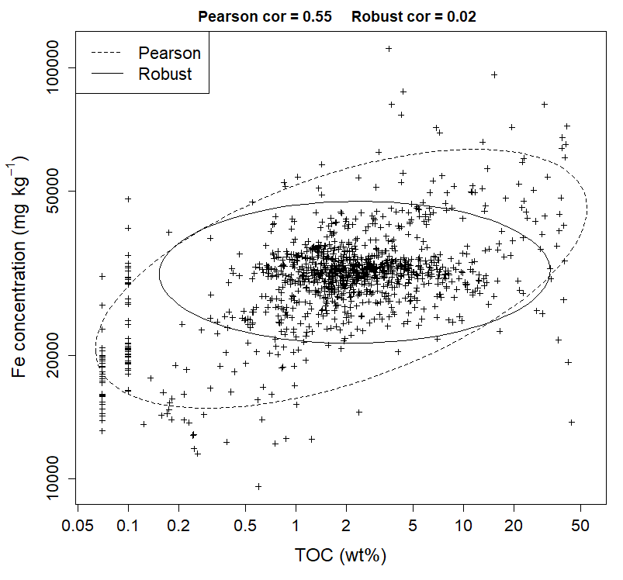
Supplementary Figure 1. Correlation plot of total Fe concentration (mg kg⁻¹) as a function of total organic carbon (TOC) content (wt%) from Yedoma Ice Complex and Alas deposits for which TOC data are available (n=1182). Points vertically distributed on the left of the plot refers to sample with limit of detection regarding TOC content (0.07 or 0.1 wt% depending on the method used). Pearson (dashed) and robust correlation (continuous ellipse) are shown on the plot and display values of 0.55 and 0.02, respectively. Samples with high TOC content (>20 wt%) and with lower Fe concentration refers to samples from top surface layers of deposits profiles (within active layer). Note that x and y-axis are logarithmic scale.

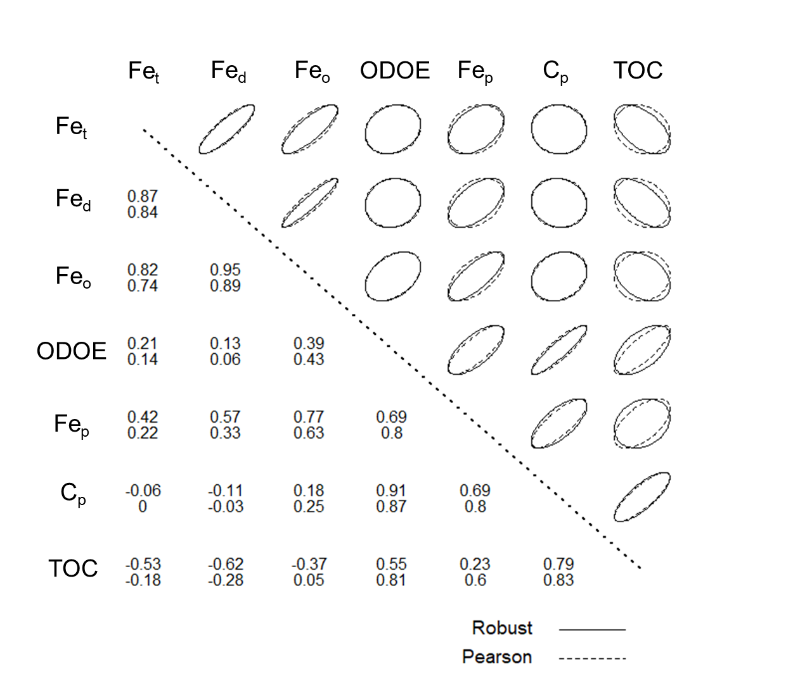
Supplementary Figure 2. Robust (full ellipse) and Pearson (dashed ellipse) correlation matrix of studied parameters: total Fe concentrations (Fe_{t}), Fe selectively extracted by dithionite-citrate-bicarbonate (Fe_{d}), Fe selectively extracted by ammonium oxalate (Fe_{o}), optical density of the oxalate extract (ODOE), Fe selectively extracted by Na-pyrophosphate (Fe_{p}), C selectively extracted by Na-pyrophosphate (C_{p}), total organic carbon (TOC) from Yedoma Ice Complex and Alas deposits. Robust correlation is the upper value and Pearson correlation the lower value displayed at the bottom part of the matrix.

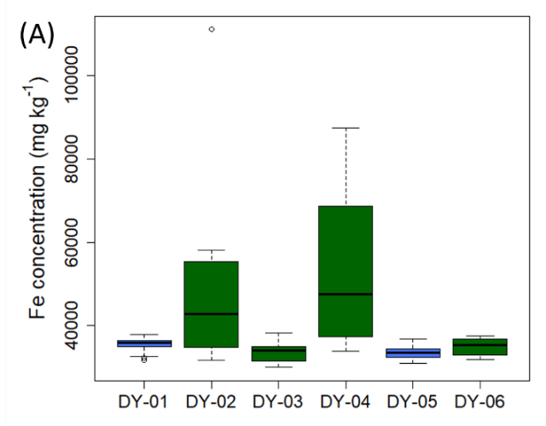
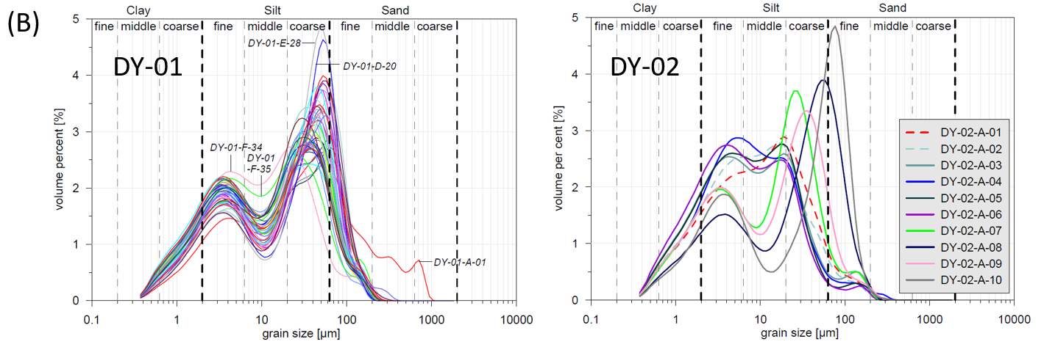
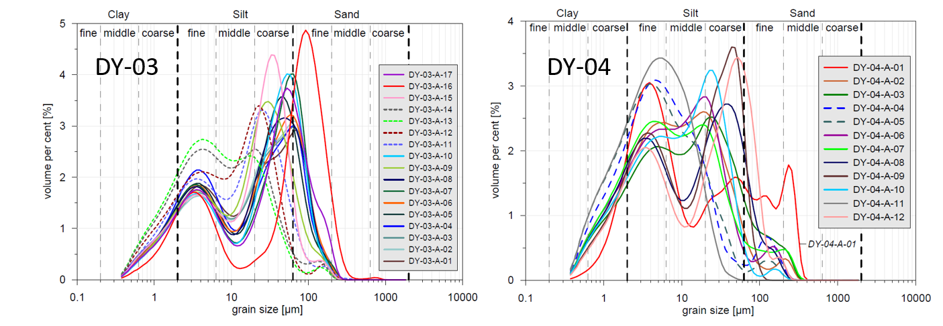
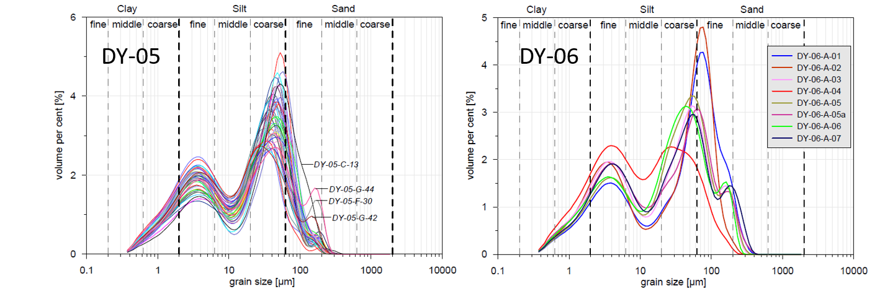
Supplementary Figure 3. (A) Boxplot of total Fe concentrations from Yedoma Ice Complex (blue) and Alas or thermokarst lake sediment (green) profiles from Duvanny Yar and (B) associated grain-size distribution (Strauss, 2010).

Supplementary Tables
Supplementary Table 1. Label identification for each profile from sites of the Yedoma domain. These labels are sometimes part of composite profiles. Details about sampling campaign are provided in reference papers from Table 1.
Site Nb | Site Name | Label
 |  | Yedoma | Alas | Deltaic/fluvial
1 | Cape Mamontov Klyk | Mak-2 to 10  Mak-12 to 19 | Mak-14
2 | Nagym (Ebe Sise Island) | Nag 4+50  Nag 4+80  Nag 6+20 | Nag 1+80
3 | Khardang Island | Kha-2
4 | Kurungnakh Island | Bkh-3  Bkh 2002 | Bkh-4  K-10
5 | Sobo Sise Island | Sob14 T2-2  Sob14 T2-3 | Sob14 T2-5 | Sob14 T2-6
6 | Bykovsky Peninsula | Mkh1  Mkh2  Mkh99  Mkh00 | BYK-Mkh 6.2  MB 6.3
7 | Muostakh Island | Muo-3
8 | Buor Khaya Penisula | Buo-02  Buo-04 | Buo-03  Buo-05
9 | Stolbovoy Island | Sto-1  Sto-2  Sto-3 | Sto-4
10 | Belkovsky Island |  | Bel-7  Bel-8
11 | Kotel’ny Island | KyS-2
12 | Bunge Land |  |  | Bun-4
13 | Bol’shoy Lyakhovsky Island | 1TZ  2TZ  3TZ  L7-18  L7-07 | R33-A1  L21+50  L7-08
14 | Oyogos Yar coast | Oy7-08 | Oy7-11
15 | Kytalyk | 11KH-3007  KY T1-1 | KY T2-2
16 | Duvanny Yar | DY-01  DY-05 | DY-02  DY-03  DY-04  DY-06
17 | Yukechi | YUK15-YUL15  YUK15-YED1 | YUK15-YUL7  YUK15-Alas1
18 | Kitluk | Kit | Kit
19 | Baldwin Peninsula | BAL16-B2 | BAL16-B3  BAL16-B4  BAL16-B5
20 | Colville | Col-5
21 | Itkillik | Itk
22 | Vault Creek Tunnel | FAI

Supplementary Table 2. Precision of selective iron extractions. The mean and associated coefficient of variation (CV, ratio of the standard deviation divided by the mean) were calculated on three samples from Yedoma and Alas deposits located in Yukechi site. Precision was assessed for Fe extracted using dithionite-citrate-bicarbonate extraction (Fe_{d}), dark ammonium oxalate extraction (Fe_{o}), and sodium pyrophosphate extraction (Fe_{p}) on three repetitions (n=3). The mean is expressed in g kg⁻¹, and the CV in %.
Sample | n | Fe_{d} |  | Fe_{o} |  | Fe_{p}
 |  | mean (g kg⁻¹) | CV (%) | mean (g kg⁻¹) | CV (%) | mean (g kg⁻¹) | CV (%)
A | 3 | 7.93 | 2.3 | 7.75 | 0.9 | 2.56 | 1.8
B | 3 | 5.64 | 3.3 | 5.41 | 1.5 | 1.52 | 6.8
C | 3 | 2.33 | 4.9 | 1.26 | 32 | 0.11 | 6.0

Supplementary Table 3. Precision of selective carbon extractions. The mean and associated coefficient of variation (CV, ratio of the standard deviation divided by the mean, expressed in %) were calculated on three samples from Yedoma and Alas deposits located in Yukechi site. Precision was assessed for optical density of the oxalate extract (ODOE, with oxalate extractant as a blank) and concentration of dissolved organic carbon released after dispersion by pyrophosphate (Cp, expressed in g kg⁻¹ dry soil) on three repetitions (n=3).
Sample | n | ODOE |  | C_{p}
 |  | Absorbance (-) | CV (%) | mean (g kg⁻¹) | CV (%)
A | 3 | 0.083 | 0.0 | 5.89 | 3.5
B | 3 | 0.070 | 2.2 | 8.30 | 3.4
C | 3 | 0.015 | 14.2 | 2.46 | 2.3

