Appendix
The 5- grade rating system (1–5) is established according to Shimizu et al. in the answer sheet as follows: when written characteristic imaging findings were definitely present, 5; when written characteristic imaging findings were definitely absent, 1^{[11]}.The details listed below.
Parameter 1: the presence of patchy hypoechoic areas
Grading 1 for absent, 2 for scattered, 3 for a few, 4 for several and 5 for numerous patchy hypoechoic areas
Supplementary figure 1: Representative images showing the presence of patchy hypoechoic areas of grade 2-5 in major salivary glands
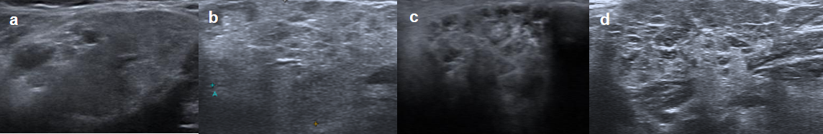
Parameter 2: the presence of large flaky hypoechoic area
Grade 1: absent; grade 2: the maximum diameter <6mm; grade 3: the maximum diameter >6mm, <10mm; grade 4: the maximum diameter >10mm, <15mm; grade 5: the maximum diameter >15mm
Supplementary figure 2: Representative images showing the presence of large flaky hypoechoic area of grade 2-5 in major salivary glands
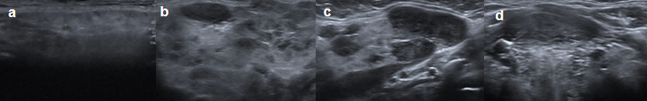
Parameter 3: the presence of diffuse hypoechoic pattern
The presence of diffuse hypoechoic pattern was graded from 1 to 5 according to the proportion of hypoechoic area in the salivary gland. Grading 1 for less than 10%, 2 for 10-50%, 3 for 50-75%, 4 for 75-90% and 5 for more than 90% of hypoechoic area in the salivary gland.
Supplementary figure 3: Representative images showing the presence of diffuse hypoechoic pattern of grade 2-5 in major salivary glands
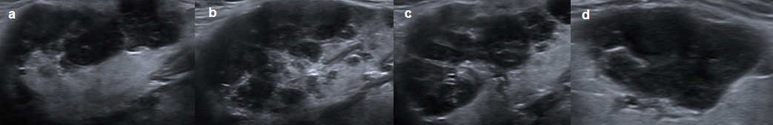
Parameter 4: hyperechoic lines and/or spots
Grading 1 for absent, 2 for scattered, 3 for a few, 4 for several and 5 for numerous hyperechoic lines and/or spots.
Supplementary figure 4: Representative images showing the presence of hyperechoic lines and/or spots of grade 2-5 in major salivary glands
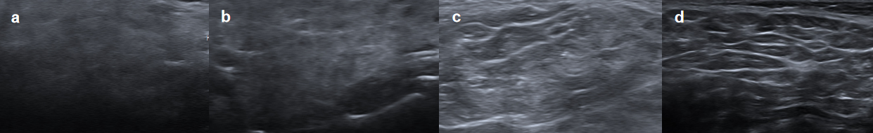
Parameter 5: homogeneity of the parenchyma
Grading 1 was for a homogeneous gland, 2 for mild inhomogeneity, 3 for evident inhomogeneity, 4 for gross inhomogeneity and 5 for a extremely inhomogeneous gland.
Supplementary figure 5: Representative images showing the homogeneity of the parenchyma of grade 2-5 in major salivary glands
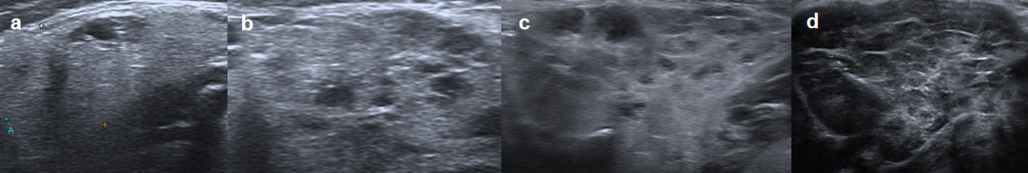
Parameter 6: color Doppler signaling
Grading 1 for absent, 2 for scattered, 3 for a few, 4 for several and 5 for numerous color Doppler signaling.
Supplementary figure 6: Representative images showing the color Doppler signaling of grade 2-5 in major salivary glands
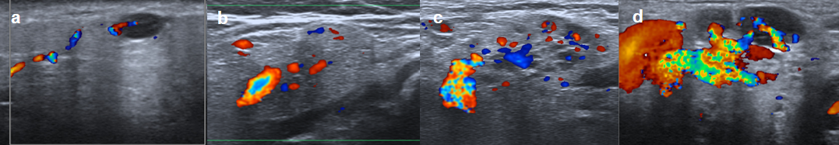
Parameter 7: clearness of salivary gland borders
Grading 1 for clear, regular defined borders, 2 for mostly defined borders, 3 for partly defined borders, 4 for ill-defined borders and 5 for borders not visible.
Supplementary figure 7: Representative images showing the clearness of salivary gland borders of grade 2-5 in major salivary glands
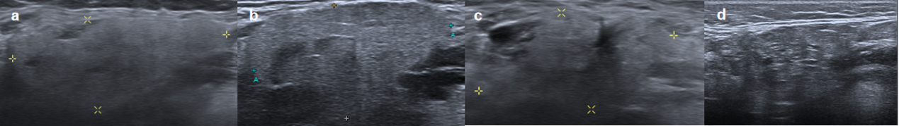
Supplementary figure 8: Images of normal parotid and submandibular glands represented grade 1 for all seven parameters
