Iyengar A. & Wu C.-F. Fly seizure EEG: field potential activity in the Drosophila brain. J Neurogenet.

Supplementary Materials

Supplemental Video 1. LFP signals and DLM spiking following electroconvulsive seizure activity and during rest and flight. Fly behavior is monitored through a Sony QX-10 camera mounted on the dissection microscope. Sound, (generated by wing-beats) is recorded through a high-gain microphone placed below the fly.

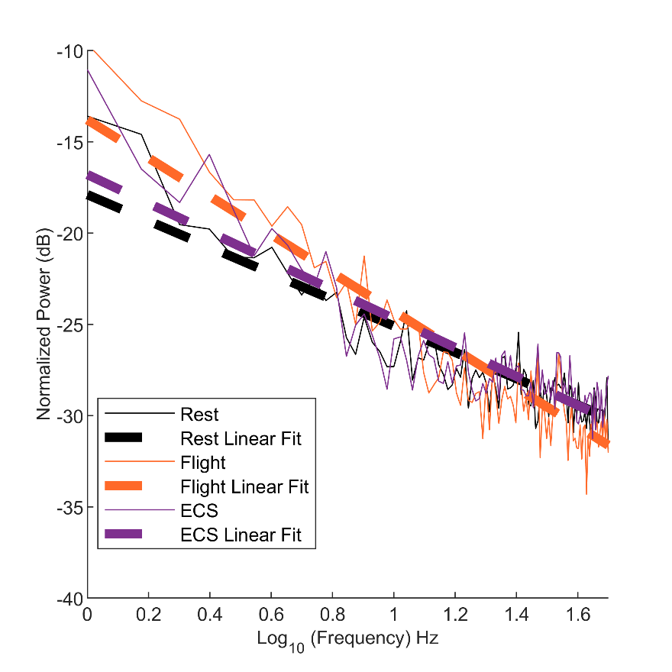
Supplemental Figure 1. Normalized power spectra of rest, flight and ECS discharge LFP activity (data from Figure 2E) re-plotted on a log-log scale. Bold lines indicate linear fits of the respective data. Slope = 0.72, 1.04 and 0.79 for the respective fits.

