The Natchez Democrat
Website: www.natchezdemocrat.com

Natchez Monument Committee looking to identify descendants of U.S. Colored Troops

Published 1:35 pm Wednesday, July 14, 2021

By Staff Reports

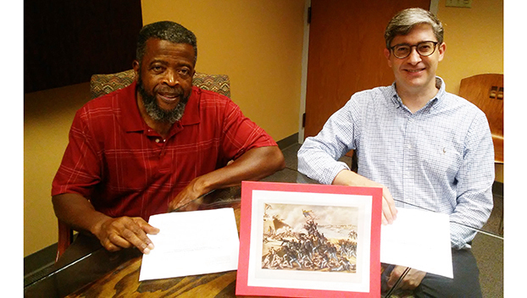
Leaders of the Natchez U.S. Colored Troops Monument Committee say they are pleased with the work being done to honor the black men who served with the U.S. Colored Troops at Fort McPherson in Natchez. Committee Chairman Robert Pernell, left, and Vice Chairman Carter Burns, are pictured here with an image of the colored troops in battle.

By Roscoe Barnes III
Special to the Democrat

NATCHEZ — Local community leaders are making progress on the monument project to honor more than 3,000 African American men who served with the U.S. Colored Troops at Fort McPherson in Natchez, according to Chairman Robert Pernell of the Natchez U.S. Colored Troops Monument Committee.

Pernell, who formerly served as chair for the “Proud to Take a Stand” monument committee, said that he is pleased with the efforts being made by the committee volunteers.

“We have an army of volunteers, and they are working hard to make this tribute possible,” he said in a recent meeting. “We are moving forward with great expectations. I’m excited about the interest in the project and the support we’re receiving from the community.”

Pernell is working with Carter Burns, who serves as vice chairman of the USCT committee. Burns is also the executive director of Historic Natchez Foundation.

Since announcing plans to erect a monument, the committee has recruited volunteers for the following five sub-committees: History and Research Sub-committee, Monument Design Sub-committee, Marketing/PR Sub-committee, Site Sub-committee and Finance/Fundraising Sub-committee.

The committee is currently seeking to identify the descendants of the Colored Troops who served in Natchez, as well as those who served in the Navy who were born in Natchez. These men served with six regiments, which included: Sixth U.S. C Heavy Artillery, 58th U.S. Colored Infantry, 70th U.S. Colored Infantry, 71st U.S. Colored Infantry, 63rd U.S. Colored Infantry and the 64th U.S. Colored Infantry.

“The men left their plantations and served for their own freedom and the freedom of their families,” said Deborah Fountain, a researcher and descendant of one of the Colored Troops. She also serves on the USCT committee.

Fountain noted a listing of the names of all the men who served is currently available through the National Park Service website and the National Archives. Each name will be included on or around the monument, depending on the design, according to Pernell.

Pernell said the committee wants to help descendants discover their relationship to the Colored Troops. He said there is a strong possibility that many of the local families are related to the soldiers.

Anyone who wants to know if they are related to the Colored Troops may use a few simple steps to determine their relationship, Fountain said.

One should start by checking his or her family tree.

“Look for the names of the men who were of age to have served in the 1860s,” she said.
Next, one should visit the website for the National Park Service: Soldiers and Sailors Database at nps.gov/civilwar/search-soldiers.htm. There, they can search the person’s name, which should be listed in one of the six noted regiments.

During the Civil War, about 200,000 black men served with the U.S. Colored Troops who fought to preserve the United Sates, according to the National Archives. That number included roughly 179,000 in the Union Army and about 19,000 in the Navy.

More than 3,000 black men from the Natchez area joined the U.S. military. Prior to the Civil War and their enlistment as colored troop soldiers, some of them had been forced to walk to the notorious Forks of the Road, where they were sold.

It is believed that the colored troops made up about 10 percent of the manpower in the Union Army.

Additional information on the Colored Troops in Natchez may be found on social media at “Descendants of Natchez (USCT).” The committee asks that any and all descendants of the Natchez Colored Troops become members of the Descendants of Natchez (USCT) group on Facebook.

Roscoe Barnes III is the Cultural Heritage and Tourism Manager at Visit Natchez.

