**SUPPLEMENTARY MATERIAL**

**Table S1** Taxonomic groups of the sponge species analyzed in each of the three regions (Mediterranean Sea, Red Sea and Caribbean Sea).

|  |  |  |  |  |
| --- | --- | --- | --- | --- |
| **Regions** | **Class** | **Order** | **Family** | **Species** |
| Mediterranean Sea | Demospongiae | Dictyoceratida | Dysideidae | *Dysidea avara* |
| Demospongiae | Poecilosclerida | Crambeidae | *Crambe crambe* |
| Demospongiae | Haplosclerida | Petrosiidae | *Petrosia ficiformis* |
| Demospongiae | Chondrosiida | Chondrosiidae | *Chondrosia reniformis* |
| Demospongiae | Agelasida | Agelasidae | *Agelas oroides* |
| Red Sea | Demospongiae | Tetractinellida | Theonellidae | *Theonella swinhoei* |
| Demospongiae | Poecilosclerida | Podospongiidae | *Diacarnus erythraenus* |
| Demospongiae | Suberitida | Suberitidae | *Suberites clavatus* |
| Demospongiae | Haplosclerida | Callyspongiidae | *Callyspongia siphonella* |
| Demospongiae | Poecilosclerida | Mycalidae | *Mycale fistulifera* |
| Demospongiae | Haplosclerida | Niphatidae | *Niphates rowi* |
| Demospongiae | Poecilosclerida | Crellidae | *Crella cyathophora* |
| Caribbean Sea | Demospongiae | Agelasida | Agelasidae | *Agelas conifera* |
| Demospongiae | Haplosclerida | Callyspongiidae | *Callyspongia vaginalis* |
| Demospongiae | Verongiida | Aplysinidae | *Aplysina archeri* |
| Demospongiae | Haplosclerida | Callyspongiidae | *Callyspongia plicifera* |
| Demospongiae | Dictyoceratida | Irciniidae | *Ircinia strobilina* |
| Demospongiae | Haplosclerida | Niphitidae | *Niphates digitalis* |
| Demospongiae | Haplosclerida | Petrosiidae | *Xestospongia muta* |
| Demospongiae | Clionaida | Clionaidae | *Spheciospongia vesparium* |

**Table S2.** Sponge volume (V, cm3), number of oscula (#) and osculum cross-sectional area (OSA, mm2) for sampled species. *n*, number of sampled specimens for each species. Average is expressed as mean ± SE. HMA: High-Microbial-Abundance; LMA: Low-Microbial-Abundance.

|  |  |  |  |  |  |  |  |  |  |  |
| --- | --- | --- | --- | --- | --- | --- | --- | --- | --- | --- |
| **Location** | **Species** | **n** | **Host type** | **V (cm3)** | | **Osculum** | | **OSA (mm2)** | | **Growth form** |
| **range** | **average** | **#** | **average** | **range** | **average** |
| Mediterranean Sea | *D. avara* | 39 | LMA | 1.5 - 148 | 32 ± 5 | 2 - 45 | 13 ± 2 | 0.14 - 25 | 5.6 ± 0.4 | encrusting |
| *C. crambe* | 39 | LMA | 0.8 - 25 | 8 ± 1 | 2- 23 | 7 ± 1 | 0.2 - 35 | 4.8 ± 0.4 | encrusting |
| *P. ficiformis* | 40 | HMA | 3 - 420 | 83 ± 15 | 2- 37 | 12 ± 2 | 0.8 - 17 | 4.3 ± 0.2 | massive |
| *C. reniformis* | 41 | HMA | 3 - 180 | 62 ± 9 | 2 - 13 | 4 ± 0.4 | 0.2 - 64 | 10.5 ± 1 | massive |
| *A. oroides* | 40 | HMA | 3 - 440 | 117 ± 20 | 2 - 10 | 4 ± 0.4 | 0.3 - 31 | 7.9 ± 0.7 | massive |
| Red Sea | *T. swinhoei* | 6 | HMA | 48 - 196 | 112 ± 20 | 1 | 1 ± 0 | 24 - 75 | 57 ± 8 | tubular |
| *D. erythraenus* | 3 | HMA | 33 -141 | 71 ± 35 | 1 - 3 | 2 ± 1 | 19 - 68 | 36 ± 7 | branching |
| *S. clavatus* | 2 | HMA | 41 - 117 | 79 ± 38 | 3 - 12 | 8 ± 5 | 11 - 23 | 17 ± 2 | massive |
| *C. siphonella* | 6 | LMA | 1 - 23 | 12 ± 5 | 1 | 1 ± 0 | 27 - 290 | 165 ± 53 | tubular |
| *M. fistulifera* | 2 | LMA | - | - | 3 | 3 ± 0 | 8 - 42 | 24 ± 6 | encrusting |
| *C. cyathophora* | 3 | LMA | 10 - 20 | 15 ± 3 | 1 - 3 | 2 ± 1 | 18 - 46 | 30 ± 5 | massive |
| *N. rowi* | 2 | LMA | 6 - 21 | 14 ± 8 | 2 - 3 | 3 ± 1 | 10 -19 | 14 ± 2 | encrusting |
| Caribbean Sea | *A. conifera* | 8 | HMA | 187 – 8808 | 2,934 ± 3048 | 1 | - | 393 – 1891 | 960 ± 514 | tubular |
| *A. archeri* | 6 | HMA | 165 - 353 | 281 ± 89 | 1 | - | 79 – 254 | 169 ± 72 | tubular |
| *C. vaginalis* | 5 | LMA | 60 - 110 | 88 ± 19 | 1 | - | 214 – 726 | 404 ± 199 | tubular |
| *C. plicifera* | 6 | LMA | 50 - 190 | 105 ± 59 | 1 | - | 1037 – 2604 | 1551 ± 577 | tubular/vase |
| *I. strobilina* | 2 | HMA | 2342 - 2544 | 2443 ± 100 | 1 | - | 2248 – 2323 | 2286 ± 38 | massive |
| *N. digitalis* | 10 | LMA | 100 - 505 | 227 ± 121 | 1 | - | 705 – 4418 | 1973 ± 1188 | tubular/vase |
| *S. vesparium* | 16 | HMA | 1226 - 32552 | 11285 ± 10297 | 1 | - | 1555 – 39584 | 10991 ± 12022 | massive |
| *X. muta* | 5 | HMA | 385 - 28253 | 12389 ± 13110 | 1 | - | 415 – 7775 | 4969 ± 3566 | massive |

**Table S3.** The parameters of the allometric function between **(A)** sponge pumping rate (PR, mL min-1 sponge-1) and total osculum cross-sectional area (∑OSA, mm2), and **(B)** between sponge pumping rate (PR, mL min-1 sponge-1) and sponge volume (V, cm3) from this study and Table 3 in Morganti et al. 2019. Data are expressed as the coefficients (*a*) and scaling exponents (*b*) ± the 95% CI. *n*, number of sampled specimens. The *b* scaling exponents were statistically different from zero in all equations (*p* < 0.001).

HMA: High-Microbial-Abundance; LMA: Low-Microbial-Abundance.

**(A) *PR = a (∑OSA)b***

|  |  |  |  |  |  |
| --- | --- | --- | --- | --- | --- |
| **Location** | **Species** | **n** | **a (mL min-1 sponge-1)** | **b** | **R2** |
| Mediterranean Sea | *D. avara* | 39 | 13.65 ± 10.71 | 0.69 ± 0.16 | 0.78 |
| *C. crambe* | 39 | 9.71 ± 3.86 | 0.73 ± 0.10 | 0.87 |
| *P. ficiformis* | 40 | 4.83 ± 4.75 | 0.91 ± 0.22 | 0.79 |
| *C. reniformis* | 41 | 12.10 ± 5.94 | 0.78 ± 0.11 | 0.86 |
| *A. oroides* | 40 | 17.81 ± 9.07 | 0.62 ± 0.12 | 0.81 |
| HMA | 121 | 11.19 ± 4.59 | 0.75 ± 0.09 | 0.76 |
| LMA | 78 | 9.72 ± 4.47 | 0.76 ± 0.10 | 0.81 |
| Caribbean and Red Sea | HMA | 48 | 4.08 ± 5.47 | 1.07 ± 0.13 | 0.92 |
| LMA | 34 | 26.48 ± 60.08 | 0.67 ± 0.30 | 0.57 |

**(B) *PR = aVb***

|  |  |  |  |  |  |
| --- | --- | --- | --- | --- | --- |
| **Location** | **Species** | **n** | **a (mL min-1 sponge-1)** | **b** | **R2** |
| Mediterranean Sea | *D. avara* | 39 | 44.83 ± 32.94 | 0.50 ± 0.19 | 0.54 |
| *C. crambe* | 39 | 23.88 ± 11.43 | 0.77 ± 0.19 | 0.75 |
| *P. ficiformis* | 40 | 10.41± 9.06 | 0.65 ± 0.17 | 0.74 |
| *C. reniformis* | 41 | 18.03 ± 14.99 | 0.61 ± 0.18 | 0.69 |
| *A. oroides* | 40 | 18.52 ± 14.02 | 0.46 ± 0.14 | 0.64 |
| HMA | 121 | 25.46 ± 12.31 | 0.46 ± 0.10 | 0.53 |
| LMA | 78 | 42.58 ± 15.99 | 0.52 ± 0.10 | 0.63 |
| Caribbean and Red Sea | HMA | 48 | 42.66 ± 174.49 | 0.80 ± 0.41 | 0.47 |
| LMA | 32 | 16.31 ± 21.30 | 1.04 ± 0.23 | 0.80 |

**Table S4.** Backward stepwise multiple regression to estimate the set of allometric variables (sponge volume, V cm3 and total osculum cross-sectional area, ∑OSA mm2) to describe the variance observed in pumping rate (PR, mL min-1 sponge-1) within each of the five Mediterranean sponge species. Values are the standardized coefficients ± standard error for each variables (rows) and each species (columns) over the two steps (Step1: V + ∑OSA; Step 2: ∑OSA). R squared (*R2*) is also reported below. Variables were removed from the model when *F*< 3.90 and *p*>0.055. The variance inflaction factor (VIF) is reported for the first step model for each specie.

|  |  |  |  |  |  |  |  |  |  |  |  |  |  |  |  |  |  |  |  |  |
| --- | --- | --- | --- | --- | --- | --- | --- | --- | --- | --- | --- | --- | --- | --- | --- | --- | --- | --- | --- | --- |
| *Step 1* | *D. avara* (n=39) | | | | *C. crambe* (n=39) | | | | *C. reniformis* (n=41) | | | | *A. oroides* (n=40) | | | | *P. ficiformis* (n=40) | | | |
|  | std.Coeff | *F* | *p* | VIF | std.Coeff | *F* | *p* | VIF | std.Coeff | *F* | *p* | VIF | std.Coeff | *F* | *p* | VIF | std.Coeff | *F* | *p* | VIF |
| V | 0.04 ± 0.65 | 0.12 | 0.729 | 2.242 | 0.43 ± 0.96 | 35.26 | <0.001 | 2.154 | 0.18 ± 0.30 | 2.37 | 0.132 | 3.442 | 0.20 ± 0.09 | 3.30 | 0.077 | 2.471 | 0.22 ± 0.26 | 1.57 | 0.219 | 5.292 |
| ∑OSA | 0.84 ± 0.36 | 48.15 | <0.001 |  | 0.59 ± 0.20 | 64.92 | <0.001 |  | 0.77 ± 0.50 | 43.50 | <0.001 |  | 0.74 ± 0.34 | 44.53 | <0.001 |  | 0.69 ± 0.59 | 16.27 | <0.001 |  |
| *Step 2* |  |  |  |  |  |  |  |  |  |  |  |  |  |  |  |  |  |  |  |  |
| ∑OSA | 0.87 ± 0.24 | 118.99 | <0.001 |  | - | - | - |  | 0.92 ± 0.27 | 215.11 | <0.001 |  | 0.89 ± 0.23 | 151.96 | <0.001 |  | 0.89 ± 0.26 | 138.87 | <0.001 |  |
| *R2* | 0.76 |  |  |  |  |  |  |  | 0.85 |  |  |  | 0.80 |  |  |  | 0.79 |  |  |  |

**Supplementary Figures**

**Figure S1**



**Figure S1.** Mosaic pictures and growth forms of the study species from Red Sea (**A-G**), Mediterranean Sea (**H-L**) and Caribbean Sea (**M-T**). **A**: *Theonella swinhoei* (tubular); **B**: *Diacarnus erythraenus* (branching); **C**: *Suberites clavatus* (massive, buried in sand); **D**: *Crella cyathophora* (massive); **E**: *Callyspongia siphonella* (tubular); **F**: *Mycale fistulifera* (encrusting); **G**: *Niphates rowi* (encrusting); **H**: *Petrosia ficiformis* (massive); **I**: *Dysidea avara* (encrusting); **J**: *Chondrosia reniformis* (massive); **K**: *Crambe crambe* (encrusting); **L**: *Agelas oroides* (massive)*;* **M:** *Spheciospongia vesparium* (massive); **N:** *Niphates digitalis* (tubular/vase); **O:** *Aplysina archeri* (tubular); **P:** *Agelas conifera* (tubular); **Q:** *Ircinia strobilina* (massive); **R:** *Callyspongia vaginalis* (tubular); **S:** *Callyspongia plicifera* (tubular/vase); **T:** *Xestospongia muta* (massive). Scale bars represent the mean oscula diameter in each species.

Photo credits: Raz Moskovich for Red sea species, Teresa Morganti for Mediterranean species and Jeremy Weisz (N, P, R, T), Sven Zea (M, Q) and Joseph Pawlik (O, S) for Caribbean species. Sponge pictures (M, Q, O and S) source from spongeguide.org

**Figure S2.**

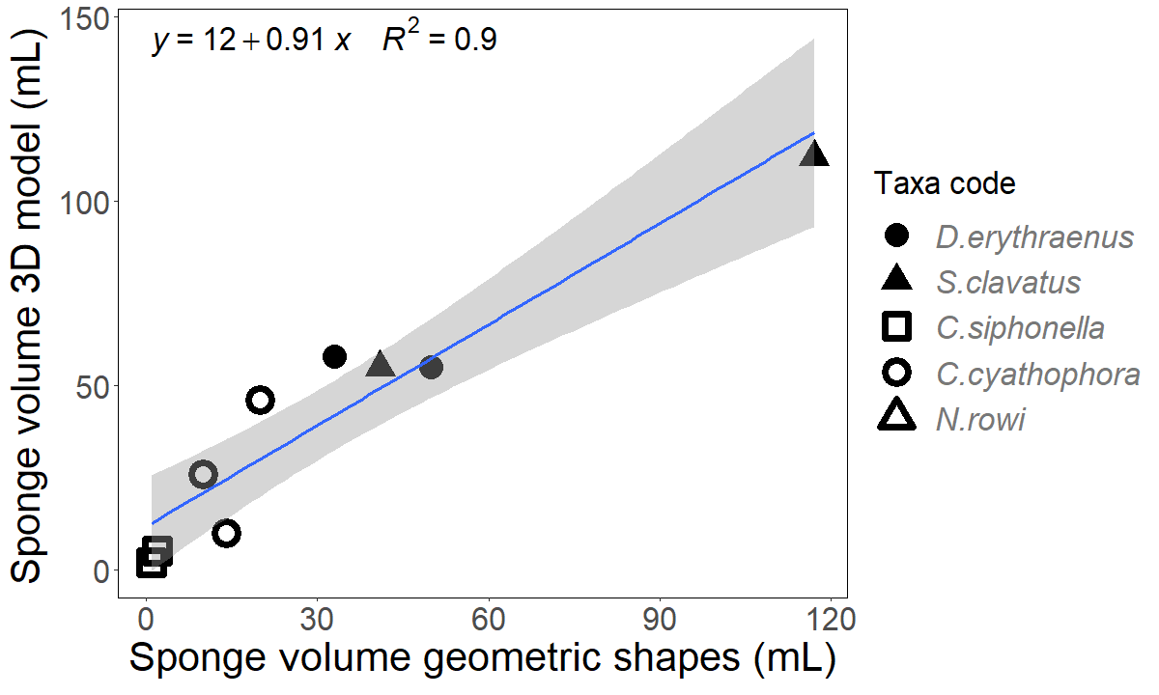

**Figure S2.** Comparison of the methods used to estimate sponge volume in the Red Sea sponge specimens: 3D model (photogrammetry) and approximation to geometric shape. Grey area represents the 95% confidence interval for the regression line. Due to niche structure, there was no access to take reasonable amount of pictures for building 3D model in *T. swinhoei* specimens.

**Figure S3**

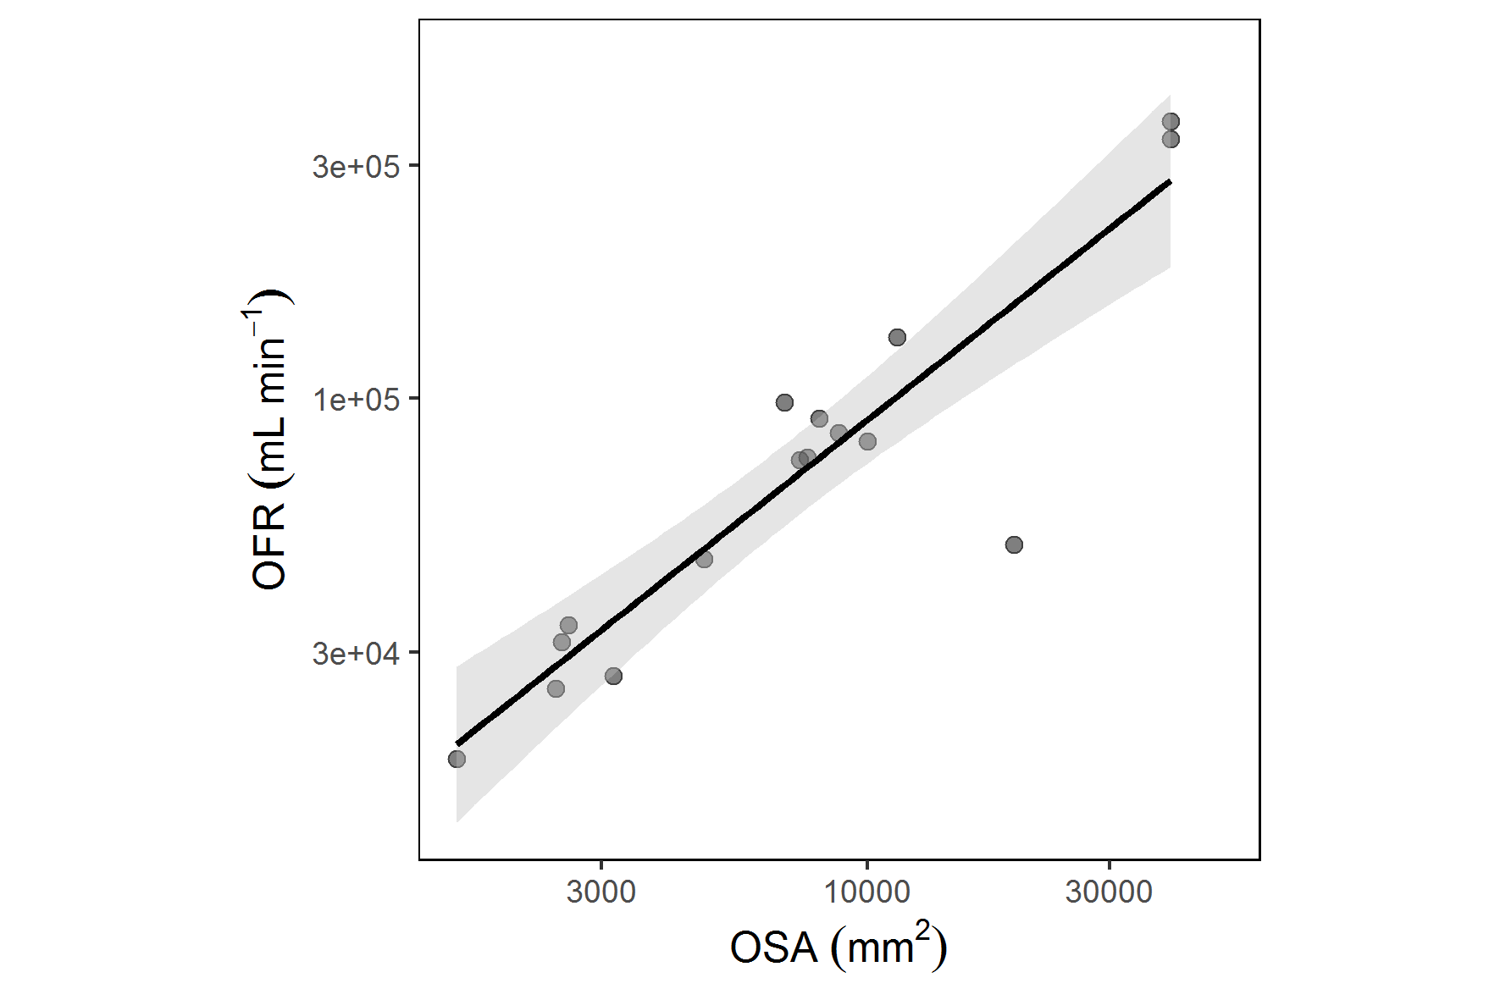

**Figure S3.** The relationship between osculum flow rate (OFR, mL min-1) and osculum cross-sectional area (OSA, mm2) on single osculated specimens of *S. vesparium* from the Caribbean Sea. Power regression: y= 10.53x 0.98, R2= 0.89, *p*<0.001, n=37. Grey area represents the 95% CI.

**Figure S4**

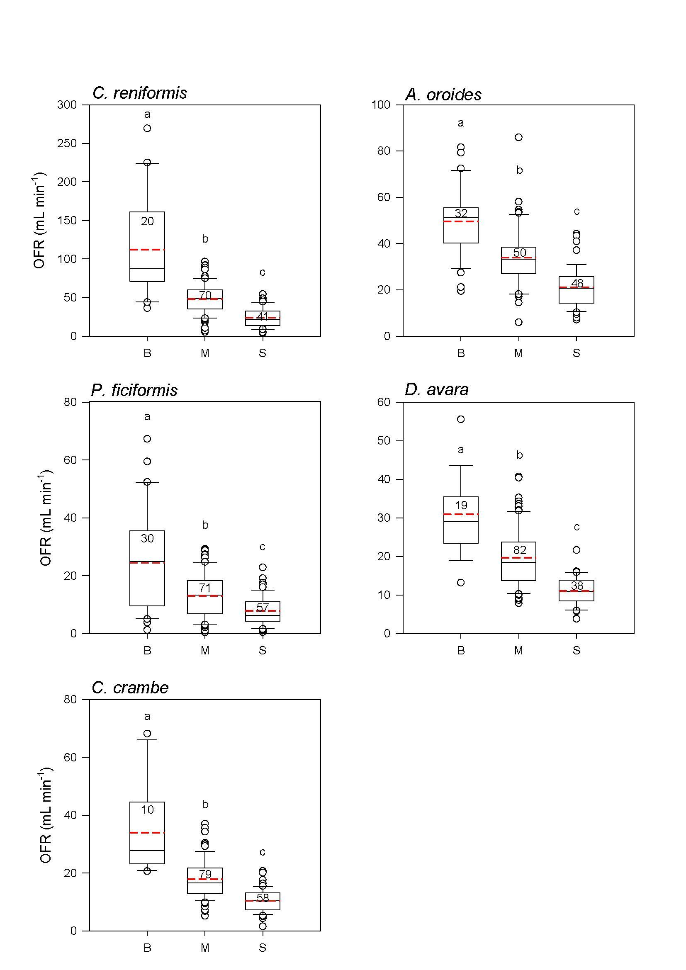

**Figure S4**. Box plots ofosculum flow rate (OFR, mL min-1) measured per each osculum size class (B=large, M=medium, S=small) in the five Mediterranean sponge species. Median and mean are indicated in the box plot as black solid and red dashed line, respectively. The number in the plot indicates sample size. Letters indicate significant differences (a>b>c).

**Figure S5**

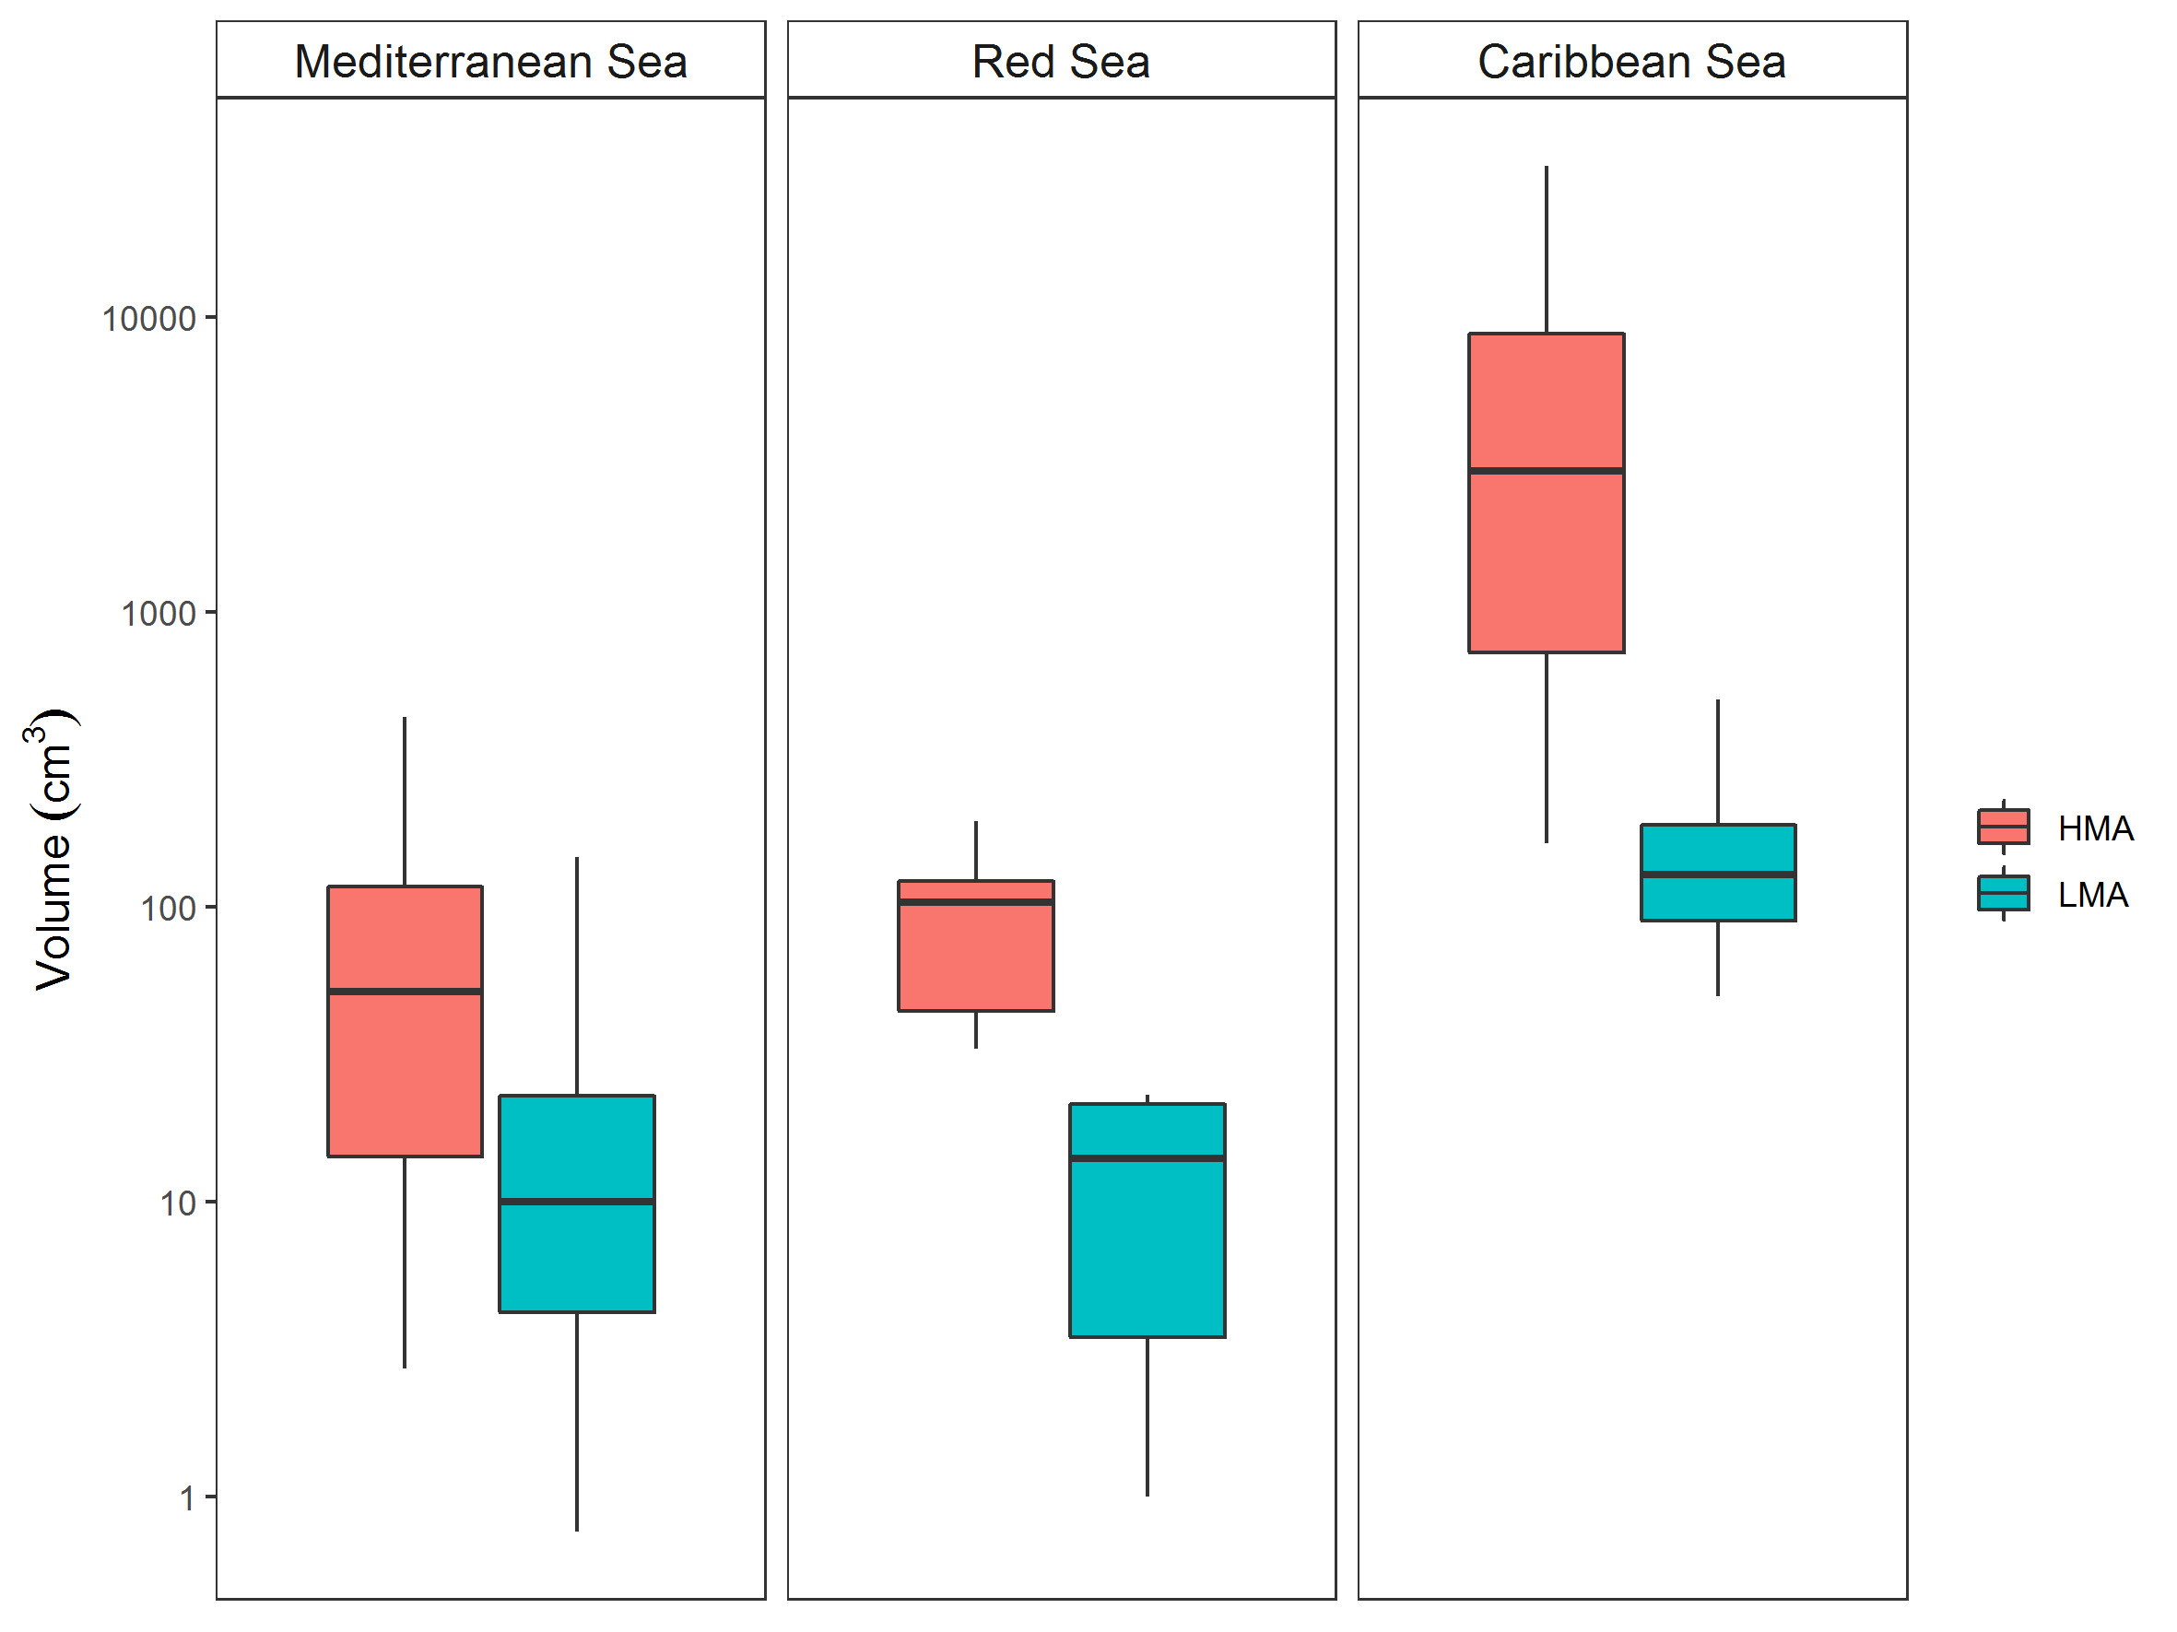

**Figure S5.** Box plots of the volume (cm3) of the analyzed sponge species from the three geographic areas (Mediterranean Sea, Red Sea and Caribbean Sea) sorted by host type: High-Microbial-Abundance (HMA, red), and Low-Microbial-Abundance (LMA, cyan) species.

**Figure S6**

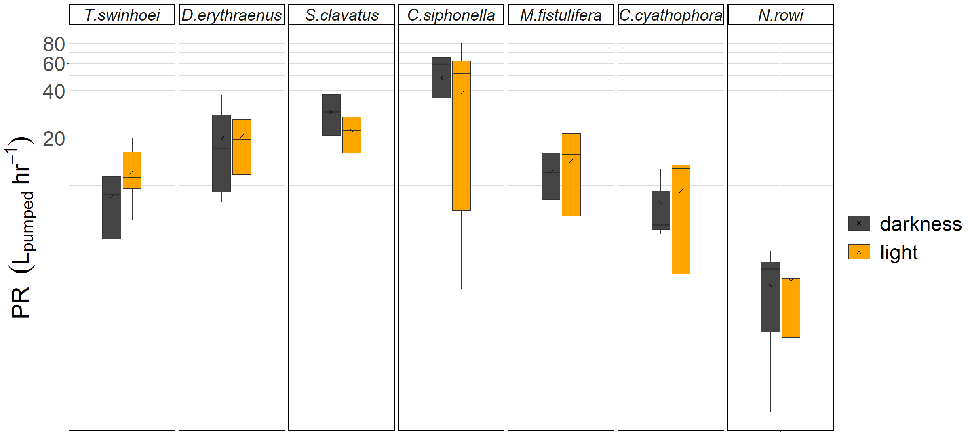

**Figure S6.** Pumping rate (PR, L hr-1 sponge-1) measured during the day (light, yellow box plot) and night (darkness, grey box plot) in the seven Red Sea species we studied. Media and mean are indicated in the box plot as black line and *x*, respectively. No significant difference was found between day and night PR measurements in all species (Permutation Test , *n*=10000, *p*>0.05).

**Figure S7**

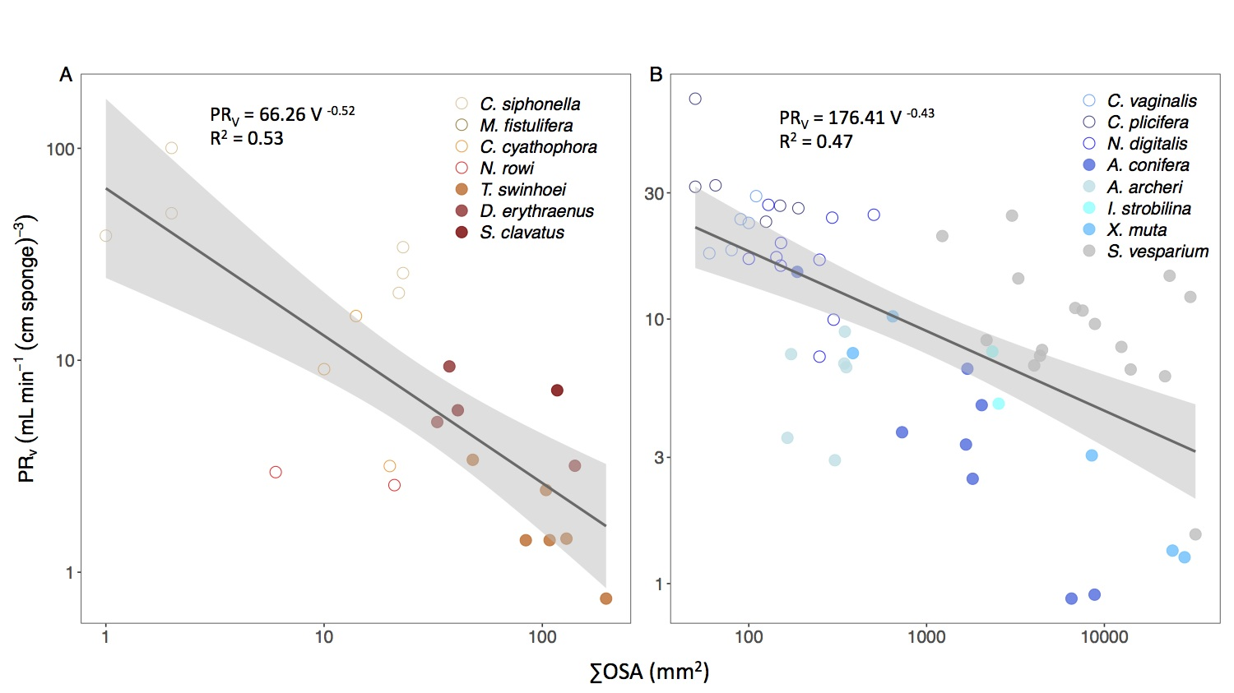

**Figure S7.** Allometric relationship (*Y = aXb*) between volume-specific pumping rate (PRv, mL min-1 (cm sponge)-3) and sponge volume (V, cm3) in the tropical species from (A) the Red Sea and (B) Caribbean Sea. The scaling exponents and coefficients are shown in each panel and the shade areas represent the 95% confidence interval for the regression line. The *b* scaling exponents were statistically different from zero in both regions (*p* < 0.001). Note the log-log scale.

**Figure S8**



**Figure S8.** Comparison between estimated and measured pumping rate (PR, mL min-1 sponge-1). The sampled oscula were ≥ 39% of total number of oscula. PR was calculated using the average OFR of each oscula class of the population (Estimated PR), and of each specimen (Measured PR, see equation 1).